Appendix

**Research Question 1:** How large is the potential pool of recruits in the U.S population of high school seniors?

**Variable Used:** The variable utilized in the analysis was high school students responding to the question of how likely they will serve in the armed forces after high school. The respondent pool is broken into three categories:

* Non-recruits (students who say they definitely will not serve in the military after high school graduation) --- these are labeled as *definitely won’t (1).*
* Recruits (students who say they definitely or probably will serve in the military) --- these are labeled as *probably will (3).*
* Potential recruits (those who say they probably will not serve) --- these are labeled as *probably won’t (2)*.

The desired recruit pool is those labeled as probably won’t.

**Analysis Procedure:** Frequency, percentages, and range were calculated. The histogram was inspected for outliers, none were present.

**Results:** 21.5% ± 2.6% (99% confidence level) high school respondents indicated they probably won’t join the armed forces after high school. Range is 209 to 1072 with 1631 total respondents.

**Interpretation:** No interpretation required for descriptive statistics.

**Supporting Analysis:**

**Exhibit : Preliminary Analysis**

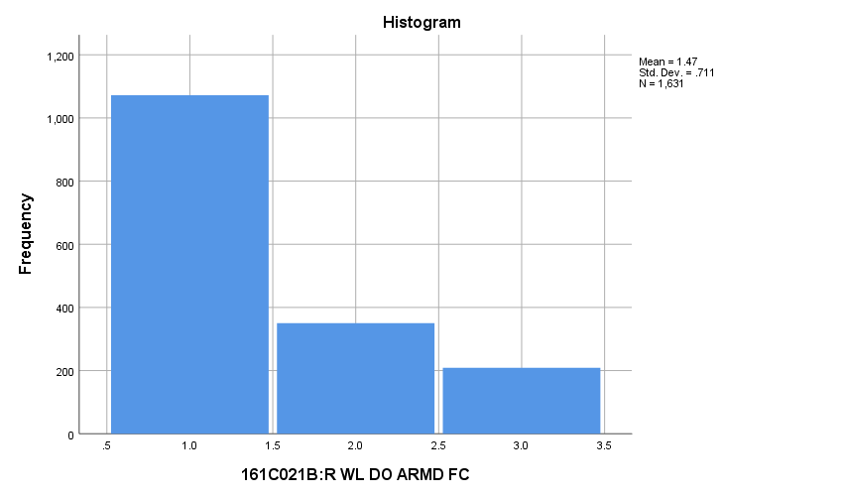

**Exhibit : Frequency Table**

|  |  |  |  |  |  |
| --- | --- | --- | --- | --- | --- |
| ***V1181*** | | | | | |
|  | | Frequency | Percent | Valid Percent | Cumulative Percent |
| Valid | DEF WONT:(1) | **1072** | **51.0** | **65.7** | **65.7** |
| PRB WONT:(2) | **350** | **16.7** | **21.5** | **87.2** |
| PRB WILL:(3) | **209** | **10.0** | **12.8** | **100.0** |
| Total | **1631** | **77.7** | **100.0** |  |
| Missing | MISSING:(-9) | **469** | **22.3** |  |  |
| Total | | **2100** | **100.0** |  |  |

**Research Question 2:** What are the demographic characteristics of potential recruits?

*2.a Demographics*

**Race:** What are the racial components of the potential pool of recruits?

**Variable Used:** The variables utilized in the analysis was the potential pool of recruits and their race. Race was divided into black (1), white (2), and Hispanic (3) categories.

**Analysis Procedure:** Frequency, percentages and range were calculated. The histogram was inspected for outliers, none were present.

**Results:**

* Black: 7.2% ± 3.9% (99% confidence level)
* White: 75.6% ± 6.5% (99% confidence level)
* Hispanic: 17.2% ± 5.7% (99% confidence level)
* Range 21-220, total respondents 291

**Interpretation:** No interpretation required for descriptive statistics.

**Supporting Analysis:**

**Exhibit : Preliminary Analysis**

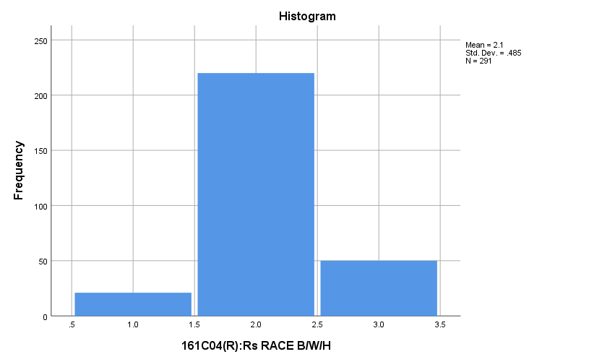

**Exhibit : Frequency Table**

|  |  |  |  |  |  |
| --- | --- | --- | --- | --- | --- |
| ***V1151*** | | | | | |
|  | | Frequency | Percent | Valid Percent | Cumulative Percent |
| Valid | BLACK:(1) | **21** | **6.0** | **7.2** | **7.2** |
| WHITE:(2) | **220** | **62.9** | **75.6** | **82.8** |
| HISPANIC:(3) | **50** | **14.3** | **17.2** | **100.0** |
| Total | **291** | **83.1** | **100.0** |  |
| Missing | MISSING:(-9) | **59** | **16.9** |  |  |
| Total | | **350** | **100.0** |  |  |

**Gender:** What are the gender characteristics of the potential pool of recruits?

**Variable Used:** The variables utilized in the analysis was the potential pool of recruits and their gender. Gender was divided into male (1) and female (2).

**Analysis Procedure:** Frequency, percentages, and range were calculated. The histogram was inspected for outliers, none were present.

**Results:**

* Male: 61.5% ± 6.8% (99% confidence level)
* Female: 38.5% ± 6.8% (99% confidence level)
* Total respondents: 338, range 130-208

**Interpretation:** No Interpretation required for descriptive statistics.

**Supporting Analysis:**

**Exhibit : Preliminary Analysis**

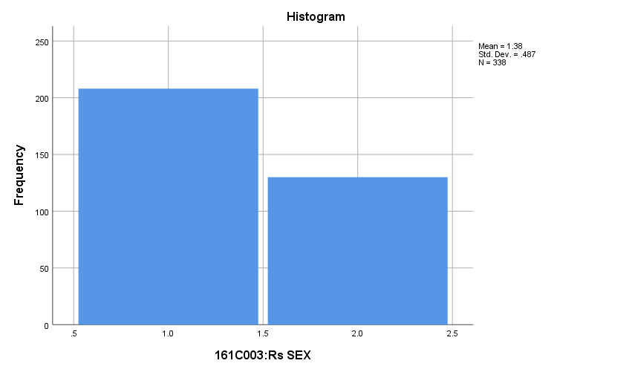

**Exhibit : Frequency Table**

|  |  |  |  |  |  |
| --- | --- | --- | --- | --- | --- |
| ***V1150*** | | | | | |
|  | | Frequency | Percent | Valid Percent | Cumulative Percent |
| Valid | MALE:(1) | **208** | **59.4** | **61.5** | **61.5** |
| FEMALE:(2) | **130** | **37.1** | **38.5** | **100.0** |
| Total | **338** | **96.6** | **100.0** |  |
| Missing | MISSING:(-9) | **12** | **3.4** |  |  |
| Total | | **350** | **100.0** |  |  |

**Age:** What is the age of the potential pool of recruits?

**Variable Used:** The variables utilized in the analysis was the age of the potential pool of recruits. Age was divided into under 18 years old and 18 years or older.

**Analysis Procedure:** Frequency, percentages, and range were calculated. Histograms were inspected for outliers, none were present.

**Results:**

* Under 18 years old: 40.1% ± 6.8% (99% confidence level)
* 18 years or older: 59.9% ± 6.8% (99% confidence level)
* Total respondents: 344, range 138 to 206

**Interpretation:** No interpretation required for descriptive statistics.

**Supporting Analysis:**

**Exhibit : Preliminary Analysis**

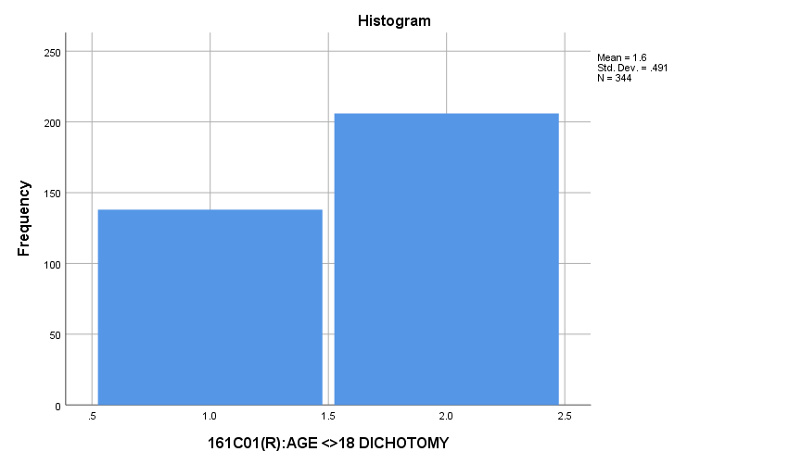

**Exhibit : Frequency Table**

|  |  |  |  |  |  |
| --- | --- | --- | --- | --- | --- |
| ***RESPONDENT_AGE*** | | | | | |
|  | | Frequency | Percent | Valid Percent | Cumulative Percent |
| Valid | UNDER 18:(1) | **138** | **39.4** | **40.1** | **40.1** |
| 18 OR OLDER:(2) | **206** | **58.9** | **59.9** | **100.0** |
| Total | **344** | **98.3** | **100.0** |  |
| Missing | MISSING:(-9) | **6** | **1.7** |  |  |
| Total | | **350** | **100.0** |  |  |

**Marital Status:** What is the marital status of the potential pool of recruits?

**Variable Used:** The variables utilized in the analysis was the marital status potential pool of recruits. Marital status was divided into four categories: married (1), engaged (2), separated or divided (3), and single (4).

**Analysis Procedure:** Frequency, percentages, and range were calculated. The histogram was inspected for outliers, none were present.

**Results:**

* Married: 5.5% ± 3.2%
* Engaged: 2.6% ± 2.2%
* Separate or Divided: 1.4% ± 1.6%
* Single: 90.4% ± 4.1%
* Total respondents: 345, range 5 to 312

**Interpretation:**

**Supporting Analysis:**

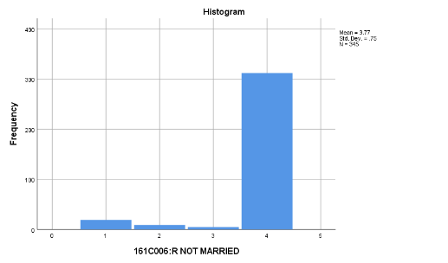**Exhibit : Preliminary Analysis**

**Exhibit : Frequency Table**

|  |  |  |  |  |  |
| --- | --- | --- | --- | --- | --- |
| ***V1153*** | | | | | |
|  | | Frequency | Percent | Valid Percent | Cumulative Percent |
| Valid | MARRIED:(1) | **19** | **5.4** | **5.5** | **5.5** |
| ENGAGED:(2) | **9** | **2.6** | **2.6** | **8.1** |
| SEP/DIV:(3) | **5** | **1.4** | **1.4** | **9.6** |
| SINGLE:(4) | **312** | **89.1** | **90.4** | **100.0** |
| Total | **345** | **98.6** | **100.0** |  |
| Missing | MISSING:(-9) | **5** | **1.4** |  |  |
| Total | | **350** | **100.0** |  |  |

**Where Did You Grow Up Mostly:** What type of area did the potential pool of recruits grow-up in?

**Variable Used:** The variables utilized in the analysis was the potential pool of recruits and where they grew up. The area where the respondents grew up was separated into nine categories:

* Mixed (0)
* Farm (1)
* Country (2)
* Small city (3)
* Medium city (4)
* Medium suburbs (5)
* Large city (6)
* Large suburbs (7)
* Very large city (8)
* Very large suburbs (9)

**Analysis Procedure:** Frequency, percentages, and range were calculated. The histogram was inspected for outliers, none were present.

**Results:**

* Mixed: 8.0% ± 3.7% (99% confidence level)
* Farm: 6.0% ± 3.3% (99% confidence level)
* Country: 11.1% ± 4.3% (99% confidence level)
* Small city: 22.0% ± 5.7% (99% confidence level)
* Medium city: 10.6% ± 4.2% (99% confidence level)
* Medium suburbs: 16.6% ± 5.1% (99% confidence level)
* Large city: 8.6% ± 3.9% (99% confidence level)
* Large suburbs: 7.1% ± 3.5% (99% confidence level)
* Very large city: 5.4% ± 3.1% (99% confidence level)
* Very large suburbs: 4.6% ± 3.1% (99% confidence level)
* Total respondents: 350, range 16-77

**Interpretation:** No interpretation required for descriptive statistics.

**Supporting Analysis:**

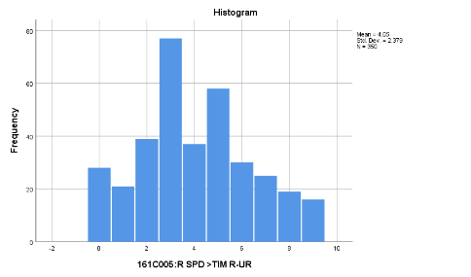**Exhibit : Preliminary Analysis**

**Exhibit : Frequency Tables**

|  |  |  |  |  |  |
| --- | --- | --- | --- | --- | --- |
| ***V1152*** | | | | | |
|  | | Frequency | Percent | Valid Percent | Cumulative Percent |
| Valid | DK/MIXED:(0) | **28** | **8.0** | **8.0** | **8.0** |
| A FARM:(1) | **21** | **6.0** | **6.0** | **14.0** |
| COUNTRY:(2) | **39** | **11.1** | **11.1** | **25.1** |
| SM CITY:(3) | **77** | **22.0** | **22.0** | **47.1** |
| MED CITY:(4) | **37** | **10.6** | **10.6** | **57.7** |
| SUB MED:(5) | **58** | **16.6** | **16.6** | **74.3** |
| LGE CITY:(6) | **30** | **8.6** | **8.6** | **82.9** |
| SUB LGE:(7) | **25** | **7.1** | **7.1** | **90.0** |
| V-LGE CITY:(8) | **19** | **5.4** | **5.4** | **95.4** |
| SUB V-LGE:(9) | **16** | **4.6** | **4.6** | **100.0** |
| Total | **350** | **100.0** | **100.0** |  |

**Father Education Level:** What is the education level of fathers for potential recruits?

**Variable Used:** The variables utilized in the analysis was the father’s education level for the potential pool of recruits. Father’s education level was broken into the following categories:

* 1 = Completed grade school
* 2 = Some high school
* 3 = Completed high school
* 4 = Some college
* 5 = Completed college
* 6 = Graduate or professional school after college
* 7 = Don’t know, or does not apply
* Total respondents 350, range 18 to 91

**Analysis Procedure:** Frequency, percentages, and range were calculated. The histogram was inspected for outliers, none were present.

**Results:**

* Completed grade school = 5.2% ± 3.1% (99% confidence level)
* Some high school = 8.7% ± 3.7% (99% confidence level)
* Completed high school = 22.5% ± 3.9% (99% confidence level)
* Some college = 15.9% ± 4.7% (99% confidence level)
* Completed college = 26.3% ± 5.0% (99% confidence level)
* Graduate or professional school after college = 13.6% ± 5.7% (99% confidence level)
* Don’t know, or does not apply = 7.8% ± 6.1% (99% confidence level)

**Interpretation:** No interpretation required for descriptive statistics.

**Supporting Analysis:**

**Exhibit : Preliminary Analysis**

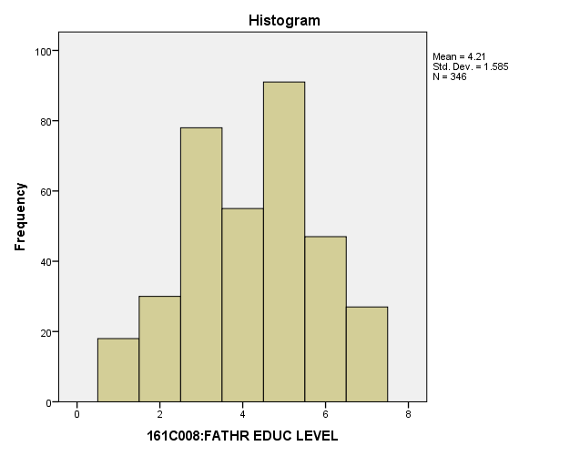

**Exhibit : Frequency Table**

|  |  |  |  |  |  |
| --- | --- | --- | --- | --- | --- |
| ***V1163*** | | | | | |
|  | | Frequency | Percent | Valid Percent | Cumulative Percent |
| Valid | GRDE SCH:(1) | **18** | **5.1** | **5.2** | **5.2** |
| SOME HS:(2) | **30** | **8.6** | **8.7** | **13.9** |
| HS GRAD:(3) | **78** | **22.3** | **22.5** | **36.4** |
| SOME CLG:(4) | **55** | **15.7** | **15.9** | **52.3** |
| CLG GRAD:(5) | **91** | **26.0** | **26.3** | **78.6** |
| GRAD SCH:(6) | **47** | **13.4** | **13.6** | **92.2** |
| DK:(7) | **27** | **7.7** | **7.8** | **100.0** |
| Total | **346** | **98.9** | **100.0** |  |
| Missing | MISSING:(-9) | **4** | **1.1** |  |  |
| Total | | **350** | **100.0** |  |  |

**Mother Education Level:** What is the education level of fathers for potential recruits?

**Variable Used:** The variables utilized in the analysis was the mother’s education level for the potential pool of recruits. Mother’s education level was broken into the following categories:

* 1 = Completed grade school
* 2 = Some high school
* 3 = Completed high school
* 4 = Some college
* 5 = Completed college
* 6 = Graduate or professional school after college
* 7 = Don’t know, or does not apply
* Total respondents 346, range 9 to 109

**Analysis Procedure:** Frequency, percentages, and range were calculated. The histogram was inspected for outliers, none were present.

**Results:**

* Completed grade school = 2.6% ± 2.2% (99% confidence level)
* Some high school = 7.8% ± 3.7% (99% confidence level)
* Completed high school = 18.8% ± 5.4% (99% confidence level)
* Some college = 16.5% ± 5.1% (99% confidence level)
* Completed college = 31.5% ± 6.4% (99% confidence level)
* Graduate or professional school after college = 16.2% ± 5.1% (99% confidence level)
* Don’t know, or does not apply = 6.6% ± 3.4% (99% confidence level)

**Interpretation:** No interpretation required for descriptive statistics.

**Supporting Analysis:**

**Exhibit : Preliminary Analysis**

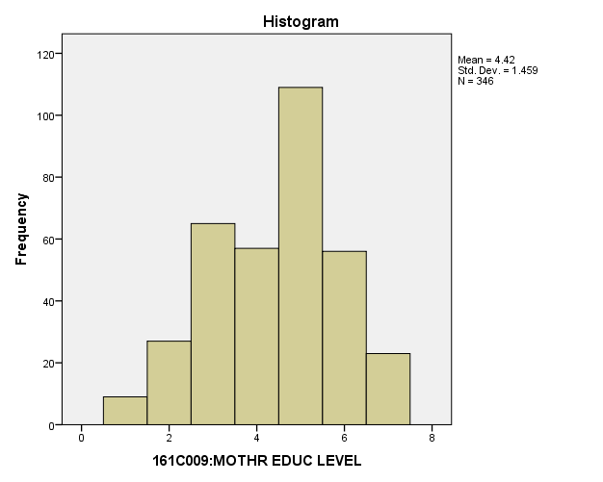

**Exhibit : Frequency Table**

|  |  |  |  |  |  |
| --- | --- | --- | --- | --- | --- |
| ***V1164*** | | | | | |
|  | | Frequency | Percent | Valid Percent | Cumulative Percent |
| Valid | GRDE SCH:(1) | **9** | **2.6** | **2.6** | **2.6** |
| SOME HS:(2) | **27** | **7.7** | **7.8** | **10.4** |
| HS GRAD:(3) | **65** | **18.6** | **18.8** | **29.2** |
| SOME CLG:(4) | **57** | **16.3** | **16.5** | **45.7** |
| CLG GRAD:(5) | **109** | **31.1** | **31.5** | **77.2** |
| GRAD SCH:(6) | **56** | **16.0** | **16.2** | **93.4** |
| DK:(7) | **23** | **6.6** | **6.6** | **100.0** |
| Total | **346** | **98.9** | **100.0** |  |
| Missing | MISSING:(-9) | **4** | **1.1** |  |  |
| Total | | **350** | **100.0** |  |  |

**Research Question 3:** In terms of the primary variables (demographics, student values, satisfaction, trustworthy and fairness, should citizens go along with the government, ability to follow rules), How do potential recruits differ from the other two groups in the sample? In what ways do they not differ?

*3.a. Demographics*

**Race:** Among the three groups in the sample, how do the potential pool of recruits differ by race from the other two groups in the sample?

**Variables Used:** The **dependent variable** used in the analysis was race (black=1, white=2, Hispanic=3) and the **independent (grouping) variable** was the pool of respondents. The respondent pool is broken into three categories:

* Non-recruits (students who say they definitely will not serve in the military after high school graduation) --- these are labeled as *definitely won’t (1).*
* Recruits (students who say they definitely or probably will serve in the military) --- these are labeled as *probably will (3).*
* Potential recruits (those who say they probably will not serve) --- these are labeled as *probably won’t (2)*.
* The desired pool of recruits is those labeled as probably won’t.
* Total respondents: 1369, range of all groups 1 to 3

**Analysis Procedure:**

* A two-way chi squared test was utilized to compare how the potential pool of recruits differs by race from other two groups.
* Prior to analysis, a histogram and Q-Q plots were inspected for outliers, none were present.
* Three post hoc tests were requested because of there was significant difference among the three groups regarding race. A Bonferroni correction was used for the post hoc tests to correct for addition type I error, requiring a p-value of less than 0.0033.
* Cohen’s W was calculated to assess effect size.

**Results:**

* Null and alternative hypothesis for each 2way chi-squared test:
  + H0 : There is no significant difference in race between the groups.
  + Ha : There is a significant difference in race between the groups.
* Initial test
  + X2 = 28.982, df = 4, reject H0, α = 0.01
* Post Hocs
  + X21,2 = 11.451, df = 2, fail to reject H0, α = 0.003
  + X21,3 = 12.153, df= 2, reject H0, α = 0.003, Cohen’s w= 0.106
  + X22,3 = 29.299, df =2, reject H0, α = 0.003, Cohen’s w = 0.250

**Interpretation:** There was a significant difference in the race of groups.

* Definitely won’t and probably will differed significantly with 21.6% of probably will being black and 67.0% of definitely won’t being white.
  + 1.12% of the variation in the respondent’s race is explainable by the respondent pool in which the individual resides.
* Probably won’t and probably will differed significantly with 21.6% of probably will being black and 75.6% of probably won’t being white.
  + 6.25% of the variation in the individuals race is explainable by which respondent pool the individual resides in.
* There was no significant difference between definitely won’t and probably won’t.

**Supporting Analysis:**

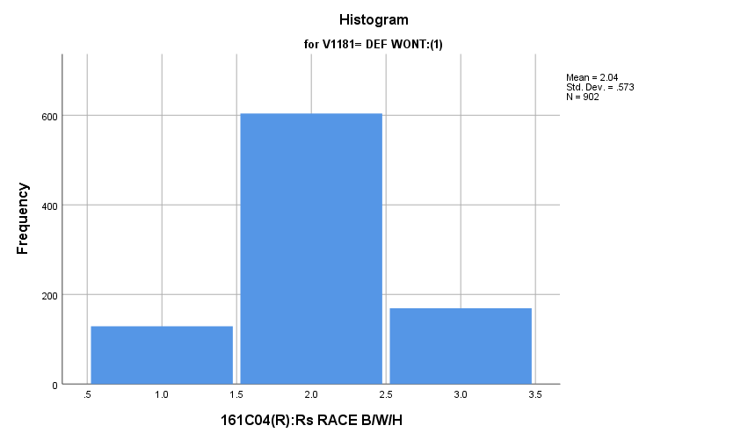**Exhibit : Preliminary Analysis**

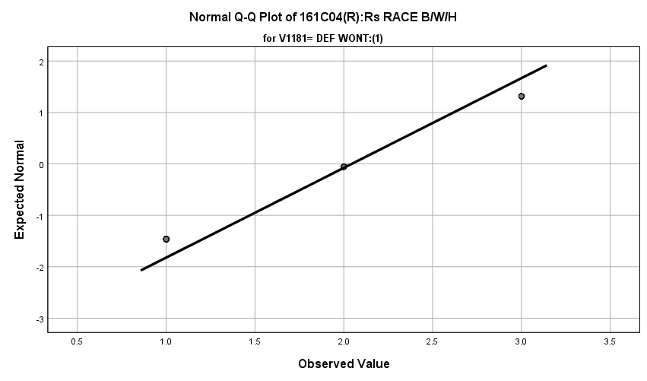

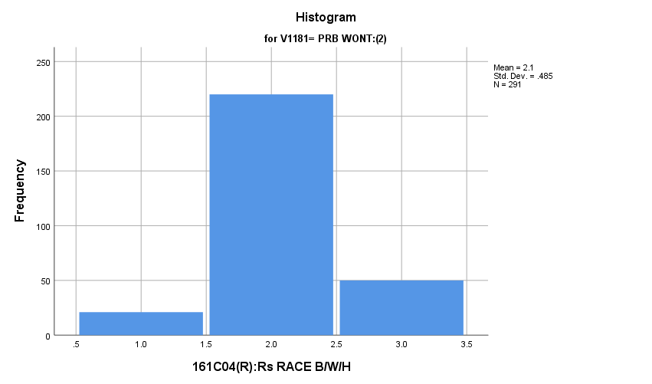

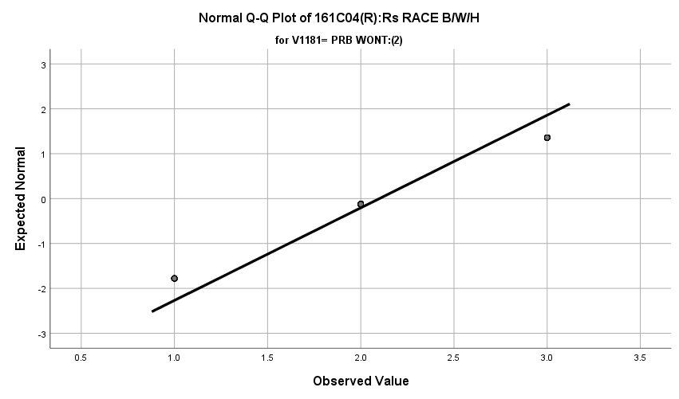

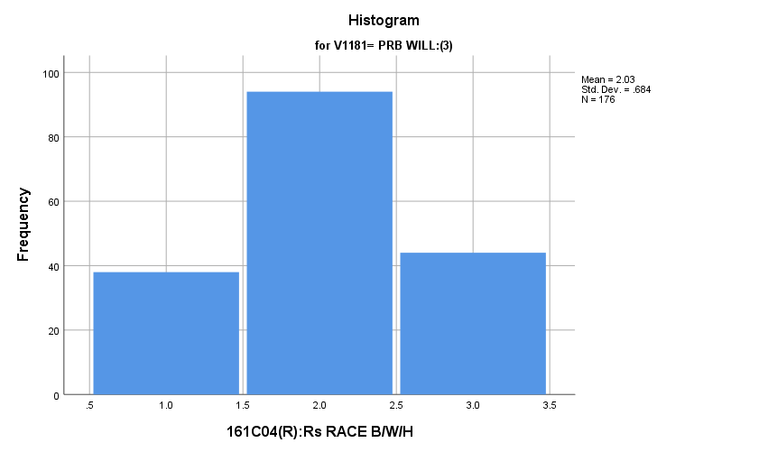

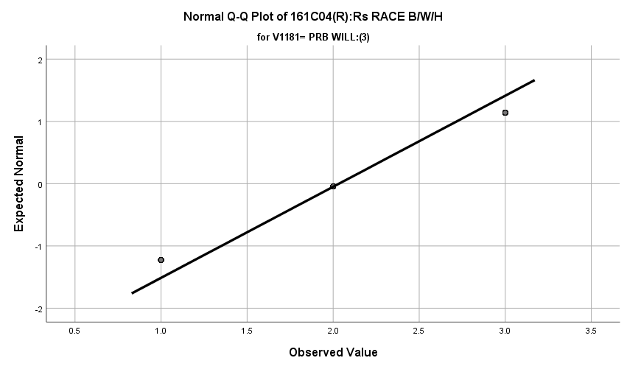

\

**Exhibit: Main Two-Way chi Squared**

|  |  |  |  |
| --- | --- | --- | --- |
| ***Chi-Square Tests*** | | | |
|  | Value | df | Asymptotic Significance (2-sided) |
| Pearson Chi-Square | **28.982a** | **4** | **.000** |
| Likelihood Ratio | **29.696** | **4** | **.000** |
| Linear-by-Linear Association | **.147** | **1** | **.701** |
| N of Valid Cases | **1369** |  |  |
| a. 0 cells (0.0%) have expected count less than 5. The minimum expected count is 24.17. | | | |

**Exhibit: Group 1 & 2 Two Way Chi Squared**

|  |  |  |  |
| --- | --- | --- | --- |
| ***Chi-Square Tests*** | | | |
|  | Value | df | Asymptotic Significance (2-sided) |
| Pearson Chi-Square | **11.451a** | **2** | **.003** |
| Likelihood Ratio | **12.532** | **2** | **.002** |
| Linear-by-Linear Association | **2.198** | **1** | **.138** |
| N of Valid Cases | **1193** |  |  |
| a. 0 cells (0.0%) have expected count less than 5. The minimum expected count is 36.59. | | | |

**Exhibit: Group 1 & 3 Two Way Chi Squared and Effect Size**

|  |  |  |  |  |  |
| --- | --- | --- | --- | --- | --- |
| ***161C04(R):Rs RACE B/W/H * 161C021B:R WL DO ARMD FC Crosstabulation*** | | | | | |
|  | | | 161C021B:R WL DO ARMD FC | | Total |
| DEF WONT:(1) | PRB WILL:(3) |
| 161C04(R):Rs RACE B/W/H | BLACK:(1) | Count | **129** | **38** | **167** |
| % within 161C021B:R WL DO ARMD FC | **14.3%** | **21.6%** | **15.5%** |
| WHITE:(2) | Count | **604** | **94** | **698** |
| % within 161C021B:R WL DO ARMD FC | **67.0%** | **53.4%** | **64.7%** |
| HISPANIC:(3) | Count | **169** | **44** | **213** |
| % within 161C021B:R WL DO ARMD FC | **18.7%** | **25.0%** | **19.8%** |
| Total | | Count | **902** | **176** | **1078** |
| % within 161C021B:R WL DO ARMD FC | **100.0%** | **100.0%** | **100.0%** |

|  |  |  |  |
| --- | --- | --- | --- |
| ***Chi-Square Tests*** | | | |
|  | Value | df | Asymptotic Significance (2-sided) |
| Pearson Chi-Square | **12.153a** | **2** | **.002** |
| Likelihood Ratio | **11.743** | **2** | **.003** |
| Linear-by-Linear Association | **.044** | **1** | **.834** |
| N of Valid Cases | **1078** |  |  |
| a. 0 cells (0.0%) have expected count less than 5. The minimum expected count is 27.27. | | | |

|  |  |  |  |
| --- | --- | --- | --- |
| ***Symmetric Measures*** | | | |
|  | | Value | Approximate Significance |
| Nominal by Nominal | Phi | **.106** | **.002** |
| Cramer's V | **.106** | **.002** |
| N of Valid Cases | | **1078** |  |

**Exhibit: Group 2&3 Two Way Chi Squared and Effect Size**

|  |  |  |  |  |  |
| --- | --- | --- | --- | --- | --- |
| ***161C04(R):Rs RACE B/W/H * 161C021B:R WL DO ARMD FC Crosstabulation*** | | | | | |
|  | | | 161C021B:R WL DO ARMD FC | | Total |
| PRB WONT:(2) | PRB WILL:(3) |
| 161C04(R):Rs RACE B/W/H | BLACK:(1) | Count | **21** | **38** | **59** |
| % within 161C021B:R WL DO ARMD FC | **7.2%** | **21.6%** | **12.6%** |
| WHITE:(2) | Count | **220** | **94** | **314** |
| % within 161C021B:R WL DO ARMD FC | **75.6%** | **53.4%** | **67.2%** |
| HISPANIC:(3) | Count | **50** | **44** | **94** |
| % within 161C021B:R WL DO ARMD FC | **17.2%** | **25.0%** | **20.1%** |
| Total | | Count | **291** | **176** | **467** |
| % within 161C021B:R WL DO ARMD FC | **100.0%** | **100.0%** | **100.0%** |

|  |  |  |  |
| --- | --- | --- | --- |
| ***Chi-Square Tests*** | | | |
|  | Value | df | Asymptotic Significance (2-sided) |
| Pearson Chi-Square | **29.299a** | **2** | **.000** |
| Likelihood Ratio | **28.752** | **2** | **.000** |
| Linear-by-Linear Association | **1.461** | **1** | **.227** |
| N of Valid Cases | **467** |  |  |
| a. 0 cells (0.0%) have expected count less than 5. The minimum expected count is 22.24. | | | |

|  |  |  |  |
| --- | --- | --- | --- |
| ***Symmetric Measures*** | | | |
|  | | Value | Approximate Significance |
| Nominal by Nominal | Phi | **.250** | **.000** |
| Cramer's V | **.250** | **.000** |
| N of Valid Cases | | **467** |  |

**Gender:** Among the three groups in the sample, how do differ regarding gender?

**Variables Used:** The **dependent variable** used in the analysis was gender (male=1, female=2) and the **independent (grouping) variable** used was the pool of respondents. The respondent pool is broken into three categories:

* Non-recruits (students who say they definitely will not serve in the military after high school graduation) --- these are labeled as *definitely won’t (1).*
* Recruits (students who say they definitely or probably will serve in the military) --- these are labeled as *probably will (3).*
* Potential recruits (those who say they probably will not serve) --- these are labeled as *probably won’t (2)*.
* The desired pool of recruits is those labeled as probably won’t.
* Total respondents: 1583, range for all groups 1 to 2

**Analysis Procedure:**

* A two-way chi squared test was utilized to compare how the potential pool of recruits differs by gender from other two groups.
* Prior to analysis, a histogram and Q-Q plots were inspected for outliers, none were present.
* Three post hoc tests were requested because of there was significant difference among the three groups regarding gender. A Bonferroni correction was used for the post hoc tests to correct for addition type I error, requiring a p-value of less than 0.003.
* Cohen’s W was calculated to assess effect size.

**Results:**

* Null and alternative hypothesis for each 2way chi-squared test:
  + H0 : There is no significant difference in sex between the groups.
  + Ha : There is a significant difference in sex between the groups.
* Initial test
  + X2 = 97.724, df = 2, reject H0, α = 0.01
* Post Hocs
  + X21,2 = 54.427, df = 1, reject H0, α = 0.003, Cohen’s w= 0.199
  + X21,3 = 58.384, df= 1, reject H0, α = 0.003, Cohen’s w= 0.217
  + X22,3 = 1.953, df =1, , fail to reject H0, α = 0.003

**Interpretation:** There was a significant difference in the genders of groups.

* Definitely won’t differed significantly regarding gender compared to the probably won’t group. Definitely won’t were predominately female (61.4%) and the probably won’t were 61.5% male.
  + 3.9% of the variation in the individuals gender is explainable by which respondent pool they reside in.
* Definitely won’t differed significantly from probably will regarding gender. Definitely won’t were 61.4% female while 67.5% of males were probably will.
  + 4.7% of the variation in the individuals gender is explainable by which respondent pool they reside in.
* There was no significant difference between probably will and probably won’t.

**Supporting Analysis:**

**Exhibit : Preliminary Analysis**

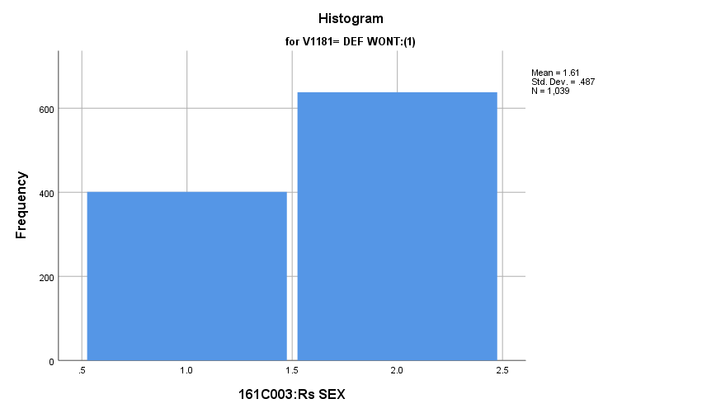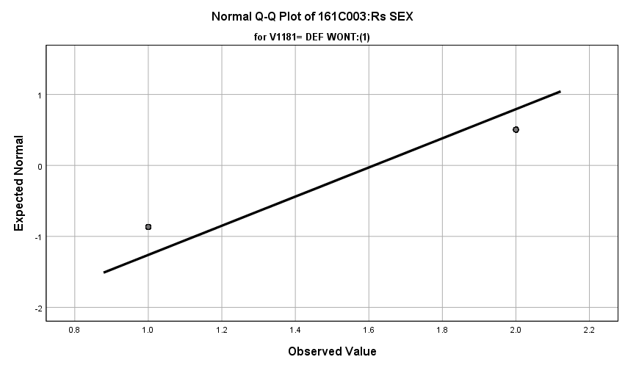

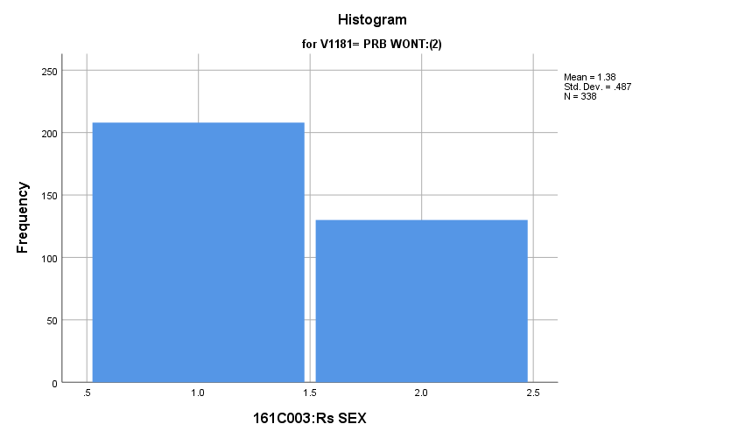

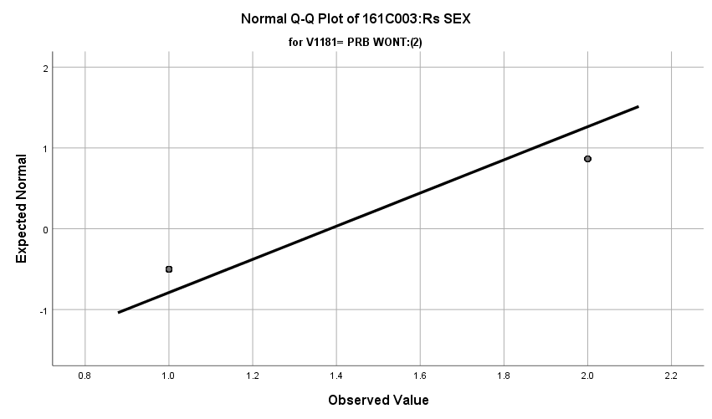

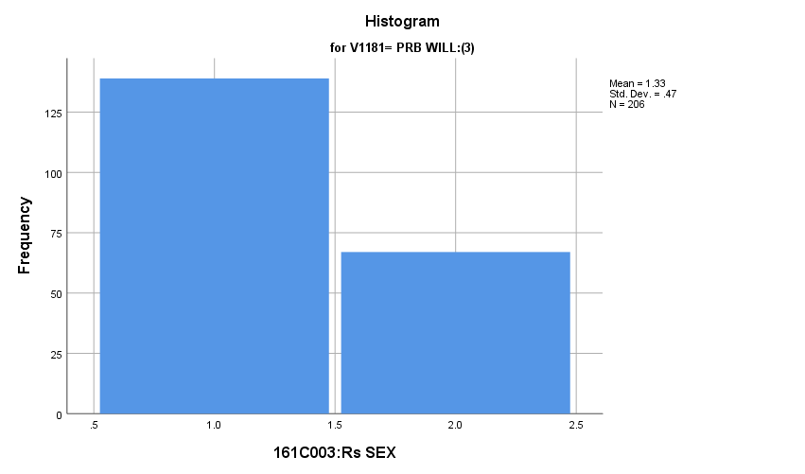

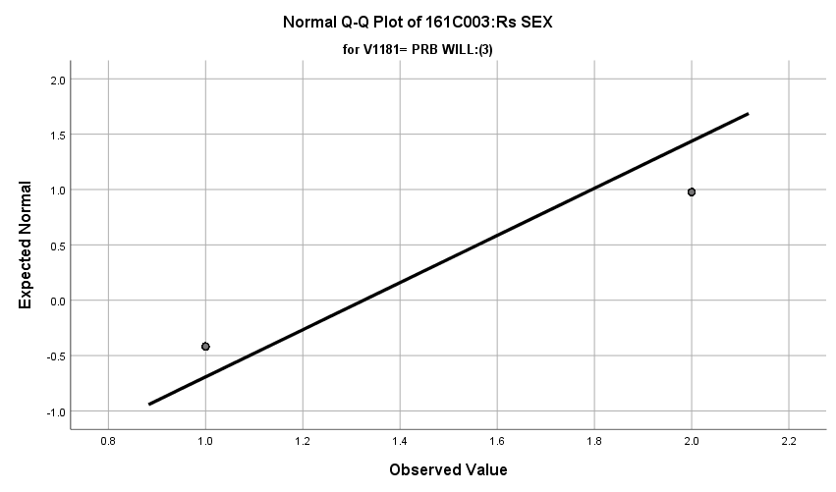

**Exhibit: Main Two Way Chi Squared**

|  |  |  |  |
| --- | --- | --- | --- |
| ***Chi-Square Tests*** | | | |
|  | Value | df | Asymptotic Significance (2-sided) |
| Pearson Chi-Square | **92.724a** | **2** | **.000** |
| Likelihood Ratio | **93.623** | **2** | **.000** |
| Linear-by-Linear Association | **86.096** | **1** | **.000** |
| N of Valid Cases | **1583** |  |  |
| a. 0 cells (0.0%) have expected count less than 5. The minimum expected count is 97.34. | | | |

**Exhibit: Group 1 & 2 Two Way Chi Squared and Effect Size**

|  |  |  |  |  |  |
| --- | --- | --- | --- | --- | --- |
| ***161C003:Rs SEX * 161C021B:R WL DO ARMD FC Crosstabulation*** | | | | | |
|  | | | 161C021B:R WL DO ARMD FC | | Total |
| DEF WONT:(1) | PRB WONT:(2) |
| 161C003:Rs SEX | MALE:(1) | Count | **401** | **208** | **609** |
| % within 161C021B:R WL DO ARMD FC | **38.6%** | **61.5%** | **44.2%** |
| FEMALE:(2) | Count | **638** | **130** | **768** |
| % within 161C021B:R WL DO ARMD FC | **61.4%** | **38.5%** | **55.8%** |
| Total | | Count | **1039** | **338** | **1377** |
| % within 161C021B:R WL DO ARMD FC | **100.0%** | **100.0%** | **100.0%** |

|  |  |  |  |  |  |
| --- | --- | --- | --- | --- | --- |
| ***Chi-Square Tests*** | | | | | |
|  | Value | df | Asymptotic Significance (2-sided) | Exact Sig. (2-sided) | Exact Sig. (1-sided) |
| Pearson Chi-Square | **54.427a** | **1** | **.000** |  |  |
| Continuity Correctionb | **53.501** | **1** | **.000** |  |  |
| Likelihood Ratio | **54.302** | **1** | **.000** |  |  |
| Fisher's Exact Test |  |  |  | **.000** | **.000** |
| Linear-by-Linear Association | **54.387** | **1** | **.000** |  |  |
| N of Valid Cases | **1377** |  |  |  |  |
| a. 0 cells (0.0%) have expected count less than 5. The minimum expected count is 149.49. | | | | | |
| b. Computed only for a 2x2 table | | | | | |

|  |  |  |  |
| --- | --- | --- | --- |
| ***Symmetric Measures*** | | | |
|  | | Value | Approximate Significance |
| Nominal by Nominal | Phi | **-.199** | **.000** |
| Cramer's V | **.199** | **.000** |
| N of Valid Cases | | **1377** |  |

**Exhibit: Group 1 & 3 Two Way Chi Squared and Effect Size**

|  |  |  |  |  |  |
| --- | --- | --- | --- | --- | --- |
| ***161C003:Rs SEX * 161C021B:R WL DO ARMD FC Crosstabulation*** | | | | | |
|  | | | 161C021B:R WL DO ARMD FC | | Total |
| DEF WONT:(1) | PRB WILL:(3) |
| 161C003:Rs SEX | MALE:(1) | Count | **401** | **139** | **540** |
| % within 161C021B:R WL DO ARMD FC | **38.6%** | **67.5%** | **43.4%** |
| FEMALE:(2) | Count | **638** | **67** | **705** |
| % within 161C021B:R WL DO ARMD FC | **61.4%** | **32.5%** | **56.6%** |
| Total | | Count | **1039** | **206** | **1245** |
| % within 161C021B:R WL DO ARMD FC | **100.0%** | **100.0%** | **100.0%** |

|  |  |  |  |  |  |
| --- | --- | --- | --- | --- | --- |
| ***Chi-Square Tests*** | | | | | |
|  | Value | df | Asymptotic Significance (2-sided) | Exact Sig. (2-sided) | Exact Sig. (1-sided) |
| Pearson Chi-Square | **58.384a** | **1** | **.000** |  |  |
| Continuity Correctionb | **57.214** | **1** | **.000** |  |  |
| Likelihood Ratio | **58.312** | **1** | **.000** |  |  |
| Fisher's Exact Test |  |  |  | **.000** | **.000** |
| Linear-by-Linear Association | **58.337** | **1** | **.000** |  |  |
| N of Valid Cases | **1245** |  |  |  |  |
| a. 0 cells (0.0%) have expected count less than 5. The minimum expected count is 89.35. | | | | | |
| b. Computed only for a 2x2 table | | | | | |

|  |  |  |  |
| --- | --- | --- | --- |
| ***Symmetric Measures*** | | | |
|  | | Value | Approximate Significance |
| Nominal by Nominal | Phi | **-.217** | **.000** |
| Cramer's V | **.217** | **.000** |
| N of Valid Cases | | **1245** |  |

**Exhibit: Group 2 & 3 Two Way Chi Squared**

|  |  |  |  |  |  |
| --- | --- | --- | --- | --- | --- |
| ***Chi-Square Tests*** | | | | | |
|  | Value | df | Asymptotic Significance (2-sided) | Exact Sig. (2-sided) | Exact Sig. (1-sided) |
| Pearson Chi-Square | **1.953a** | **1** | **.162** |  |  |
| Continuity Correctionb | **1.705** | **1** | **.192** |  |  |
| Likelihood Ratio | **1.966** | **1** | **.161** |  |  |
| Fisher's Exact Test |  |  |  | **.169** | **.096** |
| Linear-by-Linear Association | **1.950** | **1** | **.163** |  |  |
| N of Valid Cases | **544** |  |  |  |  |
| a. 0 cells (0.0%) have expected count less than 5. The minimum expected count is 74.60. | | | | | |
| b. Computed only for a 2x2 table | | | | | |

**Age:** Among the three groups in the sample how do they differ regarding age?

**Variables Used:** The **dependent** **variable** used in the analysis was age (under 18 and 18 or older) and the **independent (grouping) variable** used was pool of respondents. The respondent pool is broken into three categories:

* Non-recruits (students who say they definitely will not serve in the military after high school graduation) --- these are labeled as *definitely won’t (1).*
* Recruits (students who say they definitely or probably will serve in the military) --- these are labeled as *probably will (3).*
* Potential recruits (those who say they probably will not serve) --- these are labeled as *probably won’t (2)*.
* The desired pool of recruits is those labeled as probably won’t
* Total respondents: 1618, range of all groups 1 to 2

**Analysis Procedure:**

* A two-way Chi-Squared test was utilized to compare how the potential pool of recruits differs by age from other two groups.
* Prior to analysis, a histogram and Q-Q plots were inspected for outliers, none were present.
* Zero (0.0%) cells have expected count less than 5 in this two-way chi squared test. Categorical variables are being analyzed and there is no overlap, so a two-way chi squared test is valid

**Results:**

* Null and alternative hypothesis:
  + H0 : There is no significant difference in age between the groups.
  + Ha : There is a significant difference in age between the groups.
* Calculated X2 value: 0.413, df = 2, α = 0.01, fail to reject H0

**Interpretation:** There was no significant difference among the three groups regarding age.

**Supporting Analysis:**

**Exhibit : Preliminary Analysis**

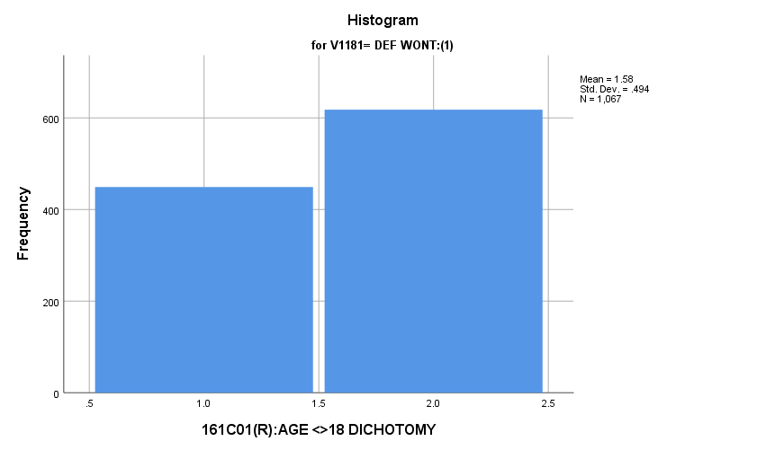

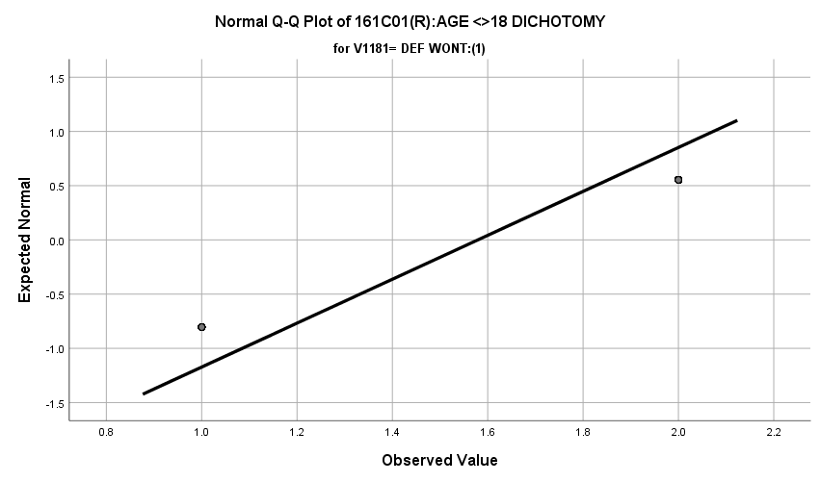

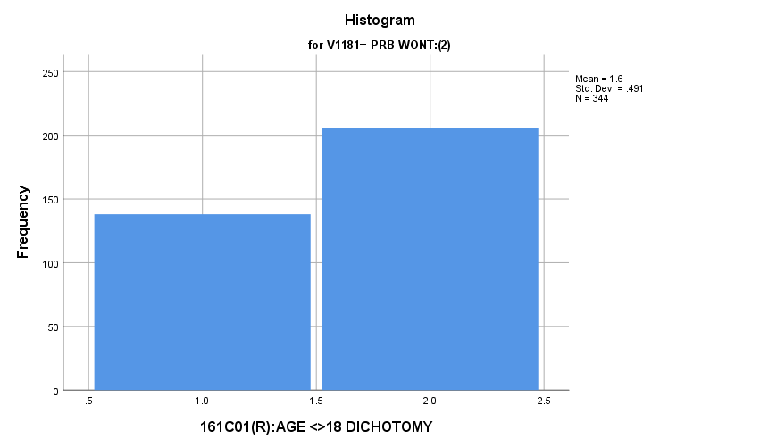

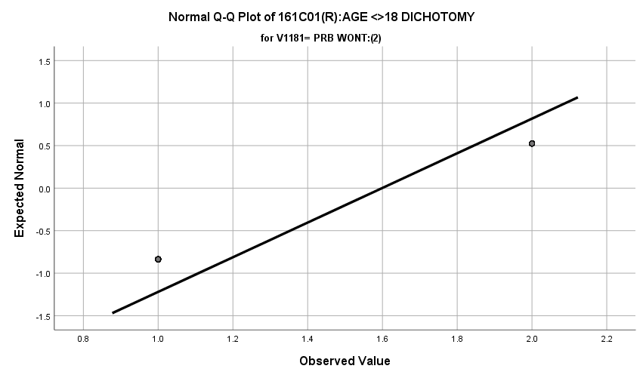

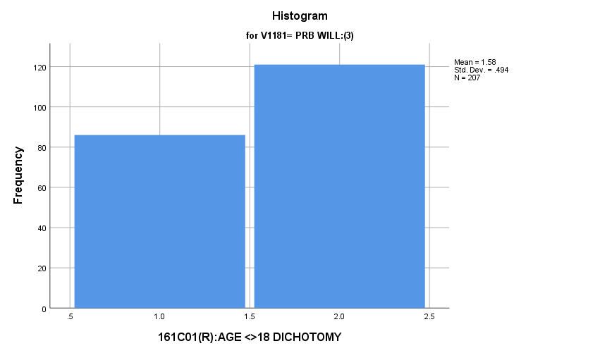

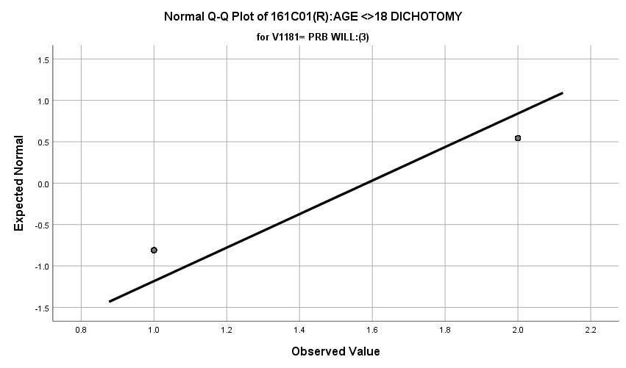

**Exhibit : Two – Way Chi Squared**

|  |  |  |  |  |  |  |
| --- | --- | --- | --- | --- | --- | --- |
| ***Case Processing Summary*** | | | | | | |
|  | Cases | | | | | |
| Valid | | Missing | | Total | |
| N | Percent | N | Percent | N | Percent |
| RESPONDENT_AGE * V1181 | **1618** | **77.0%** | **482** | **23.0%** | **2100** | **100.0%** |

|  |  |  |  |
| --- | --- | --- | --- |
| ***RESPONDENT_AGE * V1181 Crosstabulation*** | | | |
|  | | | V1181 |
| DEF WONT:(1) |
| RESPONDENT_AGE | UNDER 18:(1) | Count | **449** |
| % within V1181 | **42.1%** |
| 18 OR OLDER:(2) | Count | **618** |
| % within V1181 | **57.9%** |
| Total | | Count | **1067** |
| % within V1181 | **100.0%** |

|  |  |  |  |
| --- | --- | --- | --- |
| ***RESPONDENT_AGE * V1181 Crosstabulation*** | | | |
|  | | | V1181 |
| PRB WONT:(2) |
| RESPONDENT_AGE | UNDER 18:(1) | Count | **138** |
| % within V1181 | **40.1%** |
| 18 OR OLDER:(2) | Count | **206** |
| % within V1181 | **59.9%** |
| Total | | Count | **344** |
| % within V1181 | **100.0%** |

|  |  |  |  |  |
| --- | --- | --- | --- | --- |
| ***RESPONDENT_AGE * V1181 Crosstabulation*** | | | | |
|  | | | V1181 | Total |
| PRB WILL:(3) |
| RESPONDENT_AGE | UNDER 18:(1) | Count | **86** | **673** |
| % within V1181 | **41.5%** | **41.6%** |
| 18 OR OLDER:(2) | Count | **121** | **945** |
| % within V1181 | **58.5%** | **58.4%** |
| Total | | Count | **207** | **1618** |
| % within V1181 | **100.0%** | **100.0%** |

|  |  |  |  |
| --- | --- | --- | --- |
| ***Chi-Square Tests*** | | | |
|  | Value | df | Asymptotic Significance (2-sided) |
| Pearson Chi-Square | **.413a** | **2** | **.813** |
| Likelihood Ratio | **.414** | **2** | **.813** |
| Linear-by-Linear Association | **.141** | **1** | **.708** |
| N of Valid Cases | **1618** |  |  |
| a. 0 cells (0.0%) have expected count less than 5. The minimum expected count is 86.10. | | | |

**Marital Status:** Among the three groups in the sample, how do they differ regarding marital status?

**Variables Used:** The **dependent variable** used in the analysis was marital status (1=married, 2=engaged, 3=separated/divided, single=4) and the **independent (grouping) variable** used was pool of respondents. The respondent pool is broken into three categories:

* Non-recruits (students who say they definitely will not serve in the military after high school graduation) --- these are labeled as *definitely won’t (1).*
* Recruits (students who say they definitely or probably will serve in the military) --- these are labeled as *probably will (3).*
* Potential recruits (those who say they probably will not serve) --- these are labeled as *probably won’t (2)*.
* The desired pool of recruits is those labeled as probably won’t.
* Total respondents: 1611, range for all groups 1 to 4.

**Analysis Procedure:**

* A two-way Chi-Squared test was utilized to compare how the potential pool of recruits differs by marital status from other two groups.
* Prior to analysis, a histogram and Q-Q plots were inspected for outliers, none were present.
* Zero (0.0%) cells have expected count less than 5 in this two-way chi squared test. Categorical variables are being analyzed and there is no overlap, so a two-way chi squared test is valid

**Results:**

* Null and alternative hypothesis:
  + H0 : There is no significant difference in marital status between the groups.
  + Ha : There is a significant difference in marital status between the groups.
* Calculated X2 value: 2.927, df = 6, α = 0.01, fail to reject H0

**Interpretation:** There was no significant difference among the three groups regarding marital status

**Supporting Analysis:**

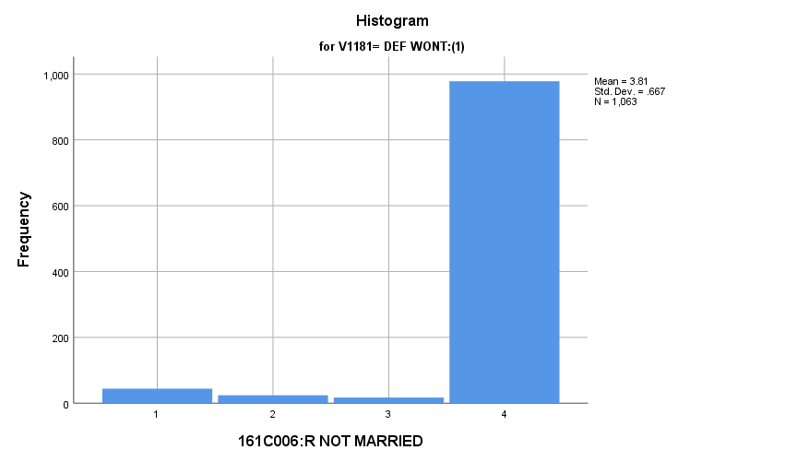**Exhibit : Preliminary Analysis**

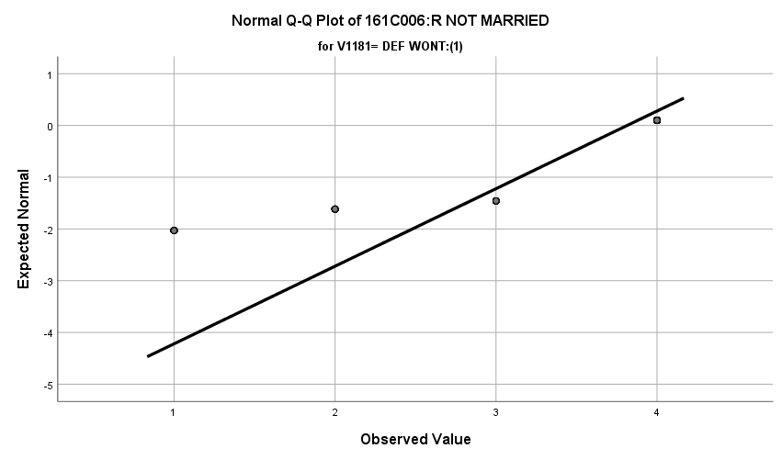

**Exhibit : Q-Q Plots**

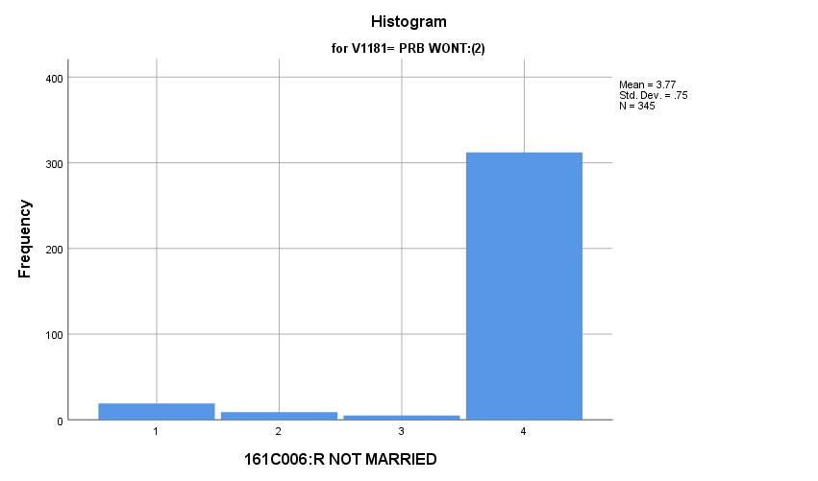

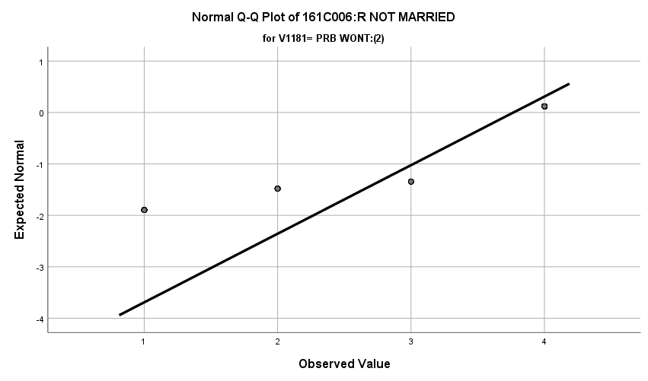

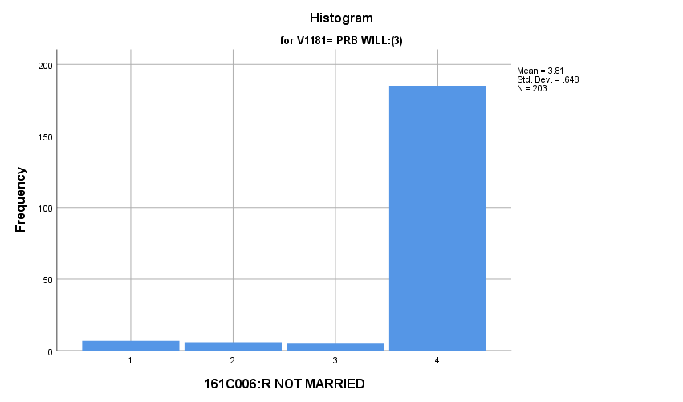

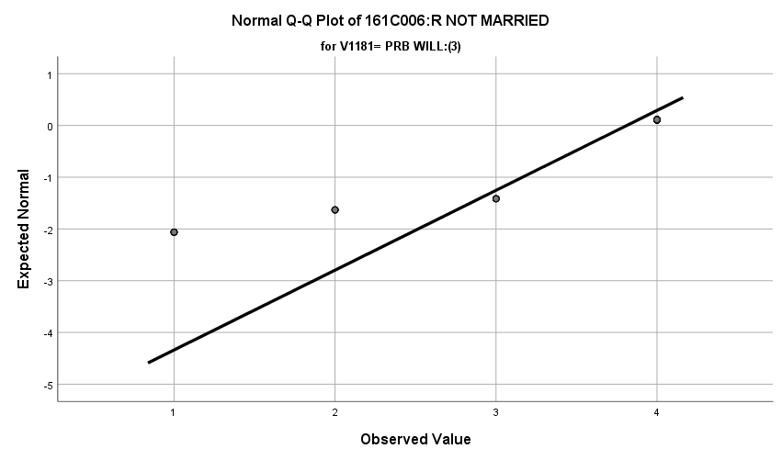

**Exhibit : Two-Way Chi Squared**

|  |  |  |  |  |  |
| --- | --- | --- | --- | --- | --- |
| ***V1153 * V1181 Crosstabulation*** | | | | | |
|  | | | V1181 | | |
| DEF WONT:(1) | PRB WONT:(2) | PRB WILL:(3) |
| V1153 | MARRIED:(1) | Count | **44** | **19** | **7** |
| % within V1181 | **4.1%** | **5.5%** | **3.4%** |
| ENGAGED:(2) | Count | **24** | **9** | **6** |
| % within V1181 | **2.3%** | **2.6%** | **3.0%** |
| SEP/DIV:(3) | Count | **17** | **5** | **5** |
| % within V1181 | **1.6%** | **1.4%** | **2.5%** |
| SINGLE:(4) | Count | **978** | **312** | **185** |
| % within V1181 | **92.0%** | **90.4%** | **91.1%** |
| Total | | Count | **1063** | **345** | **203** |
| % within V1181 | **100.0%** | **100.0%** | **100.0%** |

|  |  |  |  |
| --- | --- | --- | --- |
| ***Chi-Square Tests*** | | | |
|  | Value | df | Asymptotic Significance (2-sided) |
| Pearson Chi-Square | **2.927a** | **6** | **.818** |
| Likelihood Ratio | **2.768** | **6** | **.837** |
| Linear-by-Linear Association | **.223** | **1** | **.637** |
| N of Valid Cases | **1611** |  |  |
| a. 2 cells (16.7%) have expected count less than 5. The minimum expected count is 3.40. | | | |

**Where Did You Grow Up Mostly:** Among the three groups in the sample, how do they where they grew up?

**Variables Used:** The **dependent variable** used in the analysis was where the individual grew up and the **independent (grouping) variable** used was the pool of respondents.

* The respondent pool is broken into three categories:
  + Non-recruits (students who say they definitely will not serve in the military after high school graduation) --- these are labeled as *definitely won’t (1).*
  + Recruits (students who say they definitely or probably will serve in the military) --- these are labeled as *probably will (3).*
  + Potential recruits (those who say they probably will not serve) --- these are labeled as *probably won’t (2)*.
  + The desired pool of recruits is those labeled as probably won’t.
* Where an individual grew up was broken into several categories:
  + Mixed (0)
  + Farm (1)
  + Country (2)
  + Small city (3)
  + Medium city (4)
  + Medium suburbs (5)
  + Large city (6)
  + Large suburbs (7)
  + Very large city (8)
  + Very large suburbs (9)
* Total respondents: 1631, range for all groups 0 to 9.

**Analysis Procedure:**

* A two-way chi squared test was utilized to compare how the potential pool of recruits differs by where the individual grew up compared to the other two groups.
* Prior to analysis, a histogram and Q-Q plots were inspected for outliers, none were present.
* Three post hoc tests were requested because of there was significant difference among the three groups regarding where they grew up. A Bonferroni correction was used for the post hocs tests to correct for addition type I error, requiring a p-value of less than 0.003.
* Cohen’s W was calculated to assess effect size.

**Results:**

* Null and alternative hypothesis for each 2way chi-squared test:
  + H0 : There is no significant difference in where the individual grew up between the groups.
  + Ha : There is a significant difference in where the individual grew up between the groups.
* Initial test
  + X2 = 56.232, df = 18, reject H0, α = 0.01
* Post Hocs
  + X21,2 = 18.243, df = 9, fail to reject H0, α = 0.003,
  + X21,3 = 40.954, df= 9, reject H0, α = 0.003, Cohen’s w= 0.179
  + X22,3 = 25.499, df =9, reject H0, α = 0.003, Cohen’s w = 0.214

**Interpretation:** There was a significant difference in the where the respondent grew up among the groups.

* There was a significant difference among the groups of definitely won’t and probably will. The definitely won’t were primarily (25.4%) from a small city while the probably will were mostly from a small city (21.5%) and mixed (17.7%).
  + 3.2% of the variation in where the respondent comes from is explainable by the respondent pool in which they reside.
* There was a significant difference among the groups of probably won’t and probably will. The probably will were primarily small city (21.5%) and mixed (17.7%) while the probably won’t were primarily from a small city (22.0%) and medium suburbs (16.6%).
  + 4.6% of the variation in where the respondent comes from is explainable by the respondent pool in which they reside.

There was no significant difference in where the individual grew up among the probably won’t and definitely won’t groups.

**Supporting Analysis:**

**Exhibit : Preliminary Analysis**

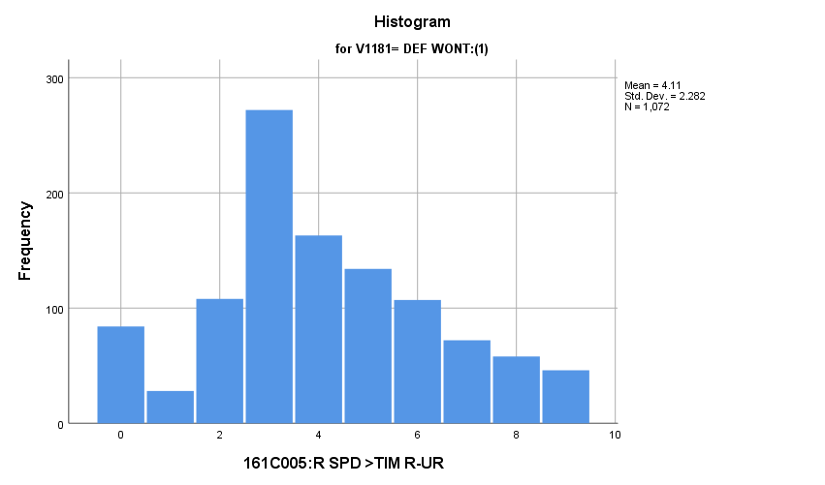

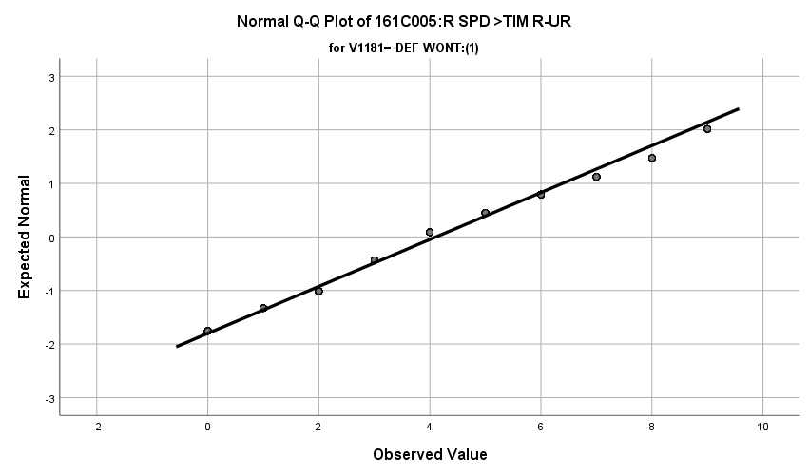

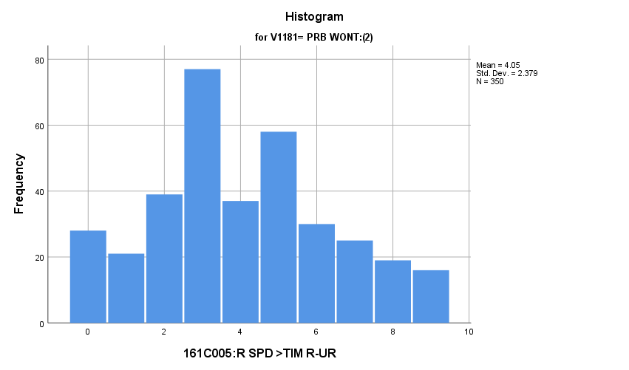

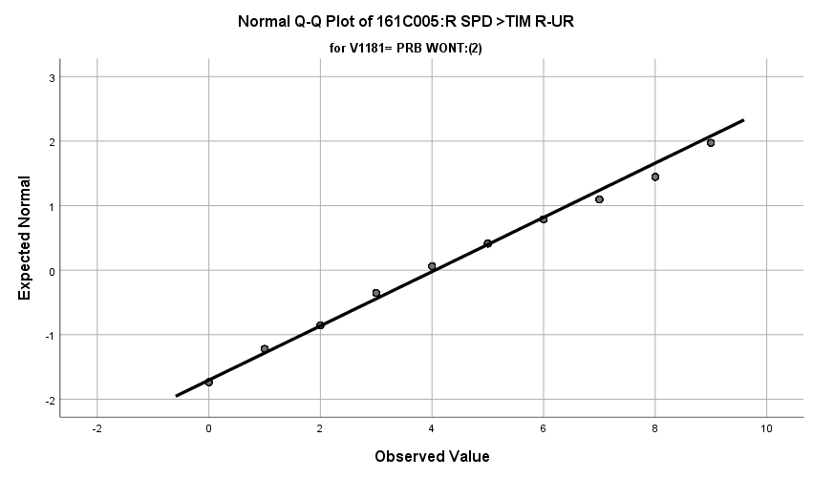

**Exhibit : Q-Q Plots**

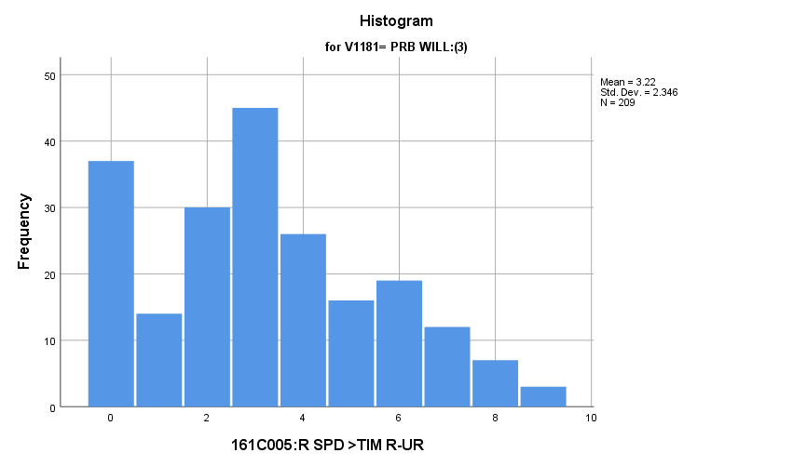

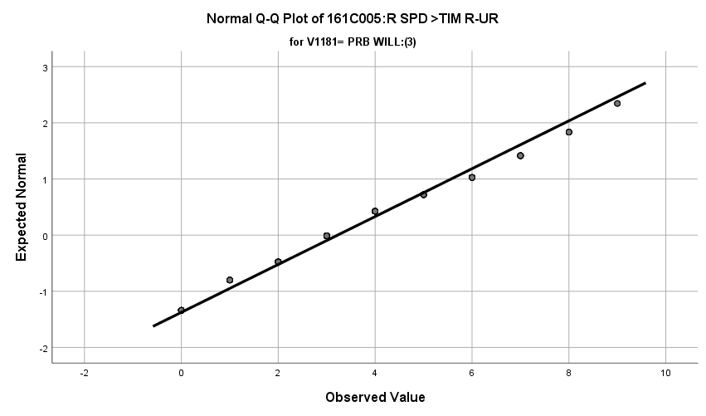

**Exhibit: Main Two-Way Chi Squared Test**

|  |  |  |  |
| --- | --- | --- | --- |
| ***Chi-Square Tests*** | | | |
|  | Value | df | Asymptotic Significance (2-sided) |
| Pearson Chi-Square | **56.232a** | **18** | **.000** |
| Likelihood Ratio | **53.594** | **18** | **.000** |
| Linear-by-Linear Association | **19.244** | **1** | **.000** |
| N of Valid Cases | **1631** |  |  |
| a. 0 cells (0.0%) have expected count less than 5. The minimum expected count is 8.07. | | | |

**Exhibit: Effect Size**

|  |  |  |  |
| --- | --- | --- | --- |
| ***Chi-Square Tests*** | | | |
|  | Value | df | Asymptotic Significance (2-sided) |
| Pearson Chi-Square | **56.232a** | **18** | **.000** |
| Likelihood Ratio | **53.594** | **18** | **.000** |
| Linear-by-Linear Association | **19.244** | **1** | **.000** |
| N of Valid Cases | **1631** |  |  |

**Exhibit: Group 1 & 2 Two-Way Chi Squared Test**

|  |  |  |  |
| --- | --- | --- | --- |
| ***Chi-Square Tests*** | | | |
|  | Value | df | Asymptotic Significance (2-sided) |
| Pearson Chi-Square | **18.243a** | **9** | **.032** |
| Likelihood Ratio | **17.385** | **9** | **.043** |
| Linear-by-Linear Association | **.155** | **1** | **.694** |
| N of Valid Cases | **1422** |  |  |
| a. 0 cells (0.0%) have expected count less than 5. The minimum expected count is 12.06. | | | |

**Exhibit: Group 1 & 3 Two-Way Chi Squared Test and Effect Size**

|  |  |  |  |  |  |
| --- | --- | --- | --- | --- | --- |
| ***161C005:R SPD >TIM R-UR * 161C021B:R WL DO ARMD FC Crosstabulation*** | | | | | |
|  | | | 161C021B:R WL DO ARMD FC | | Total |
| DEF WONT:(1) | PRB WILL:(3) |
| 161C005:R SPD >TIM R-UR | DK/MIXED:(0) | Count | **84** | **37** | **121** |
| % within 161C021B:R WL DO ARMD FC | **7.8%** | **17.7%** | **9.4%** |
| A FARM:(1) | Count | **28** | **14** | **42** |
| % within 161C021B:R WL DO ARMD FC | **2.6%** | **6.7%** | **3.3%** |
| COUNTRY:(2) | Count | **108** | **30** | **138** |
| % within 161C021B:R WL DO ARMD FC | **10.1%** | **14.4%** | **10.8%** |
| SM CITY:(3) | Count | **272** | **45** | **317** |
| % within 161C021B:R WL DO ARMD FC | **25.4%** | **21.5%** | **24.7%** |
| MED CITY:(4) | Count | **163** | **26** | **189** |
| % within 161C021B:R WL DO ARMD FC | **15.2%** | **12.4%** | **14.8%** |
| SUB MED:(5) | Count | **134** | **16** | **150** |
| % within 161C021B:R WL DO ARMD FC | **12.5%** | **7.7%** | **11.7%** |
| LGE CITY:(6) | Count | **107** | **19** | **126** |
| % within 161C021B:R WL DO ARMD FC | **10.0%** | **9.1%** | **9.8%** |
| SUB LGE:(7) | Count | **72** | **12** | **84** |
| % within 161C021B:R WL DO ARMD FC | **6.7%** | **5.7%** | **6.6%** |
| V-LGE CITY:(8) | Count | **58** | **7** | **65** |
| % within 161C021B:R WL DO ARMD FC | **5.4%** | **3.3%** | **5.1%** |
| SUB V-LGE:(9) | Count | **46** | **3** | **49** |
| % within 161C021B:R WL DO ARMD FC | **4.3%** | **1.4%** | **3.8%** |
| Total | | Count | **1072** | **209** | **1281** |
| % within 161C021B:R WL DO ARMD FC | **100.0%** | **100.0%** | **100.0%** |

|  |  |  |  |
| --- | --- | --- | --- |
| ***Chi-Square Tests*** | | | |
|  | Value | df | Asymptotic Significance (2-sided) |
| Pearson Chi-Square | **40.954a** | **9** | **.000** |
| Likelihood Ratio | **37.778** | **9** | **.000** |
| Linear-by-Linear Association | **25.585** | **1** | **.000** |
| N of Valid Cases | **1281** |  |  |
| a. 0 cells (0.0%) have expected count less than 5. The minimum expected count is 6.85. | | | |

|  |  |  |  |
| --- | --- | --- | --- |
| ***Symmetric Measures*** | | | |
|  | | Value | Approximate Significance |
| Nominal by Nominal | Phi | **.179** | **.000** |
| Cramer's V | **.179** | **.000** |
| N of Valid Cases | | **1281** |  |

**Exhibit: Group 2 & 3 Two-Way Chi Squared Test and Effect Size**

|  |  |  |  |  |  |
| --- | --- | --- | --- | --- | --- |
| ***161C005:R SPD >TIM R-UR * 161C021B:R WL DO ARMD FC Crosstabulation*** | | | | | |
|  | | | 161C021B:R WL DO ARMD FC | | Total |
| PRB WONT:(2) | PRB WILL:(3) |
| 161C005:R SPD >TIM R-UR | DK/MIXED:(0) | Count | **28** | **37** | **65** |
| % within 161C021B:R WL DO ARMD FC | **8.0%** | **17.7%** | **11.6%** |
| A FARM:(1) | Count | **21** | **14** | **35** |
| % within 161C021B:R WL DO ARMD FC | **6.0%** | **6.7%** | **6.3%** |
| COUNTRY:(2) | Count | **39** | **30** | **69** |
| % within 161C021B:R WL DO ARMD FC | **11.1%** | **14.4%** | **12.3%** |
| SM CITY:(3) | Count | **77** | **45** | **122** |
| % within 161C021B:R WL DO ARMD FC | **22.0%** | **21.5%** | **21.8%** |
| MED CITY:(4) | Count | **37** | **26** | **63** |
| % within 161C021B:R WL DO ARMD FC | **10.6%** | **12.4%** | **11.3%** |
| SUB MED:(5) | Count | **58** | **16** | **74** |
| % within 161C021B:R WL DO ARMD FC | **16.6%** | **7.7%** | **13.2%** |
| LGE CITY:(6) | Count | **30** | **19** | **49** |
| % within 161C021B:R WL DO ARMD FC | **8.6%** | **9.1%** | **8.8%** |
| SUB LGE:(7) | Count | **25** | **12** | **37** |
| % within 161C021B:R WL DO ARMD FC | **7.1%** | **5.7%** | **6.6%** |
| V-LGE CITY:(8) | Count | **19** | **7** | **26** |
| % within 161C021B:R WL DO ARMD FC | **5.4%** | **3.3%** | **4.7%** |
| SUB V-LGE:(9) | Count | **16** | **3** | **19** |
| % within 161C021B:R WL DO ARMD FC | **4.6%** | **1.4%** | **3.4%** |
| Total | | Count | **350** | **209** | **559** |
| % within 161C021B:R WL DO ARMD FC | **100.0%** | **100.0%** | **100.0%** |

|  |  |  |  |
| --- | --- | --- | --- |
| ***Chi-Square Tests*** | | | |
|  | Value | df | Asymptotic Significance (2-sided) |
| Pearson Chi-Square | **25.499a** | **9** | **.002** |
| Likelihood Ratio | **26.302** | **9** | **.002** |
| Linear-by-Linear Association | **15.646** | **1** | **.000** |
| N of Valid Cases | **559** |  |  |
| a. 0 cells (0.0%) have expected count less than 5. The minimum expected count is 7.10. | | | |

|  |  |  |  |
| --- | --- | --- | --- |
| ***Symmetric Measures*** | | | |
|  | | Value | Approximate Significance |
| Nominal by Nominal | Phi | **.214** | **.002** |
| Cramer's V | **.214** | **.002** |
| N of Valid Cases | | **559** |  |

**Father’s Education Level:** Among the three groups in the sample, how do they differ regarding the fathers education level?

**Variables Used:** The **dependent** **variable** used in the analysis the father’s education level and the **independent (grouping) variable** used was the pool of respondents. Father’s education level is broken into the following categories:

* 1 = Completed grade school
* 2 = Some high school
* 3 = Completed high school
* 4 = Some college
* 5 = Completed college
* 6 = Graduate or professional school after college
* 7 = Don’t know, or does not apply

The respondent pool is broken into three categories:

* Non-recruits (students who say they definitely will not serve in the military after high school graduation) --- these are labeled as *definitely won’t (1).*
* Recruits (students who say they definitely or probably will serve in the military) --- these are labeled as *probably will (3).*
* Potential recruits (those who say they probably will not serve) --- these are labeled as *probably won’t (2)*.
* The desired pool of recruits is those labeled as probably won’t.
* Total respondents 1608, range for all groups 0 to 1.

**Analysis Procedure:**

* A two-way Chi Squared test was utilized to compare how the potential pool of recruits differs by the father’s education level from other two groups.
* The analysis variable of present of the father’s education level categorical is mutually exclusive.
* The categorical variable is mutually exclusive.
* Expected frequency in each cell is greater than five.
* Prior to analysis, a histogram and Q-Q plots were inspected for outliers, none were present.

**Results:**

* Null and alternative hypothesis:
  + H0: There is no difference between the three groups regarding the father’s education level
  + Ha: There is a difference between the three groups regarding the father’s education level.
* Calculated two-way chi squared values
  + X2 = 12.978 , df=12, α = 0.01, fail to reject H0

**Interpretation:** There was no significant difference in means among the three groups regarding the father’s education level.

**Supporting Analysis:**

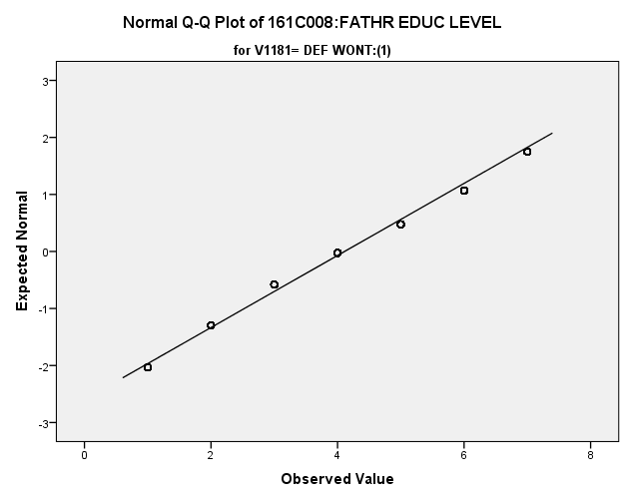**Exhibit : Preliminary Analysis**

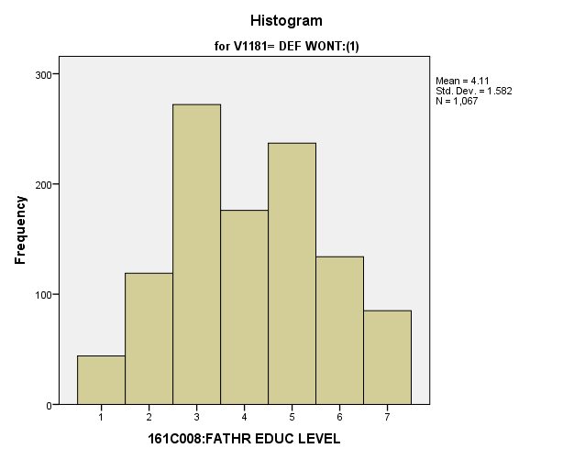

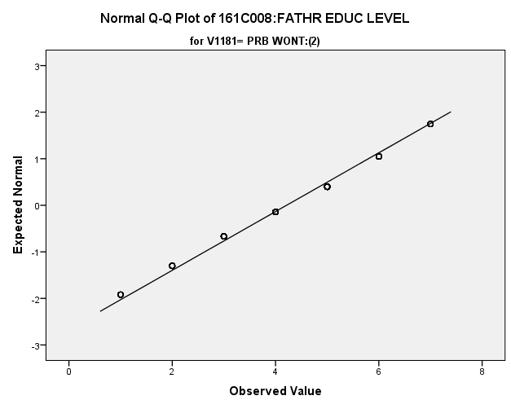

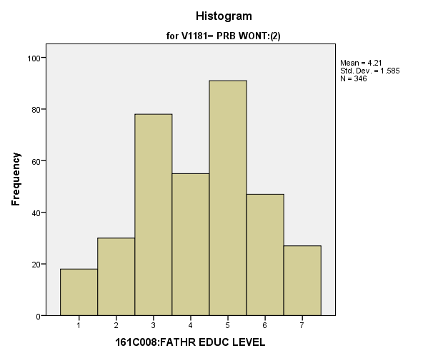

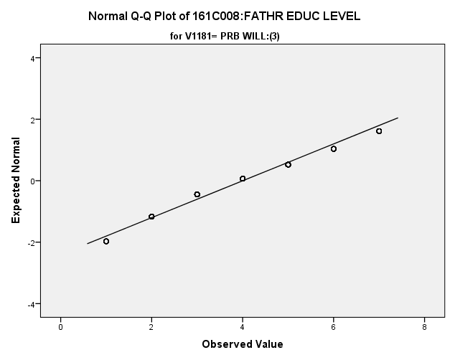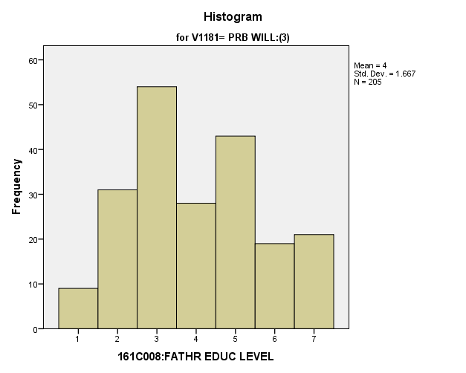

**Exhibit : Two Way Chi-Squared Table**

|  |  |  |  |  |  |
| --- | --- | --- | --- | --- | --- |
| ***V1163 * V1181 Crosstabulation*** | | | | | |
|  | | | V1181 | | |
| DEF WONT:(1) | PRB WONT:(2) | PRB WILL:(3) |
| V1163 | GRDE SCH:(1) | Count | **44** | **18** | **9** |
| % within V1181 | **4.1%** | **5.2%** | **4.4%** |
| SOME HS:(2) | Count | **119** | **30** | **31** |
| % within V1181 | **11.2%** | **8.7%** | **15.1%** |
| HS GRAD:(3) | Count | **272** | **78** | **54** |
| % within V1181 | **25.5%** | **22.5%** | **26.3%** |
| SOME CLG:(4) | Count | **176** | **55** | **28** |
| % within V1181 | **16.5%** | **15.9%** | **13.7%** |
| CLG GRAD:(5) | Count | **237** | **91** | **43** |
| % within V1181 | **22.2%** | **26.3%** | **21.0%** |
| GRAD SCH:(6) | Count | **134** | **47** | **19** |
| % within V1181 | **12.6%** | **13.6%** | **9.3%** |
| DK:(7) | Count | **85** | **27** | **21** |
| % within V1181 | **8.0%** | **7.8%** | **10.2%** |
| Total | | Count | **1067** | **346** | **205** |
| % within V1181 | **100.0%** | **100.0%** | **100.0%** |

|  |  |  |  |
| --- | --- | --- | --- |
| ***Chi-Square Tests*** | | | |
|  | Value | df | Asymptotic Significance (2-sided) |
| Pearson Chi-Square | **12.978a** | **12** | **.371** |
| Likelihood Ratio | **12.867** | **12** | **.379** |
| Linear-by-Linear Association | **.097** | **1** | **.755** |
| N of Valid Cases | **1618** |  |  |

**Mother’s Education Level:** Among the three groups in the sample, how do they differ regarding the mother’s education level?

**Variables Used:** The **dependent** **variable** used in the analysis was the mother’s education level the **independent (grouping) variable** was the pool of respondents. The mother’s education level was broken into the following categories:

* 1 = Completed grade school
* 2 = Some high school
* 3 = Completed high school
* 4 = Some college
* 5 = Completed college
* 6 = Graduate or professional school after college
* 7 = Don’t know, or does not apply

The respondent pool is broken into three categories:

* Non-recruits (students who say they definitely will not serve in the military after high school graduation) --- these are labeled as *definitely won’t (1).*
* Recruits (students who say they definitely or probably will serve in the military) --- these are labeled as *probably will (3).*
* Potential recruits (those who say they probably will not serve) --- these are labeled as *probably won’t (2)*.
* The desired pool of recruits is those labeled as probably won’t.
* Total respondents 1608, range for all groups 0 to 1.

**Analysis Procedure:**

* A two-way Chi Squared test was utilized to compare how the potential pool of recruits differs by the mother’s education level from other two groups.
* The analysis variable of present of the mother’s education level is categorical is mutually exclusive.
* The categorical variable is mutually exclusive.
* Expected frequency in each cell is greater than five.
* Prior to analysis, a histogram and Q-Q plots were inspected for outliers, none were present.

**Results:**

* Null and alternative hypothesis for initial test and post hoc:
  + H0: There is no difference between the three groups regarding the mother’s education level.
  + Ha: There is a difference between the three groups regarding the mother’s education level.
* Calculated two-way chi squared values
  + Initial test with all three categories
    - X2 = 26.414, df=12, α = 0.01, reject H0, Cohen’s W = 0.127
  + Post Hoc
    - X21,2 = 13.326, df = 6, fail to reject H0, α = 0.003,
    - X21,3 = 17.477, df = 6, fail to reject H0, α = 0.003,
    - X22,3 = 13.032, df = 6, fail to reject H0, α = 0.003

**Interpretation:** There was a significant difference in the mother’s education level between the potential recruits and either recruits or non-recruits. Due to the Bonferroni correction, none of the post hoc tests were significant. Some of the observable differences that one could see by eyeballing it are the following:

* 31.5% of probably won’t mother’s finished college
  + 29.6% for definitely won’t
  + 26.0% for probably will
* 16.2% of probably won’t mothers completed graduate school
  + 14.3% for definitely won’t
  + 9.8% for probably will

1.62% of the variation in the mother’s education level is due to the grouping variable of respondent pool.

**Supporting Analysis:**

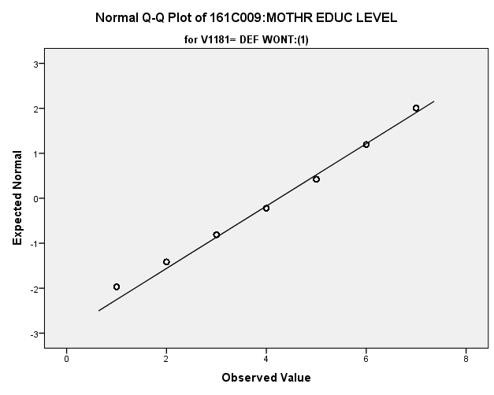**Exhibit : Preliminary Analysis**

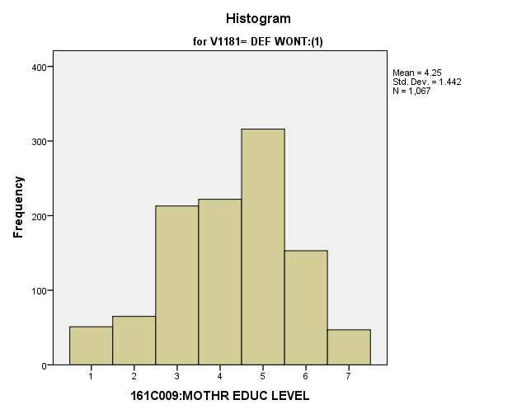

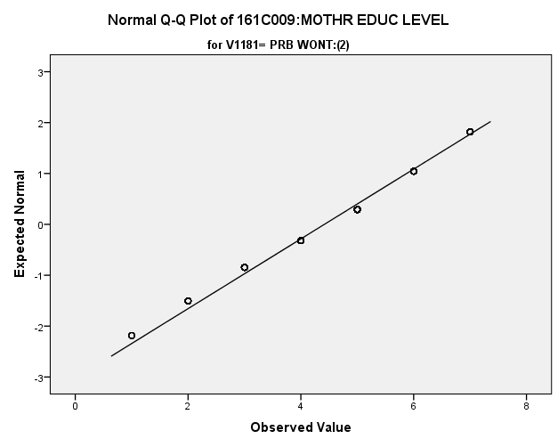

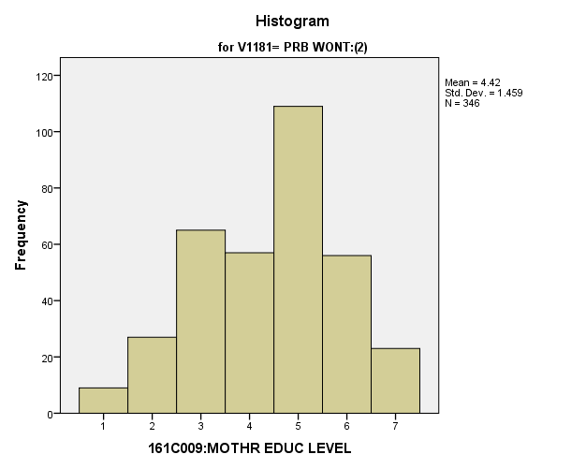

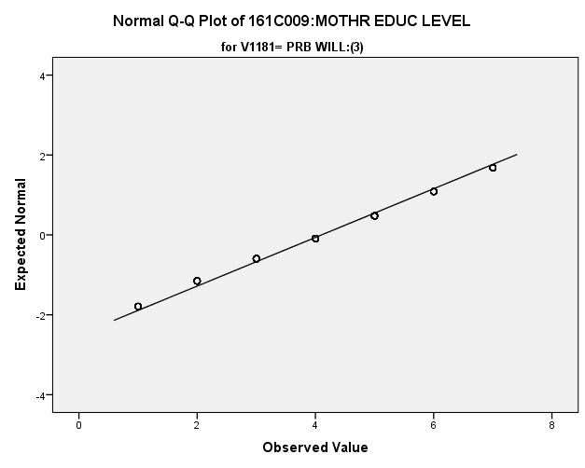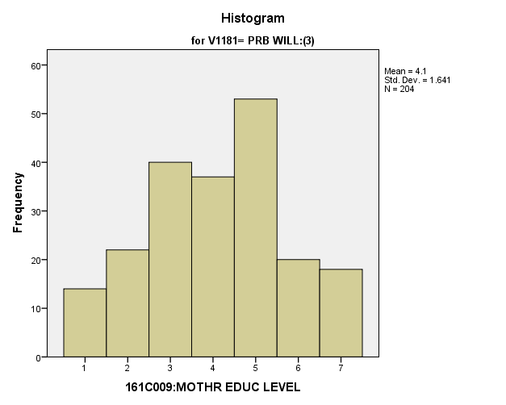

**Exhibit : Initial Two Way Chi-Squared and Effect Size**

|  |  |  |  |  |  |
| --- | --- | --- | --- | --- | --- |
| ***V1164 * V1181 Crosstabulation*** | | | | | |
|  | | | V1181 | | |
| DEF WONT:(1) | PRB WONT:(2) | PRB WILL:(3) |
| V1164 | GRDE SCH:(1) | Count | **51** | **9** | **14** |
| % within V1181 | **4.8%** | **2.6%** | **6.9%** |
| SOME HS:(2) | Count | **65** | **27** | **22** |
| % within V1181 | **6.1%** | **7.8%** | **10.8%** |
| HS GRAD:(3) | Count | **213** | **65** | **40** |
| % within V1181 | **20.0%** | **18.8%** | **19.6%** |
| SOME CLG:(4) | Count | **222** | **57** | **37** |
| % within V1181 | **20.8%** | **16.5%** | **18.1%** |
| CLG GRAD:(5) | Count | **316** | **109** | **53** |
| % within V1181 | **29.6%** | **31.5%** | **26.0%** |
| GRAD SCH:(6) | Count | **153** | **56** | **20** |
| % within V1181 | **14.3%** | **16.2%** | **9.8%** |
| DK:(7) | Count | **47** | **23** | **18** |
| % within V1181 | **4.4%** | **6.6%** | **8.8%** |
| Total | | Count | **1067** | **346** | **204** |
| % within V1181 | **100.0%** | **100.0%** | **100.0%** |

|  |  |  |  |
| --- | --- | --- | --- |
| ***Chi-Square Tests*** | | | |
|  | Value | df | Asymptotic Significance (2-sided) |
| Pearson Chi-Square | **26.414a** | **12** | **.009** |
| Likelihood Ratio | **25.943** | **12** | **.011** |
| Linear-by-Linear Association | **.135** | **1** | **.713** |
| N of Valid Cases | **1617** |  |  |

|  |  |  |  |
| --- | --- | --- | --- |
| ***Symmetric Measures*** | | | |
|  | | Value | Approximate Significance |
| Nominal by Nominal | Phi | **.128** | **.009** |
| Cramer's V | **.090** | **.009** |
| N of Valid Cases | | **1617** |  |

**Exhibit: Groups 1&2 Two Way Chi Squared**

|  |  |  |  |  |  |
| --- | --- | --- | --- | --- | --- |
| ***V1164 * V1181 Crosstabulation*** | | | | | |
|  | | | V1181 | | Total |
| DEF WONT:(1) | PRB WONT:(2) |
| V1164 | GRDE SCH:(1) | Count | **51** | **9** | **60** |
| % within V1181 | **4.8%** | **2.6%** | **4.2%** |
| SOME HS:(2) | Count | **65** | **27** | **92** |
| % within V1181 | **6.1%** | **7.8%** | **6.5%** |
| HS GRAD:(3) | Count | **213** | **65** | **278** |
| % within V1181 | **20.0%** | **18.8%** | **19.7%** |
| SOME CLG:(4) | Count | **222** | **57** | **279** |
| % within V1181 | **20.8%** | **16.5%** | **19.7%** |
| CLG GRAD:(5) | Count | **316** | **109** | **425** |
| % within V1181 | **29.6%** | **31.5%** | **30.1%** |
| GRAD SCH:(6) | Count | **153** | **56** | **209** |
| % within V1181 | **14.3%** | **16.2%** | **14.8%** |
| DK:(7) | Count | **47** | **23** | **70** |
| % within V1181 | **4.4%** | **6.6%** | **5.0%** |
| Total | | Count | **1067** | **346** | **1413** |
| % within V1181 | **100.0%** | **100.0%** | **100.0%** |

|  |  |  |  |
| --- | --- | --- | --- |
| ***Chi-Square Tests*** | | | |
|  | Value | df | Asymptotic Significance (2-sided) |
| Pearson Chi-Square | **10.326a** | **6** | **.112** |
| Likelihood Ratio | **10.527** | **6** | **.104** |
| Linear-by-Linear Association | **3.435** | **1** | **.064** |
| N of Valid Cases | **1413** |  |  |

|  |
| --- |
| a. 0 cells (0.0%) have expected count less than 5. The minimum expected count is 14.69. |

**Exhibit: Groups 1&3 Two Way Chi Squared**

|  |  |  |  |  |  |
| --- | --- | --- | --- | --- | --- |
| ***V1164 * V1181 Crosstabulation*** | | | | | |
|  | | | V1181 | | Total |
| DEF WONT:(1) | PRB WILL:(3) |
| V1164 | GRDE SCH:(1) | Count | **51** | **14** | **65** |
| % within V1181 | **4.8%** | **6.9%** | **5.1%** |
| SOME HS:(2) | Count | **65** | **22** | **87** |
| % within V1181 | **6.1%** | **10.8%** | **6.8%** |
| HS GRAD:(3) | Count | **213** | **40** | **253** |
| % within V1181 | **20.0%** | **19.6%** | **19.9%** |
| SOME CLG:(4) | Count | **222** | **37** | **259** |
| % within V1181 | **20.8%** | **18.1%** | **20.4%** |
| CLG GRAD:(5) | Count | **316** | **53** | **369** |
| % within V1181 | **29.6%** | **26.0%** | **29.0%** |
| GRAD SCH:(6) | Count | **153** | **20** | **173** |
| % within V1181 | **14.3%** | **9.8%** | **13.6%** |
| DK:(7) | Count | **47** | **18** | **65** |
| % within V1181 | **4.4%** | **8.8%** | **5.1%** |
| Total | | Count | **1067** | **204** | **1271** |
| % within V1181 | **100.0%** | **100.0%** | **100.0%** |

|  |  |  |  |
| --- | --- | --- | --- |
| ***Chi-Square Tests*** | | | |
|  | Value | df | Asymptotic Significance (2-sided) |
| Pearson Chi-Square | **17.477a** | **6** | **.008** |
| Likelihood Ratio | **16.038** | **6** | **.014** |
| Linear-by-Linear Association | **1.705** | **1** | **.192** |
| N of Valid Cases | **1271** |  |  |

**Exhibit: Groups 2&3 Two Way Chi Squared**

|  |  |  |  |  |  |
| --- | --- | --- | --- | --- | --- |
| ***V1164 * V1181 Crosstabulation*** | | | | | |
|  | | | V1181 | | Total |
| PRB WONT:(2) | PRB WILL:(3) |
| V1164 | GRDE SCH:(1) | Count | **9** | **14** | **23** |
| % within V1181 | **2.6%** | **6.9%** | **4.2%** |
| SOME HS:(2) | Count | **27** | **22** | **49** |
| % within V1181 | **7.8%** | **10.8%** | **8.9%** |
| HS GRAD:(3) | Count | **65** | **40** | **105** |
| % within V1181 | **18.8%** | **19.6%** | **19.1%** |
| SOME CLG:(4) | Count | **57** | **37** | **94** |
| % within V1181 | **16.5%** | **18.1%** | **17.1%** |
| CLG GRAD:(5) | Count | **109** | **53** | **162** |
| % within V1181 | **31.5%** | **26.0%** | **29.5%** |
| GRAD SCH:(6) | Count | **56** | **20** | **76** |
| % within V1181 | **16.2%** | **9.8%** | **13.8%** |
| DK:(7) | Count | **23** | **18** | **41** |
| % within V1181 | **6.6%** | **8.8%** | **7.5%** |
| Total | | Count | **346** | **204** | **550** |
| % within V1181 | **100.0%** | **100.0%** | **100.0%** |

|  |  |  |  |
| --- | --- | --- | --- |
| ***Chi-Square Tests*** | | | |
|  | Value | df | Asymptotic Significance (2-sided) |
| Pearson Chi-Square | **13.032a** | **6** | **.043** |
| Likelihood Ratio | **12.954** | **6** | **.044** |
| Linear-by-Linear Association | **5.345** | **1** | **.021** |
| N of Valid Cases | **550** |  |  |

*3.b. Student Values*

**Importance of Having Lots of Money:** Among the three groups in the sample, how do they differ regarding how important they thought it was to have lots of money?

**Variables Used:** The **dependent** **variable** used in the analysis was the importance of money (1=not important, 2=somewhat important, 3= quite important, 4= extremely important) and the **independent (grouping) variable** used was the pool of respondents. The respondent pool is broken into three categories:

* Non-recruits (students who say they definitely will not serve in the military after high school graduation) --- these are labeled as *definitely won’t (1).*
* Recruits (students who say they definitely or probably will serve in the military) --- these are labeled as *probably will (3).*
* Potential recruits (those who say they probably will not serve) --- these are labeled as *probably won’t (2)*.
* The desired pool of recruits is those labeled as probably won’t.
* Total respondents: 1587, range for all groups 1 to 4.

**Analysis Procedure:**

* A one-way ANOVA test was utilized to compare how the potential pool of recruits differs by the importance of money.
* The analysis variable of importance of money is interval and the grouping variables are mutually exclusive.
* Prior to analysis, a histogram and Q-Q plot were inspected for outliers, none were present. Each group was had a negative skew of less than 2.
* The homogeneity of variances assumption was tested. The assumption was met.

**Results:**

* Null and alternative hypothesis:
  + Main Test
    - H0 : µ1 = µ2 = µ3
    - Ha : ALOI
* Calculated F value: f(importance of money) 4.108 , dfnum= 2, dfden= 1628, α = 0.01, fail to reject H0;

**Interpretation:** There was no significant difference in means between the three groups regarding the importance of money.

**Supporting Analysis:**

**Exhibit : Preliminary Analysis**

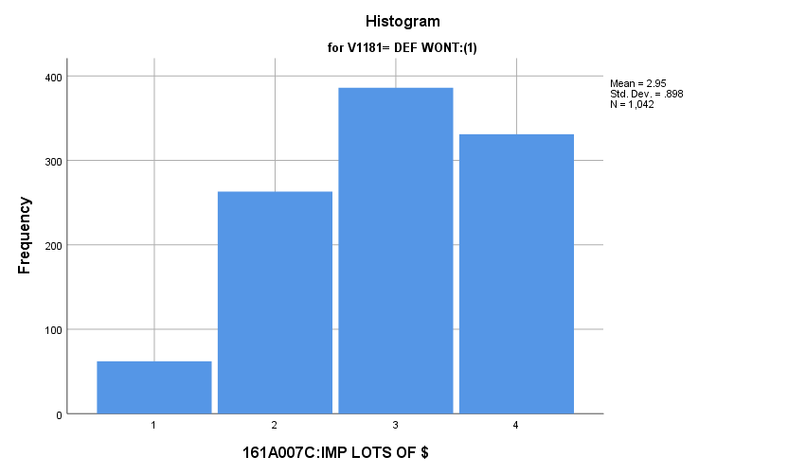

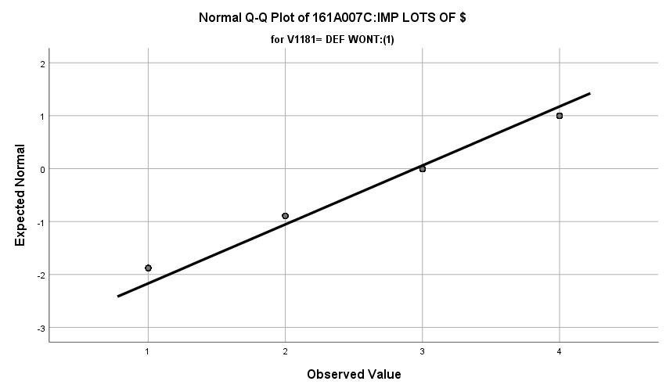

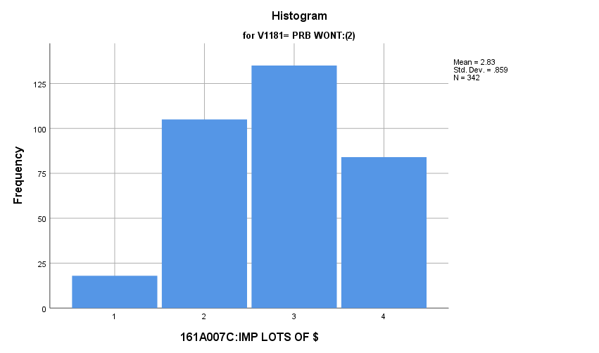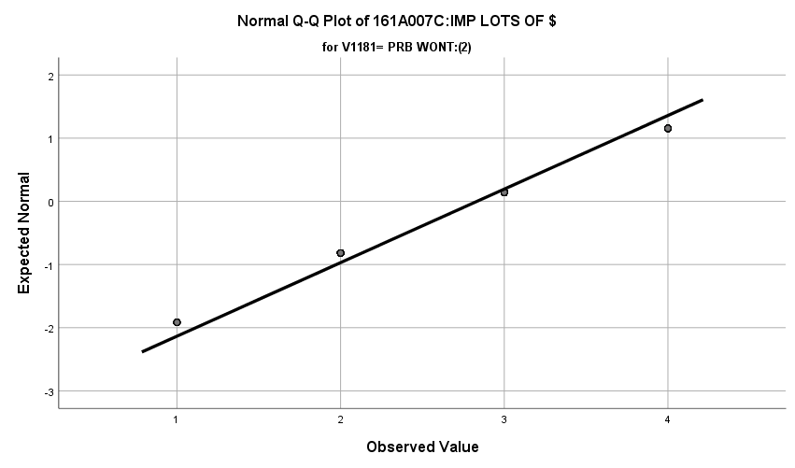

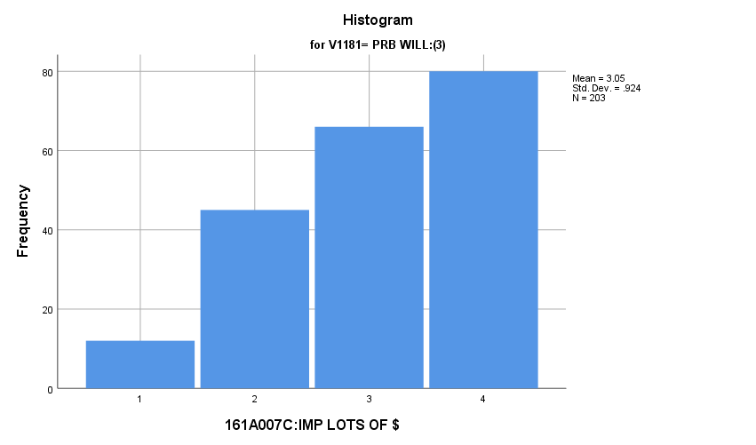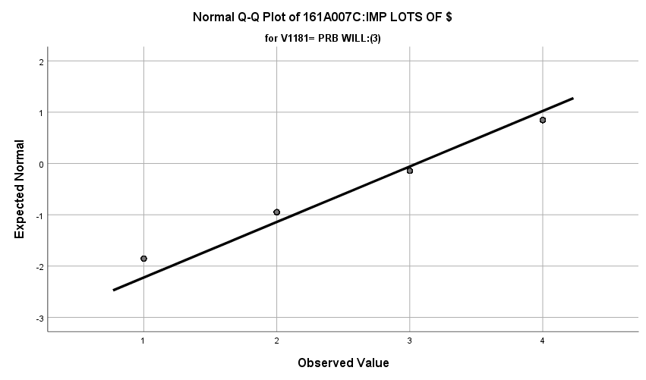

**Exhibit : Descriptives**

|  |  |  |  |  |  |
| --- | --- | --- | --- | --- | --- |
| ***Descriptives*** | | | | | |
|  | V1181 | | | Statistic | Std. Error |
| V1657 | DEF WONT:(1) | Mean | | **2.95** | **.028** |
| 99% Confidence Interval for Mean | Lower Bound | **2.87** |  |
| Upper Bound | **3.02** |  |
| 5% Trimmed Mean | | **3.00** |  |
| Median | | **3.00** |  |
| Variance | | **.806** |  |
| Std. Deviation | | **.898** |  |
| Minimum | | **1** |  |
| Maximum | | **4** |  |
| Range | | **3** |  |
| Interquartile Range | | **2** |  |
| Skewness | | **-.389** | **.076** |
| Kurtosis | | **-.765** | **.151** |
| PRB WONT:(2) | Mean | | **2.83** | **.046** |
| 99% Confidence Interval for Mean | Lower Bound | **2.71** |  |
| Upper Bound | **2.95** |  |
| 5% Trimmed Mean | | **2.87** |  |
| Median | | **3.00** |  |
| Variance | | **.738** |  |
| Std. Deviation | | **.859** |  |
| Minimum | | **1** |  |
| Maximum | | **4** |  |
| Range | | **3** |  |
| Interquartile Range | | **1** |  |
| Skewness | | **-.175** | **.132** |
| Kurtosis | | **-.779** | **.263** |
| PRB WILL:(3) | Mean | | **3.05** | **.065** |
| 99% Confidence Interval for Mean | Lower Bound | **2.89** |  |
| Upper Bound | **3.22** |  |
| 5% Trimmed Mean | | **3.12** |  |
| Median | | **3.00** |  |
| Variance | | **.853** |  |
| Std. Deviation | | **.924** |  |
| Minimum | | **1** |  |
| Maximum | | **4** |  |
| Range | | **3** |  |
| Interquartile Range | | **2** |  |
| Skewness | | **-.565** | **.171** |
| Kurtosis | | **-.712** | **.340** |

**Exhibit : One-Way ANOVA Table and Homogeneity**

|  |  |  |  |  |  |
| --- | --- | --- | --- | --- | --- |
| ***Test of Homogeneity of Variances*** | | | | | |
|  | | Levene Statistic | df1 | df2 | Sig. |
| V1657 | Based on Mean | **.438** | **2** | **1584** | **.646** |
| Based on Median | **1.119** | **2** | **1584** | **.327** |
| Based on Median and with adjusted df | **1.119** | **2** | **1583.467** | **.327** |
| Based on trimmed mean | **1.295** | **2** | **1584** | **.274** |

|  |  |  |  |  |  |
| --- | --- | --- | --- | --- | --- |
| ***ANOVA*** | | | | | |
| V1657 | | | | | |
|  | Sum of Squares | df | Mean Square | F | Sig. |
| Between Groups | **6.550** | **2** | **3.275** | **4.108** | **.017** |
| Within Groups | **1262.894** | **1584** | **.797** |  |  |
| Total | **1269.444** | **1586** |  |  |  |

**Importance of Having Strong Friendships:** Among the three groups in the sample, how do they differ regarding how important they thought it was to have strong friendships?

**Variables Used:** The **dependent** **variable** used in the analysis was the important of friendships (1=not important, 2=somewhat important, 3= quite important, 4= extremely important) and the **independent (grouping) variable** used was the pool of respondents. The respondent pool is broken into three categories:

* Non-recruits (students who say they definitely will not serve in the military after high school graduation) --- these are labeled as *definitely won’t (1).*
* Recruits (students who say they definitely or probably will serve in the military) --- these are labeled as *probably will (3).*
* Potential recruits (those who say they probably will not serve) --- these are labeled as *probably won’t (2)*.
* The desired pool of recruits is those labeled as probably won’t.
* Total respondents: 1598, range for all groups 1 to 4.

**Analysis Procedure:**

* A one-way ANOVA test was utilized to compare how the potential pool of recruits differs by the importance of friendships.
* The analysis variable of importance of friendships is interval and the grouping variables are mutually exclusive.
* Prior to analysis, a histogram was inspected for outliers, none were present. Each group was had a negative skew of less than 2.
* The homogeneity of variances assumption was tested. The assumption was not met but the group sizes are approximately equal.

**Results:**

* Null and alternative hypothesis:
  + Main Test
    - H0 : µ1 = µ2 = µ3
    - Ha : ALOI
* Calculated F value: f(importance of money) 3.559 , dfnum= 2, dfden= 1595, α = 0.01, fail to reject H0;

**Interpretation:** There was no significant difference in means between the three groups regarding the importance of friendships.

**Supporting Analysis:**

**Exhibit: Preliminary Analysis**

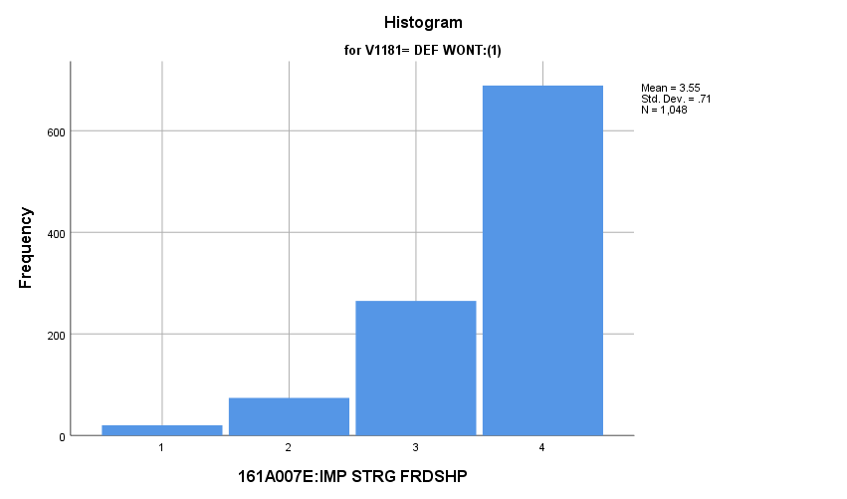

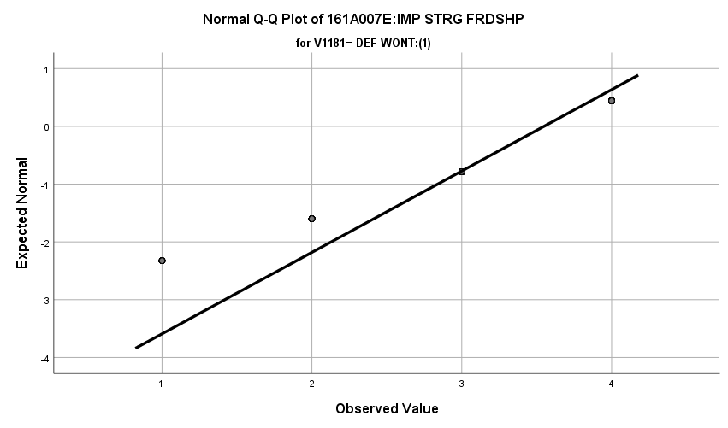

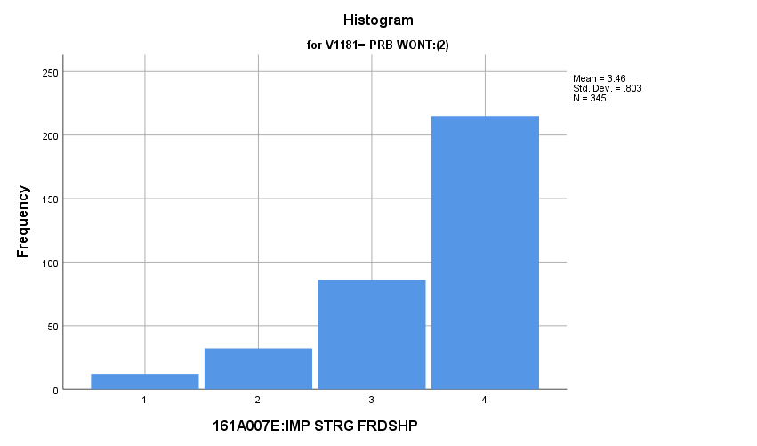

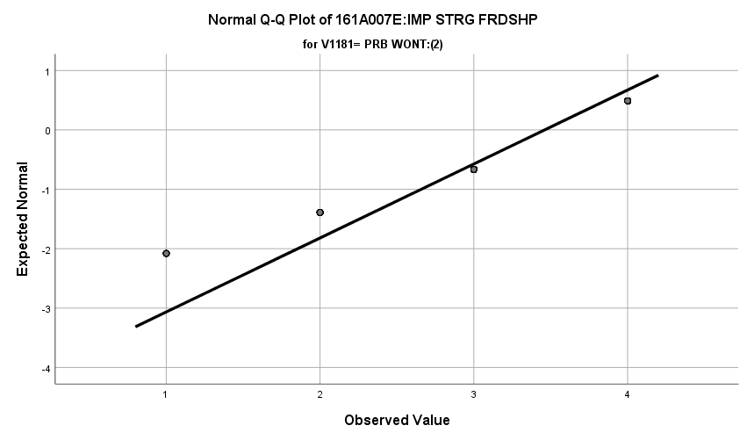

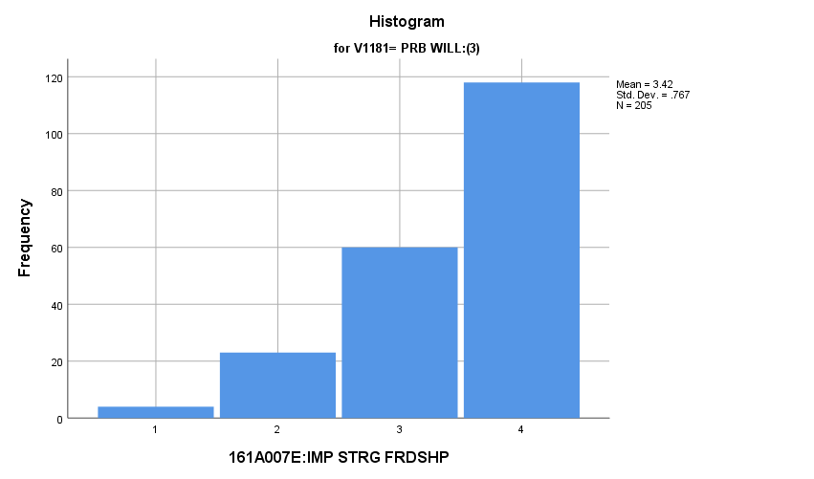

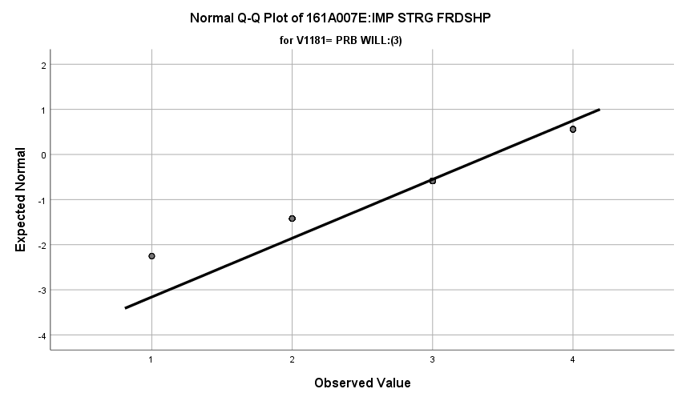

**Exhibit : Descriptives**

|  |  |  |  |  |  |
| --- | --- | --- | --- | --- | --- |
| ***Descriptives*** | | | | | |
|  | V1181 | | | Statistic | Std. Error |
| V1659 | DEF WONT:(1) | Mean | | **3.55** | **.022** |
| 99% Confidence Interval for Mean | Lower Bound | **3.49** |  |
| Upper Bound | **3.61** |  |
| 5% Trimmed Mean | | **3.63** |  |
| Median | | **4.00** |  |
| Variance | | **.504** |  |
| Std. Deviation | | **.710** |  |
| Minimum | | **1** |  |
| Maximum | | **4** |  |
| Range | | **3** |  |
| Interquartile Range | | **1** |  |
| Skewness | | **-1.569** | **.076** |
| Kurtosis | | **1.994** | **.151** |
| PRB WONT:(2) | Mean | | **3.46** | **.043** |
| 99% Confidence Interval for Mean | Lower Bound | **3.35** |  |
| Upper Bound | **3.57** |  |
| 5% Trimmed Mean | | **3.55** |  |
| Median | | **4.00** |  |
| Variance | | **.645** |  |
| Std. Deviation | | **.803** |  |
| Minimum | | **1** |  |
| Maximum | | **4** |  |
| Range | | **3** |  |
| Interquartile Range | | **1** |  |
| Skewness | | **-1.431** | **.131** |
| Kurtosis | | **1.302** | **.262** |
| PRB WILL:(3) | Mean | | **3.42** | **.054** |
| 99% Confidence Interval for Mean | Lower Bound | **3.29** |  |
| Upper Bound | **3.56** |  |
| 5% Trimmed Mean | | **3.49** |  |
| Median | | **4.00** |  |
| Variance | | **.589** |  |
| Std. Deviation | | **.767** |  |
| Minimum | | **1** |  |
| Maximum | | **4** |  |
| Range | | **3** |  |
| Interquartile Range | | **1** |  |
| Skewness | | **-1.157** | **.170** |
| Kurtosis | | **.565** | **.338** |

**Exhibit: One-Way ANOVA and Homogeneity**

|  |  |  |  |  |  |
| --- | --- | --- | --- | --- | --- |
| ***Test of Homogeneity of Variances*** | | | | | |
|  | | Levene Statistic | df1 | df2 | Sig. |
| V1659 | Based on Mean | **6.401** | **2** | **1595** | **.002** |
| Based on Median | **3.559** | **2** | **1595** | **.029** |
| Based on Median and with adjusted df | **3.559** | **2** | **1576.465** | **.029** |
| Based on trimmed mean | **6.424** | **2** | **1595** | **.002** |

|  |  |  |  |  |  |
| --- | --- | --- | --- | --- | --- |
| ***ANOVA*** | | | | | |
| V1659 | | | | | |
|  | Sum of Squares | df | Mean Square | F | Sig. |
| Between Groups | **3.879** | **2** | **1.940** | **3.559** | **.029** |
| Within Groups | **869.318** | **1595** | **.545** |  |  |
| Total | **873.197** | **1597** |  |  |  |

**Importance of Having Steady Work:** Among the three groups in the sample, how do they differ regarding how important they thought it was to have strong friendships?

**Variables Used:** The **dependent** **variable** used in the analysis was the important of steady work (1=not important, 2=somewhat important, 3= quite important, 4= extremely important) and the **independent (grouping) variable** used was the pool of respondents. The respondent pool is broken into three categories:

* Non-recruits (students who say they definitely will not serve in the military after high school graduation) --- these are labeled as *definitely won’t (1).*
* Recruits (students who say they definitely or probably will serve in the military) --- these are labeled as *probably will (3).*
* Potential recruits (those who say they probably will not serve) --- these are labeled as *probably won’t (2)*.
* The desired pool of recruits is those labeled as probably won’t.
* Total respondents: 1598, range for all groups 1 to 4 except probably won’t whose range is 2 to 4

**Analysis Procedure:**

* A one-way ANOVA test was utilized to compare how the potential pool of recruits differs by the importance of steady work.
* The analysis variable of importance of steady work is interval and the grouping variables are mutually exclusive.
* Prior to analysis, a histogram and Q-Q plot were inspected for outliers, none were present. Each group was had a negative skew of less than 2.
* The homogeneity of variances assumption was tested. The assumption was not met but the group sizes are approximately equal.

**Results:**

* Null and alternative hypothesis:
  + Main Test
    - H0 : µ1 = µ2 = µ3
    - Ha : ALOI
* Calculated F value: f(importance of steady work) 3.526, dfnum= 2, dfden= 1595, α = 0.01, fail to reject H0;

**Interpretation:** There was no significant difference in means between the three groups regarding the importance of steady work.

**Supporting Analysis:**

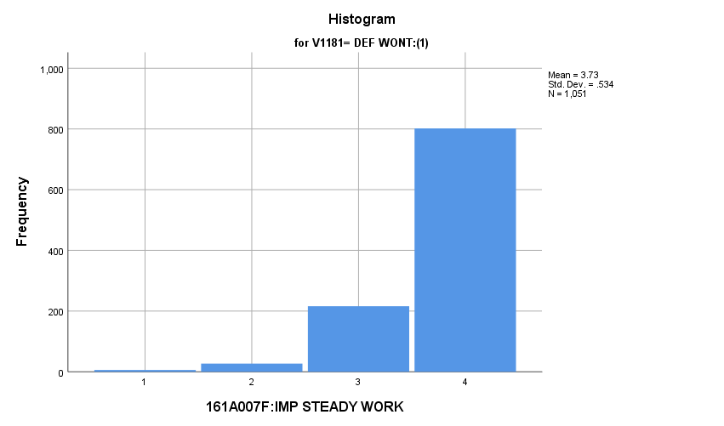**Exhibit : Preliminary Analsysis**

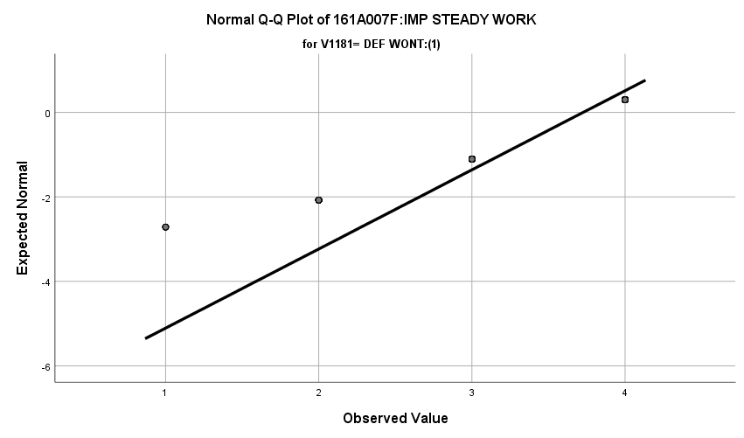

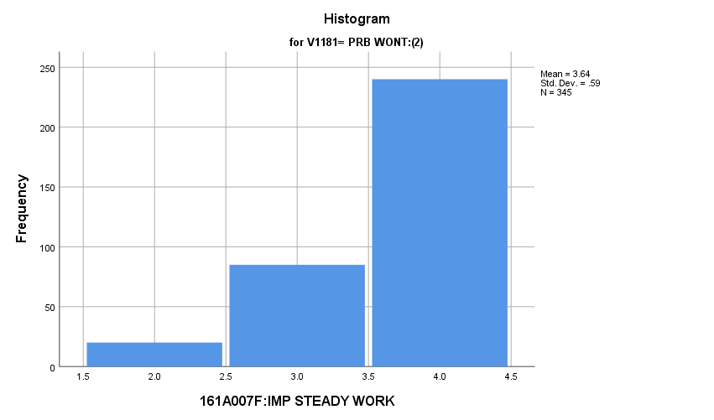

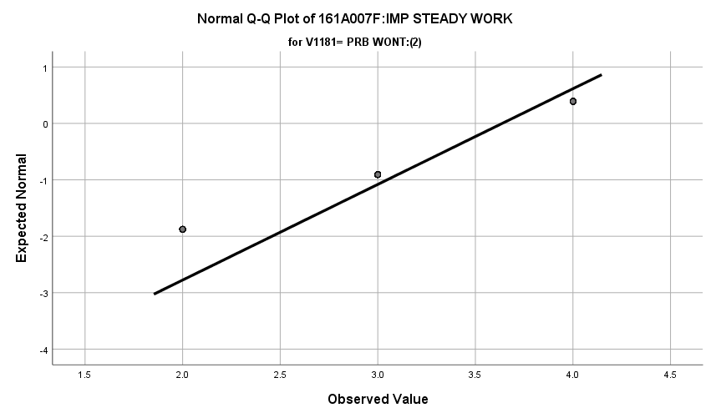

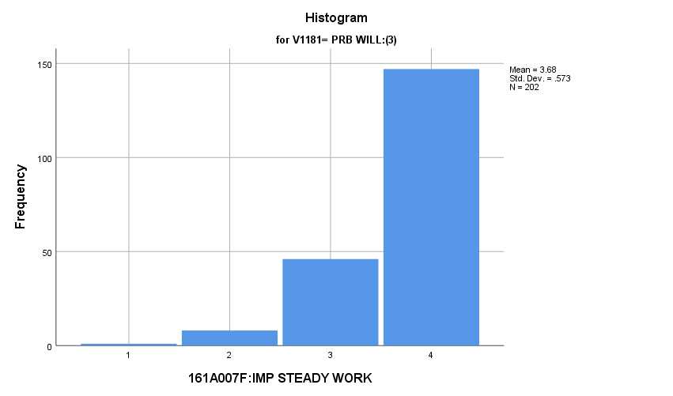

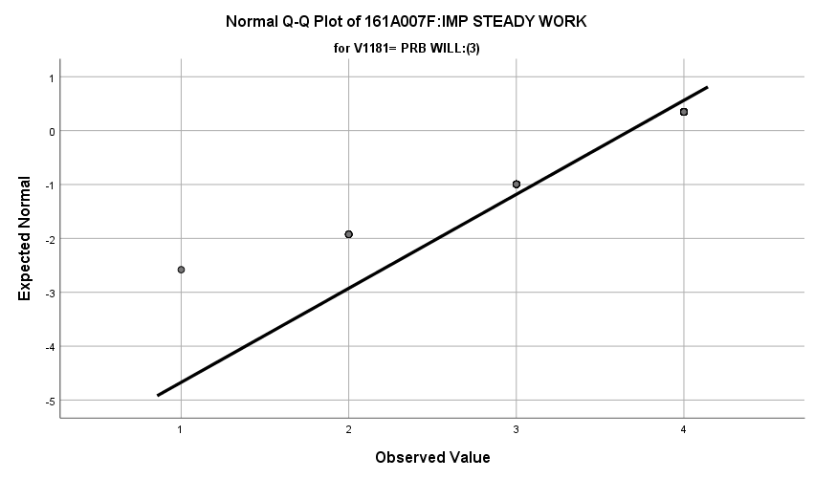

**Exhibit : Descriptives**

|  |  |  |  |  |  |
| --- | --- | --- | --- | --- | --- |
| ***Descriptives*** | | | | | |
|  | V1181 | | | Statistic | Std. Error |
| V1660 | DEF WONT:(1) | Mean | | **3.73** | **.016** |
| 99% Confidence Interval for Mean | Lower Bound | **3.68** |  |
| Upper Bound | **3.77** |  |
| 5% Trimmed Mean | | **3.79** |  |
| Median | | **4.00** |  |
| Variance | | **.285** |  |
| Std. Deviation | | **.534** |  |
| Minimum | | **1** |  |
| Maximum | | **4** |  |
| Range | | **3** |  |
| Interquartile Range | | **0** |  |
| Skewness | | **-2.049** | **.075** |
| Kurtosis | | **4.493** | **.151** |
| PRB WONT:(2) | Mean | | **3.64** | **.032** |
| 99% Confidence Interval for Mean | Lower Bound | **3.56** |  |
| Upper Bound | **3.72** |  |
| 5% Trimmed Mean | | **3.71** |  |
| Median | | **4.00** |  |
| Variance | | **.348** |  |
| Std. Deviation | | **.590** |  |
| Minimum | | **2** |  |
| Maximum | | **4** |  |
| Range | | **2** |  |
| Interquartile Range | | **1** |  |
| Skewness | | **-1.403** | **.131** |
| Kurtosis | | **.932** | **.262** |
| PRB WILL:(3) | Mean | | **3.68** | **.040** |
| 99% Confidence Interval for Mean | Lower Bound | **3.57** |  |
| Upper Bound | **3.78** |  |
| 5% Trimmed Mean | | **3.75** |  |
| Median | | **4.00** |  |
| Variance | | **.329** |  |
| Std. Deviation | | **.573** |  |
| Minimum | | **1** |  |
| Maximum | | **4** |  |
| Range | | **3** |  |
| Interquartile Range | | **1** |  |
| Skewness | | **-1.772** | **.171** |
| Kurtosis | | **2.940** | **.341** |

**Exhibit : One-Way ANOVA and Homogeneity**

|  |  |  |  |  |  |
| --- | --- | --- | --- | --- | --- |
| ***Test of Homogeneity of Variances*** | | | | | |
|  | | Levene Statistic | df1 | df2 | Sig. |
| V1660 | Based on Mean | **9.733** | **2** | **1595** | **.000** |
| Based on Median | **3.526** | **2** | **1595** | **.030** |
| Based on Median and with adjusted df | **3.526** | **2** | **1582.389** | **.030** |
| Based on trimmed mean | **8.595** | **2** | **1595** | **.000** |

|  |  |  |  |  |  |
| --- | --- | --- | --- | --- | --- |
| ***ANOVA*** | | | | | |
| V1660 | | | | | |
|  | Sum of Squares | df | Mean Square | F | Sig. |
| Between Groups | **2.144** | **2** | **1.072** | **3.526** | **.030** |
| Within Groups | **484.875** | **1595** | **.304** |  |  |
| Total | **487.019** | **1597** |  |  |  |

**Importance of Contributing to Society:** Among the three groups in the sample, how do they differ regarding how important they thought it was to contribute to society?

**Variables Used:** The **dependent** **variable** used in the analysis was the important of steady work (1=not important, 2=somewhat important, 3= quite important, 4= extremely important) and the **independent (grouping) variable** used was the pool of respondents. The respondent pool is broken into three categories:

* Non-recruits (students who say they definitely will not serve in the military after high school graduation) --- these are labeled as *definitely won’t (1).*
* Recruits (students who say they definitely or probably will serve in the military) --- these are labeled as *probably will (3).*
* Potential recruits (those who say they probably will not serve) --- these are labeled as *probably won’t (2)*.
* The desired pool of recruits is those labeled as probably won’t.
* Total respondents: 1596, range for all groups 1 to 4

**Analysis Procedure:**

* A one-way ANOVA test was utilized to compare how the potential pool of recruits differs by the importance of steady work.
* The analysis variable of importance of steady work is interval and the grouping variables are mutually exclusive.
* Prior to analysis, a histogram and Q-Q plots were inspected for outliers, none were present. Each group was had a negative skew of less than 2.
* The homogeneity of variances assumption was tested. The assumption was met.

**Results:**

* Null and alternative hypothesis:
  + Main Test
    - H0 : µ1 = µ2 = µ3
    - Ha : ALOI
* Calculated F value: f(importance of steady work) 0.804, dfnum= 2, dfden= 1596, α = 0.01, fail to reject H0;

**Interpretation:** There was no significant difference in means between the three groups regarding the importance of steady work.

**Supporting Analysis:**

**Exhibit : Preliminary Analysis**

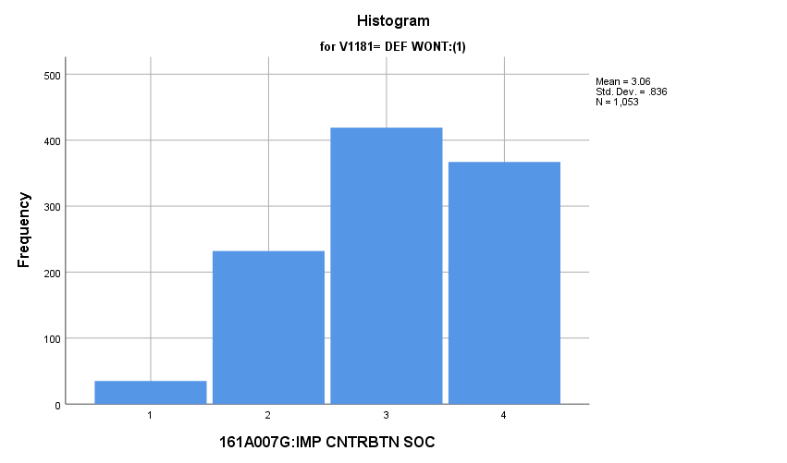

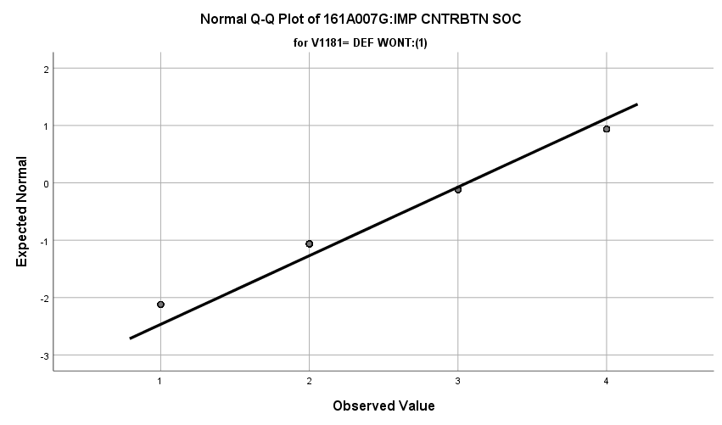

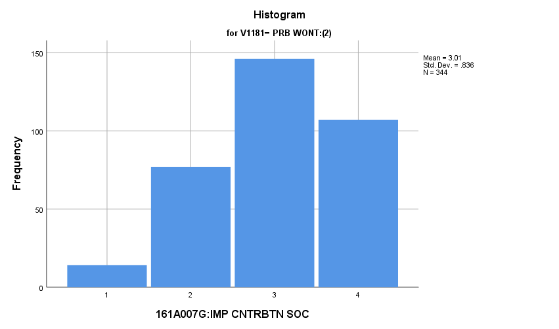

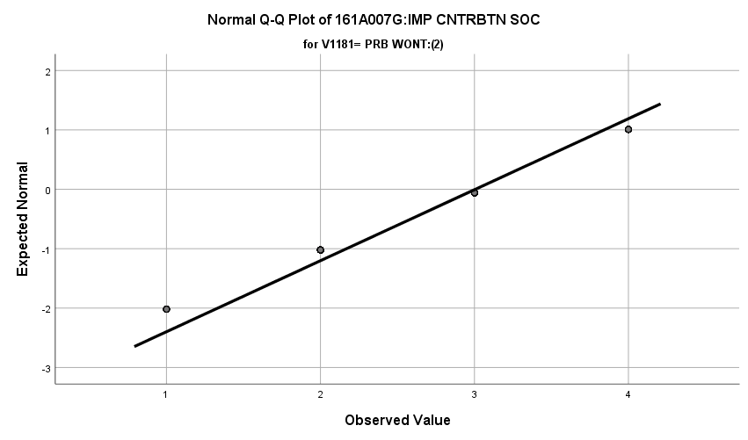

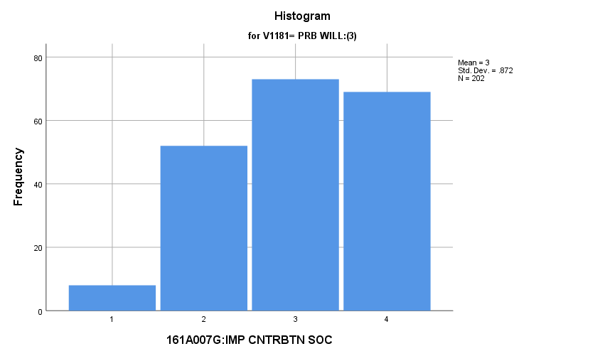

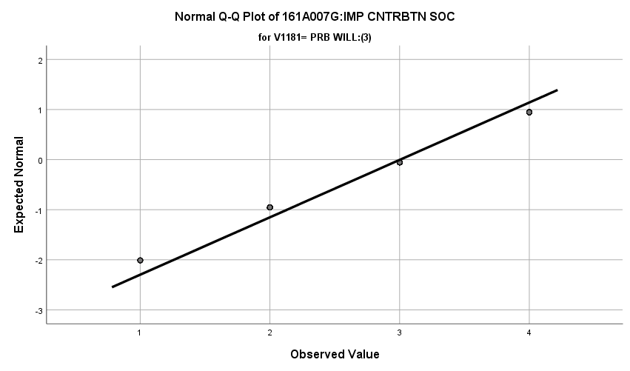

**Exhibit : Descriptives**

|  |  |  |  |  |  |
| --- | --- | --- | --- | --- | --- |
| ***Descriptives*** | | | | | |
|  | V1181 | | | Statistic | Std. Error |
| V1661 | DEF WONT:(1) | Mean | | **3.06** | **.026** |
| 99% Confidence Interval for Mean | Lower Bound | **3.00** |  |
| Upper Bound | **3.13** |  |
| 5% Trimmed Mean | | **3.11** |  |
| Median | | **3.00** |  |
| Variance | | **.699** |  |
| Std. Deviation | | **.836** |  |
| Minimum | | **1** |  |
| Maximum | | **4** |  |
| Range | | **3** |  |
| Interquartile Range | | **2** |  |
| Skewness | | **-.459** | **.075** |
| Kurtosis | | **-.636** | **.151** |
| PRB WONT:(2) | Mean | | **3.01** | **.045** |
| 99% Confidence Interval for Mean | Lower Bound | **2.89** |  |
| Upper Bound | **3.12** |  |
| 5% Trimmed Mean | | **3.05** |  |
| Median | | **3.00** |  |
| Variance | | **.700** |  |
| Std. Deviation | | **.836** |  |
| Minimum | | **1** |  |
| Maximum | | **4** |  |
| Range | | **3** |  |
| Interquartile Range | | **2** |  |
| Skewness | | **-.432** | **.131** |
| Kurtosis | | **-.542** | **.262** |
| PRB WILL:(3) | Mean | | **3.00** | **.061** |
| 99% Confidence Interval for Mean | Lower Bound | **2.85** |  |
| Upper Bound | **3.16** |  |
| 5% Trimmed Mean | | **3.05** |  |
| Median | | **3.00** |  |
| Variance | | **.761** |  |
| Std. Deviation | | **.872** |  |
| Minimum | | **1** |  |
| Maximum | | **4** |  |
| Range | | **3** |  |
| Interquartile Range | | **2** |  |
| Skewness | | **-.373** | **.171** |
| Kurtosis | | **-.834** | **.341** |

**Exhibit : One-Way ANOVA and Homogeneity**

|  |  |  |  |  |  |
| --- | --- | --- | --- | --- | --- |
| ***Test of Homogeneity of Variances*** | | | | | |
|  | | Levene Statistic | df1 | df2 | Sig. |
| V1661 | Based on Mean | **.948** | **2** | **1596** | **.388** |
| Based on Median | **.815** | **2** | **1596** | **.443** |
| Based on Median and with adjusted df | **.815** | **2** | **1594.793** | **.443** |
| Based on trimmed mean | **.872** | **2** | **1596** | **.418** |

|  |  |  |  |  |  |
| --- | --- | --- | --- | --- | --- |
| ***ANOVA*** | | | | | |
| V1661 | | | | | |
|  | Sum of Squares | df | Mean Square | F | Sig. |
| Between Groups | **1.137** | **2** | **.569** | **.804** | **.448** |
| Within Groups | **1127.971** | **1596** | **.707** |  |  |
| Total | **1129.108** | **1598** |  |  |  |

**Importance of Being a Leader in the Community:** Among the three groups in the sample, how do they differ regarding how important they thought it was to be a leader in the community?

**Variables Used:** The **dependent** **variable** used in the analysis was the importance of being a leader in the community (1=not important, 2=somewhat important, 3= quite important, 4= extremely important) and the **independent (grouping) variable** used was the pool of respondents. The respondent pool is broken into three categories:

* Non-recruits (students who say they definitely will not serve in the military after high school graduation) --- these are labeled as *definitely won’t (1).*
* Recruits (students who say they definitely or probably will serve in the military) --- these are labeled as *probably will (3).*
* Potential recruits (those who say they probably will not serve) --- these are labeled as *probably won’t (2)*.
* The desired pool of recruits is those labeled as probably won’t.
* Total respondents: 1599, range for all groups 1 to 4

**Analysis Procedure:**

* A one-way ANOVA test was utilized to compare how the potential pool of recruits differs by the importance of being a leader in the community.
* The analysis variable of importance of being a leader in the community is interval and the grouping variables are mutually exclusive.
* Prior to analysis, a histogram and Q-Q plots were inspected for outliers, none were present. Each group had a skew value of nearly zero.
* The homogeneity of variances assumption was tested. The assumption was met.

**Results:**

* Null and alternative hypothesis:
  + Main Test
    - H0 : µ1 = µ2 = µ3
    - Ha : ALOI
* Calculated F value: f(importance of steady work) 2.357, dfnum= 2, dfden= 1596, α = 0.01, fail to reject H0;

**Interpretation:** There was no significant difference in means between the three groups regarding the importance of being a contributor to the community.

**Supporting Analysis:**

**Exhibit : Preliminary Analysis**

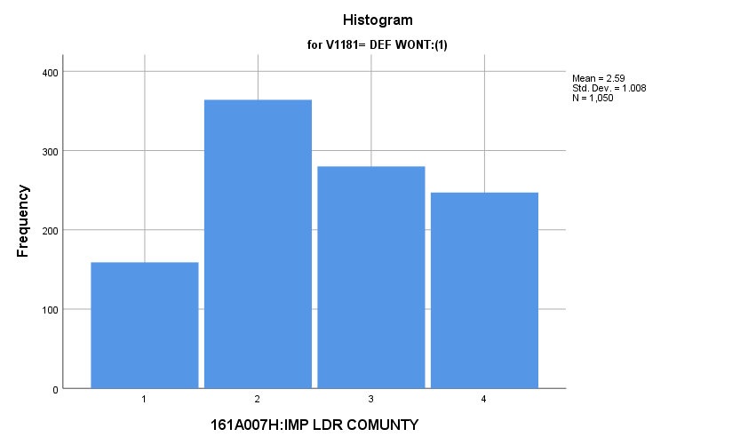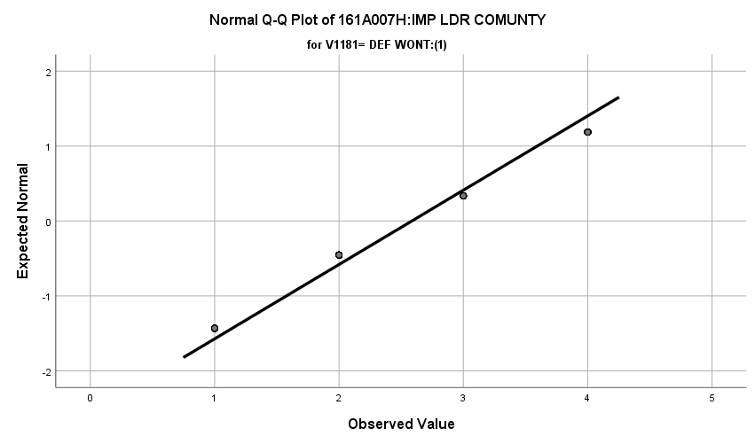

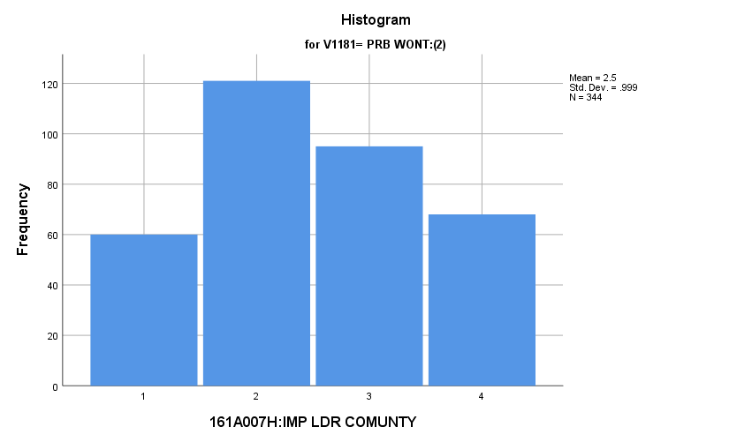

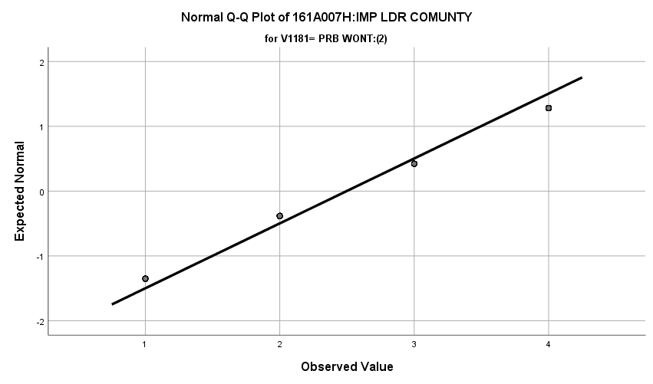

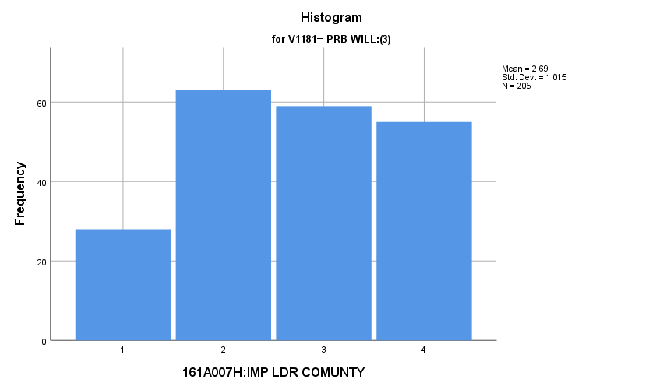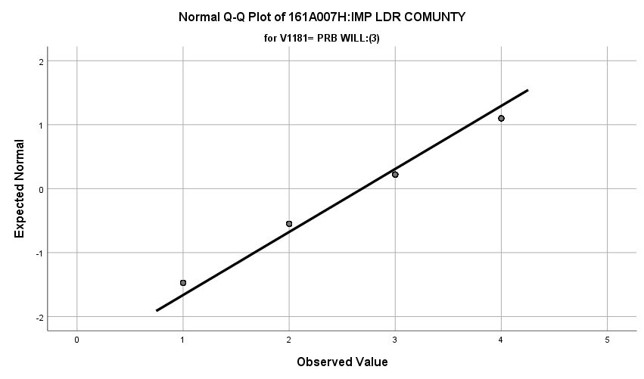

**Exhibit : Descriptives**

|  |  |  |  |  |  |
| --- | --- | --- | --- | --- | --- |
| ***Descriptives*** | | | | | |
|  | V1181 | | | Statistic | Std. Error |
| V1662 | DEF WONT:(1) | Mean | | **2.59** | **.031** |
| 99% Confidence Interval for Mean | Lower Bound | **2.51** |  |
| Upper Bound | **2.67** |  |
| 5% Trimmed Mean | | **2.60** |  |
| Median | | **3.00** |  |
| Variance | | **1.017** |  |
| Std. Deviation | | **1.008** |  |
| Minimum | | **1** |  |
| Maximum | | **4** |  |
| Range | | **3** |  |
| Interquartile Range | | **1** |  |
| Skewness | | **.011** | **.075** |
| Kurtosis | | **-1.113** | **.151** |
| PRB WONT:(2) | Mean | | **2.50** | **.054** |
| 99% Confidence Interval for Mean | Lower Bound | **2.36** |  |
| Upper Bound | **2.64** |  |
| 5% Trimmed Mean | | **2.50** |  |
| Median | | **2.00** |  |
| Variance | | **.997** |  |
| Std. Deviation | | **.999** |  |
| Minimum | | **1** |  |
| Maximum | | **4** |  |
| Range | | **3** |  |
| Interquartile Range | | **1** |  |
| Skewness | | **.079** | **.131** |
| Kurtosis | | **-1.051** | **.262** |
| PRB WILL:(3) | Mean | | **2.69** | **.071** |
| 99% Confidence Interval for Mean | Lower Bound | **2.50** |  |
| Upper Bound | **2.87** |  |
| 5% Trimmed Mean | | **2.71** |  |
| Median | | **3.00** |  |
| Variance | | **1.030** |  |
| Std. Deviation | | **1.015** |  |
| Minimum | | **1** |  |
| Maximum | | **4** |  |
| Range | | **3** |  |
| Interquartile Range | | **2** |  |
| Skewness | | **-.138** | **.170** |
| Kurtosis | | **-1.116** | **.338** |

**Exhibit : One-Way ANOVA and Homogeneity**

|  |  |  |  |  |  |
| --- | --- | --- | --- | --- | --- |
| ***Test of Homogeneity of Variances*** | | | | | |
|  | | Levene Statistic | df1 | df2 | Sig. |
| V1662 | Based on Mean | **.116** | **2** | **1596** | **.891** |
| Based on Median | **.597** | **2** | **1596** | **.550** |
| Based on Median and with adjusted df | **.597** | **2** | **1574.629** | **.550** |
| Based on trimmed mean | **.115** | **2** | **1596** | **.891** |

|  |  |  |  |  |  |
| --- | --- | --- | --- | --- | --- |
| ***ANOVA*** | | | | | |
| V1662 | | | | | |
|  | Sum of Squares | df | Mean Square | F | Sig. |
| Between Groups | **4.781** | **2** | **2.391** | **2.357** | **.095** |
| Within Groups | **1618.802** | **1596** | **1.014** |  |  |
| Total | **1623.583** | **1598** |  |  |  |

**Importance of Living Close to Parents:** Among the three groups in the sample, how do they differ regarding how important they thought it was to live close to their parents?

**Variables Used:** The **dependent** **variable** used in the analysis was the importance of living close to their parents (1=not important, 2=somewhat important, 3= quite important, 4= extremely important) and the **independent (grouping) variable** used was the pool of respondents. The respondent pool is broken into three categories:

* Non-recruits (students who say they definitely will not serve in the military after high school graduation) --- these are labeled as *definitely won’t (1).*
* Recruits (students who say they definitely or probably will serve in the military) --- these are labeled as *probably will (3).*
* Potential recruits (those who say they probably will not serve) --- these are labeled as *probably won’t (2)*.
* The desired pool of recruits is those labeled as probably won’t.
* Total respondents: 1593, range for all groups 1 to 4

**Analysis Procedure:**

* A one-way ANOVA test was utilized to compare how the potential pool of recruits differs by the importance of being a leader in the community.
* The analysis variable of importance of being a leader in the community is interval and the grouping variables are mutually exclusive.
* Prior to analysis, a histogram and Q-Q plots were inspected for outliers, none were present. Each group had a positive skew and was less than 2.
* The homogeneity of variances assumption was tested. The assumption was not met but group sizes were approximately the same.
* Three post hoc tests were requested because of there was significant difference among the three groups regarding where the respondent lived. A Games-Howell post hoc was used due to unequal group sizes.
* Eta was calculated to assess effect size.

**Results:**

* Null and alternative hypothesis:
  + Main Test
    - H0 : µ1 = µ2 = µ3
    - Ha : ALOI
  + Post Hoc (1 and 2)
    - H0 : µ1 = µ2
    - Ha : µ1 ≠ µ2
  + Post Hoc (1 and 3)
    - H0 : µ1 = µ3
    - Ha : µ1 ≠ µ3
  + Post Hoc (2 and 3)
    - H0 : µ2 = µ3
    - Ha : µ2 ≠ µ3
* Calculated F value: f(where respondent lives) 7.021, dfnum= 2, dfden= 1590, α = 0.01, reject H0; eta = 0.094

**Interpretation:** There was no significant difference in means in the following categories regarding the importance of living close to parents:

* Definitely won’t and probably will.
* Probably won’t and probably will.

There was a significant difference in means between probably won’t (2.42) and definitely won’t (2.62) regarding the importance of living close to parents. 0.9% of the variation in the importance score of living close to parents was explained by which respondent pool the individual is in.

**Supporting Analysis:**

**Exhibit : Histograms**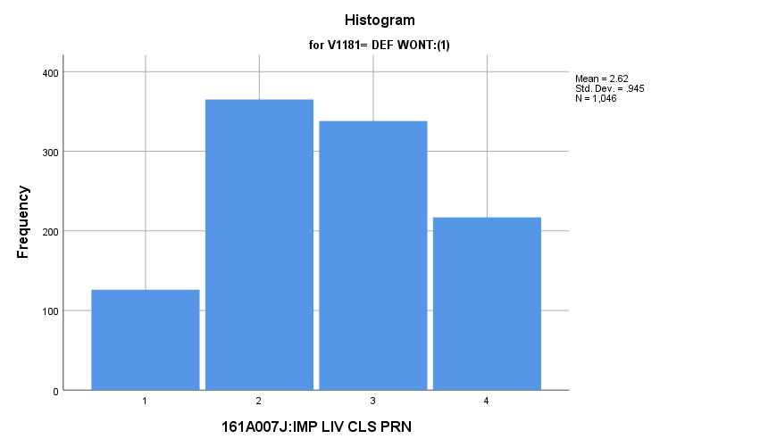

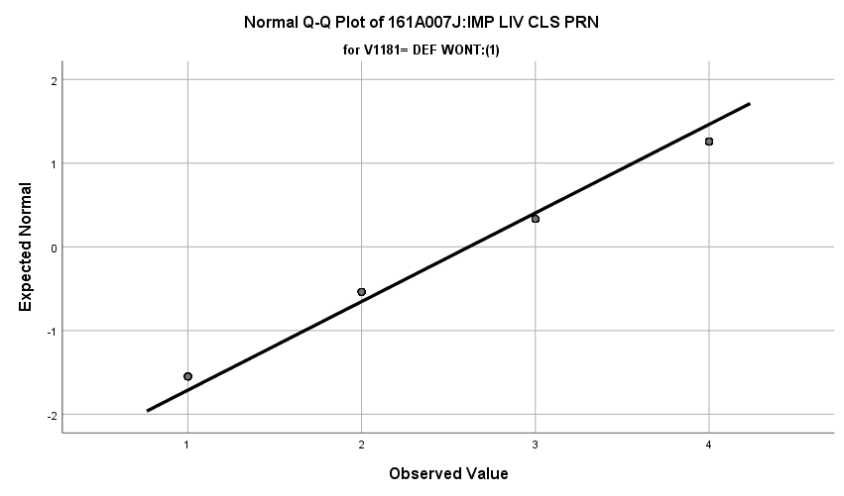

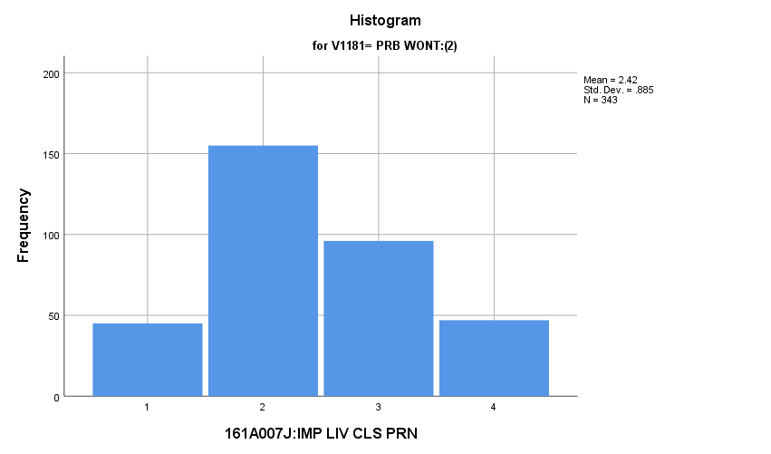

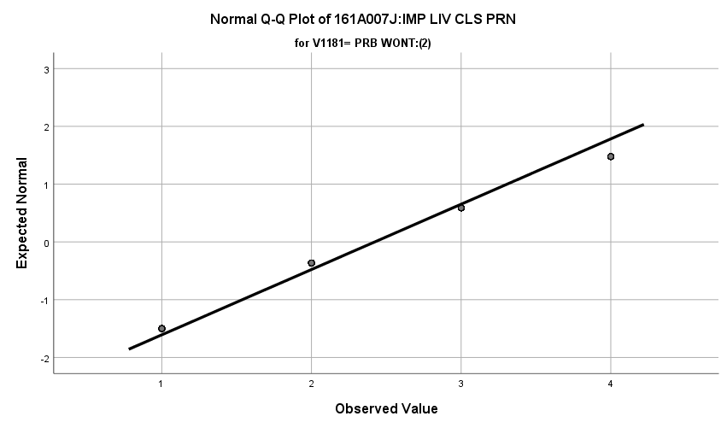

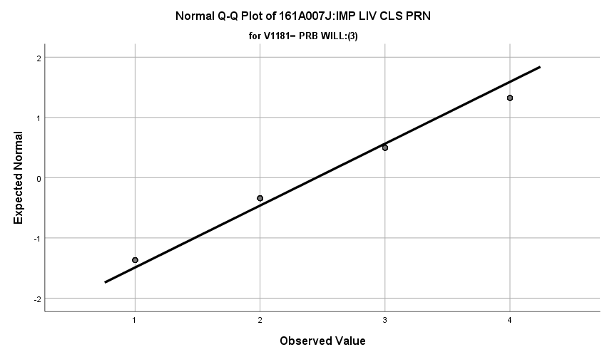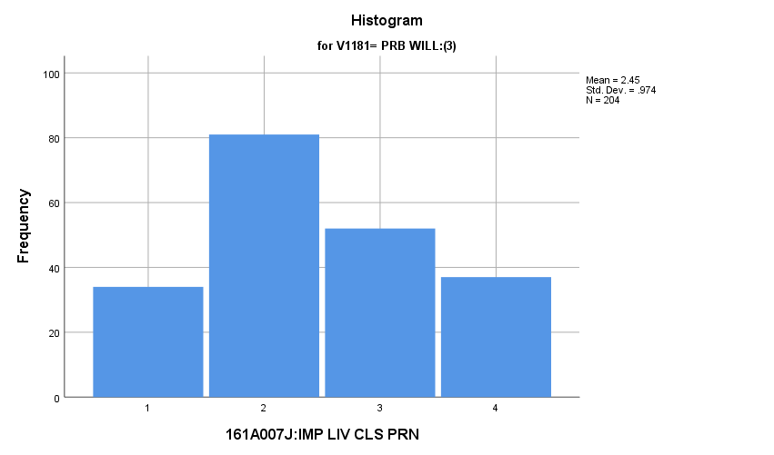

**Exhibit : Descriptives**

|  |  |  |  |  |  |
| --- | --- | --- | --- | --- | --- |
| ***Descriptives*** | | | | | |
|  | V1181 | | | Statistic | Std. Error |
| V1664 | DEF WONT:(1) | Mean | | **2.62** | **.029** |
| 99% Confidence Interval for Mean | Lower Bound | **2.54** |  |
| Upper Bound | **2.69** |  |
| 5% Trimmed Mean | | **2.63** |  |
| Median | | **3.00** |  |
| Variance | | **.893** |  |
| Std. Deviation | | **.945** |  |
| Minimum | | **1** |  |
| Maximum | | **4** |  |
| Range | | **3** |  |
| Interquartile Range | | **1** |  |
| Skewness | | **-.031** | **.076** |
| Kurtosis | | **-.938** | **.151** |
| PRB WONT:(2) | Mean | | **2.42** | **.048** |
| 99% Confidence Interval for Mean | Lower Bound | **2.30** |  |
| Upper Bound | **2.55** |  |
| 5% Trimmed Mean | | **2.41** |  |
| Median | | **2.00** |  |
| Variance | | **.783** |  |
| Std. Deviation | | **.885** |  |
| Minimum | | **1** |  |
| Maximum | | **4** |  |
| Range | | **3** |  |
| Interquartile Range | | **1** |  |
| Skewness | | **.262** | **.132** |
| Kurtosis | | **-.643** | **.263** |
| PRB WILL:(3) | Mean | | **2.45** | **.068** |
| 99% Confidence Interval for Mean | Lower Bound | **2.27** |  |
| Upper Bound | **2.63** |  |
| 5% Trimmed Mean | | **2.45** |  |
| Median | | **2.00** |  |
| Variance | | **.948** |  |
| Std. Deviation | | **.974** |  |
| Minimum | | **1** |  |
| Maximum | | **4** |  |
| Range | | **3** |  |
| Interquartile Range | | **1** |  |
| Skewness | | **.188** | **.170** |
| Kurtosis | | **-.947** | **.339** |

**Exhibit: Means Table**

|  |  |  |  |
| --- | --- | --- | --- |
| ***Report*** | | | |
| V1664 | | | |
| V1181 | Mean | N | Std. Deviation |
| DEF WONT:(1) | **2.62** | **1046** | **.945** |
| PRB WONT:(2) | **2.42** | **343** | **.885** |
| PRB WILL:(3) | **2.45** | **204** | **.974** |
| Total | **2.55** | **1593** | **.940** |

**Exhibit: One-Way ANOVA and Homogeneity**

|  |  |  |  |  |  |
| --- | --- | --- | --- | --- | --- |
| ***Test of Homogeneity of Variances*** | | | | | |
|  | | Levene Statistic | df1 | df2 | Sig. |
| V1664 | Based on Mean | **3.078** | **2** | **1590** | **.046** |
| Based on Median | **3.749** | **2** | **1590** | **.024** |
| Based on Median and with adjusted df | **3.749** | **2** | **1568.743** | **.024** |
| Based on trimmed mean | **3.112** | **2** | **1590** | **.045** |

|  |  |  |  |  |  |
| --- | --- | --- | --- | --- | --- |
| ***ANOVA*** | | | | | |
| V1664 | | | | | |
|  | Sum of Squares | df | Mean Square | F | Sig. |
| Between Groups | **12.304** | **2** | **6.152** | **7.021** | **.001** |
| Within Groups | **1393.249** | **1590** | **.876** |  |  |
| Total | **1405.553** | **1592** |  |  |  |

**Exhibit: Effect Size**

|  |  |  |  |  |  |
| --- | --- | --- | --- | --- | --- |
| ***ANOVA*** | | | | | |
| V1664 | | | | | |
|  | Sum of Squares | df | Mean Square | F | Sig. |
| Between Groups | **12.304** | **2** | **6.152** | **7.021** | **.001** |
| Within Groups | **1393.249** | **1590** | **.876** |  |  |
| Total | **1405.553** | **1592** |  |  |  |

**Exhibit: Post Hocs**

|  |  |  |  |  |  |  |
| --- | --- | --- | --- | --- | --- | --- |
| ***Multiple Comparisons*** | | | | | | |
| Dependent Variable: V1664 | | | | | | |
| Games-Howell | | | | | | |
| (I) V1181 | (J) V1181 | Mean Difference (I-J) | Std. Error | Sig. | 99% Confidence Interval | |
| Lower Bound | Upper Bound |
| DEF WONT:(1) | PRB WONT:(2) | **.195\*** | **.056** | **.002** | **.03** | **.36** |
| PRB WILL:(3) | **.167** | **.074** | **.065** | **-.05** | **.38** |
| PRB WONT:(2) | DEF WONT:(1) | **-.195\*** | **.056** | **.002** | **-.36** | **-.03** |
| PRB WILL:(3) | **-.028** | **.083** | **.939** | **-.27** | **.22** |
| PRB WILL:(3) | DEF WONT:(1) | **-.167** | **.074** | **.065** | **-.38** | **.05** |
| PRB WONT:(2) | **.028** | **.083** | **.939** | **-.22** | **.27** |
| *. The mean difference is significant at the 0.01 level. | | | | | | |

**Importance of Getting Away from this Area of the Country:** Among the three groups in the sample, how do they differ regarding how important they thought it was get away from this area of the country?

**Variables Used:** The **dependent** **variable** used in the analysis was the importance getting away from this area of the country (1=not important, 2=somewhat important, 3= quite important, 4= extremely important) and the **independent (grouping) variable** used was the pool of respondents. The respondent pool is broken into three categories:

* Non-recruits (students who say they definitely will not serve in the military after high school graduation) --- these are labeled as *definitely won’t (1).*
* Recruits (students who say they definitely or probably will serve in the military) --- these are labeled as *probably will (3).*
* Potential recruits (those who say they probably will not serve) --- these are labeled as *probably won’t (2)*.
* The desired pool of recruits is those labeled as probably won’t.
* Total respondents: 1598, range for all groups 1 to 4

**Analysis Procedure:**

* A one-way ANOVA test was utilized to compare how the potential pool of recruits differs by the importance of getting away from this area of the country.
* The analysis variable of importance getting away from this area of the country is interval and the grouping variables are mutually exclusive.
* Prior to analysis, a histogram and Q-Q plots were inspected for outliers, none were present. Each group had a positive skew and was less than 2.
* The homogeneity of variances assumption was tested. The assumption was met.
* Three post hoc tests were requested because of there was significant difference among the three groups regarding where the respondent lived. A Games-Howell post hoc was used due to unequal group sizes.
* Eta was calculated to assess effect size.

**Results:**

* Null and alternative hypothesis:
  + Main Test
    - H0 : µ1 = µ2 = µ3
    - Ha : ALOI
  + Post Hoc (1 and 2)
    - H0 : µ1 = µ2
    - Ha : µ1 ≠ µ2
  + Post Hoc (1 and 3)
    - H0 : µ1 = µ3
    - Ha : µ1 ≠ µ3
  + Post Hoc (2 and 3)
    - H0 : µ2 = µ3
    - Ha : µ2 ≠ µ3
* Calculated F value: f(getting away from this area of the country) 7.021, dfnum= 2, dfden= 1595, α = 0.01, reject H0; eta = 0.114

**Interpretation:** There was no significant difference in the means between the groups of definitely won’t and probably won’t regarding the importance of getting away from this area of the country. There was a significant difference the means in the following categories regarding the importance of getting away from this area of the country:

* Probably won’t (1.97) and probably will (2.38).
* Probably will (2.38) and definitely won’t (2.04).

1.3% of the variation in the importance score of getting away from this area of the country was explained by which respondent pool the individual is in.

**Supporting Analysis:**

**Exhibit : Preliminary Analysis**

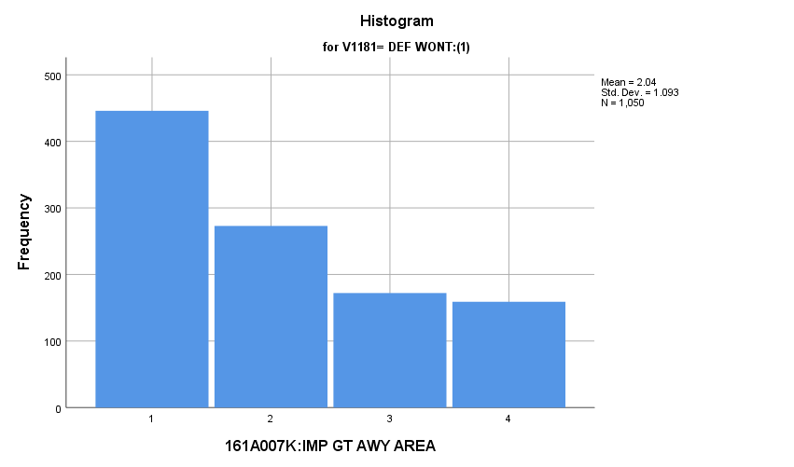

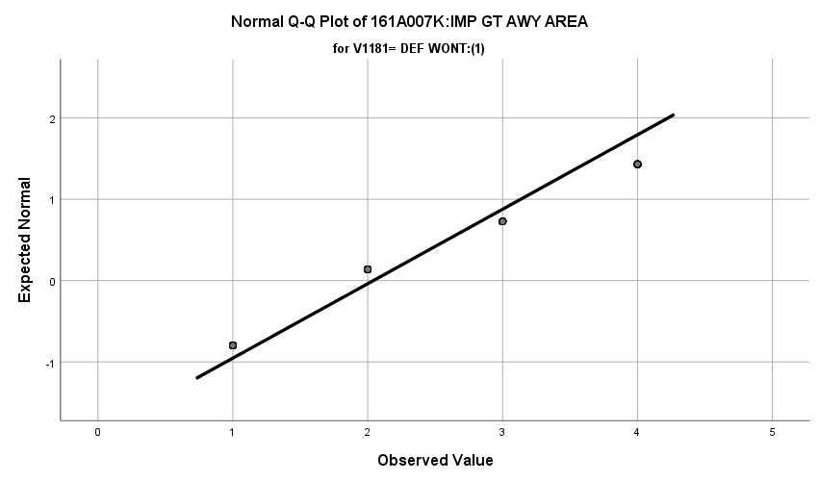

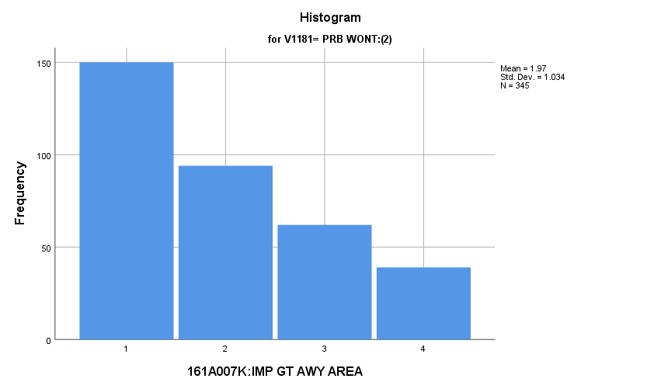

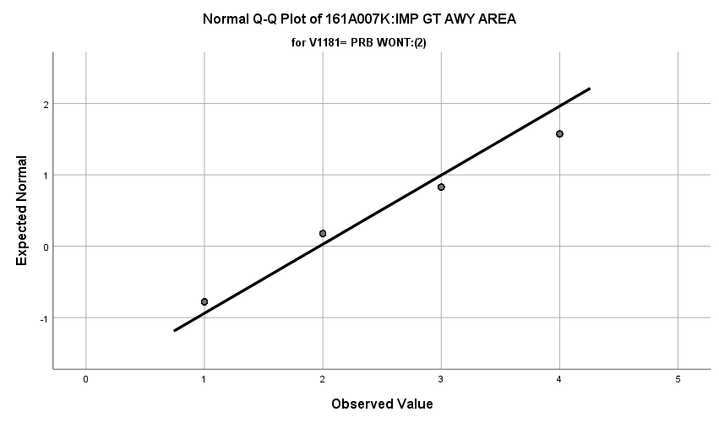

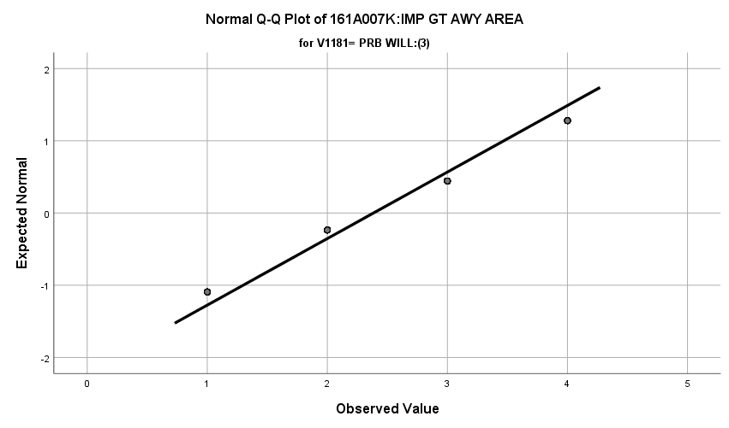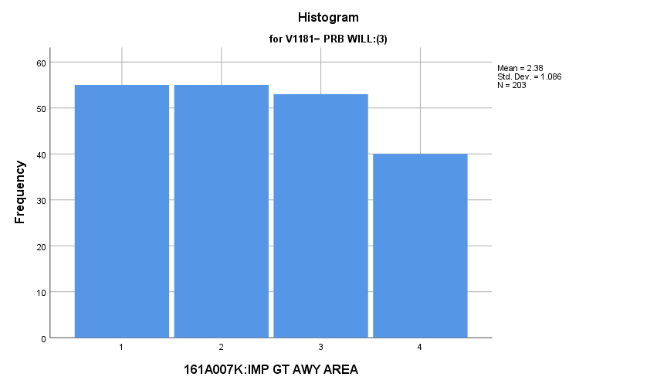

**Exhibit : Descriptives**

|  |  |  |  |  |  |
| --- | --- | --- | --- | --- | --- |
| ***Descriptives*** | | | | | |
|  | V1181 | | | Statistic | Std. Error |
| V1665 | DEF WONT:(1) | Mean | | **2.04** | **.034** |
| 99% Confidence Interval for Mean | Lower Bound | **1.95** |  |
| Upper Bound | **2.13** |  |
| 5% Trimmed Mean | | **1.99** |  |
| Median | | **2.00** |  |
| Variance | | **1.194** |  |
| Std. Deviation | | **1.093** |  |
| Minimum | | **1** |  |
| Maximum | | **4** |  |
| Range | | **3** |  |
| Interquartile Range | | **2** |  |
| Skewness | | **.616** | **.075** |
| Kurtosis | | **-.985** | **.151** |
| PRB WONT:(2) | Mean | | **1.97** | **.056** |
| 99% Confidence Interval for Mean | Lower Bound | **1.83** |  |
| Upper Bound | **2.12** |  |
| 5% Trimmed Mean | | **1.91** |  |
| Median | | **2.00** |  |
| Variance | | **1.069** |  |
| Std. Deviation | | **1.034** |  |
| Minimum | | **1** |  |
| Maximum | | **4** |  |
| Range | | **3** |  |
| Interquartile Range | | **2** |  |
| Skewness | | **.677** | **.131** |
| Kurtosis | | **-.790** | **.262** |
| PRB WILL:(3) | Mean | | **2.38** | **.076** |
| 99% Confidence Interval for Mean | Lower Bound | **2.19** |  |
| Upper Bound | **2.58** |  |
| 5% Trimmed Mean | | **2.37** |  |
| Median | | **2.00** |  |
| Variance | | **1.178** |  |
| Std. Deviation | | **1.086** |  |
| Minimum | | **1** |  |
| Maximum | | **4** |  |
| Range | | **3** |  |
| Interquartile Range | | **2** |  |
| Skewness | | **.125** | **.171** |
| Kurtosis | | **-1.270** | **.340** |

**Exhibit: Means Table**

|  |  |  |  |
| --- | --- | --- | --- |
| ***Report*** | | | |
| V1665 | | | |
| V1181 | Mean | N | Std. Deviation |
| DEF WONT:(1) | **2.04** | **1050** | **1.093** |
| PRB WONT:(2) | **1.97** | **345** | **1.034** |
| PRB WILL:(3) | **2.38** | **203** | **1.086** |
| Total | **2.07** | **1598** | **1.086** |

**Exhibit: One-Way ANOVA and Homogeneity**

|  |  |  |  |  |  |
| --- | --- | --- | --- | --- | --- |
| ***Test of Homogeneity of Variances*** | | | | | |
|  | | Levene Statistic | df1 | df2 | Sig. |
| V1665 | Based on Mean | **2.566** | **2** | **1595** | **.077** |
| Based on Median | **1.334** | **2** | **1595** | **.264** |
| Based on Median and with adjusted df | **1.334** | **2** | **1586.489** | **.264** |
| Based on trimmed mean | **1.918** | **2** | **1595** | **.147** |

|  |  |  |  |  |  |
| --- | --- | --- | --- | --- | --- |
| ***ANOVA*** | | | | | |
| V1665 | | | | | |
|  | Sum of Squares | df | Mean Square | F | Sig. |
| Between Groups | **24.254** | **2** | **12.127** | **10.411** | **.000** |
| Within Groups | **1857.896** | **1595** | **1.165** |  |  |
| Total | **1882.150** | **1597** |  |  |  |

**Exhibit: Effect Size**

|  |  |  |
| --- | --- | --- |
| ***Measures of Association*** | | |
|  | Eta | Eta Squared |
| V1665 * V1181 | **.114** | **.013** |

**Exhibit: Post Hoc**

|  |  |  |  |  |  |  |
| --- | --- | --- | --- | --- | --- | --- |
| ***Multiple Comparisons*** | | | | | | |
| Dependent Variable: V1665 | | | | | | |
| Games-Howell | | | | | | |
| (I) V1181 | (J) V1181 | Mean Difference (I-J) | Std. Error | Sig. | 99% Confidence Interval | |
| Lower Bound | Upper Bound |
| DEF WONT:(1) | PRB WONT:(2) | **.071** | **.065** | **.521** | **-.12** | **.26** |
| PRB WILL:(3) | **-.342\*** | **.083** | **.000** | **-.59** | **-.10** |
| PRB WONT:(2) | DEF WONT:(1) | **-.071** | **.065** | **.521** | **-.26** | **.12** |
| PRB WILL:(3) | **-.413\*** | **.094** | **.000** | **-.69** | **-.14** |
| PRB WILL:(3) | DEF WONT:(1) | **.342\*** | **.083** | **.000** | **.10** | **.59** |
| PRB WONT:(2) | **.413\*** | **.094** | **.000** | **.14** | **.69** |
| *. The mean difference is significant at the 0.01 level. | | | | | | |

**Importance of Finding Purpose in Life:** Among the three groups in the sample, how do they differ regarding how important they thought finding purpose in life was?

**Variables Used:** The **dependent** **variable** used in the analysis was the importance of finding purpose in life (1=not important, 2=somewhat important, 3= quite important, 4= extremely important) and the **independent (grouping) variable** used was the pool of respondents. The respondent pool is broken into three categories:

* Non-recruits (students who say they definitely will not serve in the military after high school graduation) --- these are labeled as *definitely won’t (1).*
* Recruits (students who say they definitely or probably will serve in the military) --- these are labeled as *probably will (3).*
* Potential recruits (those who say they probably will not serve) --- these are labeled as *probably won’t (2)*.
* The desired pool of recruits is those labeled as probably won’t.
* Total respondents: 1600, range for all groups 1 to 4

**Analysis Procedure:**

* A one-way ANOVA test was utilized to compare how the potential pool of recruits differs by the importance of finding purpose in life
* The analysis variable of importance of finding purpose in life is interval and the grouping variables are mutually exclusive.
* Prior to analysis, a histogram and Q-Q plots were inspected for outliers, none were present. Each group had a positive skew and was less than 2.
* The homogeneity of variances assumption was tested. The assumption was not met but the group sizes are approximately equal.
* Three post hoc tests were requested because of there was significant difference among the three groups regarding where the respondent lived. A Games-Howell post hoc was used due to unequal group sizes.
* Eta was calculated to assess effect size.

**Results:**

* Null and alternative hypothesis:
  + Main Test
    - H0 : µ1 = µ2 = µ3
    - Ha : ALOI
  + Post Hoc (1 and 2)
    - H0 : µ1 = µ2
    - Ha : µ1 ≠ µ2
  + Post Hoc (1 and 3)
    - H0 : µ1 = µ3
    - Ha : µ1 ≠ µ3
  + Post Hoc (2 and 3)
    - H0 : µ2 = µ3
    - Ha : µ2 ≠ µ3
* Calculated F value: f(importance of finding purpose in life) 5.184, dfnum= 2, dfden= 1600, α = 0.01, reject H0; eta = 0.080

**Interpretation:** There was a significant difference among the groups regarding their view of the importance of finding purpose in life. However, none of the post hoc tests showed significance in the pairwise testing.

* Probably won’t (3.54)
* Definitely won’t (3.59)
* Probably will (3.41)

One could observe a difference in probably will and definitely won’t but that is only an eyeball test and can be seen in the means graph under the means table exhibit. 0.64% of the variation in importance of finding purpose in life was explained by which respondent pool the individual is in.

**Supporting Analysis:**

**Exhibit : Preliminary Analysis**

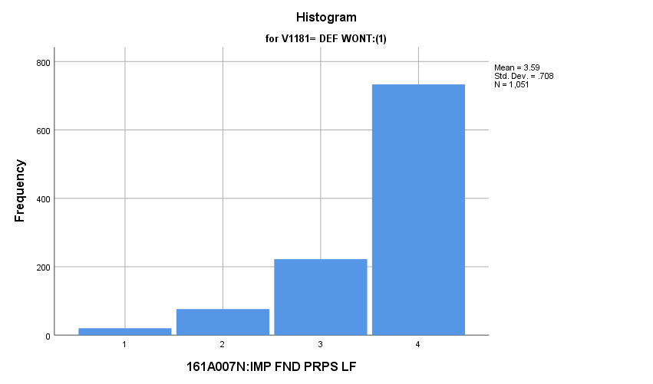

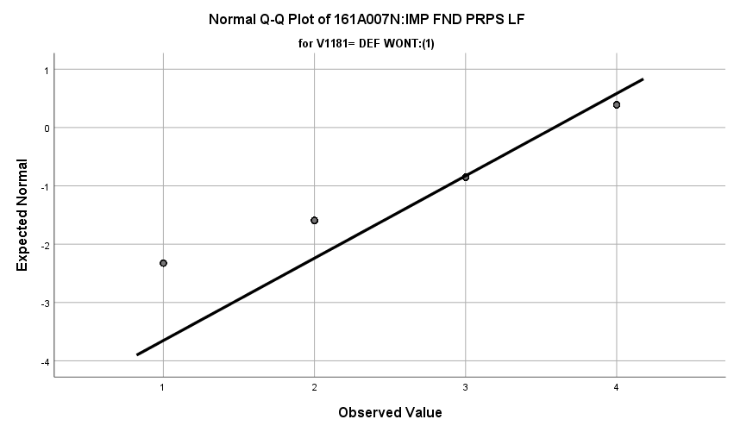

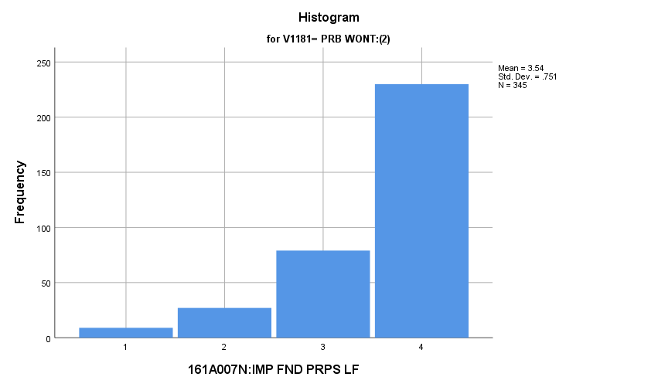

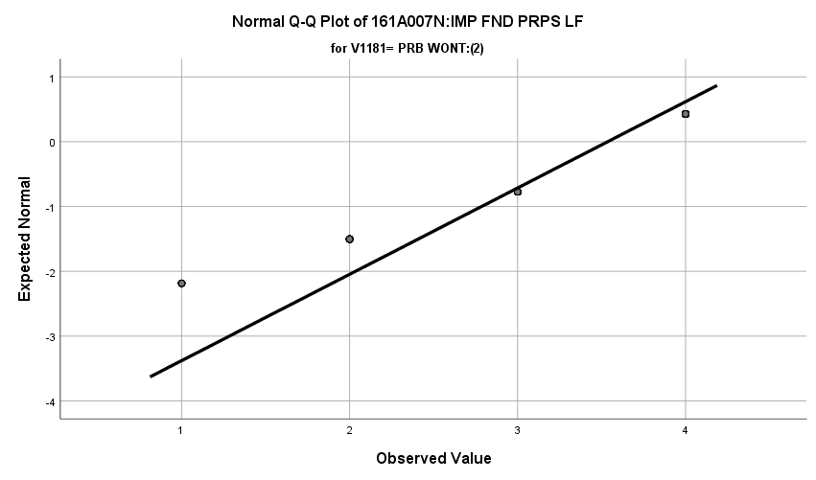

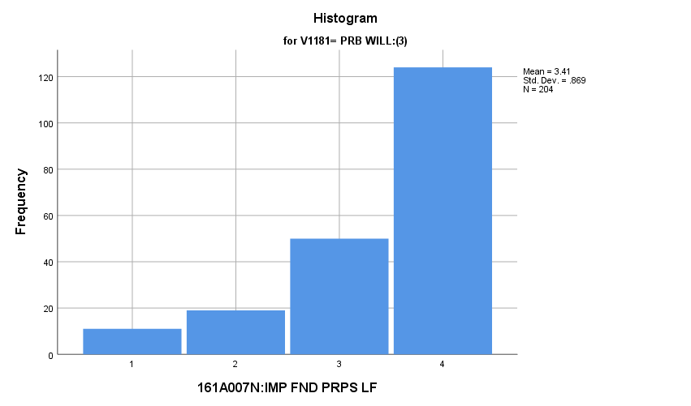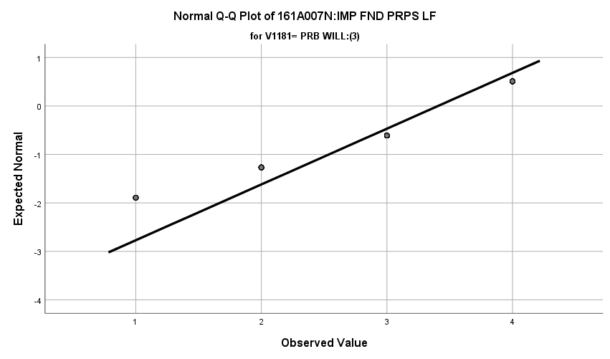

**Exhibit : Descriptives**

|  |  |  |  |  |  |
| --- | --- | --- | --- | --- | --- |
| ***Descriptives*** | | | | | |
|  | V1181 | | | Statistic | Std. Error |
| V1668 | DEF WONT:(1) | Mean | | **3.59** | **.022** |
| 99% Confidence Interval for Mean | Lower Bound | **3.53** |  |
| Upper Bound | **3.64** |  |
| 5% Trimmed Mean | | **3.67** |  |
| Median | | **4.00** |  |
| Variance | | **.502** |  |
| Std. Deviation | | **.708** |  |
| Minimum | | **1** |  |
| Maximum | | **4** |  |
| Range | | **3** |  |
| Interquartile Range | | **1** |  |
| Skewness | | **-1.728** | **.075** |
| Kurtosis | | **2.417** | **.151** |
| PRB WONT:(2) | Mean | | **3.54** | **.040** |
| 99% Confidence Interval for Mean | Lower Bound | **3.43** |  |
| Upper Bound | **3.64** |  |
| 5% Trimmed Mean | | **3.62** |  |
| Median | | **4.00** |  |
| Variance | | **.563** |  |
| Std. Deviation | | **.751** |  |
| Minimum | | **1** |  |
| Maximum | | **4** |  |
| Range | | **3** |  |
| Interquartile Range | | **1** |  |
| Skewness | | **-1.618** | **.131** |
| Kurtosis | | **2.006** | **.262** |
| PRB WILL:(3) | Mean | | **3.41** | **.061** |
| 99% Confidence Interval for Mean | Lower Bound | **3.25** |  |
| Upper Bound | **3.57** |  |
| 5% Trimmed Mean | | **3.51** |  |
| Median | | **4.00** |  |
| Variance | | **.755** |  |
| Std. Deviation | | **.869** |  |
| Minimum | | **1** |  |
| Maximum | | **4** |  |
| Range | | **3** |  |
| Interquartile Range | | **1** |  |
| Skewness | | **-1.394** | **.170** |
| Kurtosis | | **1.054** | **.339** |

**Exhibit: Means Table**

|  |  |  |  |
| --- | --- | --- | --- |
| ***Report*** | | | |
| V1668 | | | |
| V1181 | Mean | N | Std. Deviation |
| DEF WONT:(1) | **3.59** | **1051** | **.708** |
| PRB WONT:(2) | **3.54** | **345** | **.751** |
| PRB WILL:(3) | **3.41** | **204** | **.869** |
| Total | **3.55** | **1600** | **.742** |

**Exhibit : One-Way ANOVA and Homogeneity**

|  |  |  |  |  |  |
| --- | --- | --- | --- | --- | --- |
| ***Test of Homogeneity of Variances*** | | | | | |
|  | | Levene Statistic | df1 | df2 | Sig. |
| V1668 | Based on Mean | **10.264** | **2** | **1597** | **.000** |
| Based on Median | **5.184** | **2** | **1597** | **.006** |
| Based on Median and with adjusted df | **5.184** | **2** | **1561.036** | **.006** |
| Based on trimmed mean | **9.710** | **2** | **1597** | **.000** |

|  |  |  |  |  |  |
| --- | --- | --- | --- | --- | --- |
| ***ANOVA*** | | | | | |
| V1668 | | | | | |
|  | Sum of Squares | df | Mean Square | F | Sig. |
| Between Groups | **5.673** | **2** | **2.836** | **5.184** | **.006** |
| Within Groups | **873.812** | **1597** | **.547** |  |  |
| Total | **879.484** | **1599** |  |  |  |

**Exhibit : Effect Size**

|  |  |  |
| --- | --- | --- |
| ***Measures of Association*** | | |
|  | Eta | Eta Squared |
| V1668 * V1181 | **.080** | **.006** |

**Exhibit : Post Hoc**

|  |  |  |  |  |  |  |
| --- | --- | --- | --- | --- | --- | --- |
| ***Multiple Comparisons*** | | | | | | |
| Dependent Variable: V1668 | | | | | | |
| Games-Howell | | | | | | |
| (I) V1181 | (J) V1181 | Mean Difference (I-J) | Std. Error | Sig. | 99% Confidence Interval | |
| Lower Bound | Upper Bound |
| DEF WONT:(1) | PRB WONT:(2) | **.051** | **.046** | **.510** | **-.08** | **.19** |
| PRB WILL:(3) | **.180** | **.065** | **.016** | **-.01** | **.37** |
| PRB WONT:(2) | DEF WONT:(1) | **-.051** | **.046** | **.510** | **-.19** | **.08** |
| PRB WILL:(3) | **.129** | **.073** | **.181** | **-.08** | **.34** |
| PRB WILL:(3) | DEF WONT:(1) | **-.180** | **.065** | **.016** | **-.37** | **.01** |
| PRB WONT:(2) | **-.129** | **.073** | **.181** | **-.34** | **.08** |

**Importance of Being Successful in Work:** Among potential recruits vs either recruits and non-recruits, how do they differ regarding the importance of being successful in their line of work?

**Variables Used:** The **dependent** **variable** used in the analysis was the importance of being successful in their line of work (1=not important, 2=somewhat important, 3= quite important, 4= extremely important) and the **independent (grouping) variable** used was the pool of respondents. The respondent pool is broken into three categories:

* Non-recruits (students who say they definitely will not serve in the military after high school graduation) --- these are labeled as *definitely won’t (1).*
* Recruits (students who say they definitely or probably will serve in the military) --- these are labeled as *probably will (3).*
* Potential recruits (those who say they probably will not serve) --- these are labeled as *probably won’t (2)*.
* The desired pool of recruits is those labeled as probably won’t.
* Total respondents: 1600, range for all groups 1 to 4 except potential recruits which ranged from 2 to 4.

**Analysis Procedure:**

* A one-way ANOVA test was utilized to compare how the potential pool of recruits differs by the importance of being successful in their line of work.
* The analysis variable of importance of importance of being successful in their line of work is interval and the grouping variables are mutually exclusive.
* Prior to analysis, a histogram and Q-Q plots were inspected for outliers, none were present. Each group had a negative skew less than 2.
* The homogeneity of variances assumption was tested. The assumption was not met but the group sizes are approximately the same.

**Results:**

* Null and alternative hypothesis:
  + Main Test
    - H0 : µ1 = µ2 = µ3
    - Ha : ALOI
* Calculated F value: f(importance of successful at work) 0.834, dfnum= 2, dfden= 1597, α = 0.01, fail to reject H0;

**Interpretation:** There was no significant difference in means between the three groups regarding the importance of being successful in their line of work.

**Supporting Analysis:**

**Exhibit: Preliminary Analysis:**

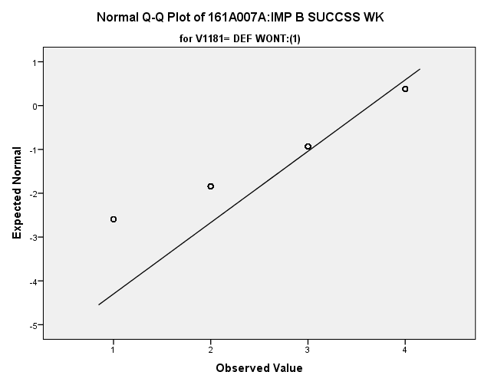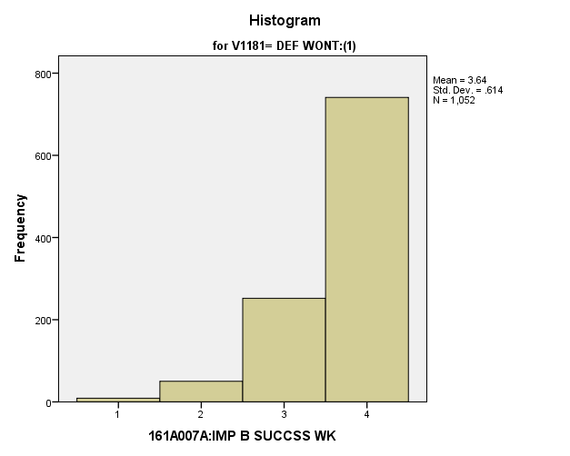

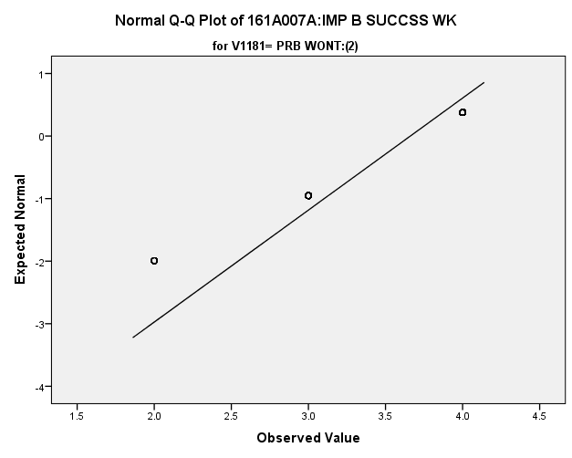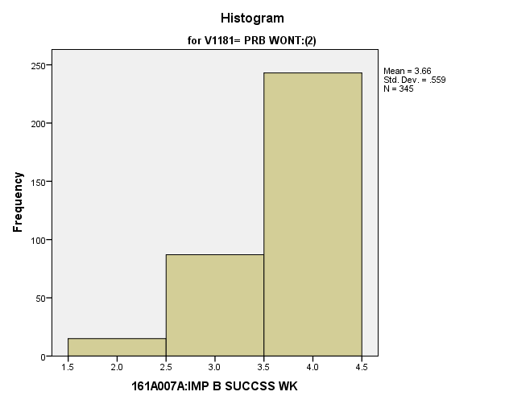

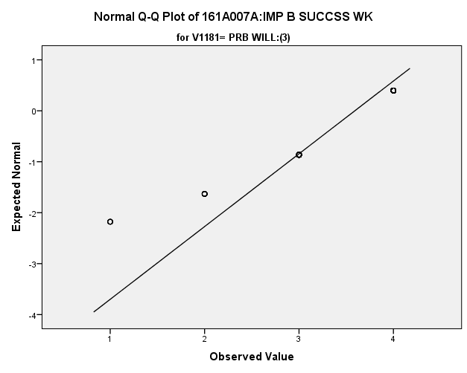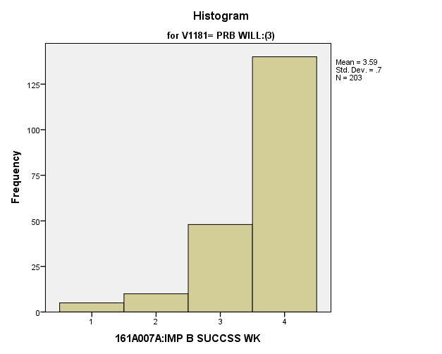

**Exhibit: Descriptives**

|  |  |  |  |  |  |
| --- | --- | --- | --- | --- | --- |
| ***Descriptives*** | | | | | |
|  | V1181 | | | Statistic | Std. Error |
| V1655 | DEF WONT:(1) | Mean | | **3.64** | **.019** |
| 99% Confidence Interval for Mean | Lower Bound | **3.59** |  |
| Upper Bound | **3.69** |  |
| 5% Trimmed Mean | | **3.72** |  |
| Median | | **4.00** |  |
| Variance | | **.377** |  |
| Std. Deviation | | **.614** |  |
| Minimum | | **1** |  |
| Maximum | | **4** |  |
| Range | | **3** |  |
| Interquartile Range | | **1** |  |
| Skewness | | **-1.717** | **.075** |
| Kurtosis | | **2.729** | **.151** |
| PRB WONT:(2) | Mean | | **3.66** | **.030** |
| 99% Confidence Interval for Mean | Lower Bound | **3.58** |  |
| Upper Bound | **3.74** |  |
| 5% Trimmed Mean | | **3.73** |  |
| Median | | **4.00** |  |
| Variance | | **.312** |  |
| Std. Deviation | | **.559** |  |
| Minimum | | **2** |  |
| Maximum | | **4** |  |
| Range | | **2** |  |
| Interquartile Range | | **1** |  |
| Skewness | | **-1.415** | **.131** |
| Kurtosis | | **1.045** | **.262** |
| PRB WILL:(3) | Mean | | **3.59** | **.049** |
| 99% Confidence Interval for Mean | Lower Bound | **3.46** |  |
| Upper Bound | **3.72** |  |
| 5% Trimmed Mean | | **3.68** |  |
| Median | | **4.00** |  |
| Variance | | **.490** |  |
| Std. Deviation | | **.700** |  |
| Minimum | | **1** |  |
| Maximum | | **4** |  |
| Range | | **3** |  |
| Interquartile Range | | **1** |  |
| Skewness | | **-1.858** | **.171** |
| Kurtosis | | **3.300** | **.340** |

**Exhibit: One Way ANOVA Table and Homogeneity Test**

|  |  |  |  |
| --- | --- | --- | --- |
| ***Test of Homogeneity of Variances*** | | | |
| V1655 | | | |
| Levene Statistic | df1 | df2 | Sig. |
| **4.030** | **2** | **1597** | **.018** |

|  |  |  |  |  |  |
| --- | --- | --- | --- | --- | --- |
| ***ANOVA*** | | | | | |
| V1655 | | | | | |
|  | Sum of Squares | df | Mean Square | F | Sig. |
| Between Groups | **.629** | **2** | **.315** | **.834** | **.435** |
| Within Groups | **602.845** | **1597** | **.377** |  |  |
| Total | **603.474** | **1599** |  |  |  |

**Importance of Having a Good Marriage and Family Life:** Among potential recruits vs either recruits and non-recruits, how do they differ regarding the importance of having a good marriage and family life?

**Variables Used:** The **dependent** **variable** used in the analysis was the importance of having a good marriage and family life (1=not important, 2=somewhat important, 3= quite important, 4= extremely important) and the **independent (grouping) variable** used was the pool of respondents. The respondent pool is broken into three categories:

* Non-recruits (students who say they definitely will not serve in the military after high school graduation) --- these are labeled as *definitely won’t (1).*
* Recruits (students who say they definitely or probably will serve in the military) --- these are labeled as *probably will (3).*
* Potential recruits (those who say they probably will not serve) --- these are labeled as *probably won’t (2)*.
* The desired pool of recruits is those labeled as probably won’t.
* Total respondents: 1600, range for all groups 1 to 4.

**Analysis Procedure:**

* A one-way ANOVA test was utilized to compare how the potential pool of recruits differs by the importance of having a good marriage and family life.
* The analysis variable of importance of importance of having a good marriage and family life is interval and the grouping variables are mutually exclusive.
* Prior to analysis, a histogram and Q-Q plots were inspected for outliers, none were present. Each group had a negative skew of less than 2.
* The homogeneity of variances assumption was tested. The assumption was not met but the group sizes are approximately the same.

**Results:**

* Null and alternative hypothesis:
  + Main Test
    - H0 : µ1 = µ2 = µ3
    - Ha : ALOI
* Calculated F value: f(importance of marriage and family) 3.710, dfnum= 2, dfden= 1597, α = 0.01, fail to reject H0;

**Interpretation:** There was no significant difference in means between the three groups regarding the importance of having a good marriage and family life.

**Supporting Analysis:**

**Exhibit: Preliminary Analysis**

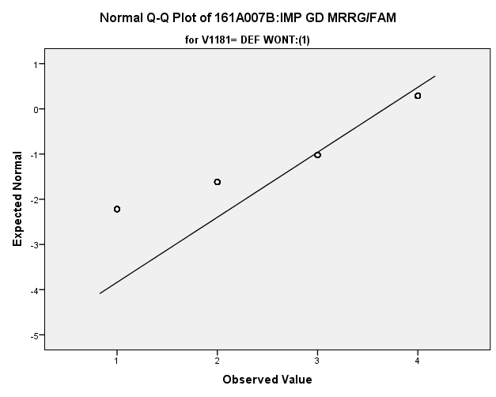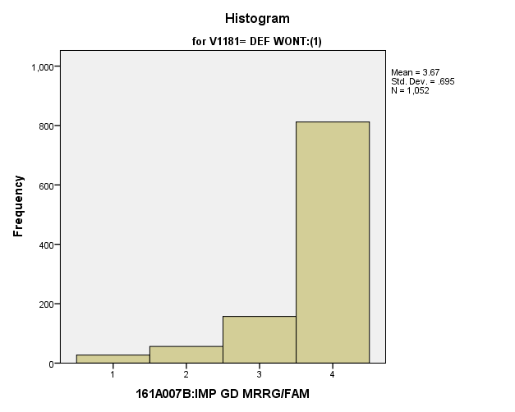

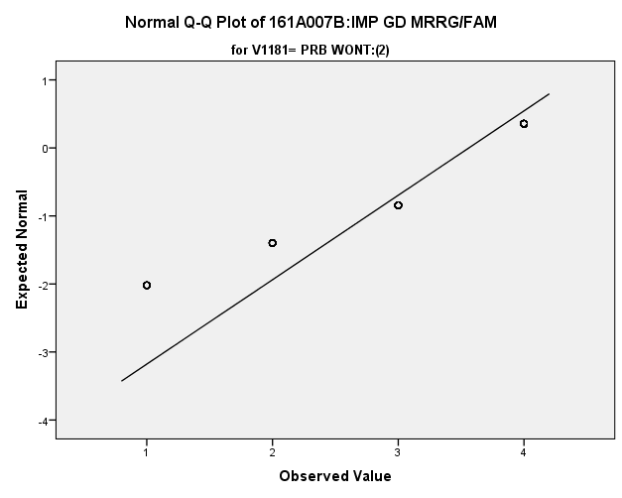

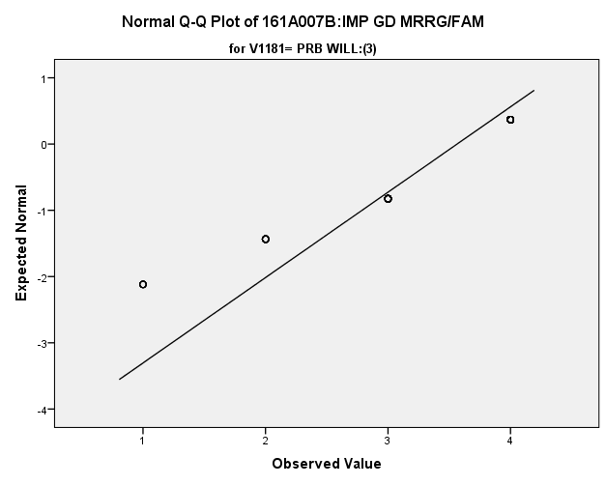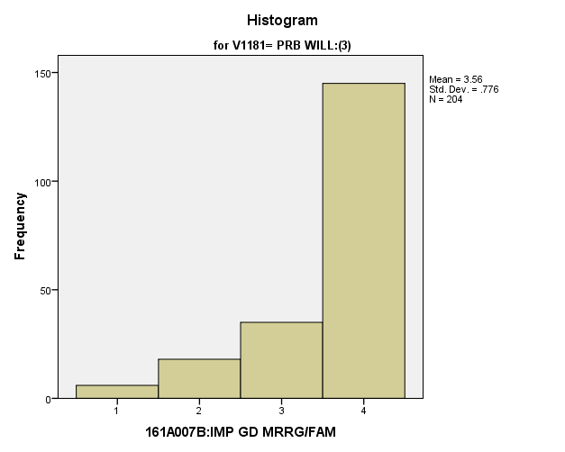

**Exhibit: Descriptives**

|  |  |  |  |  |  |
| --- | --- | --- | --- | --- | --- |
| ***Descriptives*** | | | | | |
|  | V1181 | | | Statistic | Std. Error |
| V1656 | DEF WONT:(1) | Mean | | **3.67** | **.021** |
| 99% Confidence Interval for Mean | Lower Bound | **3.61** |  |
| Upper Bound | **3.72** |  |
| 5% Trimmed Mean | | **3.77** |  |
| Median | | **4.00** |  |
| Variance | | **.483** |  |
| Std. Deviation | | **.695** |  |
| Minimum | | **1** |  |
| Maximum | | **4** |  |
| Range | | **3** |  |
| Interquartile Range | | **0** |  |
| Skewness | | **-2.240** | **.075** |
| Kurtosis | | **4.543** | **.151** |
| PRB WONT:(2) | Mean | | **3.56** | **.043** |
| 99% Confidence Interval for Mean | Lower Bound | **3.45** |  |
| Upper Bound | **3.67** |  |
| 5% Trimmed Mean | | **3.67** |  |
| Median | | **4.00** |  |
| Variance | | **.649** |  |
| Std. Deviation | | **.806** |  |
| Minimum | | **1** |  |
| Maximum | | **4** |  |
| Range | | **3** |  |
| Interquartile Range | | **1** |  |
| Skewness | | **-1.831** | **.131** |
| Kurtosis | | **2.443** | **.262** |
| PRB WILL:(3) | Mean | | **3.56** | **.054** |
| 99% Confidence Interval for Mean | Lower Bound | **3.42** |  |
| Upper Bound | **3.70** |  |
| 5% Trimmed Mean | | **3.66** |  |
| Median | | **4.00** |  |
| Variance | | **.602** |  |
| Std. Deviation | | **.776** |  |
| Minimum | | **1** |  |
| Maximum | | **4** |  |
| Range | | **3** |  |
| Interquartile Range | | **1** |  |
| Skewness | | **-1.749** | **.170** |
| Kurtosis | | **2.217** | **.339** |

**Exhibit: One Way ANOVA Table and Homogeneity**

|  |  |  |  |
| --- | --- | --- | --- |
| ***Test of Homogeneity of Variances*** | | | |
| V1656 | | | |
| Levene Statistic | df1 | df2 | Sig. |
| **10.577** | **2** | **1597** | **.000** |

|  |  |  |  |  |  |
| --- | --- | --- | --- | --- | --- |
| ***ANwOVA*** | | | | | |
| V1656 | | | | | |
|  | Sum of Squares | df | Mean Square | F | Sig. |
| Between Groups | **3.993** | **2** | **1.996** | **3.740** | **.024** |
| Within Groups | **852.445** | **1597** | **.534** |  |  |
| Total | **856.438** | **1599** |  |  |  |

**Importance of Having Plenty of Time for Recreation and Hobbies:** Among potential recruits vs either recruits and non-recruits, how do they differ regarding the importance of having plenty of time for recreation and hobbies?

**Variables Used:** The **dependent** **variable** used in the analysis was the importance of having plenty of time for recreation and hobbies (1=not important, 2=somewhat important, 3= quite important, 4= extremely important) and the **independent (grouping) variable** used was the pool of respondents. The respondent pool is broken into three categories:

* Non-recruits (students who say they definitely will not serve in the military after high school graduation) --- these are labeled as *definitely won’t (1).*
* Recruits (students who say they definitely or probably will serve in the military) --- these are labeled as *probably will (3).*
* Potential recruits (those who say they probably will not serve) --- these are labeled as *probably won’t (2)*.
* The desired pool of recruits is those labeled as probably won’t.
* Total respondents: 1600, range for all groups 1 to 4.

**Analysis Procedure:**

* A one-way ANOVA test was utilized to compare how the potential pool of recruits differs by the importance of having plenty of time for recreation and hobbies.
* The analysis variable of importance of importance of having plenty of time for recreation and hobbies is interval and the grouping variables are mutually exclusive.
* Prior to analysis, a histogram and Q-Q plots were inspected for outliers, none were present. Each group had a negative skew of less than 2.
* The homogeneity of variances assumption was tested. The assumption was met.

**Results:**

* Null and alternative hypothesis:
  + Main Test
    - H0 : µ1 = µ2 = µ3
    - Ha : ALOI
* Calculated F value: f(importance of Rec/Hobby time) 2.356, dfnum= 2, dfden= 1597, α = 0.01, fail to reject H0;

**Interpretation:** There was no significant difference in means between the three groups regarding the importance of plenty of time for recreation and hobbies.

**Supporting Analysis:**

**Exhibit: Preliminary Analysis**

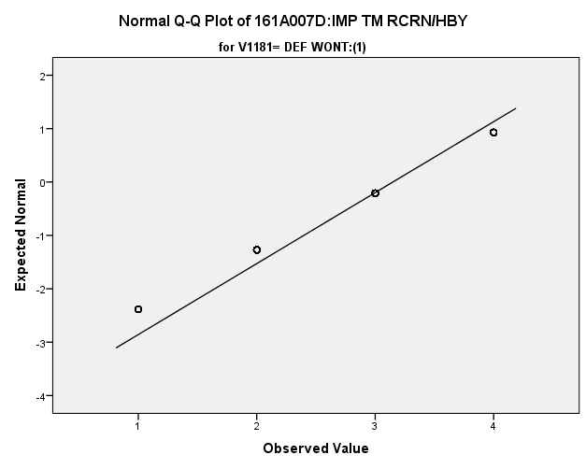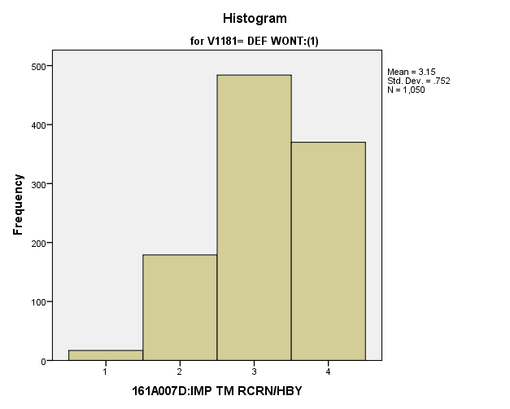

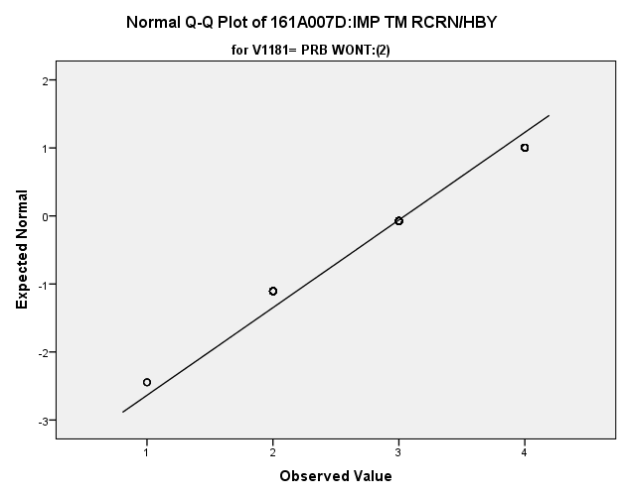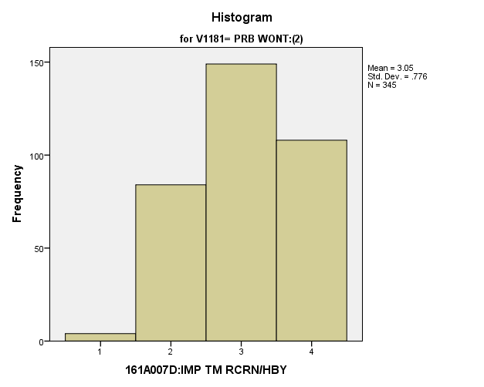

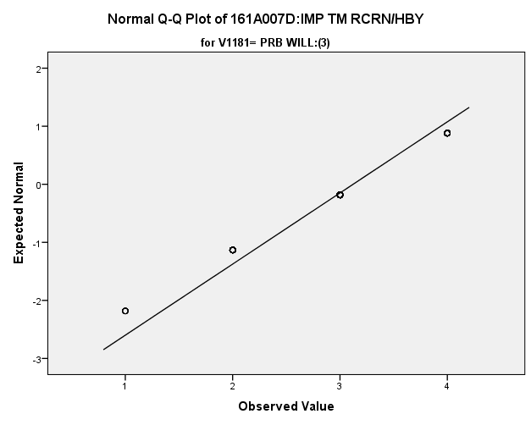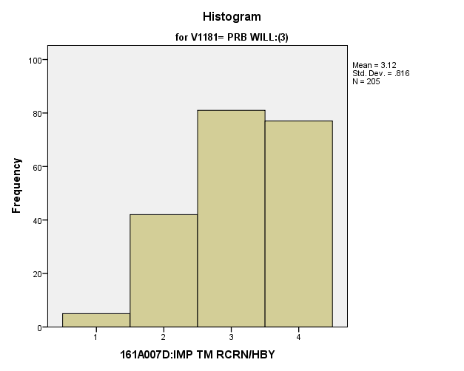

**Exhibit: Descriptives**

|  |  |  |  |  |  |
| --- | --- | --- | --- | --- | --- |
| ***Descriptives*** | | | | | |
|  | V1181 | | | Statistic | Std. Error |
| V1658 | DEF WONT:(1) | Mean | | **3.15** | **.023** |
| 99% Confidence Interval for Mean | Lower Bound | **3.09** |  |
| Upper Bound | **3.21** |  |
| 5% Trimmed Mean | | **3.18** |  |
| Median | | **3.00** |  |
| Variance | | **.566** |  |
| Std. Deviation | | **.752** |  |
| Minimum | | **1** |  |
| Maximum | | **4** |  |
| Range | | **3** |  |
| Interquartile Range | | **1** |  |
| Skewness | | **-.482** | **.075** |
| Kurtosis | | **-.405** | **.151** |
| PRB WONT:(2) | Mean | | **3.05** | **.042** |
| 99% Confidence Interval for Mean | Lower Bound | **2.94** |  |
| Upper Bound | **3.15** |  |
| 5% Trimmed Mean | | **3.06** |  |
| Median | | **3.00** |  |
| Variance | | **.602** |  |
| Std. Deviation | | **.776** |  |
| Minimum | | **1** |  |
| Maximum | | **4** |  |
| Range | | **3** |  |
| Interquartile Range | | **2** |  |
| Skewness | | **-.231** | **.131** |
| Kurtosis | | **-.906** | **.262** |
| PRB WILL:(3) | Mean | | **3.12** | **.057** |
| 99% Confidence Interval for Mean | Lower Bound | **2.97** |  |
| Upper Bound | **3.27** |  |
| 5% Trimmed Mean | | **3.16** |  |
| Median | | **3.00** |  |
| Variance | | **.666** |  |
| Std. Deviation | | **.816** |  |
| Minimum | | **1** |  |
| Maximum | | **4** |  |
| Range | | **3** |  |
| Interquartile Range | | **1** |  |
| Skewness | | **-.501** | **.170** |
| Kurtosis | | **-.615** | **.338** |

**Exhibit: One Way ANOVA Table and Homogeneity**

|  |  |  |  |
| --- | --- | --- | --- |
| ***Test of Homogeneity of Variances*** | | | |
| V1658 | | | |
| Levene Statistic | df1 | df2 | Sig. |
| **1.522** | **2** | **1597** | **.219** |

|  |  |  |  |  |  |
| --- | --- | --- | --- | --- | --- |
| ***ANOVA*** | | | | | |
| V1658 | | | | | |
|  | Sum of Squares | df | Mean Square | F | Sig. |
| Between Groups | **2.764** | **2** | **1.382** | **2.356** | **.095** |
| Within Groups | **936.734** | **1597** | **.587** |  |  |
| Total | **939.498** | **1599** |  |  |  |

**Importance of Giving My Children Better Opportunities:** Among potential recruits vs either recruits and non-recruits, how do they differ regarding the importance of being able to give my children better opportunities than they had?

**Variables Used:** The **dependent** **variable** used in the analysis was the importance of being able to give my children better opportunities than they had (1=not important, 2=somewhat important, 3= quite important, 4= extremely important) and the **independent (grouping) variable** used was the pool of respondents. The respondent pool is broken into three categories:

* Non-recruits (students who say they definitely will not serve in the military after high school graduation) --- these are labeled as *definitely won’t (1).*
* Recruits (students who say they definitely or probably will serve in the military) --- these are labeled as *probably will (3).*
* Potential recruits (those who say they probably will not serve) --- these are labeled as *probably won’t (2)*.
* The desired pool of recruits is those labeled as probably won’t.
* Total respondents: 1589, range for all groups 1 to 4.

**Analysis Procedure:**

* A one-way ANOVA test was utilized to compare how the potential pool of recruits differs by the importance of being able to give my children better opportunities than they had.
* The analysis variable of importance of importance of being able to give my children better opportunities than they had is interval and the grouping variables are mutually exclusive.
* Prior to analysis, a histogram and Q-Q plots were inspected for outliers, none were present. Each group had a negative skew of less than 2.
* The homogeneity of variances assumption was tested. The assumption was met.

**Results:**

* Null and alternative hypothesis:
  + Main Test
    - H0 : µ1 = µ2 = µ3
    - Ha : ALOI
* Calculated F value: f(importance of better child opportunities) 1.449, dfnum= 2, dfden= 1586, α = 0.01, fail to reject H0;

**Interpretation:** There was no significant difference in means between the three groups regarding the importance of being able to give my children better opportunities than they had.

**Supporting Analysis:**

**Exhibit: Preliminary Analysis**

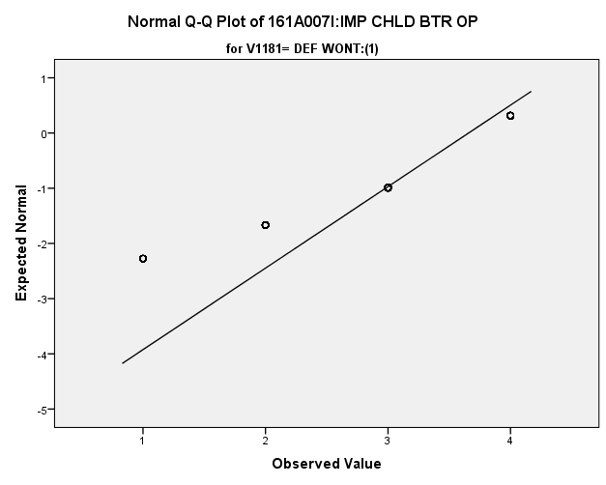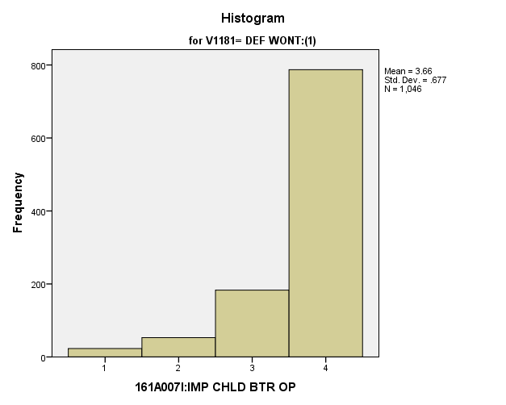

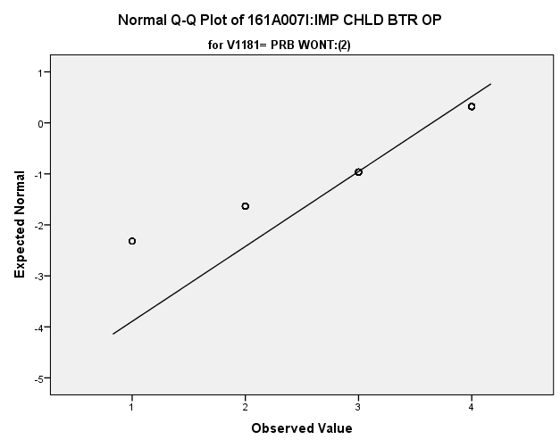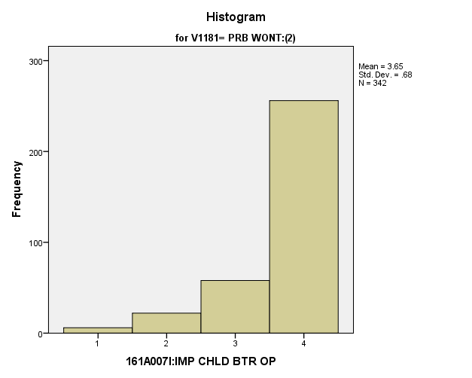

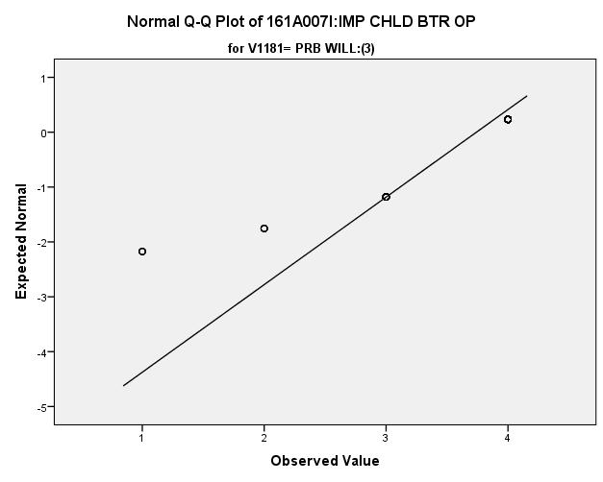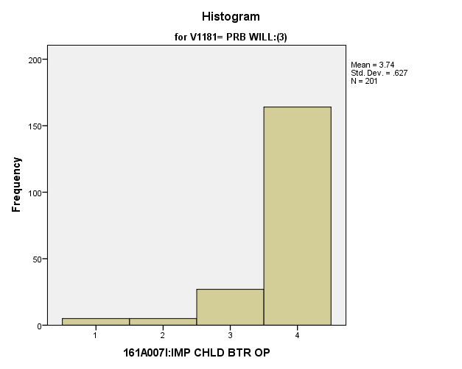

**Exhibit: Descriptives**

|  |  |  |  |  |  |
| --- | --- | --- | --- | --- | --- |
| ***Descriptives*** | | | | | |
|  | V1181 | | | Statistic | Std. Error |
| V1663 | DEF WONT:(1) | Mean | | **3.66** | **.021** |
| 99% Confidence Interval for Mean | Lower Bound | **3.60** |  |
| Upper Bound | **3.71** |  |
| 5% Trimmed Mean | | **3.76** |  |
| Median | | **4.00** |  |
| Variance | | **.459** |  |
| Std. Deviation | | **.677** |  |
| Minimum | | **1** |  |
| Maximum | | **4** |  |
| Range | | **3** |  |
| Interquartile Range | | **0** |  |
| Skewness | | **-2.140** | **.076** |
| Kurtosis | | **4.274** | **.151** |
| PRB WONT:(2) | Mean | | **3.65** | **.037** |
| 99% Confidence Interval for Mean | Lower Bound | **3.55** |  |
| Upper Bound | **3.74** |  |
| 5% Trimmed Mean | | **3.74** |  |
| Median | | **4.00** |  |
| Variance | | **.463** |  |
| Std. Deviation | | **.680** |  |
| Minimum | | **1** |  |
| Maximum | | **4** |  |
| Range | | **3** |  |
| Interquartile Range | | **1** |  |
| Skewness | | **-2.013** | **.132** |
| Kurtosis | | **3.550** | **.263** |
| PRB WILL:(3) | Mean | | **3.74** | **.044** |
| 99% Confidence Interval for Mean | Lower Bound | **3.63** |  |
| Upper Bound | **3.86** |  |
| 5% Trimmed Mean | | **3.85** |  |
| Median | | **4.00** |  |
| Variance | | **.393** |  |
| Std. Deviation | | **.627** |  |
| Minimum | | **1** |  |
| Maximum | | **4** |  |
| Range | | **3** |  |
| Interquartile Range | | **0** |  |
| Skewness | | **-2.823** | **.172** |
| Kurtosis | | **8.219** | **.341** |

**Exhibit: One Way ANOVA Table and Homogeneity**

|  |  |  |  |
| --- | --- | --- | --- |
| ***Test of Homogeneity of Variances*** | | | |
| V1663 | | | |
| Levene Statistic | df1 | df2 | Sig. |
| **4.179** | **2** | **1586** | **.015** |

|  |  |  |  |  |  |
| --- | --- | --- | --- | --- | --- |
| ***ANOVA*** | | | | | |
| V1663 | | | | | |
|  | Sum of Squares | df | Mean Square | F | Sig. |
| Between Groups | **1.308** | **2** | **.654** | **1.449** | **.235** |
| Within Groups | **715.914** | **1586** | **.451** |  |  |
| Total | **717.222** | **1588** |  |  |  |

**Importance of** **Correcting Social and Economic Inequalities:** Among potential recruits vs either recruits and non-recruits, how do they differ regarding the importance of working to correct social and economic inequalities?

**Variables Used:** The **dependent** **variable** used in the analysis was the importance of working to correct social and economic inequalities (1=not important, 2=somewhat important, 3= quite important, 4= extremely important) and the **independent (grouping) variable** used was the pool of respondents. The respondent pool is broken into three categories:

* Non-recruits (students who say they definitely will not serve in the military after high school graduation) --- these are labeled as *definitely won’t (1).*
* Recruits (students who say they definitely or probably will serve in the military) --- these are labeled as *probably will (3).*
* Potential recruits (those who say they probably will not serve) --- these are labeled as *probably won’t (2)*.
* The desired pool of recruits is those labeled as probably won’t.
* Total respondents: 1596, range for all groups 1 to 4.

**Analysis Procedure:**

* A one-way ANOVA test was utilized to compare how the potential pool of recruits differs by the importance of working to correct social and economic inequalities.
* The analysis variable of importance of working to correct social and economic inequalities is interval and the grouping variables are mutually exclusive.
* Prior to analysis, a histogram and Q-Q plots were inspected for outliers, none were present. Each group had a positive skew of less than 2.
* The homogeneity of variances assumption was tested. The assumption was met.

**Results:**

* Null and alternative hypothesis:
  + Main Test
    - H0 : µ1 = µ2 = µ3
    - Ha : ALOI
* Calculated F value: f(importance of better child opportunities) 1.338, dfnum= 2, dfden= 1595, α = 0.01, fail to reject H0;

**Interpretation:** There was no significant difference in means between the three groups regarding the importance of working to correct social and economic inequalities.

**Supporting Analysis:**

**Exhibit: Preliminary Analysis**

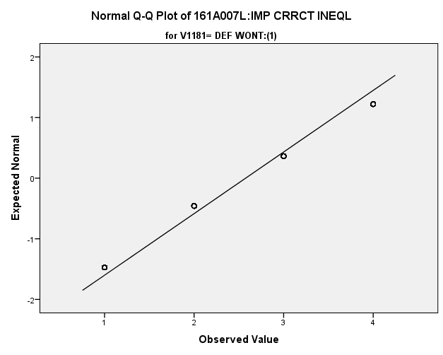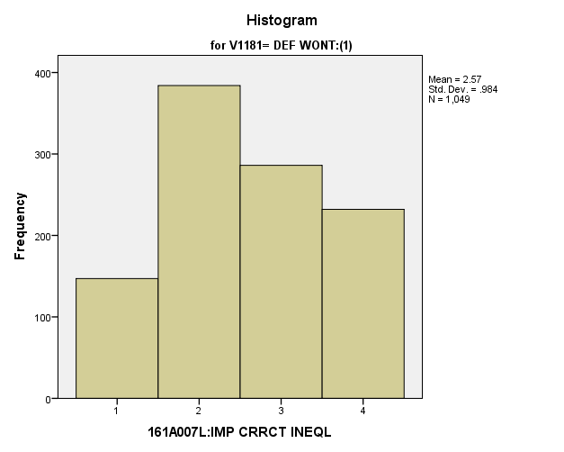

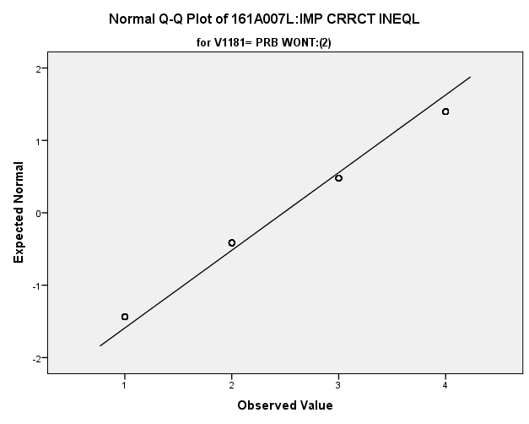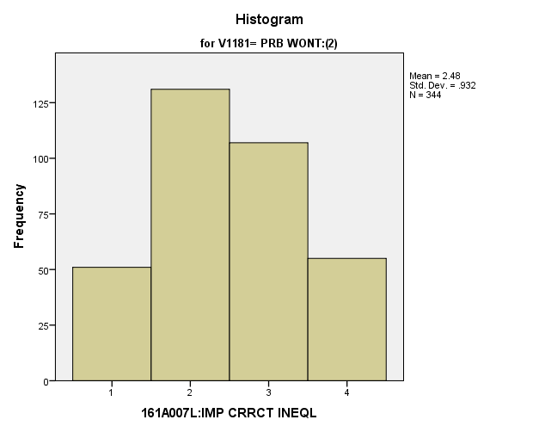

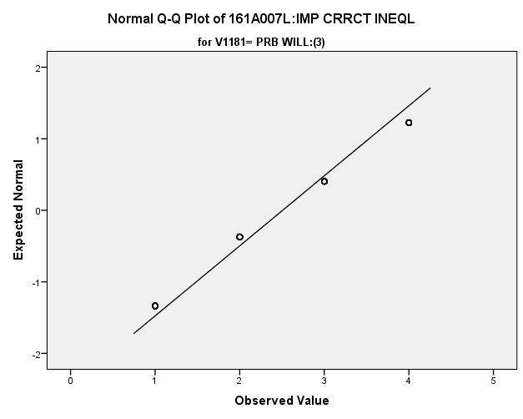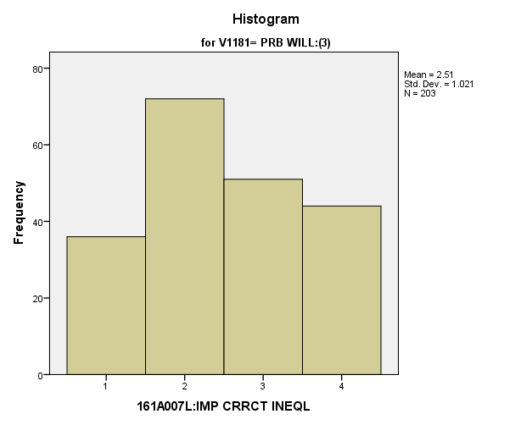

|  |  |  |  |  |  |
| --- | --- | --- | --- | --- | --- |
| ***Descriptives*** | | | | | |
|  | V1181 | | | Statistic | Std. Error |
| V1666 | DEF WONT:(1) | Mean | | **2.57** | **.030** |
| 99% Confidence Interval for Mean | Lower Bound | **2.50** |  |
| Upper Bound | **2.65** |  |
| 5% Trimmed Mean | | **2.58** |  |
| Median | | **2.00** |  |
| Variance | | **.968** |  |
| Std. Deviation | | **.984** |  |
| Minimum | | **1** |  |
| Maximum | | **4** |  |
| Range | | **3** |  |
| Interquartile Range | | **1** |  |
| Skewness | | **.047** | **.076** |
| Kurtosis | | **-1.049** | **.151** |
| PRB WONT:(2) | Mean | | **2.48** | **.050** |
| 99% Confidence Interval for Mean | Lower Bound | **2.35** |  |
| Upper Bound | **2.61** |  |
| 5% Trimmed Mean | | **2.48** |  |
| Median | | **2.00** |  |
| Variance | | **.868** |  |
| Std. Deviation | | **.932** |  |
| Minimum | | **1** |  |
| Maximum | | **4** |  |
| Range | | **3** |  |
| Interquartile Range | | **1** |  |
| Skewness | | **.095** | **.131** |
| Kurtosis | | **-.852** | **.262** |
| PRB WILL:(3) | Mean | | **2.51** | **.072** |
| 99% Confidence Interval for Mean | Lower Bound | **2.32** |  |
| Upper Bound | **2.69** |  |
| 5% Trimmed Mean | | **2.51** |  |
| Median | | **2.00** |  |
| Variance | | **1.043** |  |
| Std. Deviation | | **1.021** |  |
| Minimum | | **1** |  |
| Maximum | | **4** |  |
| Range | | **3** |  |
| Interquartile Range | | **1** |  |
| Skewness | | **.092** | **.171** |
| Kurtosis | | **-1.114** | **.340** |

**Exhibit: One Way ANOVA Table and Homogeneity**

|  |  |  |  |
| --- | --- | --- | --- |
| ***Test of Homogeneity of Variances*** | | | |
| V1666 | | | |
| Levene Statistic | df1 | df2 | Sig. |
| **2.592** | **2** | **1593** | **.075** |

|  |  |  |  |  |  |
| --- | --- | --- | --- | --- | --- |
| ***ANOVA*** | | | | | |
| V1666 | | | | | |
|  | Sum of Squares | df | Mean Square | F | Sig. |
| Between Groups | **2.559** | **2** | **1.280** | **1.338** | **.263** |
| Within Groups | **1523.010** | **1593** | **.956** |  |  |
| Total | **1525.569** | **1595** |  |  |  |

**Importance of Discovering New Ways to Experience Things:** Among potential recruits vs either recruits and non-recruits, how do they differ regarding the importance of discovering new ways to experience things?

**Variables Used:** The **dependent** **variable** used in the analysis was the importance of discovering new ways to experience things (1=not important, 2=somewhat important, 3= quite important, 4= extremely important) and the **independent (grouping) variable** used was the pool of respondents. The respondent pool is broken into three categories:

* Non-recruits (students who say they definitely will not serve in the military after high school graduation) --- these are labeled as *definitely won’t (1).*
* Recruits (students who say they definitely or probably will serve in the military) --- these are labeled as *probably will (3).*
* Potential recruits (those who say they probably will not serve) --- these are labeled as *probably won’t (2)*.
* The desired pool of recruits is those labeled as probably won’t.
* Total respondents: 1599, range for all groups 1 to 4.

**Analysis Procedure:**

* A one-way ANOVA test was utilized to compare how the potential pool of recruits differs by the importance of discovering new ways to experience things.
* The analysis variable of importance of discovering new ways to experience things is interval and the grouping variables are mutually exclusive.
* Prior to analysis, a histogram and Q-Q plots were inspected for outliers, none were present. Each group had a negative skew of less than 2.
* The homogeneity of variances assumption was tested. The assumption was not met but the groups are approximately the same size.
* Eta was calculated to assess effect size.

**Results:**

* Null and alternative hypothesis:
  + Main Test
    - H0 : µ1 = µ2 = µ3
    - Ha : ALOI
* Calculated F value: f(importance of better child opportunities) 5.376, dfnum= 2, dfden= 1596, α = 0.01, reject H0; Eta = 0.082

**Interpretation:** There was difference in means between the three groups regarding the importance of discovering new ways to experience things. While the initial test was significant, all subsequent post hoc tests were not significant. However, the analysis of probably will and probably won’t was the largest difference and nearly did not include 0 in the confidence interval. Observing the graph of the means in the means table exhibit, one can observe this relationship.

**Supporting Analysis:**

**Exhibit: Preliminary Analysis**

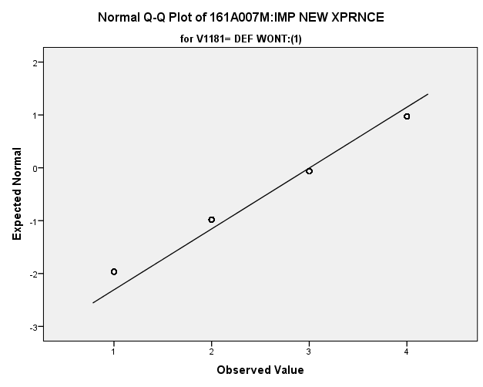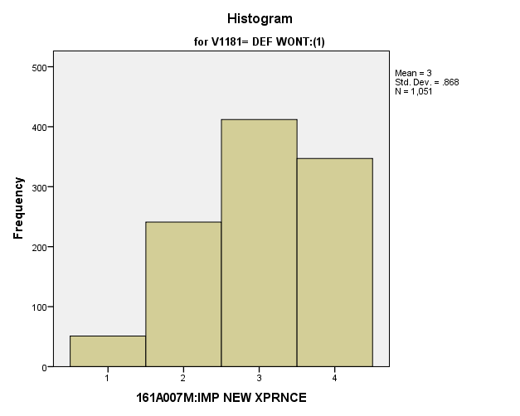

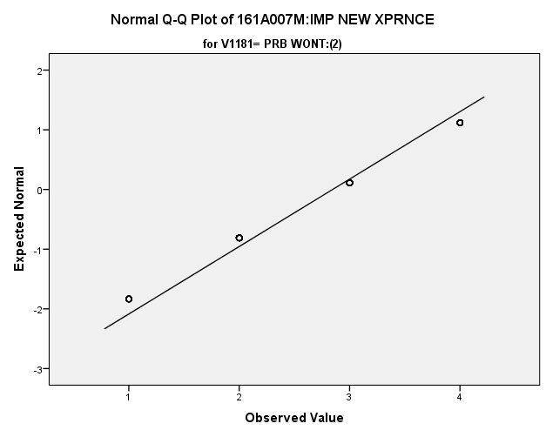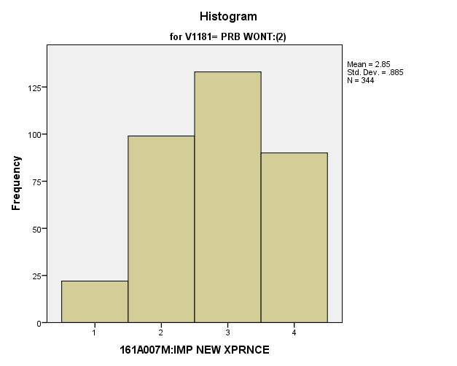

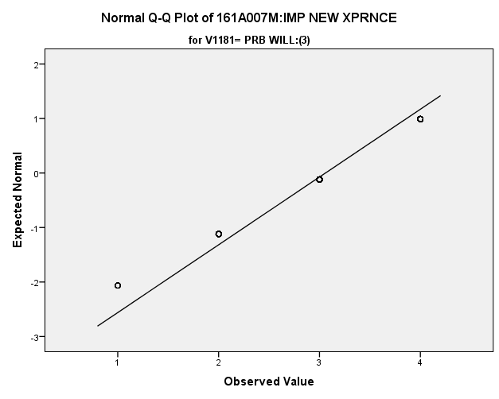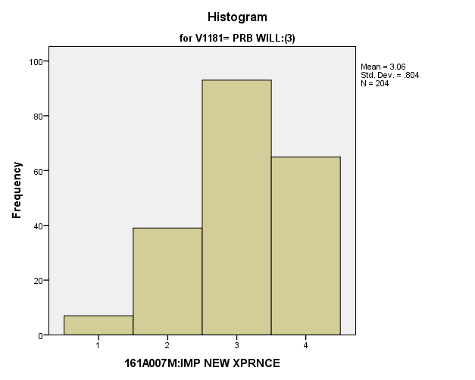

|  |  |  |  |  |  |
| --- | --- | --- | --- | --- | --- |
| ***Descriptives*** | | | | | |
|  | V1181 | | | Statistic | Std. Error |
| V1667 | DEF WONT:(1) | Mean | | **3.00** | **.027** |
| 99% Confidence Interval for Mean | Lower Bound | **2.93** |  |
| Upper Bound | **3.07** |  |
| 5% Trimmed Mean | | **3.06** |  |
| Median | | **3.00** |  |
| Variance | | **.754** |  |
| Std. Deviation | | **.868** |  |
| Minimum | | **1** |  |
| Maximum | | **4** |  |
| Range | | **3** |  |
| Interquartile Range | | **2** |  |
| Skewness | | **-.453** | **.075** |
| Kurtosis | | **-.637** | **.151** |
| PRB WONT:(2) | Mean | | **2.85** | **.048** |
| 99% Confidence Interval for Mean | Lower Bound | **2.72** |  |
| Upper Bound | **2.97** |  |
| 5% Trimmed Mean | | **2.88** |  |
| Median | | **3.00** |  |
| Variance | | **.784** |  |
| Std. Deviation | | **.885** |  |
| Minimum | | **1** |  |
| Maximum | | **4** |  |
| Range | | **3** |  |
| Interquartile Range | | **2** |  |
| Skewness | | **-.251** | **.131** |
| Kurtosis | | **-.776** | **.262** |
| PRB WILL:(3) | Mean | | **3.06** | **.056** |
| 99% Confidence Interval for Mean | Lower Bound | **2.91** |  |
| Upper Bound | **3.21** |  |
| 5% Trimmed Mean | | **3.10** |  |
| Median | | **3.00** |  |
| Variance | | **.647** |  |
| Std. Deviation | | **.804** |  |
| Minimum | | **1** |  |
| Maximum | | **4** |  |
| Range | | **3** |  |
| Interquartile Range | | **1** |  |
| Skewness | | **-.509** | **.170** |
| Kurtosis | | **-.306** | **.339** |

**Exhibit: Means Table**

|  |  |  |  |
| --- | --- | --- | --- |
| ***Report*** | | | |
| V1667 | | | |
| V1181 | Mean | N | Std. Deviation |
| DEF WONT:(1) | **3.00** | **1051** | **.868** |
| PRB WONT:(2) | **2.85** | **344** | **.885** |
| PRB WILL:(3) | **3.06** | **204** | **.804** |
| Total | **2.98** | **1599** | **.867** |

**Exhibit: One Way ANOVA Table and Homogeneity**

|  |  |  |  |
| --- | --- | --- | --- |
| ***Test of Homogeneity of Variances*** | | | |
| V1667 | | | |
| Levene Statistic | df1 | df2 | Sig. |
| **3.428** | **2** | **1596** | **.033** |

|  |  |  |  |  |  |
| --- | --- | --- | --- | --- | --- |
| ***ANOVA*** | | | | | |
| V1667 | | | | | |
|  | Sum of Squares | df | Mean Square | F | Sig. |
| Between Groups | **8.031** | **2** | **4.015** | **5.376** | **.005** |
| Within Groups | **1192.113** | **1596** | **.747** |  |  |
| Total | **1200.144** | **1598** |  |  |  |

**Exhibit: Effect Size**

|  |  |  |
| --- | --- | --- |
| ***Measures of Association*** | | |
|  | Eta | Eta Squared |
| V1667 * V1181 | **.082** | **.007** |

**Exhibit: Post Hoc Tests**

|  |  |  |  |  |  |
| --- | --- | --- | --- | --- | --- |
| ***Multiple Comparisons*** | | | | | |
| Dependent Variable: V1667 | | | | | |
| Games-Howell | | | | | |
| (I) V1181 | (J) V1181 | Mean Difference (I-J) | Std. Error | Sig. | 99% Confidence Interval |
| Lower Bound |
| DEF WONT:(1) | PRB WONT:(2) | **.158** | **.055** | **.011** | **.00** |
| PRB WILL:(3) | **-.055** | **.062** | **.652** | **-.24** |
| PRB WONT:(2) | DEF WONT:(1) | **-.158** | **.055** | **.011** | **-.32** |
| PRB WILL:(3) | **-.213** | **.074** | **.011** | **-.43** |
| PRB WILL:(3) | DEF WONT:(1) | **.055** | **.062** | **.652** | **-.13** |
| PRB WONT:(2) | **.213** | **.074** | **.011** | **.00** |

|  |  |  |
| --- | --- | --- |
| ***Multiple Comparisons*** | | |
| Dependent Variable: V1667 | | |
| Games-Howell | | |
| (I) V1181 | (J) V1181 | 99% Confidence Interval |
| Upper Bound |
| DEF WONT:(1) | PRB WONT:(2) | **.32** |
| PRB WILL:(3) | **.13** |
| PRB WONT:(2) | DEF WONT:(1) | **.00** |
| PRB WILL:(3) | **.00** |
| PRB WILL:(3) | DEF WONT:(1) | **.24** |
| PRB WONT:(2) | **.43** |

*3.c. Satisfaction*

**Satisfaction with Current Neighborhood:** How do potential recruits differ from the other two groups regarding their satisfaction with their current neighborhood?

**Variables Used:** The **dependent** **variable** used in the analysis was the satisfaction with current neighborhood (1=completely dissatisfied, 4=neutral, 7= completely satisfied) and the **independent (grouping) variable** used was the pool of respondents. The respondent pool is broken into three categories:

* Non-recruits (students who say they definitely will not serve in the military after high school graduation) --- these are labeled as *definitely won’t (1).*
* Recruits (students who say they definitely or probably will serve in the military) --- these are labeled as *probably will (3).*
* Potential recruits (those who say they probably will not serve) --- these are labeled as *probably won’t (2)*.
* The desired pool of recruits is those labeled as probably won’t.
* Total respondents: 1625, range for all groups 1 to 7

**Analysis Procedure:**

* A one-way ANOVA test was utilized to compare how the potential pool of recruits differs by the satisfaction with current neighborhood.
* The analysis variable of satisfaction with current neighborhood is interval and the grouping variables are mutually exclusive.
* Prior to analysis, a histogram and Q-Q plots were inspected for outliers, none were present. Each group had a negative skew and was than 2.
* The homogeneity of variances assumption was tested. The assumption was met.

**Results:**

* Null and alternative hypothesis:
  + Main Test
    - H0 : µ1 = µ2 = µ3
    - Ha : ALOI
* Calculated F value: f(satisfaction with current neighborhood) 3.199, dfnum= 2, dfden= 1623, α = 0.01, fail to reject H0;

**Interpretation:** There was no significant difference in means between the three groups regarding the satisfaction with current neighborhood.

**Supporting Analysis:**

**Exhibit: Preliminary Analysis**

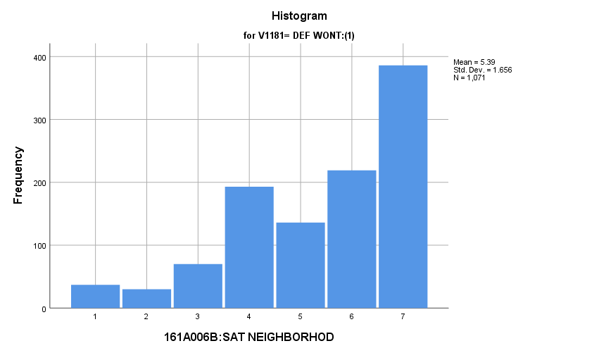

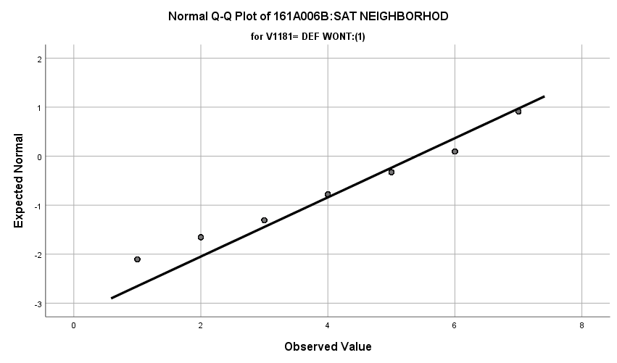

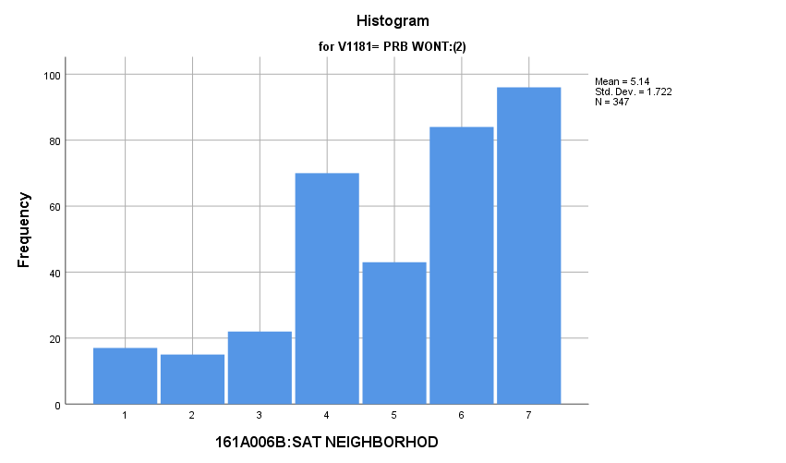

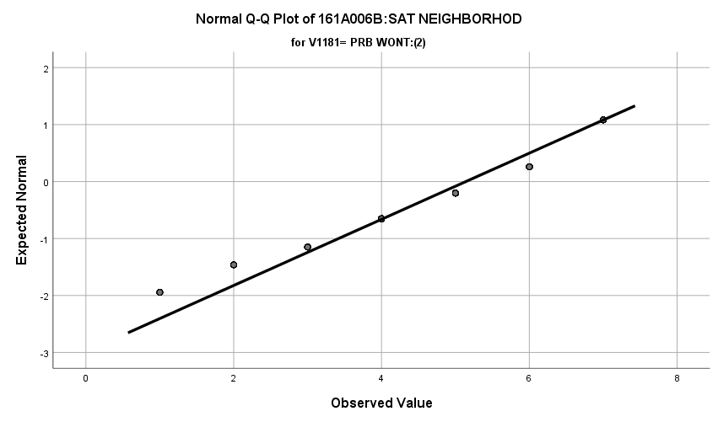

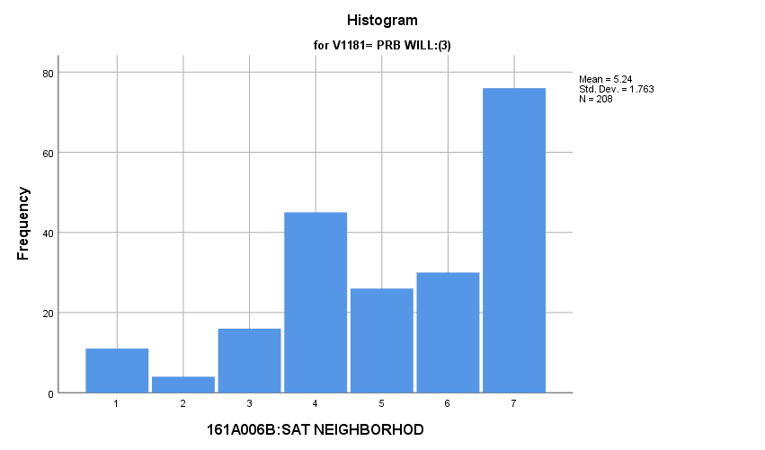

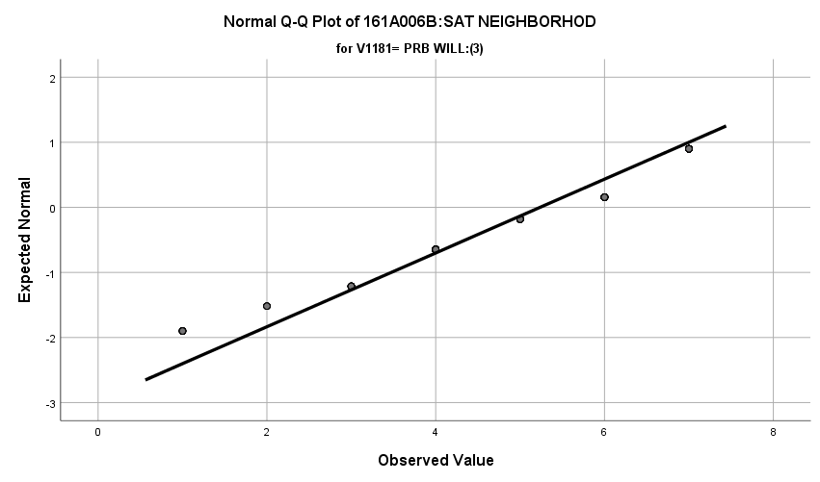

**Exhibit : Descriptives**

|  |  |  |  |  |  |
| --- | --- | --- | --- | --- | --- |
| ***Descriptives*** | | | | | |
|  | V1181 | | | Statistic | Std. Error |
| V1642 | DEF WONT:(1) | Mean | | **5.39** | **.051** |
| 99% Confidence Interval for Mean | Lower Bound | **5.26** |  |
| Upper Bound | **5.52** |  |
| 5% Trimmed Mean | | **5.53** |  |
| Median | | **6.00** |  |
| Variance | | **2.741** |  |
| Std. Deviation | | **1.656** |  |
| Minimum | | **1** |  |
| Maximum | | **7** |  |
| Range | | **6** |  |
| Interquartile Range | | **3** |  |
| Skewness | | **-.854** | **.075** |
| Kurtosis | | **-.086** | **.149** |
| PRB WONT:(2) | Mean | | **5.14** | **.092** |
| 99% Confidence Interval for Mean | Lower Bound | **4.90** |  |
| Upper Bound | **5.38** |  |
| 5% Trimmed Mean | | **5.27** |  |
| Median | | **6.00** |  |
| Variance | | **2.966** |  |
| Std. Deviation | | **1.722** |  |
| Minimum | | **1** |  |
| Maximum | | **7** |  |
| Range | | **6** |  |
| Interquartile Range | | **3** |  |
| Skewness | | **-.753** | **.131** |
| Kurtosis | | **-.273** | **.261** |
| PRB WILL:(3) | Mean | | **5.24** | **.122** |
| 99% Confidence Interval for Mean | Lower Bound | **4.92** |  |
| Upper Bound | **5.55** |  |
| 5% Trimmed Mean | | **5.37** |  |
| Median | | **6.00** |  |
| Variance | | **3.108** |  |
| Std. Deviation | | **1.763** |  |
| Minimum | | **1** |  |
| Maximum | | **7** |  |
| Range | | **6** |  |
| Interquartile Range | | **3** |  |
| Skewness | | **-.716** | **.169** |
| Kurtosis | | **-.352** | **.336** |

**Exhibit: One Way ANOVA Table and Homogeneity**

|  |  |  |  |  |  |
| --- | --- | --- | --- | --- | --- |
| ***Test of Homogeneity of Variances*** | | | | | |
|  | | Levene Statistic | df1 | df2 | Sig. |
| V1642 | Based on Mean | **1.223** | **2** | **1623** | **.294** |
| Based on Median | **1.986** | **2** | **1623** | **.138** |
| Based on Median and with adjusted df | **1.986** | **2** | **1606.571** | **.138** |
| Based on trimmed mean | **1.576** | **2** | **1623** | **.207** |

|  |  |  |  |  |  |
| --- | --- | --- | --- | --- | --- |
| ***ANOVA*** | | | | | |
| V1642 | | | | | |
|  | Sum of Squares | df | Mean Square | F | Sig. |
| Between Groups | **18.148** | **2** | **9.074** | **3.199** | **.041** |
| Within Groups | **4602.832** | **1623** | **2.836** |  |  |
| Total | **4620.979** | **1625** |  |  |  |

**Satisfaction with Educational Experience:** How do potential recruits differ from the other two groups regarding their satisfaction with their educational experience?

**Variables Used:** The **dependent** **variable** used in the analysis was the satisfaction with their educational experience (1=completely dissatisfied, 4=neutral, 7= completely satisfied) and the **independent (grouping) variable** used was the pool of respondents. The respondent pool is broken into three categories:

* Non-recruits (students who say they definitely will not serve in the military after high school graduation) --- these are labeled as *definitely won’t (1).*
* Recruits (students who say they definitely or probably will serve in the military) --- these are labeled as *probably will (3).*
* Potential recruits (those who say they probably will not serve) --- these are labeled as *probably won’t (2)*.
* The desired pool of recruits is those labeled as probably won’t.
* Total respondents: 1625, range for all groups 1 to 7

**Analysis Procedure:**

* A one-way ANOVA test was utilized to compare how the potential pool of recruits differs by the satisfaction with their educational experience.
* The analysis variable of satisfaction with their educational experience is interval and the grouping variables are mutually exclusive.
* Prior to analysis, a histogram and Q-Q plots were inspected for outliers, none were present. Each group had a negative skew and was than 2.
* The homogeneity of variances assumption was tested. The assumption was met.

**Results:**

* Null and alternative hypothesis:
  + Main Test
    - H0 : µ1 = µ2 = µ3
    - Ha : ALOI
* Calculated F value: f(satisfaction with their educational experience) 1.355, dfnum= 2, dfden= 1622, α = 0.01, fail to reject H0;

**Interpretation:** There was no significant difference in means between the three groups regarding the satisfaction with their educational experience.

**Supporting Analysis:**

**Exhibit: Preliminary Analysis**

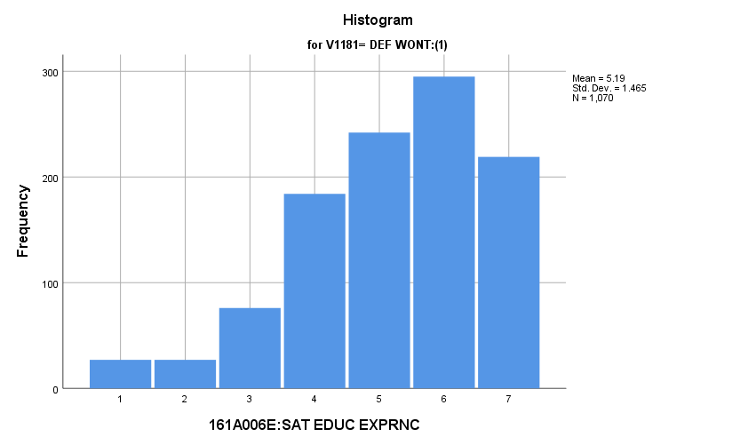

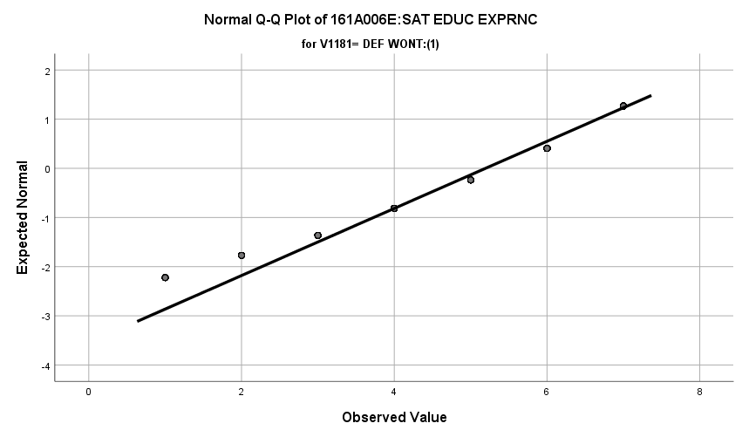

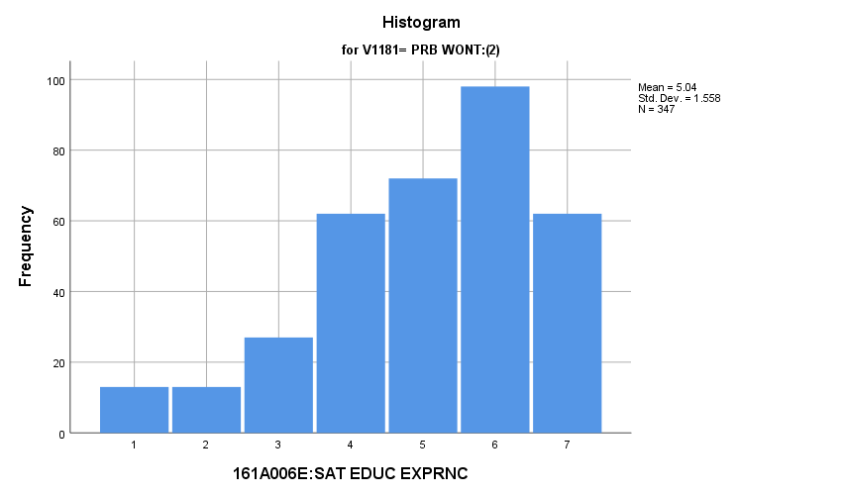

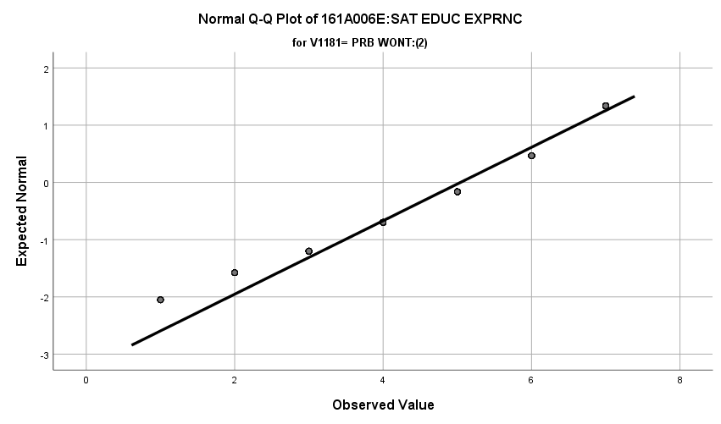

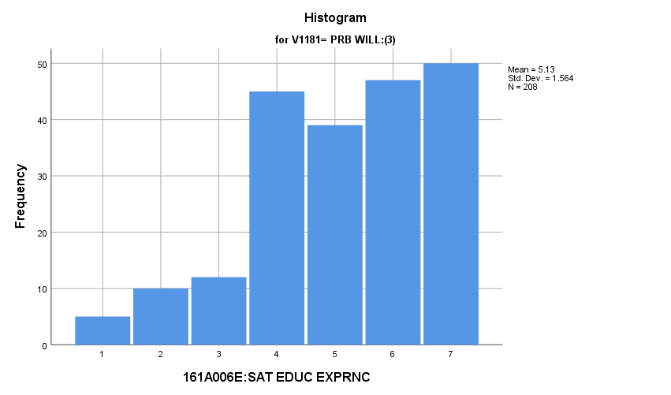

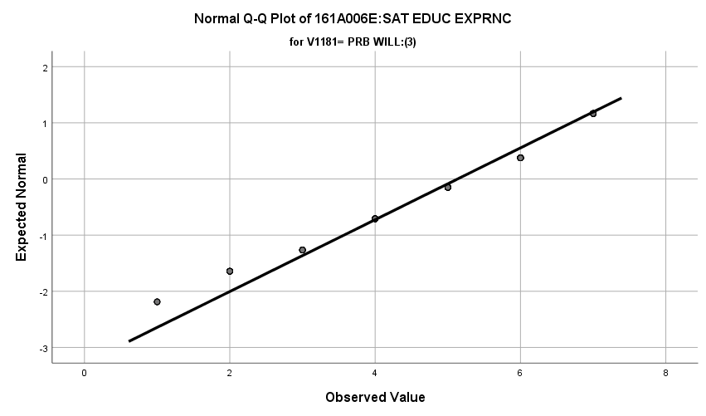

**Exhibit : Descriptives**

|  |  |  |  |  |  |
| --- | --- | --- | --- | --- | --- |
| ***Descriptives*** | | | | | |
|  | V1181 | | | Statistic | Std. Error |
| V1645 | DEF WONT:(1) | Mean | | **5.19** | **.045** |
| 99% Confidence Interval for Mean | Lower Bound | **5.08** |  |
| Upper Bound | **5.31** |  |
| 5% Trimmed Mean | | **5.30** |  |
| Median | | **5.00** |  |
| Variance | | **2.146** |  |
| Std. Deviation | | **1.465** |  |
| Minimum | | **1** |  |
| Maximum | | **7** |  |
| Range | | **6** |  |
| Interquartile Range | | **2** |  |
| Skewness | | **-.760** | **.075** |
| Kurtosis | | **.212** | **.149** |
| PRB WONT:(2) | Mean | | **5.04** | **.084** |
| 99% Confidence Interval for Mean | Lower Bound | **4.83** |  |
| Upper Bound | **5.26** |  |
| 5% Trimmed Mean | | **5.15** |  |
| Median | | **5.00** |  |
| Variance | | **2.429** |  |
| Std. Deviation | | **1.558** |  |
| Minimum | | **1** |  |
| Maximum | | **7** |  |
| Range | | **6** |  |
| Interquartile Range | | **2** |  |
| Skewness | | **-.750** | **.131** |
| Kurtosis | | **.027** | **.261** |
| PRB WILL:(3) | Mean | | **5.13** | **.108** |
| 99% Confidence Interval for Mean | Lower Bound | **4.85** |  |
| Upper Bound | **5.42** |  |
| 5% Trimmed Mean | | **5.23** |  |
| Median | | **5.00** |  |
| Variance | | **2.446** |  |
| Std. Deviation | | **1.564** |  |
| Minimum | | **1** |  |
| Maximum | | **7** |  |
| Range | | **6** |  |
| Interquartile Range | | **2** |  |
| Skewness | | **-.624** | **.169** |
| Kurtosis | | **-.232** | **.336** |

**Exhibit: One Way ANOVA Table and Homogeneity**

|  |  |  |  |  |  |
| --- | --- | --- | --- | --- | --- |
| ***Test of Homogeneity of Variances*** | | | | | |
|  | | Levene Statistic | df1 | df2 | Sig. |
| V1645 | Based on Mean | **1.493** | **2** | **1622** | **.225** |
| Based on Median | **1.443** | **2** | **1622** | **.236** |
| Based on Median and with adjusted df | **1.443** | **2** | **1618.304** | **.236** |
| Based on trimmed mean | **1.604** | **2** | **1622** | **.201** |

|  |  |  |  |  |  |
| --- | --- | --- | --- | --- | --- |
| ***ANOVA*** | | | | | |
| V1645 | | | | | |
|  | Sum of Squares | df | Mean Square | F | Sig. |
| Between Groups | **6.081** | **2** | **3.041** | **1.355** | **.258** |
| Within Groups | **3640.149** | **1622** | **2.244** |  |  |
| Total | **3646.230** | **1624** |  |  |  |

**Satisfaction with Friends:** How do potential recruits differ from the other two groups regarding their satisfaction with their friends?

**Variables Used:** The **dependent** **variable** used in the analysis was the satisfaction with their friends (1=completely dissatisfied, 4=neutral, 7= completely satisfied) and the **independent (grouping) variable** used was the pool of respondents. The respondent pool is broken into three categories:

* Non-recruits (students who say they definitely will not serve in the military after high school graduation) --- these are labeled as *definitely won’t (1).*
* Recruits (students who say they definitely or probably will serve in the military) --- these are labeled as *probably will (3).*
* Potential recruits (those who say they probably will not serve) --- these are labeled as *probably won’t (2)*.
* The desired pool of recruits is those labeled as probably won’t.
* Total respondents: 1625, range for all groups 1 to 7

**Analysis Procedure:**

* A one-way ANOVA test was utilized to compare how the potential pool of recruits differs by the satisfaction with their friends.
* The analysis variable of satisfaction with their friends is interval and the grouping variables are mutually exclusive.
* Prior to analysis, a histogram and Q-Q plots were inspected for outliers, none were present. Each group had a negative skew and was than 2.
* The homogeneity of variances assumption was tested. The assumption was not met but groups are approximately the same size.

**Results:**

* Null and alternative hypothesis:
  + Main Test
    - H0 : µ1 = µ2 = µ3
    - Ha : ALOI
* Calculated F value: f(satisfaction with their friends) 4.016, dfnum= 2, dfden= 1619, α = 0.01, fail to reject H0;

**Interpretation:** There was no significant difference in means between the three groups regarding the satisfaction with their friends.

**Supporting Analysis:**

**Exhibit: Preliminary Analysis**

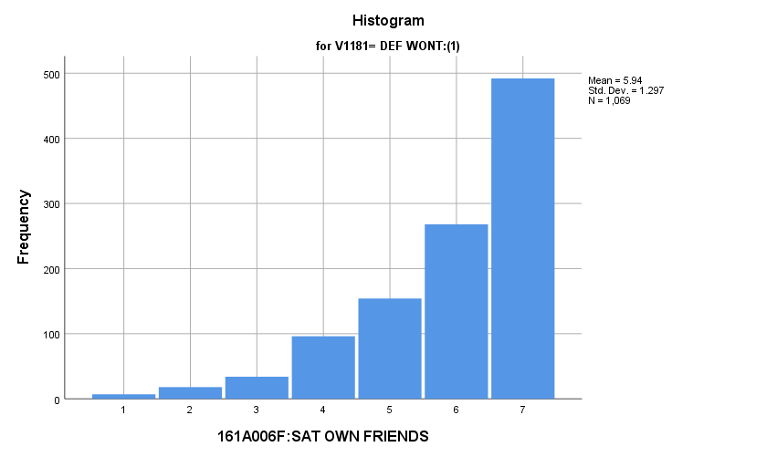

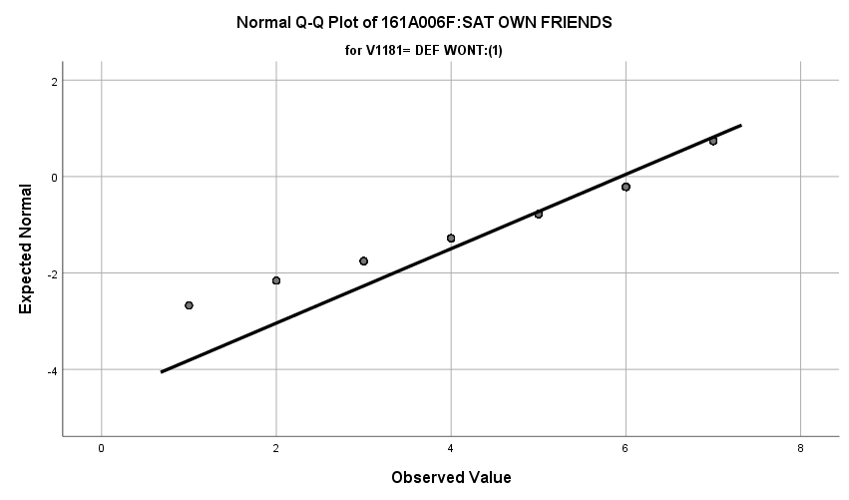

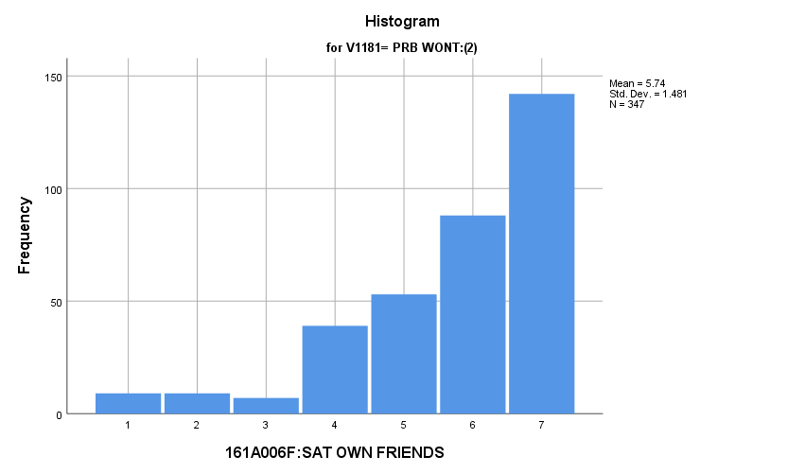

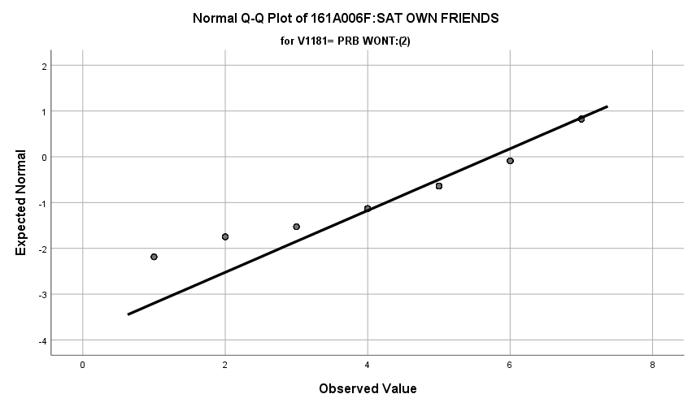

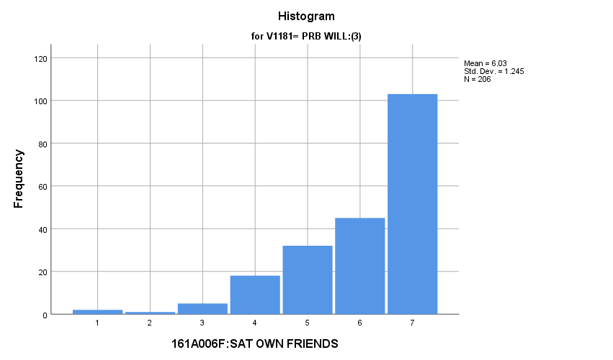

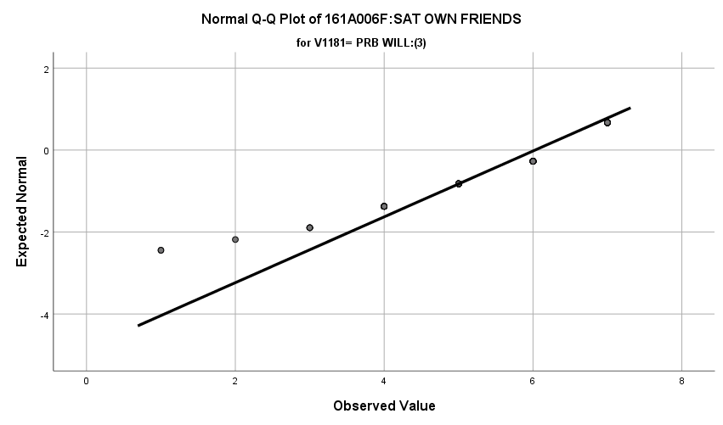

**Exhibit : Descriptives**

|  |  |  |  |  |  |
| --- | --- | --- | --- | --- | --- |
| ***Descriptives*** | | | | | |
|  | V1181 | | | Statistic | Std. Error |
| V1646 | DEF WONT:(1) | Mean | | **5.94** | **.040** |
| 99% Confidence Interval for Mean | Lower Bound | **5.84** |  |
| Upper Bound | **6.04** |  |
| 5% Trimmed Mean | | **6.08** |  |
| Median | | **6.00** |  |
| Variance | | **1.681** |  |
| Std. Deviation | | **1.297** |  |
| Minimum | | **1** |  |
| Maximum | | **7** |  |
| Range | | **6** |  |
| Interquartile Range | | **2** |  |
| Skewness | | **-1.316** | **.075** |
| Kurtosis | | **1.377** | **.149** |
| PRB WONT:(2) | Mean | | **5.74** | **.080** |
| 99% Confidence Interval for Mean | Lower Bound | **5.53** |  |
| Upper Bound | **5.94** |  |
| 5% Trimmed Mean | | **5.90** |  |
| Median | | **6.00** |  |
| Variance | | **2.194** |  |
| Std. Deviation | | **1.481** |  |
| Minimum | | **1** |  |
| Maximum | | **7** |  |
| Range | | **6** |  |
| Interquartile Range | | **2** |  |
| Skewness | | **-1.350** | **.131** |
| Kurtosis | | **1.505** | **.261** |
| PRB WILL:(3) | Mean | | **6.03** | **.087** |
| 99% Confidence Interval for Mean | Lower Bound | **5.80** |  |
| Upper Bound | **6.25** |  |
| 5% Trimmed Mean | | **6.16** |  |
| Median | | **6.50** |  |
| Variance | | **1.550** |  |
| Std. Deviation | | **1.245** |  |
| Minimum | | **1** |  |
| Maximum | | **7** |  |
| Range | | **6** |  |
| Interquartile Range | | **2** |  |
| Skewness | | **-1.403** | **.169** |
| Kurtosis | | **1.963** | **.337** |

**Exhibit: One Way ANOVA Table and Homogeneity**

|  |  |  |  |  |  |
| --- | --- | --- | --- | --- | --- |
| ***Test of Homogeneity of Variances*** | | | | | |
|  | | Levene Statistic | df1 | df2 | Sig. |
| V1646 | Based on Mean | **5.611** | **2** | **1619** | **.004** |
| Based on Median | **1.770** | **2** | **1619** | **.171** |
| Based on Median and with adjusted df | **1.770** | **2** | **1567.618** | **.171** |
| Based on trimmed mean | **2.962** | **2** | **1619** | **.052** |

|  |  |  |  |  |  |
| --- | --- | --- | --- | --- | --- |
| ***ANOVA*** | | | | | |
| V1646 | | | | | |
|  | Sum of Squares | df | Mean Square | F | Sig. |
| Between Groups | **14.248** | **2** | **7.124** | **4.016** | **.018** |
| Within Groups | **2872.248** | **1619** | **1.774** |  |  |
| Total | **2886.496** | **1621** |  |  |  |

**Satisfaction with Getting Along with Parents:** How do potential recruits differ from the other two groups regarding their satisfaction with getting along with their parents?

**Variables Used:** The **dependent** **variable** used in the analysis was the satisfaction with getting along with their parents (1=completely dissatisfied, 4=neutral, 7= completely satisfied) and the **independent (grouping) variable** used was the pool of respondents. The respondent pool is broken into three categories:

* Non-recruits (students who say they definitely will not serve in the military after high school graduation) --- these are labeled as *definitely won’t (1).*
* Recruits (students who say they definitely or probably will serve in the military) --- these are labeled as *probably will (3).*
* Potential recruits (those who say they probably will not serve) --- these are labeled as *probably won’t (2)*.
* The desired pool of recruits is those labeled as probably won’t.
* Total respondents: 1627, range for all groups 1 to 7

**Analysis Procedure:**

* A one-way ANOVA test was utilized to compare how the potential pool of recruits differs by the satisfaction with getting along with their parents.
* The analysis variable of satisfaction with getting along with their parents is interval and the grouping variables are mutually exclusive.
* Prior to analysis, a histogram and Q-Q plots were inspected for outliers, none were present. Each group had a negative skew and was than 2.
* The homogeneity of variances assumption was tested. The assumption was met.

**Results:**

* Null and alternative hypothesis:
  + Main Test
    - H0 : µ1 = µ2 = µ3
    - Ha : ALOI
* Calculated F value: f(satisfaction with getting along with their parents) 1.844 , dfnum= 2, dfden= 1624, α = 0.01, fail to reject H0;

**Interpretation:** There was no significant difference in means between the three groups regarding the satisfaction with getting along with their parents.

**Supporting Analysis:**

**Exhibit: Preliminary Analysis**

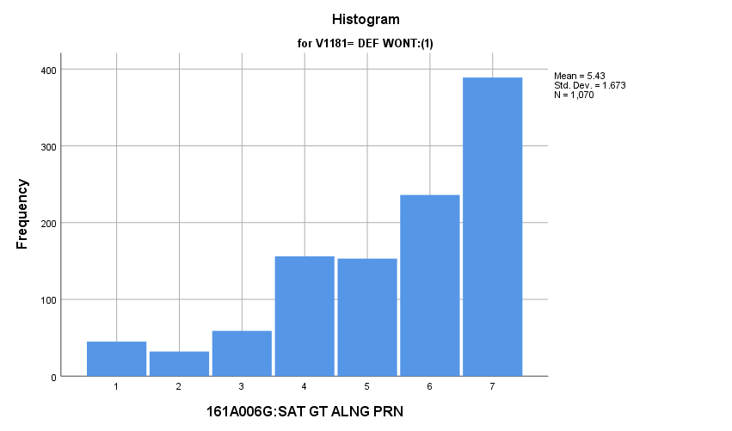

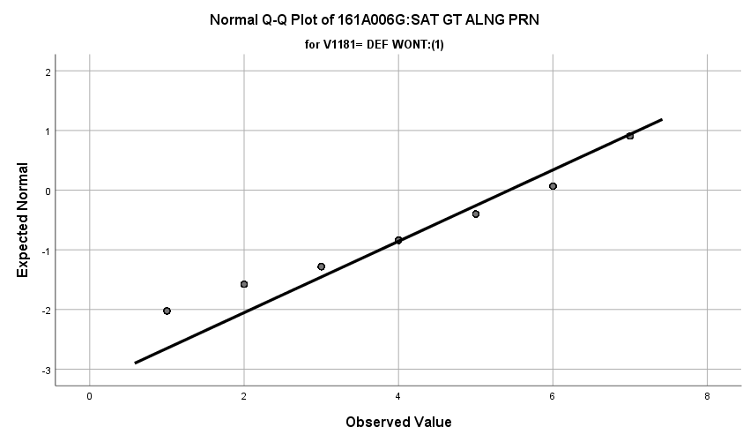

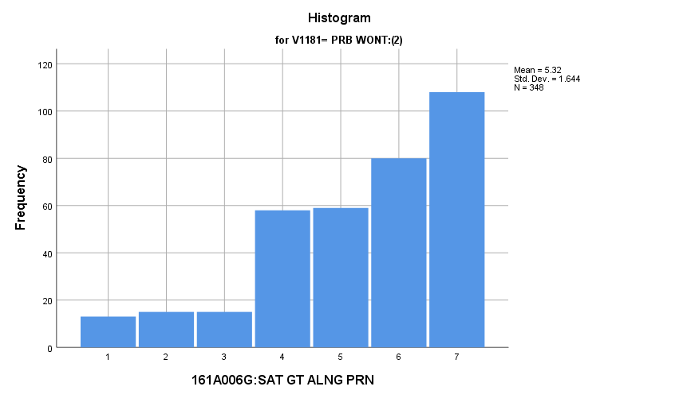

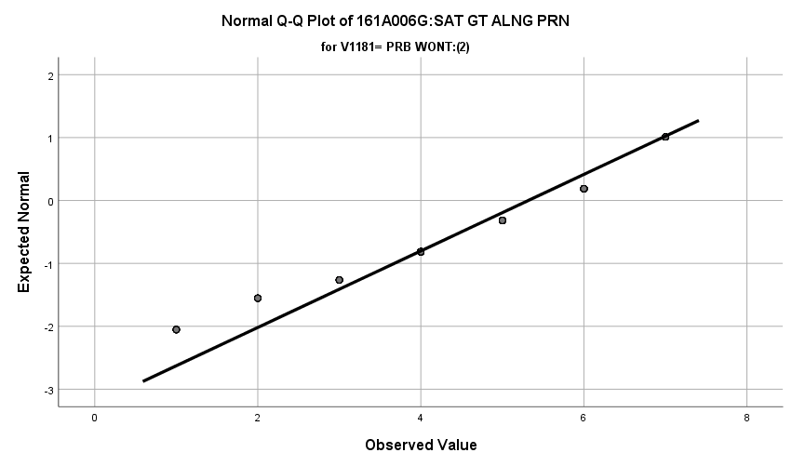

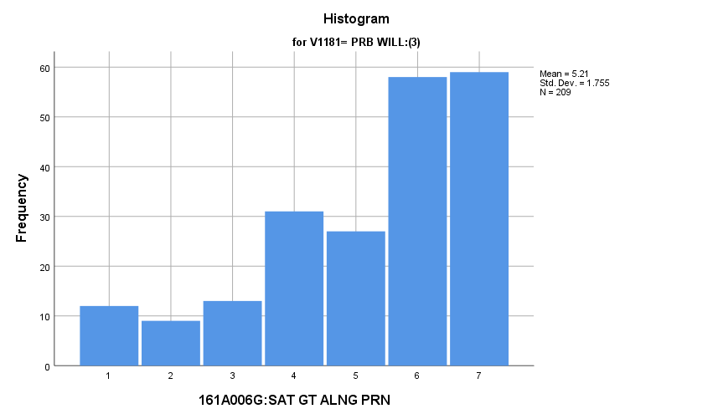

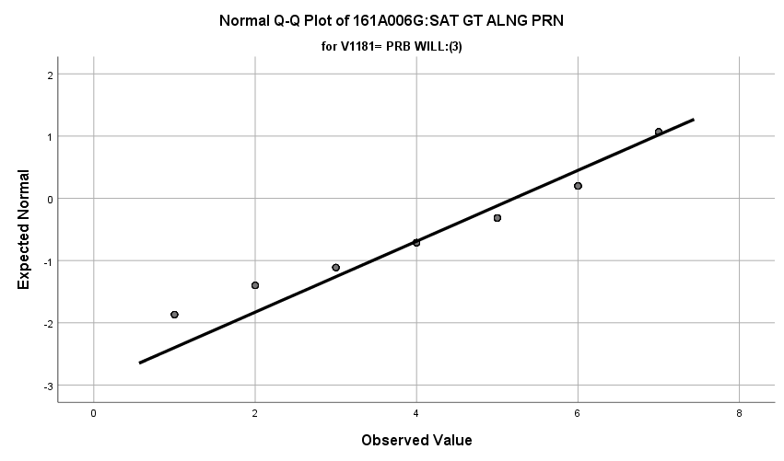

**Exhibit : Descriptives**

|  |  |  |  |  |  |
| --- | --- | --- | --- | --- | --- |
| ***Descriptives*** | | | | | |
|  | V1181 | | | Statistic | Std. Error |
| V1647 | DEF WONT:(1) | Mean | | **5.43** | **.051** |
| 99% Confidence Interval for Mean | Lower Bound | **5.30** |  |
| Upper Bound | **5.57** |  |
| 5% Trimmed Mean | | **5.58** |  |
| Median | | **6.00** |  |
| Variance | | **2.798** |  |
| Std. Deviation | | **1.673** |  |
| Minimum | | **1** |  |
| Maximum | | **7** |  |
| Range | | **6** |  |
| Interquartile Range | | **3** |  |
| Skewness | | **-1.002** | **.075** |
| Kurtosis | | **.229** | **.149** |
| PRB WONT:(2) | Mean | | **5.32** | **.088** |
| 99% Confidence Interval for Mean | Lower Bound | **5.09** |  |
| Upper Bound | **5.55** |  |
| 5% Trimmed Mean | | **5.45** |  |
| Median | | **6.00** |  |
| Variance | | **2.702** |  |
| Std. Deviation | | **1.644** |  |
| Minimum | | **1** |  |
| Maximum | | **7** |  |
| Range | | **6** |  |
| Interquartile Range | | **3** |  |
| Skewness | | **-.900** | **.131** |
| Kurtosis | | **.120** | **.261** |
| PRB WILL:(3) | Mean | | **5.21** | **.121** |
| 99% Confidence Interval for Mean | Lower Bound | **4.89** |  |
| Upper Bound | **5.53** |  |
| 5% Trimmed Mean | | **5.35** |  |
| Median | | **6.00** |  |
| Variance | | **3.080** |  |
| Std. Deviation | | **1.755** |  |
| Minimum | | **1** |  |
| Maximum | | **7** |  |
| Range | | **6** |  |
| Interquartile Range | | **3** |  |
| Skewness | | **-.918** | **.168** |
| Kurtosis | | **-.054** | **.335** |

**Exhibit: One Way ANOVA Table and Homogeneity**

|  |  |  |  |  |  |
| --- | --- | --- | --- | --- | --- |
| ***Test of Homogeneity of Variances*** | | | | | |
|  | | Levene Statistic | df1 | df2 | Sig. |
| V1647 | Based on Mean | **.630** | **2** | **1624** | **.533** |
| Based on Median | **.214** | **2** | **1624** | **.807** |
| Based on Median and with adjusted df | **.214** | **2** | **1610.265** | **.807** |
| Based on trimmed mean | **.553** | **2** | **1624** | **.575** |

|  |  |  |  |  |  |
| --- | --- | --- | --- | --- | --- |
| ***ANOVA*** | | | | | |
| V1647 | | | | | |
|  | Sum of Squares | df | Mean Square | F | Sig. |
| Between Groups | **10.378** | **2** | **5.189** | **1.844** | **.158** |
| Within Groups | **4569.120** | **1624** | **2.813** |  |  |
| Total | **4579.498** | **1626** |  |  |  |

**Satisfaction with Yourself:** How do potential recruits differ from the other two groups regarding their satisfaction with themselves?

**Variables Used:** The **dependent** **variable** used in the analysis was the satisfaction with themselves (1=completely dissatisfied, 4=neutral, 7= completely satisfied) and the **independent (grouping) variable** used was the pool of respondents. The respondent pool is broken into three categories:

* Non-recruits (students who say they definitely will not serve in the military after high school graduation) --- these are labeled as *definitely won’t (1).*
* Recruits (students who say they definitely or probably will serve in the military) --- these are labeled as *probably will (3).*
* Potential recruits (those who say they probably will not serve) --- these are labeled as *probably won’t (2)*.
* The desired pool of recruits is those labeled as probably won’t.
* Total respondents: 1627, range for all groups 1 to 7

**Analysis Procedure:**

* A one-way ANOVA test was utilized to compare how the potential pool of recruits differs by the satisfaction with themselves.
* The analysis variable of satisfaction with themselves is interval and the grouping variables are mutually exclusive.
* Prior to analysis, a histogram and Q-Q plots were inspected for outliers, none were present. Each group had a negative skew and was than 2.
* The homogeneity of variances assumption was tested. The assumption was met.

**Results:**

* Null and alternative hypothesis:
  + Main Test
    - H0 : µ1 = µ2 = µ3
    - Ha : ALOI
* Calculated F value: f(satisfaction with themselves) 1.844, dfnum= 2, dfden= 1624, α = 0.01, fail to reject H0;

**Interpretation:** There was no significant difference in means between the three groups regarding the satisfaction with themselves.

**Supporting Analysis:**

**Exhibit: Preliminary Analysis**

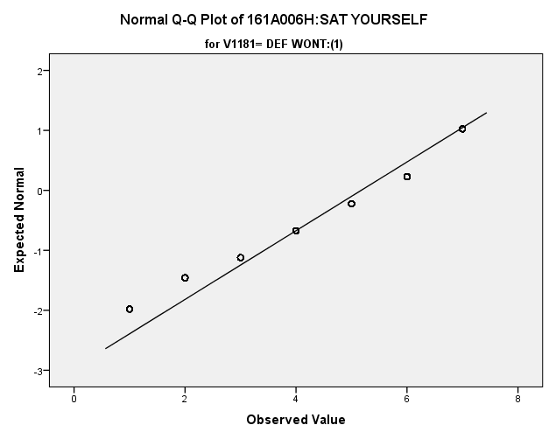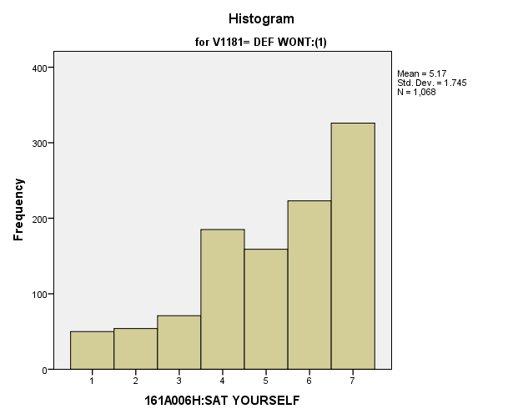

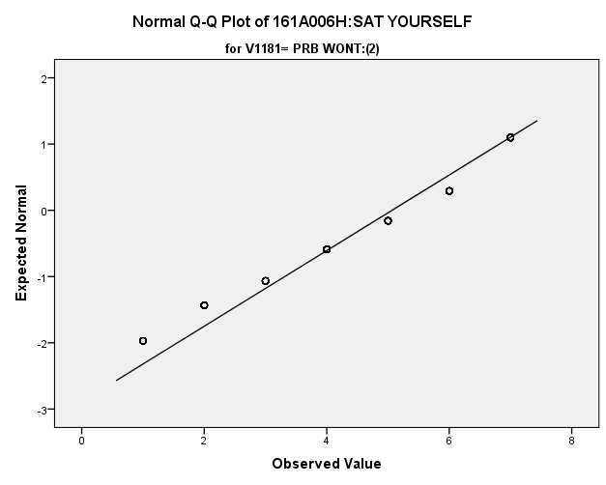

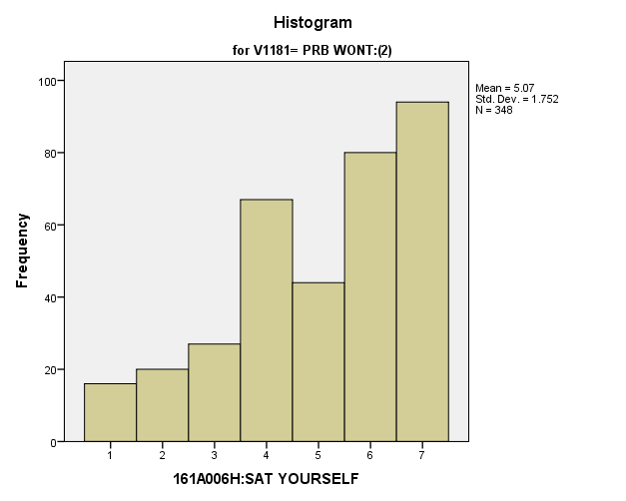

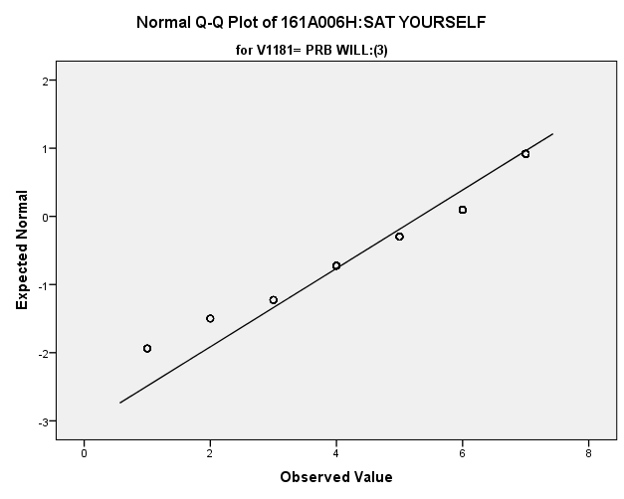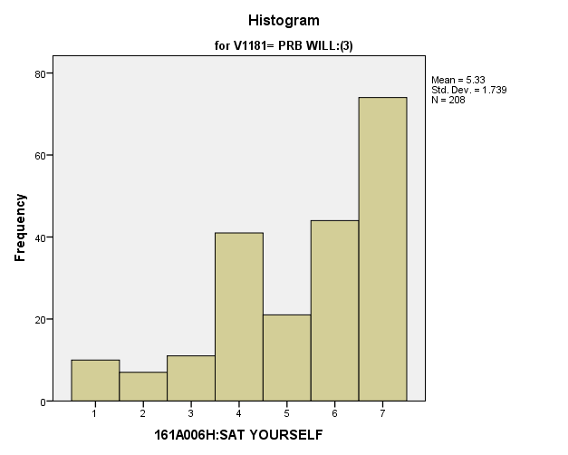

**Exhibit : Descriptives**

|  |  |  |  |  |  |
| --- | --- | --- | --- | --- | --- |
| ***Descriptives*** | | | | | |
|  | V1181 | | | Statistic | Std. Error |
| V1648 | DEF WONT:(1) | Mean | | **5.17** | **.053** |
| 99% Confidence Interval for Mean | Lower Bound | **5.04** |  |
| Upper Bound | **5.31** |  |
| 5% Trimmed Mean | | **5.30** |  |
| Median | | **6.00** |  |
| Variance | | **3.046** |  |
| Std. Deviation | | **1.745** |  |
| Minimum | | **1** |  |
| Maximum | | **7** |  |
| Range | | **6** |  |
| Interquartile Range | | **3** |  |
| Skewness | | **-.757** | **.075** |
| Kurtosis | | **-.333** | **.150** |
| PRB WONT:(2) | Mean | | **5.07** | **.094** |
| 99% Confidence Interval for Mean | Lower Bound | **4.82** |  |
| Upper Bound | **5.31** |  |
| 5% Trimmed Mean | | **5.18** |  |
| Median | | **5.50** |  |
| Variance | | **3.071** |  |
| Std. Deviation | | **1.752** |  |
| Minimum | | **1** |  |
| Maximum | | **7** |  |
| Range | | **6** |  |
| Interquartile Range | | **3** |  |
| Skewness | | **-.661** | **.131** |
| Kurtosis | | **-.509** | **.261** |
| PRB WILL:(3) | Mean | | **5.33** | **.121** |
| 99% Confidence Interval for Mean | Lower Bound | **5.01** |  |
| Upper Bound | **5.64** |  |
| 5% Trimmed Mean | | **5.47** |  |
| Median | | **6.00** |  |
| Variance | | **3.023** |  |
| Std. Deviation | | **1.739** |  |
| Minimum | | **1** |  |
| Maximum | | **7** |  |
| Range | | **6** |  |
| Interquartile Range | | **3** |  |
| Skewness | | **-.875** | **.169** |
| Kurtosis | | **-.105** | **.336** |

**Exhibit: One Way ANOVA Table and Homogeneity**

|  |  |  |  |
| --- | --- | --- | --- |
| ***Test of Homogeneity of Variances*** | | | |
|  | | | |
| Levene Statistic | df1 | df2 | Sig. |
| **.046** | **2** | **1621** | **.955** |

|  |  |  |  |  |  |
| --- | --- | --- | --- | --- | --- |
| ***ANOVA*** | | | | | |
| V1648 | | | | | |
|  | Sum of Squares | df | Mean Square | F | Sig. |
| Between Groups | **8.897** | **2** | **4.449** | **1.460** | **.233** |
| Within Groups | **4940.856** | **1621** | **3.048** |  |  |
| Total | **4949.753** | **1623** |  |  |  |

**Satisfaction with Amount of Free Time:** How do potential recruits differ from the other two groups regarding their satisfaction with the amount of time they have for doing things they like (free time)?

**Variables Used:** The **dependent** **variable** used in the analysis was the satisfaction with the amount of time they have for doing things they like (1=completely dissatisfied, 4=neutral, 7= completely satisfied) and the **independent (grouping) variable** used was the pool of respondents. The respondent pool is broken into three categories:

* Non-recruits (students who say they definitely will not serve in the military after high school graduation) --- these are labeled as *definitely won’t (1).*
* Recruits (students who say they definitely or probably will serve in the military) --- these are labeled as *probably will (3).*
* Potential recruits (those who say they probably will not serve) --- these are labeled as *probably won’t (2)*.
* The desired pool of recruits is those labeled as probably won’t.
* Total respondents: 1621, range for all groups 1 to 7

**Analysis Procedure:**

* A one-way ANOVA test was utilized to compare how the potential pool of recruits differs by the satisfaction with the amount of time they have for doing things they like.
* The analysis variable of satisfaction with the amount of time they have for doing things they like is interval and the grouping variables are mutually exclusive.
* Prior to analysis, a histogram and Q-Q plots were inspected for outliers, none were present. Each group had a negative skew and was than 2.
* The homogeneity of variances assumption was tested. The assumption was met.

**Results:**

* Null and alternative hypothesis:
  + Main Test
    - H0 : µ1 = µ2 = µ3
    - Ha : ALOI
* Calculated F value: f(satisfaction with the amount of free time) 2.710, dfnum= 2, dfden= 1618, α = 0.01, fail to reject H0;

**Interpretation:** There was no significant difference in means between the three groups regarding the satisfaction with the amount of time they have for doing things they like

**Supporting Analysis:**

**Exhibit: Preliminary Analysis**

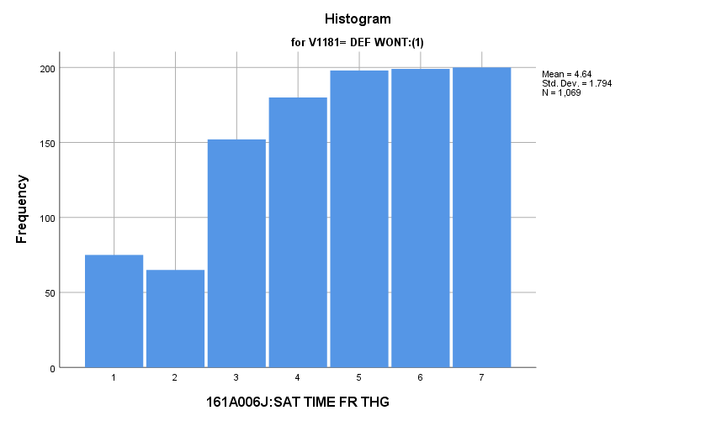

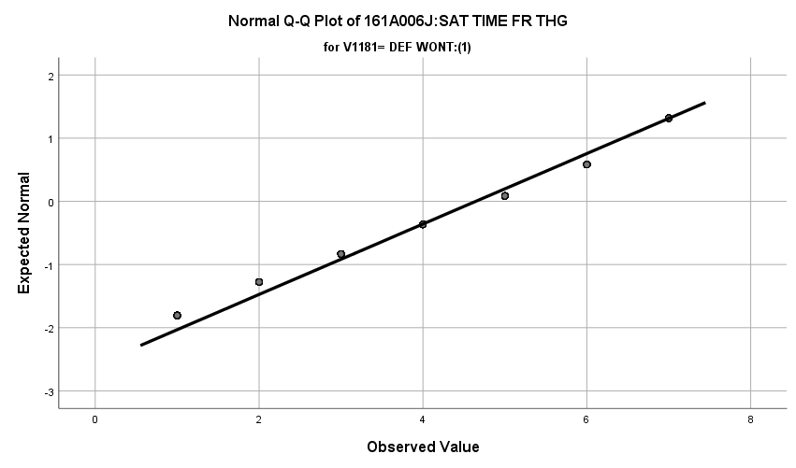

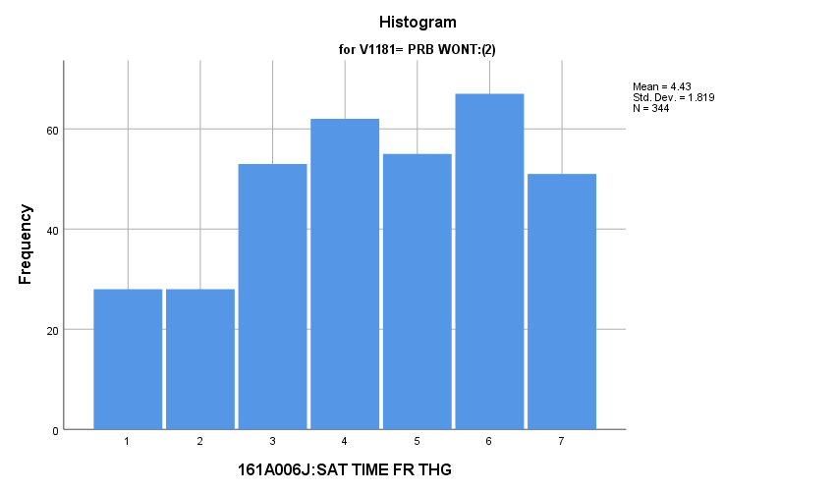

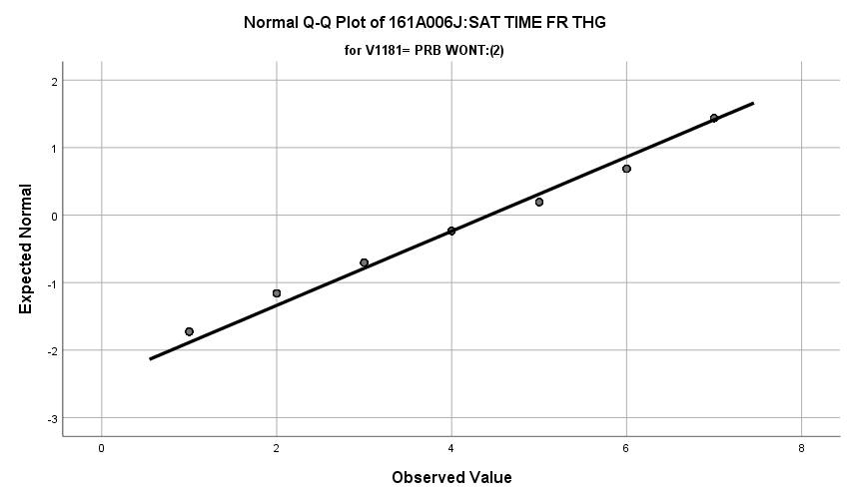

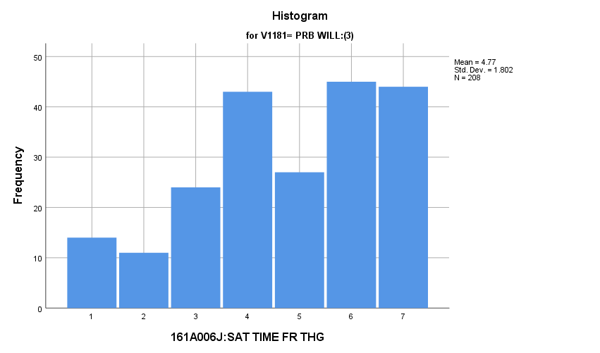

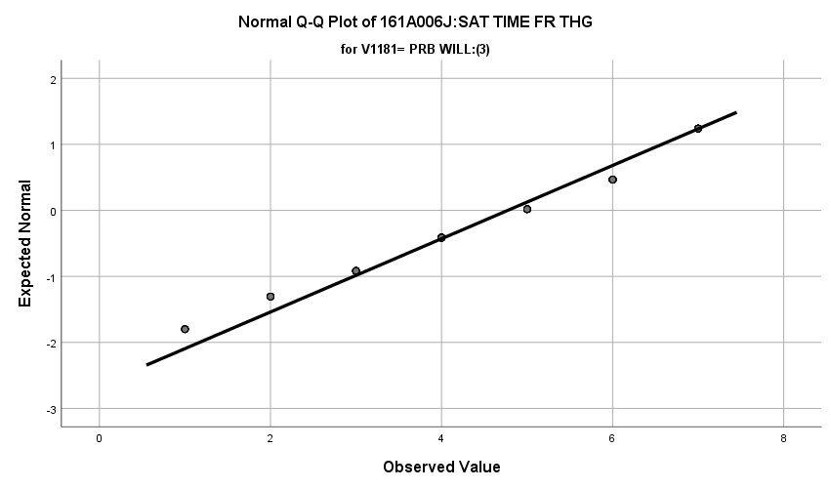

**Exhibit : Descriptives**

|  |  |  |  |  |  |
| --- | --- | --- | --- | --- | --- |
| ***Descriptives*** | | | | | |
|  | V1181 | | | Statistic | Std. Error |
| V1650 | DEF WONT:(1) | Mean | | **4.64** | **.055** |
| 99% Confidence Interval for Mean | Lower Bound | **4.50** |  |
| Upper Bound | **4.79** |  |
| 5% Trimmed Mean | | **4.72** |  |
| Median | | **5.00** |  |
| Variance | | **3.218** |  |
| Std. Deviation | | **1.794** |  |
| Minimum | | **1** |  |
| Maximum | | **7** |  |
| Range | | **6** |  |
| Interquartile Range | | **3** |  |
| Skewness | | **-.396** | **.075** |
| Kurtosis | | **-.791** | **.149** |
| PRB WONT:(2) | Mean | | **4.43** | **.098** |
| 99% Confidence Interval for Mean | Lower Bound | **4.18** |  |
| Upper Bound | **4.69** |  |
| 5% Trimmed Mean | | **4.48** |  |
| Median | | **5.00** |  |
| Variance | | **3.307** |  |
| Std. Deviation | | **1.819** |  |
| Minimum | | **1** |  |
| Maximum | | **7** |  |
| Range | | **6** |  |
| Interquartile Range | | **3** |  |
| Skewness | | **-.276** | **.131** |
| Kurtosis | | **-.933** | **.262** |
| PRB WILL:(3) | Mean | | **4.77** | **.125** |
| 99% Confidence Interval for Mean | Lower Bound | **4.45** |  |
| Upper Bound | **5.10** |  |
| 5% Trimmed Mean | | **4.86** |  |
| Median | | **5.00** |  |
| Variance | | **3.248** |  |
| Std. Deviation | | **1.802** |  |
| Minimum | | **1** |  |
| Maximum | | **7** |  |
| Range | | **6** |  |
| Interquartile Range | | **2** |  |
| Skewness | | **-.477** | **.169** |
| Kurtosis | | **-.722** | **.336** |

**Exhibit: One Way ANOVA Table and Homogeneity**

|  |  |  |  |  |  |
| --- | --- | --- | --- | --- | --- |
| ***Test of Homogeneity of Variances*** | | | | | |
|  | | Levene Statistic | df1 | df2 | Sig. |
| V1650 | Based on Mean | **.178** | **2** | **1618** | **.837** |
| Based on Median | **.612** | **2** | **1618** | **.542** |
| Based on Median and with adjusted df | **.612** | **2** | **1614.170** | **.542** |
| Based on trimmed mean | **.260** | **2** | **1618** | **.771** |

|  |  |  |  |  |  |
| --- | --- | --- | --- | --- | --- |
| ***ANOVA*** | | | | | |
| V1650 | | | | | |
|  | Sum of Squares | df | Mean Square | F | Sig. |
| Between Groups | **17.568** | **2** | **8.784** | **2.710** | **.067** |
| Within Groups | **5243.763** | **1618** | **3.241** |  |  |
| Total | **5261.330** | **1620** |  |  |  |

**Satisfaction with Leisure Time:** How do potential recruits differ from the other two groups regarding their satisfaction with how they spend their leisure time?

**Variables Used:** The **dependent** **variable** used in the analysis was the satisfaction with how they spend their leisure time (1=completely dissatisfied, 4=neutral, 7= completely satisfied) and the **independent (grouping) variable** used was the pool of respondents. The respondent pool is broken into three categories:

* Non-recruits (students who say they definitely will not serve in the military after high school graduation) --- these are labeled as *definitely won’t (1).*
* Recruits (students who say they definitely or probably will serve in the military) --- these are labeled as *probably will (3).*
* Potential recruits (those who say they probably will not serve) --- these are labeled as *probably won’t (2)*.
* The desired pool of recruits is those labeled as probably won’t.
* Total respondents: 1621, range for all groups 1 to 7

**Analysis Procedure:**

* A one-way ANOVA test was utilized to compare how the potential pool of recruits differs by the satisfaction with how they spend their leisure time.
* The analysis variable of satisfaction with how they spend their leisure time is interval and the grouping variables are mutually exclusive.
* Prior to analysis, a histogram and Q-Q plots were inspected for outliers, none were present. Each group had a negative skew and was than 2.
* The homogeneity of variances assumption was tested. The assumption was met.

**Results:**

* Null and alternative hypothesis:
  + Main Test
    - H0 : µ1 = µ2 = µ3
    - Ha : ALOI
* Calculated F value: f(satisfaction with how they spend their leisure time) 4.174, dfnum= 2, dfden= 1621, α = 0.01, fail to reject H0;

**Interpretation:** There was no significant difference in means between the three groups regarding the satisfaction with how they spend their leisure time.

**Supporting Analysis:**

**Exhibit: Preliminary Analysis**

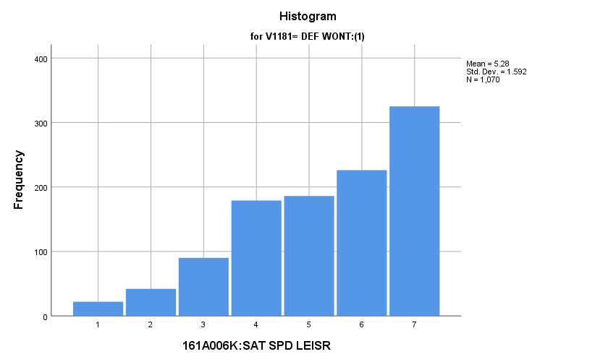

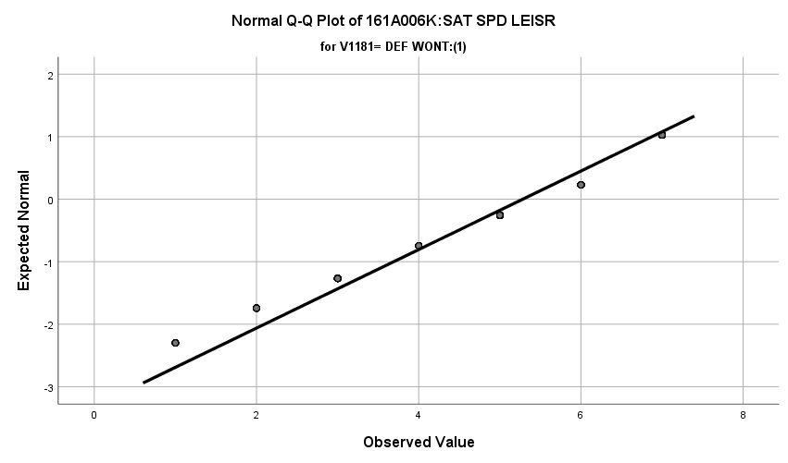

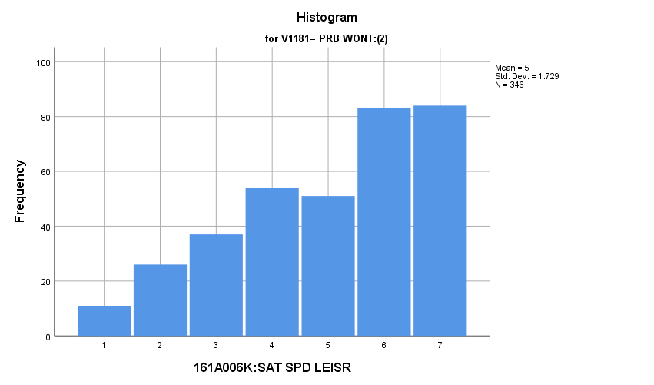

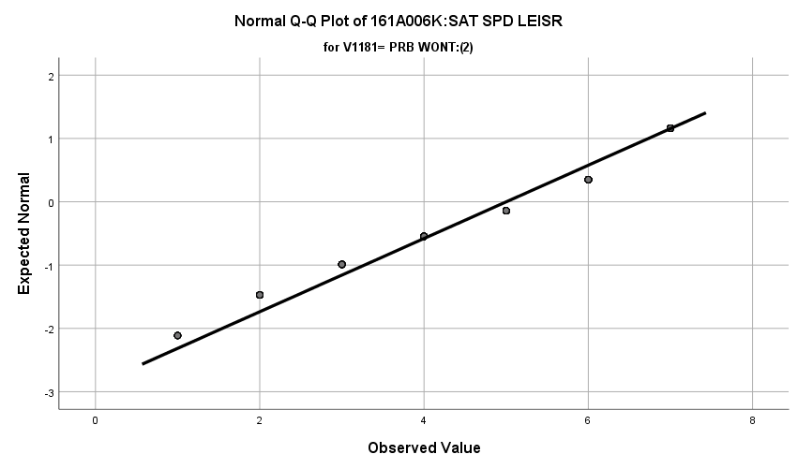

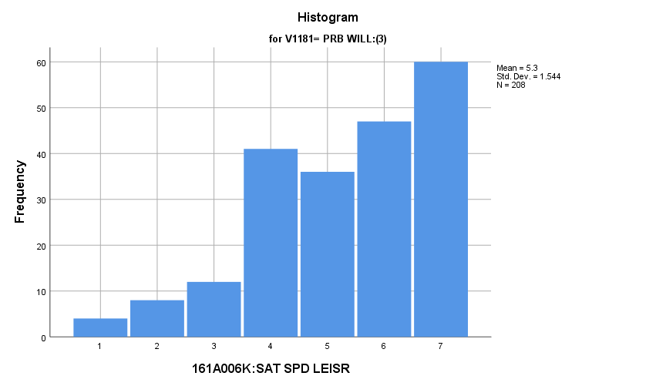

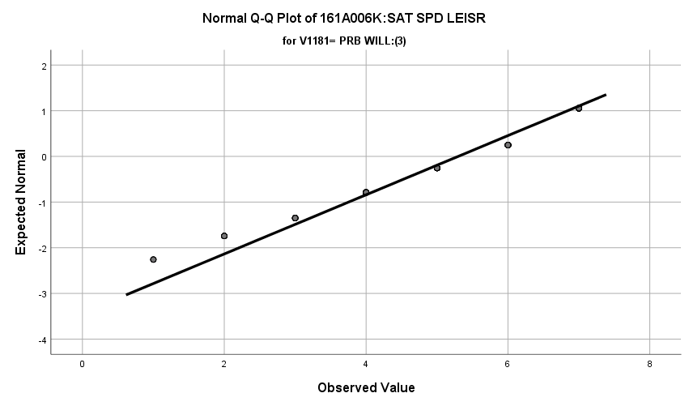

**Exhibit : Descriptives**

|  |  |  |  |  |  |
| --- | --- | --- | --- | --- | --- |
| ***Descriptives*** | | | | | |
|  | V1181 | | | Statistic | Std. Error |
| V1651 | DEF WONT:(1) | Mean | | **5.28** | **.049** |
| 99% Confidence Interval for Mean | Lower Bound | **5.16** |  |
| Upper Bound | **5.41** |  |
| 5% Trimmed Mean | | **5.39** |  |
| Median | | **6.00** |  |
| Variance | | **2.534** |  |
| Std. Deviation | | **1.592** |  |
| Minimum | | **1** |  |
| Maximum | | **7** |  |
| Range | | **6** |  |
| Interquartile Range | | **3** |  |
| Skewness | | **-.683** | **.075** |
| Kurtosis | | **-.357** | **.149** |
| PRB WONT:(2) | Mean | | **5.00** | **.093** |
| 99% Confidence Interval for Mean | Lower Bound | **4.76** |  |
| Upper Bound | **5.24** |  |
| 5% Trimmed Mean | | **5.09** |  |
| Median | | **5.00** |  |
| Variance | | **2.988** |  |
| Std. Deviation | | **1.729** |  |
| Minimum | | **1** |  |
| Maximum | | **7** |  |
| Range | | **6** |  |
| Interquartile Range | | **2** |  |
| Skewness | | **-.570** | **.131** |
| Kurtosis | | **-.712** | **.261** |
| PRB WILL:(3) | Mean | | **5.30** | **.107** |
| 99% Confidence Interval for Mean | Lower Bound | **5.02** |  |
| Upper Bound | **5.58** |  |
| 5% Trimmed Mean | | **5.41** |  |
| Median | | **6.00** |  |
| Variance | | **2.384** |  |
| Std. Deviation | | **1.544** |  |
| Minimum | | **1** |  |
| Maximum | | **7** |  |
| Range | | **6** |  |
| Interquartile Range | | **3** |  |
| Skewness | | **-.701** | **.169** |
| Kurtosis | | **-.176** | **.336** |

**Exhibit: One Way ANOVA Table and Homogeneity**

|  |  |  |  |  |  |
| --- | --- | --- | --- | --- | --- |
| ***Test of Homogeneity of Variances*** | | | | | |
|  | | Levene Statistic | df1 | df2 | Sig. |
| V1651 | Based on Mean | **2.439** | **2** | **1621** | **.088** |
| Based on Median | **2.101** | **2** | **1621** | **.123** |
| Based on Median and with adjusted df | **2.101** | **2** | **1591.210** | **.123** |
| Based on trimmed mean | **2.644** | **2** | **1621** | **.071** |

|  |  |  |  |  |  |
| --- | --- | --- | --- | --- | --- |
| ***ANOVA*** | | | | | |
| V1651 | | | | | |
|  | Sum of Squares | df | Mean Square | F | Sig. |
| Between Groups | **21.801** | **2** | **10.901** | **4.174** | **.016** |
| Within Groups | **4233.714** | **1621** | **2.612** |  |  |
| Total | **4255.515** | **1623** |  |  |  |

**Satisfaction with Life:** How do potential recruits differ from the other two groups regarding their satisfaction with life as a whole?

**Variables Used:** The **dependent** **variable** used in the analysis was the satisfaction with life as a whole (1=completely dissatisfied, 4=neutral, 7= completely satisfied) and the **independent (grouping) variable** used was the pool of respondents. The respondent pool is broken into three categories:

* Non-recruits (students who say they definitely will not serve in the military after high school graduation) --- these are labeled as *definitely won’t (1).*
* Recruits (students who say they definitely or probably will serve in the military) --- these are labeled as *probably will (3).*
* Potential recruits (those who say they probably will not serve) --- these are labeled as *probably won’t (2)*.
* The desired pool of recruits is those labeled as probably won’t.
* Total respondents: 1621, range for all groups 1 to 7

**Analysis Procedure:**

* A one-way ANOVA test was utilized to compare how the potential pool of recruits differs by the satisfaction with life as a whole.
* The analysis variable of satisfaction with life as a whole is interval and the grouping variables are mutually exclusive.
* Prior to analysis, a histogram and Q-Q plots were inspected for outliers, none were present. Each group had a negative skew and was than 2.
* The homogeneity of variances assumption was tested. The assumption was met.
* Eta was calculated to assess effect size.

**Results:**

* Null and alternative hypothesis:
  + Main Test
    - H0 : µ1 = µ2 = µ3
    - Ha : ALOI
  + Post Hoc (1 and 2)
    - H0 : µ1 = µ2
    - Ha : µ1 ≠ µ2
  + Post Hoc (1 and 3)
    - H0 : µ1 = µ3
    - Ha : µ1 ≠ µ3
  + Post Hoc (2 and 3)
    - H0 : µ2 = µ3
    - Ha : µ2 ≠ µ3
* Calculated F value: f(satisfaction with life as a whole) 4.940, dfnum= 2, dfden= 1618, α = 0.01, reject H0; eta = 0.078

**Interpretation:** There was a significant difference in means between the three groups regarding the satisfaction with life as a whole. Interestingly, there were no significant post hoc tests. Observing the values, each group had the following means:

* Probably will (3): 5.21
* Probably won’t (2): 4.87
* Definitely won’t (1): 5.15

One could view probably won’t and probably will as being significantly different but again this is only an eyeball test and can see this in the graph in the means table exhibit. 0.6% of the variation in satisfaction with life scores is explained by the group the respondent is in.

**Supporting Analysis:**

**Exhibit: Preliminary Analysis**

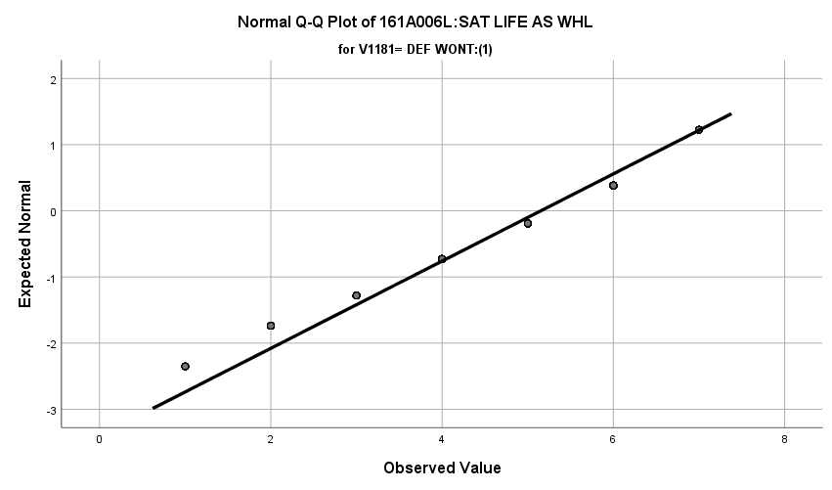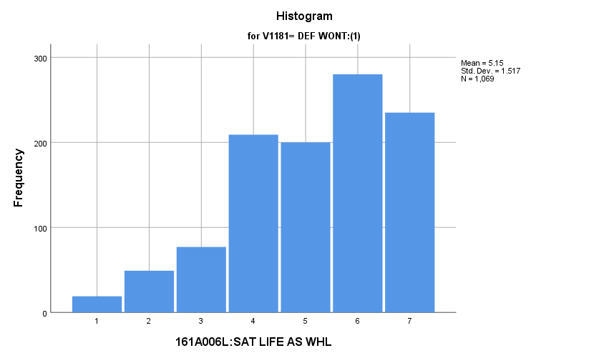

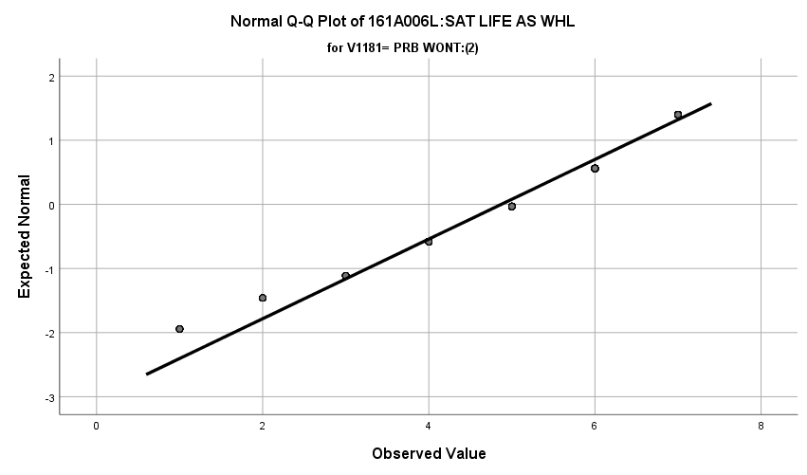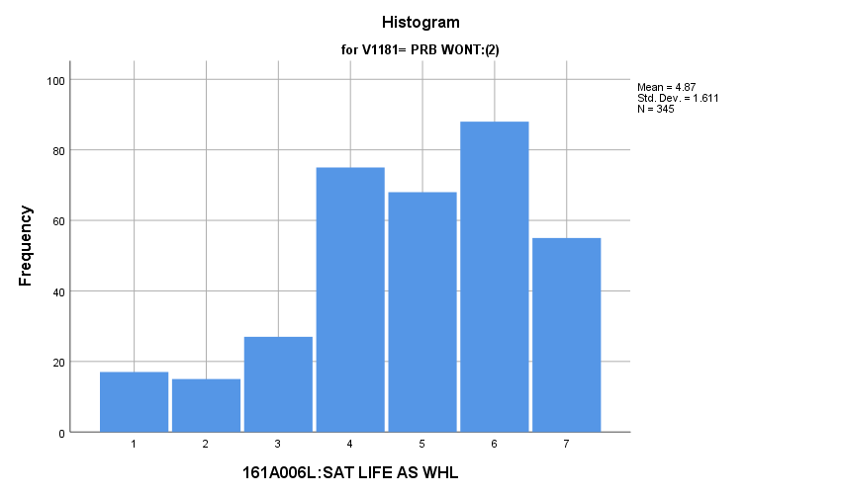

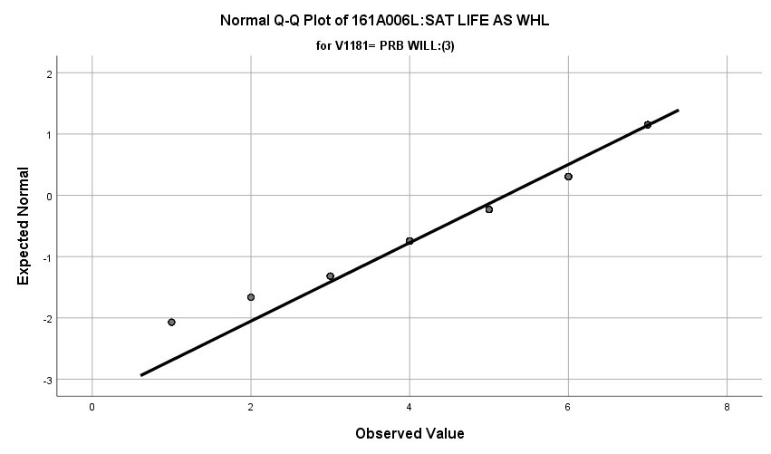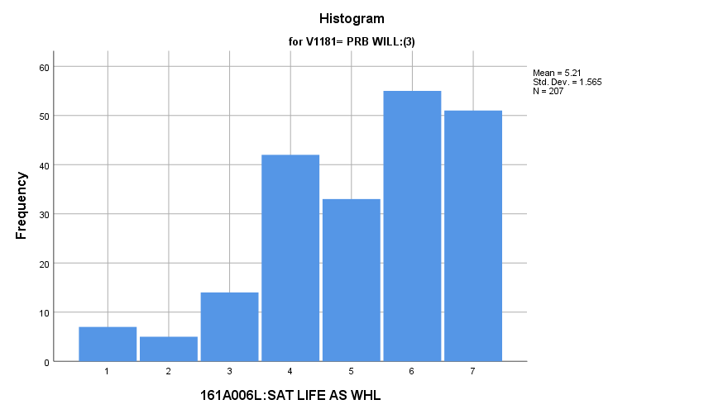

**Exhibit : Descriptives**

|  |  |  |  |  |  |
| --- | --- | --- | --- | --- | --- |
| ***Descriptives*** | | | | | |
|  | V1181 | | | Statistic | Std. Error |
| V1652 | DEF WONT:(1) | Mean | | **5.15** | **.046** |
| 99% Confidence Interval for Mean | Lower Bound | **5.03** |  |
| Upper Bound | **5.27** |  |
| 5% Trimmed Mean | | **5.25** |  |
| Median | | **5.00** |  |
| Variance | | **2.300** |  |
| Std. Deviation | | **1.517** |  |
| Minimum | | **1** |  |
| Maximum | | **7** |  |
| Range | | **6** |  |
| Interquartile Range | | **2** |  |
| Skewness | | **-.629** | **.075** |
| Kurtosis | | **-.268** | **.149** |
| PRB WONT:(2) | Mean | | **4.87** | **.087** |
| 99% Confidence Interval for Mean | Lower Bound | **4.65** |  |
| Upper Bound | **5.10** |  |
| 5% Trimmed Mean | | **4.97** |  |
| Median | | **5.00** |  |
| Variance | | **2.594** |  |
| Std. Deviation | | **1.611** |  |
| Minimum | | **1** |  |
| Maximum | | **7** |  |
| Range | | **6** |  |
| Interquartile Range | | **2** |  |
| Skewness | | **-.640** | **.131** |
| Kurtosis | | **-.174** | **.262** |
| PRB WILL:(3) | Mean | | **5.21** | **.109** |
| 99% Confidence Interval for Mean | Lower Bound | **4.93** |  |
| Upper Bound | **5.50** |  |
| 5% Trimmed Mean | | **5.33** |  |
| Median | | **6.00** |  |
| Variance | | **2.450** |  |
| Std. Deviation | | **1.565** |  |
| Minimum | | **1** |  |
| Maximum | | **7** |  |
| Range | | **6** |  |
| Interquartile Range | | **2** |  |
| Skewness | | **-.764** | **.169** |
| Kurtosis | | **.041** | **.337** |

**Exhibit: Means Table**

|  |  |  |  |
| --- | --- | --- | --- |
| ***Report*** | | | |
| V1652 | | | |
| V1181 | Mean | N | Std. Deviation |
| DEF WONT:(1) | **5.15** | **1069** | **1.517** |
| PRB WONT:(2) | **4.87** | **345** | **1.611** |
| PRB WILL:(3) | **5.21** | **207** | **1.565** |
| Total | **5.10** | **1621** | **1.547** |

**Exhibit: One Way ANOVA Table and Homogeneity**

|  |  |  |  |  |  |
| --- | --- | --- | --- | --- | --- |
| ***Test of Homogeneity of Variances*** | | | | | |
|  | | Levene Statistic | df1 | df2 | Sig. |
| V1652 | Based on Mean | **.523** | **2** | **1618** | **.593** |
| Based on Median | **.155** | **2** | **1618** | **.856** |
| Based on Median and with adjusted df | **.155** | **2** | **1523.526** | **.856** |
| Based on trimmed mean | **.211** | **2** | **1618** | **.809** |

|  |  |  |  |  |  |
| --- | --- | --- | --- | --- | --- |
| ***ANOVA*** | | | | | |
| V1652 | | | | | |
|  | Sum of Squares | df | Mean Square | F | Sig. |
| Between Groups | **23.532** | **2** | **11.766** | **4.940** | **.007** |
| Within Groups | **3853.876** | **1618** | **2.382** |  |  |
| Total | **3877.408** | **1620** |  |  |  |

**Exhibit: Post Hoc Tests**

|  |  |  |  |  |  |  |
| --- | --- | --- | --- | --- | --- | --- |
| ***Multiple Comparisons*** | | | | | | |
| Dependent Variable: V1652 | | | | | | |
| Games-Howell | | | | | | |
| (I) V1181 | (J) V1181 | Mean Difference (I-J) | Std. Error | Sig. | 99% Confidence Interval | |
| Lower Bound | Upper Bound |
| DEF WONT:(1) | PRB WONT:(2) | **.281** | **.098** | **.012** | **-.01** | **.57** |
| PRB WILL:(3) | **-.059** | **.118** | **.871** | **-.41** | **.29** |
| PRB WONT:(2) | DEF WONT:(1) | **-.281** | **.098** | **.012** | **-.57** | **.01** |
| PRB WILL:(3) | **-.340** | **.139** | **.039** | **-.75** | **.07** |
| PRB WILL:(3) | DEF WONT:(1) | **.059** | **.118** | **.871** | **-.29** | **.41** |
| PRB WONT:(2) | **.340** | **.139** | **.039** | **-.07** | **.75** |

**Exhibit Effect Size**

|  |  |  |
| --- | --- | --- |
| ***Measures of Association*** | | |
|  | Eta | Eta Squared |
| V1652 * V1181 | **.078** | **.006** |

**Satisfaction with Government:** How do potential recruits differ from the other two groups regarding how satisfied they are with government?

**Variables Used:** The **dependent** **variable** used in the analysis was how satisfied they are with government (1=completely dissatisfied, 4=neutral, 7= completely satisfied) and the **independent (grouping) variable** used was the pool of respondents. The respondent pool is broken into three categories:

* Non-recruits (students who say they definitely will not serve in the military after high school graduation) --- these are labeled as *definitely won’t (1).*
* Recruits (students who say they definitely or probably will serve in the military) --- these are labeled as *probably will (3).*
* Potential recruits (those who say they probably will not serve) --- these are labeled as *probably won’t (2)*.
* The desired pool of recruits is those labeled as probably won’t.
* Total respondents: 1622, range for all groups 1 to 7

**Analysis Procedure:**

* A one-way ANOVA test was utilized to compare how the potential pool of recruits differs by how satisfied they are with government.
* The analysis variable of how satisfied they are with government is interval and the grouping variables are mutually exclusive.
* Prior to analysis, a histogram and Q-Q plots were inspected for outliers, none were present. Each group had a positive skew and was than 2.
* The homogeneity of variances assumption was tested. The assumption was not met but the groups are approximately the same size.

**Results:**

* Null and alternative hypothesis:
  + Main Test
    - H0 : µ1 = µ2 = µ3
    - Ha : ALOI
* Calculated F value: f(how satisfied they are with government) 0.804, dfnum= 2, dfden= 1619, α = 0.01, fail to reject H0;

**Interpretation:** There was no significant difference in means between the three groups how satisfied they are with government.

**Supporting Analysis:**

**Exhibit: Preliminary Analysis**

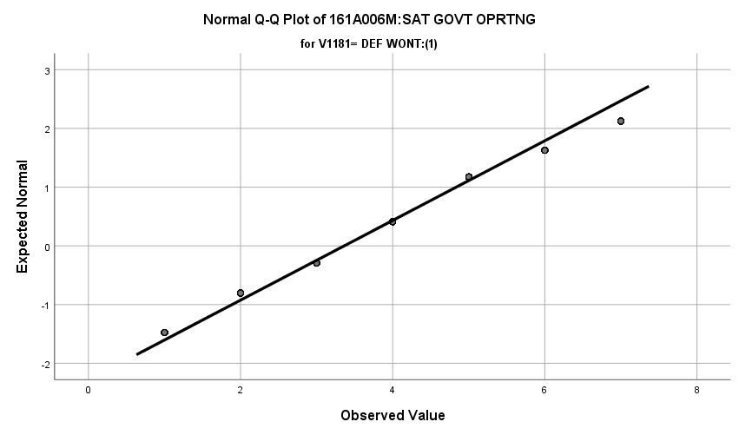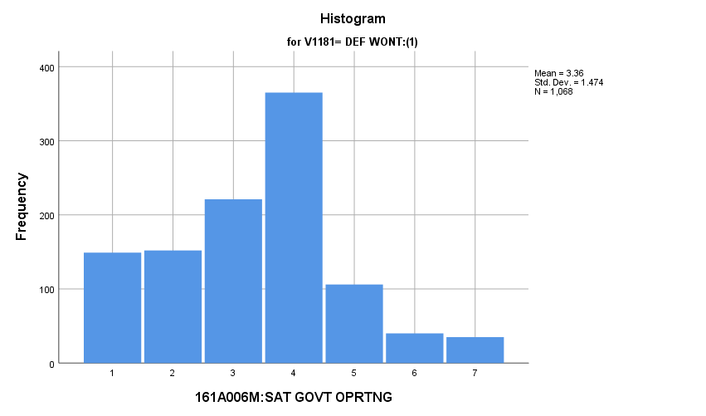

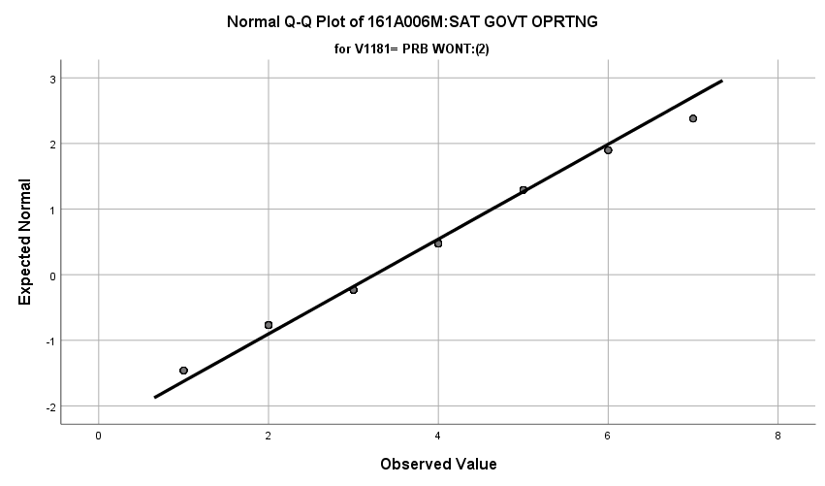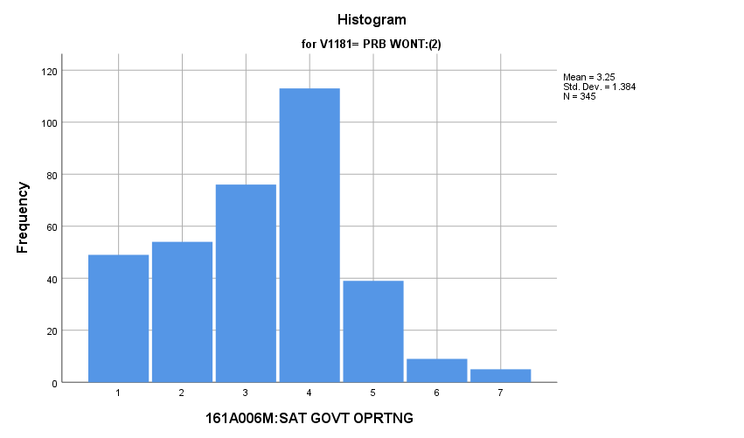

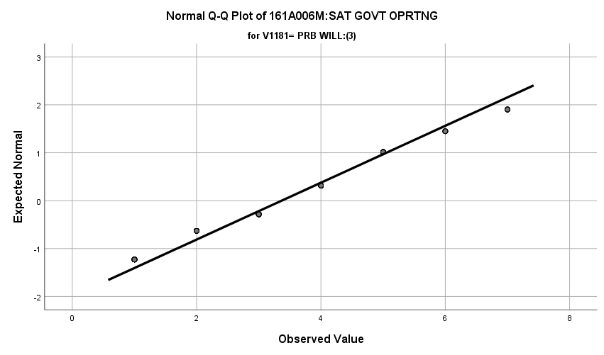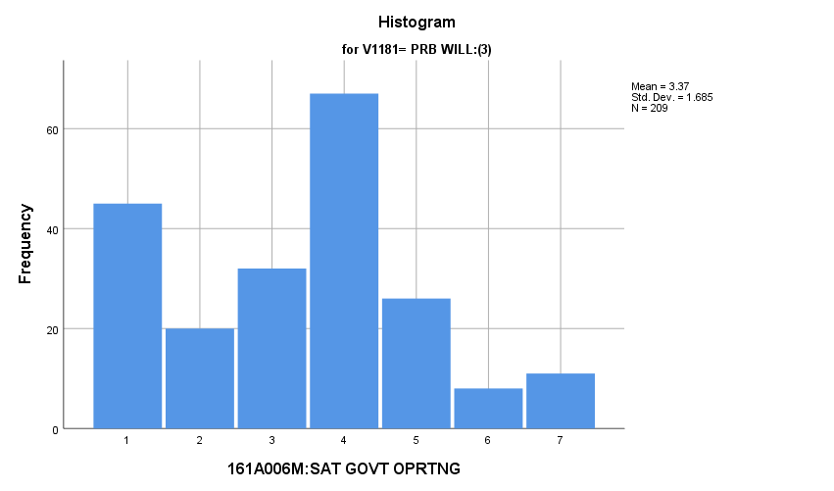

**Exhibit : Descriptives**

|  |  |  |  |  |  |
| --- | --- | --- | --- | --- | --- |
| ***Descriptives*** | | | | | |
|  | V1181 | | | Statistic | Std. Error |
| V1653 | DEF WONT:(1) | Mean | | **3.36** | **.045** |
| 99% Confidence Interval for Mean | Lower Bound | **3.25** |  |
| Upper Bound | **3.48** |  |
| 5% Trimmed Mean | | **3.31** |  |
| Median | | **4.00** |  |
| Variance | | **2.171** |  |
| Std. Deviation | | **1.474** |  |
| Minimum | | **1** |  |
| Maximum | | **7** |  |
| Range | | **6** |  |
| Interquartile Range | | **2** |  |
| Skewness | | **.182** | **.075** |
| Kurtosis | | **-.199** | **.150** |
| PRB WONT:(2) | Mean | | **3.25** | **.074** |
| 99% Confidence Interval for Mean | Lower Bound | **3.06** |  |
| Upper Bound | **3.44** |  |
| 5% Trimmed Mean | | **3.22** |  |
| Median | | **3.00** |  |
| Variance | | **1.914** |  |
| Std. Deviation | | **1.384** |  |
| Minimum | | **1** |  |
| Maximum | | **7** |  |
| Range | | **6** |  |
| Interquartile Range | | **2** |  |
| Skewness | | **.049** | **.131** |
| Kurtosis | | **-.368** | **.262** |
| PRB WILL:(3) | Mean | | **3.37** | **.117** |
| 99% Confidence Interval for Mean | Lower Bound | **3.07** |  |
| Upper Bound | **3.67** |  |
| 5% Trimmed Mean | | **3.30** |  |
| Median | | **4.00** |  |
| Variance | | **2.840** |  |
| Std. Deviation | | **1.685** |  |
| Minimum | | **1** |  |
| Maximum | | **7** |  |
| Range | | **6** |  |
| Interquartile Range | | **2** |  |
| Skewness | | **.154** | **.168** |
| Kurtosis | | **-.602** | **.335** |

**Exhibit: One Way ANOVA Table and Homogeneity**

|  |  |  |  |  |  |
| --- | --- | --- | --- | --- | --- |
| ***Test of Homogeneity of Variances*** | | | | | |
|  | | Levene Statistic | df1 | df2 | Sig. |
| V1653 | Based on Mean | **6.171** | **2** | **1619** | **.002** |
| Based on Median | **2.972** | **2** | **1619** | **.052** |
| Based on Median and with adjusted df | **2.972** | **2** | **1553.817** | **.052** |
| Based on trimmed mean | **6.463** | **2** | **1619** | **.002** |

|  |  |  |  |  |  |
| --- | --- | --- | --- | --- | --- |
| ***ANOVA*** | | | | | |
| V1653 | | | | | |
|  | Sum of Squares | df | Mean Square | F | Sig. |
| Between Groups | **3.541** | **2** | **1.771** | **.804** | **.448** |
| Within Groups | **3565.961** | **1619** | **2.203** |  |  |
| Total | **3569.502** | **1621** |  |  |  |

**Satisfaction with the Amount of Fun You Have:** How do potential recruits differ from the other two groups regarding their satisfaction with the amount of fun they have?

**Variables Used:** The **dependent** **variable** used in the analysis was how satisfied they are with the amount of fun they have (1=completely dissatisfied, 4=neutral, 7= completely satisfied) and the **independent (grouping) variable** used was the pool of respondents. The respondent pool is broken into three categories:

* Non-recruits (students who say they definitely will not serve in the military after high school graduation) --- these are labeled as *definitely won’t (1).*
* Recruits (students who say they definitely or probably will serve in the military) --- these are labeled as *probably will (3).*
* Potential recruits (those who say they probably will not serve) --- these are labeled as *probably won’t (2)*.
* The desired pool of recruits is those labeled as probably won’t.
* Total respondents: 1629, range for all groups 1 to 7

**Analysis Procedure:**

* A one-way ANOVA test was utilized to compare how the potential pool of recruits differs by how satisfied they are with the amount of fun they have.
* The analysis variable of how satisfied they are with the amount of fun they have is interval and the grouping variables are mutually exclusive.
* Prior to analysis, a histogram and Q-Q plots were inspected for outliers, none were present. Each group had a negative skew and was than 2.
* The homogeneity of variances assumption was tested. The assumption was met.

**Results:**

* Null and alternative hypothesis:
  + Main Test
    - H0 : µ1 = µ2 = µ3
    - Ha : ALOI
* Calculated F value: f(how satisfied they are with the amount of fun they have) 3.654, dfnum= 2, dfden= 1626, α = 0.01, fail to reject H0;

**Interpretation:** There was no significant difference in means between the three groups how satisfied they are with the amount of fun they have.

**Supporting Analysis:**

**Exhibit: Histograms**

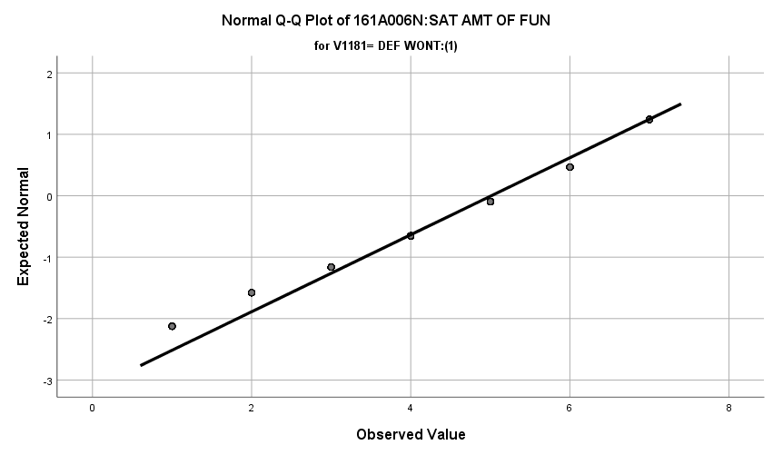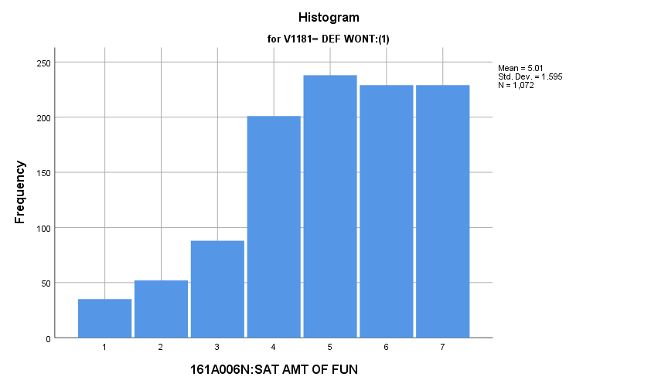

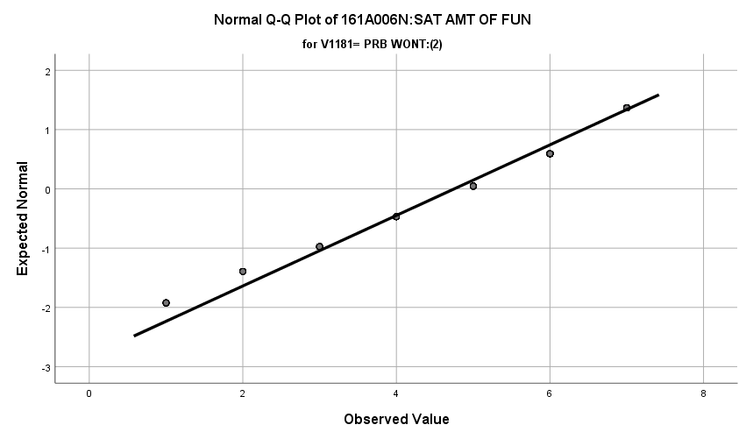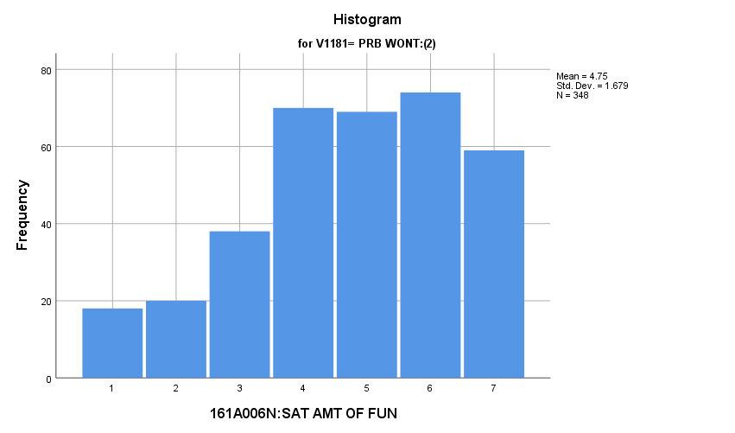

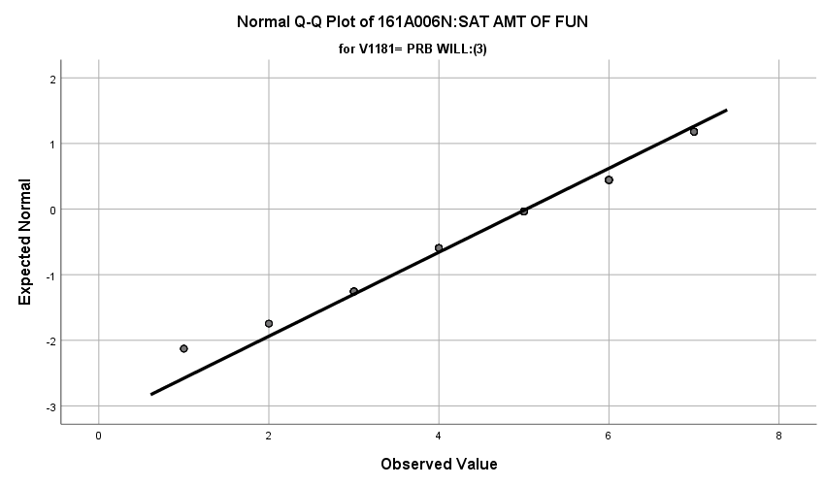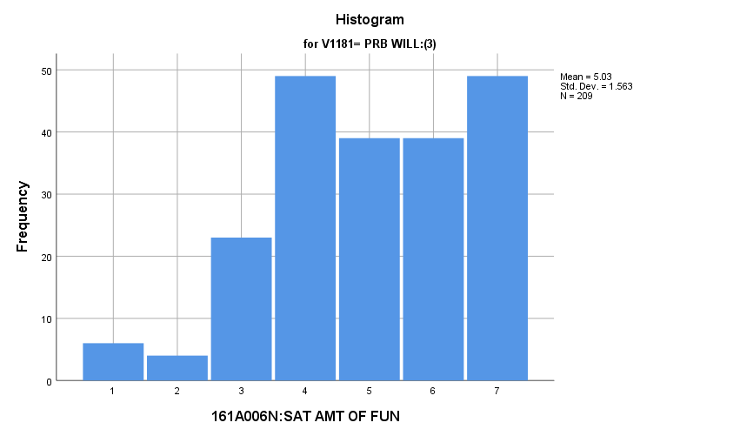

**Exhibit : Descriptives**

|  |  |  |  |  |  |
| --- | --- | --- | --- | --- | --- |
| ***Descriptives*** | | | | | |
|  | V1181 | | | Statistic | Std. Error |
| V1654 | DEF WONT:(1) | Mean | | **5.01** | **.049** |
| 99% Confidence Interval for Mean | Lower Bound | **4.89** |  |
| Upper Bound | **5.14** |  |
| 5% Trimmed Mean | | **5.11** |  |
| Median | | **5.00** |  |
| Variance | | **2.545** |  |
| Std. Deviation | | **1.595** |  |
| Minimum | | **1** |  |
| Maximum | | **7** |  |
| Range | | **6** |  |
| Interquartile Range | | **2** |  |
| Skewness | | **-.598** | **.075** |
| Kurtosis | | **-.282** | **.149** |
| PRB WONT:(2) | Mean | | **4.75** | **.090** |
| 99% Confidence Interval for Mean | Lower Bound | **4.52** |  |
| Upper Bound | **4.99** |  |
| 5% Trimmed Mean | | **4.84** |  |
| Median | | **5.00** |  |
| Variance | | **2.821** |  |
| Std. Deviation | | **1.679** |  |
| Minimum | | **1** |  |
| Maximum | | **7** |  |
| Range | | **6** |  |
| Interquartile Range | | **2** |  |
| Skewness | | **-.483** | **.131** |
| Kurtosis | | **-.526** | **.261** |
| PRB WILL:(3) | Mean | | **5.03** | **.108** |
| 99% Confidence Interval for Mean | Lower Bound | **4.75** |  |
| Upper Bound | **5.31** |  |
| 5% Trimmed Mean | | **5.12** |  |
| Median | | **5.00** |  |
| Variance | | **2.441** |  |
| Std. Deviation | | **1.563** |  |
| Minimum | | **1** |  |
| Maximum | | **7** |  |
| Range | | **6** |  |
| Interquartile Range | | **2** |  |
| Skewness | | **-.430** | **.168** |
| Kurtosis | | **-.440** | **.335** |

**Exhibit: One Way ANOVA Table and Homogeneity**

|  |  |  |  |  |  |
| --- | --- | --- | --- | --- | --- |
| ***Test of Homogeneity of Variances*** | | | | | |
|  | | Levene Statistic | df1 | df2 | Sig. |
| V1654 | Based on Mean | **2.112** | **2** | **1626** | **.121** |
| Based on Median | **.941** | **2** | **1626** | **.391** |
| Based on Median and with adjusted df | **.941** | **2** | **1615.789** | **.391** |
| Based on trimmed mean | **1.276** | **2** | **1626** | **.280** |

|  |  |  |  |  |  |
| --- | --- | --- | --- | --- | --- |
| ***ANOVA*** | | | | | |
| V1654 | | | | | |
|  | Sum of Squares | df | Mean Square | F | Sig. |
| Between Groups | **18.934** | **2** | **9.467** | **3.654** | **.026** |
| Within Groups | **4212.392** | **1626** | **2.591** |  |  |
| Total | **4231.326** | **1628** |  |  |  |

**Satisfaction with Present Job:** How do potential recruits differ from the other two groups regarding their satisfaction with their present job?

**Variables Used:** The **dependent** **variable** used in the analysis was the satisfaction with their present job (1=completely dissatisfied, 4=neutral, 7= completely satisfied) and the **independent (grouping) variable** used was the pool of respondents. The respondent pool is broken into three categories:

* Non-recruits (students who say they definitely will not serve in the military after high school graduation) --- these are labeled as *definitely won’t (1).*
* Recruits (students who say they definitely or probably will serve in the military) --- these are labeled as *probably will (3).*
* Potential recruits (those who say they probably will not serve) --- these are labeled as *probably won’t (2)*.
* The desired pool of recruits is those labeled as probably won’t.
* Total respondents: 907, range for all groups 1 to 7

**Analysis Procedure:**

* A one-way ANOVA test was utilized to compare how the potential pool of recruits differs by the satisfaction with their current job.
* The analysis variable of satisfaction with their current job interval and the grouping variables are mutually exclusive.
* Prior to analysis, a histogram and Q-Q plots were inspected for outliers, none were present. Each group had a negative skew and was than 2.
* The homogeneity of variances assumption was tested. The assumption was met.
* Eta was calculated to assess effect size.

**Results:**

* Null and alternative hypothesis:
  + Main Test
    - H0 : µ1 = µ2 = µ3
    - Ha : ALOI
  + Post Hoc (1 and 2)
    - H0 : µ1 = µ2
    - Ha : µ1 ≠ µ2
  + Post Hoc (1 and 3)
    - H0 : µ1 = µ3
    - Ha : µ1 ≠ µ3
  + Post Hoc (2 and 3)
    - H0 : µ2 = µ3
    - Ha : µ2 ≠ µ3
* Calculated F value: f(satisfaction with life as a whole) 5.762, dfnum= 2, dfden= 904, α = 0.01, reject H0; eta = 0.112

**Interpretation:** There was a significant difference in means between the three groups regarding the satisfaction with their present job. Interestingly, there were no significant post hoc tests. Observing the values, each group had the following means:

* Probably will (3): 4.62
* Probably won’t (2): 4.72
* Definitely won’t (1): 5.08

One could view probably will and definitely won’t as being significantly different but again this is only an eyeball test and can be seen on the means graph under means table exhibit. 1.25% of the variation in the satisfaction with the present job is attributable to the respondent group the individual resides in.

**Supporting Analysis:**

**Exhibit: Preliminary Analysis:**

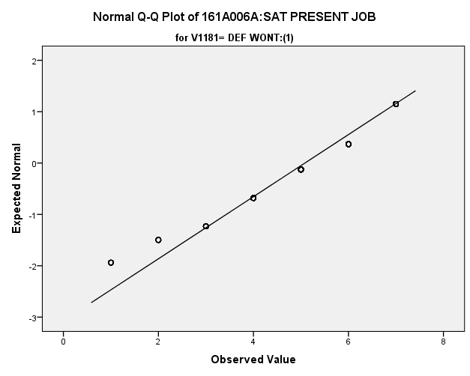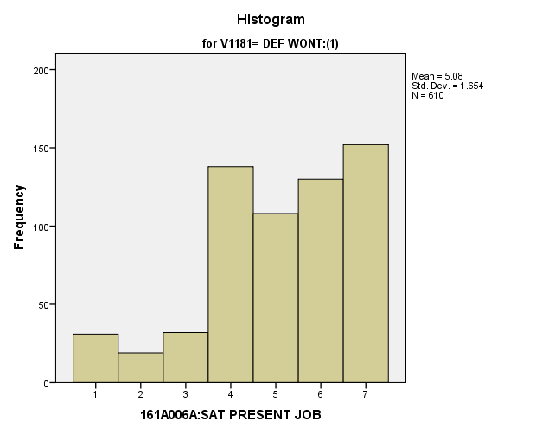

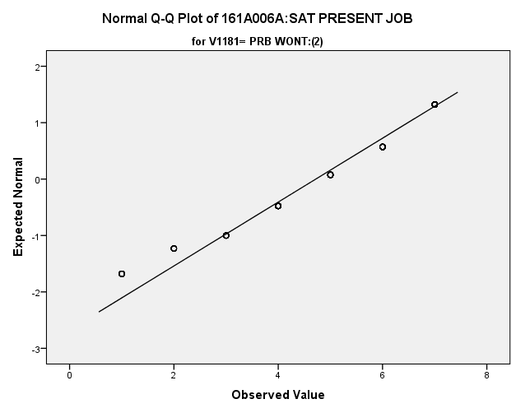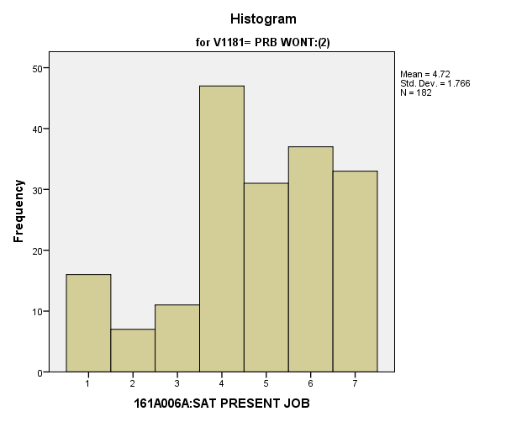

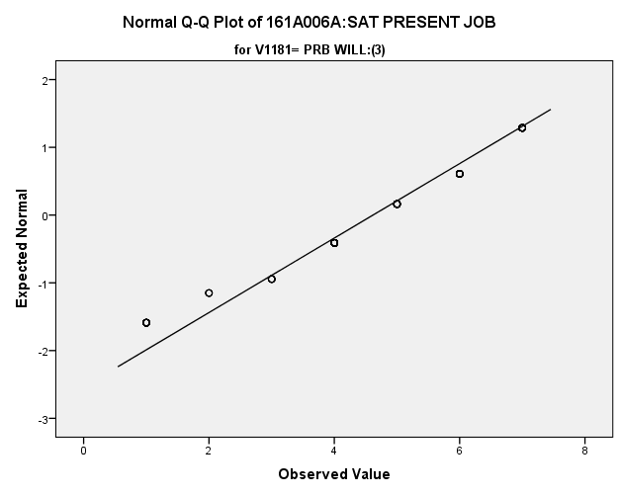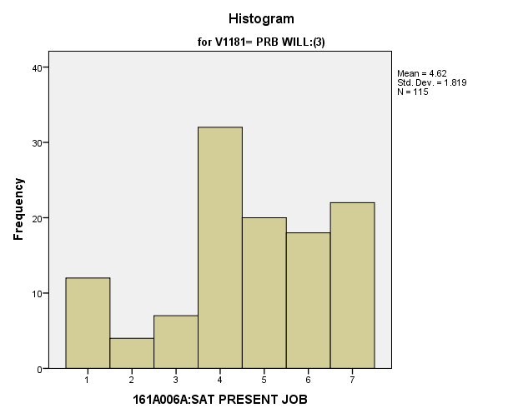

**Exhibit: Descriptives**

|  |  |  |  |  |  |
| --- | --- | --- | --- | --- | --- |
| ***Descriptives*** | | | | | |
|  | V1181 | | | Statistic | Std. Error |
| V1641 | DEF WONT:(1) | Mean | | **5.08** | **.067** |
| 99% Confidence Interval for Mean | Lower Bound | **4.91** |  |
| Upper Bound | **5.26** |  |
| 5% Trimmed Mean | | **5.20** |  |
| Median | | **5.00** |  |
| Variance | | **2.737** |  |
| Std. Deviation | | **1.654** |  |
| Minimum | | **1** |  |
| Maximum | | **7** |  |
| Range | | **6** |  |
| Interquartile Range | | **2** |  |
| Skewness | | **-.714** | **.099** |
| Kurtosis | | **-.076** | **.198** |
| PRB WONT:(2) | Mean | | **4.72** | **.131** |
| 99% Confidence Interval for Mean | Lower Bound | **4.38** |  |
| Upper Bound | **5.06** |  |
| 5% Trimmed Mean | | **4.80** |  |
| Median | | **5.00** |  |
| Variance | | **3.120** |  |
| Std. Deviation | | **1.766** |  |
| Minimum | | **1** |  |
| Maximum | | **7** |  |
| Range | | **6** |  |
| Interquartile Range | | **2** |  |
| Skewness | | **-.576** | **.180** |
| Kurtosis | | **-.383** | **.358** |
| PRB WILL:(3) | Mean | | **4.62** | **.170** |
| 99% Confidence Interval for Mean | Lower Bound | **4.17** |  |
| Upper Bound | **5.06** |  |
| 5% Trimmed Mean | | **4.69** |  |
| Median | | **5.00** |  |
| Variance | | **3.308** |  |
| Std. Deviation | | **1.819** |  |
| Minimum | | **1** |  |
| Maximum | | **7** |  |
| Range | | **6** |  |
| Interquartile Range | | **2** |  |
| Skewness | | **-.490** | **.226** |
| Kurtosis | | **-.487** | **.447** |

**Exhibit: One Way ANOVA Table and Homogeneity**

|  |  |  |  |
| --- | --- | --- | --- |
| ***Test of Homogeneity of Variances*** | | | |
| V1641 | | | |
| Levene Statistic | df1 | df2 | Sig. |
| **1.308** | **2** | **904** | **.271** |

|  |  |  |  |  |  |
| --- | --- | --- | --- | --- | --- |
| ***ANOVA*** | | | | | |
| V1641 | | | | | |
|  | Sum of Squares | df | Mean Square | F | Sig. |
| Between Groups | **33.255** | **2** | **16.628** | **5.762** | **.003** |
| Within Groups | **2608.610** | **904** | **2.886** |  |  |
| Total | **2641.865** | **906** |  |  |  |

**Exhibit: Means Table**

|  |  |  |  |
| --- | --- | --- | --- |
| ***Report*** | | | |
| V1641 | | | |
| V1181 | Mean | N | Std. Deviation |
| DEF WONT:(1) | **5.08** | **610** | **1.654** |
| PRB WONT:(2) | **4.72** | **182** | **1.766** |
| PRB WILL:(3) | **4.62** | **115** | **1.819** |
| Total | **4.95** | **907** | **1.708** |

**Exhibit: Post Hoc Tests**

|  |  |  |  |  |  |
| --- | --- | --- | --- | --- | --- |
| ***Multiple Comparisons*** | | | | | |
| Dependent Variable: V1641 | | | | | |
| Games-Howell | | | | | |
| (I) V1181 | (J) V1181 | Mean Difference (I-J) | Std. Error | Sig. | 99% Confidence Interval |
| Lower Bound |
| DEF WONT:(1) | PRB WONT:(2) | **.364** | **.147** | **.037** | **-.07** |
| PRB WILL:(3) | **.466** | **.182** | **.031** | **-.07** |
| PRB WONT:(2) | DEF WONT:(1) | **-.364** | **.147** | **.037** | **-.80** |
| PRB WILL:(3) | **.102** | **.214** | **.882** | **-.53** |
| PRB WILL:(3) | DEF WONT:(1) | **-.466** | **.182** | **.031** | **-1.01** |
| PRB WONT:(2) | **-.102** | **.214** | **.882** | **-.73** |

|  |  |  |
| --- | --- | --- |
| ***Multiple Comparisons*** | | |
| Dependent Variable: V1641 | | |
| Games-Howell | | |
| (I) V1181 | (J) V1181 | 99% Confidence Interval |
| Upper Bound |
| DEF WONT:(1) | PRB WONT:(2) | **.80** |
| PRB WILL:(3) | **1.01** |
| PRB WONT:(2) | DEF WONT:(1) | **.07** |
| PRB WILL:(3) | **.73** |
| PRB WILL:(3) | DEF WONT:(1) | **.07** |
| PRB WONT:(2) | **.53** |

**Exhibit: Effect Size**

|  |  |  |
| --- | --- | --- |
| ***Measures of Association*** | | |
|  | Eta | Eta Squared |
| V1641 * V1181 | **.112** | **.013** |

**Satisfaction with Personal Safety:** How do potential recruits differ from the other two groups regarding their satisfaction with their personal safety in their neighborhood, on your job, and in your school – safety from being attached and injured in some way (personal safety)?

**Variables Used:** The **dependent** **variable** used in the analysis was how satisfied they are with their personal safety (1=completely dissatisfied, 4=neutral, 7= completely satisfied) and the **independent (grouping) variable** used was the pool of respondents. The respondent pool is broken into three categories:

* Non-recruits (students who say they definitely will not serve in the military after high school graduation) --- these are labeled as *definitely won’t (1).*
* Recruits (students who say they definitely or probably will serve in the military) --- these are labeled as *probably will (3).*
* Potential recruits (those who say they probably will not serve) --- these are labeled as *probably won’t (2)*.
* The desired pool of recruits is those labeled as probably won’t.
* Total respondents: 1622, range for all groups 1 to 7

**Analysis Procedure:**

* A one-way ANOVA test was utilized to compare how the potential pool of recruits differs by how satisfied they are with their personal safety.
* The analysis variable of how satisfied they are with their personal safety is interval and the grouping variables are mutually exclusive.
* Prior to analysis, a histogram and Q-Q plots were inspected for outliers, none were present. Each group had a negative skew and was than 2.
* The homogeneity of variances assumption was tested. The assumption was met.

**Results:**

* Null and alternative hypothesis:
  + Main Test
    - H0 : µ1 = µ2 = µ3
    - Ha : ALOI
* Calculated F value: f(how satisfied they are with their personal safety) 2.075, dfnum= 2, dfden= 1621, α = 0.01, fail to reject H0;

**Interpretation:** There was no significant difference in means between the three groups how satisfied they are with their personal safety.

**Supporting Analysis:**

**Exhibit: Histograms**

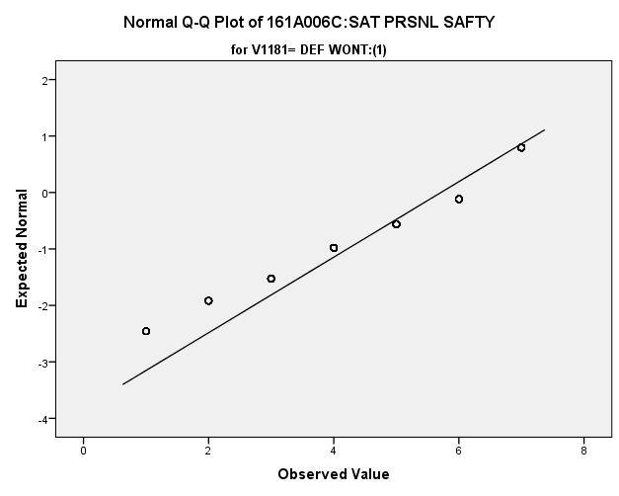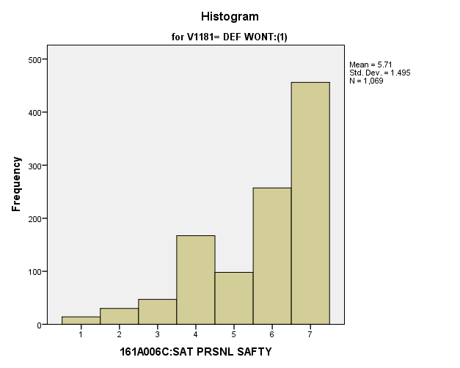

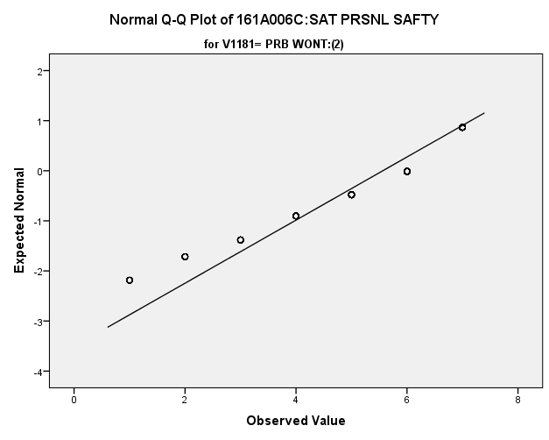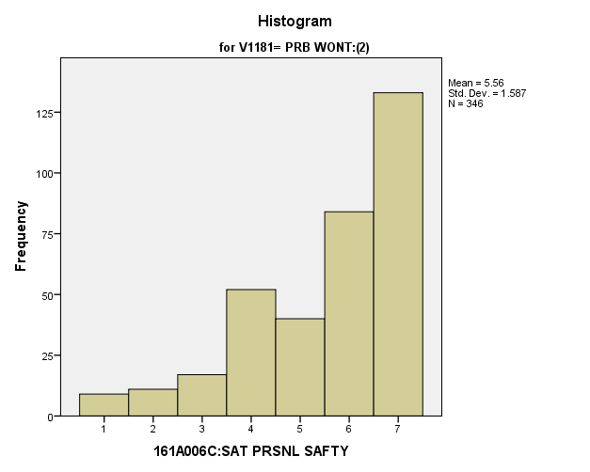

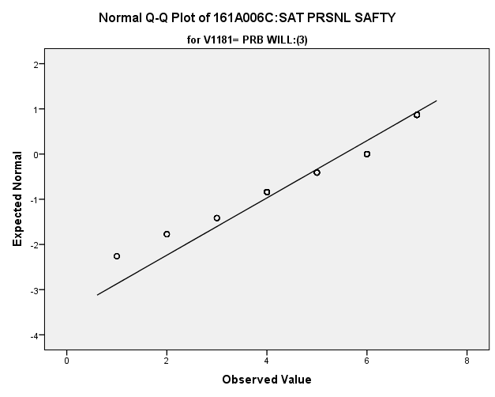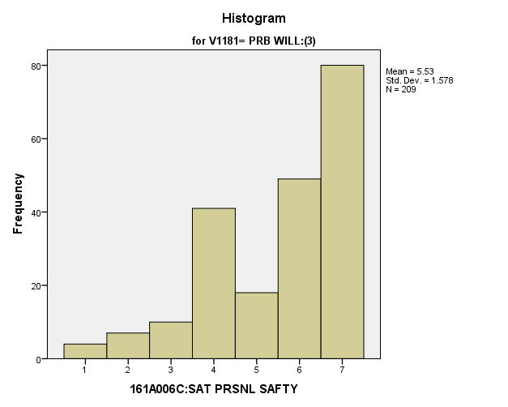

**Exhibit : Descriptives**

|  |  |  |  |  |  |
| --- | --- | --- | --- | --- | --- |
| ***Descriptives*** | | | | | |
|  | V1181 | | | Statistic | Std. Error |
| V1643 | DEF WONT:(1) | Mean | | **5.71** | **.046** |
| 99% Confidence Interval for Mean | Lower Bound | **5.59** |  |
| Upper Bound | **5.83** |  |
| 5% Trimmed Mean | | **5.85** |  |
| Median | | **6.00** |  |
| Variance | | **2.235** |  |
| Std. Deviation | | **1.495** |  |
| Minimum | | **1** |  |
| Maximum | | **7** |  |
| Range | | **6** |  |
| Interquartile Range | | **2** |  |
| Skewness | | **-1.077** | **.075** |
| Kurtosis | | **.360** | **.149** |
| PRB WONT:(2) | Mean | | **5.56** | **.085** |
| 99% Confidence Interval for Mean | Lower Bound | **5.34** |  |
| Upper Bound | **5.78** |  |
| 5% Trimmed Mean | | **5.71** |  |
| Median | | **6.00** |  |
| Variance | | **2.519** |  |
| Std. Deviation | | **1.587** |  |
| Minimum | | **1** |  |
| Maximum | | **7** |  |
| Range | | **6** |  |
| Interquartile Range | | **3** |  |
| Skewness | | **-1.053** | **.131** |
| Kurtosis | | **.365** | **.261** |
| PRB WILL:(3) | Mean | | **5.53** | **.109** |
| 99% Confidence Interval for Mean | Lower Bound | **5.25** |  |
| Upper Bound | **5.81** |  |
| 5% Trimmed Mean | | **5.67** |  |
| Median | | **6.00** |  |
| Variance | | **2.491** |  |
| Std. Deviation | | **1.578** |  |
| Minimum | | **1** |  |
| Maximum | | **7** |  |
| Range | | **6** |  |
| Interquartile Range | | **3** |  |
| Skewness | | **-.906** | **.168** |
| Kurtosis | | **-.023** | **.335** |

**Exhibit: One Way ANOVA Table and Homogeneity**

|  |  |  |  |
| --- | --- | --- | --- |
| ***Test of Homogeneity of Variances*** | | | |
| V1643 | | | |
| Levene Statistic | df1 | df2 | Sig. |
| **2.161** | **2** | **1621** | **.116** |

|  |  |  |  |  |  |
| --- | --- | --- | --- | --- | --- |
| ***ANOVA*** | | | | | |
| V1643 | | | | | |
|  | Sum of Squares | df | Mean Square | F | Sig. |
| Between Groups | **9.662** | **2** | **4.831** | **2.075** | **.126** |
| Within Groups | **3773.983** | **1621** | **2.328** |  |  |
| Total | **3783.645** | **1623** |  |  |  |

**Satisfaction with Safety of Things Owned:** How do potential recruits differ from the other two groups regarding their satisfaction with the safety of things the own from being stolen or destroyed in your neighborhood, on your job, and in your school (safety of things owned)?

**Variables Used:** The **dependent** **variable** used in the analysis was how satisfied they are with the safety of the things they own (1=completely dissatisfied, 4=neutral, 7= completely satisfied) and the **independent (grouping) variable** used was the pool of respondents. The respondent pool is broken into three categories:

* Non-recruits (students who say they definitely will not serve in the military after high school graduation) --- these are labeled as *definitely won’t (1).*
* Recruits (students who say they definitely or probably will serve in the military) --- these are labeled as *probably will (3).*
* Potential recruits (those who say they probably will not serve) --- these are labeled as *probably won’t (2)*.
* The desired pool of recruits is those labeled as probably won’t.
* Total respondents: 1622, range for all groups 1 to 7

**Analysis Procedure:**

* A one-way ANOVA test was utilized to compare how the potential pool of recruits differs by how satisfied they are with the safety of the things they own.
* The analysis variable of how satisfied they are with safety of the things they own is interval and the grouping variables are mutually exclusive.
* Prior to analysis, a histogram and Q-Q plots were inspected for outliers, none were present. Each group had a negative skew and was than 2.
* The homogeneity of variances assumption was tested. The assumption was met.

**Results:**

* Null and alternative hypothesis:
  + Main Test
    - H0 : µ1 = µ2 = µ3
    - Ha : ALOI
* Calculated F value: f(how satisfied they are with their personal safety) 3.538, dfnum= 2, dfden= 1621, α = 0.01, fail to reject H0;

**Interpretation:** There was no significant difference in means between the three groups how satisfied they are with the safety of the things they own.

**Supporting Analysis:**

**Exhibit: Histograms**

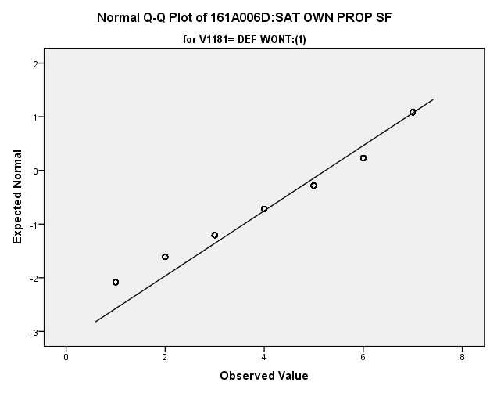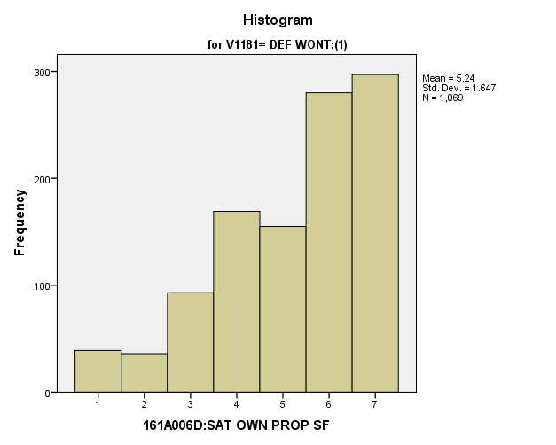

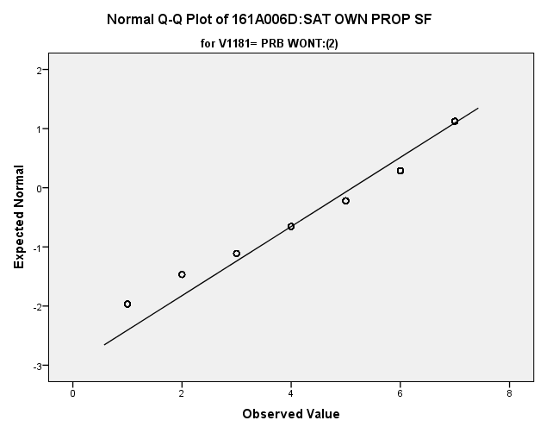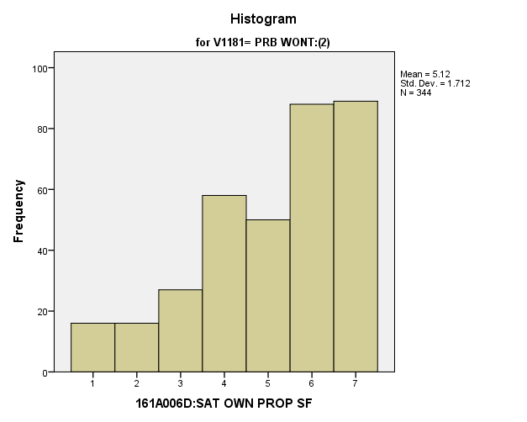

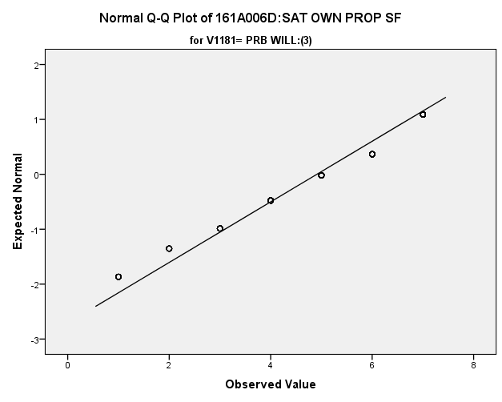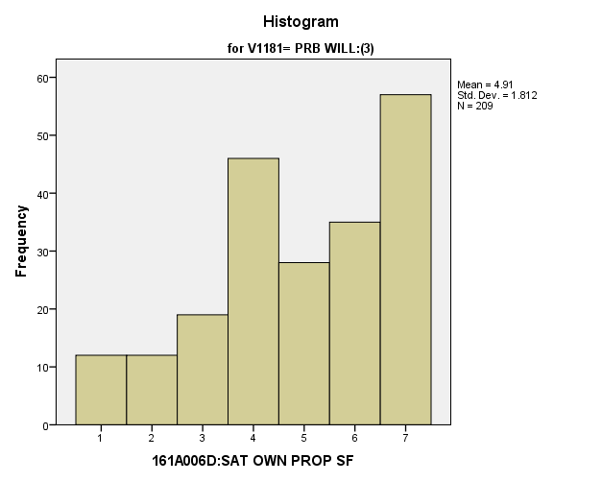

**Exhibit : Descriptives**

|  |  |  |  |  |  |
| --- | --- | --- | --- | --- | --- |
| ***Descriptives*** | | | | | |
|  | V1181 | | | Statistic | Std. Error |
| V1644 | DEF WONT:(1) | Mean | | **5.24** | **.050** |
| 99% Confidence Interval for Mean | Lower Bound | **5.11** |  |
| Upper Bound | **5.37** |  |
| 5% Trimmed Mean | | **5.36** |  |
| Median | | **6.00** |  |
| Variance | | **2.712** |  |
| Std. Deviation | | **1.647** |  |
| Minimum | | **1** |  |
| Maximum | | **7** |  |
| Range | | **6** |  |
| Interquartile Range | | **3** |  |
| Skewness | | **-.801** | **.075** |
| Kurtosis | | **-.161** | **.149** |
| PRB WONT:(2) | Mean | | **5.12** | **.092** |
| 99% Confidence Interval for Mean | Lower Bound | **4.88** |  |
| Upper Bound | **5.36** |  |
| 5% Trimmed Mean | | **5.24** |  |
| Median | | **6.00** |  |
| Variance | | **2.930** |  |
| Std. Deviation | | **1.712** |  |
| Minimum | | **1** |  |
| Maximum | | **7** |  |
| Range | | **6** |  |
| Interquartile Range | | **3** |  |
| Skewness | | **-.759** | **.131** |
| Kurtosis | | **-.282** | **.262** |
| PRB WILL:(3) | Mean | | **4.91** | **.125** |
| 99% Confidence Interval for Mean | Lower Bound | **4.58** |  |
| Upper Bound | **5.24** |  |
| 5% Trimmed Mean | | **5.01** |  |
| Median | | **5.00** |  |
| Variance | | **3.285** |  |
| Std. Deviation | | **1.812** |  |
| Minimum | | **1** |  |
| Maximum | | **7** |  |
| Range | | **6** |  |
| Interquartile Range | | **3** |  |
| Skewness | | **-.499** | **.168** |
| Kurtosis | | **-.712** | **.335** |

**Exhibit: One Way ANOVA Table and Homogeneity**

|  |  |  |  |
| --- | --- | --- | --- |
| ***Test of Homogeneity of Variances*** | | | |
| V1644 | | | |
| Levene Statistic | df1 | df2 | Sig. |
| **2.455** | **2** | **1619** | **.086** |

|  |  |  |  |  |  |
| --- | --- | --- | --- | --- | --- |
| ***ANOVA*** | | | | | |
| V1644 | | | | | |
|  | Sum of Squares | df | Mean Square | F | Sig. |
| Between Groups | **20.036** | **2** | **10.018** | **3.538** | **.029** |
| Within Groups | **4584.317** | **1619** | **2.832** |  |  |
| Total | **4604.353** | **1621** |  |  |  |

**Satisfaction with Standard of Living:** How do potential recruits differ from the other two groups regarding their satisfaction with their standard of living – the things you have like housing, car, furniture, recreation, and the like (standard of living)?

**Variables Used:** The **dependent** **variable** used in the analysis was how satisfied they are with their standard of living (1=completely dissatisfied, 4=neutral, 7= completely satisfied) and the **independent (grouping) variable** used was the pool of respondents. The respondent pool is broken into three categories:

* Non-recruits (students who say they definitely will not serve in the military after high school graduation) --- these are labeled as *definitely won’t (1).*
* Recruits (students who say they definitely or probably will serve in the military) --- these are labeled as *probably will (3).*
* Potential recruits (those who say they probably will not serve) --- these are labeled as *probably won’t (2)*.
* The desired pool of recruits is those labeled as probably won’t.
* Total respondents: 1626, range for all groups 1 to 7

**Analysis Procedure:**

* A one-way ANOVA test was utilized to compare how the potential pool of recruits differs by how satisfied they are with their standard of living.
* The analysis variable of how satisfied they are with their standard of living is interval and the grouping variables are mutually exclusive.
* Prior to analysis, a histogram and Q-Q plots were inspected for outliers, none were present. Each group had a negative skew and was than 2.
* The homogeneity of variances assumption was tested. The assumption was met.

**Results:**

* Null and alternative hypothesis:
  + Main Test
    - H0 : µ1 = µ2 = µ3
    - Ha : ALOI
* Calculated F value: f(how satisfied they are with their personal safety) 2.753, dfnum= 2, dfden= 1623, α = 0.01, fail to reject H0;

**Interpretation:** There was no significant difference in means between the three groups how satisfied they are with their standard of living.

**Supporting Analysis:**

**Exhibit: Histograms**

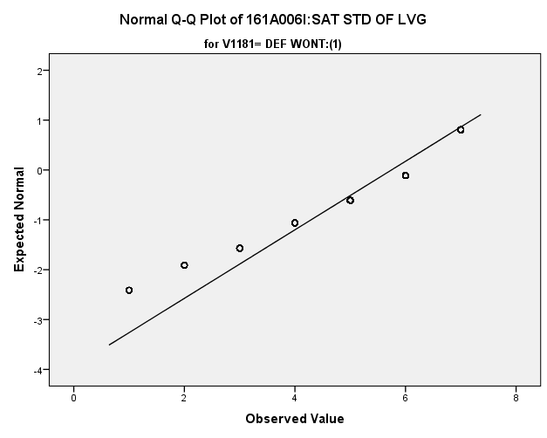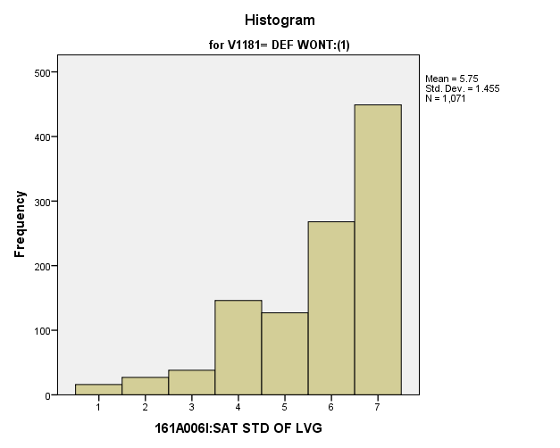

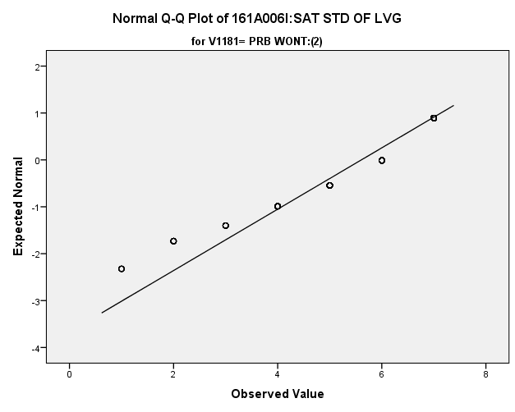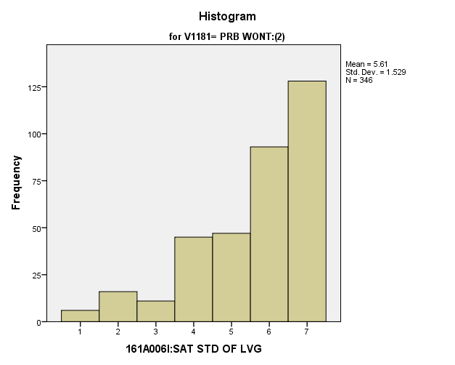

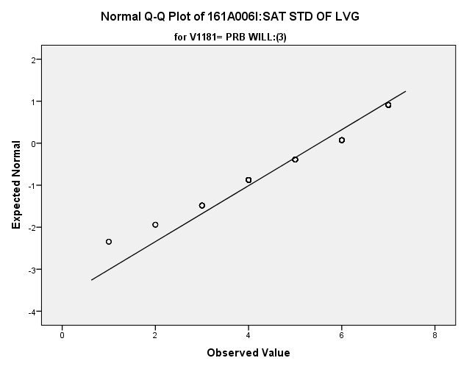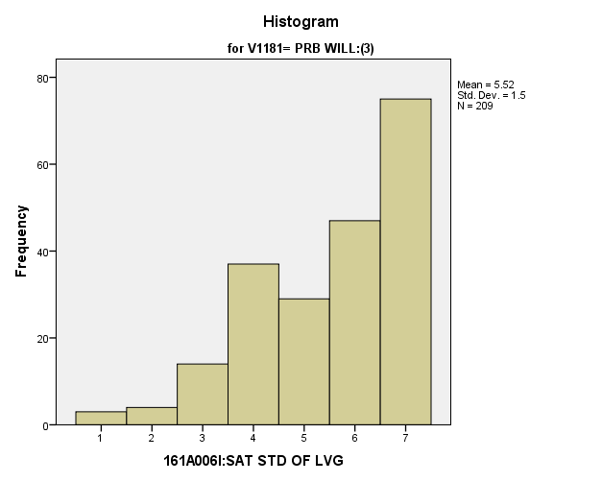

**Exhibit : Descriptives**

|  |  |  |  |  |  |
| --- | --- | --- | --- | --- | --- |
| ***Descriptives*** | | | | | |
|  | V1181 | | | Statistic | Std. Error |
| V1649 | DEF WONT:(1) | Mean | | **5.75** | **.044** |
| 99% Confidence Interval for Mean | Lower Bound | **5.63** |  |
| Upper Bound | **5.86** |  |
| 5% Trimmed Mean | | **5.89** |  |
| Median | | **6.00** |  |
| Variance | | **2.117** |  |
| Std. Deviation | | **1.455** |  |
| Minimum | | **1** |  |
| Maximum | | **7** |  |
| Range | | **6** |  |
| Interquartile Range | | **2** |  |
| Skewness | | **-1.173** | **.075** |
| Kurtosis | | **.789** | **.149** |
| PRB WONT:(2) | Mean | | **5.61** | **.082** |
| 99% Confidence Interval for Mean | Lower Bound | **5.39** |  |
| Upper Bound | **5.82** |  |
| 5% Trimmed Mean | | **5.75** |  |
| Median | | **6.00** |  |
| Variance | | **2.338** |  |
| Std. Deviation | | **1.529** |  |
| Minimum | | **1** |  |
| Maximum | | **7** |  |
| Range | | **6** |  |
| Interquartile Range | | **2** |  |
| Skewness | | **-1.124** | **.131** |
| Kurtosis | | **.595** | **.261** |
| PRB WILL:(3) | Mean | | **5.52** | **.104** |
| 99% Confidence Interval for Mean | Lower Bound | **5.25** |  |
| Upper Bound | **5.79** |  |
| 5% Trimmed Mean | | **5.63** |  |
| Median | | **6.00** |  |
| Variance | | **2.251** |  |
| Std. Deviation | | **1.500** |  |
| Minimum | | **1** |  |
| Maximum | | **7** |  |
| Range | | **6** |  |
| Interquartile Range | | **3** |  |
| Skewness | | **-.800** | **.168** |
| Kurtosis | | **-.128** | **.335** |

**Exhibit: One Way ANOVA Table and Homogeneity**

|  |  |  |  |
| --- | --- | --- | --- |
| ***Test of Homogeneity of Variances*** | | | |
| V1649 | | | |
| Levene Statistic | df1 | df2 | Sig. |
| **1.699** | **2** | **1623** | **.183** |

|  |  |  |  |  |  |
| --- | --- | --- | --- | --- | --- |
| ***ANOVA*** | | | | | |
| V1649 | | | | | |
|  | Sum of Squares | df | Mean Square | F | Sig. |
| Between Groups | **12.008** | **2** | **6.004** | **2.753** | **.064** |
| Within Groups | **3539.655** | **1623** | **2.181** |  |  |
| Total | **3551.664** | **1625** |  |  |  |

*3.d. Student Trustworthy and Fairness Variables*

**People Can’t be Trusted:** How do potential recruits differ from the other two groups regarding how strongly they feel people can be trusted?

**Variables Used:** The **dependent** **variable** used in the analysis was how strongly they feel people can be trusted (1=can’t be too careful, 2=Don’t Know, 3= most can be trusted) and the **independent (grouping) variable** used was the pool of respondents. The respondent pool is broken into three categories:

* Non-recruits (students who say they definitely will not serve in the military after high school graduation) --- these are labeled as *definitely won’t (1).*
* Recruits (students who say they definitely or probably will serve in the military) --- these are labeled as *probably will (3).*
* Potential recruits (those who say they probably will not serve) --- these are labeled as *probably won’t (2)*.
* The desired pool of recruits is those labeled as probably won’t.
* Total respondents: 1534, range for all groups 1 to 3

**Analysis Procedure:**

* A one-way ANOVA test was utilized to compare how the potential pool of recruits differs by how strongly they feel people can be trusted.
* The analysis variable of how strongly they feel people can be trusted is interval and the grouping variables are mutually exclusive.
* Prior to analysis, a histogram and Q-Q plots were inspected for outliers, none were present. Each group had a positive skew and was than 2.
* The homogeneity of variances assumption was tested. The assumption was met.

**Results:**

* Null and alternative hypothesis:
  + Main Test
    - H0 : µ1 = µ2 = µ3
    - Ha : ALOI
* Calculated F value: f(how strongly they feel people can’t be trusted) 0.895, dfnum= 2, dfden= 1531, α = 0.01, fail to reject H0;

**Interpretation:** There was no significant difference in means between the three groups how strongly they feel people can be trusted.

**Supporting Analysis:**

**Exhibit: Histograms**

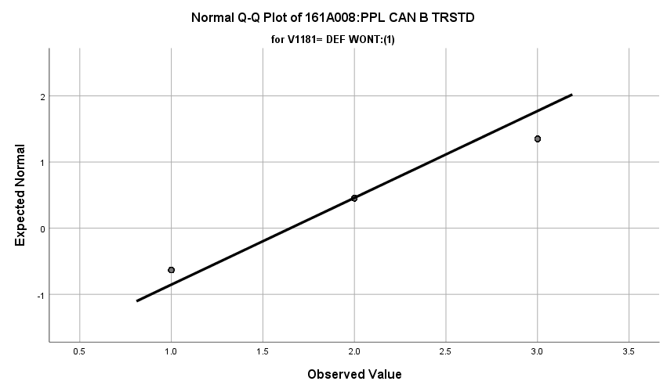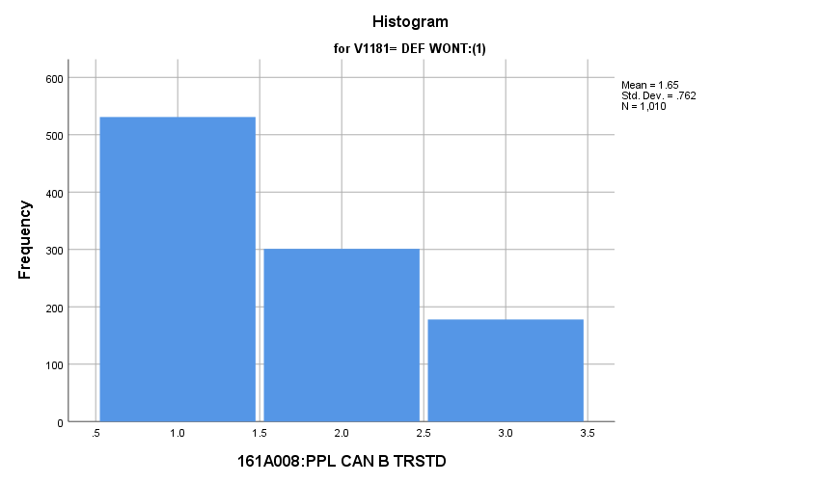

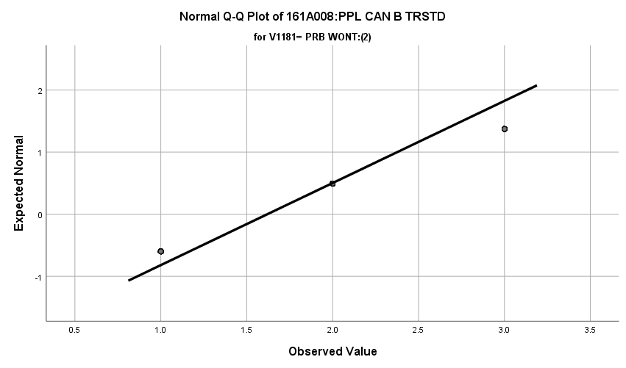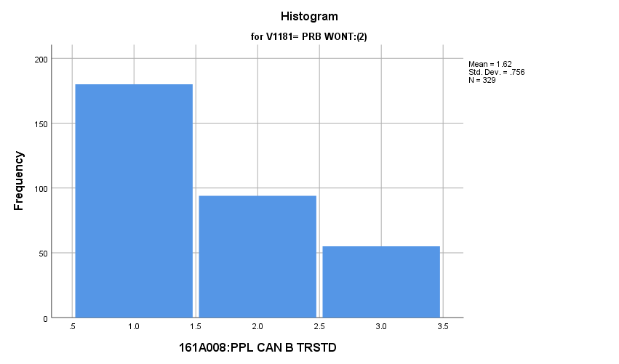

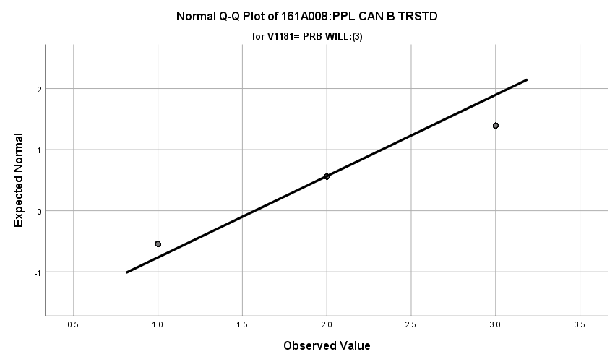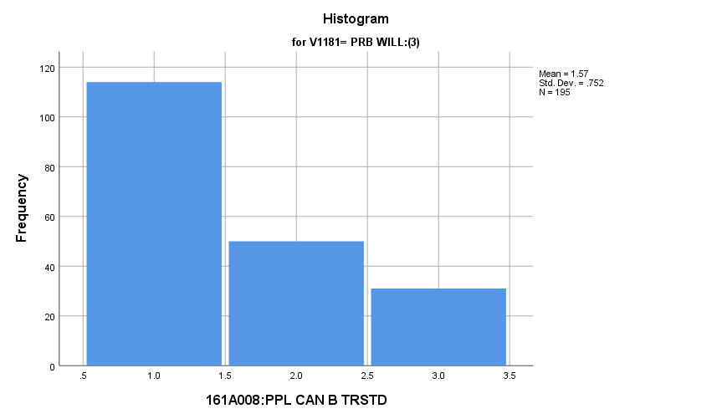

**Exhibit: Descriptives**

|  |  |  |  |  |  |
| --- | --- | --- | --- | --- | --- |
| ***Descriptives*** | | | | | |
|  | V1181 | | | Statistic | Std. Error |
| V1669 | DEF WONT:(1) | Mean | | **1.65** | **.024** |
| 99% Confidence Interval for Mean | Lower Bound | **1.59** |  |
| Upper Bound | **1.71** |  |
| 5% Trimmed Mean | | **1.61** |  |
| Median | | **1.00** |  |
| Variance | | **.580** |  |
| Std. Deviation | | **.762** |  |
| Minimum | | **1** |  |
| Maximum | | **3** |  |
| Range | | **2** |  |
| Interquartile Range | | **1** |  |
| Skewness | | **.683** | **.077** |
| Kurtosis | | **-.967** | **.154** |
| PRB WONT:(2) | Mean | | **1.62** | **.042** |
| 99% Confidence Interval for Mean | Lower Bound | **1.51** |  |
| Upper Bound | **1.73** |  |
| 5% Trimmed Mean | | **1.58** |  |
| Median | | **1.00** |  |
| Variance | | **.572** |  |
| Std. Deviation | | **.756** |  |
| Minimum | | **1** |  |
| Maximum | | **3** |  |
| Range | | **2** |  |
| Interquartile Range | | **1** |  |
| Skewness | | **.758** | **.134** |
| Kurtosis | | **-.861** | **.268** |
| PRB WILL:(3) | Mean | | **1.57** | **.054** |
| 99% Confidence Interval for Mean | Lower Bound | **1.43** |  |
| Upper Bound | **1.71** |  |
| 5% Trimmed Mean | | **1.53** |  |
| Median | | **1.00** |  |
| Variance | | **.565** |  |
| Std. Deviation | | **.752** |  |
| Minimum | | **1** |  |
| Maximum | | **3** |  |
| Range | | **2** |  |
| Interquartile Range | | **1** |  |
| Skewness | | **.883** | **.174** |
| Kurtosis | | **-.683** | **.346** |

**Exhibit: One Way ANOVA Table and Homogeneity**

|  |  |  |  |  |  |
| --- | --- | --- | --- | --- | --- |
| ***Test of Homogeneity of Variances*** | | | | | |
|  | | Levene Statistic | df1 | df2 | Sig. |
| V1669 | Based on Mean | **.127** | **2** | **1531** | **.881** |
| Based on Median | **.895** | **2** | **1531** | **.409** |
| Based on Median and with adjusted df | **.895** | **2** | **1530.858** | **.409** |
| Based on trimmed mean | **.258** | **2** | **1531** | **.772** |

|  |  |  |  |  |  |
| --- | --- | --- | --- | --- | --- |
| ***ANOVA*** | | | | | |
| V1669 | | | | | |
|  | Sum of Squares | df | Mean Square | F | Sig. |
| Between Groups | **1.032** | **2** | **.516** | **.895** | **.409** |
| Within Groups | **882.804** | **1531** | **.577** |  |  |
| Total | **883.836** | **1533** |  |  |  |

**People Take Advantage:** How do potential recruits differ from the other two groups regarding strongly they feel that people take advantage of others?

**Variables Used:** The **dependent** **variable** used in the analysis was how strongly they feel that people take advantage of others (1=try to take advantage, 2=don’t know, 3= try to be fair) and the **independent (grouping) variable** used was the pool of respondents. The respondent pool is broken into three categories:

* Non-recruits (students who say they definitely will not serve in the military after high school graduation) --- these are labeled as *definitely won’t (1).*
* Recruits (students who say they definitely or probably will serve in the military) --- these are labeled as *probably will (3).*
* Potential recruits (those who say they probably will not serve) --- these are labeled as *probably won’t (2)*.
* The desired pool of recruits is those labeled as probably won’t.
* Total respondents: 1591, range for all groups 1 to 3

**Analysis Procedure:**

* A one-way ANOVA test was utilized to compare how the potential pool of recruits differs by how strongly they feel that people take advantage of others.
* The analysis variable of how strongly they feel that people take advantage of others is interval and the grouping variables are mutually exclusive.
* Prior to analysis, a histogram and Q-Q plots were inspected for outliers, none were present. Each group had a positive skew and was than 2.
* The homogeneity of variances assumption was tested. The assumption was met.

**Results:**

* Null and alternative hypothesis:
  + Main Test
    - H0 : µ1 = µ2 = µ3
    - Ha : ALOI
* Calculated F value: f(how strongly they feel that people take advantage of others) 1.944, dfnum= 2, dfden= 1588, α = 0.01, fail to reject H0;

**Interpretation:** There was no significant difference in means between the three groups how strongly they feel that people take advantage of others.

**Supporting Analysis:**

**Exhibit: Histograms**

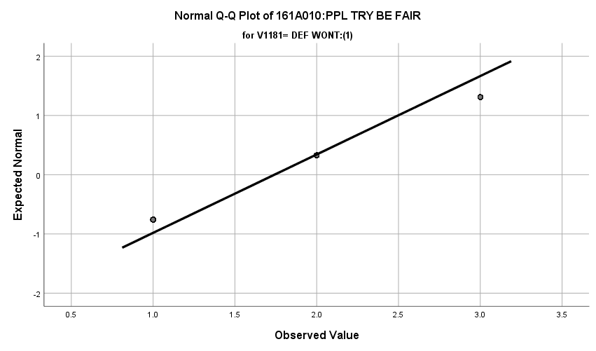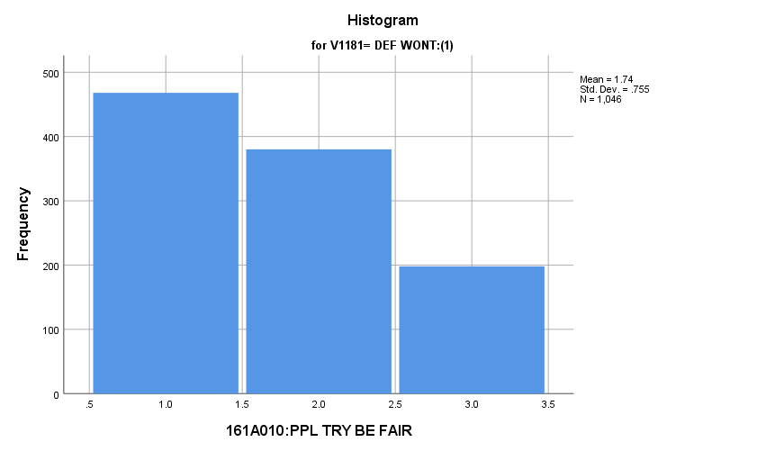

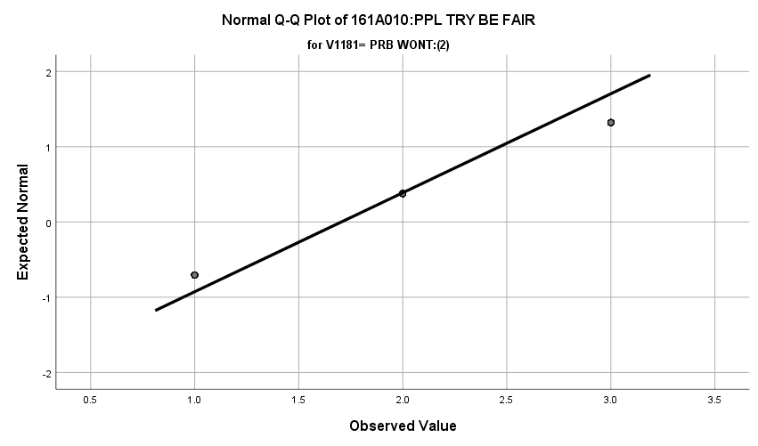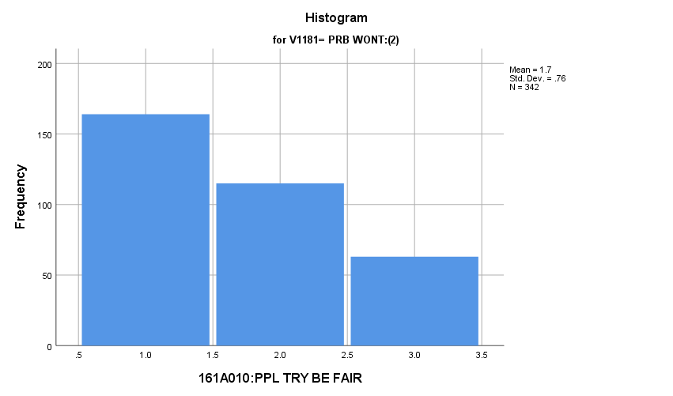

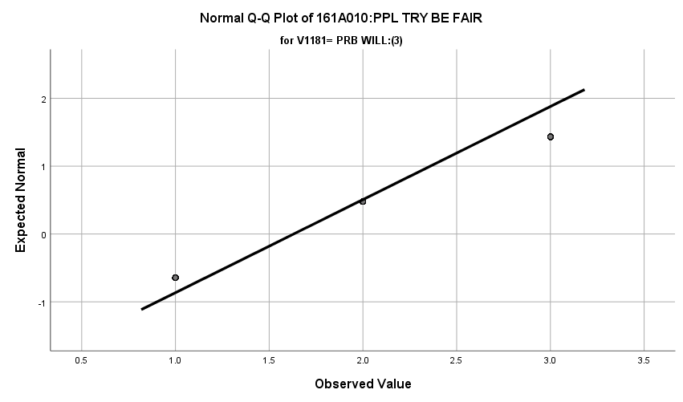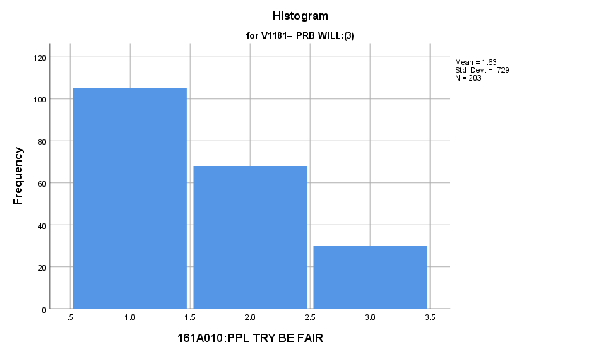

**Exhibit: Descriptives**

|  |  |  |  |  |  |
| --- | --- | --- | --- | --- | --- |
| ***Descriptives*** | | | | | |
|  | V1181 | | | Statistic | Std. Error |
| V1671 | DEF WONT:(1) | Mean | | **1.74** | **.023** |
| 99% Confidence Interval for Mean | Lower Bound | **1.68** |  |
| Upper Bound | **1.80** |  |
| 5% Trimmed Mean | | **1.71** |  |
| Median | | **2.00** |  |
| Variance | | **.571** |  |
| Std. Deviation | | **.755** |  |
| Minimum | | **1** |  |
| Maximum | | **3** |  |
| Range | | **2** |  |
| Interquartile Range | | **1** |  |
| Skewness | | **.467** | **.076** |
| Kurtosis | | **-1.118** | **.151** |
| PRB WONT:(2) | Mean | | **1.70** | **.041** |
| 99% Confidence Interval for Mean | Lower Bound | **1.60** |  |
| Upper Bound | **1.81** |  |
| 5% Trimmed Mean | | **1.67** |  |
| Median | | **2.00** |  |
| Variance | | **.578** |  |
| Std. Deviation | | **.760** |  |
| Minimum | | **1** |  |
| Maximum | | **3** |  |
| Range | | **2** |  |
| Interquartile Range | | **1** |  |
| Skewness | | **.553** | **.132** |
| Kurtosis | | **-1.074** | **.263** |
| PRB WILL:(3) | Mean | | **1.63** | **.051** |
| 99% Confidence Interval for Mean | Lower Bound | **1.50** |  |
| Upper Bound | **1.76** |  |
| 5% Trimmed Mean | | **1.59** |  |
| Median | | **1.00** |  |
| Variance | | **.531** |  |
| Std. Deviation | | **.729** |  |
| Minimum | | **1** |  |
| Maximum | | **3** |  |
| Range | | **2** |  |
| Interquartile Range | | **1** |  |
| Skewness | | **.699** | **.171** |
| Kurtosis | | **-.815** | **.340** |

**Exhibit: One Way ANOVA Table and Homogeneity**

|  |  |  |  |  |  |
| --- | --- | --- | --- | --- | --- |
| ***Test of Homogeneity of Variances*** | | | | | |
|  | | Levene Statistic | df1 | df2 | Sig. |
| V1671 | Based on Mean | **.299** | **2** | **1588** | **.741** |
| Based on Median | **.406** | **2** | **1588** | **.667** |
| Based on Median and with adjusted df | **.406** | **2** | **1392.180** | **.667** |
| Based on trimmed mean | **.361** | **2** | **1588** | **.697** |

|  |  |  |  |  |  |
| --- | --- | --- | --- | --- | --- |
| ***ANOVA*** | | | | | |
| V1671 | | | | | |
|  | Sum of Squares | df | Mean Square | F | Sig. |
| Between Groups | **2.205** | **2** | **1.103** | **1.944** | **.144** |
| Within Groups | **900.769** | **1588** | **.567** |  |  |
| Total | **902.974** | **1590** |  |  |  |

**Skipping School Recently:** How do potential recruits differ from the other two groups regarding how many days of school they have skipped in the past four weeks?

**Variables Used:** The **dependent** **variable** used in the analysis was how many days of school they have skipped in the past four weeks (1=none, 2= 1day, 3=2days, 4=3days, 5=4-5 days, 6=6-10 days, 7=11+ days) and the **independent (grouping) variable** used was the pool of respondents. The respondent pool is broken into three categories:

* Non-recruits (students who say they definitely will not serve in the military after high school graduation) --- these are labeled as *definitely won’t (1).*
* Recruits (students who say they definitely or probably will serve in the military) --- these are labeled as *probably will (3).*
* Potential recruits (those who say they probably will not serve) --- these are labeled as *probably won’t (2)*.
* The desired pool of recruits is those labeled as probably won’t.
* Total respondents: 1564, range for all groups 1 to 7

**Analysis Procedure:**

* A one-way ANOVA test was utilized to compare how the potential pool of recruits differs by how many days of school they have skipped in the past four weeks
* The analysis variable of by how many days of school they have skipped in the past four weeks is interval and the grouping variables are mutually exclusive.
* Prior to analysis, a histogram and Q-Q plots were inspected for outliers, none were present. Each group had a positive skew and was than 2.
* The homogeneity of variances assumption was tested. The assumption was not met but the groups are approximately the same size.
* Eta was calculated to assess effect size.

**Results:**

* Null and alternative hypothesis:
  + Main Test
    - H0 : µ1 = µ2 = µ3
    - Ha : ALOI
  + Post Hoc (1 and 2)
    - H0 : µ1 = µ2
    - Ha : µ1 ≠ µ2
  + Post Hoc (1 and 3)
    - H0 : µ1 = µ3
    - Ha : µ1 ≠ µ3
  + Post Hoc (2 and 3)
    - H0 : µ2 = µ3
    - Ha : µ2 ≠ µ3
* Calculated F value: f(satisfaction with life as a whole) 6.553, dfnum= 2, dfden= 1562, α = 0.01, reject H0; eta = 0.091

**Interpretation:** There was a significant difference in means between the three groups regarding the how many days of school they skipped in the past four weeks. The groups of probably won’t (1.51) and probably will (1.92) had significantly different means. The following groups did not have significantly different means:

* Definitely won’t and probably won’t
* Definitely won’t and probably will

**Supporting Analysis:**

**Exhibit: Preliminary Analysis**

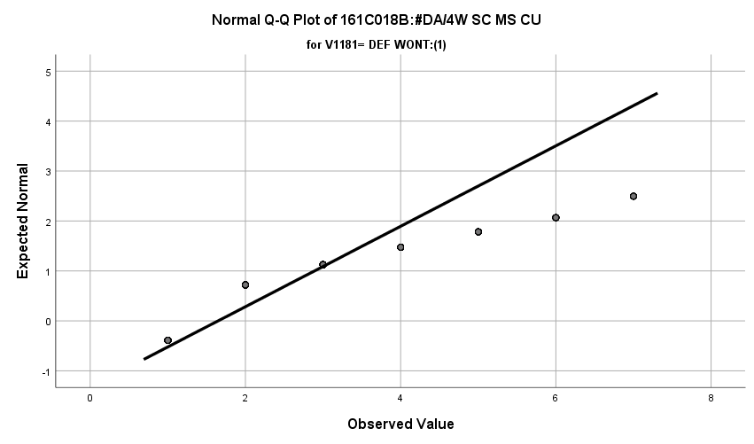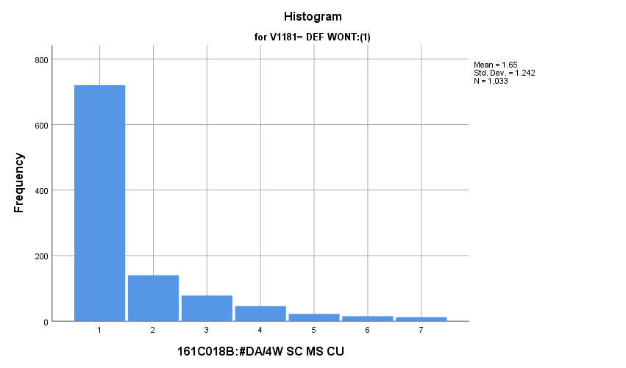

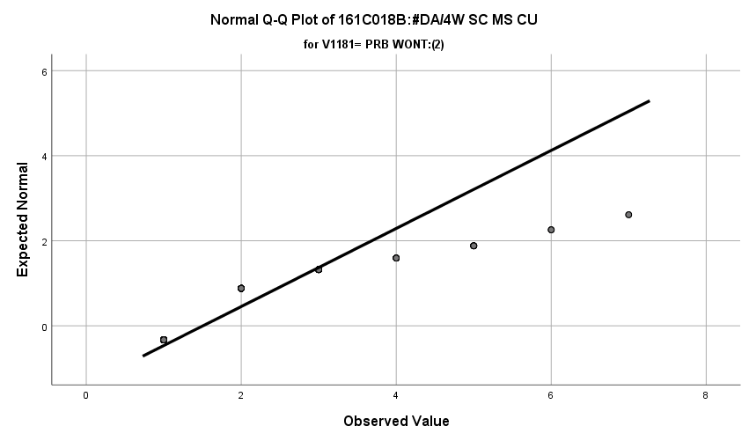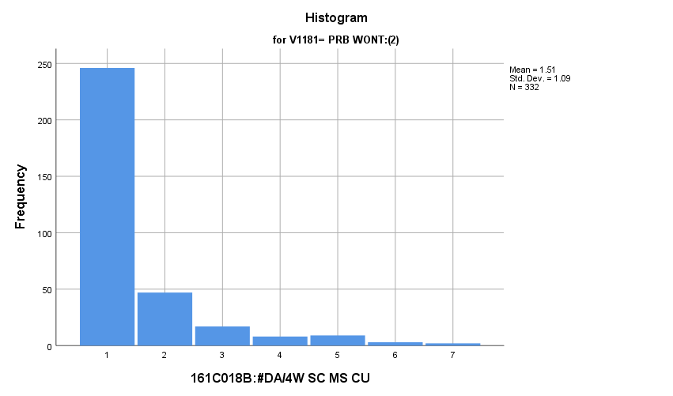

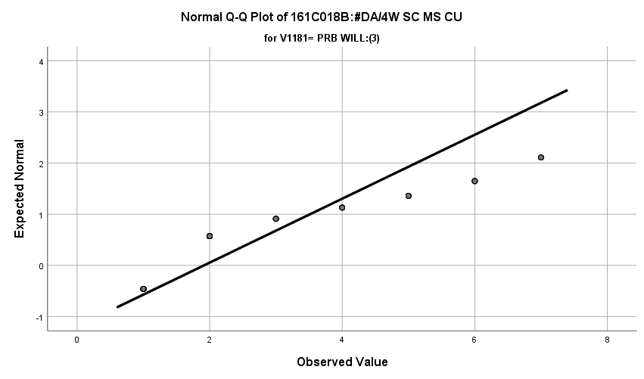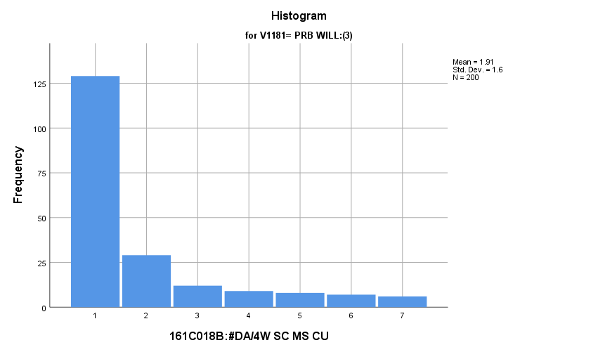

**Exhibit: Descriptives**

|  |  |  |  |  |  |
| --- | --- | --- | --- | --- | --- |
| ***Descriptives*** | | | | | |
|  | V1181 | | | Statistic | Std. Error |
| V1176 | DEF WONT:(1) | Mean | | **1.65** | **.039** |
| 99% Confidence Interval for Mean | Lower Bound | **1.55** |  |
| Upper Bound | **1.75** |  |
| 5% Trimmed Mean | | **1.46** |  |
| Median | | **1.00** |  |
| Variance | | **1.542** |  |
| Std. Deviation | | **1.242** |  |
| Minimum | | **1** |  |
| Maximum | | **7** |  |
| Range | | **6** |  |
| Interquartile Range | | **1** |  |
| Skewness | | **2.285** | **.076** |
| Kurtosis | | **5.107** | **.152** |
| PRB WONT:(2) | Mean | | **1.51** | **.060** |
| 99% Confidence Interval for Mean | Lower Bound | **1.35** |  |
| Upper Bound | **1.66** |  |
| 5% Trimmed Mean | | **1.33** |  |
| Median | | **1.00** |  |
| Variance | | **1.187** |  |
| Std. Deviation | | **1.090** |  |
| Minimum | | **1** |  |
| Maximum | | **7** |  |
| Range | | **6** |  |
| Interquartile Range | | **1** |  |
| Skewness | | **2.684** | **.134** |
| Kurtosis | | **7.449** | **.267** |
| PRB WILL:(3) | Mean | | **1.92** | **.113** |
| 99% Confidence Interval for Mean | Lower Bound | **1.62** |  |
| Upper Bound | **2.21** |  |
| 5% Trimmed Mean | | **1.71** |  |
| Median | | **1.00** |  |
| Variance | | **2.561** |  |
| Std. Deviation | | **1.600** |  |
| Minimum | | **1** |  |
| Maximum | | **7** |  |
| Range | | **6** |  |
| Interquartile Range | | **1** |  |
| Skewness | | **1.857** | **.172** |
| Kurtosis | | **2.454** | **.342** |

**Exhibit: Means Table**

|  |  |  |  |
| --- | --- | --- | --- |
| ***Report*** | | | |
| V1176 | | | |
| V1181 | Mean | N | Std. Deviation |
| DEF WONT:(1) | **1.65** | **1033** | **1.242** |
| PRB WONT:(2) | **1.51** | **332** | **1.090** |
| PRB WILL:(3) | **1.91** | **200** | **1.600** |
| Total | **1.65** | **1565** | **1.268** |

**Exhibit: One Way ANOVA Table and Homogeneity**

|  |  |  |  |  |  |
| --- | --- | --- | --- | --- | --- |
| ***Test of Homogeneity of Variances*** | | | | | |
|  | | Levene Statistic | df1 | df2 | Sig. |
| V1176 | Based on Mean | **15.235** | **2** | **1562** | **.000** |
| Based on Median | **6.553** | **2** | **1562** | **.001** |
| Based on Median and with adjusted df | **6.553** | **2** | **1472.039** | **.001** |
| Based on trimmed mean | **14.077** | **2** | **1562** | **.000** |

|  |  |  |  |  |  |
| --- | --- | --- | --- | --- | --- |
| ***ANOVA*** | | | | | |
| V1176 | | | | | |
|  | Sum of Squares | df | Mean Square | F | Sig. |
| Between Groups | **20.928** | **2** | **10.464** | **6.553** | **.001** |
| Within Groups | **2494.280** | **1562** | **1.597** |  |  |
| Total | **2515.208** | **1564** |  |  |  |

**Exhibit: Post Hoc Tests**

|  |  |  |  |  |  |  |
| --- | --- | --- | --- | --- | --- | --- |
| ***Multiple Comparisons*** | | | | | | |
| Dependent Variable: V1176 | | | | | | |
| Games-Howell | | | | | | |
| (I) V1181 | (J) V1181 | Mean Difference (I-J) | Std. Error | Sig. | 99% Confidence Interval | |
| Lower Bound | Upper Bound |
| DEF WONT:(1) | PRB WONT:(2) | **.142** | **.071** | **.116** | **-.07** | **.35** |
| PRB WILL:(3) | **-.267** | **.120** | **.067** | **-.62** | **.08** |
| PRB WONT:(2) | DEF WONT:(1) | **-.142** | **.071** | **.116** | **-.35** | **.07** |
| PRB WILL:(3) | **-.409\*** | **.128** | **.004** | **-.78** | **-.03** |
| PRB WILL:(3) | DEF WONT:(1) | **.267** | **.120** | **.067** | **-.08** | **.62** |
| PRB WONT:(2) | **.409\*** | **.128** | **.004** | **.03** | **.78** |
| *. The mean difference is significant at the 0.01 level. | | | | | | |

*3.e. Student Relationships with Government Variables*

**People Should Always Obey the Law:** How do potential recruits differ from the other two groups regarding how strongly they feel people should always obey the law?

**Variables Used:** The **dependent** **variable** used in the analysis was how strongly they feel that people should always obey the law (1=disagree, 2=mostly disagree, 3=neither, 4=mostly agree, 5=agree) and the **independent (grouping) variable** used was the pool of respondents. The respondent pool is broken into three categories:

* Non-recruits (students who say they definitely will not serve in the military after high school graduation) --- these are labeled as *definitely won’t (1).*
* Recruits (students who say they definitely or probably will serve in the military) --- these are labeled as *probably will (3).*
* Potential recruits (those who say they probably will not serve) --- these are labeled as *probably won’t (2)*.
* The desired pool of recruits is those labeled as probably won’t.
* Total respondents: 1594, range for all groups 1 to 5

**Analysis Procedure:**

* A one-way ANOVA test was utilized to compare how the potential pool of recruits differs by how strongly they feel that people should always obey the law.
* The analysis variable of how strongly they feel that people should always obey the law is interval and the grouping variables are mutually exclusive.
* Prior to analysis, a histogram and Q-Q plots were inspected for outliers, none were present. Each group had a negative skew and was than 2.
* The homogeneity of variances assumption was tested. The assumption was met.

**Results:**

* Null and alternative hypothesis:
  + Main Test
    - H0 : µ1 = µ2 = µ3
    - Ha : ALOI
* Calculated F value: f(how strongly they feel that people should always obey the law) 0.212, dfnum= 2, dfden= 1591, α = 0.01, fail to reject H0;

**Interpretation:** There was no significant difference in means between the three groups how strongly they feel that people should always obey the law.

**Supporting Analysis:**

**Exhibit: Preliminary Analysis**

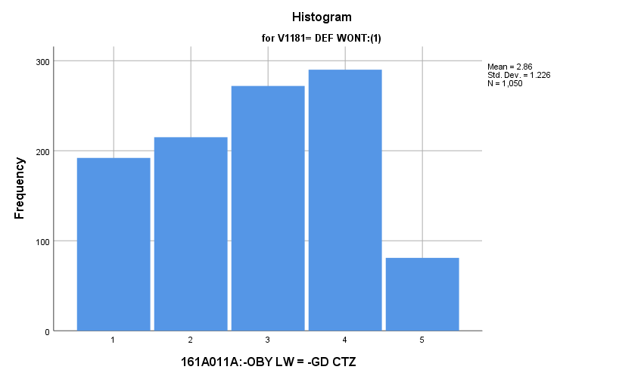

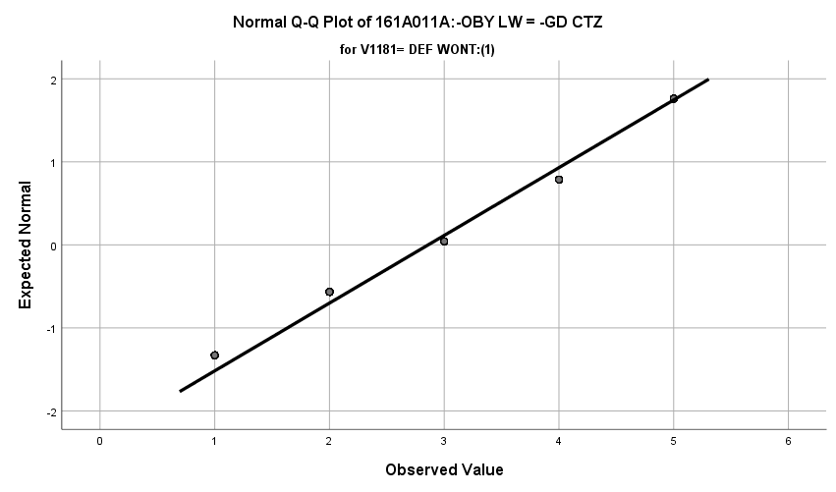

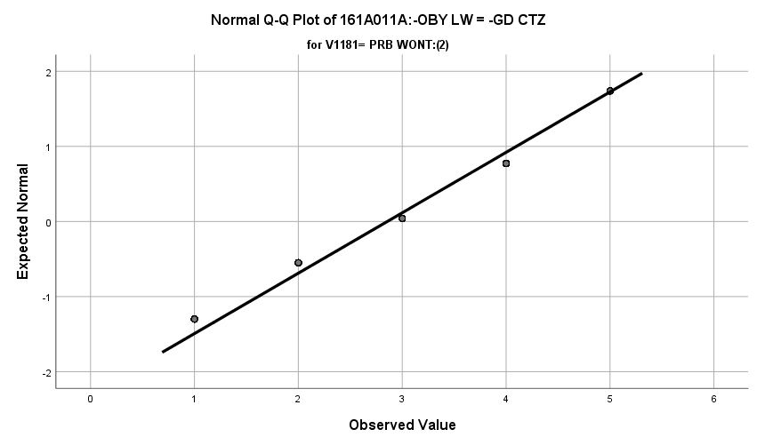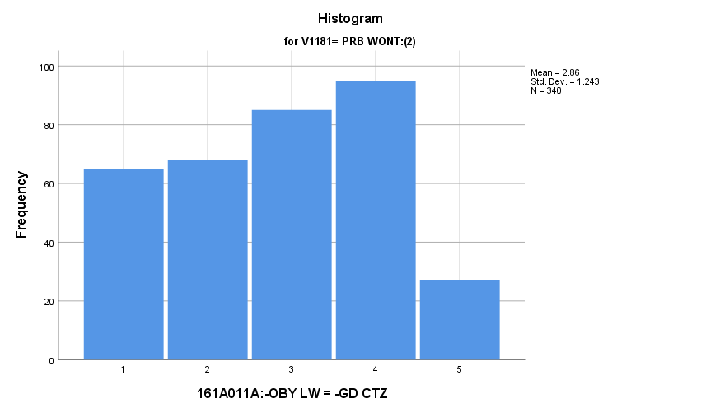

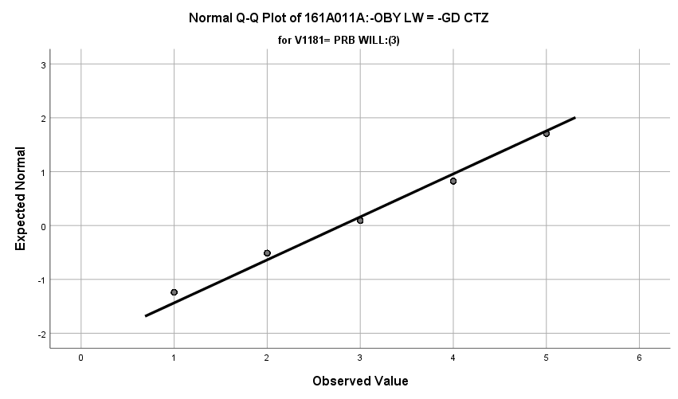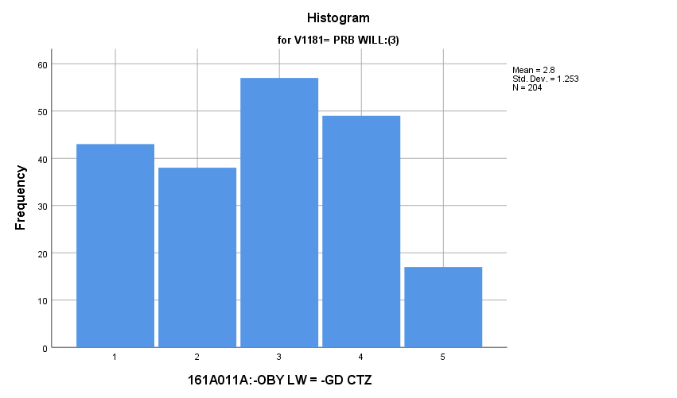

**Exhibit: Descriptives**

|  |  |  |  |  |  |
| --- | --- | --- | --- | --- | --- |
| ***Descriptives*** | | | | | |
|  | V1181 | | | Statistic | Std. Error |
| V1672 | DEF WONT:(1) | Mean | | **2.86** | **.038** |
| 99% Confidence Interval for Mean | Lower Bound | **2.76** |  |
| Upper Bound | **2.96** |  |
| 5% Trimmed Mean | | **2.84** |  |
| Median | | **3.00** |  |
| Variance | | **1.503** |  |
| Std. Deviation | | **1.226** |  |
| Minimum | | **1** |  |
| Maximum | | **5** |  |
| Range | | **4** |  |
| Interquartile Range | | **2** |  |
| Skewness | | **-.077** | **.075** |
| Kurtosis | | **-1.054** | **.151** |
| PRB WONT:(2) | Mean | | **2.86** | **.067** |
| 99% Confidence Interval for Mean | Lower Bound | **2.68** |  |
| Upper Bound | **3.03** |  |
| 5% Trimmed Mean | | **2.84** |  |
| Median | | **3.00** |  |
| Variance | | **1.546** |  |
| Std. Deviation | | **1.243** |  |
| Minimum | | **1** |  |
| Maximum | | **5** |  |
| Range | | **4** |  |
| Interquartile Range | | **2** |  |
| Skewness | | **-.076** | **.132** |
| Kurtosis | | **-1.090** | **.264** |
| PRB WILL:(3) | Mean | | **2.80** | **.088** |
| 99% Confidence Interval for Mean | Lower Bound | **2.57** |  |
| Upper Bound | **3.03** |  |
| 5% Trimmed Mean | | **2.78** |  |
| Median | | **3.00** |  |
| Variance | | **1.570** |  |
| Std. Deviation | | **1.253** |  |
| Minimum | | **1** |  |
| Maximum | | **5** |  |
| Range | | **4** |  |
| Interquartile Range | | **2** |  |
| Skewness | | **-.008** | **.170** |
| Kurtosis | | **-1.055** | **.339** |

**Exhibit: One Way ANOVA Table and Homogeneity**

|  |  |  |  |  |  |
| --- | --- | --- | --- | --- | --- |
| ***Test of Homogeneity of Variances*** | | | | | |
|  | | Levene Statistic | df1 | df2 | Sig. |
| V1672 | Based on Mean | **.185** | **2** | **1591** | **.832** |
| Based on Median | **.107** | **2** | **1591** | **.898** |
| Based on Median and with adjusted df | **.107** | **2** | **1588.995** | **.898** |
| Based on trimmed mean | **.196** | **2** | **1591** | **.822** |

|  |  |  |  |  |  |
| --- | --- | --- | --- | --- | --- |
| ***ANOVA*** | | | | | |
| V1672 | | | | | |
|  | Sum of Squares | df | Mean Square | F | Sig. |
| Between Groups | **.644** | **2** | **.322** | **.212** | **.809** |
| Within Groups | **2419.118** | **1591** | **1.521** |  |  |
| Total | **2419.762** | **1593** |  |  |  |

**Good Citizens Agree with the Government:** How do potential recruits differ from the other two groups regarding how strongly they feel that good citizens go along with the government no matter what?

**Variables Used:** The **dependent** **variable** used in the analysis was how strongly they feel that good citizens go along with the government no matter what (1=disagree, 2=mostly disagree, 3=neither, 4=mostly agree, 5=agree) and the **independent (grouping) variable** used was the pool of respondents. The respondent pool is broken into three categories:

* Non-recruits (students who say they definitely will not serve in the military after high school graduation) --- these are labeled as *definitely won’t (1).*
* Recruits (students who say they definitely or probably will serve in the military) --- these are labeled as *probably will (3).*
* Potential recruits (those who say they probably will not serve) --- these are labeled as *probably won’t (2)*.
* The desired pool of recruits is those labeled as probably won’t.
* Total respondents: 1593, range for all groups 1 to 5

**Analysis Procedure:**

* A one-way ANOVA test was utilized to compare how the potential pool of recruits differs by how strongly they feel that good citizens go along with the government no matter what.
* The analysis variable of how strongly they feel that good citizens go along with the government no matter what is interval and the grouping variables are mutually exclusive.
* Prior to analysis, a histogram and Q-Q plots were inspected for outliers, none were present. Each group had a positive skew and was than 2.
* The homogeneity of variances assumption was tested. The assumption was met.

**Results:**

* Null and alternative hypothesis:
  + Main Test
    - H0 : µ1 = µ2 = µ3
    - Ha : ALOI
* Calculated F value: f(how strongly they feel that good citizens go along with the government no matter what) 0.603, dfnum= 2, dfden= 1590, α = 0.01, fail to reject H0;

**Interpretation:** There was no significant difference in means between the three groups how strongly they feel that good citizens go along with the government no matter what.

**Supporting Analysis:**

**Exhibit: Preliminary Analysis**

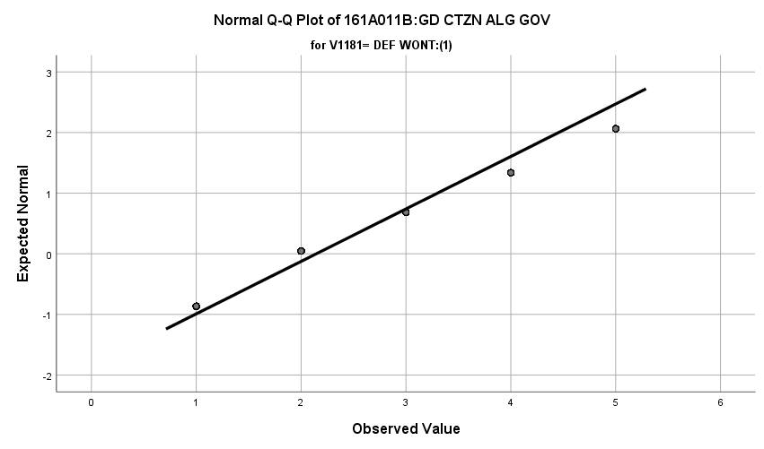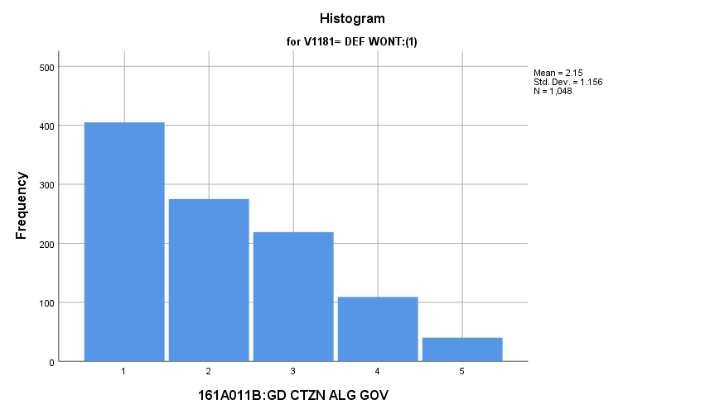

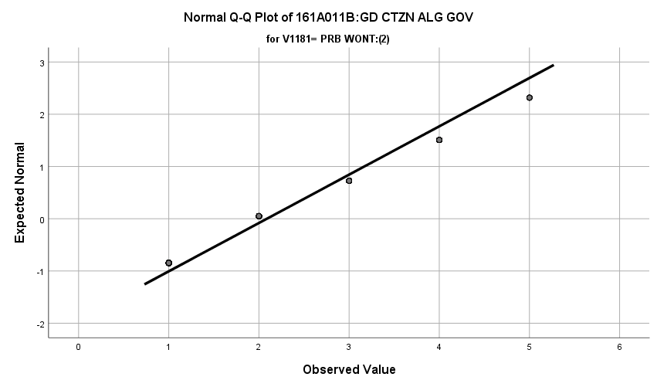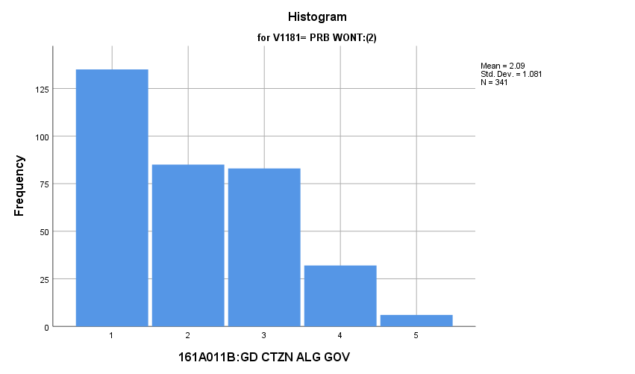

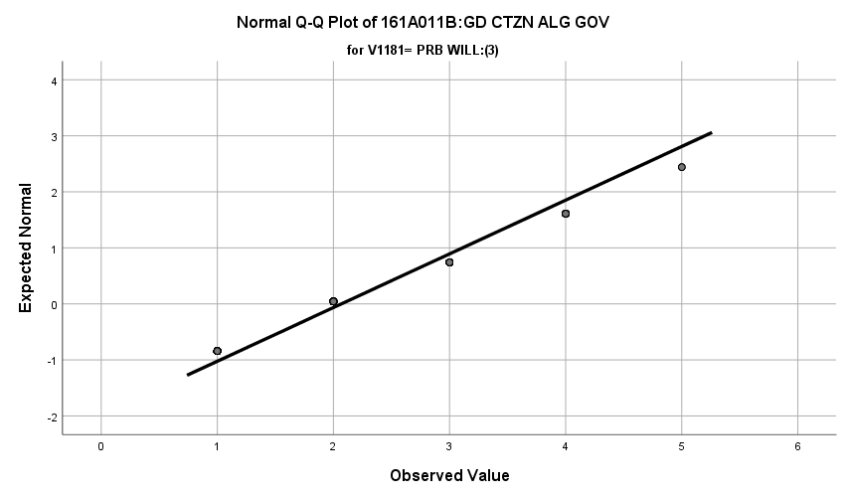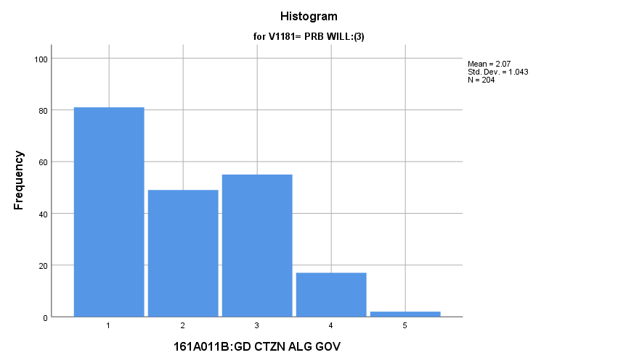

**Exhibit: Descriptives**

|  |  |  |  |  |  |
| --- | --- | --- | --- | --- | --- |
| ***Descriptives*** | | | | | |
|  | V1181 | | | Statistic | Std. Error |
| V1673 | DEF WONT:(1) | Mean | | **2.15** | **.036** |
| 99% Confidence Interval for Mean | Lower Bound | **2.05** |  |
| Upper Bound | **2.24** |  |
| 5% Trimmed Mean | | **2.06** |  |
| Median | | **2.00** |  |
| Variance | | **1.335** |  |
| Std. Deviation | | **1.156** |  |
| Minimum | | **1** |  |
| Maximum | | **5** |  |
| Range | | **4** |  |
| Interquartile Range | | **2** |  |
| Skewness | | **.716** | **.076** |
| Kurtosis | | **-.443** | **.151** |
| PRB WONT:(2) | Mean | | **2.09** | **.059** |
| 99% Confidence Interval for Mean | Lower Bound | **1.94** |  |
| Upper Bound | **2.24** |  |
| 5% Trimmed Mean | | **2.02** |  |
| Median | | **2.00** |  |
| Variance | | **1.169** |  |
| Std. Deviation | | **1.081** |  |
| Minimum | | **1** |  |
| Maximum | | **5** |  |
| Range | | **4** |  |
| Interquartile Range | | **2** |  |
| Skewness | | **.611** | **.132** |
| Kurtosis | | **-.603** | **.263** |
| PRB WILL:(3) | Mean | | **2.07** | **.073** |
| 99% Confidence Interval for Mean | Lower Bound | **1.88** |  |
| Upper Bound | **2.26** |  |
| 5% Trimmed Mean | | **2.01** |  |
| Median | | **2.00** |  |
| Variance | | **1.089** |  |
| Std. Deviation | | **1.043** |  |
| Minimum | | **1** |  |
| Maximum | | **5** |  |
| Range | | **4** |  |
| Interquartile Range | | **2** |  |
| Skewness | | **.519** | **.170** |
| Kurtosis | | **-.771** | **.339** |

**Exhibit: One Way ANOVA Table and Homogeneity**

|  |  |  |  |  |  |
| --- | --- | --- | --- | --- | --- |
| ***Test of Homogeneity of Variances*** | | | | | |
|  | | Levene Statistic | df1 | df2 | Sig. |
| V1673 | Based on Mean | **2.048** | **2** | **1590** | **.129** |
| Based on Median | **.801** | **2** | **1590** | **.449** |
| Based on Median and with adjusted df | **.801** | **2** | **1559.875** | **.449** |
| Based on trimmed mean | **1.475** | **2** | **1590** | **.229** |

|  |  |  |  |  |  |
| --- | --- | --- | --- | --- | --- |
| ***ANOVA*** | | | | | |
| V1673 | | | | | |
|  | Sum of Squares | df | Mean Square | F | Sig. |
| Between Groups | **1.530** | **2** | **.765** | **.603** | **.547** |
| Within Groups | **2016.354** | **1590** | **1.268** |  |  |
| Total | **2017.884** | **1592** |  |  |  |

**Good Citizens Challenge the Government:** How do potential recruits differ from the other two groups regarding how strongly they feel people should challenge the government?

**Variables Used:** The **dependent** **variable** used in the analysis was how strongly they feel people should challenge the government (1=disagree, 2=mostly disagree, 3=neither, 4=mostly agree, 5=agree) and the **independent (grouping) variable** used was the pool of respondents. The respondent pool is broken into three categories:

* Non-recruits (students who say they definitely will not serve in the military after high school graduation) --- these are labeled as *definitely won’t (1).*
* Recruits (students who say they definitely or probably will serve in the military) --- these are labeled as *probably will (3).*
* Potential recruits (those who say they probably will not serve) --- these are labeled as *probably won’t (2)*.
* The desired pool of recruits is those labeled as probably won’t.
* Total respondents: 1587, range for all groups 1 to 5

**Analysis Procedure:**

* A one-way ANOVA test was utilized to compare how the potential pool of recruits differs by how strongly they feel people should challenge the government.
* The analysis variable of how strongly they feel people should challenge the government is interval and the grouping variables are mutually exclusive.
* Prior to analysis, a histogram and Q-Q plots were inspected for outliers, none were present. Each group had a negative skew and was than 2.
* The homogeneity of variances assumption was tested. The assumption was met.

**Results:**

* Null and alternative hypothesis:
  + Main Test
    - H0 : µ1 = µ2 = µ3
    - Ha : ALOI
* Calculated F value: f(how strongly they feel people should challenge the government) 1.531, dfnum= 2, dfden= 1584, α = 0.01, fail to reject H0;

**Interpretation:** There was no significant difference in means between the three groups how strongly they feel people should challenge the government.

**Supporting Analysis:**

**Exhibit: Preliminary Analysis**

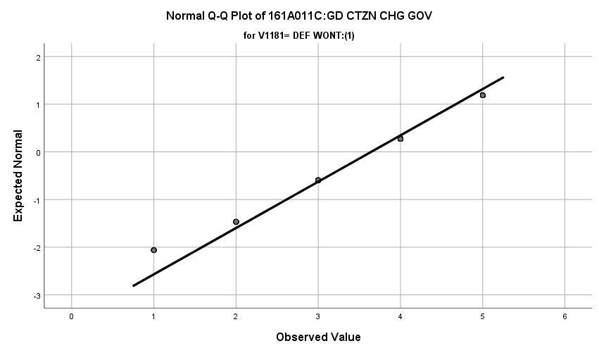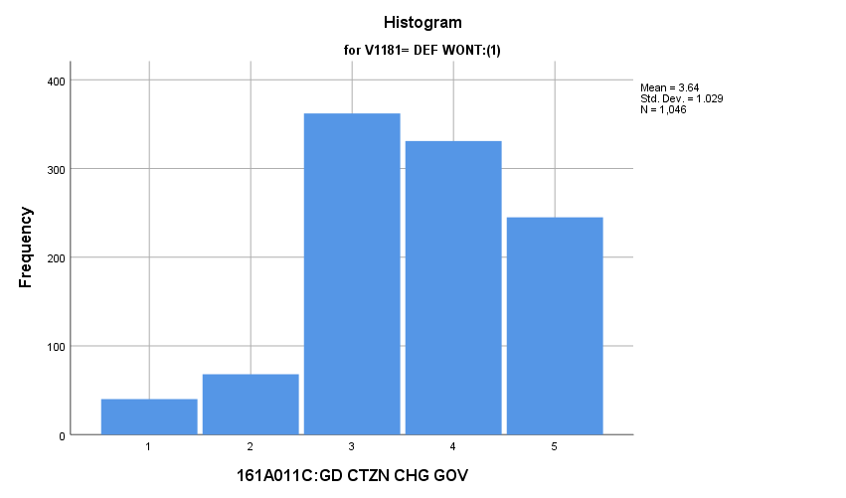

\

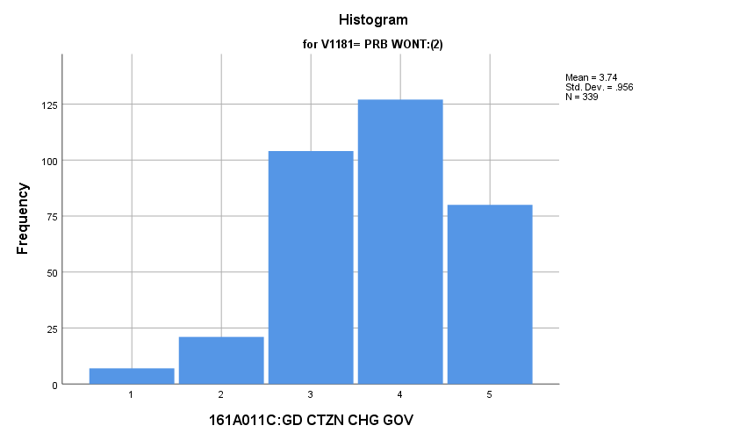

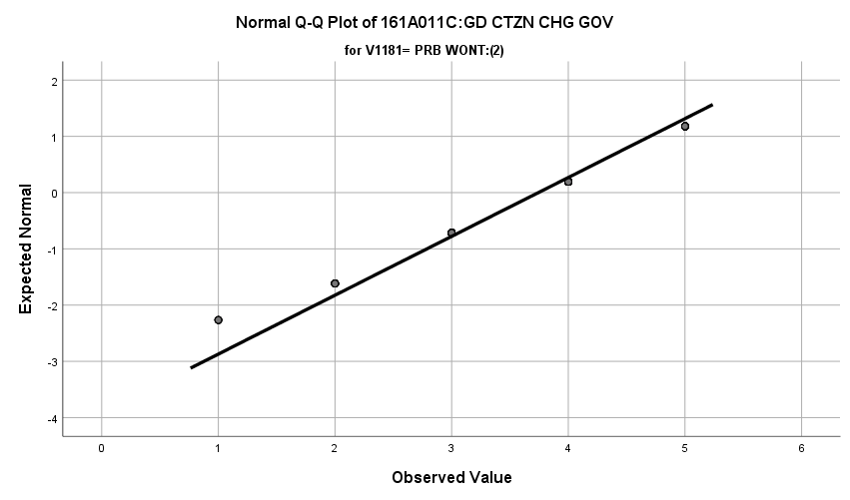

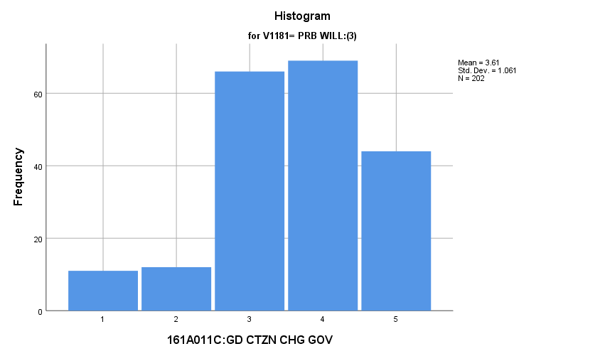

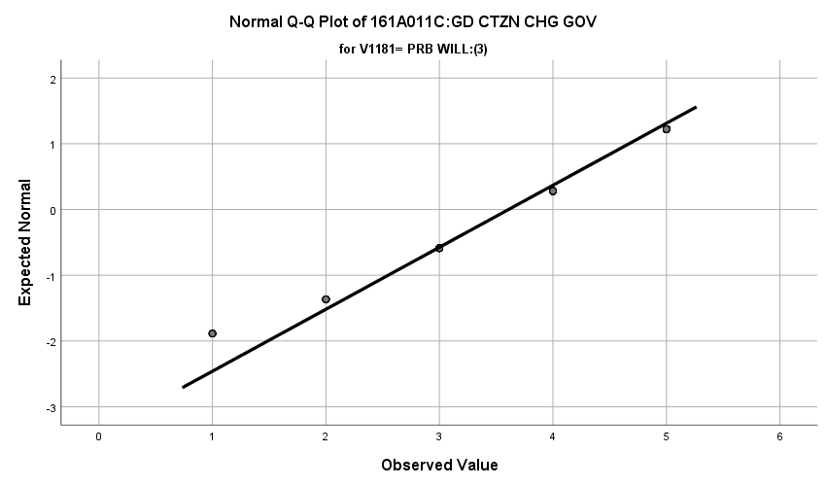

**Exhibit: Descriptives**

|  |  |  |  |  |  |
| --- | --- | --- | --- | --- | --- |
| ***Descriptives*** | | | | | |
|  | V1181 | | | Statistic | Std. Error |
| V1674 | DEF WONT:(1) | Mean | | **3.64** | **.032** |
| 99% Confidence Interval for Mean | Lower Bound | **3.56** |  |
| Upper Bound | **3.73** |  |
| 5% Trimmed Mean | | **3.70** |  |
| Median | | **4.00** |  |
| Variance | | **1.058** |  |
| Std. Deviation | | **1.029** |  |
| Minimum | | **1** |  |
| Maximum | | **5** |  |
| Range | | **4** |  |
| Interquartile Range | | **1** |  |
| Skewness | | **-.449** | **.076** |
| Kurtosis | | **-.133** | **.151** |
| PRB WONT:(2) | Mean | | **3.74** | **.052** |
| 99% Confidence Interval for Mean | Lower Bound | **3.61** |  |
| Upper Bound | **3.88** |  |
| 5% Trimmed Mean | | **3.79** |  |
| Median | | **4.00** |  |
| Variance | | **.913** |  |
| Std. Deviation | | **.956** |  |
| Minimum | | **1** |  |
| Maximum | | **5** |  |
| Range | | **4** |  |
| Interquartile Range | | **1** |  |
| Skewness | | **-.469** | **.132** |
| Kurtosis | | **-.058** | **.264** |
| PRB WILL:(3) | Mean | | **3.61** | **.075** |
| 99% Confidence Interval for Mean | Lower Bound | **3.41** |  |
| Upper Bound | **3.80** |  |
| 5% Trimmed Mean | | **3.68** |  |
| Median | | **4.00** |  |
| Variance | | **1.125** |  |
| Std. Deviation | | **1.061** |  |
| Minimum | | **1** |  |
| Maximum | | **5** |  |
| Range | | **4** |  |
| Interquartile Range | | **1** |  |
| Skewness | | **-.580** | **.171** |
| Kurtosis | | **.055** | **.341** |

**Exhibit: One Way ANOVA Table and Homogeneity**

|  |  |  |  |  |  |
| --- | --- | --- | --- | --- | --- |
| ***Test of Homogeneity of Variances*** | | | | | |
|  | | Levene Statistic | df1 | df2 | Sig. |
| V1674 | Based on Mean | **2.581** | **2** | **1584** | **.076** |
| Based on Median | **2.478** | **2** | **1584** | **.084** |
| Based on Median and with adjusted df | **2.478** | **2** | **1573.601** | **.084** |
| Based on trimmed mean | **2.756** | **2** | **1584** | **.064** |

|  |  |  |  |  |  |
| --- | --- | --- | --- | --- | --- |
| ***ANOVA*** | | | | | |
| V1674 | | | | | |
|  | Sum of Squares | df | Mean Square | F | Sig. |
| Between Groups | **3.171** | **2** | **1.585** | **1.531** | **.217** |
| Within Groups | **1640.766** | **1584** | **1.036** |  |  |
| Total | **1643.937** | **1586** |  |  |  |

**USA is the Best System in the World:** How do potential recruits differ from the other two groups regarding how strongly they feel that the USA has the best system in the world?

**Variables Used:** The **dependent** **variable** used in the analysis was how strongly they feel that the USA has the best system in the world (1=disagree, 2=mostly disagree, 3=neither, 4=mostly agree, 5=agree) and the **independent (grouping) variable** used was the pool of respondents. The respondent pool is broken into three categories:

* Non-recruits (students who say they definitely will not serve in the military after high school graduation) --- these are labeled as *definitely won’t (1).*
* Recruits (students who say they definitely or probably will serve in the military) --- these are labeled as *probably will (3).*
* Potential recruits (those who say they probably will not serve) --- these are labeled as *probably won’t (2)*.
* The desired pool of recruits is those labeled as probably won’t.
* Total respondents: 1587, range for all groups 1 to 5

**Analysis Procedure:**

* A one-way ANOVA test was utilized to compare how the potential pool of recruits differs by how strongly they feel that the USA has the best system in the world.
* The analysis variable of how strongly they feel that the USA has the best system in the world is interval and the grouping variables are mutually exclusive.
* Prior to analysis, a histogram and Q-Q plots were inspected for outliers, none were present. Each group had a negative skew and was than 2.
* The homogeneity of variances assumption was tested. The assumption was met.

**Results:**

* Null and alternative hypothesis:
  + Main Test
    - H0 : µ1 = µ2 = µ3
    - Ha : ALOI
* Calculated F value: f(how strongly they feel that the USA has the best system in the world) 1.531, dfnum= 2, dfden= 1584, α = 0.01, fail to reject H0;

**Interpretation:** There was no significant difference in means between the three groups how strongly they feel that the USA has the best system in the world.

**Supporting Analysis:**

**Exhibit: Preliminary Analysis**

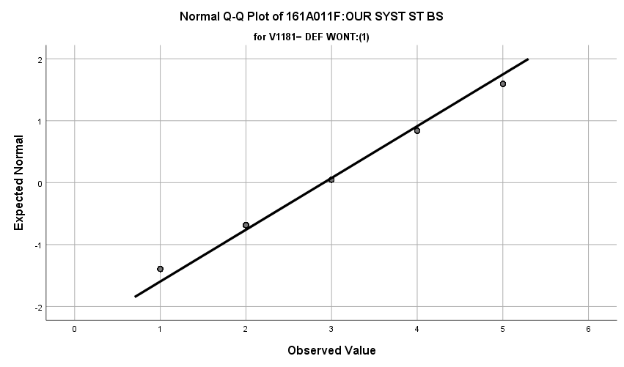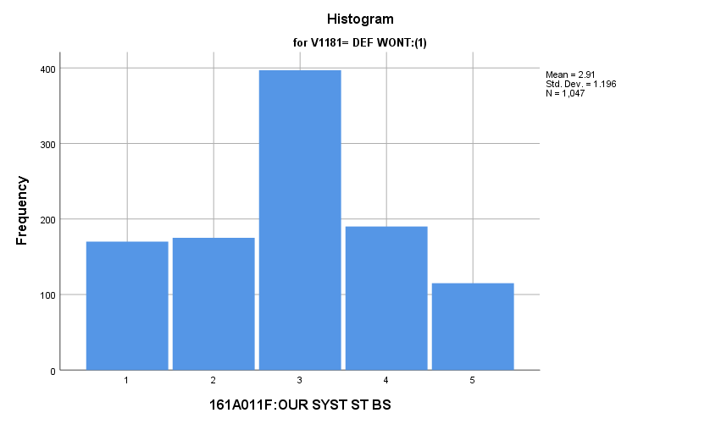

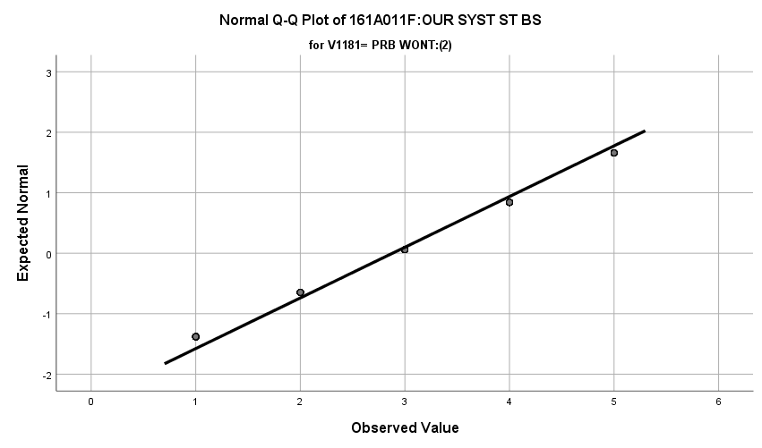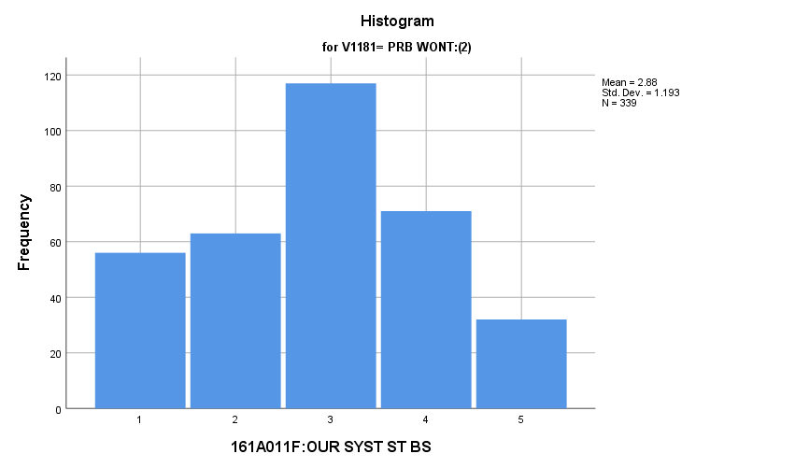

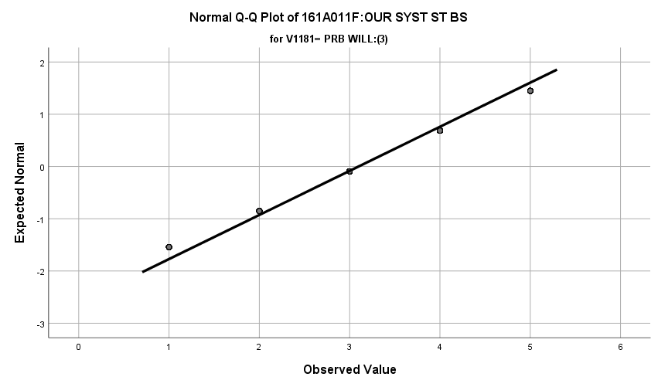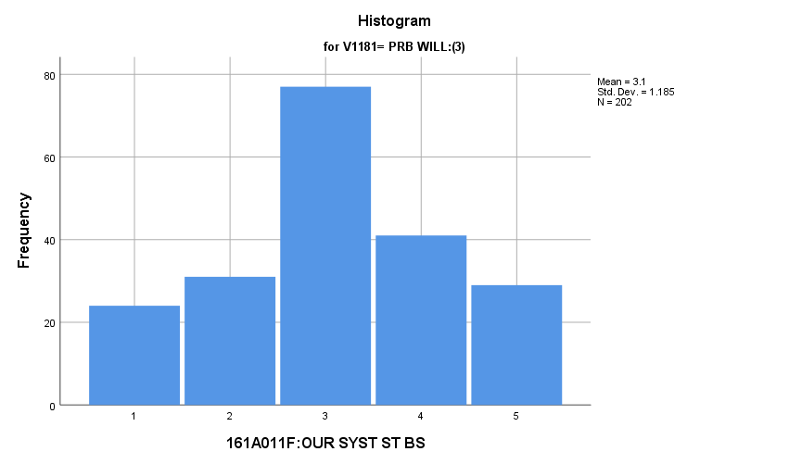

**Exhibit: Descriptives**

|  |  |  |  |  |  |
| --- | --- | --- | --- | --- | --- |
| ***Descriptives*** | | | | | |
|  | V1181 | | | Statistic | Std. Error |
| V1677 | DEF WONT:(1) | Mean | | **2.91** | **.037** |
| 99% Confidence Interval for Mean | Lower Bound | **2.81** |  |
| Upper Bound | **3.00** |  |
| 5% Trimmed Mean | | **2.90** |  |
| Median | | **3.00** |  |
| Variance | | **1.431** |  |
| Std. Deviation | | **1.196** |  |
| Minimum | | **1** |  |
| Maximum | | **5** |  |
| Range | | **4** |  |
| Interquartile Range | | **2** |  |
| Skewness | | **-.009** | **.076** |
| Kurtosis | | **-.732** | **.151** |
| PRB WONT:(2) | Mean | | **2.88** | **.065** |
| 99% Confidence Interval for Mean | Lower Bound | **2.71** |  |
| Upper Bound | **3.05** |  |
| 5% Trimmed Mean | | **2.87** |  |
| Median | | **3.00** |  |
| Variance | | **1.424** |  |
| Std. Deviation | | **1.193** |  |
| Minimum | | **1** |  |
| Maximum | | **5** |  |
| Range | | **4** |  |
| Interquartile Range | | **2** |  |
| Skewness | | **-.023** | **.132** |
| Kurtosis | | **-.805** | **.264** |
| PRB WILL:(3) | Mean | | **3.10** | **.083** |
| 99% Confidence Interval for Mean | Lower Bound | **2.88** |  |
| Upper Bound | **3.32** |  |
| 5% Trimmed Mean | | **3.11** |  |
| Median | | **3.00** |  |
| Variance | | **1.403** |  |
| Std. Deviation | | **1.185** |  |
| Minimum | | **1** |  |
| Maximum | | **5** |  |
| Range | | **4** |  |
| Interquartile Range | | **2** |  |
| Skewness | | **-.103** | **.171** |
| Kurtosis | | **-.658** | **.341** |

**Exhibit: One Way ANOVA Table and Homogeneity**

|  |  |  |  |  |  |
| --- | --- | --- | --- | --- | --- |
| ***Test of Homogeneity of Variances*** | | | | | |
|  | | Levene Statistic | df1 | df2 | Sig. |
| V1677 | Based on Mean | **.204** | **2** | **1585** | **.815** |
| Based on Median | **.134** | **2** | **1585** | **.875** |
| Based on Median and with adjusted df | **.134** | **2** | **1583.899** | **.875** |
| Based on trimmed mean | **.213** | **2** | **1585** | **.808** |

|  |  |  |  |  |  |
| --- | --- | --- | --- | --- | --- |
| ***ANOVA*** | | | | | |
| V1677 | | | | | |
|  | Sum of Squares | df | Mean Square | F | Sig. |
| Between Groups | **6.992** | **2** | **3.496** | **2.452** | **.086** |
| Within Groups | **2259.680** | **1585** | **1.426** |  |  |
| Total | **2266.672** | **1587** |  |  |  |

*3.f. Student Ability to Follow Rules*

**Going to School is Enjoyable:** How do potential recruits differ from the other two groups regarding how strongly they feel that school is an enjoyable experience for them?

**Variables Used:** The **dependent** **variable** used in the analysis was how strongly they feel that school is an enjoyable experience for them (1=disagree, 2=mostly disagree, 3=neither, 4=mostly agree, 5=agree) and the **independent (grouping) variable** used was the pool of respondents. The respondent pool is broken into three categories:

* Non-recruits (students who say they definitely will not serve in the military after high school graduation) --- these are labeled as *definitely won’t (1).*
* Recruits (students who say they definitely or probably will serve in the military) --- these are labeled as *probably will (3).*
* Potential recruits (those who say they probably will not serve) --- these are labeled as *probably won’t (2)*.
* The desired pool of recruits is those labeled as probably won’t.
* Total respondents: 1590, range for all groups 1 to 5

**Analysis Procedure:**

* A one-way ANOVA test was utilized to compare how the potential pool of recruits differs by how strongly they feel that school is an enjoyable experience for them.
* The analysis variable of how strongly they feel that school is an enjoyable experience for them is interval and the grouping variables are mutually exclusive.
* Prior to analysis, a histogram and Q-Q plots were inspected for outliers, none were present. Each group had a negative skew and was than 2.
* The homogeneity of variances assumption was tested. The assumption was met.

**Results:**

* Null and alternative hypothesis:
  + Main Test
    - H0 : µ1 = µ2 = µ3
    - Ha : ALOI
* Calculated F value: f(how strongly they feel that school is an enjoyable experience for them) 1.407, dfnum= 2, dfden= 1587, α = 0.01, fail to reject H0;

**Interpretation:** There was no significant difference in means between the three groups how strongly they feel that school is an enjoyable experience for them.

**Supporting Analysis:**

**Exhibit: Preliminary Analysis**

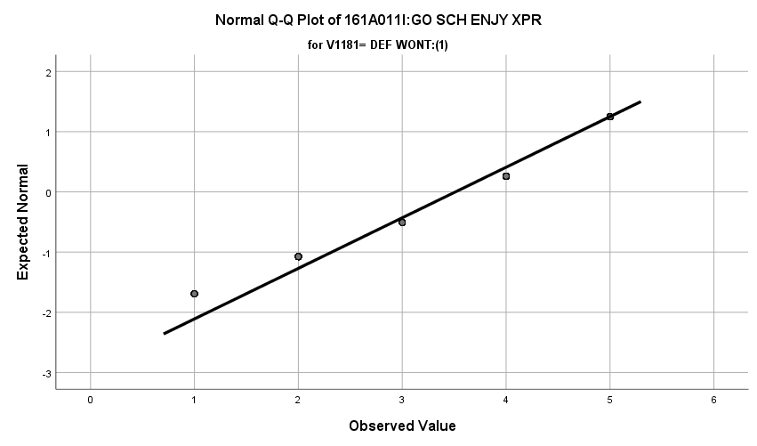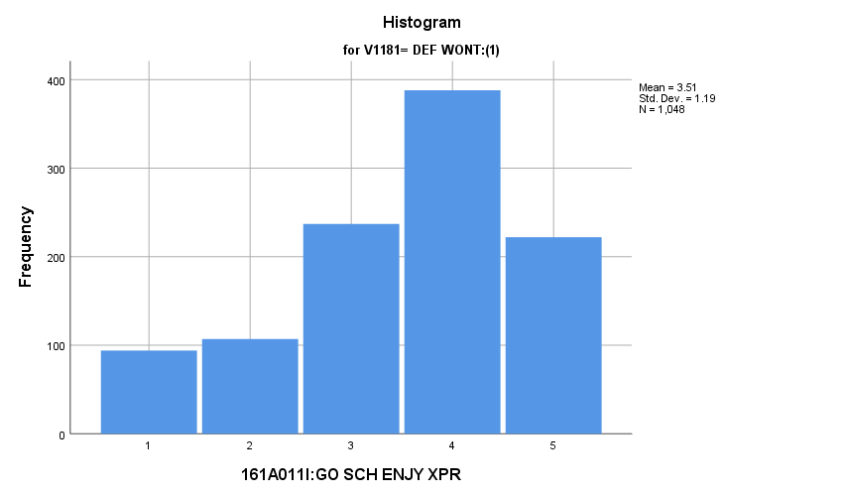

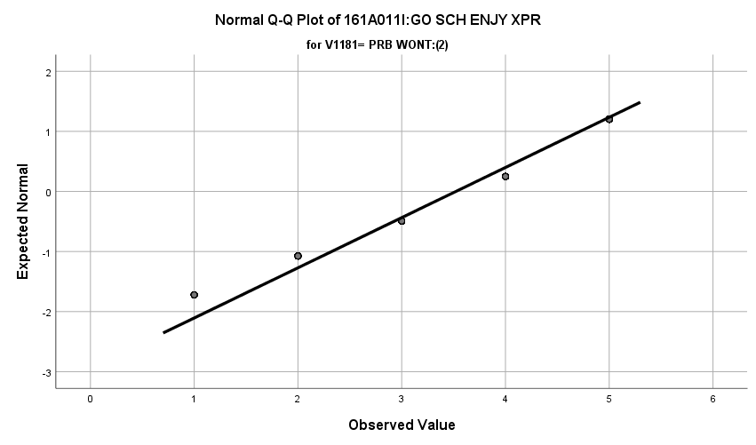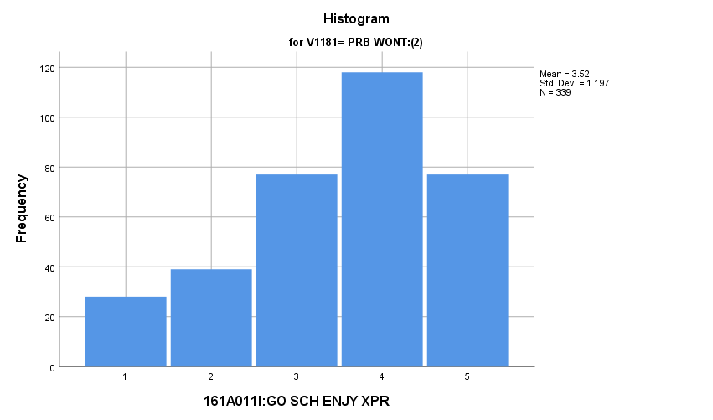

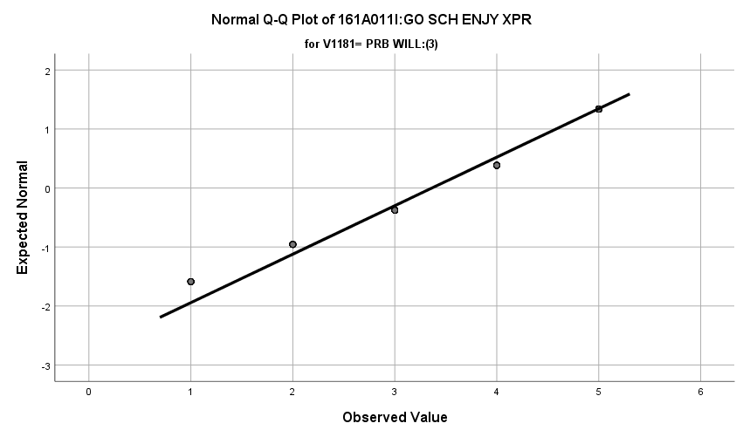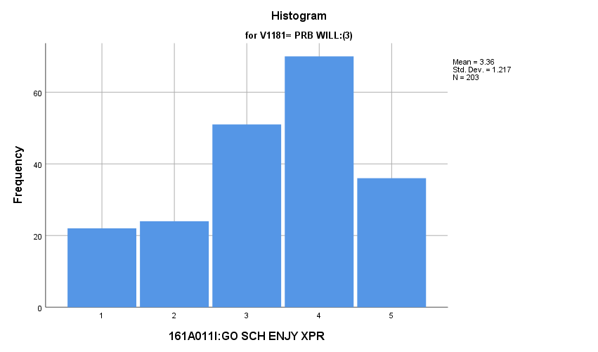

**Exhibit: Descriptives**

|  |  |  |  |  |  |
| --- | --- | --- | --- | --- | --- |
| ***Descriptives*** | | | | | |
|  | V1181 | | | Statistic | Std. Error |
| V1680 | DEF WONT:(1) | Mean | | **3.51** | **.037** |
| 99% Confidence Interval for Mean | Lower Bound | **3.42** |  |
| Upper Bound | **3.61** |  |
| 5% Trimmed Mean | | **3.57** |  |
| Median | | **4.00** |  |
| Variance | | **1.417** |  |
| Std. Deviation | | **1.190** |  |
| Minimum | | **1** |  |
| Maximum | | **5** |  |
| Range | | **4** |  |
| Interquartile Range | | **1** |  |
| Skewness | | **-.634** | **.076** |
| Kurtosis | | **-.411** | **.151** |
| PRB WONT:(2) | Mean | | **3.52** | **.065** |
| 99% Confidence Interval for Mean | Lower Bound | **3.35** |  |
| Upper Bound | **3.69** |  |
| 5% Trimmed Mean | | **3.58** |  |
| Median | | **4.00** |  |
| Variance | | **1.434** |  |
| Std. Deviation | | **1.197** |  |
| Minimum | | **1** |  |
| Maximum | | **5** |  |
| Range | | **4** |  |
| Interquartile Range | | **1** |  |
| Skewness | | **-.583** | **.132** |
| Kurtosis | | **-.504** | **.264** |
| PRB WILL:(3) | Mean | | **3.36** | **.085** |
| 99% Confidence Interval for Mean | Lower Bound | **3.14** |  |
| Upper Bound | **3.59** |  |
| 5% Trimmed Mean | | **3.41** |  |
| Median | | **4.00** |  |
| Variance | | **1.480** |  |
| Std. Deviation | | **1.217** |  |
| Minimum | | **1** |  |
| Maximum | | **5** |  |
| Range | | **4** |  |
| Interquartile Range | | **1** |  |
| Skewness | | **-.496** | **.171** |
| Kurtosis | | **-.623** | **.340** |

**Exhibit: One Way ANOVA Table and Homogeneity**

|  |  |  |  |  |  |
| --- | --- | --- | --- | --- | --- |
| ***Test of Homogeneity of Variances*** | | | | | |
|  | | Levene Statistic | df1 | df2 | Sig. |
| V1680 | Based on Mean | **.166** | **2** | **1587** | **.847** |
| Based on Median | **.651** | **2** | **1587** | **.522** |
| Based on Median and with adjusted df | **.651** | **2** | **1584.744** | **.522** |
| Based on trimmed mean | **.243** | **2** | **1587** | **.784** |

|  |  |  |  |  |  |
| --- | --- | --- | --- | --- | --- |
| ***ANOVA*** | | | | | |
| V1680 | | | | | |
|  | Sum of Squares | df | Mean Square | F | Sig. |
| Between Groups | **4.022** | **2** | **2.011** | **1.407** | **.245** |
| Within Groups | **2267.447** | **1587** | **1.429** |  |  |
| Total | **2271.469** | **1589** |  |  |  |

**Doing well in School is Important:** How do potential recruits differ from the other two groups regarding how strongly they feel doing well in school is important for their job and life in general?

**Variables Used:** The **dependent** **variable** used in the analysis was how strongly they feel doing well in school is important for their job and life in general (1=disagree, 2=mostly disagree, 3=neither, 4=mostly agree, 5=agree) and the **independent (grouping) variable** used was the pool of respondents. The respondent pool is broken into three categories:

* Non-recruits (students who say they definitely will not serve in the military after high school graduation) --- these are labeled as *definitely won’t (1).*
* Recruits (students who say they definitely or probably will serve in the military) --- these are labeled as *probably will (3).*
* Potential recruits (those who say they probably will not serve) --- these are labeled as *probably won’t (2)*.
* The desired pool of recruits is those labeled as probably won’t.
* Total respondents: 1593, range for all groups 1 to 5

**Analysis Procedure:**

* A one-way ANOVA test was utilized to compare how the potential pool of recruits differs by how strongly they feel doing well in school is important for their job and life in general.
* The analysis variable of how strongly they doing well in school is important for their job and life in general is interval and the grouping variables are mutually exclusive.
* Prior to analysis, a histogram and Q-Q plots were inspected for outliers, none were present. Each group had a negative skew and was than 2.
* The homogeneity of variances assumption was tested. The assumption was met.
* Eta was calculated to assess effect size.

**Results:**

* Null and alternative hypothesis:
  + Main Test
    - H0 : µ1 = µ2 = µ3
    - Ha : ALOI
  + Post Hoc (1 and 2)
    - H0 : µ1 = µ2
    - Ha : µ1 ≠ µ2
  + Post Hoc (1 and 3)
    - H0 : µ1 = µ3
    - Ha : µ1 ≠ µ3
  + Post Hoc (2 and 3)
    - H0 : µ2 = µ3
    - Ha : µ2 ≠ µ3
* Calculated F value: f(satisfaction with life as a whole) 5.365, dfnum= 2, dfden= 1590, α = 0.01, reject H0; eta = 0.082

**Interpretation:** There was a significant difference among the groups regarding how doing well in school is important for their job and life in general. Interestingly, there was no significant difference among any groups in the post hoc tests. Here are the means of each group:

* Definitely won’t: 4.29
* Probably won’t: 4.13
* Probably will: 4.11

Observing the values, one could see a difference in the groups of definitely wont and probably will but this is only an eyeball test. 0.67% of the variation in the importance of doing well in school is important to job/life is explained by which respondent pool the individual is in.

**Supporting Analysis:**

**Exhibit: Preliminary Analysis**

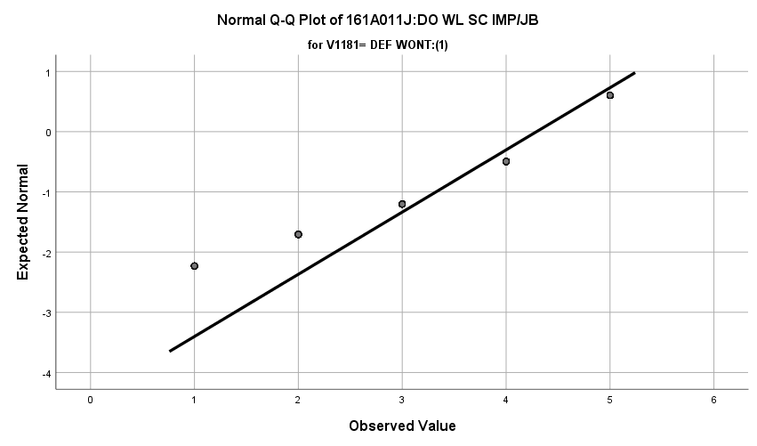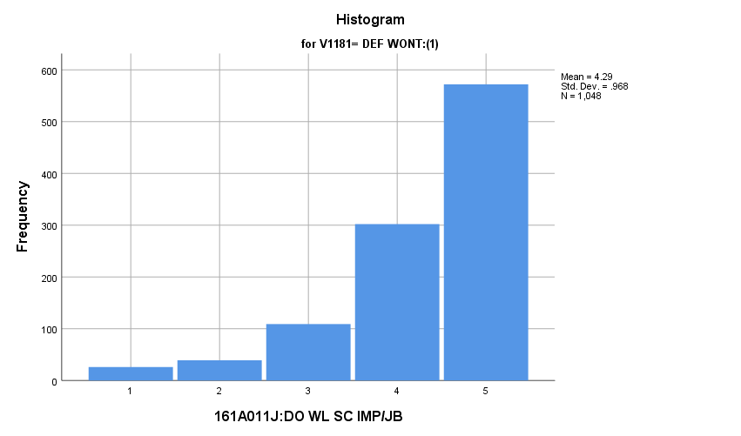

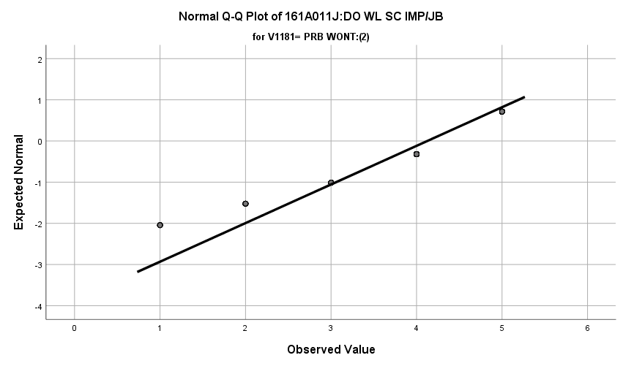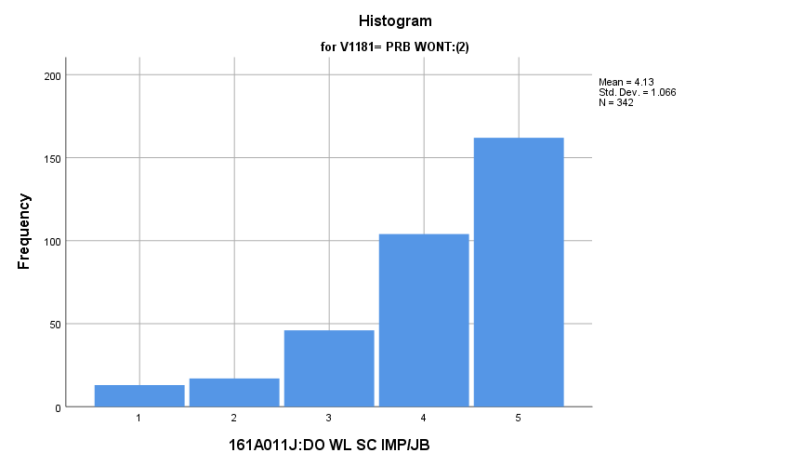

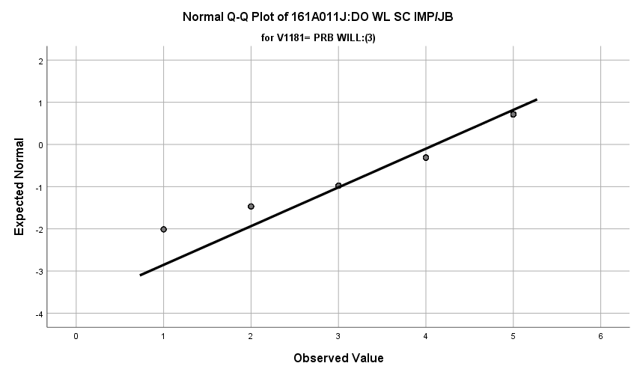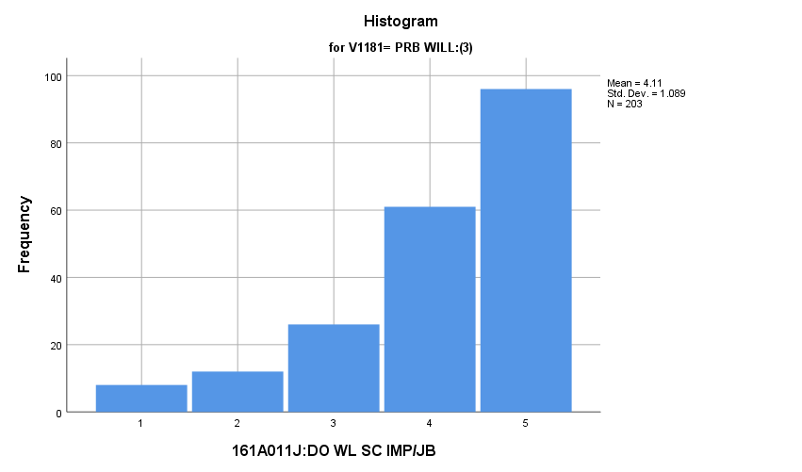

**Exhibit: Descriptives**

|  |  |  |  |  |  |
| --- | --- | --- | --- | --- | --- |
| ***Descriptives*** | | | | | |
|  | V1181 | | | Statistic | Std. Error |
| V1681 | DEF WONT:(1) | Mean | | **4.29** | **.030** |
| 99% Confidence Interval for Mean | Lower Bound | **4.22** |  |
| Upper Bound | **4.37** |  |
| 5% Trimmed Mean | | **4.41** |  |
| Median | | **5.00** |  |
| Variance | | **.937** |  |
| Std. Deviation | | **.968** |  |
| Minimum | | **1** |  |
| Maximum | | **5** |  |
| Range | | **4** |  |
| Interquartile Range | | **1** |  |
| Skewness | | **-1.519** | **.076** |
| Kurtosis | | **2.008** | **.151** |
| PRB WONT:(2) | Mean | | **4.13** | **.058** |
| 99% Confidence Interval for Mean | Lower Bound | **3.98** |  |
| Upper Bound | **4.28** |  |
| 5% Trimmed Mean | | **4.24** |  |
| Median | | **4.00** |  |
| Variance | | **1.137** |  |
| Std. Deviation | | **1.066** |  |
| Minimum | | **1** |  |
| Maximum | | **5** |  |
| Range | | **4** |  |
| Interquartile Range | | **1** |  |
| Skewness | | **-1.261** | **.132** |
| Kurtosis | | **1.031** | **.263** |
| PRB WILL:(3) | Mean | | **4.11** | **.076** |
| 99% Confidence Interval for Mean | Lower Bound | **3.91** |  |
| Upper Bound | **4.31** |  |
| 5% Trimmed Mean | | **4.22** |  |
| Median | | **4.00** |  |
| Variance | | **1.186** |  |
| Std. Deviation | | **1.089** |  |
| Minimum | | **1** |  |
| Maximum | | **5** |  |
| Range | | **4** |  |
| Interquartile Range | | **1** |  |
| Skewness | | **-1.239** | **.171** |
| Kurtosis | | **.883** | **.340** |

**Exhibit: Means Table**

|  |  |  |  |
| --- | --- | --- | --- |
| ***Report*** | | | |
| V1681 | | | |
| V1181 | Mean | N | Std. Deviation |
| DEF WONT:(1) | **4.29** | **1048** | **.968** |
| PRB WONT:(2) | **4.13** | **342** | **1.066** |
| PRB WILL:(3) | **4.11** | **203** | **1.089** |
| Total | **4.23** | **1593** | **1.008** |

**Exhibit: One Way ANOVA Table and Homogeneity**

|  |  |  |  |  |  |
| --- | --- | --- | --- | --- | --- |
| ***Test of Homogeneity of Variances*** | | | | | |
|  | | Levene Statistic | df1 | df2 | Sig. |
| V1681 | Based on Mean | **1.851** | **2** | **1590** | **.157** |
| Based on Median | **3.348** | **2** | **1590** | **.035** |
| Based on Median and with adjusted df | **3.348** | **2** | **1477.377** | **.035** |
| Based on trimmed mean | **2.797** | **2** | **1590** | **.061** |

|  |  |  |  |  |  |
| --- | --- | --- | --- | --- | --- |
| ***ANOVA*** | | | | | |
| V1681 | | | | | |
|  | Sum of Squares | df | Mean Square | F | Sig. |
| Between Groups | **10.853** | **2** | **5.426** | **5.365** | **.005** |
| Within Groups | **1608.277** | **1590** | **1.011** |  |  |
| Total | **1619.130** | **1592** |  |  |  |

**Exhibit: Effect Size**

|  |  |  |
| --- | --- | --- |
| ***Measures of Association*** | | |
|  | Eta | Eta Squared |
| V1681 * V1181 | **.082** | **.007** |

**Exhibit: Post Hoc**

|  |  |  |  |  |  |  |
| --- | --- | --- | --- | --- | --- | --- |
| ***Multiple Comparisons*** | | | | | | |
| Dependent Variable: V1681 | | | | | | |
| Games-Howell | | | | | | |
| (I) V1181 | (J) V1181 | Mean Difference (I-J) | Std. Error | Sig. | 99% Confidence Interval | |
| Lower Bound | Upper Bound |
| DEF WONT:(1) | PRB WONT:(2) | **.167** | **.065** | **.028** | **-.02** | **.36** |
| PRB WILL:(3) | **.185** | **.082** | **.065** | **-.06** | **.43** |
| PRB WONT:(2) | DEF WONT:(1) | **-.167** | **.065** | **.028** | **-.36** | **.02** |
| PRB WILL:(3) | **.017** | **.096** | **.982** | **-.26** | **.30** |
| PRB WILL:(3) | DEF WONT:(1) | **-.185** | **.082** | **.065** | **-.43** | **.06** |
| PRB WONT:(2) | **-.017** | **.096** | **.982** | **-.30** | **.26** |

**Research Question 4:** Within the potential recruit group, are there gender differences in the variables studied?

*4.a. Student Value Variables:*

**Importance of Being Successful at Work:** Within the potential recruit group, are there gender differences in how important they thought it was be successful at work?

**Variables used:** The dependent variable was importance of being successful at work, which allowed students to rank their responses from 1 to 4, with a high number meaning they found it more important. The independent (grouping) variable was sex (male or female).

**Analysis Procedure:**

* A t-test was used to compare average rating of how important students found being successful at work between the two gender groups (males versus females)
* Before conducting analysis, the distribution was checked separately for the two groups by means of visual inspection of histograms and Q-Q plots. No outliers were observed. The skew of both distributions was left skewed.
* The equality of variances assumption was tested. This assumption was not met.
* Eta-squared was calculated to assess effect size.

**Results:**

* Null and alternative hypothesis. H0: μ1 = μ2; Ha: μ1 ≠ μ2.
* Calculated t value: t = -3.319, df = 1719.7, reject H0, with a p-value of .001; Eta Squared = .006

**Interpretation:** There is a significant difference between the two gender groups in how important they found being successful at work. Furthermore, .6% of how important students found being successful at work can be explained by their gender.

**Supporting Analysis:**

*Preliminary Tests:*

|  |  |  |  |  |
| --- | --- | --- | --- | --- |
| ***Descriptives*** | | | | |
|  | 161C003:Rs SEX | | | Statistic |
| 161A007A:IMP B SUCCSS WK | MALE:(1) | Mean | | **3.57** |
| 99% Confidence Interval for Mean | Lower Bound | **3.51** |
| Upper Bound | **3.63** |
| 5% Trimmed Mean | | **3.65** |
| Median | | **4.00** |
| Variance | | **.450** |
| Std. Deviation | | **.671** |
| Minimum | | **1** |
| Maximum | | **4** |
| Range | | **3** |
| Interquartile Range | | **1** |
| Skewness | | **-1.553** |
| Kurtosis | | **2.093** |
| FEMALE:(2) | Mean | | **3.67** |
| 99% Confidence Interval for Mean | Lower Bound | **3.62** |
| Upper Bound | **3.72** |
| 5% Trimmed Mean | | **3.75** |
| Median | | **4.00** |
| Variance | | **.353** |
| Std. Deviation | | **.594** |
| Minimum | | **1** |
| Maximum | | **4** |
| Range | | **3** |
| Interquartile Range | | **1** |
| Skewness | | **-1.806** |
| Kurtosis | | **2.977** |

|  |  |  |  |  |
| --- | --- | --- | --- | --- |
| ***Descriptives*** | | | | |
|  | 161C003:Rs SEX | | | Std. Error |
| 161A007A:IMP B SUCCSS WK | MALE:(1) | Mean | | **.023** |
| 99% Confidence Interval for Mean | Lower Bound |  |
| Upper Bound |  |
| 5% Trimmed Mean | |  |
| Median | |  |
| Variance | |  |
| Std. Deviation | |  |
| Minimum | |  |
| Maximum | |  |
| Range | |  |
| Interquartile Range | |  |
| Skewness | | **.083** |
| Kurtosis | | **.167** |
| FEMALE:(2) | Mean | | **.019** |
| 99% Confidence Interval for Mean | Lower Bound |  |
| Upper Bound |  |
| 5% Trimmed Mean | |  |
| Median | |  |
| Variance | |  |
| Std. Deviation | |  |
| Minimum | |  |
| Maximum | |  |
| Range | |  |
| Interquartile Range | |  |
| Skewness | | **.080** |
| Kurtosis | | **.160** |

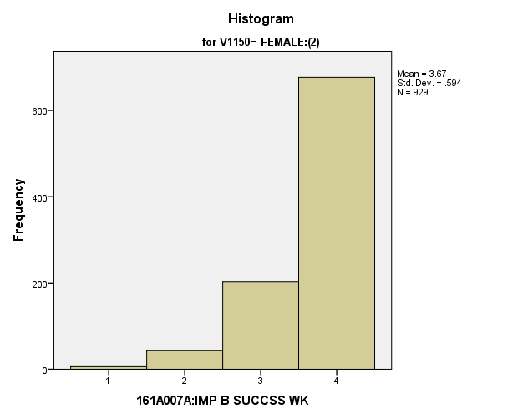

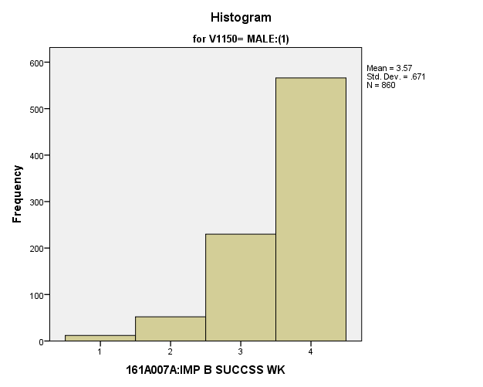

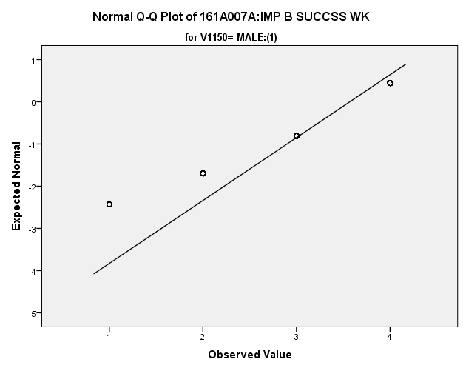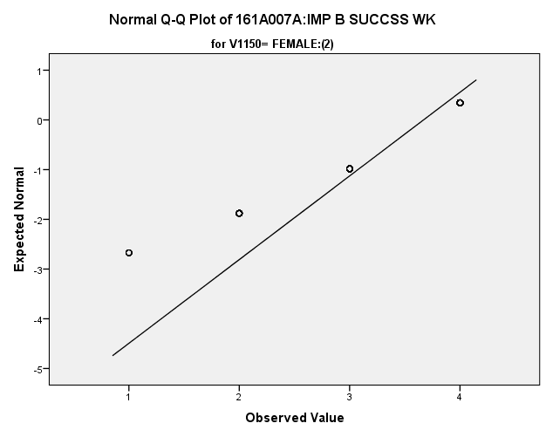

*Primary Analysis:*

|  |  |  |  |  |  |
| --- | --- | --- | --- | --- | --- |
| ***Group Statistics*** | | | | | |
|  | 161C003:Rs SEX | N | Mean | Std. Deviation | Std. Error Mean |
| 161A007A:IMP B SUCCSS WK | MALE:(1) | **860** | **3.57** | **.671** | **.023** |
| FEMALE:(2) | **929** | **3.67** | **.594** | **.019** |

|  |  |  |  |  |
| --- | --- | --- | --- | --- |
| ***Independent Samples Test*** | | | | |
|  | | Levene's Test for Equality of Variances | | t-test for Equality of Means |
| F | Sig. | t |
|
| 161A007A:IMP B SUCCSS WK | Equal variances assumed | **25.646** | **.000** | **-3.335** |
| Equal variances not assumed |  |  | **-3.319** |

|  |  |  |  |  |
| --- | --- | --- | --- | --- |
| ***Independent Samples Test*** | | | | |
|  | | t-test for Equality of Means | | |
| df | Sig. (2-tailed) | Mean Difference |
|
| 161A007A:IMP B SUCCSS WK | Equal variances assumed | **1787** | **.001** | **-.100** |
| Equal variances not assumed | **1719.734** | **.001** | **-.100** |

|  |  |  |  |  |
| --- | --- | --- | --- | --- |
| ***Independent Samples Test*** | | | | |
|  | | t-test for Equality of Means | | |
| Std. Error Difference | 99% Confidence Interval of the Difference | |
| Lower | Upper |
| 161A007A:IMP B SUCCSS WK | Equal variances assumed | **.030** | **-.177** | **-.023** |
| Equal variances not assumed | **.030** | **-.177** | **-.022** |

|  |  |  |
| --- | --- | --- |
| ***Measures of Association*** | | |
|  | Eta | Eta Squared |
| 161A007A:IMP B SUCCSS WK * 161C003:Rs SEX | **.079** | **.006** |

**Importance of Having a Good Marriage and Family:** Within the potential recruit group, are there gender differences in how important they thought it was to have a good marriage and family?

**Variables used:** The dependent variable was importance of having a good marriage and family, which allowed students to rank their responses from 1 to 4, with a high number meaning they found it more important. The independent (grouping) variable was sex (male or female).

**Analysis Procedure:**

* A t-test was used to compare average rating of how important students found having a good marriage and family money between the two gender groups (males versus females)
* Before conducting analysis, the distribution was checked separately for the two groups by means of visual inspection of histograms and Q-Q plots. No outliers were observed and both were left skewed.
* The equality of variances assumption was tested. This assumption was not met.
* Eta-squared was calculated to assess effect size.

**Results:**

* Null and alternative hypothesis. H0: μ1 = μ2; Ha: μ1 ≠ μ2.
* Calculated t value: t = -3.403, df = 1686, reject H0, with a p-value of .001; Eta Squared = .007

**Interpretation:** There is a significant difference between the two gender groups in how important they found having a good marriage and family. Furthermore, .7% of how important students found having a good marriage and family can be explained by their gender.

**Supporting Analysis:**

|  |  |  |  |  |
| --- | --- | --- | --- | --- |
| ***Descriptives*** | | | | |
|  | 161C003:Rs SEX | | | Statistic |
| 161A007B:IMP GD MRRG/FAM | MALE:(1) | Mean | | **3.56** |
| 99% Confidence Interval for Mean | Lower Bound | **3.49** |
| Upper Bound | **3.63** |
| 5% Trimmed Mean | | **3.66** |
| Median | | **4.00** |
| Variance | | **.643** |
| Std. Deviation | | **.802** |
| Minimum | | **1** |
| Maximum | | **4** |
| Range | | **3** |
| Interquartile Range | | **1** |
| Skewness | | **-1.812** |
| Kurtosis | | **2.412** |
| FEMALE:(2) | Mean | | **3.68** |
| 99% Confidence Interval for Mean | Lower Bound | **3.62** |
| Upper Bound | **3.73** |
| 5% Trimmed Mean | | **3.77** |
| Median | | **4.00** |
| Variance | | **.458** |
| Std. Deviation | | **.677** |
| Minimum | | **1** |
| Maximum | | **4** |
| Range | | **3** |
| Interquartile Range | | **0** |
| Skewness | | **-2.188** |
| Kurtosis | | **4.250** |

|  |  |  |  |  |
| --- | --- | --- | --- | --- |
| ***Descriptives*** | | | | |
|  | 161C003:Rs SEX | | | Std. Error |
| 161A007B:IMP GD MRRG/FAM | MALE:(1) | Mean | | **.027** |
| 99% Confidence Interval for Mean | Lower Bound |  |
| Upper Bound |  |
| 5% Trimmed Mean | |  |
| Median | |  |
| Variance | |  |
| Std. Deviation | |  |
| Minimum | |  |
| Maximum | |  |
| Range | |  |
| Interquartile Range | |  |
| Skewness | | **.083** |
| Kurtosis | | **.167** |
| FEMALE:(2) | Mean | | **.022** |
| 99% Confidence Interval for Mean | Lower Bound |  |
| Upper Bound |  |
| 5% Trimmed Mean | |  |
| Median | |  |
| Variance | |  |
| Std. Deviation | |  |
| Minimum | |  |
| Maximum | |  |
| Range | |  |
| Interquartile Range | |  |
| Skewness | | **.080** |
| Kurtosis | | **.160** |

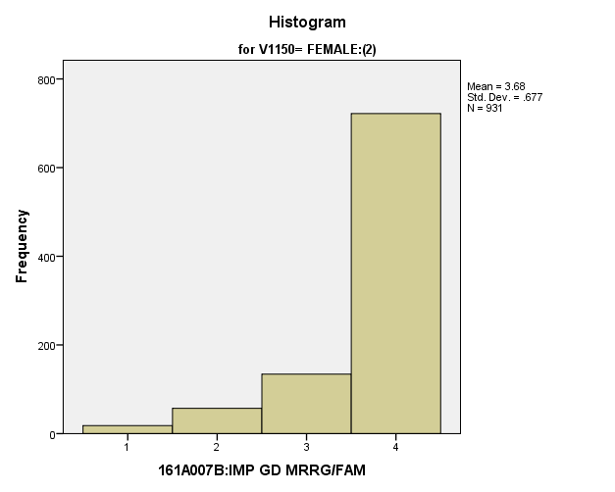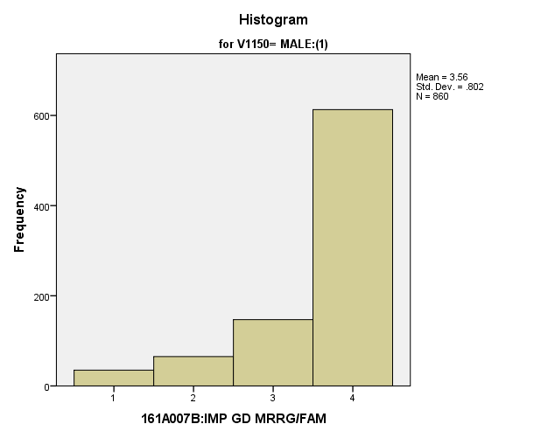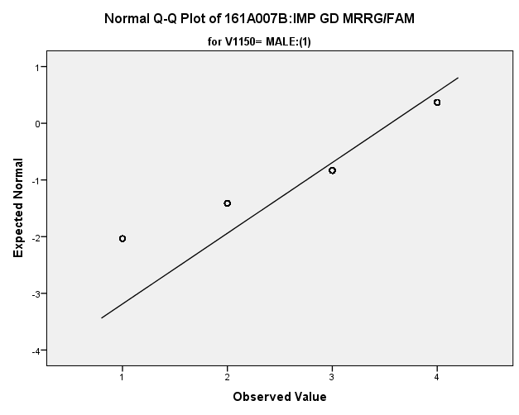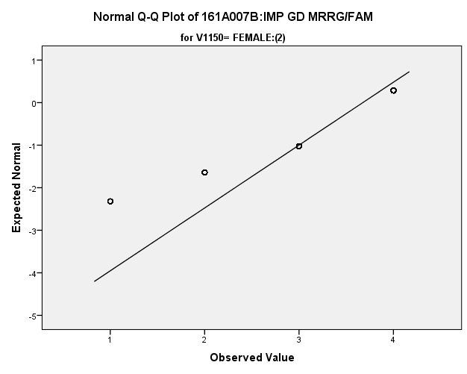

*Primary Analysis:*

|  |  |  |  |  |  |
| --- | --- | --- | --- | --- | --- |
| ***Group Statistics*** | | | | | |
|  | 161C003:Rs SEX | N | Mean | Std. Deviation | Std. Error Mean |
| 161A007B:IMP GD MRRG/FAM | MALE:(1) | **860** | **3.56** | **.802** | **.027** |
| FEMALE:(2) | **931** | **3.68** | **.677** | **.022** |

|  |  |  |  |  |
| --- | --- | --- | --- | --- |
| ***Independent Samples Test*** | | | | |
|  | | Levene's Test for Equality of Variances | | t-test for Equality of Means |
| F | Sig. | t |
|
| 161A007B:IMP GD MRRG/FAM | Equal variances assumed | **34.024** | **.000** | **-3.425** |
| Equal variances not assumed |  |  | **-3.403** |

|  |  |  |  |  |
| --- | --- | --- | --- | --- |
| ***Independent Samples Test*** | | | | |
|  | | t-test for Equality of Means | | |
| df | Sig. (2-tailed) | Mean Difference |
|
| 161A007B:IMP GD MRRG/FAM | Equal variances assumed | **1789** | **.001** | **-.120** |
| Equal variances not assumed | **1686.871** | **.001** | **-.120** |

|  |  |  |  |  |  |  |  |
| --- | --- | --- | --- | --- | --- | --- | --- |
| ***Independent Samples Test*** | | | | | | | |
|  | | | | | t-test for Equality of Means | | |
| Std. Error Difference | 99% Confidence Interval of the Difference | |
| Lower | Upper |
| 161A007B:IMP GD MRRG/FAM | Equal variances assumed | | | | **.035** | **-.210** | **-.030** |
| Equal variances not assumed | | | | **.035** | **-.211** | **-.029** |
| ***Measures of Association*** | | | |
|  | | Eta | Eta Squared |
| 161A007B:IMP GD MRRG/FAM * 161C003:Rs SEX | | **.081** | **.007** |

**Importance of Having Lots of Money:** Within the potential recruit group, are there gender differences in how important they thought it was to have lots of money?

**Variables used:** The dependent variable was importance of having lots of money, which allowed students to rank their responses from 1 to 4, with a high number meaning they found it more important. The independent (grouping) variable was sex (male or female).

**Analysis Procedure:**

* A t-test was used to compare average rating of how important students found having lots of money between the two gender groups (males versus females)
* Before conducting analysis, the distribution for importance of having lots of money was checked separately for the two groups by means of visual inspection of histograms and Q-Q plots. No outliers were observed.
* The equality of variances assumption was tested. This assumption was met.
* Eta-squared was calculated to assess effect size.

**Results:**

* Null and alternative hypothesis. H0: μ1 = μ2; Ha: μ1 ≠ μ2.
* Calculated t value: t = 3.223, df = 329, reject H0, with a p-value of .001; Eta Squared = .031.

**Interpretation:** There is a significant difference between the two gender groups in how important they found having lots of money. Furthermore, 3.1% of how important students found having lots of money can be explained by their gender.

**Supporting Analysis:**

*Preliminary Tests:*

|  |  |  |  |  |
| --- | --- | --- | --- | --- |
| ***Descriptives*** | | | | |
|  | 161C003:Rs SEX | | | Statistic |
| 161A007C:IMP LOTS OF $ | MALE:(1) | Mean | | **3.02** |
| 99% Confidence Interval for Mean | Lower Bound | **2.94** |
| Upper Bound | **3.10** |
| 5% Trimmed Mean | | **3.08** |
| Median | | **3.00** |
| Variance | | **.824** |
| Std. Deviation | | **.908** |
| Minimum | | **1** |
| Maximum | | **4** |
| Range | | **3** |
| Interquartile Range | | **2** |
| Skewness | | **-.490** |
| Kurtosis | | **-.760** |
| FEMALE:(2) | Mean | | **2.89** |
| 99% Confidence Interval for Mean | Lower Bound | **2.82** |
| Upper Bound | **2.97** |
| 5% Trimmed Mean | | **2.93** |
| Median | | **3.00** |
| Variance | | **.768** |
| Std. Deviation | | **.876** |
| Minimum | | **1** |
| Maximum | | **4** |
| Range | | **3** |
| Interquartile Range | | **2** |
| Skewness | | **-.293** |
| Kurtosis | | **-.759** |

|  |  |  |  |  |
| --- | --- | --- | --- | --- |
| ***Descriptives*** | | | | |
|  | 161C003:Rs SEX | | | Std. Error |
| 161A007C:IMP LOTS OF $ | MALE:(1) | Mean | | **.031** |
| 99% Confidence Interval for Mean | Lower Bound |  |
| Upper Bound |  |
| 5% Trimmed Mean | |  |
| Median | |  |
| Variance | |  |
| Std. Deviation | |  |
| Minimum | |  |
| Maximum | |  |
| Range | |  |
| Interquartile Range | |  |
| Skewness | | **.084** |
| Kurtosis | | **.167** |
| FEMALE:(2) | Mean | | **.029** |
| 99% Confidence Interval for Mean | Lower Bound |  |
| Upper Bound |  |
| 5% Trimmed Mean | |  |
| Median | |  |
| Variance | |  |
| Std. Deviation | |  |
| Minimum | |  |
| Maximum | |  |
| Range | |  |
| Interquartile Range | |  |
| Skewness | | **.081** |
| Kurtosis | | **.161** |

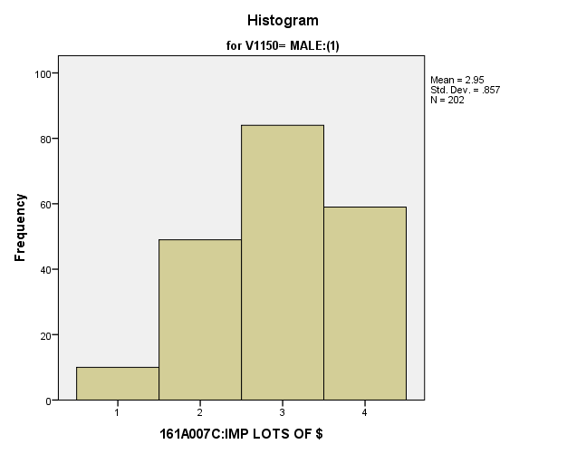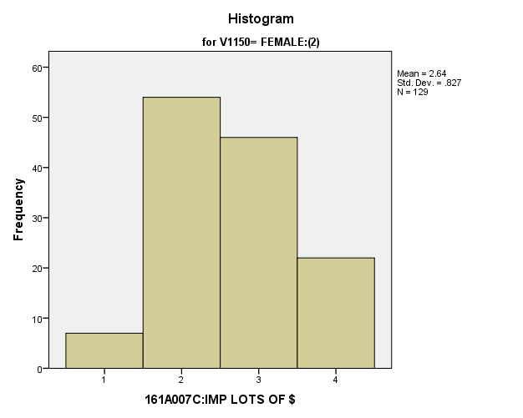

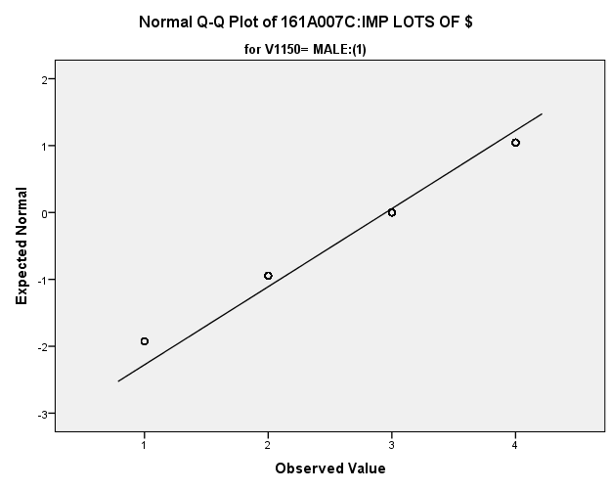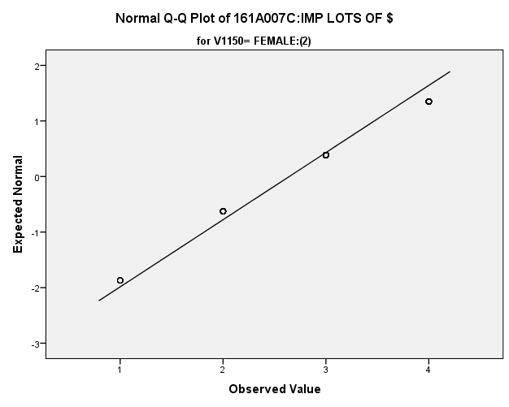

*Primary Analysis:*

|  |  |  |  |  |  |
| --- | --- | --- | --- | --- | --- |
| ***Group Statistics*** | | | | | |
|  | V1150 | N | Mean | Std. Deviation | Std. Error Mean |
| V1657 | MALE:(1) | **202** | **2.95** | **.857** | **.060** |
| FEMALE:(2) | **129** | **2.64** | **.827** | **.073** |

|  |  |  |  |  |  |
| --- | --- | --- | --- | --- | --- |
| ***Independent Samples Test*** | | | | | |
|  | | Levene's Test for Equality of Variances | | t-test for Equality of Means | |
| F | Sig. | t | df |
|
| V1657 | Equal variances assumed | **1.240** | **.266** | **3.223** | **329** |
| Equal variances not assumed |  |  | **3.248** | **279.783** |

|  |  |  |  |  |  |
| --- | --- | --- | --- | --- | --- |
| ***Independent Samples Test*** | | | | | |
|  | | t-test for Equality of Means | | | |
| Sig. (2-tailed) | Mean Difference | Std. Error Difference | 99% Confidence Interval of the Difference |
| Lower |
| V1657 | Equal variances assumed | **.001** | **.307** | **.095** | **.060** |
| Equal variances not assumed | **.001** | **.307** | **.095** | **.062** |

|  |  |  |
| --- | --- | --- |
| ***Independent Samples Test*** | | |
|  | | t-test for Equality of Means |
| 99% Confidence Interval of the Difference |
| Upper |
| V1657 | Equal variances assumed | **.554** |
| Equal variances not assumed | **.552** |

|  |  |  |
| --- | --- | --- |
| **Measures of Association** | | |
|  | Eta | Eta Squared |
| V1657 * V1150 | **.175** | **.031** |

**Importance of Time for Recreation and Hobby:** Within the potential recruit group, are there gender differences in how important they thought it was to have time for recreation and hobby?

**Variables used:** The dependent variable was importance of having time for recreation and hobby, which students ranked importance on a scale of 1 to 4, with a higher number meaning they found it more important. The independent (grouping) variable was sex (male or female).

**Analysis Procedure:**

* A t-test was used to compare average rating of how important students found having time for recreation and hobby between the two gender groups (males versus females)
* Before conducting analysis, the distribution for importance of having time for recreation and hobby was checked separately for the two groups by means of visual inspection of histograms and Q-Q plots. No outliers were observed. However, the distribution was left skewed for both groups.
* The equality of variances assumption was tested. This assumption was not met.

**Results:**

* Null and alternative hypothesis. H0: μ1 = μ2; Ha: μ1 ≠ μ2.
* Calculated t value: t = 3.884, df =1771, reject H0, with a p-value of .000; Eta squared =.008

**Interpretation:** There is a significant difference between the two gender groups in how important they found having time for recreation and hobby. Furthermore, .8% of how important students found having lots of money can be explained by their gender.

**Supporting Analysis:**

*Preliminary Analysis:*

|  |  |  |  |  |
| --- | --- | --- | --- | --- |
| ***Descriptives*** | | | | |
|  | 161C003:Rs SEX | | | Statistic |
| 161A007D:IMP TM RCRN/HBY | MALE:(1) | Mean | | **3.20** |
| 99% Confidence Interval for Mean | Lower Bound | **3.13** |
| Upper Bound | **3.27** |
| 5% Trimmed Mean | | **3.24** |
| Median | | **3.00** |
| Variance | | **.612** |
| Std. Deviation | | **.782** |
| Minimum | | **1** |
| Maximum | | **4** |
| Range | | **3** |
| Interquartile Range | | **1** |
| Skewness | | **-.639** |
| Kurtosis | | **-.289** |
| FEMALE:(2) | Mean | | **3.05** |
| 99% Confidence Interval for Mean | Lower Bound | **2.99** |
| Upper Bound | **3.12** |
| 5% Trimmed Mean | | **3.08** |
| Median | | **3.00** |
| Variance | | **.589** |
| Std. Deviation | | **.768** |
| Minimum | | **1** |
| Maximum | | **4** |
| Range | | **3** |
| Interquartile Range | | **1** |
| Skewness | | **-.294** |
| Kurtosis | | **-.714** |

|  |  |  |  |  |
| --- | --- | --- | --- | --- |
| ***Descriptives*** | | | | |
|  | 161C003:Rs SEX | | | Std. Error |
| 161A007D:IMP TM RCRN/HBY | MALE:(1) | Mean | | **.027** |
| 99% Confidence Interval for Mean | Lower Bound |  |
| Upper Bound |  |
| 5% Trimmed Mean | |  |
| Median | |  |
| Variance | |  |
| Std. Deviation | |  |
| Minimum | |  |
| Maximum | |  |
| Range | |  |
| Interquartile Range | |  |
| Skewness | | **.083** |
| Kurtosis | | **.166** |
| FEMALE:(2) | Mean | | **.025** |
| 99% Confidence Interval for Mean | Lower Bound |  |
| Upper Bound |  |
| 5% Trimmed Mean | |  |
| Median | |  |
| Variance | |  |
| Std. Deviation | |  |
| Minimum | |  |
| Maximum | |  |
| Range | |  |
| Interquartile Range | |  |
| Skewness | | **.080** |
| Kurtosis | | **.160** |

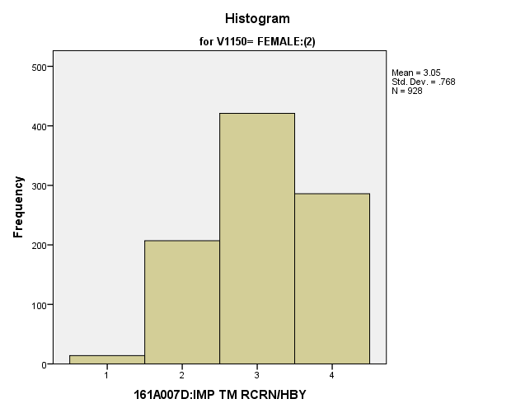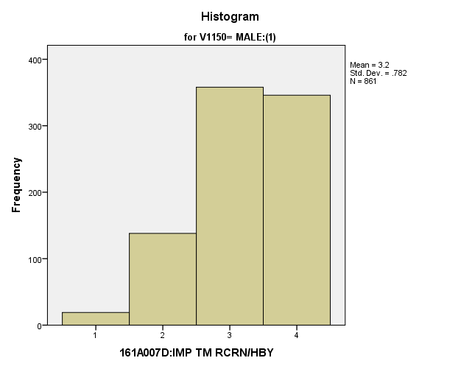

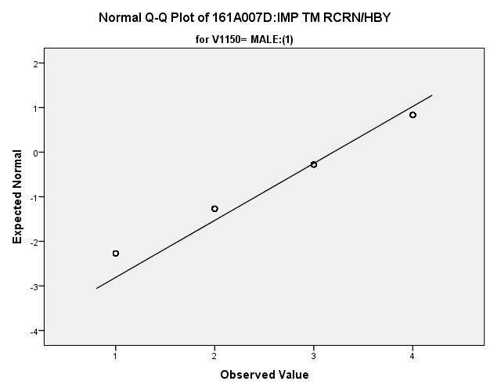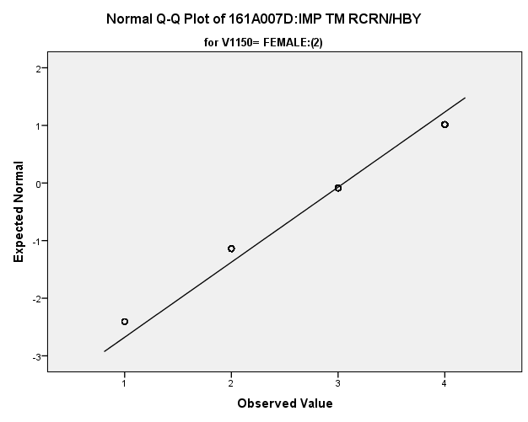

*Primary Analysis:*

|  |  |  |  |  |  |
| --- | --- | --- | --- | --- | --- |
| ***Group Statistics*** | | | | | |
|  | 161C003:Rs SEX | N | Mean | Std. Deviation | Std. Error Mean |
| 161A007D:IMP TM RCRN/HBY | MALE:(1) | **861** | **3.20** | **.782** | **.027** |
| FEMALE:(2) | **928** | **3.05** | **.768** | **.025** |

|  |  |  |  |  |
| --- | --- | --- | --- | --- |
| ***Independent Samples Test*** | | | | |
|  | | Levene's Test for Equality of Variances | | t-test for Equality of Means |
| F | Sig. | t |
|
| 161A007D:IMP TM RCRN/HBY | Equal variances assumed | **7.809** | **.005** | **3.887** |
| Equal variances not assumed |  |  | **3.884** |

|  |  |  |  |  |
| --- | --- | --- | --- | --- |
| ***Independent Samples Test*** | | | | |
|  | | t-test for Equality of Means | | |
| df | Sig. (2-tailed) | Mean Difference |
|
| 161A007D:IMP TM RCRN/HBY | Equal variances assumed | **1787** | **.000** | **.142** |
| Equal variances not assumed | **1771.331** | **.000** | **.142** |

|  |  |  |  |  |
| --- | --- | --- | --- | --- |
| ***Independent Samples Test*** | | | | |
|  | | t-test for Equality of Means | | |
| Std. Error Difference | 99% Confidence Interval of the Difference | |
| Lower | Upper |
| 161A007D:IMP TM RCRN/HBY | Equal variances assumed | **.037** | **.048** | **.237** |
| Equal variances not assumed | **.037** | **.048** | **.237** |

|  |  |  |
| --- | --- | --- |
| ***Measures of Association*** | | |
|  | Eta | Eta Squared |
| 161A007D:IMP TM RCRN/HBY * 161C003:Rs SEX | **.092** | **.008** |

**Importance of Having Strong Friendships:** Within the potential recruit group, are there gender differences in how important they thought it was to have strong friendships?

**Variables used:** The dependent variable was importance of having strong friendships, which students ranked importance on a scale of 1 to 4, with a higher number meaning they found it more important. The independent (grouping) variable was sex (male or female).

**Analysis Procedure:**

* A t-test was used to compare average rating of how important students found having strong friendships between the two gender groups (males versus females)
* Before conducting analysis, the distribution for importance of having strong friendships was checked separately for the two groups by means of visual inspection of histograms and Q-Q plots. No outliers were observed. However, the distribution of how important students found having strong friendships was left skewed for both groups.
* The equality of variances assumption was tested. This assumption was met.

**Results:**

* Null and alternative hypothesis. H0: μ1 = μ2; Ha: μ1 ≠ μ2.
* Calculated t value: t = .794, df = 332, fail to reject H0, with a p-value of .072

**Interpretation:** There is not a significant difference between the two groups in how important they found having strong friendships.

**Supporting Analysis:**

*Preliminary Analysis:*

|  |  |  |  |  |
| --- | --- | --- | --- | --- |
| ***Descriptives*** | | | | |
|  | 161C003:Rs SEX | | | Statistic |
| 161A007E:IMP STRG FRDSHP | MALE:(1) | Mean | | **3.51** |
| 99% Confidence Interval for Mean | Lower Bound | **3.44** |
| Upper Bound | **3.57** |
| 5% Trimmed Mean | | **3.58** |
| Median | | **4.00** |
| Variance | | **.536** |
| Std. Deviation | | **.732** |
| Minimum | | **1** |
| Maximum | | **4** |
| Range | | **3** |
| Interquartile Range | | **1** |
| Skewness | | **-1.434** |
| Kurtosis | | **1.512** |
| FEMALE:(2) | Mean | | **3.49** |
| 99% Confidence Interval for Mean | Lower Bound | **3.43** |
| Upper Bound | **3.56** |
| 5% Trimmed Mean | | **3.57** |
| Median | | **4.00** |
| Variance | | **.582** |
| Std. Deviation | | **.763** |
| Minimum | | **1** |
| Maximum | | **4** |
| Range | | **3** |
| Interquartile Range | | **1** |
| Skewness | | **-1.404** |
| Kurtosis | | **1.198** |

|  |  |  |  |  |
| --- | --- | --- | --- | --- |
| ***Descriptives*** | | | | |
|  | 161C003:Rs SEX | | | Std. Error |
| 161A007E:IMP STRG FRDSHP | MALE:(1) | Mean | | **.025** |
| 99% Confidence Interval for Mean | Lower Bound |  |
| Upper Bound |  |
| 5% Trimmed Mean | |  |
| Median | |  |
| Variance | |  |
| Std. Deviation | |  |
| Minimum | |  |
| Maximum | |  |
| Range | |  |
| Interquartile Range | |  |
| Skewness | | **.083** |
| Kurtosis | | **.166** |
| FEMALE:(2) | Mean | | **.025** |
| 99% Confidence Interval for Mean | Lower Bound |  |
| Upper Bound |  |
| 5% Trimmed Mean | |  |
| Median | |  |
| Variance | |  |
| Std. Deviation | |  |
| Minimum | |  |
| Maximum | |  |
| Range | |  |
| Interquartile Range | |  |
| Skewness | | **.080** |
| Kurtosis | | **.160** |

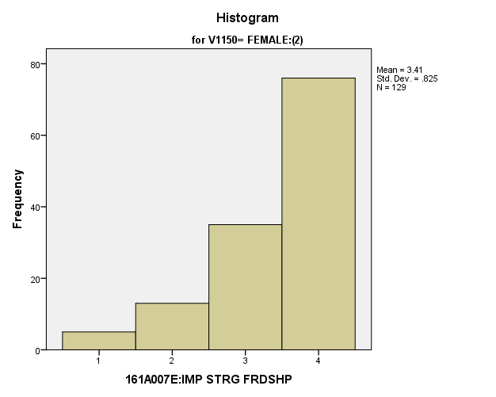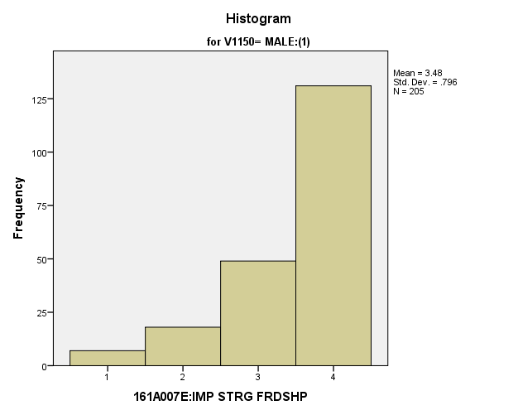

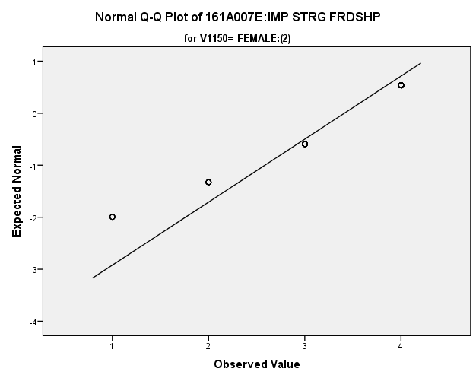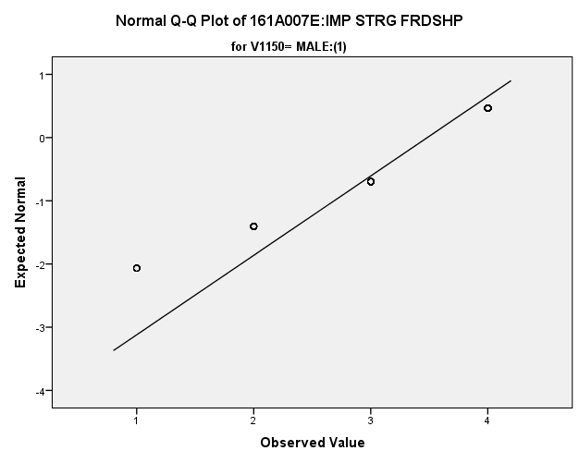

|  |  |  |  |  |  |
| --- | --- | --- | --- | --- | --- |
| *Primary Analysis:*  ***Group Statistics*** | | | | | |
|  | V1150 | N | Mean | Std. Deviation | Std. Error Mean |
| V1659 | MALE:(1) | **205** | **3.48** | **.796** | **.056** |
| FEMALE:(2) | **129** | **3.41** | **.825** | **.073** |

|  |  |  |  |  |  |
| --- | --- | --- | --- | --- | --- |
| ***Independent Samples Test*** | | | | | |
|  | | Levene's Test for Equality of Variances | | t-test for Equality of Means | |
| F | Sig. | t | df |
|
| V1659 | Equal variances assumed | **.452** | **.502** | **.794** | **332** |
| Equal variances not assumed |  |  | **.788** | **264.686** |

|  |  |  |  |  |  |
| --- | --- | --- | --- | --- | --- |
| ***Independent Samples Test*** | | | | | |
|  | | t-test for Equality of Means | | | |
| Sig. (2-tailed) | Mean Difference | Std. Error Difference | 99% Confidence Interval of the Difference |
| Lower |
| V1659 | Equal variances assumed | **.428** | **.072** | **.091** | **-.163** |
| Equal variances not assumed | **.432** | **.072** | **.091** | **-.165** |

|  |  |  |
| --- | --- | --- |
| ***Independent Samples Test*** | | |
|  | | t-test for Equality of Means |
| 99% Confidence Interval of the Difference |
| Upper |
| V1659 | Equal variances assumed | **.307** |
| Equal variances not assumed | **.309** |

**Importance of Having Steady Work:** Within the potential recruit group, are there gender differences in how important they thought it was to have steady work?

**Variables used:** The dependent variable was importance of having steady work, which students rated on a scale of 1 to 4, with a higher number meaning they found it more important. The independent (grouping) variable was sex (male or female).

**Analysis Procedure:**

* A t-test was used to compare average rating of how important students found having steady work between the two gender groups (males versus females)
* Before conducting analysis, the distribution for importance of having steady work was checked separately for the two groups by means of visual inspection of histograms and Q-Q plots. No outliers were observed. However, the distribution of how important students found having steady work was left skewed for both groups.
* The equality of variances assumption was tested. This assumption was not met.

**Results:**

* Null and alternative hypothesis. H0: μ1 = μ2; Ha: μ1 ≠ μ2.
* Calculated t value: t = -1.802, df = 299.535, fail to reject H0, with a p-value of .072

**Interpretation:** There is not a significant difference between the two groups in how important they find having steady work.

**Supporting Analysis:**

*Preliminary Analysis:*

|  |  |  |  |  |
| --- | --- | --- | --- | --- |
| ***Descriptives*** | | | | |
|  | 161C003:Rs SEX | | | Statistic |
| 161A007F:IMP STEADY WORK | MALE:(1) | Mean | | **3.63** |
| 99% Confidence Interval for Mean | Lower Bound | **3.58** |
| Upper Bound | **3.69** |
| 5% Trimmed Mean | | **3.71** |
| Median | | **4.00** |
| Variance | | **.368** |
| Std. Deviation | | **.607** |
| Minimum | | **1** |
| Maximum | | **4** |
| Range | | **3** |
| Interquartile Range | | **1** |
| Skewness | | **-1.647** |
| Kurtosis | | **2.577** |
| FEMALE:(2) | Mean | | **3.73** |
| 99% Confidence Interval for Mean | Lower Bound | **3.69** |
| Upper Bound | **3.78** |
| 5% Trimmed Mean | | **3.80** |
| Median | | **4.00** |
| Variance | | **.279** |
| Std. Deviation | | **.528** |
| Minimum | | **1** |
| Maximum | | **4** |
| Range | | **3** |
| Interquartile Range | | **0** |
| Skewness | | **-1.931** |
| Kurtosis | | **3.327** |

|  |  |  |  |  |
| --- | --- | --- | --- | --- |
| ***Descriptives*** | | | | |
|  | 161C003:Rs SEX | | | Std. Error |
| 161A007F:IMP STEADY WORK | MALE:(1) | Mean | | **.021** |
| 99% Confidence Interval for Mean | Lower Bound |  |
| Upper Bound |  |
| 5% Trimmed Mean | |  |
| Median | |  |
| Variance | |  |
| Std. Deviation | |  |
| Minimum | |  |
| Maximum | |  |
| Range | |  |
| Interquartile Range | |  |
| Skewness | | **.083** |
| Kurtosis | | **.167** |
| FEMALE:(2) | Mean | | **.017** |
| 99% Confidence Interval for Mean | Lower Bound |  |
| Upper Bound |  |
| 5% Trimmed Mean | |  |
| Median | |  |
| Variance | |  |
| Std. Deviation | |  |
| Minimum | |  |
| Maximum | |  |
| Range | |  |
| Interquartile Range | |  |
| Skewness | | **.080** |
| Kurtosis | | **.160** |

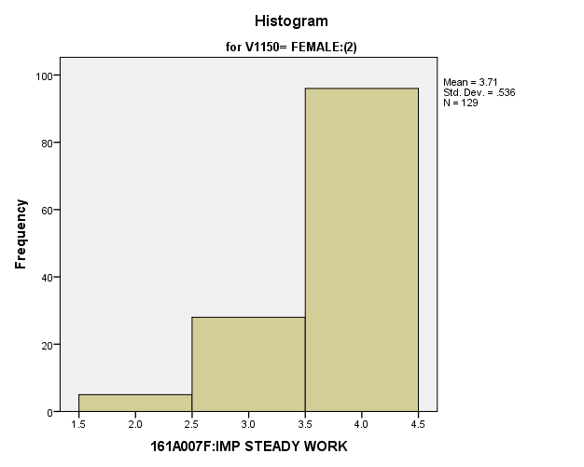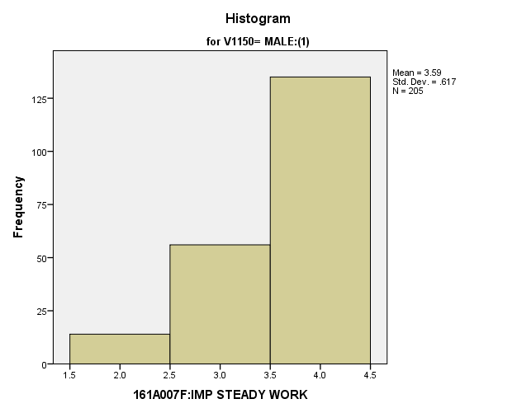

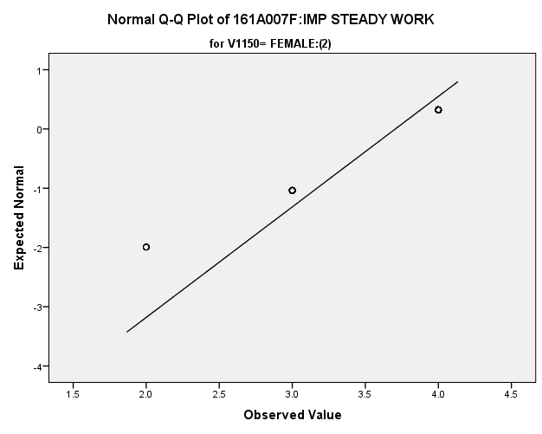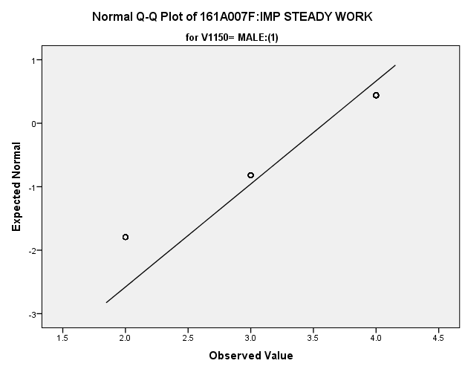

|  |  |  |  |  |  |
| --- | --- | --- | --- | --- | --- |
| *Primary Analysis:*  ***Group Statistics*** | | | | | |
|  | V1150 | N | Mean | Std. Deviation | Std. Error Mean |
| V1660 | MALE:(1) | **205** | **3.59** | **.617** | **.043** |
| FEMALE:(2) | **129** | **3.71** | **.536** | **.047** |

|  |  |  |  |  |  |
| --- | --- | --- | --- | --- | --- |
| ***Independent Samples Test*** | | | | | |
|  | | Levene's Test for Equality of Variances | | t-test for Equality of Means | |
| F | Sig. | t | df |
|
| V1660 | Equal variances assumed | **9.017** | **.003** | **-1.746** | **332** |
| Equal variances not assumed |  |  | **-1.802** | **299.535** |

|  |  |  |  |  |  |
| --- | --- | --- | --- | --- | --- |
| ***Independent Samples Test*** | | | | | |
|  | | t-test for Equality of Means | | | |
| Sig. (2-tailed) | Mean Difference | Std. Error Difference | 99% Confidence Interval of the Difference |
| Lower |
| V1660 | Equal variances assumed | **.082** | **-.115** | **.066** | **-.286** |
| Equal variances not assumed | **.072** | **-.115** | **.064** | **-.281** |

|  |  |  |
| --- | --- | --- |
| ***Independent Samples Test*** | | |
|  | | t-test for Equality of Means |
| 99% Confidence Interval of the Difference |
| Upper |
| V1660 | Equal variances assumed | **.056** |
| Equal variances not assumed | **.050** |

**Importance of Contribute to Society:** Within the potential recruit group, are there gender differences in how important they thought it was to contribute to society?

**Variables used:** The dependent variable was importance of making a contribution to society, with students rating the importance on a scale of 1 to 4, with a higher number meaning more importance. The independent (grouping) variable was sex (male or female).

**Analysis Procedure:**

* A t-test was used to compare average rating of how important students found making a contribution to society is between the two gender groups (males versus females)
* Before conducting analysis, the distribution for importance of contributing to society was checked separately for the two groups by means of visual inspection of histograms and Q-Q plots. No outliers were observed. However, the distribution of how important students found making a contribution to society was left skewed for both groups.
* The equality of variances assumption was tested. This assumption was met.

**Results:**

* Null and alternative hypothesis. H0: μ1 = μ2; Ha: μ1 ≠ μ2.
* Calculated t value: t = -.886, df = 331, fail to reject H0 with a p-value of .377

**Interpretation:** There is not a significant difference between the two groups in how important they found making a contribution to society.

**Supporting Analysis:**

*Preliminary Analysis:*

|  |  |  |  |  |
| --- | --- | --- | --- | --- |
| ***Descriptives*** | | | | |
|  | 161C003:Rs SEX | | | Statistic |
| 161A007G:IMP CNTRBTN SOC | MALE:(1) | Mean | | **2.99** |
| 99% Confidence Interval for Mean | Lower Bound | **2.91** |
| Upper Bound | **3.07** |
| 5% Trimmed Mean | | **3.04** |
| Median | | **3.00** |
| Variance | | **.787** |
| Std. Deviation | | **.887** |
| Minimum | | **1** |
| Maximum | | **4** |
| Range | | **3** |
| Interquartile Range | | **2** |
| Skewness | | **-.469** |
| Kurtosis | | **-.643** |
| FEMALE:(2) | Mean | | **3.06** |
| 99% Confidence Interval for Mean | Lower Bound | **3.00** |
| Upper Bound | **3.13** |
| 5% Trimmed Mean | | **3.10** |
| Median | | **3.00** |
| Variance | | **.651** |
| Std. Deviation | | **.807** |
| Minimum | | **1** |
| Maximum | | **4** |
| Range | | **3** |
| Interquartile Range | | **2** |
| Skewness | | **-.366** |
| Kurtosis | | **-.758** |

|  |  |  |  |  |
| --- | --- | --- | --- | --- |
| ***Descriptives*** | | | | |
|  | 161C003:Rs SEX | | | Std. Error |
| 161A007G:IMP CNTRBTN SOC | MALE:(1) | Mean | | **.030** |
| 99% Confidence Interval for Mean | Lower Bound |  |
| Upper Bound |  |
| 5% Trimmed Mean | |  |
| Median | |  |
| Variance | |  |
| Std. Deviation | |  |
| Minimum | |  |
| Maximum | |  |
| Range | |  |
| Interquartile Range | |  |
| Skewness | | **.083** |
| Kurtosis | | **.167** |
| FEMALE:(2) | Mean | | **.027** |
| 99% Confidence Interval for Mean | Lower Bound |  |
| Upper Bound |  |
| 5% Trimmed Mean | |  |
| Median | |  |
| Variance | |  |
| Std. Deviation | |  |
| Minimum | |  |
| Maximum | |  |
| Range | |  |
| Interquartile Range | |  |
| Skewness | | **.080** |
| Kurtosis | | **.161** |

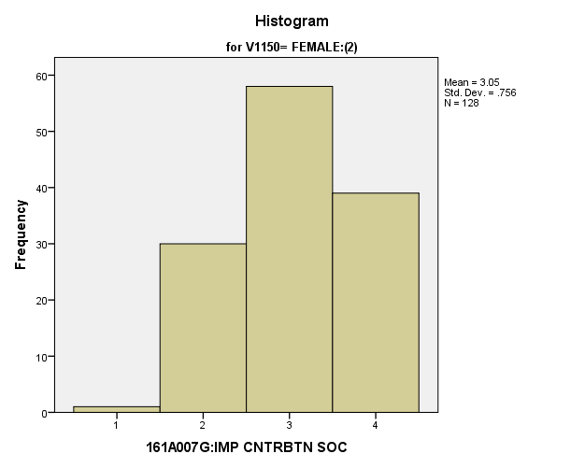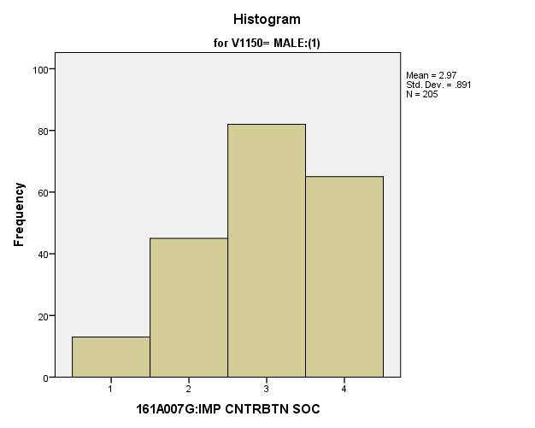

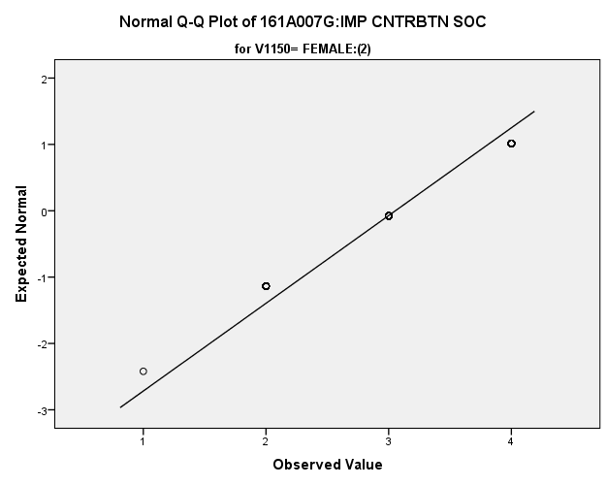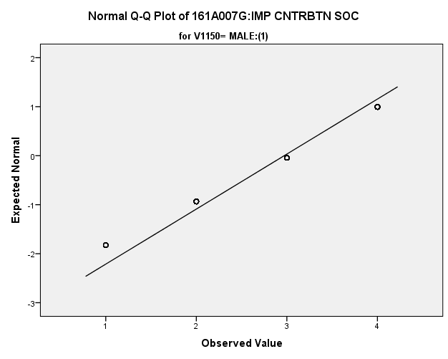

*Primary Analysis*

|  |  |  |  |  |  |
| --- | --- | --- | --- | --- | --- |
| ***Group Statistics*** | | | | | |
|  | V1150 | N | Mean | Std. Deviation | Std. Error Mean |
| V1661 | MALE:(1) | **205** | **2.97** | **.891** | **.062** |
| FEMALE:(2) | **128** | **3.05** | **.756** | **.067** |

|  |  |  |  |  |  |
| --- | --- | --- | --- | --- | --- |
| ***Independent Samples Test*** | | | | | |
|  | | Levene's Test for Equality of Variances | | t-test for Equality of Means | |
| F | Sig. | t | df |
|
| V1661 | Equal variances assumed | **2.658** | **.104** | **-.886** | **331** |
| Equal variances not assumed |  |  | **-.920** | **301.485** |

|  |  |  |  |  |  |
| --- | --- | --- | --- | --- | --- |
| ***Independent Samples Test*** | | | | | |
|  | | t-test for Equality of Means | | | |
| Sig. (2-tailed) | Mean Difference | Std. Error Difference | 99% Confidence Interval of the Difference |
| Lower |
| V1661 | Equal variances assumed | **.377** | **-.084** | **.095** | **-.330** |
| Equal variances not assumed | **.359** | **-.084** | **.091** | **-.321** |

|  |  |  |
| --- | --- | --- |
| ***Independent Samples Test*** | | |
|  | | t-test for Equality of Means |
| 99% Confidence Interval of the Difference |
| Upper |
| V1661 | Equal variances assumed | **.162** |
| Equal variances not assumed | **.153** |

**Importance of Being a Leader in the Community:** Within the potential recruit group, are there gender differences in how important they thought it was to be a leader in the community?

**Variables used:** The dependent variable was importance of being a leader in the community, with students rating the importance on a scale of 1 to 4, with a higher number meaning more importance. The independent (grouping) variable was sex (male or female).

**Analysis Procedure:**

* A t-test was used to compare average rating of how important being a leader in the community is between the two gender groups (males versus females)
* Before conducting analysis, the distribution for importance of being a leader in the community was checked separately for the two groups by means of visual inspection of histograms and Q-Q plots. No outliers were observed.
* The equality of variances assumption was tested. This assumption was not met.

**Results:**

* Null and alternative hypothesis. H0: μ1 = μ2; Ha: μ1 ≠ μ2.
* Calculated t value: t = -.775, df = 301.992, fail to reject H0, with a p-value of .439

**Interpretation:** There is not a significant difference between the two groups in how important they feel it is to be a leader in the community.

**Supporting Analysis:**

*Preliminary Analysis:*

|  |  |  |  |  |
| --- | --- | --- | --- | --- |
| ***Descriptives*** | | | | |
|  | 161C003:Rs SEX | | | Statistic |
| 161A007H:IMP LDR COMUNTY | MALE:(1) | Mean | | **2.56** |
| 99% Confidence Interval for Mean | Lower Bound | **2.47** |
| Upper Bound | **2.65** |
| 5% Trimmed Mean | | **2.57** |
| Median | | **3.00** |
| Variance | | **1.072** |
| Std. Deviation | | **1.035** |
| Minimum | | **1** |
| Maximum | | **4** |
| Range | | **3** |
| Interquartile Range | | **1** |
| Skewness | | **-.003** |
| Kurtosis | | **-1.168** |
| FEMALE:(2) | Mean | | **2.61** |
| 99% Confidence Interval for Mean | Lower Bound | **2.53** |
| Upper Bound | **2.69** |
| 5% Trimmed Mean | | **2.62** |
| Median | | **3.00** |
| Variance | | **.956** |
| Std. Deviation | | **.978** |
| Minimum | | **1** |
| Maximum | | **4** |
| Range | | **3** |
| Interquartile Range | | **1** |
| Skewness | | **.003** |
| Kurtosis | | **-1.044** |

|  |  |  |  |  |
| --- | --- | --- | --- | --- |
| ***Descriptives*** | | | | |
|  | 161C003:Rs SEX | | | Std. Error |
| 161A007H:IMP LDR COMUNTY | MALE:(1) | Mean | | **.035** |
| 99% Confidence Interval for Mean | Lower Bound |  |
| Upper Bound |  |
| 5% Trimmed Mean | |  |
| Median | |  |
| Variance | |  |
| Std. Deviation | |  |
| Minimum | |  |
| Maximum | |  |
| Range | |  |
| Interquartile Range | |  |
| Skewness | | **.083** |
| Kurtosis | | **.167** |
| FEMALE:(2) | Mean | | **.032** |
| 99% Confidence Interval for Mean | Lower Bound |  |
| Upper Bound |  |
| 5% Trimmed Mean | |  |
| Median | |  |
| Variance | |  |
| Std. Deviation | |  |
| Minimum | |  |
| Maximum | |  |
| Range | |  |
| Interquartile Range | |  |
| Skewness | | **.080** |
| Kurtosis | | **.160** |

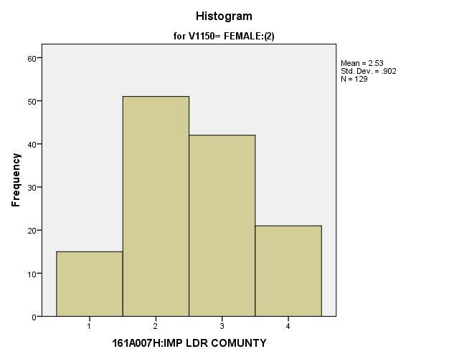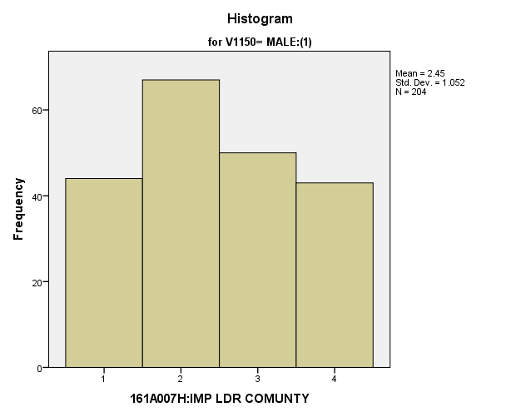

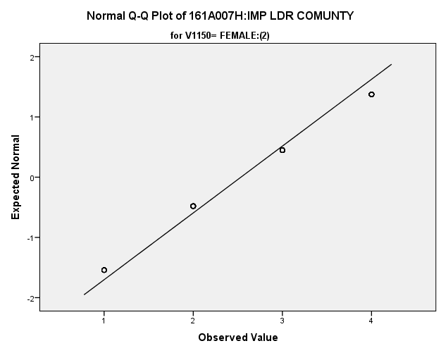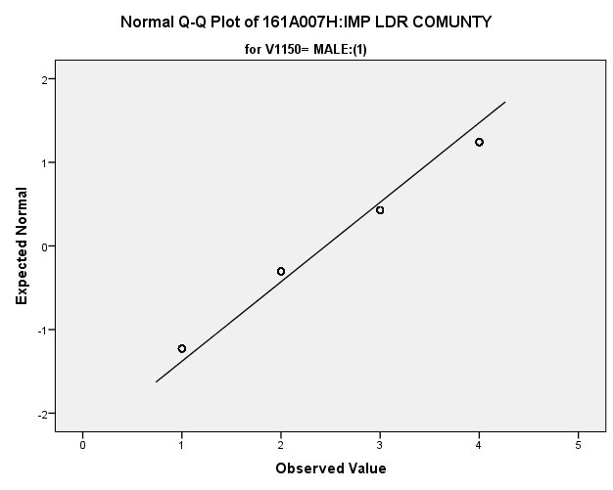

|  |  |  |  |  |  |
| --- | --- | --- | --- | --- | --- |
| *Primary Analysis:*  ***Group Statistics*** | | | | | |
|  | V1150 | N | Mean | Std. Deviation | Std. Error Mean |
| V1662 | MALE:(1) | **204** | **2.45** | **1.052** | **.074** |
| FEMALE:(2) | **129** | **2.53** | **.902** | **.079** |

|  |  |  |  |  |  |
| --- | --- | --- | --- | --- | --- |
| ***Independent Samples Test*** | | | | | |
|  | | Levene's Test for Equality of Variances | | t-test for Equality of Means | |
| F | Sig. | t | df |
|
| V1662 | Equal variances assumed | **6.905** | **.009** | **-.749** | **331** |
| Equal variances not assumed |  |  | **-.775** | **301.992** |

|  |  |  |  |  |  |
| --- | --- | --- | --- | --- | --- |
| ***Independent Samples Test*** | | | | | |
|  | | t-test for Equality of Means | | | |
| Sig. (2-tailed) | Mean Difference | Std. Error Difference | 99% Confidence Interval of the Difference |
| Lower |
| V1662 | Equal variances assumed | **.455** | **-.084** | **.112** | **-.374** |
| Equal variances not assumed | **.439** | **-.084** | **.108** | **-.365** |

|  |  |  |
| --- | --- | --- |
| ***Independent Samples Test*** | | |
|  | | t-test for Equality of Means |
| 99% Confidence Interval of the Difference |
| Upper |
| V1662 | Equal variances assumed | **.206** |
| Equal variances not assumed | **.197** |

**Importance of Giving Children Better Opportunities:** Within the potential recruit group, are there gender differences in how important they thought it was to give their children better opportunities

**Variables used:** The dependent variable was importance of giving their children better opportunities, with students rating importance on a scale of 1 to 4, with a higher number meaning more importance. The independent (grouping) variable was sex (male or female).

**Analysis Procedure:**

* A t-test was used to compare average rating of how important they thought it was to give their children better opportunities to be between the two gender groups (males versus females)
* Before conducting analysis, the distribution was checked separately for the two groups by means of visual inspection of histograms and Q-Q plots. No outliers were observed. However, the distribution of how important relatives to be was left skewed for both groups.
* The equality of variances assumption was tested. This assumption was not met.

**Results:**

* Null and alternative hypothesis. H0: μ1 = μ2; Ha: μ1 ≠ μ2.
* Calculated t value: t = -1.456, df = 1730, fail to reject H0, with a p-value of .146

**Interpretation:** There is not a significant difference between the two gender groups in how important they found it was to give their children better opportunities.

**Supporting Analysis:**

*Preliminary Analysis:*

|  |  |  |  |  |
| --- | --- | --- | --- | --- |
| ***Descriptives*** | | | | |
|  | 161C003:Rs SEX | | | Statistic |
| 161A007I:IMP CHLD BTR OP | MALE:(1) | Mean | | **3.64** |
| 99% Confidence Interval for Mean | Lower Bound | **3.57** |
| Upper Bound | **3.70** |
| 5% Trimmed Mean | | **3.74** |
| Median | | **4.00** |
| Variance | | **.512** |
| Std. Deviation | | **.715** |
| Minimum | | **1** |
| Maximum | | **4** |
| Range | | **3** |
| Interquartile Range | | **1** |
| Skewness | | **-2.135** |
| Kurtosis | | **4.138** |
| FEMALE:(2) | Mean | | **3.68** |
| 99% Confidence Interval for Mean | Lower Bound | **3.63** |
| Upper Bound | **3.74** |
| 5% Trimmed Mean | | **3.78** |
| Median | | **4.00** |
| Variance | | **.423** |
| Std. Deviation | | **.650** |
| Minimum | | **1** |
| Maximum | | **4** |
| Range | | **3** |
| Interquartile Range | | **0** |
| Skewness | | **-2.212** |
| Kurtosis | | **4.616** |

|  |  |  |  |  |
| --- | --- | --- | --- | --- |
| ***Descriptives*** | | | | |
|  | 161C003:Rs SEX | | | Std. Error |
| 161A007I:IMP CHLD BTR OP | MALE:(1) | Mean | | **.024** |
| 99% Confidence Interval for Mean | Lower Bound |  |
| Upper Bound |  |
| 5% Trimmed Mean | |  |
| Median | |  |
| Variance | |  |
| Std. Deviation | |  |
| Minimum | |  |
| Maximum | |  |
| Range | |  |
| Interquartile Range | |  |
| Skewness | | **.083** |
| Kurtosis | | **.167** |
| FEMALE:(2) | Mean | | **.021** |
| 99% Confidence Interval for Mean | Lower Bound |  |
| Upper Bound |  |
| 5% Trimmed Mean | |  |
| Median | |  |
| Variance | |  |
| Std. Deviation | |  |
| Minimum | |  |
| Maximum | |  |
| Range | |  |
| Interquartile Range | |  |
| Skewness | | **.080** |
| Kurtosis | | **.161** |

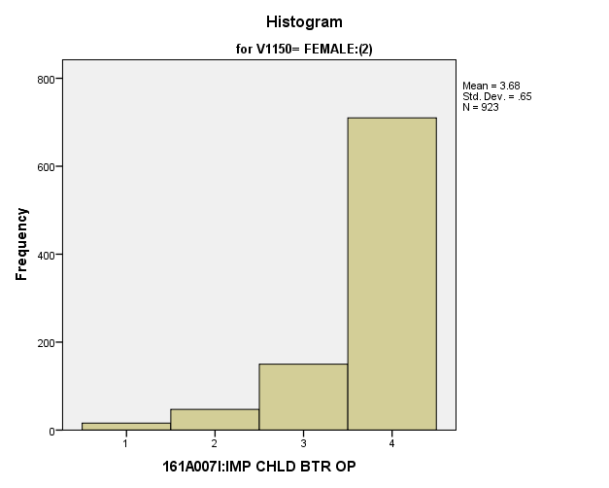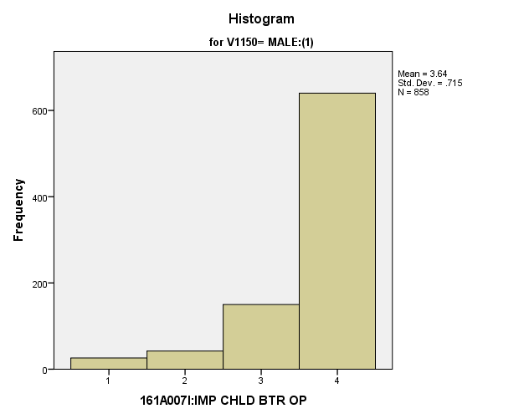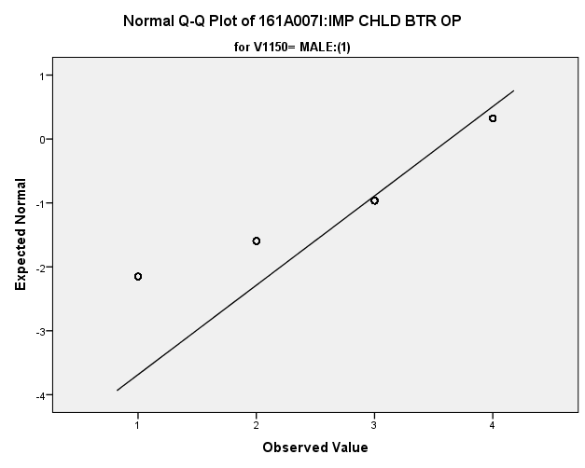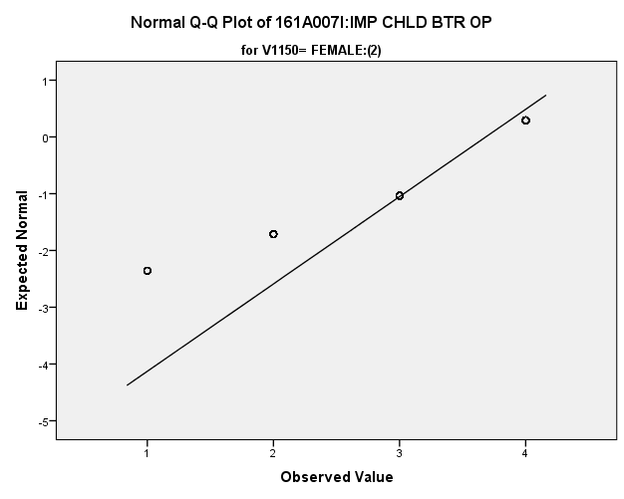

*Primary Analysis:*

|  |  |  |  |  |  |
| --- | --- | --- | --- | --- | --- |
| ***Group Statistics*** | | | | | |
|  | 161C003:Rs SEX | N | Mean | Std. Deviation | Std. Error Mean |
| 161A007I:IMP CHLD BTR OP | MALE:(1) | **858** | **3.64** | **.715** | **.024** |
| FEMALE:(2) | **923** | **3.68** | **.650** | **.021** |

|  |  |  |  |  |
| --- | --- | --- | --- | --- |
| ***Independent Samples Test*** | | | | |
|  | | Levene's Test for Equality of Variances | | t-test for Equality of Means |
| F | Sig. | t |
|
| 161A007I:IMP CHLD BTR OP | Equal variances assumed | **6.894** | **.009** | **-1.461** |
| Equal variances not assumed |  |  | **-1.456** |

|  |  |  |  |  |
| --- | --- | --- | --- | --- |
| ***Independent Samples Test*** | | | | |
|  | | t-test for Equality of Means | | |
| df | Sig. (2-tailed) | Mean Difference |
|
| 161A007I:IMP CHLD BTR OP | Equal variances assumed | **1779** | **.144** | **-.047** |
| Equal variances not assumed | **1730.115** | **.146** | **-.047** |

|  |  |  |  |  |
| --- | --- | --- | --- | --- |
| ***Independent Samples Test*** | | | | |
|  | | t-test for Equality of Means | | |
| Std. Error Difference | 99% Confidence Interval of the Difference | |
| Lower | Upper |
| 161A007I:IMP CHLD BTR OP | Equal variances assumed | **.032** | **-.131** | **.036** |
| Equal variances not assumed | **.032** | **-.131** | **.036** |

**Importance of Living Close to Parents:** Within the potential recruit group, are there gender differences in how important they thought it was to live close to their parents and relatives?

**Variables used:** The dependent variable was importance of living close to parents and relatives, with students rating importance on a scale of 1 to 4, with a higher number meaning more importance. The independent (grouping) variable was sex (male or female).

**Analysis Procedure:**

* A t-test was used to compare average rating of how important students found living close to parents and relatives to be between the two gender groups (males versus females)
* Before conducting analysis, the distribution for importance of living close to parents was checked separately for the two groups by means of visual inspection of histograms and Q-Q plots. No outliers were observed. However, the distribution of how important students living close to parents and relatives to be was right skewed for both groups.
* The equality of variances assumption was tested. This assumption was met.

**Results:**

* Null and alternative hypothesis. H0: μ1 = μ2; Ha: μ1 ≠ μ2.
* Calculated t value: t = -.332, df = 330, fail to reject H0, with a p-value of .740

**Interpretation:** There is not a significant difference between the two groups in how important they find living close to parents and relatives.

**Supporting Analysis:**

*Preliminary Analysis:*

|  |  |  |  |  |
| --- | --- | --- | --- | --- |
| ***Descriptives*** | | | | |
|  | 161C003:Rs SEX | | | Statistic |
| 161A007J:IMP LIV CLS PRN | MALE:(1) | Mean | | **2.52** |
| 99% Confidence Interval for Mean | Lower Bound | **2.43** |
| Upper Bound | **2.60** |
| 5% Trimmed Mean | | **2.52** |
| Median | | **2.00** |
| Variance | | **.905** |
| Std. Deviation | | **.951** |
| Minimum | | **1** |
| Maximum | | **4** |
| Range | | **3** |
| Interquartile Range | | **1** |
| Skewness | | **.087** |
| Kurtosis | | **-.928** |
| FEMALE:(2) | Mean | | **2.62** |
| 99% Confidence Interval for Mean | Lower Bound | **2.54** |
| Upper Bound | **2.70** |
| 5% Trimmed Mean | | **2.63** |
| Median | | **3.00** |
| Variance | | **.908** |
| Std. Deviation | | **.953** |
| Minimum | | **1** |
| Maximum | | **4** |
| Range | | **3** |
| Interquartile Range | | **1** |
| Skewness | | **-.012** |
| Kurtosis | | **-.971** |

|  |  |  |  |  |
| --- | --- | --- | --- | --- |
| ***Descriptives*** | | | | |
|  | 161C003:Rs SEX | | | Std. Error |
| 161A007J:IMP LIV CLS PRN | MALE:(1) | Mean | | **.032** |
| 99% Confidence Interval for Mean | Lower Bound |  |
| Upper Bound |  |
| 5% Trimmed Mean | |  |
| Median | |  |
| Variance | |  |
| Std. Deviation | |  |
| Minimum | |  |
| Maximum | |  |
| Range | |  |
| Interquartile Range | |  |
| Skewness | | **.083** |
| Kurtosis | | **.166** |
| FEMALE:(2) | Mean | | **.031** |
| 99% Confidence Interval for Mean | Lower Bound |  |
| Upper Bound |  |
| 5% Trimmed Mean | |  |
| Median | |  |
| Variance | |  |
| Std. Deviation | |  |
| Minimum | |  |
| Maximum | |  |
| Range | |  |
| Interquartile Range | |  |
| Skewness | | **.080** |
| Kurtosis | | **.161** |

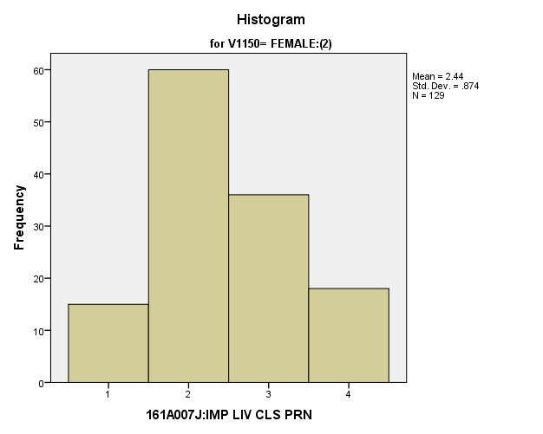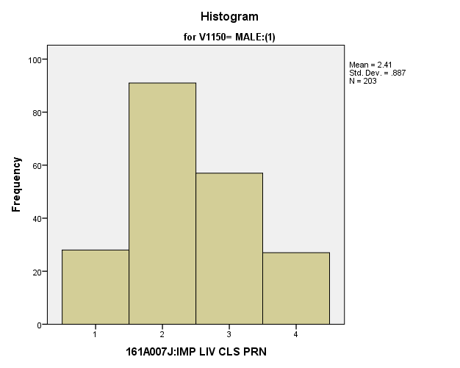

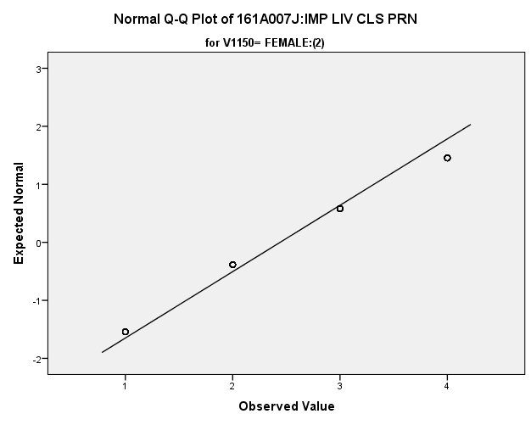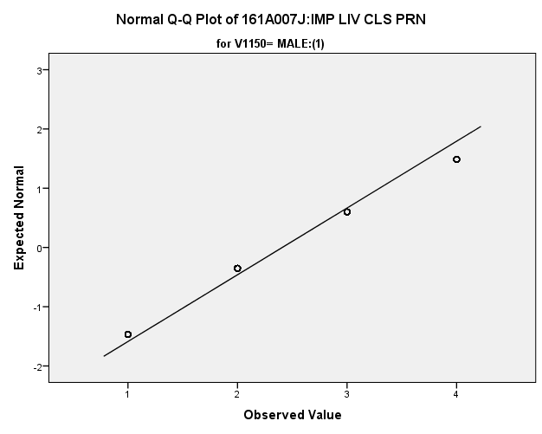

*Primary Analysis:*

|  |  |  |  |  |  |
| --- | --- | --- | --- | --- | --- |
| ***Group Statistics*** | | | | | |
|  | V1150 | N | Mean | Std. Deviation | Std. Error Mean |
| V1664 | MALE:(1) | **203** | **2.41** | **.887** | **.062** |
| FEMALE:(2) | **129** | **2.44** | **.874** | **.077** |

|  |  |  |  |  |  |
| --- | --- | --- | --- | --- | --- |
| ***Independent Samples Test*** | | | | | |
|  | | Levene's Test for Equality of Variances | | t-test for Equality of Means | |
| F | Sig. | t | df |
|
| V1664 | Equal variances assumed | **.030** | **.863** | **-.332** | **330** |
| Equal variances not assumed |  |  | **-.333** | **275.629** |

|  |  |  |  |  |  |
| --- | --- | --- | --- | --- | --- |
| ***Independent Samples Test*** | | | | | |
|  | | t-test for Equality of Means | | | |
| Sig. (2-tailed) | Mean Difference | Std. Error Difference | 99% Confidence Interval of the Difference |
| Lower |
| V1664 | Equal variances assumed | **.740** | **-.033** | **.099** | **-.290** |
| Equal variances not assumed | **.739** | **-.033** | **.099** | **-.290** |

|  |  |  |
| --- | --- | --- |
| ***Independent Samples Test*** | | |
|  | | t-test for Equality of Means |
| 99% Confidence Interval of the Difference |
| Upper |
| V1664 | Equal variances assumed | **.224** |
| Equal variances not assumed | **.224** |

**Importance of Getting Away from this Area of the Country:** Within the potential recruit group, are there gender differences in how important they thought it was to have get away from this area of the country?

**Variables used:** The dependent variable was importance of getting away from this area of the country, with students rating importance on a scale from 1 to 4, with a higher number meaning more importance. The independent (grouping) variable was sex (male or female)

**Analysis Procedure:**

* A t-test was used to compare average rating of how important students found getting away from this area of the country between the two gender groups (males versus females)
* Before conducting analysis, the distribution for importance of getting away from this area of the country was checked separately for the two groups by means of visual inspection of histograms and Q-Q plots. No outliers were observed. However, the distribution of how important students found getting away from this area of the country to be was right skewed for both groups.
* The equality of variances assumption was tested. This assumption was met.
* Eta squared was calculated to assess effect size.

**Results:**

* Null and alternative hypothesis. H0: μ1 = μ2; Ha: μ1 ≠ μ2.
* Calculated t value: t = -2.682, df = 332, reject H0, with a p-value of .008; Eta Squared = .021

**Interpretation:** There is a significant difference between the two groups in how important they found getting out of this area of the country. Furthermore 2.1% of how important students find getting out of this area of the country to be can be explained by their gender.

**Supporting Analysis:**

*Preliminary Analysis:*

|  |  |  |  |  |
| --- | --- | --- | --- | --- |
| ***Descriptives*** | | | | |
|  | 161C003:Rs SEX | | | Statistic |
| 161A007K:IMP GT AWY AREA | MALE:(1) | Mean | | **2.03** |
| 99% Confidence Interval for Mean | Lower Bound | **1.93** |
| Upper Bound | **2.12** |
| 5% Trimmed Mean | | **1.97** |
| Median | | **2.00** |
| Variance | | **1.207** |
| Std. Deviation | | **1.099** |
| Minimum | | **1** |
| Maximum | | **4** |
| Range | | **3** |
| Interquartile Range | | **2** |
| Skewness | | **.643** |
| Kurtosis | | **-.970** |
| FEMALE:(2) | Mean | | **2.15** |
| 99% Confidence Interval for Mean | Lower Bound | **2.05** |
| Upper Bound | **2.24** |
| 5% Trimmed Mean | | **2.11** |
| Median | | **2.00** |
| Variance | | **1.172** |
| Std. Deviation | | **1.083** |
| Minimum | | **1** |
| Maximum | | **4** |
| Range | | **3** |
| Interquartile Range | | **2** |
| Skewness | | **.451** |
| Kurtosis | | **-1.111** |

|  |  |  |  |  |
| --- | --- | --- | --- | --- |
| ***Descriptives*** | | | | |
|  | 161C003:Rs SEX | | | Std. Error |
| 161A007K:IMP GT AWY AREA | MALE:(1) | Mean | | **.037** |
| 99% Confidence Interval for Mean | Lower Bound |  |
| Upper Bound |  |
| 5% Trimmed Mean | |  |
| Median | |  |
| Variance | |  |
| Std. Deviation | |  |
| Minimum | |  |
| Maximum | |  |
| Range | |  |
| Interquartile Range | |  |
| Skewness | | **.083** |
| Kurtosis | | **.166** |
| FEMALE:(2) | Mean | | **.036** |
| 99% Confidence Interval for Mean | Lower Bound |  |
| Upper Bound |  |
| 5% Trimmed Mean | |  |
| Median | |  |
| Variance | |  |
| Std. Deviation | |  |
| Minimum | |  |
| Maximum | |  |
| Range | |  |
| Interquartile Range | |  |
| Skewness | | **.080** |
| Kurtosis | | **.161** |

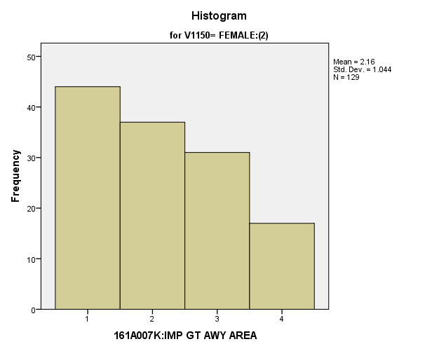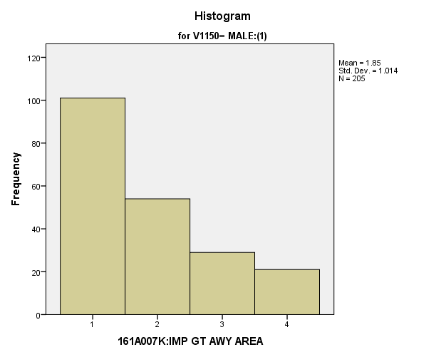

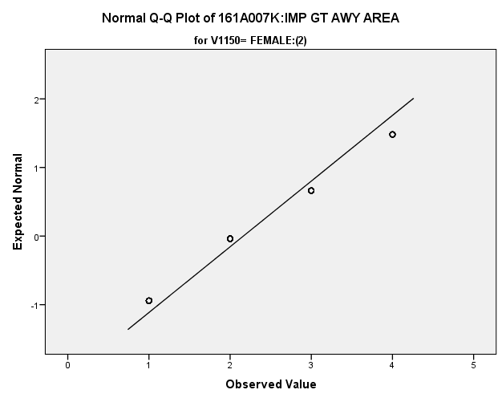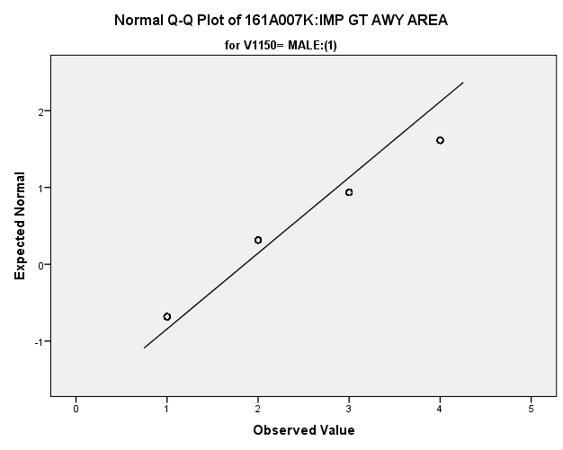

*Primary Analysis:*

|  |  |  |  |  |  |
| --- | --- | --- | --- | --- | --- |
| ***Group Statistics*** | | | | | |
|  | V1150 | N | Mean | Std. Deviation | Std. Error Mean |
| V1665 | MALE:(1) | **205** | **1.85** | **1.014** | **.071** |
| FEMALE:(2) | **129** | **2.16** | **1.044** | **.092** |

|  |  |  |  |  |  |
| --- | --- | --- | --- | --- | --- |
| ***Independent Samples Test*** | | | | | |
|  | | Levene's Test for Equality of Variances | | t-test for Equality of Means | |
| F | Sig. | t | df |
|
| V1665 | Equal variances assumed | **.528** | **.468** | **-2.682** | **332** |
| Equal variances not assumed |  |  | **-2.664** | **266.092** |

|  |  |  |  |  |  |
| --- | --- | --- | --- | --- | --- |
| ***Independent Samples Test*** | | | | | |
|  | | t-test for Equality of Means | | | |
| Sig. (2-tailed) | Mean Difference | Std. Error Difference | 99% Confidence Interval of the Difference |
| Lower |
| V1665 | Equal variances assumed | **.008** | **-.309** | **.115** | **-.608** |
| Equal variances not assumed | **.008** | **-.309** | **.116** | **-.610** |

|  |  |  |  |  |  |
| --- | --- | --- | --- | --- | --- |
| ***Independent Samples Test*** | | | | | |
|  | | | | | t-test for Equality of Means |
| 99% Confidence Interval of the Difference |
| Upper |
| V1665 | | Equal variances assumed | | | **-.011** |
| Equal variances not assumed | | | **-.008** |
| **Measures of Association** | | | |
|  | Eta | | Eta Squared |
| V1665 * V1150 | **.146** | | **.021** |

**Importance of Correcting Inequalities:** Within the potential recruit group, are there gender differences in how important they thought it was to correct inequalities?

**Variables used:** The dependent variable was importance of correcting inequalities, with students rating importance on a scale of 1 to 4, with a higher number meaning more importance. The independent (grouping) variable was sex (male or female).

**Analysis Procedure:**

* A t-test was used to compare average rating of how important students found correcting inequalities between the two gender groups (males versus females)
* Before conducting analysis, the distribution was checked separately for the two groups by means of visual inspection of histograms and Q-Q plots. No outliers were observed. However, the distribution to be was similarly skewed for both groups.
* The equality of variances assumption was tested. This assumption was met.
* Eta Squared was calculated to assess effect size.

**Results:**

* Null and alternative hypothesis. H0: μ1 = μ2; Ha: μ1 ≠ μ2.
* Calculated t value: t =-3.986, df = 1784, reject H0, with a p-value of .000; Eta Squared = .09

**Interpretation:** There is a significant difference between the two gender groups in how important they found correcting inequalities. Furthermore, 9% of how important students found having lots of money can be explained by their gender.

**Supporting Analysis:**

*Preliminary Analysis:*

|  |  |  |  |  |
| --- | --- | --- | --- | --- |
| ***Descriptives*** | | | | |
|  | 161C003:Rs SEX | | | Statistic |
| 161A007L:IMP CRRCT INEQL | MALE:(1) | Mean | | **2.44** |
| 99% Confidence Interval for Mean | Lower Bound | **2.36** |
| Upper Bound | **2.53** |
| 5% Trimmed Mean | | **2.44** |
| Median | | **2.00** |
| Variance | | **.973** |
| Std. Deviation | | **.986** |
| Minimum | | **1** |
| Maximum | | **4** |
| Range | | **3** |
| Interquartile Range | | **1** |
| Skewness | | **.160** |
| Kurtosis | | **-.996** |
| FEMALE:(2) | Mean | | **2.63** |
| 99% Confidence Interval for Mean | Lower Bound | **2.54** |
| Upper Bound | **2.71** |
| 5% Trimmed Mean | | **2.64** |
| Median | | **3.00** |
| Variance | | **.940** |
| Std. Deviation | | **.969** |
| Minimum | | **1** |
| Maximum | | **4** |
| Range | | **3** |
| Interquartile Range | | **1** |
| Skewness | | **-.011** |
| Kurtosis | | **-1.026** |

|  |  |  |  |  |
| --- | --- | --- | --- | --- |
| ***Descriptives*** | | | | |
|  | 161C003:Rs SEX | | | Std. Error |
| 161A007L:IMP CRRCT INEQL | MALE:(1) | Mean | | **.034** |
| 99% Confidence Interval for Mean | Lower Bound |  |
| Upper Bound |  |
| 5% Trimmed Mean | |  |
| Median | |  |
| Variance | |  |
| Std. Deviation | |  |
| Minimum | |  |
| Maximum | |  |
| Range | |  |
| Interquartile Range | |  |
| Skewness | | **.083** |
| Kurtosis | | **.166** |
| FEMALE:(2) | Mean | | **.032** |
| 99% Confidence Interval for Mean | Lower Bound |  |
| Upper Bound |  |
| 5% Trimmed Mean | |  |
| Median | |  |
| Variance | |  |
| Std. Deviation | |  |
| Minimum | |  |
| Maximum | |  |
| Range | |  |
| Interquartile Range | |  |
| Skewness | | **.080** |
| Kurtosis | | **.161** |

|  |  |  |  |  |  |
| --- | --- | --- | --- | --- | --- |
| ***Group Statistics*** | | | | | |
|  | 161C003:Rs SEX | N | Mean | Std. Deviation | Std. Error Mean |
| 161A007L:IMP CRRCT INEQL | MALE:(1) | **861** | **2.44** | **.986** | **.034** |
| FEMALE:(2) | **925** | **2.63** | **.969** | **.032** |

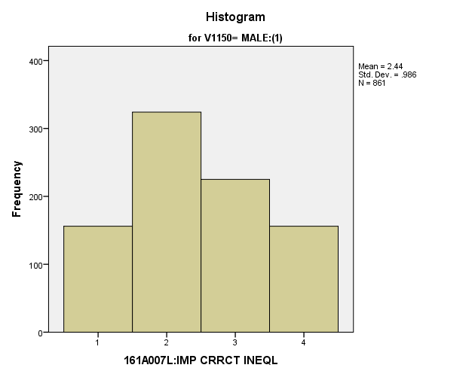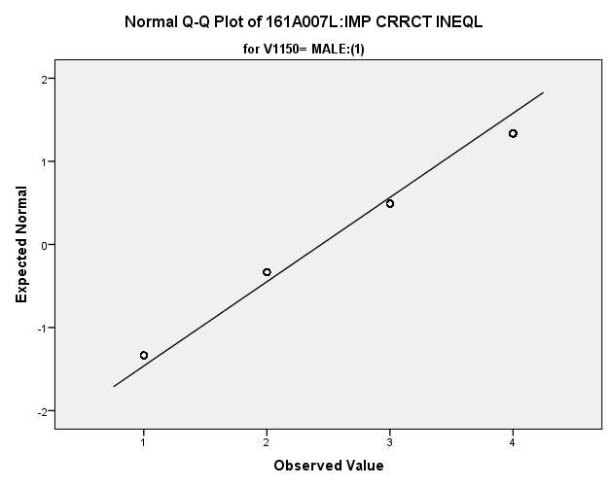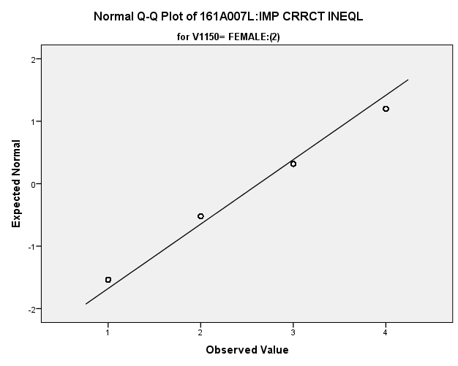

*Primary Analysis:*

|  |  |  |  |  |
| --- | --- | --- | --- | --- |
| ***Independent Samples Test*** | | | | |
|  | | Levene's Test for Equality of Variances | | t-test for Equality of Means |
| F | Sig. | t |
|
| 161A007L:IMP CRRCT INEQL | Equal variances assumed | **.146** | **.702** | **-3.986** |
| Equal variances not assumed |  |  | **-3.984** |

|  |  |  |  |  |
| --- | --- | --- | --- | --- |
| ***Independent Samples Test*** | | | | |
|  | | t-test for Equality of Means | | |
| df | Sig. (2-tailed) | Mean Difference |
|
| 161A007L:IMP CRRCT INEQL | Equal variances assumed | **1784** | **.000** | **-.185** |
| Equal variances not assumed | **1770.013** | **.000** | **-.185** |

|  |  |  |  |  |
| --- | --- | --- | --- | --- |
| ***Independent Samples Test*** | | | | |
|  | | t-test for Equality of Means | | |
| Std. Error Difference | 99% Confidence Interval of the Difference | |
| Lower | Upper |
| 161A007L:IMP CRRCT INEQL | Equal variances assumed | **.046** | **-.304** | **-.065** |
| Equal variances not assumed | **.046** | **-.304** | **-.065** |

|  |  |  |
| --- | --- | --- |
| ***Measures of Association*** | | |
|  | Eta | Eta Squared |
| 161A007L:IMP CRRCT INEQL * 161C003:Rs SEX | **.094** | **.009** |

**Importance of Having New Experiences:** Within the potential recruit group, are there gender differences in how important they thought it was to have new experiences?

**Variables used:** The dependent variable was having new experiences, with students rating importance on a scale of 1 to 4, with a higher number meaning more importance. The independent (grouping) variable was sex (male or female).

**Analysis Procedure:**

* A t-test was used to compare average rating of how important students found having new experiences between the two gender groups (males versus females)
* Before conducting analysis, the distribution for importance of having new experiences was checked separately for the two groups by means of visual inspection of histograms and Q-Q plots. No outliers were observed. However, the distribution to be was left skewed for both groups.
* The equality of variances assumption was tested. This assumption was met.
* Eta Squared was calculated to assess effect size.

**Results:**

* Null and alternative hypothesis. H0: μ1 = μ2; Ha: μ1 ≠ μ2.
* Calculated t value: t = -2.911, df = 1789, reject H0, with a p-value of .004; Eta Squared = .005

**Interpretation:** There is a significant difference between the two gender groups in how important they found having new experiences. Furthermore, .005% of how important students found having new experiences can be explained by their gender.

**Supporting Analysis:**

*Preliminary Analysis:*

|  |  |  |  |  |
| --- | --- | --- | --- | --- |
| ***Descriptives*** | | | | |
|  | 161C003:Rs SEX | | | Statistic |
| 161A007M:IMP NEW XPRNCE | MALE:(1) | Mean | | **2.92** |
| 99% Confidence Interval for Mean | Lower Bound | **2.85** |
| Upper Bound | **3.00** |
| 5% Trimmed Mean | | **2.97** |
| Median | | **3.00** |
| Variance | | **.759** |
| Std. Deviation | | **.871** |
| Minimum | | **1** |
| Maximum | | **4** |
| Range | | **3** |
| Interquartile Range | | **2** |
| Skewness | | **-.303** |
| Kurtosis | | **-.784** |
| FEMALE:(2) | Mean | | **3.04** |
| 99% Confidence Interval for Mean | Lower Bound | **2.97** |
| Upper Bound | **3.11** |
| 5% Trimmed Mean | | **3.09** |
| Median | | **3.00** |
| Variance | | **.727** |
| Std. Deviation | | **.853** |
| Minimum | | **1** |
| Maximum | | **4** |
| Range | | **3** |
| Interquartile Range | | **2** |
| Skewness | | **-.486** |
| Kurtosis | | **-.581** |

|  |  |  |  |  |
| --- | --- | --- | --- | --- |
| ***Descriptives*** | | | | |
|  | 161C003:Rs SEX | | | Std. Error |
| 161A007M:IMP NEW XPRNCE | MALE:(1) | Mean | | **.030** |
| 99% Confidence Interval for Mean | Lower Bound |  |
| Upper Bound |  |
| 5% Trimmed Mean | |  |
| Median | |  |
| Variance | |  |
| Std. Deviation | |  |
| Minimum | |  |
| Maximum | |  |
| Range | |  |
| Interquartile Range | |  |
| Skewness | | **.083** |
| Kurtosis | | **.166** |
| FEMALE:(2) | Mean | | **.028** |
| 99% Confidence Interval for Mean | Lower Bound |  |
| Upper Bound |  |
| 5% Trimmed Mean | |  |
| Median | |  |
| Variance | |  |
| Std. Deviation | |  |
| Minimum | |  |
| Maximum | |  |
| Range | |  |
| Interquartile Range | |  |
| Skewness | | **.080** |
| Kurtosis | | **.160** |

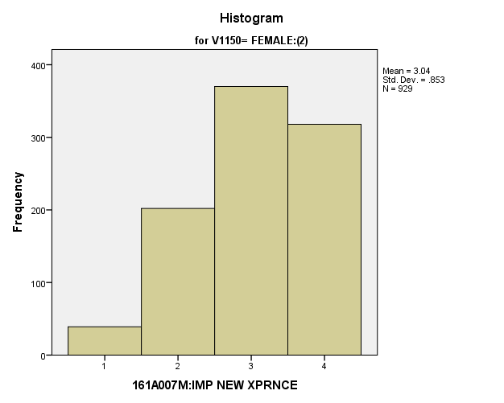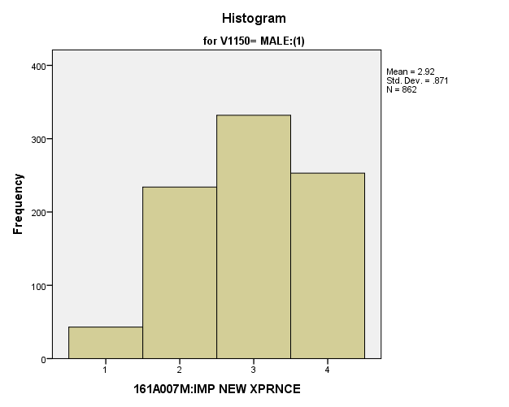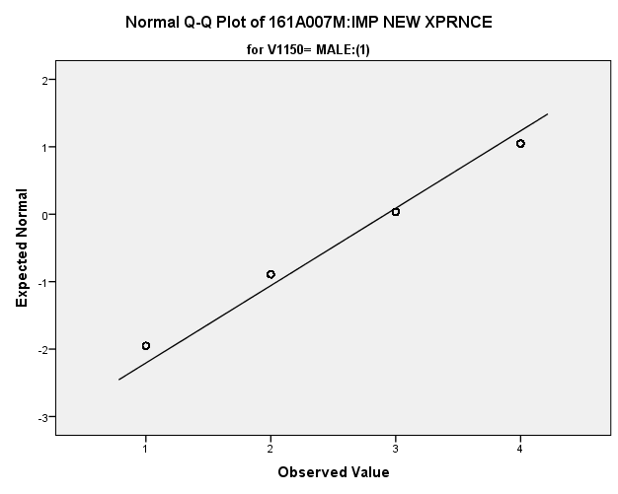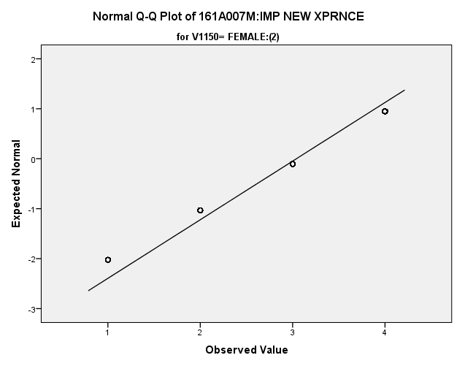

*Primary Analysis:*

|  |  |  |  |  |  |
| --- | --- | --- | --- | --- | --- |
| ***Group Statistics*** | | | | | |
|  | 161C003:Rs SEX | N | Mean | Std. Deviation | Std. Error Mean |
| 161A007M:IMP NEW XPRNCE | MALE:(1) | **862** | **2.92** | **.871** | **.030** |
| FEMALE:(2) | **929** | **3.04** | **.853** | **.028** |

|  |  |  |  |  |
| --- | --- | --- | --- | --- |
| ***Independent Samples Test*** | | | | |
|  | | Levene's Test for Equality of Variances | | t-test for Equality of Means |
| F | Sig. | t |
|
| 161A007M:IMP NEW XPRNCE | Equal variances assumed | **2.005** | **.157** | **-2.911** |
| Equal variances not assumed |  |  | **-2.909** |

|  |  |  |  |  |
| --- | --- | --- | --- | --- |
| ***Independent Samples Test*** | | | | |
|  | | t-test for Equality of Means | | |
| df | Sig. (2-tailed) | Mean Difference |
|
| 161A007M:IMP NEW XPRNCE | Equal variances assumed | **1789** | **.004** | **-.119** |
| Equal variances not assumed | **1772.394** | **.004** | **-.119** |

|  |  |  |  |  |
| --- | --- | --- | --- | --- |
| ***Independent Samples Test*** | | | | |
|  | | t-test for Equality of Means | | |
| Std. Error Difference | 99% Confidence Interval of the Difference | |
| Lower | Upper |
| 161A007M:IMP NEW XPRNCE | Equal variances assumed | **.041** | **-.224** | **-.014** |
| Equal variances not assumed | **.041** | **-.224** | **-.013** |

|  |  |  |
| --- | --- | --- |
| ***Measures of Association*** | | |
|  | Eta | Eta Squared |
| 161A007M:IMP NEW XPRNCE * 161C003:Rs SEX | **.069** | **.005** |

**Importance of Finding Purpose in Life:** Within the potential recruit group, are there gender differences in how important they thought it was to find purpose in life?

**Variables used:** The dependent variable was importance of finding purpose in life, with students rating importance on a scale of 1 to 4, with a higher number meaning more importance. The independent (grouping) variable was sex (male or female).

**Analysis Procedure:**

* A t-test was used to compare average rating of how important students found finding purpose in life between the two gender groups (males versus females)
* Before conducting analysis, the distribution for importance of finding purpose in life was checked separately for the two groups by means of visual inspection of histograms and Q-Q plots. No outliers were observed. However, the distribution of how important students found finding a purpose in life to be was left skewed for both groups.
* The equality of variances assumption was tested. This assumption was not met.
* Eta Squared was calculated to assess effect size.

**Results:**

* Null and alternative hypothesis. H0: μ1 = μ2; Ha: μ1 ≠ μ2.
* Calculated t value: t = -3.050, df = 315.742, reject H0, with a p-value of .002; Eta Squared = .025

**Interpretation:** There is a significant difference between the two groups in how important they found finding purpose in life to be. Furthermore, 2.5 percent of how important students found finding purpose in life to be can be explained by their gender.

**Supporting Analysis:**

*Preliminary Analysis:*

|  |  |  |  |  |
| --- | --- | --- | --- | --- |
| ***Descriptives*** | | | | |
|  | 161C003:Rs SEX | | | Statistic |
| 161A007N:IMP FND PRPS LF | MALE:(1) | Mean | | **3.45** |
| 99% Confidence Interval for Mean | Lower Bound | **3.38** |
| Upper Bound | **3.52** |
| 5% Trimmed Mean | | **3.54** |
| Median | | **4.00** |
| Variance | | **.653** |
| Std. Deviation | | **.808** |
| Minimum | | **1** |
| Maximum | | **4** |
| Range | | **3** |
| Interquartile Range | | **1** |
| Skewness | | **-1.397** |
| Kurtosis | | **1.154** |
| FEMALE:(2) | Mean | | **3.64** |
| 99% Confidence Interval for Mean | Lower Bound | **3.59** |
| Upper Bound | **3.70** |
| 5% Trimmed Mean | | **3.73** |
| Median | | **4.00** |
| Variance | | **.434** |
| Std. Deviation | | **.659** |
| Minimum | | **1** |
| Maximum | | **4** |
| Range | | **3** |
| Interquartile Range | | **1** |
| Skewness | | **-1.915** |
| Kurtosis | | **3.253** |

|  |  |  |  |  |
| --- | --- | --- | --- | --- |
| ***Descriptives*** | | | | |
|  | 161C003:Rs SEX | | | Std. Error |
| 161A007N:IMP FND PRPS LF | MALE:(1) | Mean | | **.028** |
| 99% Confidence Interval for Mean | Lower Bound |  |
| Upper Bound |  |
| 5% Trimmed Mean | |  |
| Median | |  |
| Variance | |  |
| Std. Deviation | |  |
| Minimum | |  |
| Maximum | |  |
| Range | |  |
| Interquartile Range | |  |
| Skewness | | **.083** |
| Kurtosis | | **.167** |
| FEMALE:(2) | Mean | | **.022** |
| 99% Confidence Interval for Mean | Lower Bound |  |
| Upper Bound |  |
| 5% Trimmed Mean | |  |
| Median | |  |
| Variance | |  |
| Std. Deviation | |  |
| Minimum | |  |
| Maximum | |  |
| Range | |  |
| Interquartile Range | |  |
| Skewness | | **.080** |
| Kurtosis | | **.160** |

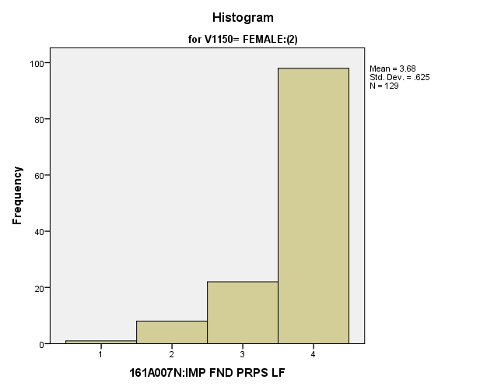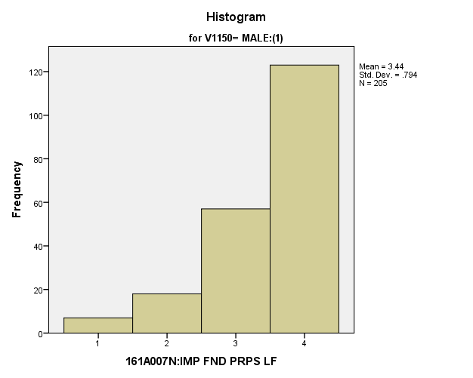

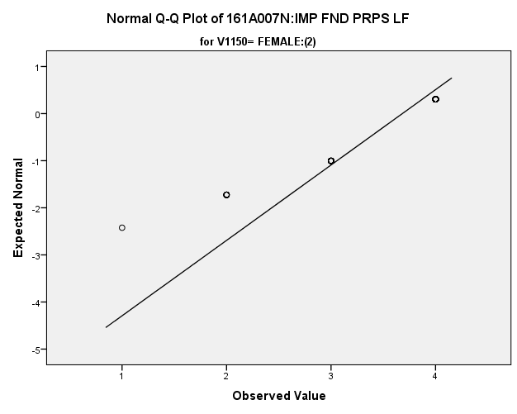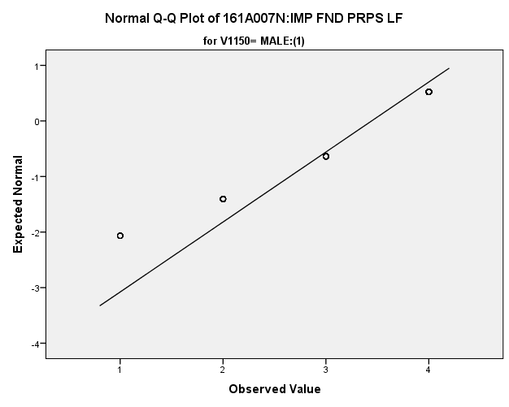

|  |  |  |  |  |  |
| --- | --- | --- | --- | --- | --- |
| *Primary Analysis:*  ***Group Statistics*** | | | | | |
|  | V1150 | N | Mean | Std. Deviation | Std. Error Mean |
| V1668 | MALE:(1) | **205** | **3.44** | **.794** | **.055** |
| FEMALE:(2) | **129** | **3.68** | **.625** | **.055** |

|  |  |  |  |  |  |
| --- | --- | --- | --- | --- | --- |
| ***Independent Samples Test*** | | | | | |
|  | | Levene's Test for Equality of Variances | | t-test for Equality of Means | |
| F | Sig. | t | df |
|
| V1668 | Equal variances assumed | **15.628** | **.000** | **-2.891** | **332** |
| Equal variances not assumed |  |  | **-3.050** | **315.742** |

|  |  |  |  |  |  |
| --- | --- | --- | --- | --- | --- |
| ***Independent Samples Test*** | | | | | |
|  | | t-test for Equality of Means | | | |
| Sig. (2-tailed) | Mean Difference | Std. Error Difference | 99% Confidence Interval of the Difference |
| Lower |
| V1668 | Equal variances assumed | **.004** | **-.238** | **.082** | **-.452** |
| Equal variances not assumed | **.002** | **-.238** | **.078** | **-.441** |

|  |  |  |
| --- | --- | --- |
| ***Independent Samples Test*** | | |
|  | | t-test for Equality of Means |
| 99% Confidence Interval of the Difference |
| Upper |
| V1668 | Equal variances assumed | **-.025** |
| Equal variances not assumed | **-.036** |

|  |  |  |
| --- | --- | --- |
| **Measures of Association** | | |
|  | Eta | Eta Squared |
| V1668 * V1150 | **.157** | **.025** |

*4.b. Student Satisfaction Variables:*

**Satisfaction with Present Job:** Within the potential recruit group, are there gender differences in how satisfied they are with their present job?

**Variables used:** The dependent variable was satisfaction with their present job, with students rating satisfaction on a scale of 1 to 7, with a higher number meaning more satisfaction. The independent (grouping) variable was sex (male or female).

**Analysis Procedure:**

* A t-test was used to compare average rating of how satisfied students are with their present job between the two gender groups (males versus females)
* Before conducting analysis, the distribution was checked separately for the two groups by means of visual inspection of histograms and Q-Q plots. No outliers were observed. However, the distribution was left skewed for both groups.
* The equality of variances assumption was tested. This assumption was met.

**Results:**

* Null and alternative hypothesis. H0: μ1 = μ2; Ha: μ1 ≠ μ2.
* Calculated t value: t = 1.191, df = 1005, fail to reject H0, with a p-value of .234

**Interpretation:** There is not a significant difference between the two gender groups in how satisfied students are with their present job.

**Supporting Analysis:**

*Preliminary Analysis:*

|  |  |  |  |  |
| --- | --- | --- | --- | --- |
| ***Descriptives*** | | | | |
|  | 161C003:Rs SEX | | | Statistic |
| 161A006A:SAT PRESENT JOB | MALE:(1) | Mean | | **5.00** |
| 99% Confidence Interval for Mean | Lower Bound | **4.81** |
| Upper Bound | **5.20** |
| 5% Trimmed Mean | | **5.12** |
| Median | | **5.00** |
| Variance | | **2.720** |
| Std. Deviation | | **1.649** |
| Minimum | | **1** |
| Maximum | | **7** |
| Range | | **6** |
| Interquartile Range | | **2** |
| Skewness | | **-.636** |
| Kurtosis | | **-.118** |
| FEMALE:(2) | Mean | | **4.88** |
| 99% Confidence Interval for Mean | Lower Bound | **4.68** |
| Upper Bound | **5.08** |
| 5% Trimmed Mean | | **4.97** |
| Median | | **5.00** |
| Variance | | **3.070** |
| Std. Deviation | | **1.752** |
| Minimum | | **1** |
| Maximum | | **7** |
| Range | | **6** |
| Interquartile Range | | **2** |
| Skewness | | **-.596** |
| Kurtosis | | **-.400** |

|  |  |  |  |  |
| --- | --- | --- | --- | --- |
| ***Descriptives*** | | | | |
|  | 161C003:Rs SEX | | | Std. Error |
| 161A006A:SAT PRESENT JOB | MALE:(1) | Mean | | **.075** |
| 99% Confidence Interval for Mean | Lower Bound |  |
| Upper Bound |  |
| 5% Trimmed Mean | |  |
| Median | |  |
| Variance | |  |
| Std. Deviation | |  |
| Minimum | |  |
| Maximum | |  |
| Range | |  |
| Interquartile Range | |  |
| Skewness | | **.110** |
| Kurtosis | | **.220** |
| FEMALE:(2) | Mean | | **.077** |
| 99% Confidence Interval for Mean | Lower Bound |  |
| Upper Bound |  |
| 5% Trimmed Mean | |  |
| Median | |  |
| Variance | |  |
| Std. Deviation | |  |
| Minimum | |  |
| Maximum | |  |
| Range | |  |
| Interquartile Range | |  |
| Skewness | | **.107** |
| Kurtosis | | **.214** |

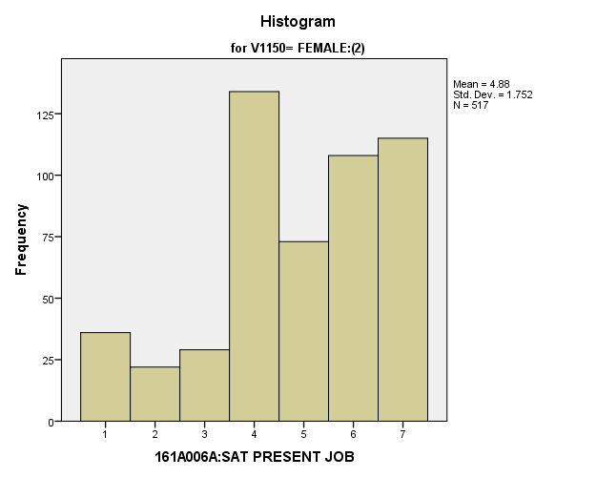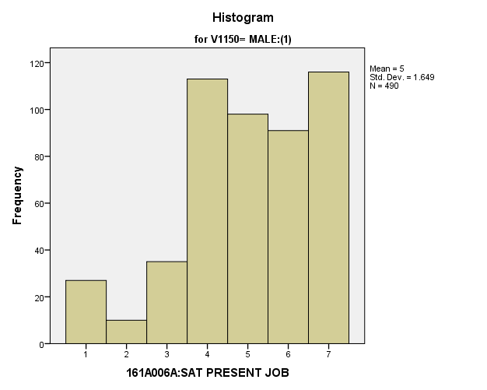

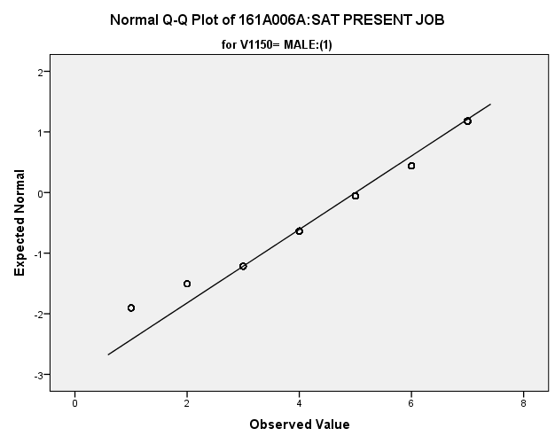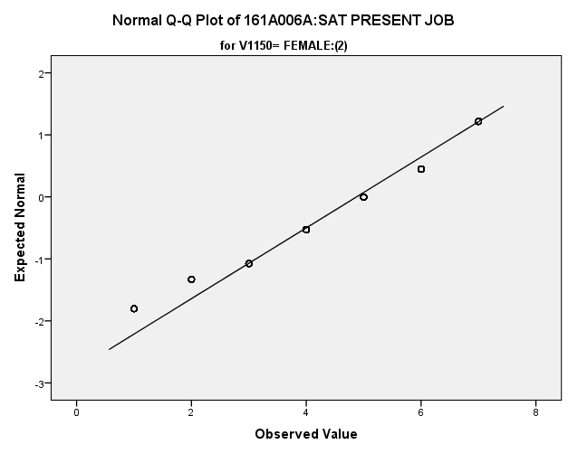

*Primary Analysis:*

|  |  |  |  |  |  |
| --- | --- | --- | --- | --- | --- |
| ***Group Statistics*** | | | | | |
|  | 161C003:Rs SEX | N | Mean | Std. Deviation | Std. Error Mean |
| 161A006A:SAT PRESENT JOB | MALE:(1) | **490** | **5.00** | **1.649** | **.075** |
| FEMALE:(2) | **517** | **4.88** | **1.752** | **.077** |

|  |  |  |  |  |
| --- | --- | --- | --- | --- |
| ***Independent Samples Test*** | | | | |
|  | | Levene's Test for Equality of Variances | | t-test for Equality of Means |
| F | Sig. | t |
|
| 161A006A:SAT PRESENT JOB | Equal variances assumed | **4.654** | **.031** | **1.191** |
| Equal variances not assumed |  |  | **1.193** |

|  |  |  |  |  |
| --- | --- | --- | --- | --- |
| ***Independent Samples Test*** | | | | |
|  | | t-test for Equality of Means | | |
| df | Sig. (2-tailed) | Mean Difference |
|
| 161A006A:SAT PRESENT JOB | Equal variances assumed | **1005** | **.234** | **.128** |
| Equal variances not assumed | **1004.953** | **.233** | **.128** |

|  |  |  |  |  |
| --- | --- | --- | --- | --- |
| ***Independent Samples Test*** | | | | |
|  | | t-test for Equality of Means | | |
| Std. Error Difference | 99% Confidence Interval of the Difference | |
| Lower | Upper |
| 161A006A:SAT PRESENT JOB | Equal variances assumed | **.107** | **-.149** | **.405** |
| Equal variances not assumed | **.107** | **-.149** | **.404** |

**Satisfaction with Current Neighborhood:** Within the potential recruit group, are there gender differences in how satisfied they are with their current neighborhood?

**Variables used:** The dependent variable was satisfaction with current neighborhood, with students rating satisfaction on a scale of 1 to 7, with a higher number meaning more satisfaction. The independent (grouping) variable was sex (male or female).

**Analysis Procedure:**

* A t-test was used to compare average rating of how satisfied students are with their current neighborhood between the two gender groups (males versus females)
* Before conducting analysis, the distribution for how satisfied students are with their current neighborhood between was checked separately for the two groups by means of visual inspection of histograms and Q-Q plots. No outliers were observed. However, the distribution was left skewed for both groups.
* The equality of variances assumption was tested. This assumption was met.

**Results:**

* Null and alternative hypothesis. H0: μ1 = μ2; Ha: μ1 ≠ μ2.
* Calculated t value: t = .204, df = 334, fail to reject H0, with a p-value of .839

**Interpretation:** There was not a significant difference between the two groups in how satisfied they are with their current neighborhood.

**Supporting Analysis:**

*Preliminary Analysis:*

|  |  |  |  |  |
| --- | --- | --- | --- | --- |
| ***Descriptives*** | | | | |
|  | 161C003:Rs SEX | | | Statistic |
| 161A006B:SAT NEIGHBORHOD | MALE:(1) | Mean | | **5.35** |
| 99% Confidence Interval for Mean | Lower Bound | **5.21** |
| Upper Bound | **5.50** |
| 5% Trimmed Mean | | **5.50** |
| Median | | **6.00** |
| Variance | | **2.833** |
| Std. Deviation | | **1.683** |
| Minimum | | **1** |
| Maximum | | **7** |
| Range | | **6** |
| Interquartile Range | | **3** |
| Skewness | | **-.892** |
| Kurtosis | | **-.015** |
| FEMALE:(2) | Mean | | **5.26** |
| 99% Confidence Interval for Mean | Lower Bound | **5.12** |
| Upper Bound | **5.41** |
| 5% Trimmed Mean | | **5.39** |
| Median | | **6.00** |
| Variance | | **2.924** |
| Std. Deviation | | **1.710** |
| Minimum | | **1** |
| Maximum | | **7** |
| Range | | **6** |
| Interquartile Range | | **3** |
| Skewness | | **-.723** |
| Kurtosis | | **-.360** |

|  |  |  |  |  |
| --- | --- | --- | --- | --- |
| ***Descriptives*** | | | | |
|  | 161C003:Rs SEX | | | Std. Error |
| 161A006B:SAT NEIGHBORHOD | MALE:(1) | Mean | | **.057** |
| 99% Confidence Interval for Mean | Lower Bound |  |
| Upper Bound |  |
| 5% Trimmed Mean | |  |
| Median | |  |
| Variance | |  |
| Std. Deviation | |  |
| Minimum | |  |
| Maximum | |  |
| Range | |  |
| Interquartile Range | |  |
| Skewness | | **.082** |
| Kurtosis | | **.165** |
| FEMALE:(2) | Mean | | **.056** |
| 99% Confidence Interval for Mean | Lower Bound |  |
| Upper Bound |  |
| 5% Trimmed Mean | |  |
| Median | |  |
| Variance | |  |
| Std. Deviation | |  |
| Minimum | |  |
| Maximum | |  |
| Range | |  |
| Interquartile Range | |  |
| Skewness | | **.080** |
| Kurtosis | | **.159** |

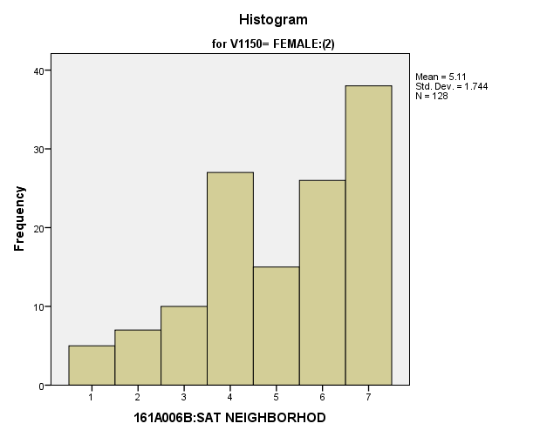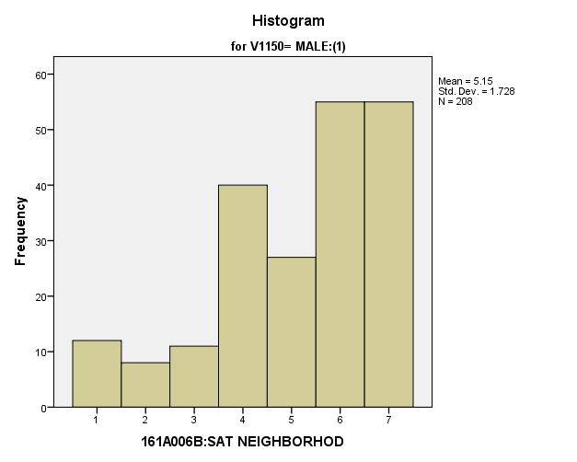

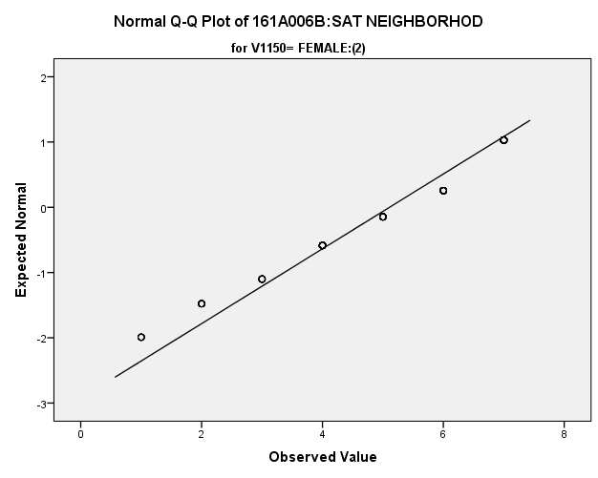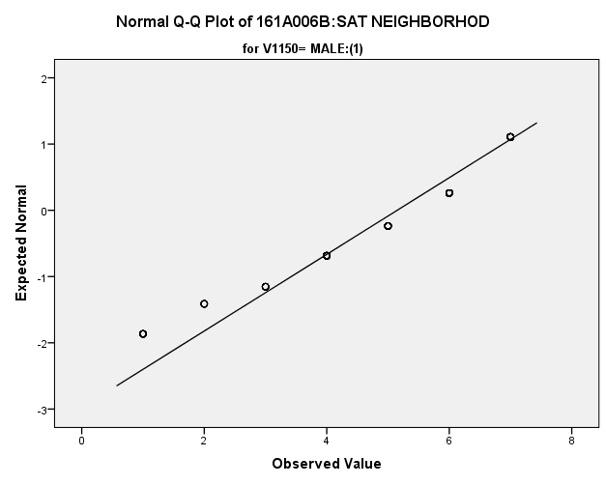

|  |  |  |  |  |  |
| --- | --- | --- | --- | --- | --- |
| *Primary Analysis:*  **Group Statistics** | | | | | |
|  | V1150 | N | Mean | Std. Deviation | Std. Error Mean |
| V1642 | MALE:(1) | **208** | **5.15** | **1.728** | **.120** |
| FEMALE:(2) | **128** | **5.11** | **1.744** | **.154** |

|  |  |  |  |  |  |  |
| --- | --- | --- | --- | --- | --- | --- |
| **Independent Samples Test** | | | | | | |
|  | | Levene's Test for Equality of Variances | | t-test for Equality of Means | | |
| F | Sig. | t | df | Sig. (2-tailed) |
|
| V1642 | Equal variances assumed | **.273** | **.602** | **.204** | **334** | **.839** |
| Equal variances not assumed |  |  | **.203** | **267.009** | **.839** |

|  |  |  |  |  |  |
| --- | --- | --- | --- | --- | --- |
| **Independent Samples Test** | | | | | |
|  | | t-test for Equality of Means | | | |
| Mean Difference | Std. Error Difference | 99% Confidence Interval of the Difference | |
| Lower | Upper |
| V1642 | Equal variances assumed | **.040** | **.195** | **-.465** | **.544** |
| Equal variances not assumed | **.040** | **.195** | **-.467** | **.546** |

**Satisfaction with Personal Safety:** Within the potential recruit group, are there gender differences in how satisfied they are with their personal safety?

**Variables used:** The dependent variable was satisfaction with personal safety, with students rating satisfaction on a scale from 1 to 7, with a higher number meaning more satisfaction. The independent (grouping) variable was sex (male or female).

**Analysis Procedure:**

* A t-test was used to compare average rating of how satisfied students are with their personal safety between the two gender groups (males versus females)
* Before conducting analysis, the distribution was checked separately for the two groups by means of visual inspection of histograms and Q-Q plots. No outliers were observed. However, the distribution of was left skewed for both groups.
* The equality of variances assumption was tested. This assumption was not met.

**Results:**

* Null and alternative hypothesis. H0: μ1 = μ2; Ha: μ1 ≠ μ2.
* Calculated t value: t = 4.539, df = 1815, fail to reject H0, with a p-value of .000; Eta Squared = .011

**Interpretation:** There is a significant difference between the two gender groups in how satisfied they are with their personal safety. Furthermore, 1.1% of how satisfied students are with their personal safety can be explained by their gender.

**Supporting Analysis:**

*Preliminary Analysis:*

|  |  |  |  |  |
| --- | --- | --- | --- | --- |
| ***Descriptives*** | | | | |
|  | 161C003:Rs SEX | | | Statistic |
| 161A006C:SAT PRSNL SAFTY | MALE:(1) | Mean | | **5.80** |
| 99% Confidence Interval for Mean | Lower Bound | **5.67** |
| Upper Bound | **5.93** |
| 5% Trimmed Mean | | **5.95** |
| Median | | **6.00** |
| Variance | | **2.174** |
| Std. Deviation | | **1.475** |
| Minimum | | **1** |
| Maximum | | **7** |
| Range | | **6** |
| Interquartile Range | | **2** |
| Skewness | | **-1.240** |
| Kurtosis | | **.872** |
| FEMALE:(2) | Mean | | **5.47** |
| 99% Confidence Interval for Mean | Lower Bound | **5.34** |
| Upper Bound | **5.61** |
| 5% Trimmed Mean | | **5.60** |
| Median | | **6.00** |
| Variance | | **2.533** |
| Std. Deviation | | **1.591** |
| Minimum | | **1** |
| Maximum | | **7** |
| Range | | **6** |
| Interquartile Range | | **3** |
| Skewness | | **-.856** |
| Kurtosis | | **-.133** |

|  |  |  |  |  |
| --- | --- | --- | --- | --- |
| ***Descriptives*** | | | | |
|  | 161C003:Rs SEX | | | Std. Error |
| 161A006C:SAT PRSNL SAFTY | MALE:(1) | Mean | | **.050** |
| 99% Confidence Interval for Mean | Lower Bound |  |
| Upper Bound |  |
| 5% Trimmed Mean | |  |
| Median | |  |
| Variance | |  |
| Std. Deviation | |  |
| Minimum | |  |
| Maximum | |  |
| Range | |  |
| Interquartile Range | |  |
| Skewness | | **.083** |
| Kurtosis | | **.165** |
| FEMALE:(2) | Mean | | **.052** |
| 99% Confidence Interval for Mean | Lower Bound |  |
| Upper Bound |  |
| 5% Trimmed Mean | |  |
| Median | |  |
| Variance | |  |
| Std. Deviation | |  |
| Minimum | |  |
| Maximum | |  |
| Range | |  |
| Interquartile Range | |  |
| Skewness | | **.080** |
| Kurtosis | | **.159** |

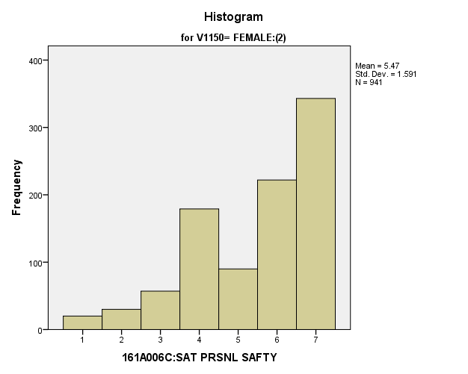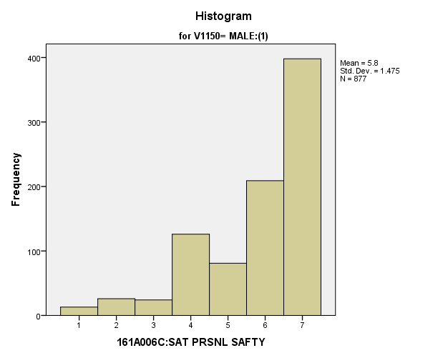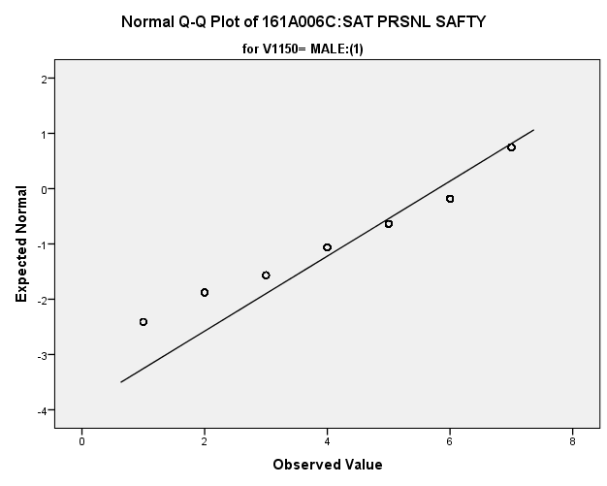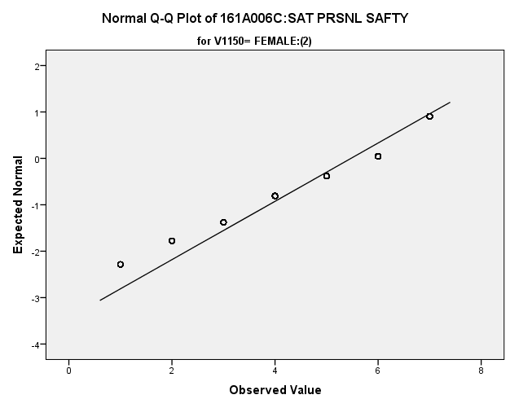

*Primary Analysis:*

|  |  |  |  |  |  |
| --- | --- | --- | --- | --- | --- |
| ***Group Statistics*** | | | | | |
|  | 161C003:Rs SEX | N | Mean | Std. Deviation | Std. Error Mean |
| 161A006C:SAT PRSNL SAFTY | MALE:(1) | **877** | **5.80** | **1.475** | **.050** |
| FEMALE:(2) | **941** | **5.47** | **1.591** | **.052** |

|  |  |  |  |  |
| --- | --- | --- | --- | --- |
| ***Independent Samples Test*** | | | | |
|  | | Levene's Test for Equality of Variances | | t-test for Equality of Means |
| F | Sig. | t |
|
| 161A006C:SAT PRSNL SAFTY | Equal variances assumed | **19.653** | **.000** | **4.527** |
| Equal variances not assumed |  |  | **4.539** |

|  |  |  |  |  |
| --- | --- | --- | --- | --- |
| ***Independent Samples Test*** | | | | |
|  | | t-test for Equality of Means | | |
| df | Sig. (2-tailed) | Mean Difference |
|
| 161A006C:SAT PRSNL SAFTY | Equal variances assumed | **1816** | **.000** | **.326** |
| Equal variances not assumed | **1815.939** | **.000** | **.326** |

|  |  |  |  |  |
| --- | --- | --- | --- | --- |
| ***Independent Samples Test*** | | | | |
|  | | t-test for Equality of Means | | |
| Std. Error Difference | 99% Confidence Interval of the Difference | |
| Lower | Upper |
| 161A006C:SAT PRSNL SAFTY | Equal variances assumed | **.072** | **.141** | **.512** |
| Equal variances not assumed | **.072** | **.141** | **.512** |

|  |  |  |
| --- | --- | --- |
| ***Measures of Association*** | | |
|  | Eta | Eta Squared |
| 161A006C:SAT PRSNL SAFTY * 161C003:Rs SEX | **.106** | **.011** |

**Satisfaction with Safety of Property:** Within the potential recruit group, are there gender differences in how satisfied they are with the safety of their property?

**Variables used:** The dependent variable was satisfaction with the safety of their property, with students rating satisfaction on a scale from 1 to 7, with a higher number meaning more satisfaction. The independent (grouping) variable was sex (male or female).

**Analysis Procedure:**

* A t-test was used to compare average rating of how satisfied students are with the safety of their property between the two gender groups (males versus females)
* Before conducting analysis, the distribution for how satisfied students are with the safety of their property was checked separately for the two groups by means of visual inspection of histograms and Q-Q plots. No outliers were observed. However, the distribution of was left skewed for both groups.
* The equality of variances assumption was tested. This assumption was met.

**Results:**

* Null and alternative hypothesis. H0: μ1 = μ2; Ha: μ1 ≠ μ2.
* Calculated t value: t = 3.904, df = 1812, reject H0, with a p-value of .000; Eta squared = .008

**Interpretation:** There is a significant difference between the two groups in how satisfied students are with the safety of their property. Furthermore, .8% of how important they found it to be can be attributed to their gender.

**Supporting Analysis:**

*Preliminary Analysis:*

|  |  |  |  |  |
| --- | --- | --- | --- | --- |
| ***Descriptives*** | | | | |
|  | 161C003:Rs SEX | | | Statistic |
| 161A006D:SAT OWN PROP SF | MALE:(1) | Mean | | **5.31** |
| 99% Confidence Interval for Mean | Lower Bound | **5.16** |
| Upper Bound | **5.45** |
| 5% Trimmed Mean | | **5.44** |
| Median | | **6.00** |
| Variance | | **2.750** |
| Std. Deviation | | **1.658** |
| Minimum | | **1** |
| Maximum | | **7** |
| Range | | **6** |
| Interquartile Range | | **3** |
| Skewness | | **-.865** |
| Kurtosis | | **-.060** |
| FEMALE:(2) | Mean | | **4.99** |
| 99% Confidence Interval for Mean | Lower Bound | **4.85** |
| Upper Bound | **5.14** |
| 5% Trimmed Mean | | **5.11** |
| Median | | **5.00** |
| Variance | | **3.035** |
| Std. Deviation | | **1.742** |
| Minimum | | **1** |
| Maximum | | **7** |
| Range | | **6** |
| Interquartile Range | | **2** |
| Skewness | | **-.618** |
| Kurtosis | | **-.521** |

|  |  |  |  |  |
| --- | --- | --- | --- | --- |
| ***Descriptives*** | | | | |
|  | 161C003:Rs SEX | | | Std. Error |
| 161A006D:SAT OWN PROP SF | MALE:(1) | Mean | | **.056** |
| 99% Confidence Interval for Mean | Lower Bound |  |
| Upper Bound |  |
| 5% Trimmed Mean | |  |
| Median | |  |
| Variance | |  |
| Std. Deviation | |  |
| Minimum | |  |
| Maximum | |  |
| Range | |  |
| Interquartile Range | |  |
| Skewness | | **.083** |
| Kurtosis | | **.165** |
| FEMALE:(2) | Mean | | **.057** |
| 99% Confidence Interval for Mean | Lower Bound |  |
| Upper Bound |  |
| 5% Trimmed Mean | |  |
| Median | |  |
| Variance | |  |
| Std. Deviation | |  |
| Minimum | |  |
| Maximum | |  |
| Range | |  |
| Interquartile Range | |  |
| Skewness | | **.080** |
| Kurtosis | | **.159** |

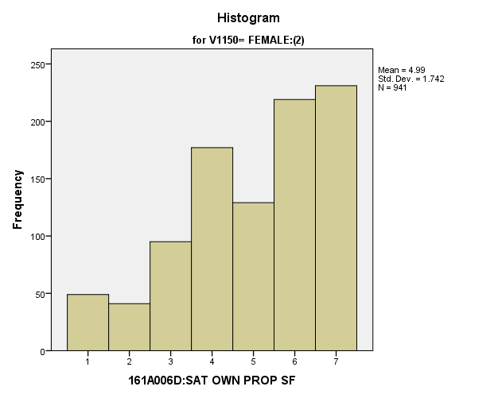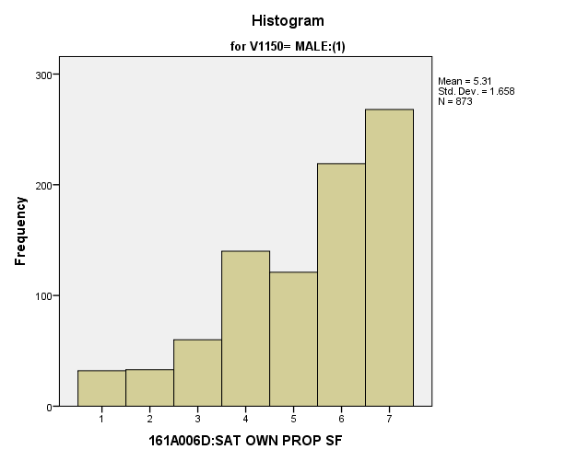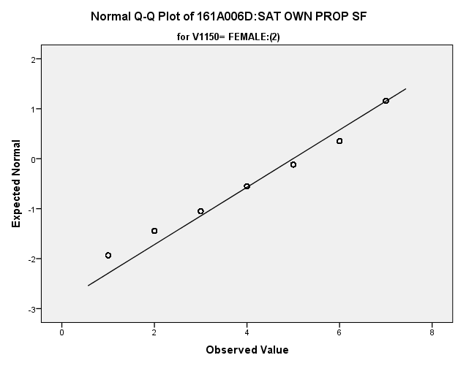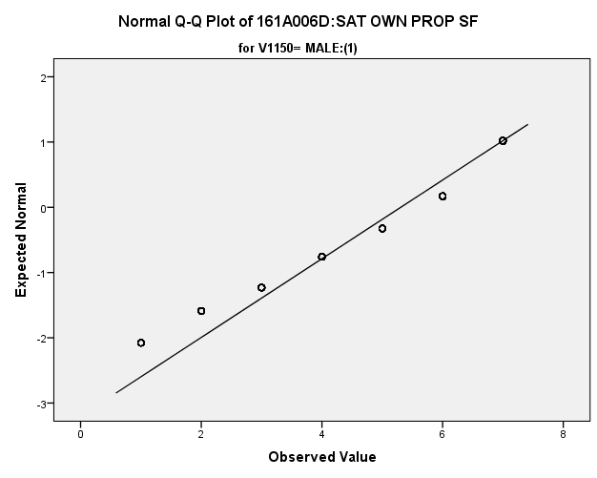

*Primary Analysis:*

|  |  |  |  |  |  |
| --- | --- | --- | --- | --- | --- |
| ***Group Statistics*** | | | | | |
|  | 161C003:Rs SEX | N | Mean | Std. Deviation | Std. Error Mean |
| 161A006D:SAT OWN PROP SF | MALE:(1) | **873** | **5.31** | **1.658** | **.056** |
| FEMALE:(2) | **941** | **4.99** | **1.742** | **.057** |

|  |  |  |  |  |
| --- | --- | --- | --- | --- |
| ***Independent Samples Test*** | | | | |
|  | | Levene's Test for Equality of Variances | | t-test for Equality of Means |
| F | Sig. | t |
|
| 161A006D:SAT OWN PROP SF | Equal variances assumed | **2.313** | **.128** | **3.904** |
| Equal variances not assumed |  |  | **3.911** |

|  |  |  |  |  |
| --- | --- | --- | --- | --- |
| ***Independent Samples Test*** | | | | |
|  | | t-test for Equality of Means | | |
| df | Sig. (2-tailed) | Mean Difference |
|
| 161A006D:SAT OWN PROP SF | Equal variances assumed | **1812** | **.000** | **.312** |
| Equal variances not assumed | **1810.806** | **.000** | **.312** |

|  |  |  |  |  |
| --- | --- | --- | --- | --- |
| ***Independent Samples Test*** | | | | |
|  | | t-test for Equality of Means | | |
| Std. Error Difference | 99% Confidence Interval of the Difference | |
| Lower | Upper |
| 161A006D:SAT OWN PROP SF | Equal variances assumed | **.080** | **.106** | **.519** |
| Equal variances not assumed | **.080** | **.106** | **.518** |

|  |  |  |
| --- | --- | --- |
| ***Measures of Association*** | | |
|  | Eta | Eta Squared |
| 161A006D:SAT OWN PROP SF * 161C003:Rs SEX | **.091** | **.008** |

**Satisfaction with Education Experience:** Within the potential recruit group, are there gender differences in how satisfied they are with their Education Experience?

**Variables used:** The dependent variable was satisfaction with education experience, with students rating satisfaction on a scale from 1 to 7, with a higher number meaning more satisfaction. The independent (grouping) variable was sex (male or female).

**Analysis Procedure:**

* A t-test was used to compare average rating of how satisfied students are with their education experience between the two gender groups (males versus females)
* Before conducting analysis, the distribution for how satisfied students are with their education experience between was checked separately for the two groups by means of visual inspection of histograms and Q-Q plots. No outliers were observed. However, the distribution of was left skewed for both groups.
* The equality of variances assumption was tested. This assumption was met.

**Results:**

* Null and alternative hypothesis. H0: μ1 = μ2; Ha: μ1 ≠ μ2.
* Calculated t value: t = .795, df = 334, fail to reject H0, with a p-value of .427

**Interpretation:** There is not a significant difference between the two groups in how satisfied students are with their education experience.

**Supporting Analysis:**

*Preliminary Analysis:*

|  |  |  |  |  |
| --- | --- | --- | --- | --- |
| ***Descriptives*** | | | | |
|  | 161C003:Rs SEX | | | Statistic |
| 161A006E:SAT EDUC EXPRNC | MALE:(1) | Mean | | **5.18** |
| 99% Confidence Interval for Mean | Lower Bound | **5.05** |
| Upper Bound | **5.32** |
| 5% Trimmed Mean | | **5.29** |
| Median | | **5.00** |
| Variance | | **2.335** |
| Std. Deviation | | **1.528** |
| Minimum | | **1** |
| Maximum | | **7** |
| Range | | **6** |
| Interquartile Range | | **2** |
| Skewness | | **-.779** |
| Kurtosis | | **.126** |
| FEMALE:(2) | Mean | | **5.10** |
| 99% Confidence Interval for Mean | Lower Bound | **4.98** |
| Upper Bound | **5.23** |
| 5% Trimmed Mean | | **5.20** |
| Median | | **5.00** |
| Variance | | **2.229** |
| Std. Deviation | | **1.493** |
| Minimum | | **1** |
| Maximum | | **7** |
| Range | | **6** |
| Interquartile Range | | **2** |
| Skewness | | **-.666** |
| Kurtosis | | **.030** |

|  |  |  |  |  |
| --- | --- | --- | --- | --- |
| ***Descriptives*** | | | | |
|  | 161C003:Rs SEX | | | Std. Error |
| 161A006E:SAT EDUC EXPRNC | MALE:(1) | Mean | | **.052** |
| 99% Confidence Interval for Mean | Lower Bound |  |
| Upper Bound |  |
| 5% Trimmed Mean | |  |
| Median | |  |
| Variance | |  |
| Std. Deviation | |  |
| Minimum | |  |
| Maximum | |  |
| Range | |  |
| Interquartile Range | |  |
| Skewness | | **.083** |
| Kurtosis | | **.165** |
| FEMALE:(2) | Mean | | **.049** |
| 99% Confidence Interval for Mean | Lower Bound |  |
| Upper Bound |  |
| 5% Trimmed Mean | |  |
| Median | |  |
| Variance | |  |
| Std. Deviation | |  |
| Minimum | |  |
| Maximum | |  |
| Range | |  |
| Interquartile Range | |  |
| Skewness | | **.080** |
| Kurtosis | | **.159** |

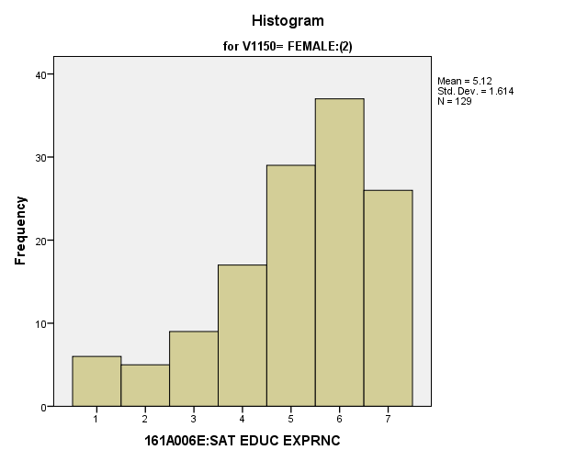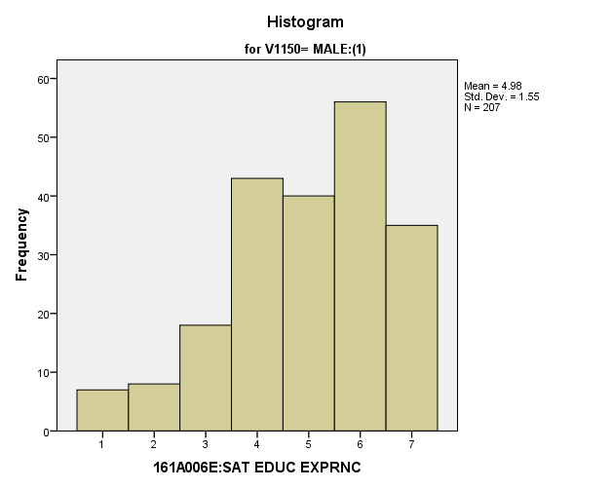

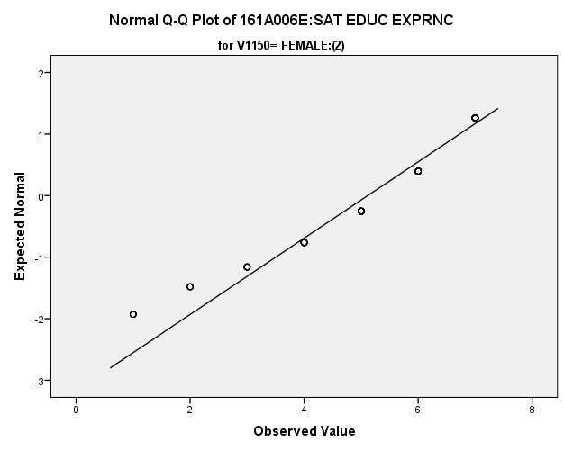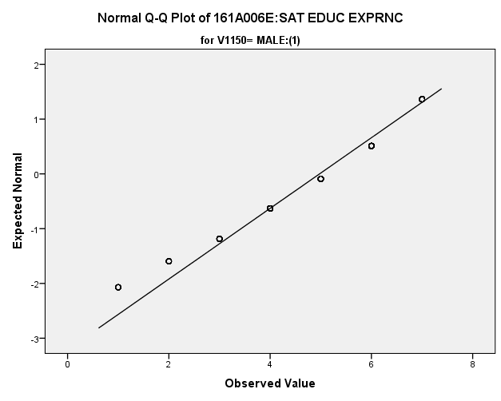

|  |  |  |  |  |  |
| --- | --- | --- | --- | --- | --- |
| *Primary Analysis:*  **Group Statistics** | | | | | |
|  | V1150 | N | Mean | Std. Deviation | Std. Error Mean |
| V1645 | MALE:(1) | **207** | **4.98** | **1.550** | **.108** |
| FEMALE:(2) | **129** | **5.12** | **1.614** | **.142** |

|  |  |  |  |  |  |  |
| --- | --- | --- | --- | --- | --- | --- |
| **Independent Samples Test** | | | | | | |
|  | | Levene's Test for Equality of Variances | | t-test for Equality of Means | | |
| F | Sig. | t | df | Sig. (2-tailed) |
|
| V1645 | Equal variances assumed | **.030** | **.863** | **-.795** | **334** | **.427** |
| Equal variances not assumed |  |  | **-.788** | **263.410** | **.432** |

|  |  |  |  |  |  |
| --- | --- | --- | --- | --- | --- |
| **Independent Samples Test** | | | | | |
|  | | t-test for Equality of Means | | | |
| Mean Difference | Std. Error Difference | 99% Confidence Interval of the Difference | |
| Lower | Upper |
| V1645 | Equal variances assumed | **-.140** | **.177** | **-.598** | **.317** |
| Equal variances not assumed | **-.140** | **.178** | **-.603** | **.322** |

**Satisfaction with Friends:** Within the potential recruit group, are there gender differences in how satisfied they are with their friends?

**Variables used:** The dependent variable was satisfaction with friends. The independent (grouping) variable was gender.

**Analysis Procedure:**

* A t-test was used to compare average rating of how satisfied students are with their friends, with students rating satisfaction on a scale from 1 to 7, with a higher number meaning more satisfaction, between the two gender groups (males versus females)
* Before conducting analysis, the distribution for how satisfied students are with their friends was checked separately for the two groups by means of visual inspection of histograms and Q-Q plots. No outliers were observed. However, the distribution was left skewed for both groups.
* The equality of variances assumption was tested. This assumption was met.

**Results:**

* Null and alternative hypothesis. H0: μ1 = μ2; Ha: μ1 ≠ μ2.
* Calculated t value: t = 1.524, df = 334, fail to reject H0, with a p-value of .129

**Interpretation:** There was not a significant difference between the two groups in how satisfied students are with their friends.

**Supporting Analysis:**

*Preliminary Analysis:*

|  |  |  |  |  |
| --- | --- | --- | --- | --- |
| ***Descriptives*** | | | | |
|  | 161C003:Rs SEX | | | Statistic |
| 161A006F:SAT OWN FRIENDS | MALE:(1) | Mean | | **5.98** |
| 99% Confidence Interval for Mean | Lower Bound | **5.87** |
| Upper Bound | **6.10** |
| 5% Trimmed Mean | | **6.12** |
| Median | | **6.00** |
| Variance | | **1.633** |
| Std. Deviation | | **1.278** |
| Minimum | | **1** |
| Maximum | | **7** |
| Range | | **6** |
| Interquartile Range | | **2** |
| Skewness | | **-1.343** |
| Kurtosis | | **1.512** |
| FEMALE:(2) | Mean | | **5.80** |
| 99% Confidence Interval for Mean | Lower Bound | **5.68** |
| Upper Bound | **5.92** |
| 5% Trimmed Mean | | **5.94** |
| Median | | **6.00** |
| Variance | | **1.974** |
| Std. Deviation | | **1.405** |
| Minimum | | **1** |
| Maximum | | **7** |
| Range | | **6** |
| Interquartile Range | | **2** |
| Skewness | | **-1.258** |
| Kurtosis | | **1.175** |

|  |  |  |  |  |
| --- | --- | --- | --- | --- |
| ***Descriptives*** | | | | |
|  | 161C003:Rs SEX | | | Std. Error |
| 161A006F:SAT OWN FRIENDS | MALE:(1) | Mean | | **.043** |
| 99% Confidence Interval for Mean | Lower Bound |  |
| Upper Bound |  |
| 5% Trimmed Mean | |  |
| Median | |  |
| Variance | |  |
| Std. Deviation | |  |
| Minimum | |  |
| Maximum | |  |
| Range | |  |
| Interquartile Range | |  |
| Skewness | | **.083** |
| Kurtosis | | **.165** |
| FEMALE:(2) | Mean | | **.046** |
| 99% Confidence Interval for Mean | Lower Bound |  |
| Upper Bound |  |
| 5% Trimmed Mean | |  |
| Median | |  |
| Variance | |  |
| Std. Deviation | |  |
| Minimum | |  |
| Maximum | |  |
| Range | |  |
| Interquartile Range | |  |
| Skewness | | **.080** |
| Kurtosis | | **.159** |

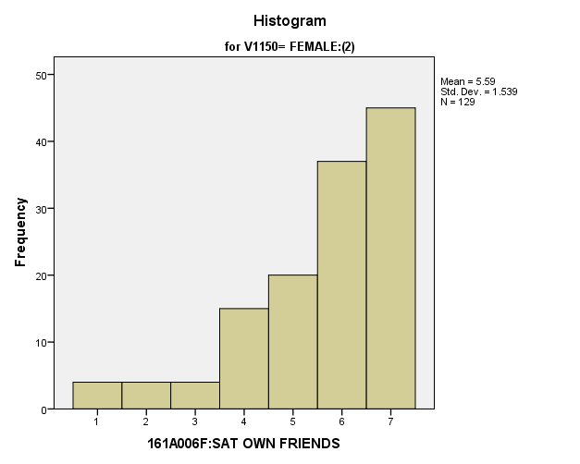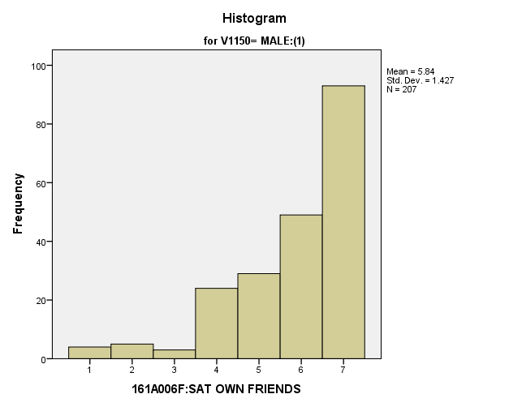

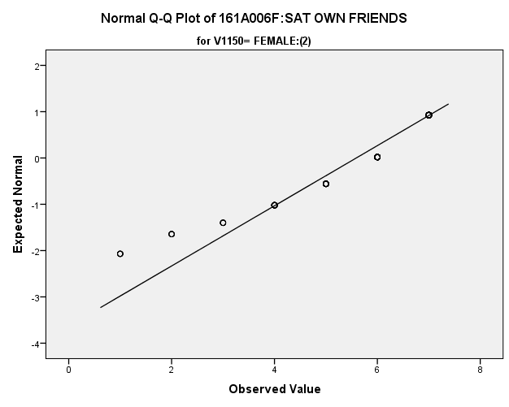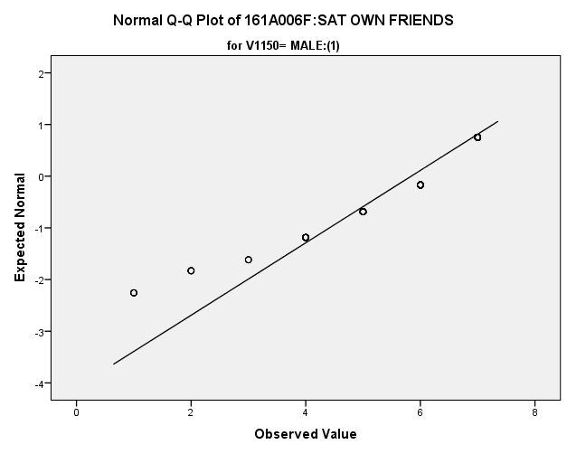

*Primary Analysis:*

|  |  |  |  |  |  |  |  |  |  |
| --- | --- | --- | --- | --- | --- | --- | --- | --- | --- |
| **Group Statistics** | | | | | | | | | |
|  | | V1150 | N | Mean | | Std. Deviation | | Std. Error Mean | |
| V1646 | | MALE:(1) | **207** | **5.84** | | **1.427** | | **.099** | |
| FEMALE:(2) | **129** | **5.59** | | **1.539** | | **.136** | |
| **Independent Samples Test** | | | | | | | | | | | | |
|  | | | | | Levene's Test for Equality of Variances | | | | t-test for Equality of Means | | | |
| F | | Sig. | | t | | df | Sig. (2-tailed) |
|
| V1646 | Equal variances assumed | | | | **1.028** | | **.311** | | **1.524** | | **334** | **.129** |
| Equal variances not assumed | | | |  | |  | | **1.497** | | **256.249** | **.136** |

|  |  |  |  |  |  |
| --- | --- | --- | --- | --- | --- |
| **Independent Samples Test** | | | | | |
|  | | t-test for Equality of Means | | | |
| Mean Difference | Std. Error Difference | 99% Confidence Interval of the Difference | |
| Lower | Upper |
| V1646 | Equal variances assumed | **.251** | **.165** | **-.176** | **.679** |
| Equal variances not assumed | **.251** | **.168** | **-.184** | **.687** |

**Satisfaction with Getting Along with Parents:** Within the potential recruit group, are there gender differences in how satisfied they are with how they get along with their parents?

**Variables used:** The dependent variable was satisfaction with getting along with parents, with students rating satisfaction on a scale from 1 to 7, with a higher number meaning more satisfaction. The independent (grouping) variable was sex (male or female).

**Analysis Procedure:**

* A t-test was used to compare average rating of variable was satisfaction with getting along with parents between the two gender groups (males versus females)
* Before conducting analysis, the distribution for satisfaction with getting along with parents was checked separately for the two groups by means of visual inspection of histograms and Q-Q plots. No outliers were observed.
* The equality of variances assumption was tested. This assumption was not met.

**Results:**

* Null and alternative hypothesis. H0: μ1 = μ2; Ha: μ1 ≠ μ2.
* Calculated t value: t = -.110, df = 326.12, fail to reject H0, with a p-value of .913

**Interpretation:** There was not a significant difference between the two groups in satisfaction with getting along with parents.

**Supporting Analysis:**

*Preliminary Analysis:*

|  |  |  |  |  |
| --- | --- | --- | --- | --- |
| ***Descriptives*** | | | | |
|  | 161C003:Rs SEX | | | Statistic |
| 161A006G:SAT GT ALNG PRN | MALE:(1) | Mean | | **5.49** |
| 99% Confidence Interval for Mean | Lower Bound | **5.34** |
| Upper Bound | **5.63** |
| 5% Trimmed Mean | | **5.65** |
| Median | | **6.00** |
| Variance | | **2.714** |
| Std. Deviation | | **1.647** |
| Minimum | | **1** |
| Maximum | | **7** |
| Range | | **6** |
| Interquartile Range | | **3** |
| Skewness | | **-1.121** |
| Kurtosis | | **.557** |
| FEMALE:(2) | Mean | | **5.27** |
| 99% Confidence Interval for Mean | Lower Bound | **5.13** |
| Upper Bound | **5.41** |
| 5% Trimmed Mean | | **5.41** |
| Median | | **6.00** |
| Variance | | **2.927** |
| Std. Deviation | | **1.711** |
| Minimum | | **1** |
| Maximum | | **7** |
| Range | | **6** |
| Interquartile Range | | **3** |
| Skewness | | **-.847** |
| Kurtosis | | **-.100** |

|  |  |  |  |  |
| --- | --- | --- | --- | --- |
| ***Descriptives*** | | | | |
|  | 161C003:Rs SEX | | | Std. Error |
| 161A006G:SAT GT ALNG PRN | MALE:(1) | Mean | | **.056** |
| 99% Confidence Interval for Mean | Lower Bound |  |
| Upper Bound |  |
| 5% Trimmed Mean | |  |
| Median | |  |
| Variance | |  |
| Std. Deviation | |  |
| Minimum | |  |
| Maximum | |  |
| Range | |  |
| Interquartile Range | |  |
| Skewness | | **.083** |
| Kurtosis | | **.165** |
| FEMALE:(2) | Mean | | **.056** |
| 99% Confidence Interval for Mean | Lower Bound |  |
| Upper Bound |  |
| 5% Trimmed Mean | |  |
| Median | |  |
| Variance | |  |
| Std. Deviation | |  |
| Minimum | |  |
| Maximum | |  |
| Range | |  |
| Interquartile Range | |  |
| Skewness | | **.080** |
| Kurtosis | | **.159** |

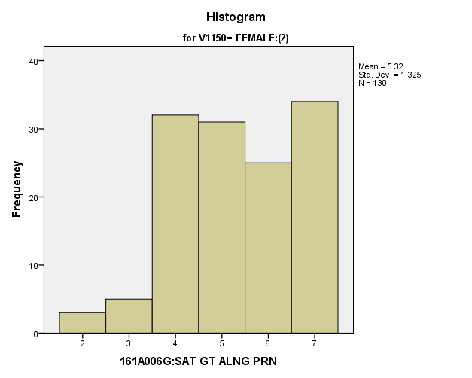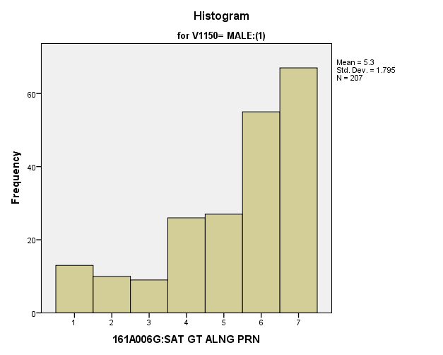

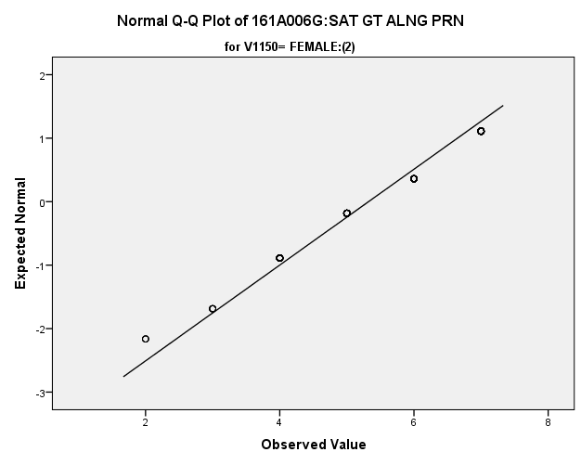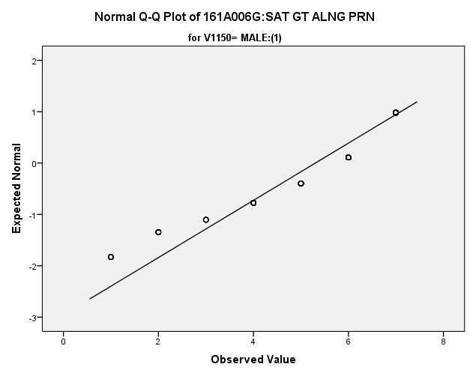

*Primary Analysis:*

|  |  |  |  |  |  |  |  |  |  |
| --- | --- | --- | --- | --- | --- | --- | --- | --- | --- |
| **Group Statistics** | | | | | | | | | |
|  | | V1150 | N | Mean | | Std. Deviation | | Std. Error Mean | |
| V1647 | | MALE:(1) | **207** | **5.30** | | **1.795** | | **.125** | |
| FEMALE:(2) | **130** | **5.32** | | **1.325** | | **.116** | |
| **Independent Samples Test** | | | | | | | | | | | | |
|  | | | | | Levene's Test for Equality of Variances | | | | t-test for Equality of Means | | | |
| F | | Sig. | | t | | df | Sig. (2-tailed) |
|
| V1647 | Equal variances assumed | | | | **10.530** | | **.001** | | **-.103** | | **335** | **.918** |
| Equal variances not assumed | | | |  | |  | | **-.110** | | **326.312** | **.913** |

|  |  |  |  |  |  |
| --- | --- | --- | --- | --- | --- |
| **Independent Samples Test** | | | | | |
|  | | t-test for Equality of Means | | | |
| Mean Difference | Std. Error Difference | 99% Confidence Interval of the Difference | |
| Lower | Upper |
| V1647 | Equal variances assumed | **-.019** | **.182** | **-.491** | **.454** |
| Equal variances not assumed | **-.019** | **.170** | **-.460** | **.423** |

**Satisfaction with Yourself:** Within the potential recruit group, are there gender differences in how satisfied they are with themselves?

**Variables used:** The dependent variable was satisfaction with yourself, with students rating satisfaction on a scale of 1 to 7, with a higher number meaning more satisfaction. The independent (grouping) variable was sex (male or female).

**Analysis Procedure:**

* A t-test was used to compare average rating of how satisfied students were with themselves between the two gender groups (males versus females)
* Before conducting analysis, the distribution for was checked separately for the two groups by means of visual inspection of histograms and Q-Q plots. No outliers were observed. However, the distribution was left skewed for both groups.
* The equality of variances assumption was tested. This assumption was not met.

**Results:**

* Null and alternative hypothesis. H0: μ1 = μ2; Ha: μ1 ≠ μ2.
* Calculated t value: t = 2.319, df = 251.915, fail to reject H0, with a p-value of .024

**Interpretation:** There was not a significant difference between the two groups in how satisfied students were with themselves.

**Supporting Analysis:**

*Preliminary Analysis:*

|  |  |  |  |  |
| --- | --- | --- | --- | --- |
| ***Descriptives*** | | | | |
|  | 161C003:Rs SEX | | | Statistic |
| 161A006H:SAT YOURSELF | MALE:(1) | Mean | | **5.34** |
| 99% Confidence Interval for Mean | Lower Bound | **5.20** |
| Upper Bound | **5.49** |
| 5% Trimmed Mean | | **5.48** |
| Median | | **6.00** |
| Variance | | **2.856** |
| Std. Deviation | | **1.690** |
| Minimum | | **1** |
| Maximum | | **7** |
| Range | | **6** |
| Interquartile Range | | **3** |
| Skewness | | **-.862** |
| Kurtosis | | **-.062** |
| FEMALE:(2) | Mean | | **5.01** |
| 99% Confidence Interval for Mean | Lower Bound | **4.85** |
| Upper Bound | **5.16** |
| 5% Trimmed Mean | | **5.12** |
| Median | | **5.00** |
| Variance | | **3.364** |
| Std. Deviation | | **1.834** |
| Minimum | | **1** |
| Maximum | | **7** |
| Range | | **6** |
| Interquartile Range | | **3** |
| Skewness | | **-.655** |
| Kurtosis | | **-.608** |

|  |  |  |  |  |
| --- | --- | --- | --- | --- |
| ***Descriptives*** | | | | |
|  | 161C003:Rs SEX | | | Std. Error |
| 161A006H:SAT YOURSELF | MALE:(1) | Mean | | **.057** |
| 99% Confidence Interval for Mean | Lower Bound |  |
| Upper Bound |  |
| 5% Trimmed Mean | |  |
| Median | |  |
| Variance | |  |
| Std. Deviation | |  |
| Minimum | |  |
| Maximum | |  |
| Range | |  |
| Interquartile Range | |  |
| Skewness | | **.083** |
| Kurtosis | | **.165** |
| FEMALE:(2) | Mean | | **.060** |
| 99% Confidence Interval for Mean | Lower Bound |  |
| Upper Bound |  |
| 5% Trimmed Mean | |  |
| Median | |  |
| Variance | |  |
| Std. Deviation | |  |
| Minimum | |  |
| Maximum | |  |
| Range | |  |
| Interquartile Range | |  |
| Skewness | | **.080** |
| Kurtosis | | **.159** |

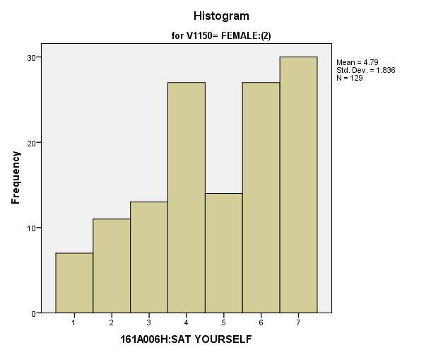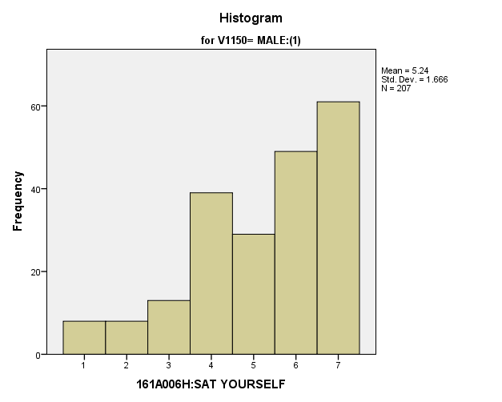

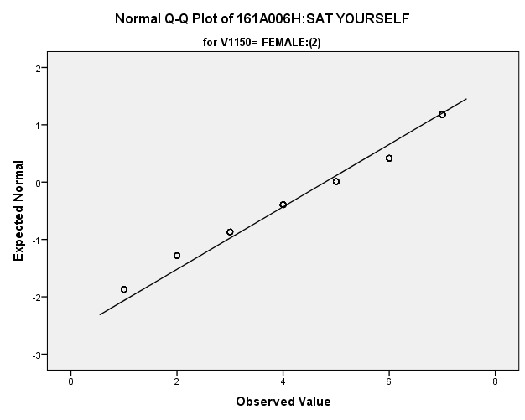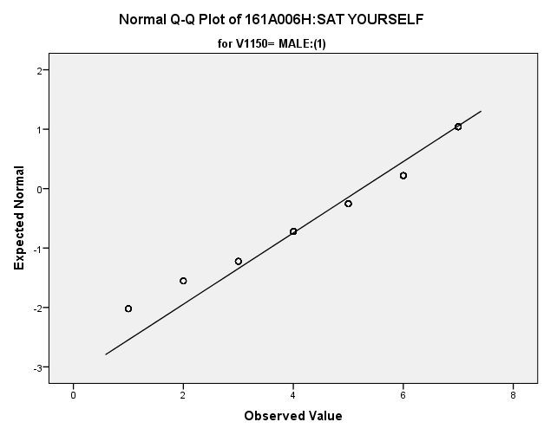

*Primary Analysis:*

|  |  |  |  |  |  |  |  |  |  |
| --- | --- | --- | --- | --- | --- | --- | --- | --- | --- |
| **Group Statistics** | | | | | | | | | |
|  | | V1150 | N | Mean | | Std. Deviation | | Std. Error Mean | |
| V1648 | | MALE:(1) | **207** | **5.24** | | **1.666** | | **.116** | |
| FEMALE:(2) | **129** | **4.79** | | **1.836** | | **.162** | |
| **Independent Samples Test** | | | | | | | | | | | | |
|  | | | | | Levene's Test for Equality of Variances | | | | t-test for Equality of Means | | | |
| F | | Sig. | | t | | df | Sig. (2-tailed) |
|
| V1648 | Equal variances assumed | | | | **3.219** | | **.074** | | **2.319** | | **334** | **.021** |
| Equal variances not assumed | | | |  | |  | | **2.267** | | **251.915** | **.024** |

|  |  |  |  |  |  |
| --- | --- | --- | --- | --- | --- |
| **Independent Samples Test** | | | | | |
|  | | t-test for Equality of Means | | | |
| Mean Difference | Std. Error Difference | 99% Confidence Interval of the Difference | |
| Lower | Upper |
| V1648 | Equal variances assumed | **.451** | **.194** | **-.053** | **.955** |
| Equal variances not assumed | **.451** | **.199** | **-.065** | **.967** |

**Satisfaction with Standard of Living:** Within the potential recruit group, are there gender differences in how satisfied they are with their standard of living?

**Variables used:** The dependent variable was satisfaction with their standard of living, with students rating satisfaction on a scale of 1 to 7, with a higher number meaning more satisfaction. The independent (grouping) variable was sex (male or female).

**Analysis Procedure:**

* A t-test was used to compare average rating of how satisfied students are with their standard of living between the two gender groups (males versus females)
* Before conducting analysis, the distribution was checked separately for the two groups by means of visual inspection of histograms and Q-Q plots. No outliers were observed. However, the distribution was left skewed for both groups.
* The equality of variances assumption was tested. This assumption was met.

**Results:**

* Null and alternative hypothesis. H0: μ1 = μ2; Ha: μ1 ≠ μ2.
* Calculated t value: t = 1.250, df = 1818, fail to reject H0, with a p-value of .211

**Interpretation:** There is not a significant difference between the two groups in how satisfied students are with their standard of living based on their gender.

**Supporting Analysis:**

*Preliminary Analysis:*

|  |  |  |  |  |
| --- | --- | --- | --- | --- |
| ***Descriptives*** | | | | |
|  | 161C003:Rs SEX | | | Statistic |
| 161A006I:SAT STD OF LVG | MALE:(1) | Mean | | **5.71** |
| 99% Confidence Interval for Mean | Lower Bound | **5.58** |
| Upper Bound | **5.84** |
| 5% Trimmed Mean | | **5.87** |
| Median | | **6.00** |
| Variance | | **2.262** |
| Std. Deviation | | **1.504** |
| Minimum | | **1** |
| Maximum | | **7** |
| Range | | **6** |
| Interquartile Range | | **2** |
| Skewness | | **-1.235** |
| Kurtosis | | **.952** |
| FEMALE:(2) | Mean | | **5.63** |
| 99% Confidence Interval for Mean | Lower Bound | **5.50** |
| Upper Bound | **5.75** |
| 5% Trimmed Mean | | **5.76** |
| Median | | **6.00** |
| Variance | | **2.215** |
| Std. Deviation | | **1.488** |
| Minimum | | **1** |
| Maximum | | **7** |
| Range | | **6** |
| Interquartile Range | | **2** |
| Skewness | | **-.997** |
| Kurtosis | | **.315** |

|  |  |  |  |  |
| --- | --- | --- | --- | --- |
| ***Descriptives*** | | | | |
|  | 161C003:Rs SEX | | | Std. Error |
| 161A006I:SAT STD OF LVG | MALE:(1) | Mean | | **.051** |
| 99% Confidence Interval for Mean | Lower Bound |  |
| Upper Bound |  |
| 5% Trimmed Mean | |  |
| Median | |  |
| Variance | |  |
| Std. Deviation | |  |
| Minimum | |  |
| Maximum | |  |
| Range | |  |
| Interquartile Range | |  |
| Skewness | | **.083** |
| Kurtosis | | **.165** |
| FEMALE:(2) | Mean | | **.048** |
| 99% Confidence Interval for Mean | Lower Bound |  |
| Upper Bound |  |
| 5% Trimmed Mean | |  |
| Median | |  |
| Variance | |  |
| Std. Deviation | |  |
| Minimum | |  |
| Maximum | |  |
| Range | |  |
| Interquartile Range | |  |
| Skewness | | **.080** |
| Kurtosis | | **.159** |

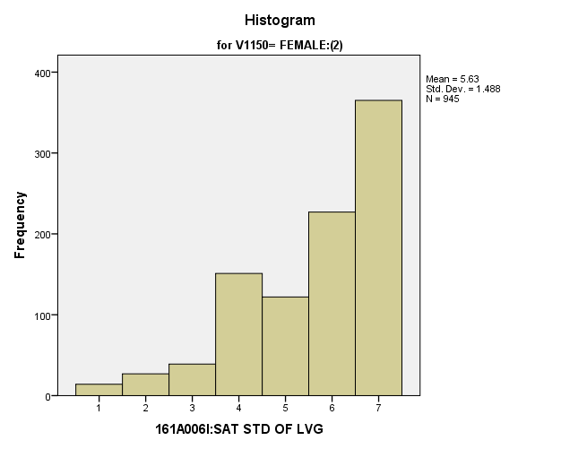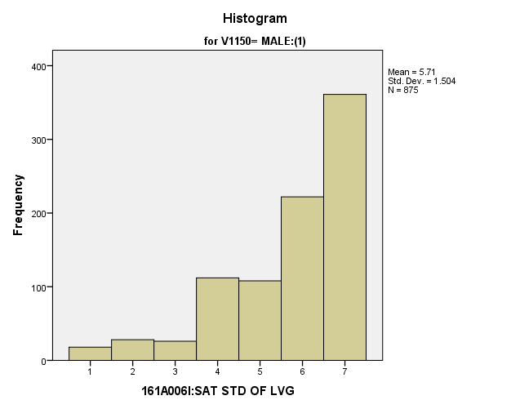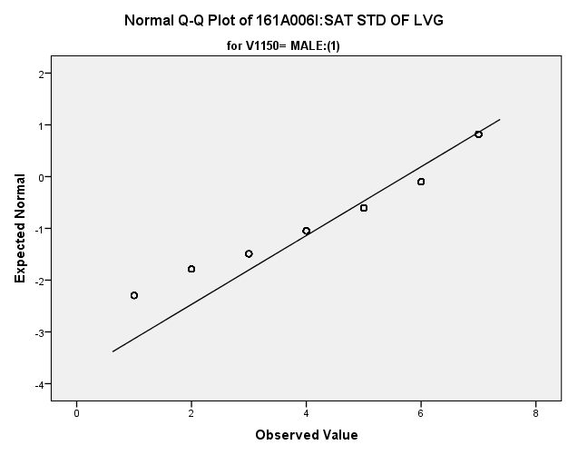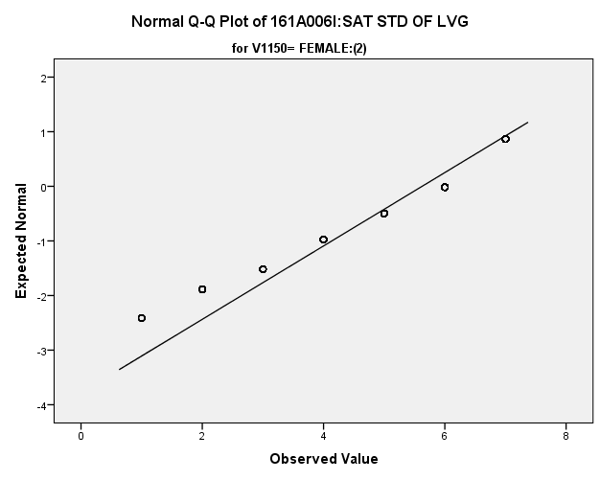

*Primary Analysis:*

|  |  |  |  |  |  |
| --- | --- | --- | --- | --- | --- |
| ***Group Statistics*** | | | | | |
|  | 161C003:Rs SEX | N | Mean | Std. Deviation | Std. Error Mean |
| 161A006I:SAT STD OF LVG | MALE:(1) | **875** | **5.71** | **1.504** | **.051** |
| FEMALE:(2) | **945** | **5.63** | **1.488** | **.048** |

|  |  |  |  |  |
| --- | --- | --- | --- | --- |
| ***Independent Samples Test*** | | | | |
|  | | Levene's Test for Equality of Variances | | t-test for Equality of Means |
| F | Sig. | t |
|
| 161A006I:SAT STD OF LVG | Equal variances assumed | **.733** | **.392** | **1.250** |
| Equal variances not assumed |  |  | **1.250** |

|  |  |  |  |  |
| --- | --- | --- | --- | --- |
| ***Independent Samples Test*** | | | | |
|  | | t-test for Equality of Means | | |
| df | Sig. (2-tailed) | Mean Difference |
|
| 161A006I:SAT STD OF LVG | Equal variances assumed | **1818** | **.211** | **.088** |
| Equal variances not assumed | **1804.215** | **.212** | **.088** |

|  |  |  |  |  |
| --- | --- | --- | --- | --- |
| ***Independent Samples Test*** | | | | |
|  | | t-test for Equality of Means | | |
| Std. Error Difference | 99% Confidence Interval of the Difference | |
| Lower | Upper |
| 161A006I:SAT STD OF LVG | Equal variances assumed | **.070** | **-.093** | **.269** |
| Equal variances not assumed | **.070** | **-.093** | **.269** |

**Satisfaction with Amount of Free Time:** Within the potential recruit group, are there gender differences in how satisfied they are with the amount of time they have for doing things that they like?

**Variables used:** The dependent variable was satisfaction with amount of free time, with students rating satisfaction on a scale of 1 to 7, with a higher number meaning more satisfaction. The independent (grouping) variable was sex (male or female).

**Analysis Procedure:**

* A t-test was used to compare average rating of how satisfied students are with the amount of free time they have between the two gender groups (males versus females)
* Before conducting analysis, the distribution for how satisfied students are with the amount of free time they have was checked separately for the two groups by means of visual inspection of histograms and Q-Q plots. No outliers were observed. However, the distribution was similarly skewed for both groups.
* The equality of variances assumption was tested. This assumption was met.
* Eta Squared was calculated to assess effect size.

**Results:**

* Null and alternative hypothesis. H0: μ1 = μ2; Ha: μ1 ≠ μ2.
* Calculated t value: t = 2.666, df = 331, reject H0, with a p-value of .008; Eta Squared = .021

**Interpretation:** There is a significant difference between the two groups in how satisfied students are with the amount of free time they have. Furthermore, 2.1% of how satisfied students are with the amount of free time they have is explained by their sex.

**Supporting Analysis:**

*Preliminary Analysis:*

|  |  |  |  |  |
| --- | --- | --- | --- | --- |
| ***Descriptives*** | | | | |
|  | 161C003:Rs SEX | | | Statistic |
| 161A006J:SAT TIME FR THG | MALE:(1) | Mean | | **4.86** |
| 99% Confidence Interval for Mean | Lower Bound | **4.71** |
| Upper Bound | **5.02** |
| 5% Trimmed Mean | | **4.96** |
| Median | | **5.00** |
| Variance | | **3.108** |
| Std. Deviation | | **1.763** |
| Minimum | | **1** |
| Maximum | | **7** |
| Range | | **6** |
| Interquartile Range | | **2** |
| Skewness | | **-.520** |
| Kurtosis | | **-.673** |
| FEMALE:(2) | Mean | | **4.44** |
| 99% Confidence Interval for Mean | Lower Bound | **4.29** |
| Upper Bound | **4.59** |
| 5% Trimmed Mean | | **4.49** |
| Median | | **5.00** |
| Variance | | **3.333** |
| Std. Deviation | | **1.826** |
| Minimum | | **1** |
| Maximum | | **7** |
| Range | | **6** |
| Interquartile Range | | **3** |
| Skewness | | **-.281** |
| Kurtosis | | **-.877** |

|  |  |  |  |  |
| --- | --- | --- | --- | --- |
| ***Descriptives*** | | | | |
|  | 161C003:Rs SEX | | | Std. Error |
| 161A006J:SAT TIME FR THG | MALE:(1) | Mean | | **.060** |
| 99% Confidence Interval for Mean | Lower Bound |  |
| Upper Bound |  |
| 5% Trimmed Mean | |  |
| Median | |  |
| Variance | |  |
| Std. Deviation | |  |
| Minimum | |  |
| Maximum | |  |
| Range | |  |
| Interquartile Range | |  |
| Skewness | | **.083** |
| Kurtosis | | **.165** |
| FEMALE:(2) | Mean | | **.059** |
| 99% Confidence Interval for Mean | Lower Bound |  |
| Upper Bound |  |
| 5% Trimmed Mean | |  |
| Median | |  |
| Variance | |  |
| Std. Deviation | |  |
| Minimum | |  |
| Maximum | |  |
| Range | |  |
| Interquartile Range | |  |
| Skewness | | **.080** |
| Kurtosis | | **.159** |

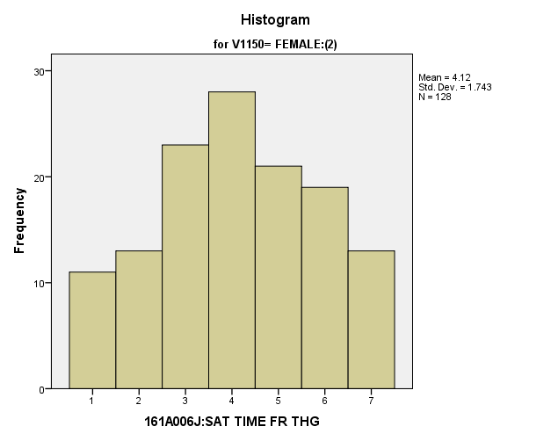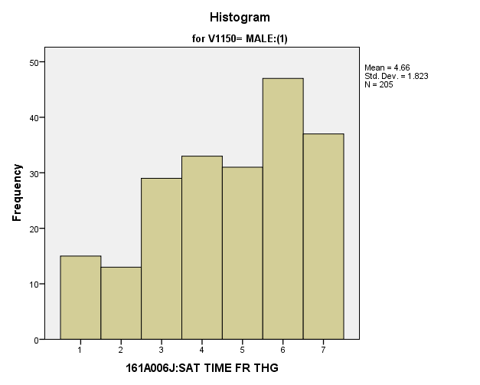

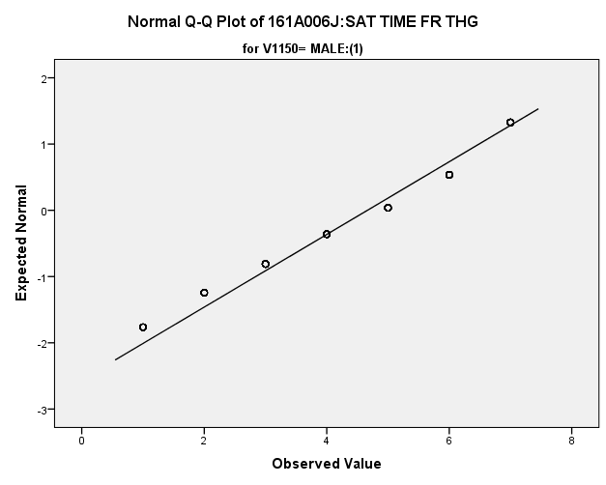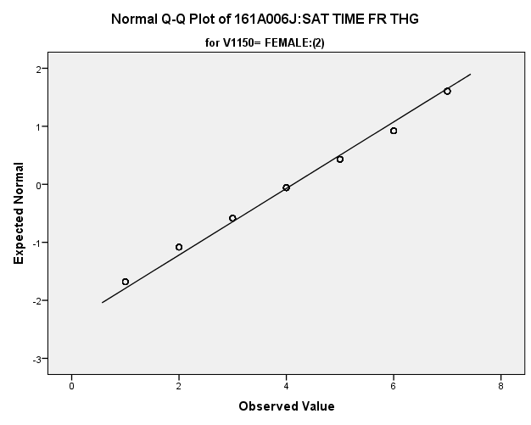

*Primary Analysis:*

|  |  |  |  |  |  |  |  |  |  |
| --- | --- | --- | --- | --- | --- | --- | --- | --- | --- |
| **Group Statistics** | | | | | | | | | |
|  | | V1150 | N | Mean | | Std. Deviation | | Std. Error Mean | |
| V1650 | | MALE:(1) | **205** | **4.66** | | **1.823** | | **.127** | |
| FEMALE:(2) | **128** | **4.13** | | **1.743** | | **.154** | |
| **Independent Samples Test** | | | | | | | | | | | | |
|  | | | | | Levene's Test for Equality of Variances | | | | t-test for Equality of Means | | | |
| F | | Sig. | | t | | df | Sig. (2-tailed) |
|
| V1650 | Equal variances assumed | | | | **1.453** | | **.229** | | **2.666** | | **331** | **.008** |
| Equal variances not assumed | | | |  | |  | | **2.694** | | **278.700** | **.007** |

|  |  |  |  |  |  |  |  |  |
| --- | --- | --- | --- | --- | --- | --- | --- | --- |
| **Independent Samples Test** | | | | | | | | |
|  | | | | t-test for Equality of Means | | | | |
| Mean Difference | | Std. Error Difference | 99% Confidence Interval of the Difference | |
| Lower | Upper |
| V1650 | Equal variances assumed | | | **.538** | | **.202** | **.015** | **1.062** |
| Equal variances not assumed | | | **.538** | | **.200** | **.020** | **1.057** |
| **Measures of Association** | | | | |
|  | | Eta | Eta Squared | |
| V1650 * V1150 | | **.145** | **.021** | |

**Satisfaction with Leisure Time:** Within the potential recruit group, are there gender differences in how satisfied they are spending their leisure time?

**Variables used:** The dependent variable was satisfaction with leisure time, with students rating satisfaction on a scale of 1 to 7, with a higher number meaning more satisfaction. The independent (grouping) variable was sex (male or female).

**Analysis Procedure:**

* A t-test was used to compare average rating of how satisfied students are with their leisure time between the two gender groups (males versus females)
* Before conducting analysis, the distribution for how satisfied students are with their leisure time was checked separately for the two groups by means of visual inspection of histograms and Q-Q plots. No outliers were observed.
* The equality of variances assumption was tested. This assumption was met.
* Eta Squared was calculated to assess effect size.

**Results:**

* Null and alternative hypothesis. H0: μ1 = μ2; Ha: μ1 ≠ μ2.
* Calculated t value: t = 3.593, df =333, reject H0, with a p-value of .000; Eta squared = .037

**Interpretation:** There is a significant difference between the two groups in how satisfied students are with their leisure time. Furthermore, 3.7% of how satisfied students are with their leisure time is due to their sex.

**Supporting Analysis:**

*Preliminary Analysis:*

|  |  |  |  |  |
| --- | --- | --- | --- | --- |
| ***Descriptives*** | | | | |
|  | 161C003:Rs SEX | | | Statistic |
| 161A006K:SAT SPD LEISR | MALE:(1) | Mean | | **5.43** |
| 99% Confidence Interval for Mean | Lower Bound | **5.30** |
| Upper Bound | **5.56** |
| 5% Trimmed Mean | | **5.56** |
| Median | | **6.00** |
| Variance | | **2.337** |
| Std. Deviation | | **1.529** |
| Minimum | | **1** |
| Maximum | | **7** |
| Range | | **6** |
| Interquartile Range | | **3** |
| Skewness | | **-.837** |
| Kurtosis | | **.008** |
| FEMALE:(2) | Mean | | **5.05** |
| 99% Confidence Interval for Mean | Lower Bound | **4.91** |
| Upper Bound | **5.19** |
| 5% Trimmed Mean | | **5.14** |
| Median | | **5.00** |
| Variance | | **2.756** |
| Std. Deviation | | **1.660** |
| Minimum | | **1** |
| Maximum | | **7** |
| Range | | **6** |
| Interquartile Range | | **3** |
| Skewness | | **-.520** |
| Kurtosis | | **-.606** |

|  |  |  |  |  |
| --- | --- | --- | --- | --- |
| ***Descriptives*** | | | | |
|  | 161C003:Rs SEX | | | Std. Error |
| 161A006K:SAT SPD LEISR | MALE:(1) | Mean | | **.052** |
| 99% Confidence Interval for Mean | Lower Bound |  |
| Upper Bound |  |
| 5% Trimmed Mean | |  |
| Median | |  |
| Variance | |  |
| Std. Deviation | |  |
| Minimum | |  |
| Maximum | |  |
| Range | |  |
| Interquartile Range | |  |
| Skewness | | **.083** |
| Kurtosis | | **.165** |
| FEMALE:(2) | Mean | | **.054** |
| 99% Confidence Interval for Mean | Lower Bound |  |
| Upper Bound |  |
| 5% Trimmed Mean | |  |
| Median | |  |
| Variance | |  |
| Std. Deviation | |  |
| Minimum | |  |
| Maximum | |  |
| Range | |  |
| Interquartile Range | |  |
| Skewness | | **.080** |
| Kurtosis | | **.159** |

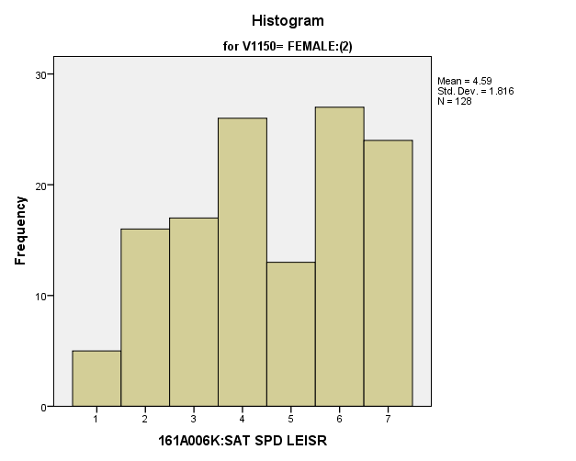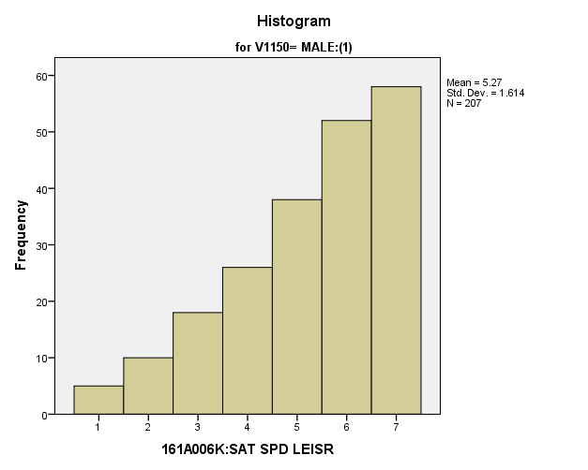

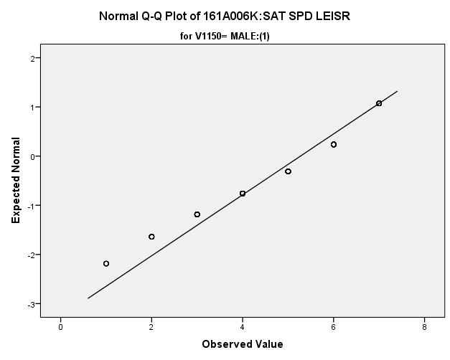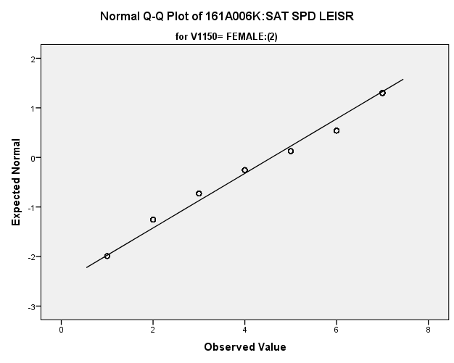

*Primary Analysis:*

|  |  |  |  |  |  |
| --- | --- | --- | --- | --- | --- |
| **Group Statistics** | | | | | |
|  | V1150 | N | Mean | Std. Deviation | Std. Error Mean |
| V1651 | MALE:(1) | **207** | **5.27** | **1.614** | **.112** |
| FEMALE:(2) | **128** | **4.59** | **1.816** | **.161** |

|  |  |  |  |  |  |  |  |  |  |  |  |  |  |  |
| --- | --- | --- | --- | --- | --- | --- | --- | --- | --- | --- | --- | --- | --- | --- |
| **Independent Samples Test** | | | | | | | | | | | | | | |
|  | | | | | Levene's Test for Equality of Variances | | | | | t-test for Equality of Means | | | | |
| F | | | Sig. | | t | | df | Sig. (2-tailed) | |
|
| V1651 | Equal variances assumed | | | | **6.233** | | | **.013** | | **3.593** | | **333** | **.000** | |
| Equal variances not assumed | | | |  | | |  | | **3.495** | | **245.274** | **.001** | |
| **Independent Samples Test** | | | | | | | | | | | | | | | |
|  | | | | | | t-test for Equality of Means | | | | | | | | | |
| Mean Difference | | | Std. Error Difference | | 99% Confidence Interval of the Difference | | | | |
| Lower | | | Upper | |
| V1651 | | Equal variances assumed | | | | **.685** | | | **.191** | | **.191** | | | **1.178** | |
| Equal variances not assumed | | | | **.685** | | | **.196** | | **.176** | | | **1.193** | |
| **Measures of Association** | | | | | | |
|  | | | Eta | Eta Squared | | |
| V1651 * V1150 | | | **.193** | **.037** | | |

**Satisfaction with Life:** Within the potential recruit group, are there gender differences in how satisfied are they are with life?

**Variables used:** The dependent variable was satisfaction with life, with students rating satisfaction on a scale of 1 to 7, with a higher number meaning more satisfaction. The independent (grouping) variable was sex (male or female).

**Analysis Procedure:**

* A t-test was used to compare average rating of how satisfied students are with life between the two gender groups (males versus females)
* Before conducting analysis, the distribution for how satisfied students are with life was checked separately for the two groups by means of visual inspection of histograms and Q-Q plots. No outliers were observed. The equality of variances assumption was tested. This assumption was met.

**Results:**

* Null and alternative hypothesis. H0: μ1 = μ2; Ha: μ1 ≠ μ2.
* Calculated t value: t = 2.354, df = 332, fail to reject H0, with a p-value of .019

**Interpretation:** There is a significant difference between the two groups in how satisfied students are with life.

**Supporting Analysis:**

*Preliminary Analysis:*

|  |  |  |  |  |
| --- | --- | --- | --- | --- |
| ***Descriptives*** | | | | |
|  | 161C003:Rs SEX | | | Statistic |
| 161A006L:SAT LIFE AS WHL | MALE:(1) | Mean | | **5.28** |
| 99% Confidence Interval for Mean | Lower Bound | **5.14** |
| Upper Bound | **5.41** |
| 5% Trimmed Mean | | **5.39** |
| Median | | **6.00** |
| Variance | | **2.248** |
| Std. Deviation | | **1.499** |
| Minimum | | **1** |
| Maximum | | **7** |
| Range | | **6** |
| Interquartile Range | | **2** |
| Skewness | | **-.754** |
| Kurtosis | | **.030** |
| FEMALE:(2) | Mean | | **4.93** |
| 99% Confidence Interval for Mean | Lower Bound | **4.79** |
| Upper Bound | **5.06** |
| 5% Trimmed Mean | | **5.01** |
| Median | | **5.00** |
| Variance | | **2.516** |
| Std. Deviation | | **1.586** |
| Minimum | | **1** |
| Maximum | | **7** |
| Range | | **6** |
| Interquartile Range | | **2** |
| Skewness | | **-.578** |
| Kurtosis | | **-.310** |

|  |  |  |  |  |
| --- | --- | --- | --- | --- |
| ***Descriptives*** | | | | |
|  | 161C003:Rs SEX | | | Std. Error |
| 161A006L:SAT LIFE AS WHL | MALE:(1) | Mean | | **.051** |
| 99% Confidence Interval for Mean | Lower Bound |  |
| Upper Bound |  |
| 5% Trimmed Mean | |  |
| Median | |  |
| Variance | |  |
| Std. Deviation | |  |
| Minimum | |  |
| Maximum | |  |
| Range | |  |
| Interquartile Range | |  |
| Skewness | | **.083** |
| Kurtosis | | **.166** |
| FEMALE:(2) | Mean | | **.052** |
| 99% Confidence Interval for Mean | Lower Bound |  |
| Upper Bound |  |
| 5% Trimmed Mean | |  |
| Median | |  |
| Variance | |  |
| Std. Deviation | |  |
| Minimum | |  |
| Maximum | |  |
| Range | |  |
| Interquartile Range | |  |
| Skewness | | **.080** |
| Kurtosis | | **.159** |

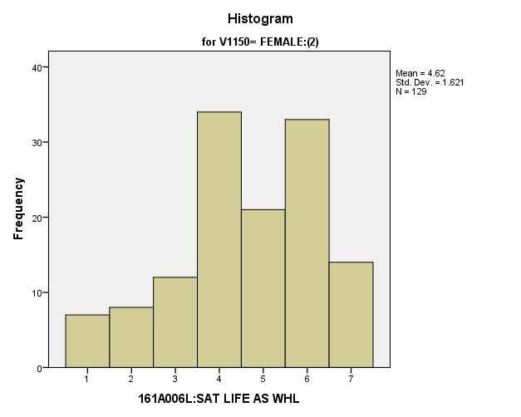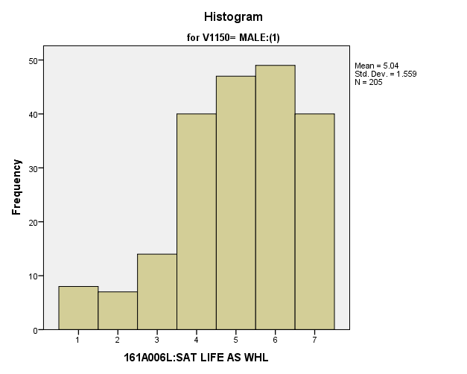

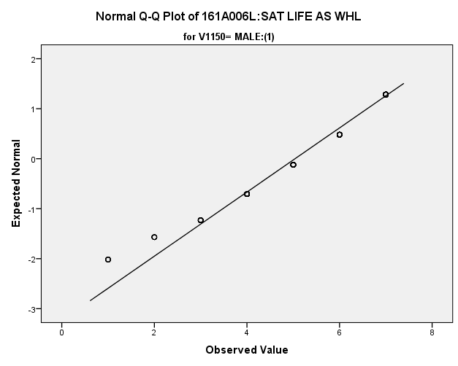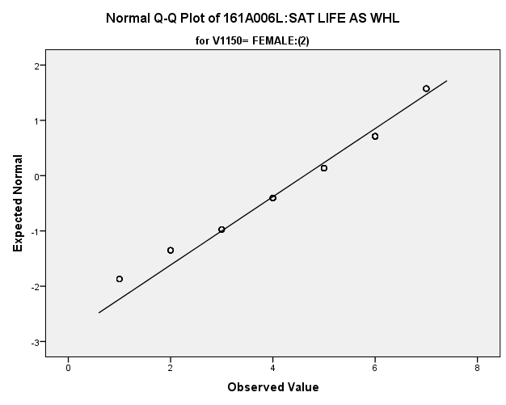

|  |  |  |  |  |  |  |  |  |  |
| --- | --- | --- | --- | --- | --- | --- | --- | --- | --- |
| *Primary Analysis:*  **Group Statistics** | | | | | | | | | |
|  | | V1150 | N | Mean | | Std. Deviation | | Std. Error Mean | |
| V1652 | | MALE:(1) | **205** | **5.04** | | **1.559** | | **.109** | |
| FEMALE:(2) | **129** | **4.62** | | **1.621** | | **.143** | |
| **Independent Samples Test** | | | | | | | | | | | | |
|  | | | | | Levene's Test for Equality of Variances | | | | t-test for Equality of Means | | | |
| F | | Sig. | | t | | df | Sig. (2-tailed) |
|
| V1652 | Equal variances assumed | | | | **1.335** | | **.249** | | **2.354** | | **332** | **.019** |
| Equal variances not assumed | | | |  | |  | | **2.333** | | **264.165** | **.020** |

|  |  |  |  |  |  |
| --- | --- | --- | --- | --- | --- |
| **Independent Samples Test** | | | | | |
|  | | t-test for Equality of Means | | | |
| Mean Difference | Std. Error Difference | 99% Confidence Interval of the Difference | |
| Lower | Upper |
| V1652 | Equal variances assumed | **.419** | **.178** | **-.042** | **.880** |
| Equal variances not assumed | **.419** | **.180** | **-.047** | **.885** |

**Satisfaction with Government:** Within the potential recruit group, are there gender differences in how satisfied they are with the government?

**Variables used:** The dependent variable was satisfaction with the government, with students rating satisfaction on a scale of 1 to 7, with a higher number meaning more satisfaction. The independent (grouping) variable was sex (male or female).

**Analysis Procedure:**

* A t-test was used to compare average rating of how satisfied students are with the way the government is operating between the two gender groups (males versus females)
* Before conducting analysis, the distribution for satisfaction with the government was checked separately for the two groups by means of visual inspection of histograms and Q-Q plots. No outliers were observed. However, the distribution of how satisfied students are with the government was similarly skewed for both groups.
* The equality of variances assumption was tested. This assumption was met.

**Results:**

* Null and alternative hypothesis. H0: μ1 = μ2; Ha: μ1 ≠ μ2.
* Calculated t value: t = 1.019, df = 332, fail to reject H0, with a p-value or .309

**Interpretation:** There is not a significant difference between the two groups in satisfaction with the way the government is operating.

**Supporting Analysis:**

*Preliminary Analysis:*

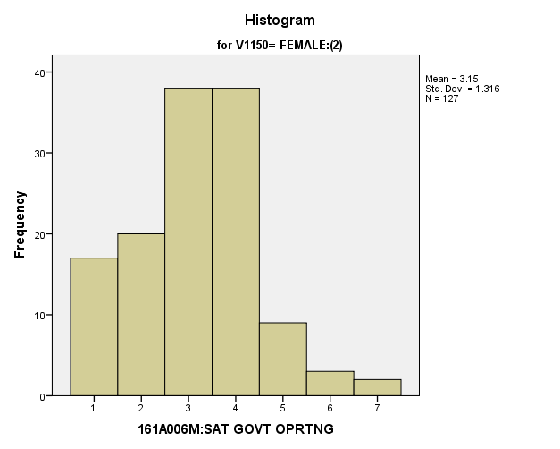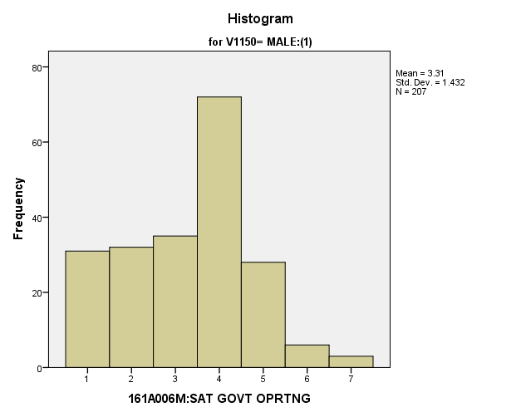

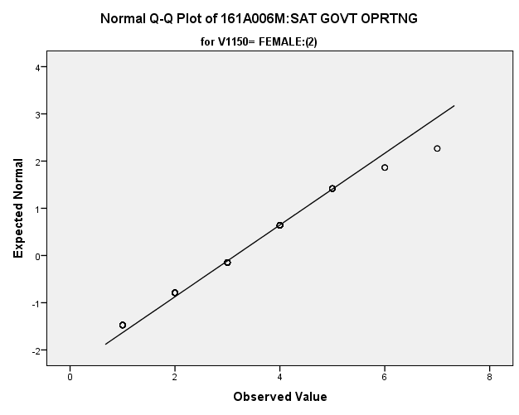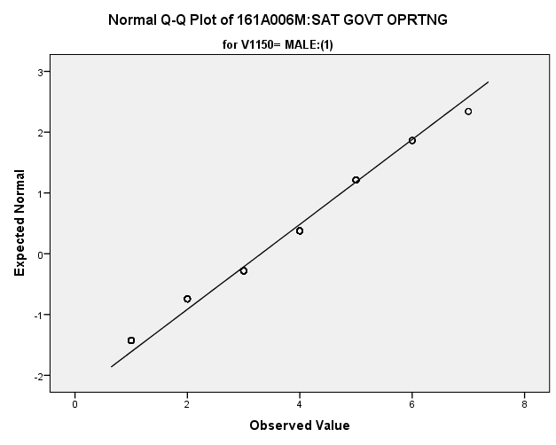

*Primary Analysis:*

|  |  |  |  |  |  |
| --- | --- | --- | --- | --- | --- |
| ***Group Statistics*** | | | | | |
|  | V1150 | N | Mean | Std. Deviation | Std. Error Mean |
| V1653 | MALE:(1) | **207** | **3.31** | **1.432** | **.100** |
| FEMALE:(2) | **127** | **3.15** | **1.316** | **.117** |

|  |  |  |  |  |  |
| --- | --- | --- | --- | --- | --- |
| ***Independent Samples Test*** | | | | | |
|  | | Levene's Test for Equality of Variances | | t-test for Equality of Means | |
| F | Sig. | t | df |
|
| V1653 | Equal variances assumed | **3.801** | **.052** | **1.019** | **332** |
| Equal variances not assumed |  |  | **1.040** | **283.890** |

|  |  |  |  |  |  |
| --- | --- | --- | --- | --- | --- |
| ***Independent Samples Test*** | | | | | |
|  | | t-test for Equality of Means | | | |
| Sig. (2-tailed) | Mean Difference | Std. Error Difference | 99% Confidence Interval of the Difference |
| Lower |
| V1653 | Equal variances assumed | **.309** | **.160** | **.157** | **-.246** |
| Equal variances not assumed | **.299** | **.160** | **.153** | **-.238** |

|  |  |  |
| --- | --- | --- |
| ***Independent Samples Test*** | | |
|  | | t-test for Equality of Means |
| 99% Confidence Interval of the Difference |
| Upper |
| V1653 | Equal variances assumed | **.565** |
| Equal variances not assumed | **.557** |

**Satisfaction with Amount of Fun:** Within the potential recruit group, are there gender differences in how satisfied they are with the amount of fun they have?

**Variables used:** The dependent variable was satisfaction with amount of fun, with students rating satisfaction on a scale of 1 to 7, with a higher number meaning more satisfaction. The independent (grouping) variable was sex (male or female).

**Analysis Procedure:**

* A t-test was used to compare average rating of how satisfied students are with the amount of fun they have between the two gender groups (males versus females)
* Before conducting analysis, the distribution for how satisfied students are with the amount of fun they have was checked separately for the two groups by means of visual inspection of histograms and Q-Q plots. No outliers were observed. However, the distribution was similarly skewed for both groups.
* The equality of variances assumption was tested. This assumption was met.
* Eta Squared was calculated to assess effect size.

**Results:**

* Null and alternative hypothesis. H0: μ1 = μ2; Ha: μ1 ≠ μ2.
* Calculated t value: t = 2.447, df = 335, reject H0, with a p-value of .001; Eta Squared = .034

**Interpretation:** There is a significant difference between the two groups in how satisfied students are with the amount of fun they have. Furthermore, 3.4% of how satisfied students was due to their sex.

**Supporting Analysis:**

*Preliminary Analysis:*

|  |  |  |  |  |
| --- | --- | --- | --- | --- |
| ***Descriptives*** | | | | |
|  | 161C003:Rs SEX | | | Statistic |
| 161A006N:SAT AMT OF FUN | MALE:(1) | Mean | | **5.17** |
| 99% Confidence Interval for Mean | Lower Bound | **5.03** |
| Upper Bound | **5.30** |
| 5% Trimmed Mean | | **5.27** |
| Median | | **5.00** |
| Variance | | **2.401** |
| Std. Deviation | | **1.550** |
| Minimum | | **1** |
| Maximum | | **7** |
| Range | | **6** |
| Interquartile Range | | **2** |
| Skewness | | **-.670** |
| Kurtosis | | **-.182** |
| FEMALE:(2) | Mean | | **4.76** |
| 99% Confidence Interval for Mean | Lower Bound | **4.63** |
| Upper Bound | **4.90** |
| 5% Trimmed Mean | | **4.84** |
| Median | | **5.00** |
| Variance | | **2.721** |
| Std. Deviation | | **1.649** |
| Minimum | | **1** |
| Maximum | | **7** |
| Range | | **6** |
| Interquartile Range | | **2** |
| Skewness | | **-.422** |
| Kurtosis | | **-.515** |

|  |  |  |  |  |
| --- | --- | --- | --- | --- |
| ***Descriptives*** | | | | |
|  | 161C003:Rs SEX | | | Std. Error |
| 161A006N:SAT AMT OF FUN | MALE:(1) | Mean | | **.052** |
| 99% Confidence Interval for Mean | Lower Bound |  |
| Upper Bound |  |
| 5% Trimmed Mean | |  |
| Median | |  |
| Variance | |  |
| Std. Deviation | |  |
| Minimum | |  |
| Maximum | |  |
| Range | |  |
| Interquartile Range | |  |
| Skewness | | **.083** |
| Kurtosis | | **.165** |
| FEMALE:(2) | Mean | | **.054** |
| 99% Confidence Interval for Mean | Lower Bound |  |
| Upper Bound |  |
| 5% Trimmed Mean | |  |
| Median | |  |
| Variance | |  |
| Std. Deviation | |  |
| Minimum | |  |
| Maximum | |  |
| Range | |  |
| Interquartile Range | |  |
| Skewness | | **.080** |
| Kurtosis | | **.159** |

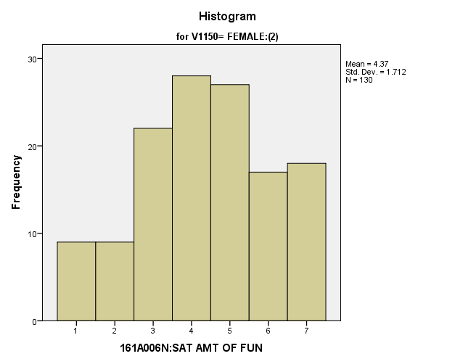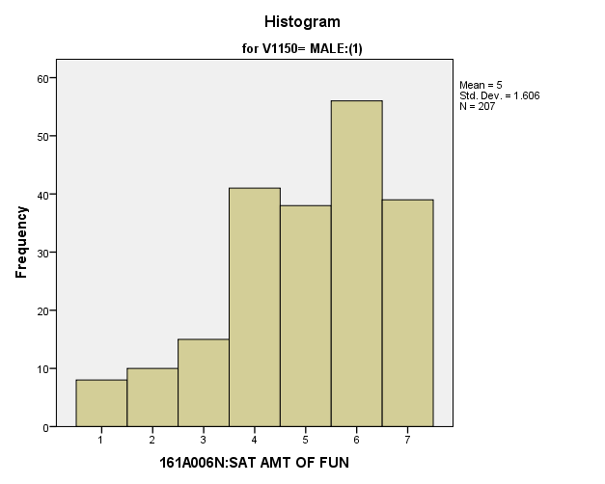

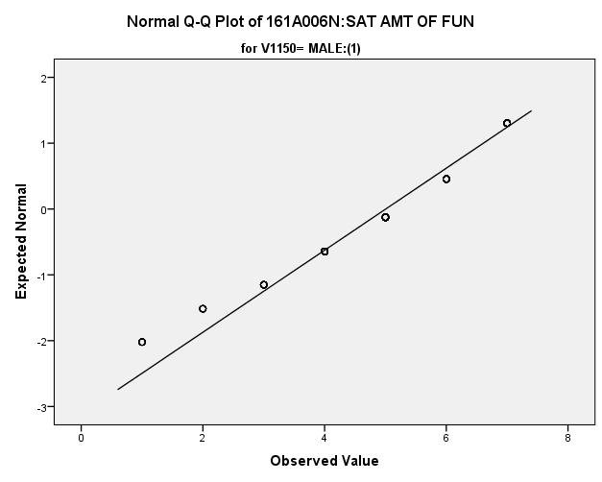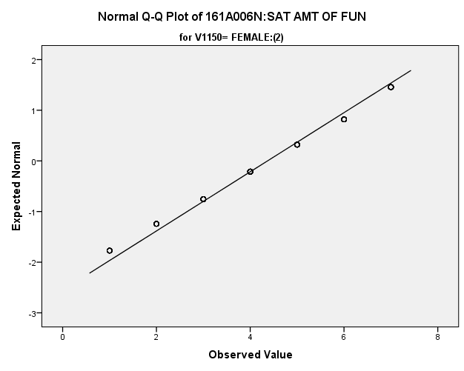

|  |  |  |  |  |  |
| --- | --- | --- | --- | --- | --- |
| *Primary Analysis:*  **Group Statistics** | | | | | |
|  | V1150 | N | Mean | Std. Deviation | Std. Error Mean |
| V1654 | MALE:(1) | **207** | **5.00** | **1.606** | **.112** |
| FEMALE:(2) | **130** | **4.37** | **1.712** | **.150** |

|  |  |  |  |  |  |  |
| --- | --- | --- | --- | --- | --- | --- |
| **Independent Samples Test** | | | | | | |
|  | | Levene's Test for Equality of Variances | | t-test for Equality of Means | | |
| F | Sig. | t | df | Sig. (2-tailed) |
|
| V1654 | Equal variances assumed | **1.416** | **.235** | **3.447** | **335** | **.001** |
| Equal variances not assumed |  |  | **3.397** | **260.943** | **.001** |

|  |  |  |  |  |  |  |  |  |
| --- | --- | --- | --- | --- | --- | --- | --- | --- |
| **Independent Samples Test** | | | | | | | | |
|  | | | | t-test for Equality of Means | | | | |
| Mean Difference | | Std. Error Difference | 99% Confidence Interval of the Difference | |
| Lower | Upper |
| V1654 | Equal variances assumed | | | **.636** | | **.184** | **.158** | **1.113** |
| Equal variances not assumed | | | **.636** | | **.187** | **.150** | **1.121** |
| **Measures of Association** | | | | |
|  | | Eta | Eta Squared | |
| V1654 * V1150 | | **.185** | **.034** | |

*4.c. Student Trustworthy and Fairness Variables*

**People Can be Trusted:** Within the potential recruit group, are there gender differences in how strongly they feel that people can’t be trusted?

**Variables used:** The dependent variable was if people can be trusted. The independent (grouping) variable was sex (male or female).

**Analysis Procedure:**

* A t-test was used to compare average rating of how much students think that people can be trusted between the two gender groups (males versus females)
* Before conducting analysis, the distribution for how much students think that people can be trusted was checked separately for the two groups by means of visual inspection of histograms and Q-Q plots. No outliers were observed. However, the distribution was right skewed for both groups.
* The equality of variances assumption was tested. This assumption was met.

**Results:**

* Null and alternative hypothesis. H0: μ1 = μ2; Ha: μ1 ≠ μ2.
* Calculated t value: t = .428, df = 316, fail to reject H0, with a p-value of .669

**Interpretation:** There is not a significant difference between the two groups in how much students think that people can be trusted.

**Supporting Analysis:**

*Preliminary Analysis*:

|  |  |  |  |  |
| --- | --- | --- | --- | --- |
| ***Descriptives*** | | | | |
|  | 161C003:Rs SEX | | | Statistic |
| 161A008:PPL CAN B TRSTD | MALE:(1) | Mean | | **1.69** |
| 99% Confidence Interval for Mean | Lower Bound | **1.62** |
| Upper Bound | **1.76** |
| 5% Trimmed Mean | | **1.65** |
| Median | | **1.00** |
| Variance | | **.622** |
| Std. Deviation | | **.788** |
| Minimum | | **1** |
| Maximum | | **3** |
| Range | | **2** |
| Interquartile Range | | **1** |
| Skewness | | **.612** |
| Kurtosis | | **-1.133** |
| FEMALE:(2) | Mean | | **1.58** |
| 99% Confidence Interval for Mean | Lower Bound | **1.52** |
| Upper Bound | **1.64** |
| 5% Trimmed Mean | | **1.53** |
| Median | | **1.00** |
| Variance | | **.527** |
| Std. Deviation | | **.726** |
| Minimum | | **1** |
| Maximum | | **3** |
| Range | | **2** |
| Interquartile Range | | **1** |
| Skewness | | **.838** |
| Kurtosis | | **-.651** |

|  |  |  |  |  |
| --- | --- | --- | --- | --- |
| ***Descriptives*** | | | | |
|  | 161C003:Rs SEX | | | Std. Error |
| 161A008:PPL CAN B TRSTD | MALE:(1) | Mean | | **.027** |
| 99% Confidence Interval for Mean | Lower Bound |  |
| Upper Bound |  |
| 5% Trimmed Mean | |  |
| Median | |  |
| Variance | |  |
| Std. Deviation | |  |
| Minimum | |  |
| Maximum | |  |
| Range | |  |
| Interquartile Range | |  |
| Skewness | | **.085** |
| Kurtosis | | **.170** |
| FEMALE:(2) | Mean | | **.024** |
| 99% Confidence Interval for Mean | Lower Bound |  |
| Upper Bound |  |
| 5% Trimmed Mean | |  |
| Median | |  |
| Variance | |  |
| Std. Deviation | |  |
| Minimum | |  |
| Maximum | |  |
| Range | |  |
| Interquartile Range | |  |
| Skewness | | **.082** |
| Kurtosis | | **.163** |

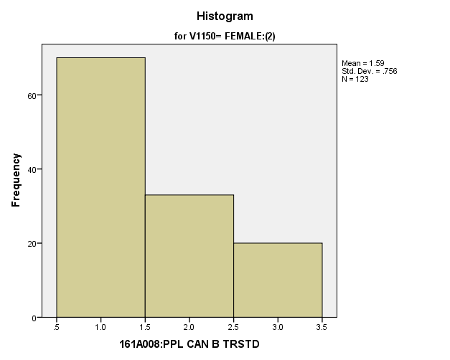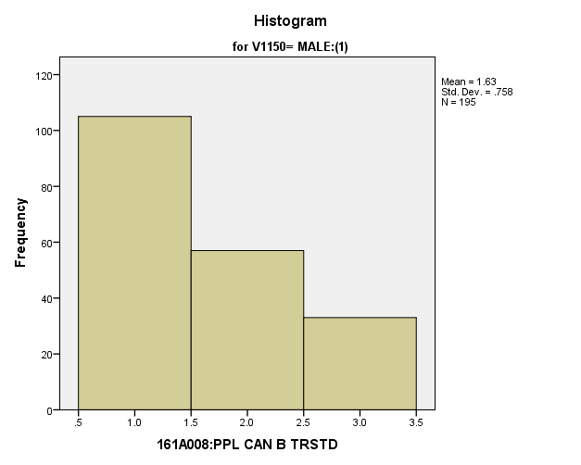

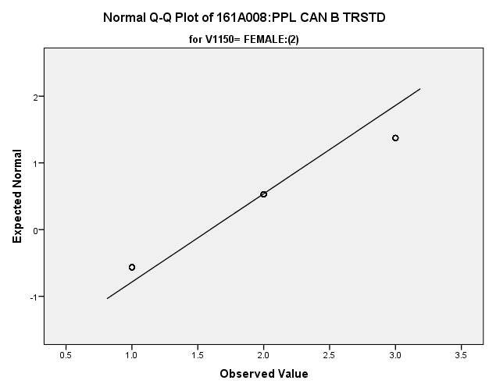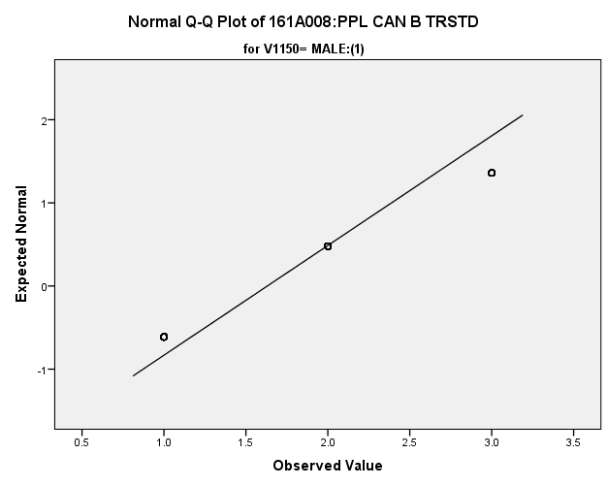

*Primary Analysis:*

|  |  |  |  |  |  |
| --- | --- | --- | --- | --- | --- |
| **Group Statistics** | | | | | |
|  | V1150 | N | Mean | Std. Deviation | Std. Error Mean |
| V1669 | MALE:(1) | **195** | **1.63** | **.758** | **.054** |
| FEMALE:(2) | **123** | **1.59** | **.756** | **.068** |

|  |  |  |  |  |  |  |
| --- | --- | --- | --- | --- | --- | --- |
| **Independent Samples Test** | | | | | | |
|  | | Levene's Test for Equality of Variances | | t-test for Equality of Means | | |
| F | Sig. | t | df | Sig. (2-tailed) |
|
| V1669 | Equal variances assumed | **.010** | **.922** | **.428** | **316** | **.669** |
| Equal variances not assumed |  |  | **.428** | **260.057** | **.669** |

|  |  |  |  |  |  |
| --- | --- | --- | --- | --- | --- |
| **Independent Samples Test** | | | | | |
|  | | t-test for Equality of Means | | | |
| Mean Difference | Std. Error Difference | 99% Confidence Interval of the Difference | |
| Lower | Upper |
| V1669 | Equal variances assumed | **.037** | **.087** | **-.189** | **.263** |
| Equal variances not assumed | **.037** | **.087** | **-.189** | **.263** |

**People Take Advantage:** Within the potential recruit group, are there gender differences in how strongly they feel that people take advantage of others?

**Variables used:** The dependent variable was if people take advantage of others. The independent (grouping) variable was sex (male or female).

**Analysis Procedure:**

* A t-test was used to compare average rating of how much students think that people tend to take advantage of others between the two gender groups (males versus females)
* Before conducting analysis, the distribution for how much students think that people tend to take advantage of others was checked separately for the two groups by means of visual inspection of histograms and Q-Q plots. No outliers were observed. However, the distribution was right skewed for both groups.
* The equality of variances assumption was tested. This assumption was met.

**Results:**

* Null and alternative hypothesis. H0: μ1 = μ2; Ha: μ1 ≠ μ2.
* Calculated t value: t = .860, df = 329, fail to reject H0, with a p-value of .390

**Interpretation:** There is not a significant difference between the two groups in how much students think that people tend to take advantage of others.

**Supporting Analysis:**

*Preliminary Analysis:*

|  |  |  |  |  |
| --- | --- | --- | --- | --- |
| ***Descriptives*** | | | | |
|  | 161C003:Rs SEX | | | Statistic |
| 161A010:PPL TRY BE FAIR | MALE:(1) | Mean | | **1.78** |
| 99% Confidence Interval for Mean | Lower Bound | **1.71** |
| Upper Bound | **1.85** |
| 5% Trimmed Mean | | **1.76** |
| Median | | **2.00** |
| Variance | | **.594** |
| Std. Deviation | | **.771** |
| Minimum | | **1** |
| Maximum | | **3** |
| Range | | **2** |
| Interquartile Range | | **1** |
| Skewness | | **.398** |
| Kurtosis | | **-1.218** |
| FEMALE:(2) | Mean | | **1.69** |
| 99% Confidence Interval for Mean | Lower Bound | **1.63** |
| Upper Bound | **1.76** |
| 5% Trimmed Mean | | **1.66** |
| Median | | **2.00** |
| Variance | | **.548** |
| Std. Deviation | | **.741** |
| Minimum | | **1** |
| Maximum | | **3** |
| Range | | **2** |
| Interquartile Range | | **1** |
| Skewness | | **.561** |
| Kurtosis | | **-.993** |

|  |  |  |  |  |
| --- | --- | --- | --- | --- |
| ***Descriptives*** | | | | |
|  | 161C003:Rs SEX | | | Std. Error |
| 161A010:PPL TRY BE FAIR | MALE:(1) | Mean | | **.026** |
| 99% Confidence Interval for Mean | Lower Bound |  |
| Upper Bound |  |
| 5% Trimmed Mean | |  |
| Median | |  |
| Variance | |  |
| Std. Deviation | |  |
| Minimum | |  |
| Maximum | |  |
| Range | |  |
| Interquartile Range | |  |
| Skewness | | **.083** |
| Kurtosis | | **.167** |
| FEMALE:(2) | Mean | | **.024** |
| 99% Confidence Interval for Mean | Lower Bound |  |
| Upper Bound |  |
| 5% Trimmed Mean | |  |
| Median | |  |
| Variance | |  |
| Std. Deviation | |  |
| Minimum | |  |
| Maximum | |  |
| Range | |  |
| Interquartile Range | |  |
| Skewness | | **.081** |
| Kurtosis | | **.161** |

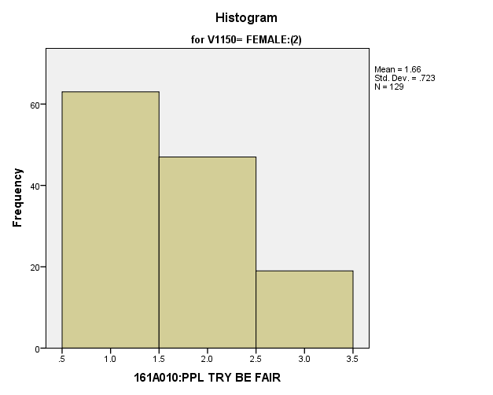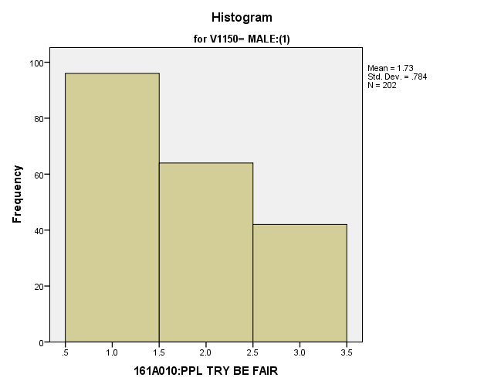

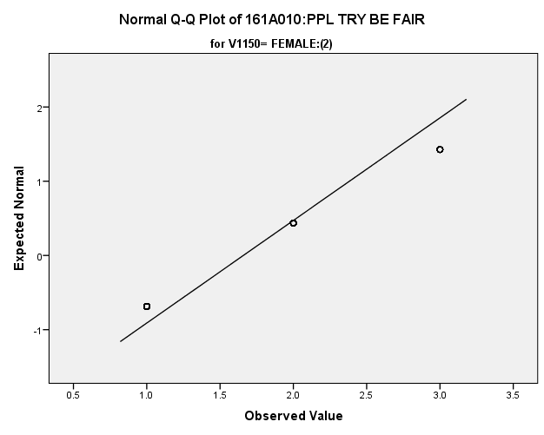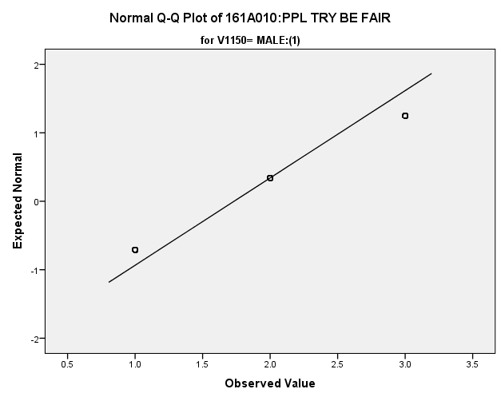

|  |  |  |  |  |  |  |  |  |  |
| --- | --- | --- | --- | --- | --- | --- | --- | --- | --- |
| *Primary Analysis:*  **Group Statistics** | | | | | | | | | |
|  | | V1150 | N | Mean | | Std. Deviation | | Std. Error Mean | |
| V1671 | | MALE:(1) | **202** | **1.73** | | **.784** | | **.055** | |
| FEMALE:(2) | **129** | **1.66** | | **.723** | | **.064** | |
| **Independent Samples Test** | | | | | | | | | | | | |
|  | | | | | Levene's Test for Equality of Variances | | | | t-test for Equality of Means | | | |
| F | | Sig. | | t | | df | Sig. (2-tailed) |
|
| V1671 | Equal variances assumed | | | | **1.845** | | **.175** | | **.860** | | **329** | **.390** |
| Equal variances not assumed | | | |  | |  | | **.875** | | **288.628** | **.382** |

|  |  |  |  |  |  |
| --- | --- | --- | --- | --- | --- |
| **Independent Samples Test** | | | | | |
|  | | t-test for Equality of Means | | | |
| Mean Difference | Std. Error Difference | 99% Confidence Interval of the Difference | |
| Lower | Upper |
| V1671 | Equal variances assumed | **.074** | **.086** | **-.148** | **.296** |
| Equal variances not assumed | **.074** | **.084** | **-.145** | **.292** |

**Skipping School Recently:** Within the potential recruit group, are there gender differences in how many days they have skipped in the past four weeks?

**Variables used:** The dependent variable was skipping school in past four weeks. The independent (grouping) variable was sex (male or female).

**Analysis Procedure:**

* A t-test was used to compare average rating of how many times students have skipped school in the past four weeks between the two gender groups (males versus females)
* Before conducting analysis, the distribution for how many times students have skipped school in the past four weeks was checked separately for the two groups by means of visual inspection of histograms and Q-Q plots. No outliers were observed. However, the distribution was right skewed for both groups.
* The equality of variances assumption was tested. This assumption was met.

**Results:**

* Null and alternative hypothesis. H0: μ1 = μ2; Ha: μ1 ≠ μ2.
* Calculated t value: t = .589, df = 318, fail to reject H0, with a p-value of .557

**Interpretation:** There is not a significant difference between the two groups in how many times students have skipped school in the past four weeks.

**Supporting Analysis:**

*Preliminary Analysis:*

|  |  |  |  |  |
| --- | --- | --- | --- | --- |
| ***Descriptives*** | | | | |
|  | 161C003:Rs SEX | | | Statistic |
| 161C018B:#DA/4W SC MS CU | MALE:(1) | Mean | | **1.57** |
| 99% Confidence Interval for Mean | Lower Bound | **1.46** |
| Upper Bound | **1.68** |
| 5% Trimmed Mean | | **1.38** |
| Median | | **1.00** |
| Variance | | **1.411** |
| Std. Deviation | | **1.188** |
| Minimum | | **1** |
| Maximum | | **7** |
| Range | | **6** |
| Interquartile Range | | **1** |
| Skewness | | **2.536** |
| Kurtosis | | **6.431** |
| FEMALE:(2) | Mean | | **1.76** |
| 99% Confidence Interval for Mean | Lower Bound | **1.64** |
| Upper Bound | **1.88** |
| 5% Trimmed Mean | | **1.56** |
| Median | | **1.00** |
| Variance | | **1.899** |
| Std. Deviation | | **1.378** |
| Minimum | | **1** |
| Maximum | | **7** |
| Range | | **6** |
| Interquartile Range | | **1** |
| Skewness | | **2.069** |
| Kurtosis | | **3.762** |

|  |  |  |  |  |
| --- | --- | --- | --- | --- |
| ***Descriptives*** | | | | |
|  | 161C003:Rs SEX | | | Std. Error |
| 161C018B:#DA/4W SC MS CU | MALE:(1) | Mean | | **.042** |
| 99% Confidence Interval for Mean | Lower Bound |  |
| Upper Bound |  |
| 5% Trimmed Mean | |  |
| Median | |  |
| Variance | |  |
| Std. Deviation | |  |
| Minimum | |  |
| Maximum | |  |
| Range | |  |
| Interquartile Range | |  |
| Skewness | | **.087** |
| Kurtosis | | **.174** |
| FEMALE:(2) | Mean | | **.047** |
| 99% Confidence Interval for Mean | Lower Bound |  |
| Upper Bound |  |
| 5% Trimmed Mean | |  |
| Median | |  |
| Variance | |  |
| Std. Deviation | |  |
| Minimum | |  |
| Maximum | |  |
| Range | |  |
| Interquartile Range | |  |
| Skewness | | **.083** |
| Kurtosis | | **.165** |

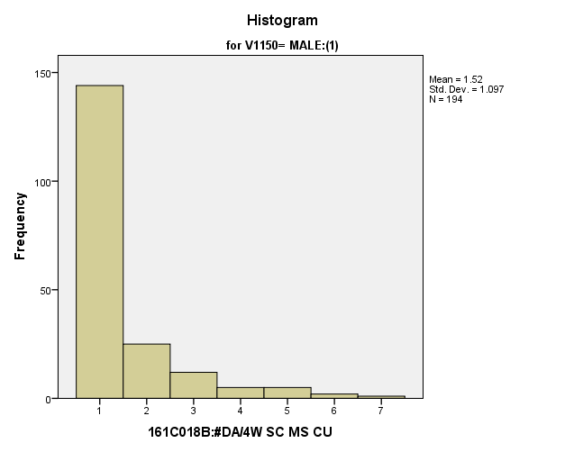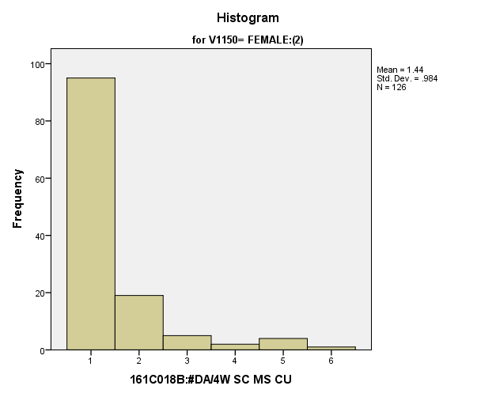

|  |  |  |  |  |  |  |  |  |  |
| --- | --- | --- | --- | --- | --- | --- | --- | --- | --- |
| *Primary Analysis:*  **Group Statistics** | | | | | | | | | |
|  | | V1150 | N | Mean | | Std. Deviation | | Std. Error Mean | |
| V1176 | | MALE:(1) | **194** | **1.52** | | **1.097** | | **.079** | |
| FEMALE:(2) | **126** | **1.44** | | **.984** | | **.088** | |
| **Independent Samples Test** | | | | | | | | | | | | |
|  | | | | | Levene's Test for Equality of Variances | | | | t-test for Equality of Means | | | |
| F | | Sig. | | t | | df | Sig. (2-tailed) |
|
| V1176 | Equal variances assumed | | | | **1.196** | | **.275** | | **.589** | | **318** | **.557** |
| Equal variances not assumed | | | |  | |  | | **.602** | | **287.111** | **.547** |

|  |  |  |  |  |  |
| --- | --- | --- | --- | --- | --- |
| **Independent Samples Test** | | | | | |
|  | | t-test for Equality of Means | | | |
| Mean Difference | Std. Error Difference | 99% Confidence Interval of the Difference | |
| Lower | Upper |
| V1176 | Equal variances assumed | **.071** | **.121** | **-.242** | **.384** |
| Equal variances not assumed | **.071** | **.118** | **-.235** | **.377** |

*4.d. Student Relationship with Government Variables*

**People Should Always Obey the Law:** Within the potential recruit group, are there gender differences in how strongly they feel that people should always obey the law?

**Variables used:** The dependent variable was if people should always obey the law. The independent (grouping) variable was sex (male or female).

**Analysis Procedure:**

* A t-test was used to compare average rating of how much students thought that people should always obey the law between the two gender groups (males versus females)
* Before conducting analysis, the distribution for how much students thought that people should always obey the law was checked separately for the two groups by means of visual inspection of histograms and Q-Q plots. No outliers were observed. However, the distribution was similarly skewed for both groups.
* The equality of variances assumption was tested. This assumption was met.

**Results:**

* Null and alternative hypothesis. H0: μ1 = μ2; Ha: μ1 ≠ μ2.
* Calculated t value: t = -1.725, df = 327, fail to reject H0, with a p-value of .085

**Interpretation:** There is not a significant difference between the two groups in how much students thought that people should always obey the law.

**Supporting Analysis:**

*Preliminary Analysis:*

|  |  |  |  |  |
| --- | --- | --- | --- | --- |
| ***Descriptives*** | | | | |
|  | 161C003:Rs SEX | | | Statistic |
| 161A011A:-OBY LW = -GD CTZ | MALE:(1) | Mean | | **2.77** |
| 99% Confidence Interval for Mean | Lower Bound | **2.66** |
| Upper Bound | **2.88** |
| 5% Trimmed Mean | | **2.74** |
| Median | | **3.00** |
| Variance | | **1.607** |
| Std. Deviation | | **1.268** |
| Minimum | | **1** |
| Maximum | | **5** |
| Range | | **4** |
| Interquartile Range | | **2** |
| Skewness | | **.090** |
| Kurtosis | | **-1.077** |
| FEMALE:(2) | Mean | | **2.90** |
| 99% Confidence Interval for Mean | Lower Bound | **2.79** |
| Upper Bound | **3.00** |
| 5% Trimmed Mean | | **2.88** |
| Median | | **3.00** |
| Variance | | **1.412** |
| Std. Deviation | | **1.188** |
| Minimum | | **1** |
| Maximum | | **5** |
| Range | | **4** |
| Interquartile Range | | **2** |
| Skewness | | **-.166** |
| Kurtosis | | **-.972** |

|  |  |  |  |  |
| --- | --- | --- | --- | --- |
| ***Descriptives*** | | | | |
|  | 161C003:Rs SEX | | | Std. Error |
| 161A011A:-OBY LW = -GD CTZ | MALE:(1) | Mean | | **.043** |
| 99% Confidence Interval for Mean | Lower Bound |  |
| Upper Bound |  |
| 5% Trimmed Mean | |  |
| Median | |  |
| Variance | |  |
| Std. Deviation | |  |
| Minimum | |  |
| Maximum | |  |
| Range | |  |
| Interquartile Range | |  |
| Skewness | | **.083** |
| Kurtosis | | **.167** |
| FEMALE:(2) | Mean | | **.039** |
| 99% Confidence Interval for Mean | Lower Bound |  |
| Upper Bound |  |
| 5% Trimmed Mean | |  |
| Median | |  |
| Variance | |  |
| Std. Deviation | |  |
| Minimum | |  |
| Maximum | |  |
| Range | |  |
| Interquartile Range | |  |
| Skewness | | **.080** |
| Kurtosis | | **.161** |

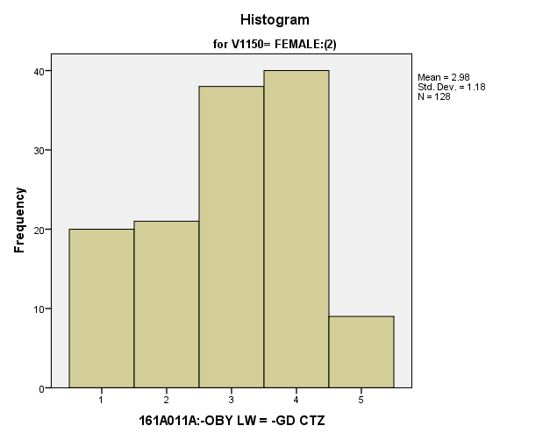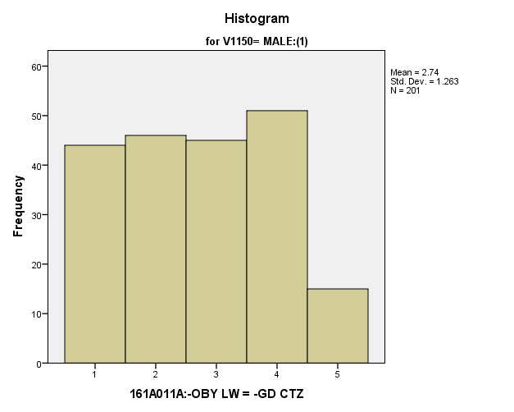

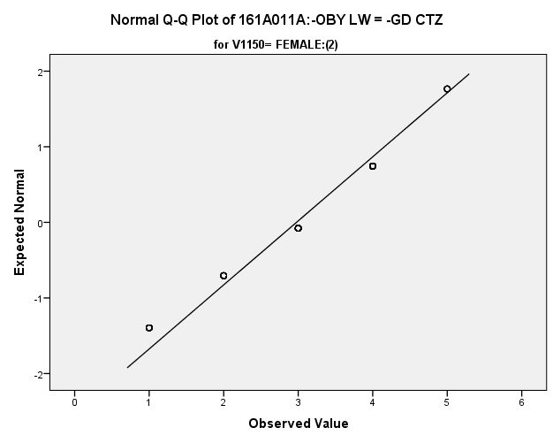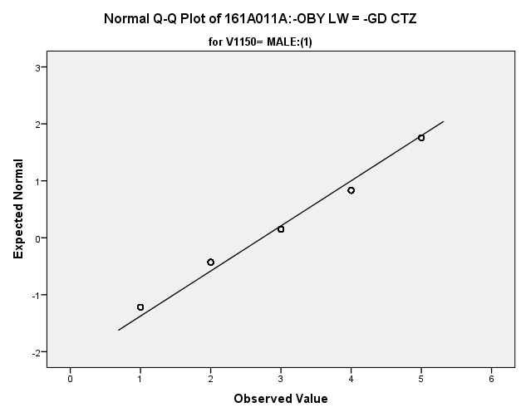

|  |  |  |  |  |  |  |  |  |  |
| --- | --- | --- | --- | --- | --- | --- | --- | --- | --- |
| *Primary Analysis:*  **Group Statistics** | | | | | | | | | |
|  | | V1150 | N | Mean | | Std. Deviation | | Std. Error Mean | |
| V1672 | | MALE:(1) | **201** | **2.74** | | **1.263** | | **.089** | |
| FEMALE:(2) | **128** | **2.98** | | **1.180** | | **.104** | |
| **Independent Samples Test** | | | | | | | | | | | | |
|  | | | | | Levene's Test for Equality of Variances | | | | t-test for Equality of Means | | | |
| F | | Sig. | | t | | df | Sig. (2-tailed) |
|
| V1672 | Equal variances assumed | | | | **4.579** | | **.033** | | **-1.725** | | **327** | **.085** |
| Equal variances not assumed | | | |  | |  | | **-1.751** | | **283.883** | **.081** |

|  |  |  |  |  |  |
| --- | --- | --- | --- | --- | --- |
| **Independent Samples Test** | | | | | |
|  | | t-test for Equality of Means | | | |
| Mean Difference | Std. Error Difference | 99% Confidence Interval of the Difference | |
| Lower | Upper |
| V1672 | Equal variances assumed | **-.240** | **.139** | **-.601** | **.121** |
| Equal variances not assumed | **-.240** | **.137** | **-.596** | **.116** |

**Good Citizens Agree with Government** Within the potential recruit group, are there gender differences in how strongly they feel that good citizens go along with the government no matter what?

**Variables used:** The dependent variable was if good citizens agree with the government. The independent (grouping) variable was sex (male or female).

**Analysis Procedure:**

* A t-test was used to compare average rating of how much students thought that good citizens always agree with the government between the two gender groups (males versus females)
* Before conducting analysis, the distribution for how much students thought that good citizens always agree with the government was checked separately for the two groups by means of visual inspection of histograms and Q-Q plots. No outliers were observed. However, the distribution was right skewed for both groups.
* The equality of variances assumption was tested. This assumption was met.

**Results:**

* Null and alternative hypothesis. H0: μ1 = μ2; Ha: μ1 ≠ μ2.
* Calculated t value: t = -.228, df = 328, fail to reject H0, with a p-value of .820

**Interpretation:** There is not a significant difference between the two groups in how much students thought that good citizens always agree with the government.

**Supporting Analysis:**

*Preliminary Analysis:*

|  |  |  |  |  |
| --- | --- | --- | --- | --- |
| ***Descriptives*** | | | | |
|  | 161C003:Rs SEX | | | Statistic |
| 161A011B:GD CTZN ALG GOV | MALE:(1) | Mean | | **2.14** |
| 99% Confidence Interval for Mean | Lower Bound | **2.04** |
| Upper Bound | **2.24** |
| 5% Trimmed Mean | | **2.06** |
| Median | | **2.00** |
| Variance | | **1.280** |
| Std. Deviation | | **1.131** |
| Minimum | | **1** |
| Maximum | | **5** |
| Range | | **4** |
| Interquartile Range | | **2** |
| Skewness | | **.670** |
| Kurtosis | | **-.457** |
| FEMALE:(2) | Mean | | **2.12** |
| 99% Confidence Interval for Mean | Lower Bound | **2.03** |
| Upper Bound | **2.22** |
| 5% Trimmed Mean | | **2.06** |
| Median | | **2.00** |
| Variance | | **1.217** |
| Std. Deviation | | **1.103** |
| Minimum | | **1** |
| Maximum | | **5** |
| Range | | **4** |
| Interquartile Range | | **2** |
| Skewness | | **.637** |
| Kurtosis | | **-.537** |

|  |  |  |  |  |
| --- | --- | --- | --- | --- |
| ***Descriptives*** | | | | |
|  | 161C003:Rs SEX | | | Std. Error |
| 161A011B:GD CTZN ALG GOV | MALE:(1) | Mean | | **.039** |
| 99% Confidence Interval for Mean | Lower Bound |  |
| Upper Bound |  |
| 5% Trimmed Mean | |  |
| Median | |  |
| Variance | |  |
| Std. Deviation | |  |
| Minimum | |  |
| Maximum | |  |
| Range | |  |
| Interquartile Range | |  |
| Skewness | | **.083** |
| Kurtosis | | **.167** |
| FEMALE:(2) | Mean | | **.036** |
| 99% Confidence Interval for Mean | Lower Bound |  |
| Upper Bound |  |
| 5% Trimmed Mean | |  |
| Median | |  |
| Variance | |  |
| Std. Deviation | |  |
| Minimum | |  |
| Maximum | |  |
| Range | |  |
| Interquartile Range | |  |
| Skewness | | **.081** |
| Kurtosis | | **.161** |

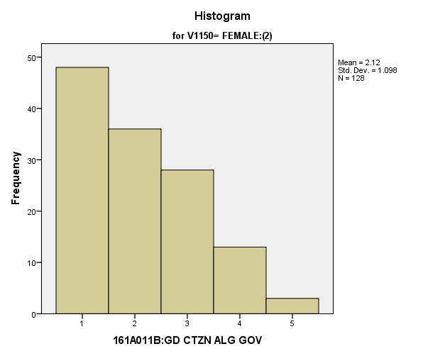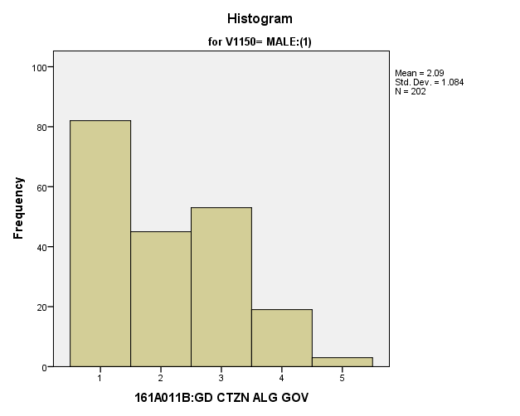

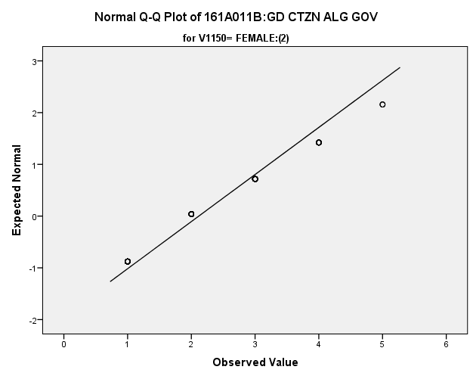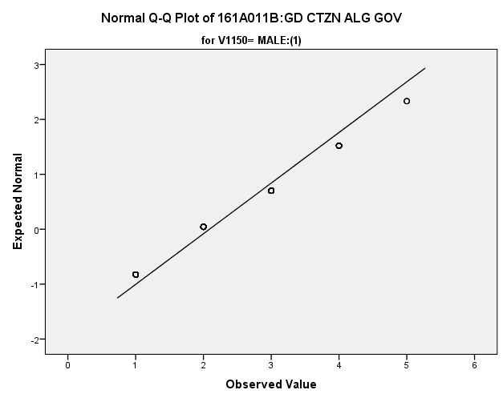

|  |  |  |  |  |  |  |  |  |  |  |  |
| --- | --- | --- | --- | --- | --- | --- | --- | --- | --- | --- | --- |
| *Primary Analysis:*  **Group Statistics** | | | | | | | | | | | |
|  | V1150 | | N | Mean | | | Std. Deviation | | | Std. Error Mean | |
| V1673 | MALE:(1) | | **202** | **2.09** | | | **1.084** | | | **.076** | |
| FEMALE:(2) | | **128** | **2.12** | | | **1.098** | | | **.097** | |
| **Independent Samples Test** | | | | | | | | | | | | | | | | |
|  | | | | | Levene's Test for Equality of Variances | | | | | | t-test for Equality of Means | | | | | |
| F | | | Sig. | | | t | | | df | Sig. (2-tailed) | |
|
| V1673 | Equal variances assumed | | | | **.092** | | | **.761** | | | **-.228** | | | **328** | **.820** | |
| Equal variances not assumed | | | |  | | |  | | | **-.227** | | | **267.782** | **.820** | |
| **Independent Samples Test** | | | | | | | | | | | | | | | | | |
|  | | | | | | t-test for Equality of Means | | | | | | | | | | | |
| Mean Difference | | | Std. Error Difference | | | | 99% Confidence Interval of the Difference | | | | |
| Lower | | | Upper | |
| V1673 | | Equal variances assumed | | | | **-.028** | | | **.123** | | | | **-.347** | | | **.291** | |
| Equal variances not assumed | | | | **-.028** | | | **.123** | | | | **-.348** | | | **.292** | |

**Good Citizens Challenge the Government** Within the potential recruit group, are there gender differences in how strongly they feel that people should challenge the government?

**Variables used:** The dependent variable was if good citizens challenge the government. The independent (grouping) variable was sex (male or female).

**Analysis Procedure:**

* A t-test was used to compare average rating of how much students thought that good citizens challenge the government between the two gender groups (males versus females)
* Before conducting analysis, the distribution for good citizens challenge the government was checked separately for the two groups by means of visual inspection of histograms and Q-Q plots. No outliers were observed. However, the distribution was left skewed for both groups.
* The equality of variances assumption was tested. This assumption was met.

**Results:**

* Null and alternative hypothesis. H0: μ1 = μ2; Ha: μ1 ≠ μ2.
* Calculated t value: t = .641, df = 326, xxx H0, with a p-value of .522

**Interpretation:** There is not a significant difference between the two groups in good citizens challenge the government.

**Supporting Analysis:**

*Preliminary Analysis:*

|  |  |  |  |  |
| --- | --- | --- | --- | --- |
| ***Descriptives*** | | | | |
|  | 161C003:Rs SEX | | | Statistic |
| 161A011C:GD CTZN CHG GOV | MALE:(1) | Mean | | **3.69** |
| 99% Confidence Interval for Mean | Lower Bound | **3.60** |
| Upper Bound | **3.78** |
| 5% Trimmed Mean | | **3.74** |
| Median | | **4.00** |
| Variance | | **1.015** |
| Std. Deviation | | **1.008** |
| Minimum | | **1** |
| Maximum | | **5** |
| Range | | **4** |
| Interquartile Range | | **1** |
| Skewness | | **-.430** |
| Kurtosis | | **-.223** |
| FEMALE:(2) | Mean | | **3.58** |
| 99% Confidence Interval for Mean | Lower Bound | **3.49** |
| Upper Bound | **3.67** |
| 5% Trimmed Mean | | **3.64** |
| Median | | **4.00** |
| Variance | | **1.097** |
| Std. Deviation | | **1.047** |
| Minimum | | **1** |
| Maximum | | **5** |
| Range | | **4** |
| Interquartile Range | | **1** |
| Skewness | | **-.471** |
| Kurtosis | | **-.083** |

|  |  |  |  |  |
| --- | --- | --- | --- | --- |
| ***Descriptives*** | | | | |
|  | 161C003:Rs SEX | | | Std. Error |
| 161A011C:GD CTZN CHG GOV | MALE:(1) | Mean | | **.034** |
| 99% Confidence Interval for Mean | Lower Bound |  |
| Upper Bound |  |
| 5% Trimmed Mean | |  |
| Median | |  |
| Variance | |  |
| Std. Deviation | |  |
| Minimum | |  |
| Maximum | |  |
| Range | |  |
| Interquartile Range | |  |
| Skewness | | **.084** |
| Kurtosis | | **.167** |
| FEMALE:(2) | Mean | | **.035** |
| 99% Confidence Interval for Mean | Lower Bound |  |
| Upper Bound |  |
| 5% Trimmed Mean | |  |
| Median | |  |
| Variance | |  |
| Std. Deviation | |  |
| Minimum | |  |
| Maximum | |  |
| Range | |  |
| Interquartile Range | |  |
| Skewness | | **.081** |
| Kurtosis | | **.161** |

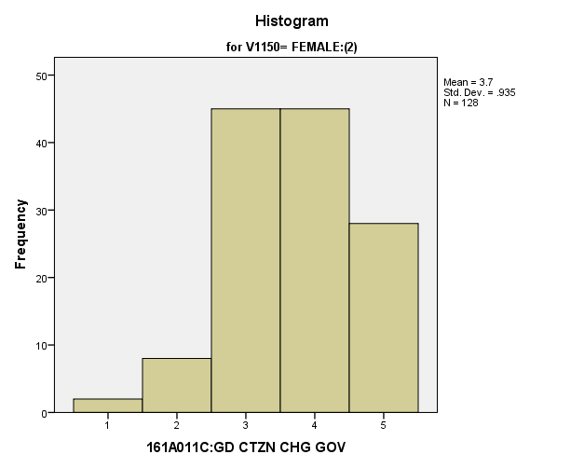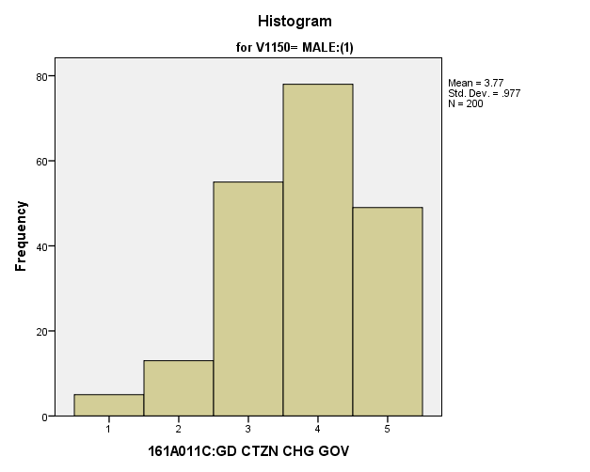

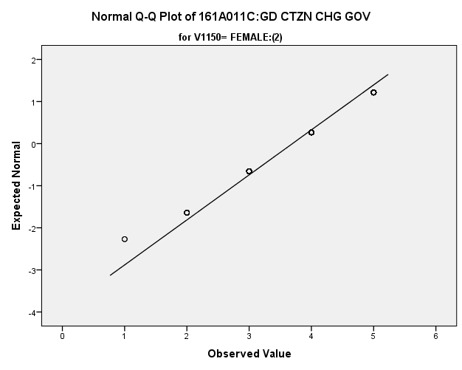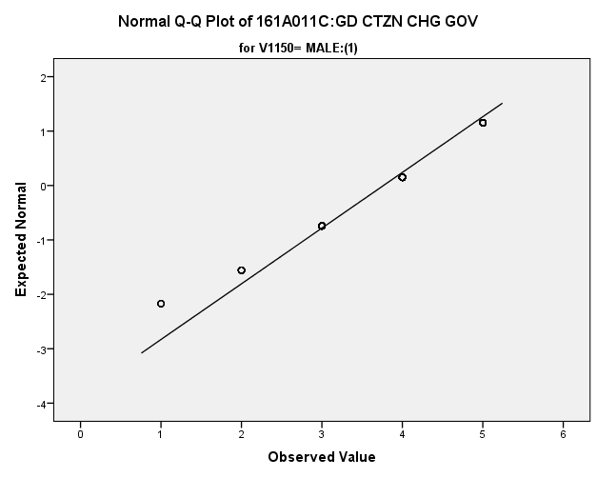

*Primary Analysis:*

|  |  |  |  |  |  |  |  |  |  |
| --- | --- | --- | --- | --- | --- | --- | --- | --- | --- |
| **Group Statistics** | | | | | | | | | |
|  | | V1150 | N | Mean | | Std. Deviation | | Std. Error Mean | |
| V1674 | | MALE:(1) | **200** | **3.77** | | **.977** | | **.069** | |
| FEMALE:(2) | **128** | **3.70** | | **.935** | | **.083** | |
| **Independent Samples Test** | | | | | | | | | | | | |
|  | | | | | Levene's Test for Equality of Variances | | | | t-test for Equality of Means | | | |
| F | | Sig. | | t | | df | Sig. (2-tailed) |
|
| V1674 | Equal variances assumed | | | | **.003** | | **.956** | | **.641** | | **326** | **.522** |
| Equal variances not assumed | | | |  | |  | | **.647** | | **279.351** | **.518** |

|  |  |  |  |  |  |
| --- | --- | --- | --- | --- | --- |
| **Independent Samples Test** | | | | | |
|  | | t-test for Equality of Means | | | |
| Mean Difference | Std. Error Difference | 99% Confidence Interval of the Difference | |
| Lower | Upper |
| V1674 | Equal variances assumed | **.070** | **.109** | **-.212** | **.352** |
| Equal variances not assumed | **.070** | **.108** | **-.210** | **.349** |

**USA is Best System in World** Within the potential recruit group, are there gender differences in how strongly they feel that the USA has the best system in the world?

**Variables used:** The dependent variable was if the USA is the best system in the world. The independent (grouping) variable was sex (male or female).

**Analysis Procedure:**

* A t-test was used to compare average rating of how much students thought that our system is the best in the world between the two gender groups (males versus females)
* Before conducting analysis, the distribution for how much students thought that our system is the best in the world was checked separately for the two groups by means of visual inspection of histograms and Q-Q plots. No outliers were observed. However, the distribution was similarly skewed for both groups.
* The equality of variances assumption was tested. This assumption was met.
* Eta Squared was calculated to assess effect size.

**Results:**

* Null and alternative hypothesis. H0: μ1 = μ2; Ha: μ1 ≠ μ2.
* Calculated t value: t = 3.269, df = 326, reject H0, with a p-value or .001; Eta Squared = .032

**Interpretation:** There is a significant difference between the two groups in how much students thought that our system is the best in the world. Furthermore, 3.2% of how satisfied students were was due to their sex.

**Supporting Analysis:**

*Preliminary Analysis:*

|  |  |  |  |  |
| --- | --- | --- | --- | --- |
| ***Descriptives*** | | | | |
|  | 161C003:Rs SEX | | | Statistic |
| 161A011F:OUR SYST ST BS | MALE:(1) | Mean | | **3.02** |
| 99% Confidence Interval for Mean | Lower Bound | **2.92** |
| Upper Bound | **3.13** |
| 5% Trimmed Mean | | **3.03** |
| Median | | **3.00** |
| Variance | | **1.499** |
| Std. Deviation | | **1.224** |
| Minimum | | **1** |
| Maximum | | **5** |
| Range | | **4** |
| Interquartile Range | | **2** |
| Skewness | | **-.082** |
| Kurtosis | | **-.814** |
| FEMALE:(2) | Mean | | **2.83** |
| 99% Confidence Interval for Mean | Lower Bound | **2.74** |
| Upper Bound | **2.93** |
| 5% Trimmed Mean | | **2.82** |
| Median | | **3.00** |
| Variance | | **1.313** |
| Std. Deviation | | **1.146** |
| Minimum | | **1** |
| Maximum | | **5** |
| Range | | **4** |
| Interquartile Range | | **2** |
| Skewness | | **.000** |
| Kurtosis | | **-.639** |

|  |  |  |  |  |
| --- | --- | --- | --- | --- |
| ***Descriptives*** | | | | |
|  | 161C003:Rs SEX | | | Std. Error |
| 161A011F:OUR SYST ST BS | MALE:(1) | Mean | | **.042** |
| 99% Confidence Interval for Mean | Lower Bound |  |
| Upper Bound |  |
| 5% Trimmed Mean | |  |
| Median | |  |
| Variance | |  |
| Std. Deviation | |  |
| Minimum | |  |
| Maximum | |  |
| Range | |  |
| Interquartile Range | |  |
| Skewness | | **.084** |
| Kurtosis | | **.167** |
| FEMALE:(2) | Mean | | **.038** |
| 99% Confidence Interval for Mean | Lower Bound |  |
| Upper Bound |  |
| 5% Trimmed Mean | |  |
| Median | |  |
| Variance | |  |
| Std. Deviation | |  |
| Minimum | |  |
| Maximum | |  |
| Range | |  |
| Interquartile Range | |  |
| Skewness | | **.081** |
| Kurtosis | | **.161** |

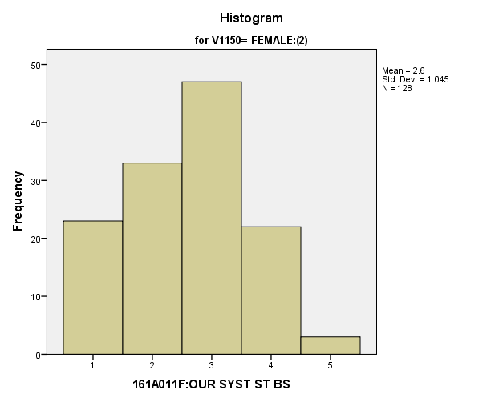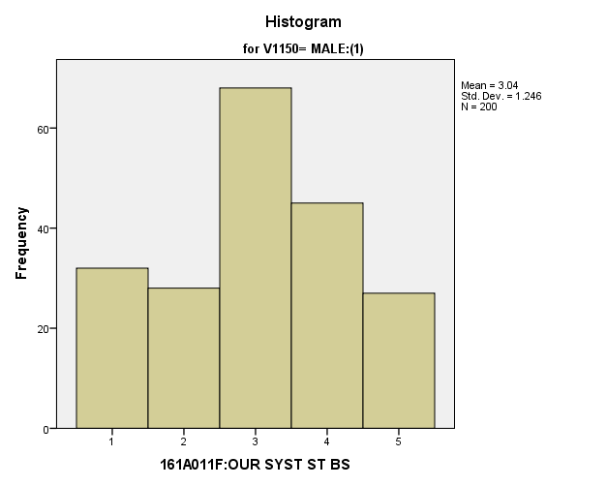

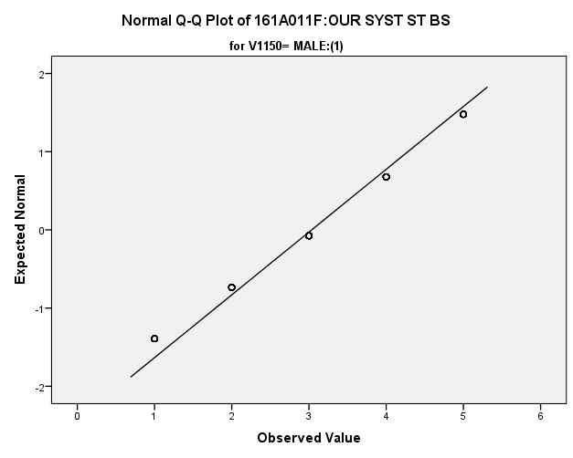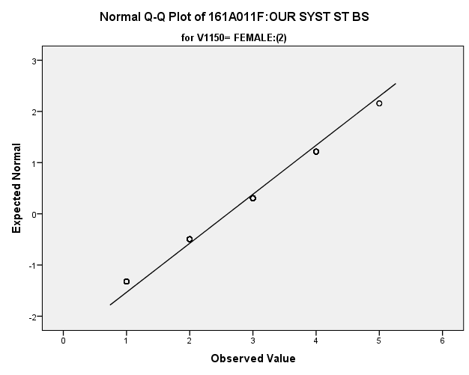

|  |  |  |  |  |  |  |  |  |  |
| --- | --- | --- | --- | --- | --- | --- | --- | --- | --- |
| *Primary Analysis:*  **Group Statistics** | | | | | | | | | |
|  | | V1150 | N | Mean | | Std. Deviation | | Std. Error Mean | |
| V1677 | | MALE:(1) | **200** | **3.04** | | **1.246** | | **.088** | |
| FEMALE:(2) | **128** | **2.60** | | **1.045** | | **.092** | |
| **Independent Samples Test** | | | | | | | | | | | | |
|  | | | | | Levene's Test for Equality of Variances | | | | t-test for Equality of Means | | | |
| F | | Sig. | | t | | df | Sig. (2-tailed) |
|
| V1677 | Equal variances assumed | | | | **.989** | | **.321** | | **3.269** | | **326** | **.001** |
| Equal variances not assumed | | | |  | |  | | **3.396** | | **303.060** | **.001** |

|  |  |  |  |  |  |  |  |  |
| --- | --- | --- | --- | --- | --- | --- | --- | --- |
| **Independent Samples Test** | | | | | | | | |
|  | | | | t-test for Equality of Means | | | | |
| Mean Difference | | Std. Error Difference | 99% Confidence Interval of the Difference | |
| Lower | Upper |
| V1677 | Equal variances assumed | | | **.433** | | **.133** | **.090** | **.777** |
| Equal variances not assumed | | | **.433** | | **.128** | **.103** | **.764** |
| **Measures of Association** | | | | |
|  | | Eta | Eta Squared | |
| V1677 * V1150 | | **.178** | **.032** | |

*4.e. Student Ability to Follow Rules Variables:*

**Going to School is Enjoyable** Within the potential recruit group, are there gender differences in how strongly they feel that school is an enjoyable experience for them?

**Variables used:** The dependent variable was if going to school is enjoyable. The independent (grouping) variable was sex (male or female).

**Analysis Procedure:**

* A t-test was used to compare average rating of how much students thought that going to school is enjoyable between the two gender groups (males versus females)
* Before conducting analysis, the distribution for how much students thought that going to school is enjoyable was checked separately for the two groups by means of visual inspection of histograms and Q-Q plots. No outliers were observed. However, the distribution was left skewed for both groups.
* The equality of variances assumption was tested. This assumption was met.

**Results:**

* Null and alternative hypothesis. H0: μ1 = μ2; Ha: μ1 ≠ μ2.
* Calculated t value: t = .752, df = 327, fail to reject H0, with a p-value of .452

**Interpretation:** There is not a significant difference between the two groups in how much students thought that going to school is enjoyable.

**Supporting Analysis:**

*Preliminary Analysis:*

|  |  |  |  |  |
| --- | --- | --- | --- | --- |
| ***Descriptives*** | | | | |
|  | 161C003:Rs SEX | | | Statistic |
| 161A011I:GO SCH ENJY XPR | MALE:(1) | Mean | | **3.52** |
| 99% Confidence Interval for Mean | Lower Bound | **3.42** |
| Upper Bound | **3.63** |
| 5% Trimmed Mean | | **3.58** |
| Median | | **4.00** |
| Variance | | **1.365** |
| Std. Deviation | | **1.168** |
| Minimum | | **1** |
| Maximum | | **5** |
| Range | | **4** |
| Interquartile Range | | **1** |
| Skewness | | **-.585** |
| Kurtosis | | **-.423** |
| FEMALE:(2) | Mean | | **3.43** |
| 99% Confidence Interval for Mean | Lower Bound | **3.33** |
| Upper Bound | **3.53** |
| 5% Trimmed Mean | | **3.48** |
| Median | | **4.00** |
| Variance | | **1.494** |
| Std. Deviation | | **1.222** |
| Minimum | | **1** |
| Maximum | | **5** |
| Range | | **4** |
| Interquartile Range | | **1** |
| Skewness | | **-.548** |
| Kurtosis | | **-.591** |

|  |  |  |  |  |
| --- | --- | --- | --- | --- |
| ***Descriptives*** | | | | |
|  | 161C003:Rs SEX | | | Std. Error |
| 161A011I:GO SCH ENJY XPR | MALE:(1) | Mean | | **.040** |
| 99% Confidence Interval for Mean | Lower Bound |  |
| Upper Bound |  |
| 5% Trimmed Mean | |  |
| Median | |  |
| Variance | |  |
| Std. Deviation | |  |
| Minimum | |  |
| Maximum | |  |
| Range | |  |
| Interquartile Range | |  |
| Skewness | | **.084** |
| Kurtosis | | **.167** |
| FEMALE:(2) | Mean | | **.040** |
| 99% Confidence Interval for Mean | Lower Bound |  |
| Upper Bound |  |
| 5% Trimmed Mean | |  |
| Median | |  |
| Variance | |  |
| Std. Deviation | |  |
| Minimum | |  |
| Maximum | |  |
| Range | |  |
| Interquartile Range | |  |
| Skewness | | **.081** |
| Kurtosis | | **.161** |

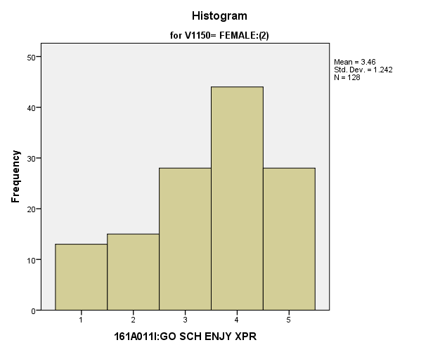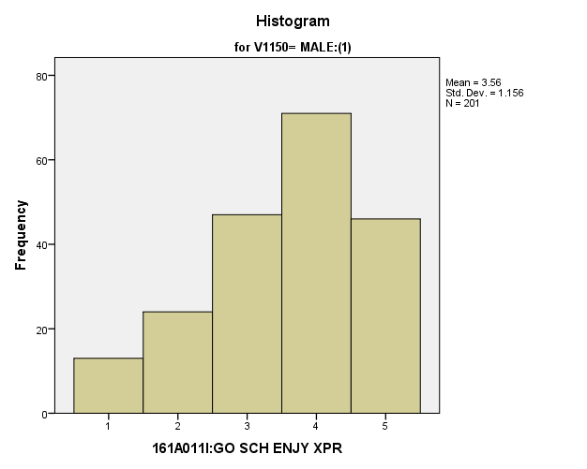

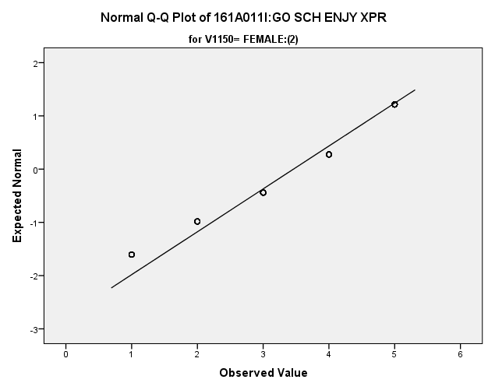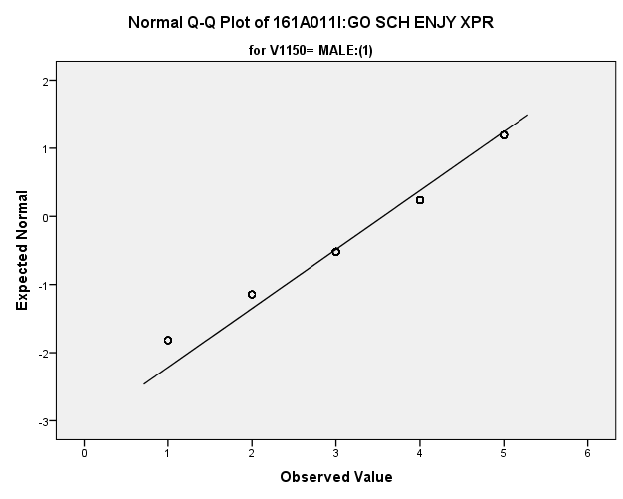

|  |  |  |  |  |  |  |  |  |  |
| --- | --- | --- | --- | --- | --- | --- | --- | --- | --- |
| *Primary Analysis:*  **Group Statistics** | | | | | | | | | |
|  | | V1150 | N | Mean | | Std. Deviation | | Std. Error Mean | |
| V1680 | | MALE:(1) | **201** | **3.56** | | **1.156** | | **.082** | |
| FEMALE:(2) | **128** | **3.46** | | **1.242** | | **.110** | |
| **Independent Samples Test** | | | | | | | | | | | | |
|  | | | | | Levene's Test for Equality of Variances | | | | t-test for Equality of Means | | | |
| F | | Sig. | | t | | df | Sig. (2-tailed) |
|
| V1680 | Equal variances assumed | | | | **1.104** | | **.294** | | **.752** | | **327** | **.452** |
| Equal variances not assumed | | | |  | |  | | **.740** | | **256.382** | **.460** |

|  |  |  |  |  |  |
| --- | --- | --- | --- | --- | --- |
| **Independent Samples Test** | | | | | |
|  | | t-test for Equality of Means | | | |
| Mean Difference | Std. Error Difference | 99% Confidence Interval of the Difference | |
| Lower | Upper |
| V1680 | Equal variances assumed | **.101** | **.135** | **-.247** | **.450** |
| Equal variances not assumed | **.101** | **.137** | **-.254** | **.456** |

**Doing Well in School is Important:** Within the potential recruit group, are there gender differences in how strongly they feel that doing well in school is important for their job and life in general?

**Variables used:** The dependent variable was if doing well in school is important. The independent (grouping) variable was sex (male or female).

**Analysis Procedure:**

* A t-test was used to compare average rating of how much students thought that doing well in school is important between the two gender groups (males versus females)
* Before conducting analysis, the distribution for how much students thought that doing well in school is important was checked separately for the two groups by means of visual inspection of histograms and Q-Q plots. No outliers were observed. However, the distribution was left skewed for both groups.
* The equality of variances assumption was tested. This assumption was met.
* Eta squared was calculated to assess effect size.

**Results:**

* Null and alternative hypothesis. H0: μ1 = μ2; Ha: μ1 ≠ μ2.
* Calculated t value: t = -2.715, df = 329, reject H0, with a p-value of .007; Eta squared = .022

**Interpretation:** There is a significant difference between the two groups in how much students thought that doing well in school is important. Furthermore, 2.2% of how much students thought doing well in school is important was due to their sex.

**Supporting Analysis:**

*Preliminary Analysis:*

|  |  |  |  |  |
| --- | --- | --- | --- | --- |
| ***Descriptives*** | | | | |
|  | 161C003:Rs SEX | | | Statistic |
| 161A011J:DO WL SC IMP/JB | MALE:(1) | Mean | | **4.07** |
| 99% Confidence Interval for Mean | Lower Bound | **3.97** |
| Upper Bound | **4.16** |
| 5% Trimmed Mean | | **4.18** |
| Median | | **4.00** |
| Variance | | **1.175** |
| Std. Deviation | | **1.084** |
| Minimum | | **1** |
| Maximum | | **5** |
| Range | | **4** |
| Interquartile Range | | **1** |
| Skewness | | **-1.158** |
| Kurtosis | | **.710** |
| FEMALE:(2) | Mean | | **4.35** |
| 99% Confidence Interval for Mean | Lower Bound | **4.27** |
| Upper Bound | **4.43** |
| 5% Trimmed Mean | | **4.47** |
| Median | | **5.00** |
| Variance | | **.895** |
| Std. Deviation | | **.946** |
| Minimum | | **1** |
| Maximum | | **5** |
| Range | | **4** |
| Interquartile Range | | **1** |
| Skewness | | **-1.652** |
| Kurtosis | | **2.519** |

|  |  |  |  |  |
| --- | --- | --- | --- | --- |
| ***Descriptives*** | | | | |
|  | 161C003:Rs SEX | | | Std. Error |
| 161A011J:DO WL SC IMP/JB | MALE:(1) | Mean | | **.037** |
| 99% Confidence Interval for Mean | Lower Bound |  |
| Upper Bound |  |
| 5% Trimmed Mean | |  |
| Median | |  |
| Variance | |  |
| Std. Deviation | |  |
| Minimum | |  |
| Maximum | |  |
| Range | |  |
| Interquartile Range | |  |
| Skewness | | **.084** |
| Kurtosis | | **.167** |
| FEMALE:(2) | Mean | | **.031** |
| 99% Confidence Interval for Mean | Lower Bound |  |
| Upper Bound |  |
| 5% Trimmed Mean | |  |
| Median | |  |
| Variance | |  |
| Std. Deviation | |  |
| Minimum | |  |
| Maximum | |  |
| Range | |  |
| Interquartile Range | |  |
| Skewness | | **.080** |
| Kurtosis | | **.161** |

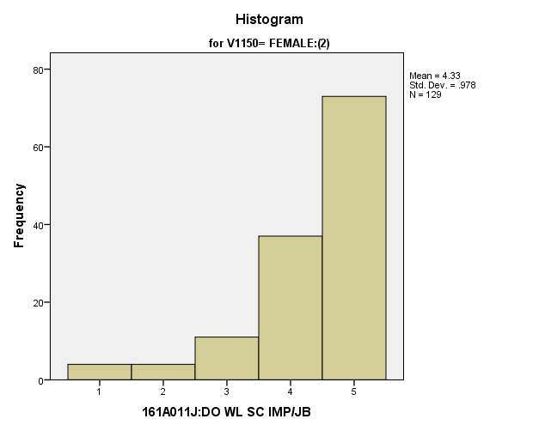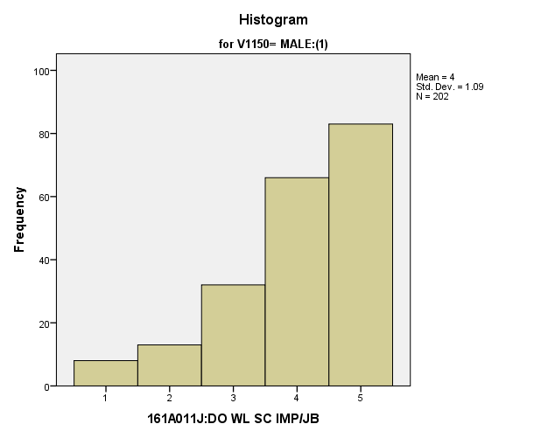

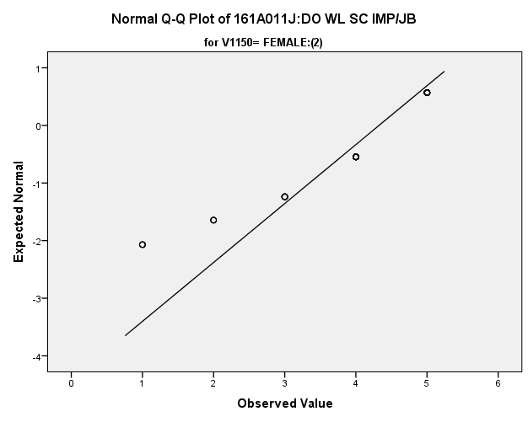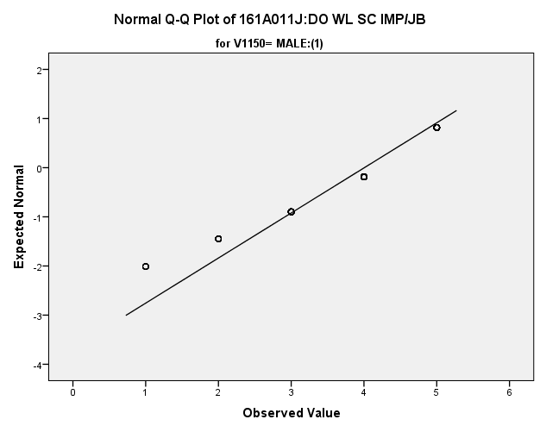

*Primary Analysis:*

|  |  |  |  |  |  |  |  |  |  |
| --- | --- | --- | --- | --- | --- | --- | --- | --- | --- |
| **Group Statistics** | | | | | | | | | |
|  | | V1150 | N | Mean | | Std. Deviation | | Std. Error Mean | |
| V1681 | | MALE:(1) | **202** | **4.00** | | **1.090** | | **.077** | |
| FEMALE:(2) | **129** | **4.33** | | **.978** | | **.086** | |
| **Independent Samples Test** | | | | | | | | | | | | |
|  | | | | | Levene's Test for Equality of Variances | | | | t-test for Equality of Means | | | |
| F | | Sig. | | t | | df | Sig. (2-tailed) |
|
| V1681 | Equal variances assumed | | | | **.508** | | **.477** | | **-2.715** | | **329** | **.007** |
| Equal variances not assumed | | | |  | |  | | **-2.781** | | **294.012** | **.006** |

|  |  |  |  |  |  |  |  |  |
| --- | --- | --- | --- | --- | --- | --- | --- | --- |
| **Independent Samples Test** | | | | | | | | |
|  | | | | t-test for Equality of Means | | | | |
| Mean Difference | | Std. Error Difference | 99% Confidence Interval of the Difference | |
| Lower | Upper |
| V1681 | Equal variances assumed | | | **-.321** | | **.118** | **-.627** | **-.015** |
| Equal variances not assumed | | | **-.321** | | **.115** | **-.620** | **-.022** |
| **Measures of Association** | | | | |
|  | | Eta | Eta Squared | |
| V1681 * V1150 | | **.148** | **.022** | |

**Research Question 5:** Within the potential recruit group, are there racial differences (White vs. Non-white) in the variables studied?

*5.a. Student Value Variables:*

**Importance of Being Successful at Work:** Within the potential recruit group, are there racial differences in how important they thought it was to be successful at work?

**Variables used:** The dependent variable was importance of being successful at work with students rating the importance on a scale of 1 to 4, with a higher number meaning more importance. The independent (grouping) variable was race (white or non-white).

**Analysis Procedure:**

* A t-test was used to compare average rating of how important students found being successful at work between the two racial groups (whites versus non-whites)
* Before conducting analysis, the distribution was checked separately for the two groups by means of visual inspection of histograms and Q-Q plots. No outliers were observed and both were left skewed.
* The equality of variances assumption was tested. This assumption was met.

**Results:**

* Null and alternative hypothesis. H0: μ1 = μ2; Ha: μ1 ≠ μ2.
* Calculated t value: t = .1939, df = 1557, fail to reject H0, with a p-value of .053

**Interpretation:** There is not a significant difference between the two groups in important student found being successful at work between the two racial groups.

**Supporting Analysis:**

*Preliminary Analysis:*

|  |  |  |  |  |
| --- | --- | --- | --- | --- |
| ***Descriptives*** | | | | |
|  | RACE | | | Statistic |
| 161A007A:IMP B SUCCSS WK | 1.00 | Mean | | **3.67** |
| 99% Confidence Interval for Mean | Lower Bound | **3.60** |
| Upper Bound | **3.74** |
| 5% Trimmed Mean | | **3.76** |
| Median | | **4.00** |
| Variance | | **.434** |
| Std. Deviation | | **.659** |
| Minimum | | **1** |
| Maximum | | **4** |
| Range | | **3** |
| Interquartile Range | | **0** |
| Skewness | | **-2.136** |
| Kurtosis | | **4.308** |
| 2.00 | Mean | | **3.60** |
| 99% Confidence Interval for Mean | Lower Bound | **3.55** |
| Upper Bound | **3.65** |
| 5% Trimmed Mean | | **3.68** |
| Median | | **4.00** |
| Variance | | **.390** |
| Std. Deviation | | **.625** |
| Minimum | | **1** |
| Maximum | | **4** |
| Range | | **3** |
| Interquartile Range | | **1** |
| Skewness | | **-1.515** |
| Kurtosis | | **1.979** |

|  |  |  |  |  |
| --- | --- | --- | --- | --- |
| ***Descriptives*** | | | | |
|  | RACE | | | Std. Error |
| 161A007A:IMP B SUCCSS WK | 1.00 | Mean | | **.028** |
| 99% Confidence Interval for Mean | Lower Bound |  |
| Upper Bound |  |
| 5% Trimmed Mean | |  |
| Median | |  |
| Variance | |  |
| Std. Deviation | |  |
| Minimum | |  |
| Maximum | |  |
| Range | |  |
| Interquartile Range | |  |
| Skewness | | **.104** |
| Kurtosis | | **.208** |
| 2.00 | Mean | | **.020** |
| 99% Confidence Interval for Mean | Lower Bound |  |
| Upper Bound |  |
| 5% Trimmed Mean | |  |
| Median | |  |
| Variance | |  |
| Std. Deviation | |  |
| Minimum | |  |
| Maximum | |  |
| Range | |  |
| Interquartile Range | |  |
| Skewness | | **.077** |
| Kurtosis | | **.154** |

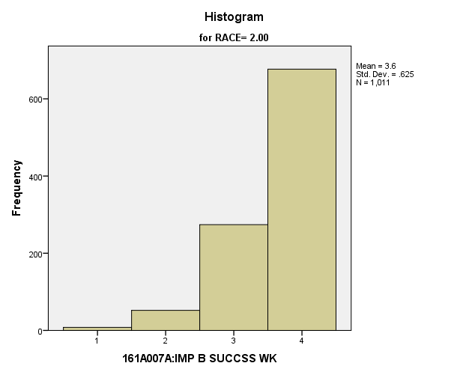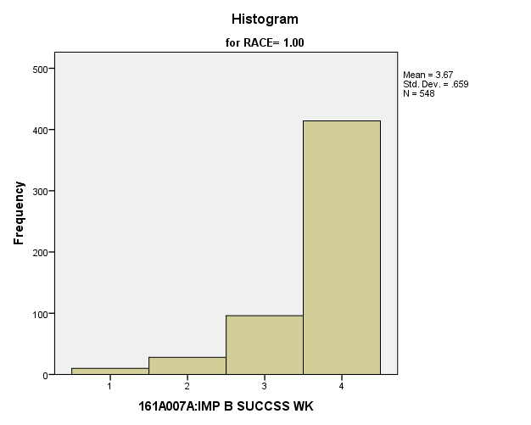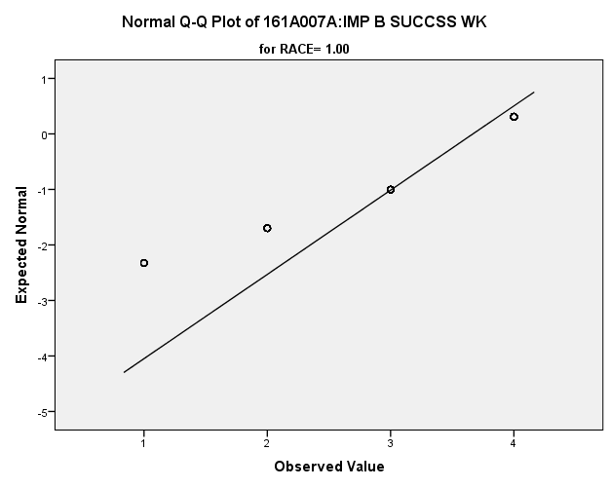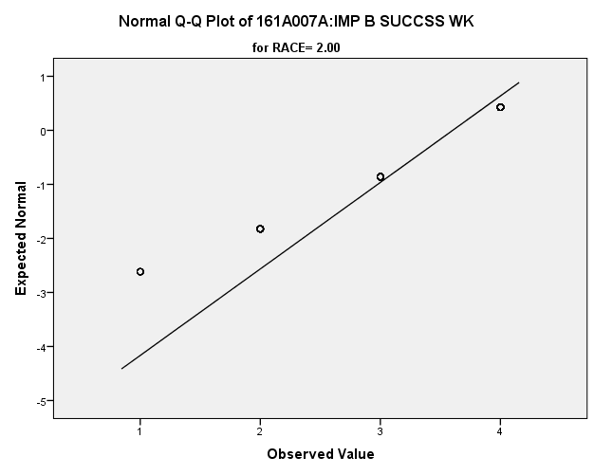

*Primary Analysis:*

|  |  |  |  |  |  |
| --- | --- | --- | --- | --- | --- |
| ***Group Statistics*** | | | | | |
|  | RACE | N | Mean | Std. Deviation | Std. Error Mean |
| 161A007A:IMP B SUCCSS WK | 1.00 | **548** | **3.67** | **.659** | **.028** |
| 2.00 | **1011** | **3.60** | **.625** | **.020** |

|  |  |  |  |  |
| --- | --- | --- | --- | --- |
| ***Independent Samples Test*** | | | | |
|  | | Levene's Test for Equality of Variances | | t-test for Equality of Means |
| F | Sig. | t |
|
| 161A007A:IMP B SUCCSS WK | Equal variances assumed | **2.522** | **.112** | **1.939** |
| Equal variances not assumed |  |  | **1.908** |

|  |  |  |  |  |
| --- | --- | --- | --- | --- |
| ***Independent Samples Test*** | | | | |
|  | | t-test for Equality of Means | | |
| df | Sig. (2-tailed) | Mean Difference |
|
| 161A007A:IMP B SUCCSS WK | Equal variances assumed | **1557** | **.053** | **.066** |
| Equal variances not assumed | **1071.908** | **.057** | **.066** |

|  |  |  |  |  |
| --- | --- | --- | --- | --- |
| ***Independent Samples Test*** | | | | |
|  | | t-test for Equality of Means | | |
| Std. Error Difference | 99% Confidence Interval of the Difference | |
| Lower | Upper |
| 161A007A:IMP B SUCCSS WK | Equal variances assumed | **.034** | **-.022** | **.153** |
| Equal variances not assumed | **.034** | **-.023** | **.154** |

**Importance of Having a Good Marriage and Family:** Within the potential recruit group, are there racial differences in how important they thought it was to have lots of money?

**Variables used:** The dependent variable was importance of having a good marriage and family, with students rating the importance on a scale of 1 to 4, with a higher number meaning more importance. The independent (grouping) variable was race (white or non-white).

**Analysis Procedure:**

* A t-test was used to compare average rating of how important students found a good marriage and family between the two racial groups (whites versus non-whites)
* Before conducting analysis, the distribution for importance of having a good marriage and family was checked separately for the two groups by means of visual inspection of histograms and Q-Q plots. No outliers were observed and the distributions were left skewed.
* The equality of variances assumption was tested. This assumption was met.

**Results:**

* Null and alternative hypothesis. H0: μ1 = μ2; Ha: μ1 ≠ μ2.
* Calculated t value: t = -.882, df = 1559, fail to reject H0, with a p-value of .378

**Interpretation:** There is not a significant difference between the two groups in how important they found having a good marriage to be based on their race.

**Supporting Analysis:**

*Preliminary Analysis:*

|  |  |  |  |  |
| --- | --- | --- | --- | --- |
| ***Descriptives*** | | | | |
|  | RACE | | | Statistic |
| 161A007B:IMP GD MRRG/FAM | 1.00 | Mean | | **3.60** |
| 99% Confidence Interval for Mean | Lower Bound | **3.52** |
| Upper Bound | **3.69** |
| 5% Trimmed Mean | | **3.72** |
| Median | | **4.00** |
| Variance | | **.597** |
| Std. Deviation | | **.773** |
| Minimum | | **1** |
| Maximum | | **4** |
| Range | | **3** |
| Interquartile Range | | **1** |
| Skewness | | **-2.068** |
| Kurtosis | | **3.570** |
| 2.00 | Mean | | **3.64** |
| 99% Confidence Interval for Mean | Lower Bound | **3.58** |
| Upper Bound | **3.70** |
| 5% Trimmed Mean | | **3.74** |
| Median | | **4.00** |
| Variance | | **.520** |
| Std. Deviation | | **.721** |
| Minimum | | **1** |
| Maximum | | **4** |
| Range | | **3** |
| Interquartile Range | | **0** |
| Skewness | | **-2.067** |
| Kurtosis | | **3.591** |

|  |  |  |  |  |
| --- | --- | --- | --- | --- |
| ***Descriptives*** | | | | |
|  | RACE | | | Std. Error |
| 161A007B:IMP GD MRRG/FAM | 1.00 | Mean | | **.033** |
| 99% Confidence Interval for Mean | Lower Bound |  |
| Upper Bound |  |
| 5% Trimmed Mean | |  |
| Median | |  |
| Variance | |  |
| Std. Deviation | |  |
| Minimum | |  |
| Maximum | |  |
| Range | |  |
| Interquartile Range | |  |
| Skewness | | **.104** |
| Kurtosis | | **.208** |
| 2.00 | Mean | | **.023** |
| 99% Confidence Interval for Mean | Lower Bound |  |
| Upper Bound |  |
| 5% Trimmed Mean | |  |
| Median | |  |
| Variance | |  |
| Std. Deviation | |  |
| Minimum | |  |
| Maximum | |  |
| Range | |  |
| Interquartile Range | |  |
| Skewness | | **.077** |
| Kurtosis | | **.154** |

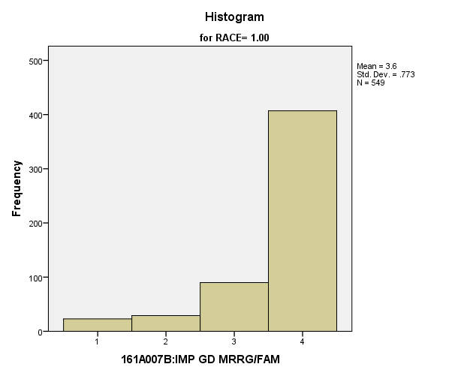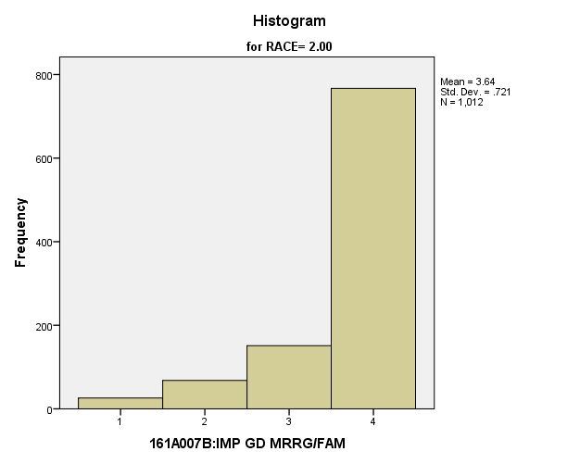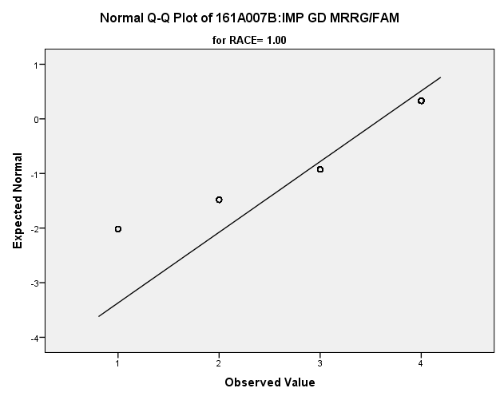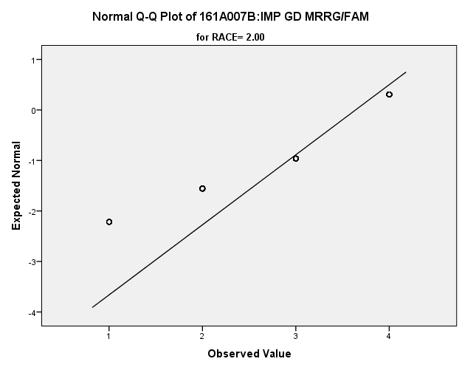

*Primary Analysis:*

|  |  |  |  |  |  |
| --- | --- | --- | --- | --- | --- |
| ***Group Statistics*** | | | | | |
|  | RACE | N | Mean | Std. Deviation | Std. Error Mean |
| 161A007B:IMP GD MRRG/FAM | 1.00 | **549** | **3.60** | **.773** | **.033** |
| 2.00 | **1012** | **3.64** | **.721** | **.023** |

|  |  |  |  |  |
| --- | --- | --- | --- | --- |
| ***Independent Samples Test*** | | | | |
|  | | Levene's Test for Equality of Variances | | t-test for Equality of Means |
| F | Sig. | t |
|
| 161A007B:IMP GD MRRG/FAM | Equal variances assumed | **2.376** | **.123** | **-.882** |
| Equal variances not assumed |  |  | **-.864** |

|  |  |  |  |  |
| --- | --- | --- | --- | --- |
| ***Independent Samples Test*** | | | | |
|  | | t-test for Equality of Means | | |
| df | Sig. (2-tailed) | Mean Difference |
|
| 161A007B:IMP GD MRRG/FAM | Equal variances assumed | **1559** | **.378** | **-.035** |
| Equal variances not assumed | **1059.545** | **.388** | **-.035** |

|  |  |  |  |  |
| --- | --- | --- | --- | --- |
| ***Independent Samples Test*** | | | | |
|  | | t-test for Equality of Means | | |
| Std. Error Difference | 99% Confidence Interval of the Difference | |
| Lower | Upper |
| 161A007B:IMP GD MRRG/FAM | Equal variances assumed | **.039** | **-.136** | **.067** |
| Equal variances not assumed | **.040** | **-.138** | **.069** |

**Importance of Having Lots of Money:** Within the potential recruit group, are there racial differences in how important they thought it was to have lots of money?

**Variables used:** The dependent variable was importance of having lots of money, with students rating the importance on a scale of 1 to 4, with a higher number meaning more importance. The independent (grouping) variable was race (white or non-white).

**Analysis Procedure:**

* A t-test was used to compare average rating of how important students found having lots of money between the two racial groups (whites versus non-whites)
* Before conducting analysis, the distribution for importance of having lots of money was checked separately for the two groups by means of visual inspection of histograms and Q-Q plots. No outliers were observed.
* The equality of variances assumption was tested. This assumption was met.

**Results:**

* Null and alternative hypothesis. H0: μ1 = μ2; Ha: μ1 ≠ μ2.
* Calculated t value: t = 2.556, df = 283, fail to reject H0, with a p-value of .011

**Interpretation:** There is not a significant difference between the two racial groups in how important they found having lots of money.

**Supporting Analysis:**

*Preliminary Analysis:*

|  |  |  |  |  |
| --- | --- | --- | --- | --- |
| ***Descriptives*** | | | | |
|  | RACE | | | Statistic |
| 161A007C:IMP LOTS OF $ | 1.00 | Mean | | **3.14** |
| 99% Confidence Interval for Mean | Lower Bound | **3.04** |
| Upper Bound | **3.24** |
| 5% Trimmed Mean | | **3.21** |
| Median | | **3.00** |
| Variance | | **.783** |
| Std. Deviation | | **.885** |
| Minimum | | **1** |
| Maximum | | **4** |
| Range | | **3** |
| Interquartile Range | | **1** |
| Skewness | | **-.681** |
| Kurtosis | | **-.491** |
| 2.00 | Mean | | **2.84** |
| 99% Confidence Interval for Mean | Lower Bound | **2.77** |
| Upper Bound | **2.91** |
| 5% Trimmed Mean | | **2.88** |
| Median | | **3.00** |
| Variance | | **.786** |
| Std. Deviation | | **.887** |
| Minimum | | **1** |
| Maximum | | **4** |
| Range | | **3** |
| Interquartile Range | | **2** |
| Skewness | | **-.227** |
| Kurtosis | | **-.812** |

|  |  |  |  |  |
| --- | --- | --- | --- | --- |
| ***Descriptives*** | | | | |
|  | RACE | | | Std. Error |
| 161A007C:IMP LOTS OF $ | 1.00 | Mean | | **.038** |
| 99% Confidence Interval for Mean | Lower Bound |  |
| Upper Bound |  |
| 5% Trimmed Mean | |  |
| Median | |  |
| Variance | |  |
| Std. Deviation | |  |
| Minimum | |  |
| Maximum | |  |
| Range | |  |
| Interquartile Range | |  |
| Skewness | | **.105** |
| Kurtosis | | **.210** |
| 2.00 | Mean | | **.028** |
| 99% Confidence Interval for Mean | Lower Bound |  |
| Upper Bound |  |
| 5% Trimmed Mean | |  |
| Median | |  |
| Variance | |  |
| Std. Deviation | |  |
| Minimum | |  |
| Maximum | |  |
| Range | |  |
| Interquartile Range | |  |
| Skewness | | **.077** |
| Kurtosis | | **.154** |

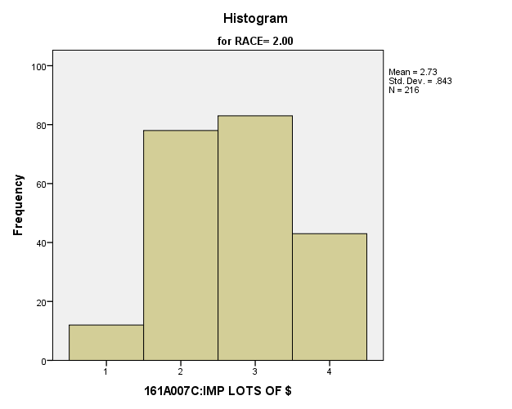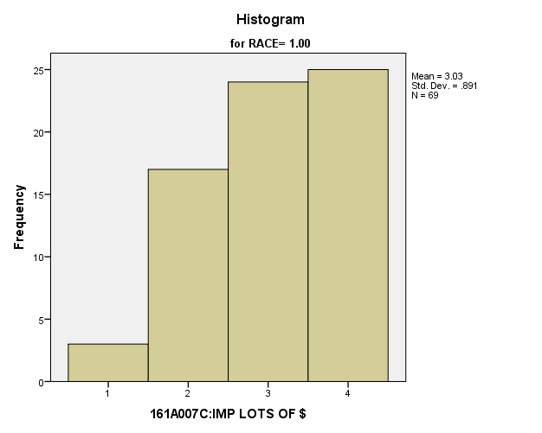

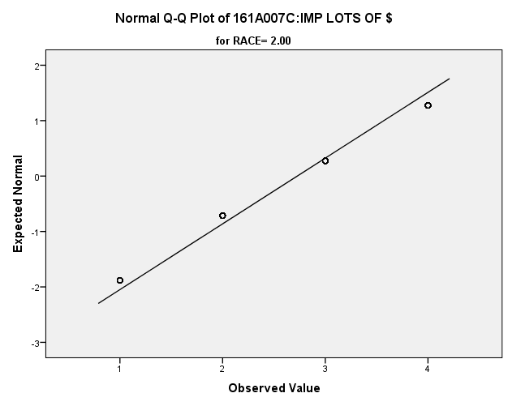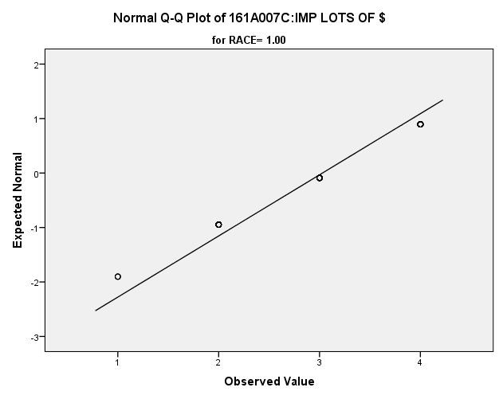

*Primary Analysis:*

|  |  |  |  |  |  |  |  |  |  |  |  |  |
| --- | --- | --- | --- | --- | --- | --- | --- | --- | --- | --- | --- | --- |
| **Group Statistics** | | | | | | | | | | | | |
|  | RACE | | N | Mean | | | Std. Deviation | | | Std. Error Mean | | |
| V1657 | 1.00 | | 69 | 3.03 | | | .891 | | | .107 | | |
| 2.00 | | 216 | 2.73 | | | .843 | | | .057 | | |
| **Independent Samples Test** | | | | | | | | | | | | | | | |
|  | | | | | Levene's Test for Equality of Variances | | | | | | t-test for Equality of Means | | | | |
| F | | | Sig. | | | t | | | df | |
|
| V1657 | Equal variances assumed | | | | .042 | | | .838 | | | 2.556 | | | 283 | |
| Equal variances not assumed | | | |  | | |  | | | 2.484 | | | 109.675 | |
| **Independent Samples Test** | | | | | | | | | | | | | | | | |
|  | | | | | | t-test for Equality of Means | | | | | | | | | | |
| Sig. (2-tailed) | | | Mean Difference | | | Std. Error Difference | | | 99% Confidence Interval of the Difference | |
| Lower | |
| V1657 | | Equal variances assumed | | | | .011 | | | .302 | | | .118 | | | -.004 | |
| Equal variances not assumed | | | | .014 | | | .302 | | | .122 | | | -.017 | |

|  |  |  |
| --- | --- | --- |
| **Independent Samples Test** | | |
|  | | t-test for Equality of Means |
| 99% Confidence Interval of the Difference |
| Upper |
| V1657 | Equal variances assumed | .609 |
| Equal variances not assumed | .621 |

**Importance of Having Time for Recreation and Hobby:** Within the potential recruit group, are there racial differences in how important they thought it was to have time for recreation and hobby?

**Variables used:** The dependent variable was importance of having time for recreation and hobby, with students rating importance on scale from 1 to 4, with a larger number meaning more importance. The independent (grouping) variable was race (white or non-white).

**Analysis Procedure:**

* A t-test was used to compare average rating of how important students found having time for recreation and hobby between the two racial groups (whites versus non-whites)
* Before conducting analysis, the distribution for importance of having time for recreation and hobby was checked separately for the two groups by means of visual inspection of histograms and Q-Q plots. No outliers were observed. However, the distribution was left skewed for both groups.
* The equality of variances assumption was tested. This assumption was not met.

**Results:**

* Null and alternative hypothesis. H0: μ1 = μ2; Ha: μ1 ≠ μ2.
* Calculated t value: t = -.677, df = 1003, fail to reject H0, with a p-value .499

**Interpretation:** There is not a significant difference between the two groups in how important students found having time for recreation and hobby based on their race.

**Supporting Analysis:**

*Preliminary Analysis:*

|  |  |  |  |  |
| --- | --- | --- | --- | --- |
| ***Descriptives*** | | | | |
|  | RACE | | | Statistic |
| 161A007D:IMP TM RCRN/HBY | 1.00 | Mean | | **3.11** |
| 99% Confidence Interval for Mean | Lower Bound | **3.02** |
| Upper Bound | **3.20** |
| 5% Trimmed Mean | | **3.16** |
| Median | | **3.00** |
| Variance | | **.714** |
| Std. Deviation | | **.845** |
| Minimum | | **1** |
| Maximum | | **4** |
| Range | | **3** |
| Interquartile Range | | **1** |
| Skewness | | **-.574** |
| Kurtosis | | **-.513** |
| 2.00 | Mean | | **3.14** |
| 99% Confidence Interval for Mean | Lower Bound | **3.08** |
| Upper Bound | **3.20** |
| 5% Trimmed Mean | | **3.16** |
| Median | | **3.00** |
| Variance | | **.547** |
| Std. Deviation | | **.739** |
| Minimum | | **1** |
| Maximum | | **4** |
| Range | | **3** |
| Interquartile Range | | **1** |
| Skewness | | **-.358** |
| Kurtosis | | **-.688** |

|  |  |  |  |  |
| --- | --- | --- | --- | --- |
| ***Descriptives*** | | | | |
|  | RACE | | | Std. Error |
| 161A007D:IMP TM RCRN/HBY | 1.00 | Mean | | **.036** |
| 99% Confidence Interval for Mean | Lower Bound |  |
| Upper Bound |  |
| 5% Trimmed Mean | |  |
| Median | |  |
| Variance | |  |
| Std. Deviation | |  |
| Minimum | |  |
| Maximum | |  |
| Range | |  |
| Interquartile Range | |  |
| Skewness | | **.104** |
| Kurtosis | | **.208** |
| 2.00 | Mean | | **.023** |
| 99% Confidence Interval for Mean | Lower Bound |  |
| Upper Bound |  |
| 5% Trimmed Mean | |  |
| Median | |  |
| Variance | |  |
| Std. Deviation | |  |
| Minimum | |  |
| Maximum | |  |
| Range | |  |
| Interquartile Range | |  |
| Skewness | | **.077** |
| Kurtosis | | **.154** |

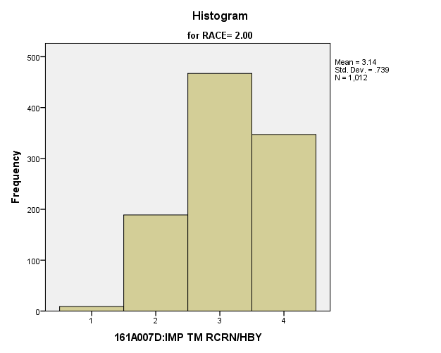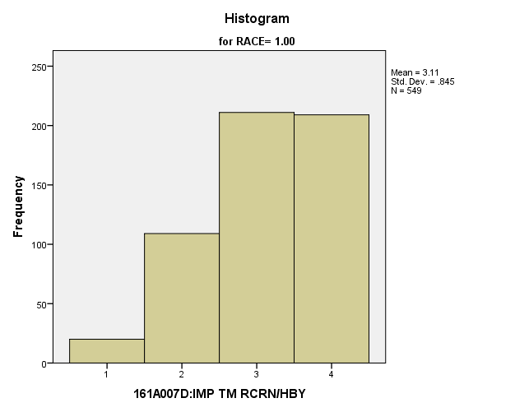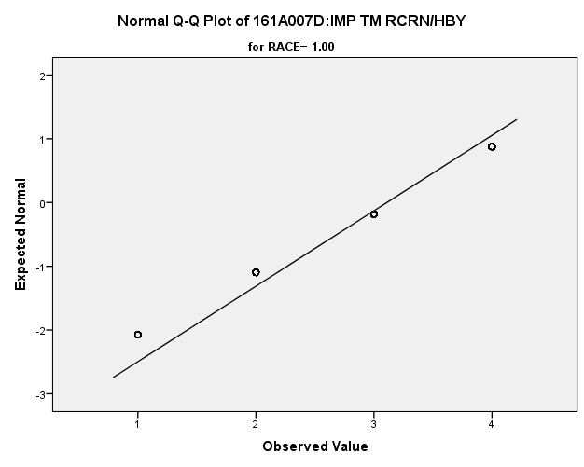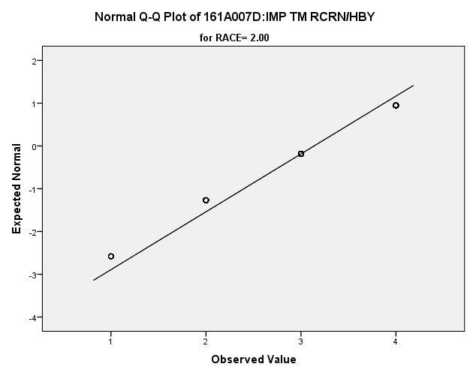

*Primary Analysis:*

|  |  |  |  |  |  |
| --- | --- | --- | --- | --- | --- |
| ***Group Statistics*** | | | | | |
|  | RACE | N | Mean | Std. Deviation | Std. Error Mean |
| 161A007D:IMP TM RCRN/HBY | 1.00 | **549** | **3.11** | **.845** | **.036** |
| 2.00 | **1012** | **3.14** | **.739** | **.023** |

|  |  |  |  |  |
| --- | --- | --- | --- | --- |
| ***Independent Samples Test*** | | | | |
|  | | Levene's Test for Equality of Variances | | t-test for Equality of Means |
| F | Sig. | t |
|
| 161A007D:IMP TM RCRN/HBY | Equal variances assumed | **12.495** | **.000** | **-.704** |
| Equal variances not assumed |  |  | **-.677** |

|  |  |  |  |  |
| --- | --- | --- | --- | --- |
| ***Independent Samples Test*** | | | | |
|  | | t-test for Equality of Means | | |
| df | Sig. (2-tailed) | Mean Difference |
|
| 161A007D:IMP TM RCRN/HBY | Equal variances assumed | **1559** | **.481** | **-.029** |
| Equal variances not assumed | **1003.673** | **.499** | **-.029** |

|  |  |  |  |  |
| --- | --- | --- | --- | --- |
| ***Independent Samples Test*** | | | | |
|  | | t-test for Equality of Means | | |
| Std. Error Difference | 99% Confidence Interval of the Difference | |
| Lower | Upper |
| 161A007D:IMP TM RCRN/HBY | Equal variances assumed | **.041** | **-.135** | **.077** |
| Equal variances not assumed | **.043** | **-.140** | **.082** |

**Importance of Having Strong Friendships:** Within the potential recruit group, are there racial differences in how important they thought it was to have strong friendships?

**Variables used:** The dependent variable was importance of having strong friendships, with students rating importance on scale from 1 to 4, with a larger number meaning more importance. The independent (grouping) variable was race (white or non-white).

**Analysis Procedure:**

* A t-test was used to compare average rating of how important students found having strong friendships between the two racial groups (whites versus non-whites)
* Before conducting analysis, the distribution for importance of having strong friendships was checked separately for the two groups by means of visual inspection of histograms and Q-Q plots. No outliers were observed. However, the distribution of how important students having strong friendships was left skewed for both groups.
* The equality of variances assumption was tested. This assumption was not met.
* Eta Squared was calculated to assess effect size.

**Results:**

* Null and alternative hypothesis. H0: μ1 = μ2; Ha: μ1 ≠ μ2.
* Calculated t value: t = -3.471, df = 91.971, reject H0, with a p-value or .001; Eta Squared = .002.

**Interpretation:** There is a significant difference between the two racial groups in how important they found having strong friendships to be. Furthermore, .2% of how important students found it to be was due to their race.

**Supporting Analysis:**

*Preliminary Analysis:*

|  |  |  |  |  |  |  |
| --- | --- | --- | --- | --- | --- | --- |
| ***Case Processing Summary*** | | | | | | |
|  | RACE | Cases | | | | |
| Valid | | Missing | | Total |
| N | Percent | N | Percent | N |
| 161A007E:IMP STRG FRDSHP | 1.00 | **547** | **97.3%** | **15** | **2.7%** | **562** |
| 2.00 | **1012** | **98.3%** | **17** | **1.7%** | **1029** |

|  |  |  |
| --- | --- | --- |
| ***Case Processing Summary*** | | |
|  | RACE | Cases |
| Total |
| Percent |
| 161A007E:IMP STRG FRDSHP | 1.00 | **100.0%** |
| 2.00 | **100.0%** |

|  |  |  |  |  |
| --- | --- | --- | --- | --- |
| ***Descriptives*** | | | | |
|  | RACE | | | Statistic |
| 161A007E:IMP STRG FRDSHP | 1.00 | Mean | | **3.33** |
| 99% Confidence Interval for Mean | Lower Bound | **3.23** |
| Upper Bound | **3.42** |
| 5% Trimmed Mean | | **3.42** |
| Median | | **4.00** |
| Variance | | **.795** |
| Std. Deviation | | **.892** |
| Minimum | | **1** |
| Maximum | | **4** |
| Range | | **3** |
| Interquartile Range | | **1** |
| Skewness | | **-1.106** |
| Kurtosis | | **.175** |
| 2.00 | Mean | | **3.58** |
| 99% Confidence Interval for Mean | Lower Bound | **3.53** |
| Upper Bound | **3.63** |
| 5% Trimmed Mean | | **3.65** |
| Median | | **4.00** |
| Variance | | **.426** |
| Std. Deviation | | **.653** |
| Minimum | | **1** |
| Maximum | | **4** |
| Range | | **3** |
| Interquartile Range | | **1** |
| Skewness | | **-1.488** |
| Kurtosis | | **1.801** |

|  |  |  |  |  |
| --- | --- | --- | --- | --- |
| ***Descriptives*** | | | | |
|  | RACE | | | Std. Error |
| 161A007E:IMP STRG FRDSHP | 1.00 | Mean | | **.038** |
| 99% Confidence Interval for Mean | Lower Bound |  |
| Upper Bound |  |
| 5% Trimmed Mean | |  |
| Median | |  |
| Variance | |  |
| Std. Deviation | |  |
| Minimum | |  |
| Maximum | |  |
| Range | |  |
| Interquartile Range | |  |
| Skewness | | **.104** |
| Kurtosis | | **.209** |
| 2.00 | Mean | | **.021** |
| 99% Confidence Interval for Mean | Lower Bound |  |
| Upper Bound |  |
| 5% Trimmed Mean | |  |
| Median | |  |
| Variance | |  |
| Std. Deviation | |  |
| Minimum | |  |
| Maximum | |  |
| Range | |  |
| Interquartile Range | |  |
| Skewness | | **.077** |
| Kurtosis | | **.154** |

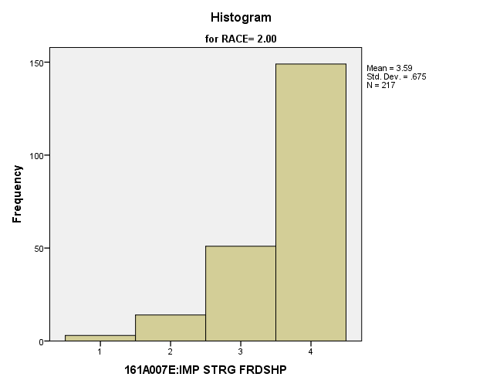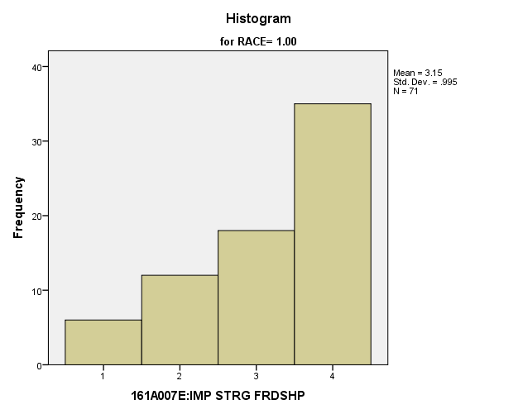

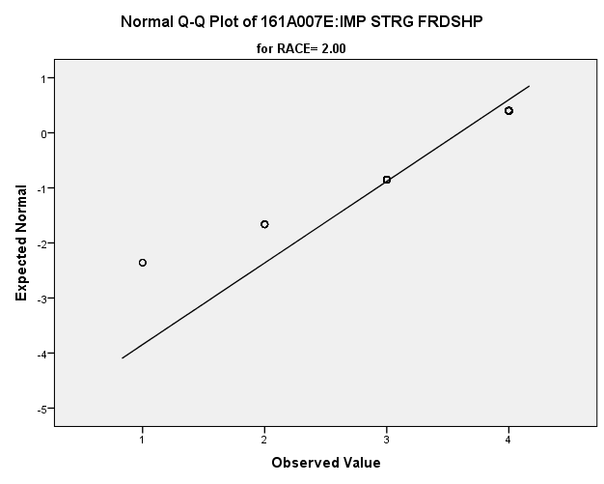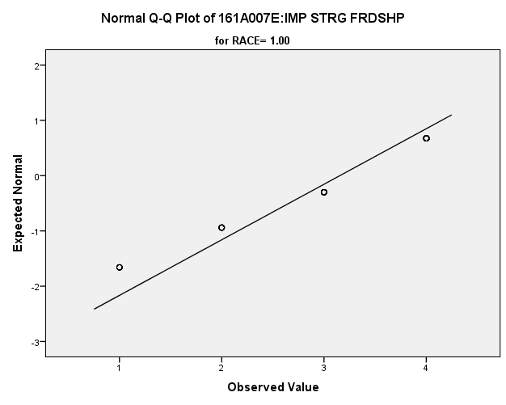

*Primary Analysis:*

|  |  |  |  |  |  |  |  |  |  |  |  |  |
| --- | --- | --- | --- | --- | --- | --- | --- | --- | --- | --- | --- | --- |
| **Group Statistics** | | | | | | | | | | | | |
|  | RACE | | N | Mean | | | Std. Deviation | | | Std. Error Mean | | |
| V1659 | 1.00 | | 71 | 3.15 | | | .995 | | | .118 | | |
| 2.00 | | 217 | 3.59 | | | .675 | | | .046 | | |
| **Independent Samples Test** | | | | | | | | | | | | | | | |
|  | | | | | Levene's Test for Equality of Variances | | | | | | t-test for Equality of Means | | | | |
| F | | | Sig. | | | t | | | df | |
|
| V1659 | Equal variances assumed | | | | 22.887 | | | .000 | | | -4.199 | | | 286 | |
| Equal variances not assumed | | | |  | | |  | | | -3.471 | | | 91.971 | |
| **Independent Samples Test** | | | | | | | | | | | | | | | | |
|  | | | | | | t-test for Equality of Means | | | | | | | | | | |
| Sig. (2-tailed) | | | Mean Difference | | | Std. Error Difference | | | 99% Confidence Interval of the Difference | |
| Lower | |
| V1659 | | Equal variances assumed | | | | .000 | | | -.440 | | | .105 | | | -.711 | |
| Equal variances not assumed | | | | .001 | | | -.440 | | | .127 | | | -.773 | |

|  |  |  |
| --- | --- | --- |
| **Independent Samples Test** | | |
|  | | t-test for Equality of Means |
| 99% Confidence Interval of the Difference |
| Upper |
| V1659 | Equal variances assumed | -.168 |
| Equal variances not assumed | -.106 |

|  |  |  |
| --- | --- | --- |
| **Measures of Association** | | |
|  | Eta | Eta Squared |
| V1655 * RACE | **.049** | **.002** |

**Importance of Having Steady Work:** Within the potential recruit group, are there racial differences in how important they thought it was to have steady work?

**Variables used:** The dependent variable was importance of having steady work, with students rating importance on a scale from 1 to 4, with a higher number meaning more importance. The independent (grouping) variable was race (white or non-white).

**Analysis Procedure:**

* A t-test was used to compare average rating of how important students found having steady work to be between the two racial groups (whites versus non-whites)
* Before conducting analysis, the distribution for importance of having steady work was checked separately for the two groups by means of visual inspection of histograms and Q-Q plots. No outliers were observed. However, the distribution of how important students found having steady work was left skewed for both groups.
* The equality of variances assumption was tested. This assumption was met.

**Results:**

* Null and alternative hypothesis. H0: μ1 = μ2; Ha: μ1 ≠ μ2.
* Calculated t value: t = .559, df = 286, fail to reject H0, with a p-value of .577

**Interpretation:** There is not a significant difference between the two racial groups in how important they found having steady work to be.

**Supporting Analysis:**

*Preliminary Analysis:*

|  |  |  |  |  |
| --- | --- | --- | --- | --- |
| ***Descriptives*** | | | | |
|  | RACE | | | Statistic |
| 161A007F:IMP STEADY WORK | 1.00 | Mean | | **3.72** |
| 99% Confidence Interval for Mean | Lower Bound | **3.66** |
| Upper Bound | **3.79** |
| 5% Trimmed Mean | | **3.81** |
| Median | | **4.00** |
| Variance | | **.324** |
| Std. Deviation | | **.569** |
| Minimum | | **1** |
| Maximum | | **4** |
| Range | | **3** |
| Interquartile Range | | **0** |
| Skewness | | **-2.306** |
| Kurtosis | | **5.776** |
| 2.00 | Mean | | **3.66** |
| 99% Confidence Interval for Mean | Lower Bound | **3.62** |
| Upper Bound | **3.71** |
| 5% Trimmed Mean | | **3.74** |
| Median | | **4.00** |
| Variance | | **.330** |
| Std. Deviation | | **.575** |
| Minimum | | **1** |
| Maximum | | **4** |
| Range | | **3** |
| Interquartile Range | | **1** |
| Skewness | | **-1.635** |
| Kurtosis | | **2.282** |

|  |  |  |  |  |
| --- | --- | --- | --- | --- |
| ***Descriptives*** | | | | |
|  | RACE | | | Std. Error |
| 161A007F:IMP STEADY WORK | 1.00 | Mean | | **.024** |
| 99% Confidence Interval for Mean | Lower Bound |  |
| Upper Bound |  |
| 5% Trimmed Mean | |  |
| Median | |  |
| Variance | |  |
| Std. Deviation | |  |
| Minimum | |  |
| Maximum | |  |
| Range | |  |
| Interquartile Range | |  |
| Skewness | | **.104** |
| Kurtosis | | **.208** |
| 2.00 | Mean | | **.018** |
| 99% Confidence Interval for Mean | Lower Bound |  |
| Upper Bound |  |
| 5% Trimmed Mean | |  |
| Median | |  |
| Variance | |  |
| Std. Deviation | |  |
| Minimum | |  |
| Maximum | |  |
| Range | |  |
| Interquartile Range | |  |
| Skewness | | **.077** |
| Kurtosis | | **.154** |

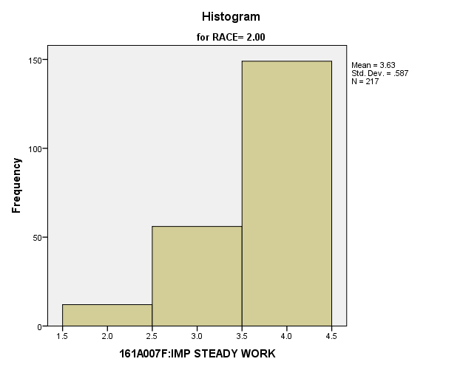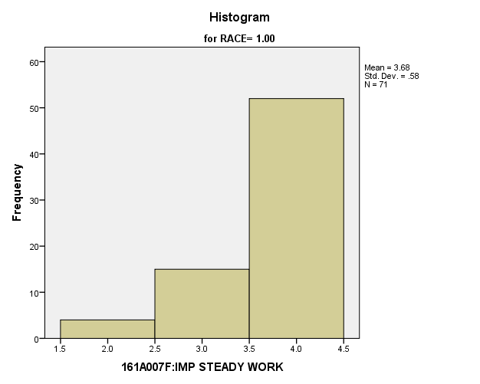

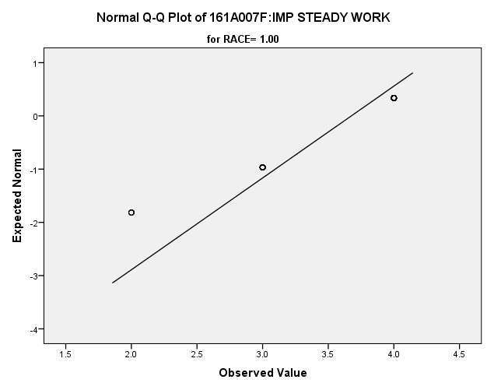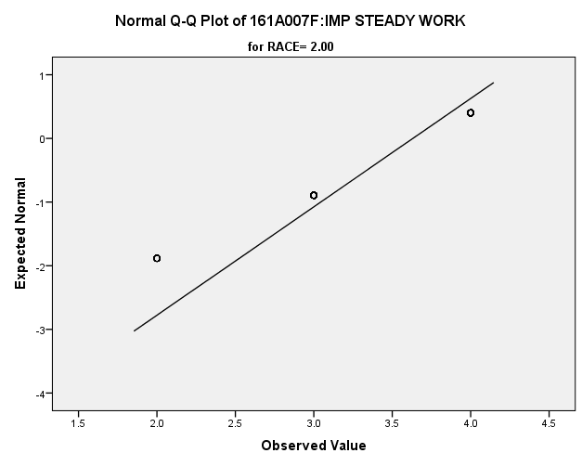

*Primary Analysis:*

|  |  |  |  |  |  |  |  |  |  |  |  |  |
| --- | --- | --- | --- | --- | --- | --- | --- | --- | --- | --- | --- | --- |
| **Group Statistics** | | | | | | | | | | | | |
|  | RACE | | N | Mean | | | Std. Deviation | | | Std. Error Mean | | |
| V1660 | 1.00 | | 71 | 3.68 | | | .580 | | | .069 | | |
| 2.00 | | 217 | 3.63 | | | .587 | | | .040 | | |
| **Independent Samples Test** | | | | | | | | | | | | | | | |
|  | | | | | Levene's Test for Equality of Variances | | | | | | t-test for Equality of Means | | | | |
| F | | | Sig. | | | t | | | df | |
|
| V1660 | Equal variances assumed | | | | .584 | | | .445 | | | .559 | | | 286 | |
| Equal variances not assumed | | | |  | | |  | | | .562 | | | 120.452 | |
| **Independent Samples Test** | | | | | | | | | | | | | | | | |
|  | | | | | | t-test for Equality of Means | | | | | | | | | | |
| Sig. (2-tailed) | | | Mean Difference | | | Std. Error Difference | | | 99% Confidence Interval of the Difference | |
| Lower | |
| V1660 | | Equal variances assumed | | | | .577 | | | .045 | | | .080 | | | -.163 | |
| Equal variances not assumed | | | | .575 | | | .045 | | | .080 | | | -.163 | |

|  |  |  |
| --- | --- | --- |
| **Independent Samples Test** | | |
|  | | t-test for Equality of Means |
| 99% Confidence Interval of the Difference |
| Upper |
| V1660 | Equal variances assumed | .252 |
| Equal variances not assumed | .253 |

**Importance of Contribute to Society:** Within the potential recruit group, are there racial differences in how important they thought it was to contribute to society?

**Variables used:** The dependent variable was importance of making a contribution to society, with students rating importance on a scale from 1 to 4, with a higher number meaning more importance. The independent (grouping) variable was race (white or non-white).

**Analysis Procedure:**

* A t-test was used to compare average rating of how important students found making a contribution to society to be between the two racial groups (whites versus non-whites)
* Before conducting analysis, the distribution for making a contribution to society was checked separately for the two groups by means of visual inspection of histograms and Q-Q plots. No outliers were observed. However, the distribution of how important students found making a contribution to society was left skewed for both groups.
* The equality of variances assumption was tested. This assumption was met.

**Results:**

* Null and alternative hypothesis. H0: μ1 = μ2; Ha: μ1 ≠ μ2.
* Calculated t value: t = -1.226, df = 285, fail to reject H0, with a p-value of .221

**Interpretation:** There is not a significant difference between the two groups in how important students found making a contribution to society to be.

**Supporting Analysis:**

*Preliminary Analysis:*

|  |  |  |  |  |
| --- | --- | --- | --- | --- |
| ***Descriptives*** | | | | |
|  | RACE | | | Statistic |
| 161A007G:IMP CNTRBTN SOC | 1.00 | Mean | | **3.04** |
| 99% Confidence Interval for Mean | Lower Bound | **2.95** |
| Upper Bound | **3.14** |
| 5% Trimmed Mean | | **3.10** |
| Median | | **3.00** |
| Variance | | **.791** |
| Std. Deviation | | **.889** |
| Minimum | | **1** |
| Maximum | | **4** |
| Range | | **3** |
| Interquartile Range | | **2** |
| Skewness | | **-.510** |
| Kurtosis | | **-.687** |
| 2.00 | Mean | | **3.01** |
| 99% Confidence Interval for Mean | Lower Bound | **2.94** |
| Upper Bound | **3.07** |
| 5% Trimmed Mean | | **3.05** |
| Median | | **3.00** |
| Variance | | **.686** |
| Std. Deviation | | **.828** |
| Minimum | | **1** |
| Maximum | | **4** |
| Range | | **3** |
| Interquartile Range | | **2** |
| Skewness | | **-.390** |
| Kurtosis | | **-.616** |

|  |  |  |  |  |
| --- | --- | --- | --- | --- |
| ***Descriptives*** | | | | |
|  | RACE | | | Std. Error |
| 161A007G:IMP CNTRBTN SOC | 1.00 | Mean | | **.038** |
| 99% Confidence Interval for Mean | Lower Bound |  |
| Upper Bound |  |
| 5% Trimmed Mean | |  |
| Median | |  |
| Variance | |  |
| Std. Deviation | |  |
| Minimum | |  |
| Maximum | |  |
| Range | |  |
| Interquartile Range | |  |
| Skewness | | **.105** |
| Kurtosis | | **.209** |
| 2.00 | Mean | | **.026** |
| 99% Confidence Interval for Mean | Lower Bound |  |
| Upper Bound |  |
| 5% Trimmed Mean | |  |
| Median | |  |
| Variance | |  |
| Std. Deviation | |  |
| Minimum | |  |
| Maximum | |  |
| Range | |  |
| Interquartile Range | |  |
| Skewness | | **.077** |
| Kurtosis | | **.154** |

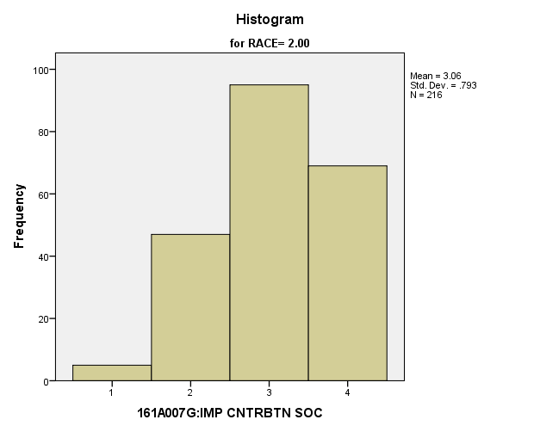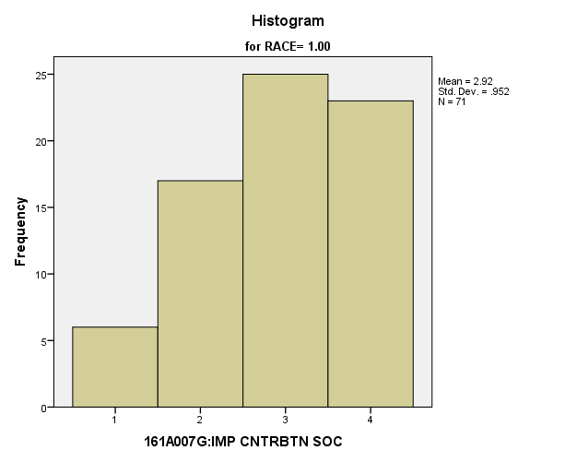

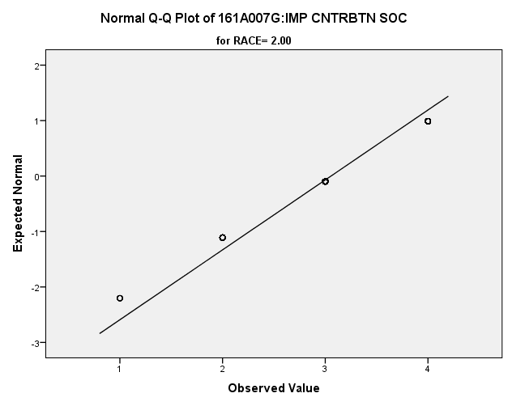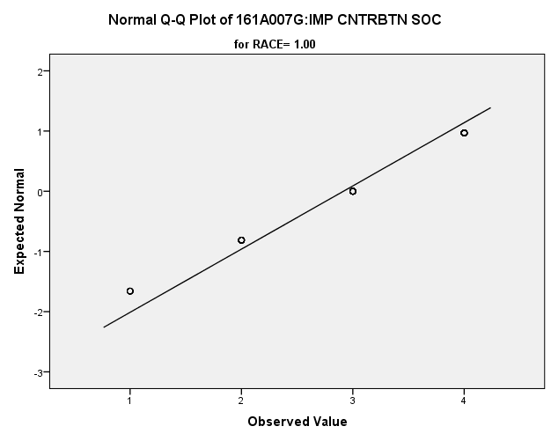

*Primary Analysis:*

|  |  |  |  |  |  |  |  |  |  |  |  |  |
| --- | --- | --- | --- | --- | --- | --- | --- | --- | --- | --- | --- | --- |
| **Group Statistics** | | | | | | | | | | | | |
|  | RACE | | N | Mean | | | Std. Deviation | | | Std. Error Mean | | |
| V1661 | 1.00 | | 71 | 2.92 | | | .952 | | | .113 | | |
| 2.00 | | 216 | 3.06 | | | .793 | | | .054 | | |
| **Independent Samples Test** | | | | | | | | | | | | | | | |
|  | | | | | Levene's Test for Equality of Variances | | | | | | t-test for Equality of Means | | | | |
| F | | | Sig. | | | t | | | df | |
|
| V1661 | Equal variances assumed | | | | 4.862 | | | .028 | | | -1.226 | | | 285 | |
| Equal variances not assumed | | | |  | | |  | | | -1.118 | | | 103.819 | |
| **Independent Samples Test** | | | | | | | | | | | | | | | | |
|  | | | | | | t-test for Equality of Means | | | | | | | | | | |
| Sig. (2-tailed) | | | Mean Difference | | | Std. Error Difference | | | 99% Confidence Interval of the Difference | |
| Lower | |
| V1661 | | Equal variances assumed | | | | .221 | | | -.140 | | | .114 | | | -.436 | |
| Equal variances not assumed | | | | .266 | | | -.140 | | | .125 | | | -.469 | |

|  |  |  |
| --- | --- | --- |
| **Independent Samples Test** | | |
|  | | t-test for Equality of Means |
| 99% Confidence Interval of the Difference |
| Upper |
| V1661 | Equal variances assumed | .156 |
| Equal variances not assumed | .189 |

**Importance of Being a Leader in the Community:** Within the potential recruit group, are there racial differences in how important they thought it was to be a leader in the community?

**Variables used:** The dependent variable was importance of being a leader in the community, with students rating importance on a scale from 1 to 4, with a higher number meaning more importance. The independent (grouping) variable was race (white or non-white).

**Analysis Procedure:**

* A t-test was used to compare average rating of how important students thought it was to be a leader in the community between the two racial groups (whites versus non-whites)
* Before conducting analysis, the distribution for how important students thought it was to be a leader in the community was checked separately for the two groups by means of visual inspection of histograms and Q-Q plots. No outliers were observed.
* The equality of variances assumption was tested. This assumption was met.

**Results:**

* Null and alternative hypothesis. H0: μ1 = μ2; Ha: μ1 ≠ μ2.
* Calculated t value: t = .399, df = 285, fail to reject H0, with a p-value of .690

**Interpretation:** There is not a significant difference between the two groups in how important students thought it was to be a leader in the community.

**Supporting Analysis:**

*Preliminary Analysis:*

|  |  |  |  |  |
| --- | --- | --- | --- | --- |
| ***Descriptives*** | | | | |
|  | RACE | | | Statistic |
| 161A007H:IMP LDR COMUNTY | 1.00 | Mean | | **2.72** |
| 99% Confidence Interval for Mean | Lower Bound | **2.60** |
| Upper Bound | **2.83** |
| 5% Trimmed Mean | | **2.74** |
| Median | | **3.00** |
| Variance | | **1.061** |
| Std. Deviation | | **1.030** |
| Minimum | | **1** |
| Maximum | | **4** |
| Range | | **3** |
| Interquartile Range | | **2** |
| Skewness | | **-.169** |
| Kurtosis | | **-1.162** |
| 2.00 | Mean | | **2.52** |
| 99% Confidence Interval for Mean | Lower Bound | **2.44** |
| Upper Bound | **2.60** |
| 5% Trimmed Mean | | **2.52** |
| Median | | **2.00** |
| Variance | | **.960** |
| Std. Deviation | | **.980** |
| Minimum | | **1** |
| Maximum | | **4** |
| Range | | **3** |
| Interquartile Range | | **1** |
| Skewness | | **.093** |
| Kurtosis | | **-1.012** |

|  |  |  |  |  |
| --- | --- | --- | --- | --- |
| ***Descriptives*** | | | | |
|  | RACE | | | Std. Error |
| 161A007H:IMP LDR COMUNTY | 1.00 | Mean | | **.044** |
| 99% Confidence Interval for Mean | Lower Bound |  |
| Upper Bound |  |
| 5% Trimmed Mean | |  |
| Median | |  |
| Variance | |  |
| Std. Deviation | |  |
| Minimum | |  |
| Maximum | |  |
| Range | |  |
| Interquartile Range | |  |
| Skewness | | **.104** |
| Kurtosis | | **.209** |
| 2.00 | Mean | | **.031** |
| 99% Confidence Interval for Mean | Lower Bound |  |
| Upper Bound |  |
| 5% Trimmed Mean | |  |
| Median | |  |
| Variance | |  |
| Std. Deviation | |  |
| Minimum | |  |
| Maximum | |  |
| Range | |  |
| Interquartile Range | |  |
| Skewness | | **.077** |
| Kurtosis | | **.154** |

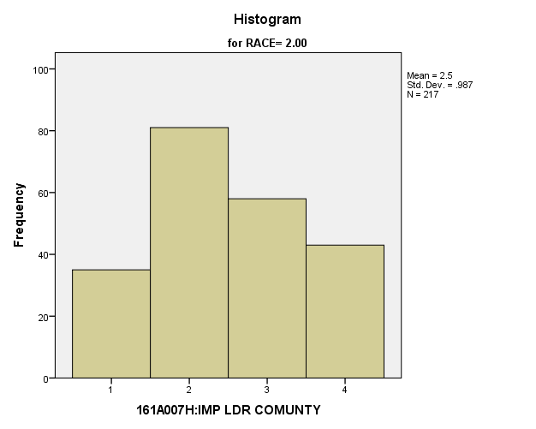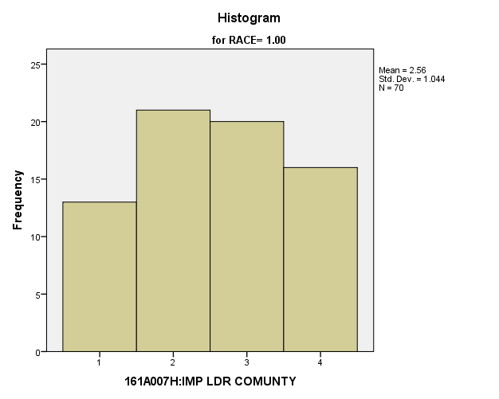

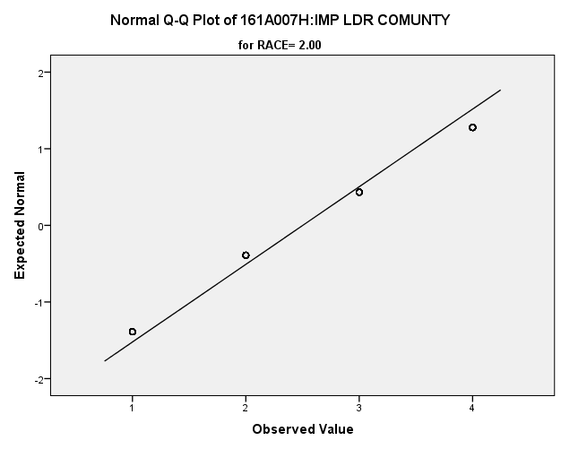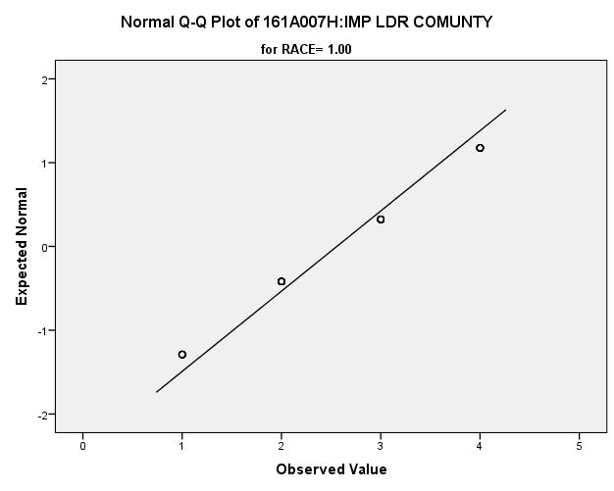

*Primary Analysis:*

|  |  |  |  |  |  |  |  |  |
| --- | --- | --- | --- | --- | --- | --- | --- | --- |
| **Group Statistics** | | | | | | | | |
|  | RACE | N | Mean | | Std. Deviation | | Std. Error Mean | |
| V1662 | 1.00 | 70 | 2.56 | | 1.044 | | .125 | |
| 2.00 | 217 | 2.50 | | .987 | | .067 | |
| **Independent Samples Test** | | | | | | | | | | |
|  | | | | Levene's Test for Equality of Variances | | | | t-test for Equality of Means | | |
| F | | Sig. | | t | | df |
|
| V1662 | Equal variances assumed | | | .635 | | .426 | | .399 | | 285 |
| Equal variances not assumed | | |  | |  | | .387 | | 111.487 |

|  |  |  |  |  |  |
| --- | --- | --- | --- | --- | --- |
| **Independent Samples Test** | | | | | |
|  | | t-test for Equality of Means | | | |
| Sig. (2-tailed) | Mean Difference | Std. Error Difference | 99% Confidence Interval of the Difference |
| Lower |
| V1662 | Equal variances assumed | .690 | .055 | .138 | -.302 |
| Equal variances not assumed | .699 | .055 | .142 | -.316 |

|  |  |  |
| --- | --- | --- |
| **Independent Samples Test** | | |
|  | | t-test for Equality of Means |
| 99% Confidence Interval of the Difference |
| Upper |
| V1662 | Equal variances assumed | .412 |
| Equal variances not assumed | .426 |

**Importance of Giving Children Better Opportunities:** Within the potential recruit group, are there racial differences in how important they thought it was to give their children better opportunities?

**Variables used:** The dependent variable was importance giving their children better opportunities, with students rating importance on a scale from 1 to 4, with a higher number meaning more importance. The independent (grouping) variable was race (white or non-white).

**Analysis Procedure:**

* A t-test was used to compare average rating of how important giving their children a better opportunity to be between the two racial groups (whites versus non-whites)
* Before conducting analysis, the distribution was done separately for the two groups by means of visual inspection of histograms and Q-Q plots. No outliers were observed. However, the distribution was left skewed for both groups.
* The equality of variances assumption was tested. This assumption was not met.

**Results:**

* Null and alternative hypothesis. H0: μ1 = μ2; Ha: μ1 ≠ μ2.
* Calculated t value: t = 5.96, df = 1340, reject H0, with a p-value of .000; Eta squared = .020

**Interpretation:** There is a significant difference between the two groups in how important students found giving their children better opportunities. Furthermore, 2% of how important they found it to be was due to their race.

**Supporting Analysis:**

*Preliminary Analysis:*

|  |  |  |  |  |
| --- | --- | --- | --- | --- |
| ***Descriptives*** | | | | |
|  | RACE | | | Statistic |
| 161A007I:IMP CHLD BTR OP | 1.00 | Mean | | **3.79** |
| 99% Confidence Interval for Mean | Lower Bound | **3.72** |
| Upper Bound | **3.85** |
| 5% Trimmed Mean | | **3.89** |
| Median | | **4.00** |
| Variance | | **.341** |
| Std. Deviation | | **.584** |
| Minimum | | **1** |
| Maximum | | **4** |
| Range | | **3** |
| Interquartile Range | | **0** |
| Skewness | | **-3.159** |
| Kurtosis | | **10.257** |
| 2.00 | Mean | | **3.58** |
| 99% Confidence Interval for Mean | Lower Bound | **3.52** |
| Upper Bound | **3.64** |
| 5% Trimmed Mean | | **3.68** |
| Median | | **4.00** |
| Variance | | **.536** |
| Std. Deviation | | **.732** |
| Minimum | | **1** |
| Maximum | | **4** |
| Range | | **3** |
| Interquartile Range | | **1** |
| Skewness | | **-1.822** |
| Kurtosis | | **2.783** |

|  |  |  |  |  |
| --- | --- | --- | --- | --- |
| ***Descriptives*** | | | | |
|  | RACE | | | Std. Error |
| 161A007I:IMP CHLD BTR OP | 1.00 | Mean | | **.025** |
| 99% Confidence Interval for Mean | Lower Bound |  |
| Upper Bound |  |
| 5% Trimmed Mean | |  |
| Median | |  |
| Variance | |  |
| Std. Deviation | |  |
| Minimum | |  |
| Maximum | |  |
| Range | |  |
| Interquartile Range | |  |
| Skewness | | **.105** |
| Kurtosis | | **.209** |
| 2.00 | Mean | | **.023** |
| 99% Confidence Interval for Mean | Lower Bound |  |
| Upper Bound |  |
| 5% Trimmed Mean | |  |
| Median | |  |
| Variance | |  |
| Std. Deviation | |  |
| Minimum | |  |
| Maximum | |  |
| Range | |  |
| Interquartile Range | |  |
| Skewness | | **.077** |
| Kurtosis | | **.154** |

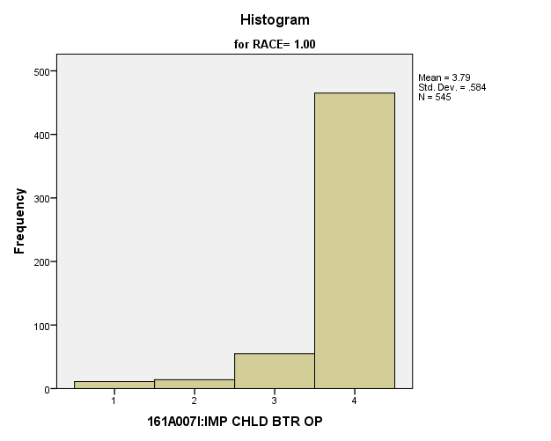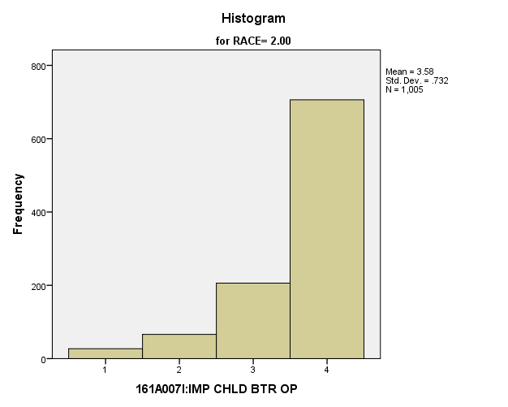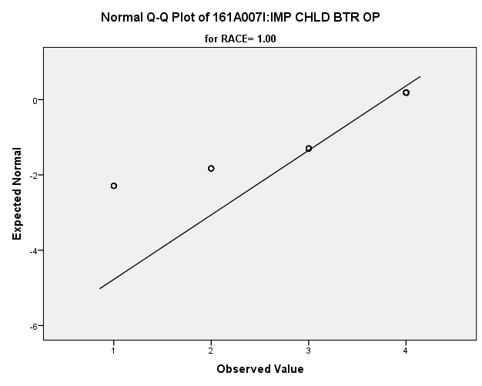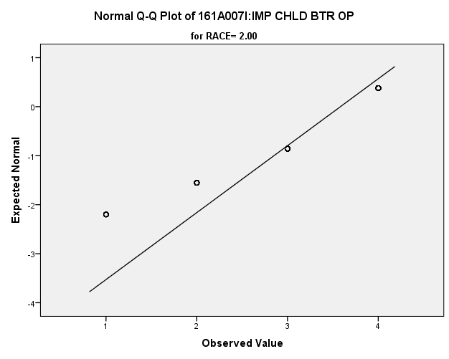

*Primary Analysis:*

|  |  |  |  |  |  |
| --- | --- | --- | --- | --- | --- |
| ***Group Statistics*** | | | | | |
|  | RACE | N | Mean | Std. Deviation | Std. Error Mean |
| 161A007I:IMP CHLD BTR OP | 1.00 | **545** | **3.79** | **.584** | **.025** |
| 2.00 | **1005** | **3.58** | **.732** | **.023** |

|  |  |  |  |  |
| --- | --- | --- | --- | --- |
| ***Independent Samples Test*** | | | | |
|  | | Levene's Test for Equality of Variances | | t-test for Equality of Means |
| F | Sig. | t |
|
| 161A007I:IMP CHLD BTR OP | Equal variances assumed | **88.282** | **.000** | **5.611** |
| Equal variances not assumed |  |  | **5.996** |

|  |  |  |  |  |
| --- | --- | --- | --- | --- |
| ***Independent Samples Test*** | | | | |
|  | | t-test for Equality of Means | | |
| df | Sig. (2-tailed) | Mean Difference |
|
| 161A007I:IMP CHLD BTR OP | Equal variances assumed | **1548** | **.000** | **.204** |
| Equal variances not assumed | **1340.021** | **.000** | **.204** |

|  |  |  |  |  |  |  |  |
| --- | --- | --- | --- | --- | --- | --- | --- |
| ***Independent Samples Test*** | | | | | | | |
|  | | | | | t-test for Equality of Means | | |
| Std. Error Difference | 99% Confidence Interval of the Difference | |
| Lower | Upper |
| 161A007I:IMP CHLD BTR OP | Equal variances assumed | | | | **.036** | **.110** | **.298** |
| Equal variances not assumed | | | | **.034** | **.116** | **.292** |
| ***Measures of Association*** | | | |
|  | | Eta | Eta Squared |
| 161A007I:IMP CHLD BTR OP * RACE | | **.141** | **.020** |

**Importance of Living Close to Parents:** Within the potential recruit group, are there racial differences in how important they thought it was to live close to their parents?

**Variables used:** The dependent variable was importance of living close to parents, with students rating importance on a scale from 1 to 4, with a higher number meaning more importance. The independent (grouping) variable was race (white or non-white).

**Analysis Procedure:**

* A t-test was used to compare average rating of how important students found living close to parents to be between the two racial groups (whites versus non-whites)
* Before conducting analysis, the distribution for important students found living close to parents was checked separately for the two groups by means of visual inspection of histograms and Q-Q plots. No outliers were observed. However, the distribution of how important students found having lots of money was right skewed for both groups.
* The equality of variances assumption was tested. This assumption was met.

**Results:**

* Null and alternative hypothesis. H0: μ1 = μ2; Ha: μ1 ≠ μ2.
* Calculated t value: t = 1.829, df = 284, fail to reject H0, with a p-value of .068

**Interpretation:** There is not a significant difference between the two racial groups in how important students found living close to parents.

**Supporting Analysis:**

*Preliminary Analysis:*

|  |  |  |  |  |
| --- | --- | --- | --- | --- |
| ***Descriptives*** | | | | |
|  | RACE | | | Statistic |
| 161A007J:IMP LIV CLS PRN | 1.00 | Mean | | **2.68** |
| 99% Confidence Interval for Mean | Lower Bound | **2.57** |
| Upper Bound | **2.79** |
| 5% Trimmed Mean | | **2.70** |
| Median | | **3.00** |
| Variance | | **.942** |
| Std. Deviation | | **.970** |
| Minimum | | **1** |
| Maximum | | **4** |
| Range | | **3** |
| Interquartile Range | | **1** |
| Skewness | | **-.104** |
| Kurtosis | | **-1.013** |
| 2.00 | Mean | | **2.52** |
| 99% Confidence Interval for Mean | Lower Bound | **2.44** |
| Upper Bound | **2.59** |
| 5% Trimmed Mean | | **2.52** |
| Median | | **2.00** |
| Variance | | **.857** |
| Std. Deviation | | **.926** |
| Minimum | | **1** |
| Maximum | | **4** |
| Range | | **3** |
| Interquartile Range | | **1** |
| Skewness | | **.097** |
| Kurtosis | | **-.855** |

|  |  |  |  |  |
| --- | --- | --- | --- | --- |
| ***Descriptives*** | | | | |
|  | RACE | | | Std. Error |
| 161A007J:IMP LIV CLS PRN | 1.00 | Mean | | **.042** |
| 99% Confidence Interval for Mean | Lower Bound |  |
| Upper Bound |  |
| 5% Trimmed Mean | |  |
| Median | |  |
| Variance | |  |
| Std. Deviation | |  |
| Minimum | |  |
| Maximum | |  |
| Range | |  |
| Interquartile Range | |  |
| Skewness | | **.105** |
| Kurtosis | | **.209** |
| 2.00 | Mean | | **.029** |
| 99% Confidence Interval for Mean | Lower Bound |  |
| Upper Bound |  |
| 5% Trimmed Mean | |  |
| Median | |  |
| Variance | |  |
| Std. Deviation | |  |
| Minimum | |  |
| Maximum | |  |
| Range | |  |
| Interquartile Range | |  |
| Skewness | | **.077** |
| Kurtosis | | **.154** |

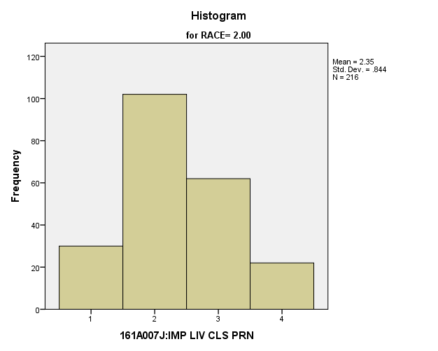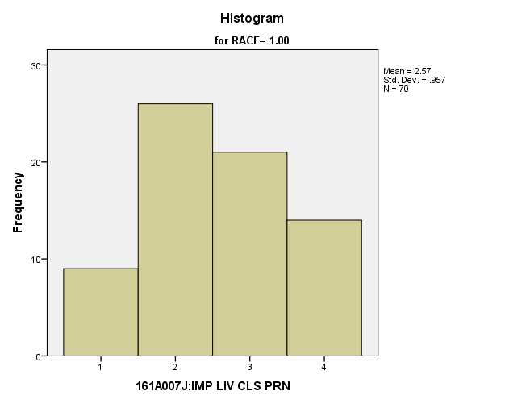

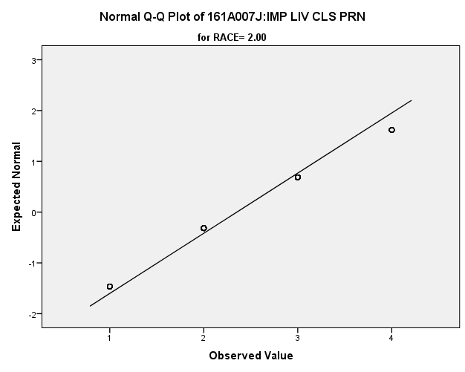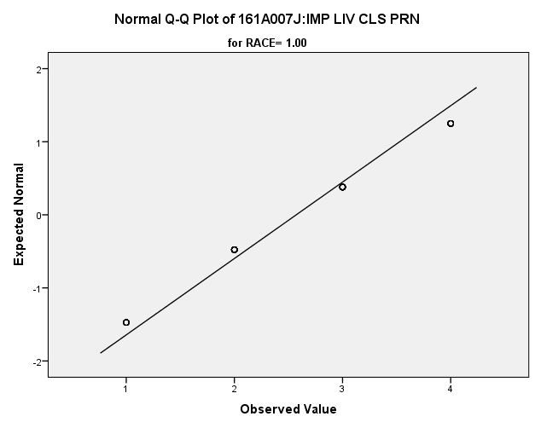

*Primary Analysis:*

|  |  |  |  |  |  |  |  |  |  |  |  |  |
| --- | --- | --- | --- | --- | --- | --- | --- | --- | --- | --- | --- | --- |
| **Group Statistics** | | | | | | | | | | | | |
|  | RACE | | N | Mean | | | Std. Deviation | | | Std. Error Mean | | |
| V1664 | 1.00 | | 70 | 2.57 | | | .957 | | | .114 | | |
| 2.00 | | 216 | 2.35 | | | .844 | | | .057 | | |
| **Independent Samples Test** | | | | | | | | | | | | | | | |
|  | | | | | Levene's Test for Equality of Variances | | | | | | t-test for Equality of Means | | | | |
| F | | | Sig. | | | t | | | df | |
|
| V1664 | Equal variances assumed | | | | 3.641 | | | .057 | | | 1.829 | | | 284 | |
| Equal variances not assumed | | | |  | | |  | | | 1.716 | | | 106.065 | |
| **Independent Samples Test** | | | | | | | | | | | | | | | | |
|  | | | | | | t-test for Equality of Means | | | | | | | | | | |
| Sig. (2-tailed) | | | Mean Difference | | | Std. Error Difference | | | 99% Confidence Interval of the Difference | |
| Lower | |
| V1664 | | Equal variances assumed | | | | .068 | | | .220 | | | .120 | | | -.092 | |
| Equal variances not assumed | | | | .089 | | | .220 | | | .128 | | | -.116 | |

|  |  |  |
| --- | --- | --- |
| **Independent Samples Test** | | |
|  | | t-test for Equality of Means |
| 99% Confidence Interval of the Difference |
| Upper |
| V1664 | Equal variances assumed | .531 |
| Equal variances not assumed | .555 |

**Importance of Getting Away from this Area of the Country:** Within the potential recruit group, are there racial differences in how important they thought it was to have get away from this area of the country?

**Variables used:** The dependent variable was importance of getting away from this area of the country, with students rating importance on a scale from 1 to 4, with a higher number meaning more importance. The independent (grouping) variable was race (white or non-white).

**Analysis Procedure:**

* A t-test was used to compare average rating of how important students found getting away from this area of the country to be between the two racial groups (whites versus non-whites)
* Before conducting analysis, the distribution for how important students found getting away from this area of the country to be was checked separately for the two groups by means of visual inspection of histograms and Q-Q plots. No outliers were observed. However, the distribution of how important students how important students found getting away from this area of the country to be was right skewed for both groups.
* The equality of variances assumption was tested. This assumption was met.

**Results:**

* Null and alternative hypothesis. H0: μ1 = μ2; Ha: μ1 ≠ μ2.
* Calculated t value: t = 1.988, df =286, fail to reject H0, with a p-value of .048

**Interpretation:** There is not a significant difference between the two groups in how important students found getting away from this area of the country to be.

**Supporting Analysis:**

*Preliminary Analysis:*

|  |  |  |  |  |
| --- | --- | --- | --- | --- |
| ***Descriptives*** | | | | |
|  | RACE | | | Statistic |
| 161A007K:IMP GT AWY AREA | 1.00 | Mean | | **2.26** |
| 99% Confidence Interval for Mean | Lower Bound | **2.14** |
| Upper Bound | **2.39** |
| 5% Trimmed Mean | | **2.24** |
| Median | | **2.00** |
| Variance | | **1.247** |
| Std. Deviation | | **1.117** |
| Minimum | | **1** |
| Maximum | | **4** |
| Range | | **3** |
| Interquartile Range | | **2** |
| Skewness | | **.306** |
| Kurtosis | | **-1.278** |
| 2.00 | Mean | | **2.00** |
| 99% Confidence Interval for Mean | Lower Bound | **1.91** |
| Upper Bound | **2.09** |
| 5% Trimmed Mean | | **1.94** |
| Median | | **2.00** |
| Variance | | **1.157** |
| Std. Deviation | | **1.076** |
| Minimum | | **1** |
| Maximum | | **4** |
| Range | | **3** |
| Interquartile Range | | **2** |
| Skewness | | **.671** |
| Kurtosis | | **-.888** |

|  |  |  |  |  |
| --- | --- | --- | --- | --- |
| ***Descriptives*** | | | | |
|  | RACE | | | Std. Error |
| 161A007K:IMP GT AWY AREA | 1.00 | Mean | | **.048** |
| 99% Confidence Interval for Mean | Lower Bound |  |
| Upper Bound |  |
| 5% Trimmed Mean | |  |
| Median | |  |
| Variance | |  |
| Std. Deviation | |  |
| Minimum | |  |
| Maximum | |  |
| Range | |  |
| Interquartile Range | |  |
| Skewness | | **.104** |
| Kurtosis | | **.208** |
| 2.00 | Mean | | **.034** |
| 99% Confidence Interval for Mean | Lower Bound |  |
| Upper Bound |  |
| 5% Trimmed Mean | |  |
| Median | |  |
| Variance | |  |
| Std. Deviation | |  |
| Minimum | |  |
| Maximum | |  |
| Range | |  |
| Interquartile Range | |  |
| Skewness | | **.077** |
| Kurtosis | | **.154** |

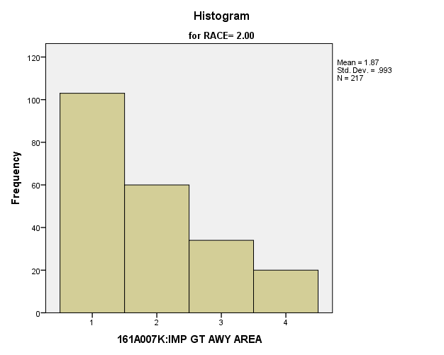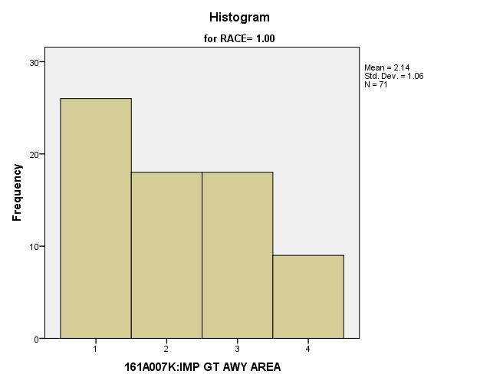

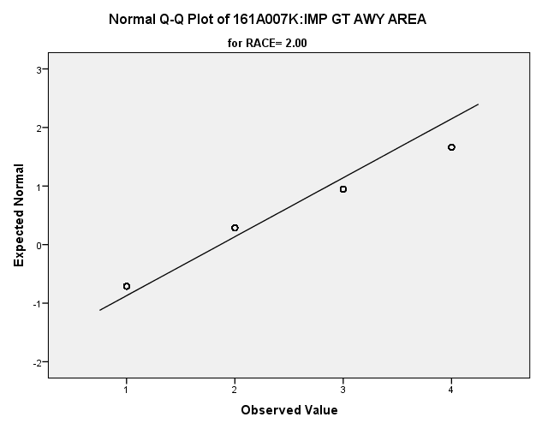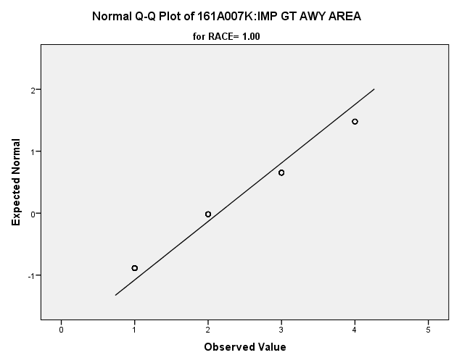

*Primary Analysis:*

|  |  |  |  |  |  |  |  |  |  |  |  |  |
| --- | --- | --- | --- | --- | --- | --- | --- | --- | --- | --- | --- | --- |
| **Group Statistics** | | | | | | | | | | | | |
|  | RACE | | N | Mean | | | Std. Deviation | | | Std. Error Mean | | |
| V1665 | 1.00 | | 71 | 2.14 | | | 1.060 | | | .126 | | |
| 2.00 | | 217 | 1.87 | | | .993 | | | .067 | | |
| **Independent Samples Test** | | | | | | | | | | | | | | | |
|  | | | | | Levene's Test for Equality of Variances | | | | | | t-test for Equality of Means | | | | |
| F | | | Sig. | | | t | | | df | |
|
| V1665 | Equal variances assumed | | | | 1.263 | | | .262 | | | 1.988 | | | 286 | |
| Equal variances not assumed | | | |  | | |  | | | 1.924 | | | 113.015 | |
| **Independent Samples Test** | | | | | | | | | | | | | | | | |
|  | | | | | | t-test for Equality of Means | | | | | | | | | | |
| Sig. (2-tailed) | | | Mean Difference | | | Std. Error Difference | | | 99% Confidence Interval of the Difference | |
| Lower | |
| V1665 | | Equal variances assumed | | | | .048 | | | .274 | | | .138 | | | -.084 | |
| Equal variances not assumed | | | | .057 | | | .274 | | | .143 | | | -.099 | |

|  |  |  |
| --- | --- | --- |
| **Independent Samples Test** | | |
|  | | t-test for Equality of Means |
| 99% Confidence Interval of the Difference |
| Upper |
| V1665 | Equal variances assumed | .633 |
| Equal variances not assumed | .648 |

**Importance of Correcting Inequalities:** Within the potential recruit group, are there racial differences in how important they thought it was to correct inequalities?

**Variables used:** The dependent variable was importance of correcting inequalities, with students rating importance on a scale from 1 to 4, with a higher number meaning more importance. The independent (grouping) variable was race (white or non-white).

**Analysis Procedure:**

* A t-test was used to compare average rating of how important students found correcting inequalities to be between the two racial groups (whites versus non-whites)
* Before conducting analysis, the distribution was checked separately for the two groups by means of visual inspection of histograms and Q-Q plots. No outliers were observed. However, the distribution was similarly skewed for both groups.
* The equality of variances assumption was tested. This assumption was met.

**Results:**

* Null and alternative hypothesis. H0: μ1 = μ2; Ha: μ1 ≠ μ2.
* Calculated t value: t =7.254, df = 1553, reject H0, with a p-value of .000; Eta squared = .053

**Interpretation:** There is a significant difference between the two groups in how satisfied students are with correcting inequalities. Furthermore, 5.3% of how important they felt it was is due their race.

**Supporting Analysis:**

*Preliminary Analysis:*

|  |  |  |  |  |
| --- | --- | --- | --- | --- |
| ***Descriptives*** | | | | |
|  | RACE | | | Statistic |
| 161A007L:IMP CRRCT INEQL | 1.00 | Mean | | **2.78** |
| 99% Confidence Interval for Mean | Lower Bound | **2.67** |
| Upper Bound | **2.88** |
| 5% Trimmed Mean | | **2.81** |
| Median | | **3.00** |
| Variance | | **.932** |
| Std. Deviation | | **.965** |
| Minimum | | **1** |
| Maximum | | **4** |
| Range | | **3** |
| Interquartile Range | | **2** |
| Skewness | | **-.191** |
| Kurtosis | | **-1.022** |
| 2.00 | Mean | | **2.40** |
| 99% Confidence Interval for Mean | Lower Bound | **2.32** |
| Upper Bound | **2.48** |
| 5% Trimmed Mean | | **2.39** |
| Median | | **2.00** |
| Variance | | **.942** |
| Std. Deviation | | **.971** |
| Minimum | | **1** |
| Maximum | | **4** |
| Range | | **3** |
| Interquartile Range | | **1** |
| Skewness | | **.204** |
| Kurtosis | | **-.930** |

|  |  |  |  |  |
| --- | --- | --- | --- | --- |
| ***Descriptives*** | | | | |
|  | RACE | | | Std. Error |
| 161A007L:IMP CRRCT INEQL | 1.00 | Mean | | **.041** |
| 99% Confidence Interval for Mean | Lower Bound |  |
| Upper Bound |  |
| 5% Trimmed Mean | |  |
| Median | |  |
| Variance | |  |
| Std. Deviation | |  |
| Minimum | |  |
| Maximum | |  |
| Range | |  |
| Interquartile Range | |  |
| Skewness | | **.104** |
| Kurtosis | | **.209** |
| 2.00 | Mean | | **.031** |
| 99% Confidence Interval for Mean | Lower Bound |  |
| Upper Bound |  |
| 5% Trimmed Mean | |  |
| Median | |  |
| Variance | |  |
| Std. Deviation | |  |
| Minimum | |  |
| Maximum | |  |
| Range | |  |
| Interquartile Range | |  |
| Skewness | | **.077** |
| Kurtosis | | **.154** |

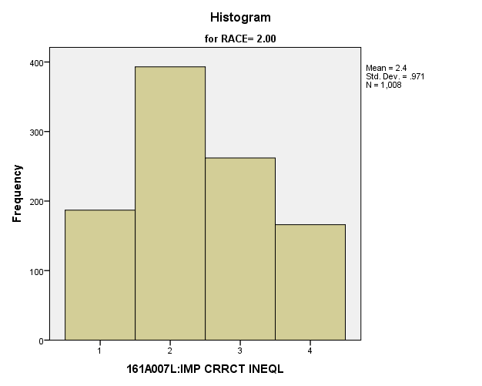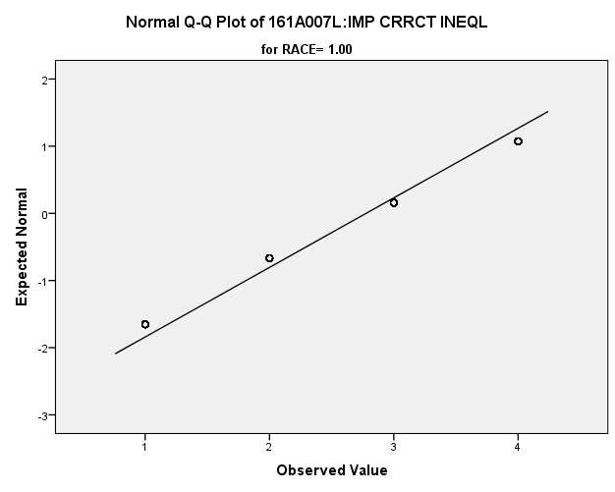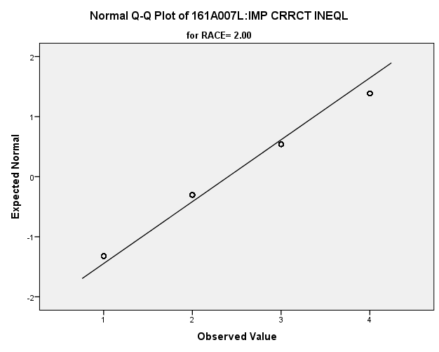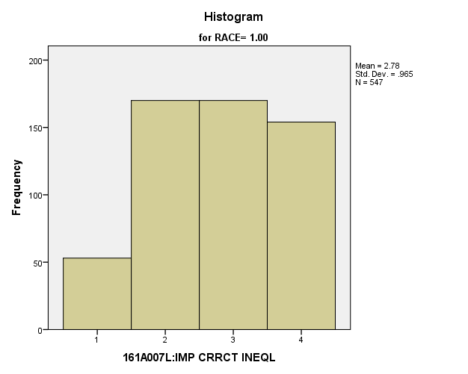

*Primary Analysis:*

|  |  |  |  |  |  |
| --- | --- | --- | --- | --- | --- |
| ***Group Statistics*** | | | | | |
|  | RACE | N | Mean | Std. Deviation | Std. Error Mean |
| 161A007L:IMP CRRCT INEQL | 1.00 | **547** | **2.78** | **.965** | **.041** |
| 2.00 | **1008** | **2.40** | **.971** | **.031** |

|  |  |  |  |  |
| --- | --- | --- | --- | --- |
| ***Independent Samples Test*** | | | | |
|  | | Levene's Test for Equality of Variances | | t-test for Equality of Means |
| F | Sig. | t |
|
| 161A007L:IMP CRRCT INEQL | Equal variances assumed | **.102** | **.749** | **7.254** |
| Equal variances not assumed |  |  | **7.266** |

|  |  |  |  |  |
| --- | --- | --- | --- | --- |
| ***Independent Samples Test*** | | | | |
|  | | t-test for Equality of Means | | |
| df | Sig. (2-tailed) | Mean Difference |
|
| 161A007L:IMP CRRCT INEQL | Equal variances assumed | **1553** | **.000** | **.373** |
| Equal variances not assumed | **1125.711** | **.000** | **.373** |

|  |  |  |  |  |
| --- | --- | --- | --- | --- |
| ***Independent Samples Test*** | | | | |
|  | | t-test for Equality of Means | | |
| Std. Error Difference | 99% Confidence Interval of the Difference | |
| Lower | Upper |
| 161A007L:IMP CRRCT INEQL | Equal variances assumed | **.051** | **.241** | **.506** |
| Equal variances not assumed | **.051** | **.241** | **.506** |

|  |  |  |
| --- | --- | --- |
| ***Measures of Association*** | | |
|  | Eta | Eta Squared |
| 161A007L:IMP CRRCT INEQL * RACE | **.181** | **.033** |

**Importance of Having New Experiences:** Within the potential recruit group, are there racial differences in how important they thought it was to have new experiences?

**Variables used:** The dependent variable was importance of having new experiences, with students rating importance on a scale from 1 to 4, with a higher number meaning more importance. The independent (grouping) variable was race (white or non-white).

**Analysis Procedure:**

* A t-test was used to compare average rating of how important students found having new experiences to be between the two racial groups (whites versus non-whites)
* Before conducting analysis, the distribution for how important students found having new experiences to be was checked separately for the two groups by means of visual inspection of histograms and Q-Q plots. No outliers were observed. However, the distribution was left skewed for both groups.
* The equality of variances assumption was tested. This assumption was met.

**Results:**

* Null and alternative hypothesis. H0: μ1 = μ2; Ha: μ1 ≠ μ2.
* Calculated t value: t = 5.682, df = 1558, reject H0, with a p-value of .000; Eta squared = .020

**Interpretation:** There is a significant difference between the two groups in how important they felt having new experiences was. Furthermore, 2% of how important they felt it was is due to their race.

**Supporting Analysis:**

*Preliminary Analysis:*

|  |  |  |  |  |
| --- | --- | --- | --- | --- |
| ***Descriptives*** | | | | |
|  | RACE | | | Statistic |
| 161A007M:IMP NEW XPRNCE | 1.00 | Mean | | **3.15** |
| 99% Confidence Interval for Mean | Lower Bound | **3.06** |
| Upper Bound | **3.24** |
| 5% Trimmed Mean | | **3.20** |
| Median | | **3.00** |
| Variance | | **.684** |
| Std. Deviation | | **.827** |
| Minimum | | **1** |
| Maximum | | **4** |
| Range | | **3** |
| Interquartile Range | | **1** |
| Skewness | | **-.594** |
| Kurtosis | | **-.504** |
| 2.00 | Mean | | **2.89** |
| 99% Confidence Interval for Mean | Lower Bound | **2.82** |
| Upper Bound | **2.96** |
| 5% Trimmed Mean | | **2.93** |
| Median | | **3.00** |
| Variance | | **.770** |
| Std. Deviation | | **.877** |
| Minimum | | **1** |
| Maximum | | **4** |
| Range | | **3** |
| Interquartile Range | | **2** |
| Skewness | | **-.314** |
| Kurtosis | | **-.723** |

|  |  |  |  |  |
| --- | --- | --- | --- | --- |
| ***Descriptives*** | | | | |
|  | RACE | | | Std. Error |
| 161A007M:IMP NEW XPRNCE | 1.00 | Mean | | **.035** |
| 99% Confidence Interval for Mean | Lower Bound |  |
| Upper Bound |  |
| 5% Trimmed Mean | |  |
| Median | |  |
| Variance | |  |
| Std. Deviation | |  |
| Minimum | |  |
| Maximum | |  |
| Range | |  |
| Interquartile Range | |  |
| Skewness | | **.104** |
| Kurtosis | | **.208** |
| 2.00 | Mean | | **.028** |
| 99% Confidence Interval for Mean | Lower Bound |  |
| Upper Bound |  |
| 5% Trimmed Mean | |  |
| Median | |  |
| Variance | |  |
| Std. Deviation | |  |
| Minimum | |  |
| Maximum | |  |
| Range | |  |
| Interquartile Range | |  |
| Skewness | | **.077** |
| Kurtosis | | **.154** |

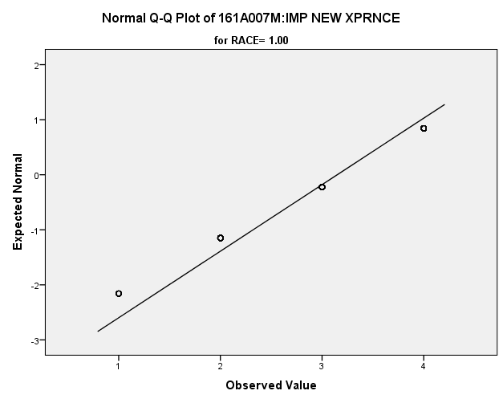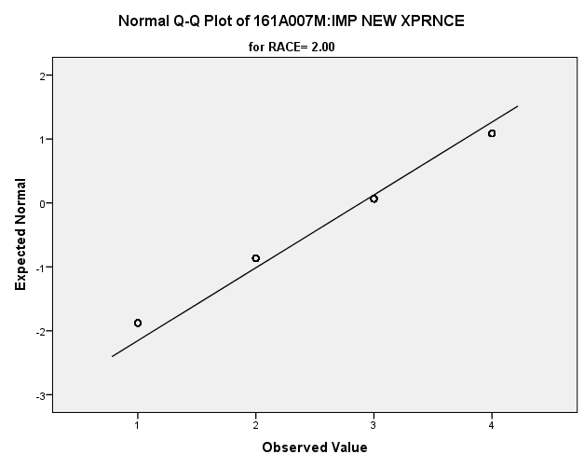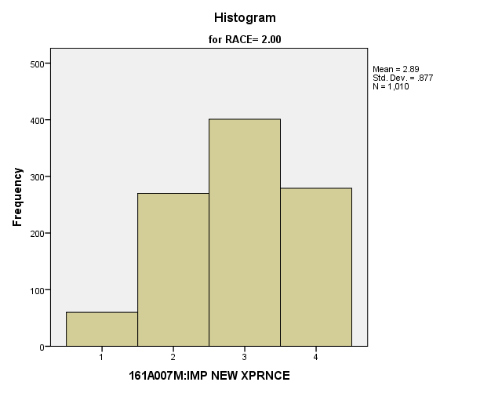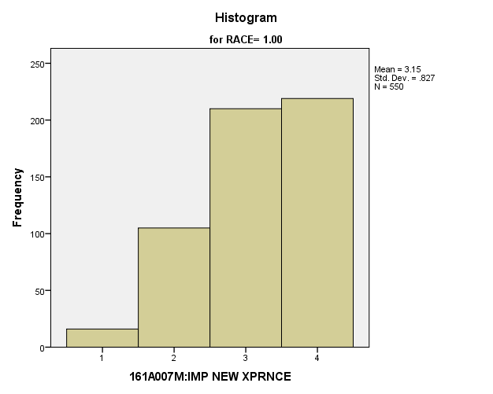

*Primary Analysis:*

|  |  |  |  |  |  |
| --- | --- | --- | --- | --- | --- |
| ***Group Statistics*** | | | | | |
|  | RACE | N | Mean | Std. Deviation | Std. Error Mean |
| 161A007M:IMP NEW XPRNCE | 1.00 | **550** | **3.15** | **.827** | **.035** |
| 2.00 | **1010** | **2.89** | **.877** | **.028** |

|  |  |  |  |  |
| --- | --- | --- | --- | --- |
| ***Independent Samples Test*** | | | | |
|  | | Levene's Test for Equality of Variances | | t-test for Equality of Means |
| F | Sig. | t |
|
| 161A007M:IMP NEW XPRNCE | Equal variances assumed | **.715** | **.398** | **5.682** |
| Equal variances not assumed |  |  | **5.781** |

|  |  |  |  |  |
| --- | --- | --- | --- | --- |
| ***Independent Samples Test*** | | | | |
|  | | t-test for Equality of Means | | |
| df | Sig. (2-tailed) | Mean Difference |
|
| 161A007M:IMP NEW XPRNCE | Equal variances assumed | **1558** | **.000** | **.259** |
| Equal variances not assumed | **1185.496** | **.000** | **.259** |

|  |  |  |  |  |
| --- | --- | --- | --- | --- |
| ***Independent Samples Test*** | | | | |
|  | | t-test for Equality of Means | | |
| Std. Error Difference | 99% Confidence Interval of the Difference | |
| Lower | Upper |
| 161A007M:IMP NEW XPRNCE | Equal variances assumed | **.046** | **.141** | **.377** |
| Equal variances not assumed | **.045** | **.143** | **.375** |

|  |  |  |
| --- | --- | --- |
| ***Measures of Association*** | | |
|  | Eta | Eta Squared |
| 161A007M:IMP NEW XPRNCE * RACE | **.142** | **.020** |

**Importance of Finding Purpose in Life:** Within the potential recruit group, are there racial differences in how important they thought it was to find purpose in life?

**Variables used:** The dependent variable was importance of finding purpose in life, with students rating importance on a scale from 1 to 4, with a higher number meaning more importance. The independent (grouping) variable was race (white or non-white).

**Analysis Procedure:**

* A t-test was used to compare average rating of how important students found finding a purpose in life to be between the two racial groups (whites versus non-whites)
* Before conducting analysis, the distribution for how important students found finding a purpose in life to be was checked separately for the two groups by means of visual inspection of histograms and Q-Q plots. No outliers were observed. However, the distribution of how important students found finding a purpose in life to be was left skewed for both groups.
* The equality of variances assumption was tested. This assumption was met.

**Results:**

* Null and alternative hypothesis. H0: μ1 = μ2; Ha: μ1 ≠ μ2.
* Calculated t value: t = .940, df = 286, fail to reject H0, with a p-value of .348

**Interpretation:** There is not a significant difference between the two racial groups in how important students found finding a purpose in life to be.

**Supporting Analysis:**

*Preliminary Analysis:*

|  |  |  |  |  |
| --- | --- | --- | --- | --- |
| ***Descriptives*** | | | | |
|  | RACE | | | Statistic |
| 161A007N:IMP FND PRPS LF | 1.00 | Mean | | **3.64** |
| 99% Confidence Interval for Mean | Lower Bound | **3.56** |
| Upper Bound | **3.72** |
| 5% Trimmed Mean | | **3.74** |
| Median | | **4.00** |
| Variance | | **.513** |
| Std. Deviation | | **.716** |
| Minimum | | **1** |
| Maximum | | **4** |
| Range | | **3** |
| Interquartile Range | | **1** |
| Skewness | | **-2.091** |
| Kurtosis | | **3.838** |
| 2.00 | Mean | | **3.52** |
| 99% Confidence Interval for Mean | Lower Bound | **3.46** |
| Upper Bound | **3.58** |
| 5% Trimmed Mean | | **3.61** |
| Median | | **4.00** |
| Variance | | **.567** |
| Std. Deviation | | **.753** |
| Minimum | | **1** |
| Maximum | | **4** |
| Range | | **3** |
| Interquartile Range | | **1** |
| Skewness | | **-1.555** |
| Kurtosis | | **1.785** |

|  |  |  |  |  |
| --- | --- | --- | --- | --- |
| ***Descriptives*** | | | | |
|  | RACE | | | Std. Error |
| 161A007N:IMP FND PRPS LF | 1.00 | Mean | | **.031** |
| 99% Confidence Interval for Mean | Lower Bound |  |
| Upper Bound |  |
| 5% Trimmed Mean | |  |
| Median | |  |
| Variance | |  |
| Std. Deviation | |  |
| Minimum | |  |
| Maximum | |  |
| Range | |  |
| Interquartile Range | |  |
| Skewness | | **.104** |
| Kurtosis | | **.208** |
| 2.00 | Mean | | **.024** |
| 99% Confidence Interval for Mean | Lower Bound |  |
| Upper Bound |  |
| 5% Trimmed Mean | |  |
| Median | |  |
| Variance | |  |
| Std. Deviation | |  |
| Minimum | |  |
| Maximum | |  |
| Range | |  |
| Interquartile Range | |  |
| Skewness | | **.077** |
| Kurtosis | | **.154** |

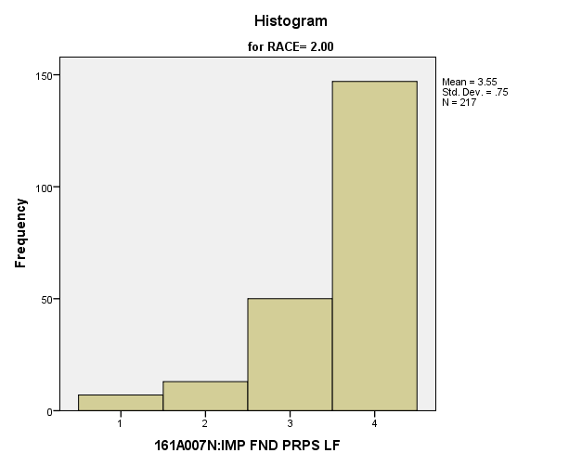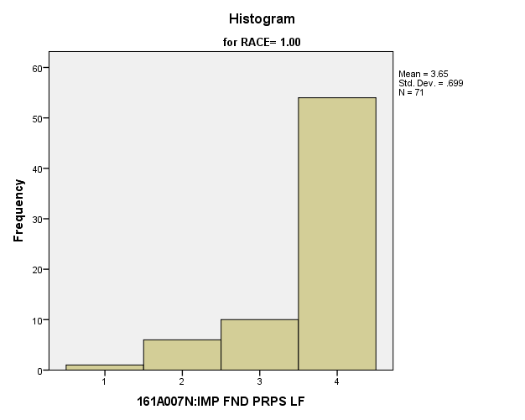

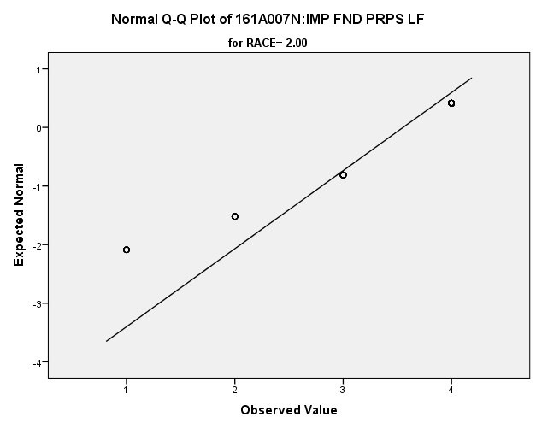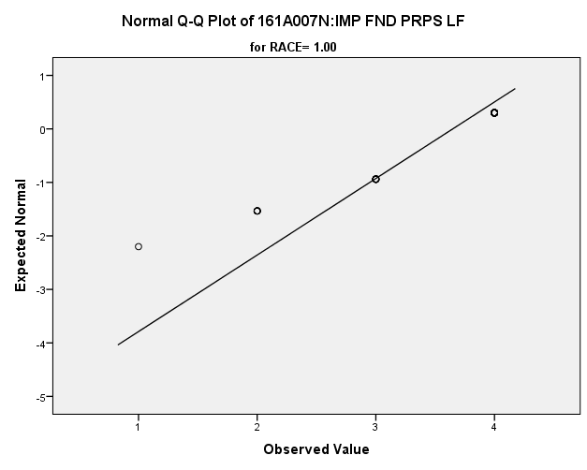

*Primary Analysis:*

|  |  |  |  |  |  |  |  |  |
| --- | --- | --- | --- | --- | --- | --- | --- | --- |
| **Group Statistics** | | | | | | | | |
|  | RACE | N | Mean | | Std. Deviation | | Std. Error Mean | |
| V1668 | 1.00 | 71 | 3.65 | | .699 | | .083 | |
| 2.00 | 217 | 3.55 | | .750 | | .051 | |
| **Independent Samples Test** | | | | | | | | | | |
|  | | | | Levene's Test for Equality of Variances | | | | t-test for Equality of Means | | |
| F | | Sig. | | t | | df |
|
| V1668 | Equal variances assumed | | | 1.342 | | .248 | | .940 | | 286 |
| Equal variances not assumed | | |  | |  | | .975 | | 126.910 |

|  |  |  |  |  |  |
| --- | --- | --- | --- | --- | --- |
| **Independent Samples Test** | | | | | |
|  | | t-test for Equality of Means | | | |
| Sig. (2-tailed) | Mean Difference | Std. Error Difference | 99% Confidence Interval of the Difference |
| Lower |
| V1668 | Equal variances assumed | .348 | .095 | .101 | -.167 |
| Equal variances not assumed | .332 | .095 | .097 | -.160 |

|  |  |  |
| --- | --- | --- |
| **Independent Samples Test** | | |
|  | | t-test for Equality of Means |
| 99% Confidence Interval of the Difference |
| Upper |
| V1668 | Equal variances assumed | .357 |
| Equal variances not assumed | .349 |

*5.b. Student Satisfaction Variables:*

**Satisfaction with Present job:** Within the potential recruit group, are there racial differences in how satisfied they are with their current neighborhood?

**Variables used:** The dependent variable was satisfaction with present job, with students rating satisfaction on a scale of 1 to 7, with a higher number meaning more satisfaction. The independent (grouping) variable was race.

**Analysis Procedure:**

* A t-test was used to compare average rating of how satisfied students were with their present job between the two racial groups (whites versus non-whites)
* Before conducting analysis, the distribution was checked separately for the two groups by means of visual inspection of histograms and Q-Q plots. No outliers were observed. However, the distribution was similarly skewed for both groups.
* The equality of variances assumption was tested. This assumption was met.

**Results:**

* Null and alternative hypothesis. H0: μ1 = μ2; Ha: μ1 ≠ μ2.
* Calculated t value: t =2.587, df =904, reject H0, with a p-value of .010; Eta squared = .007

**Interpretation:** There is a significant difference between the two groups in how satisfied students are with their present job. Furthermore, .7% of how satisfied students are is due to their race.

**Supporting Analysis:**

*Preliminary Analysis:*

|  |  |  |  |  |  |  |  |
| --- | --- | --- | --- | --- | --- | --- | --- |
| **Case Processing Summary** | | | | | | | |
|  | RACE | Cases | | | | | |
| Valid | | Missing | | Total | |
| N | Percent | N | Percent | N | Percent |
| V1641 | 1.00 | **281** | **50.0%** | **281** | **50.0%** | **562** | **100.0%** |
| 2.00 | **625** | **60.7%** | **404** | **39.3%** | **1029** | **100.0%** |

|  |  |  |  |  |  |
| --- | --- | --- | --- | --- | --- |
| **Descriptives** | | | | | |
|  | RACE | | | Statistic | Std. Error |
| V1641 | 1.00 | Mean | | **4.75** | **.105** |
| 99% Confidence Interval for Mean | Lower Bound | **4.47** |  |
| Upper Bound | **5.02** |  |
| 5% Trimmed Mean | | **4.83** |  |
| Median | | **5.00** |  |
| Variance | | **3.104** |  |
| Std. Deviation | | **1.762** |  |
| Minimum | | **1** |  |
| Maximum | | **7** |  |
| Range | | **6** |  |
| Interquartile Range | | **2** |  |
| Skewness | | **-.447** | **.145** |
| Kurtosis | | **-.474** | **.290** |
| 2.00 | Mean | | **5.07** | **.068** |
| 99% Confidence Interval for Mean | Lower Bound | **4.89** |  |
| Upper Bound | **5.24** |  |
| 5% Trimmed Mean | | **5.18** |  |
| Median | | **5.00** |  |
| Variance | | **2.856** |  |
| Std. Deviation | | **1.690** |  |
| Minimum | | **1** |  |
| Maximum | | **7** |  |
| Range | | **6** |  |
| Interquartile Range | | **2** |  |
| Skewness | | **-.729** | **.098** |
| Kurtosis | | **-.145** | **.195** |

|  |  |  |  |  |  |  |  |
| --- | --- | --- | --- | --- | --- | --- | --- |
| **Tests of Normality** | | | | | | | |
|  | RACE | Kolmogorov-Smirnova | | | Shapiro-Wilk | | |
| Statistic | df | Sig. | Statistic | df | Sig. |
| V1641 | 1.00 | **.168** | **281** | **.000** | **.900** | **281** | **.000** |
| 2.00 | **.182** | **625** | **.000** | **.890** | **625** | **.000** |

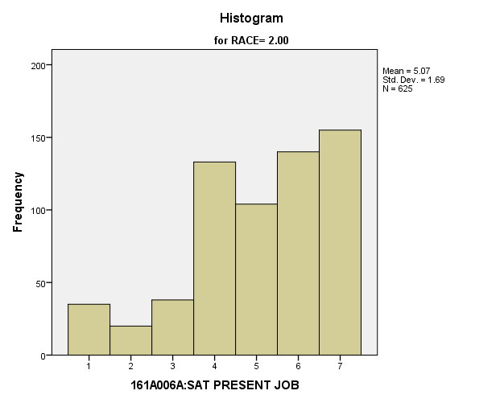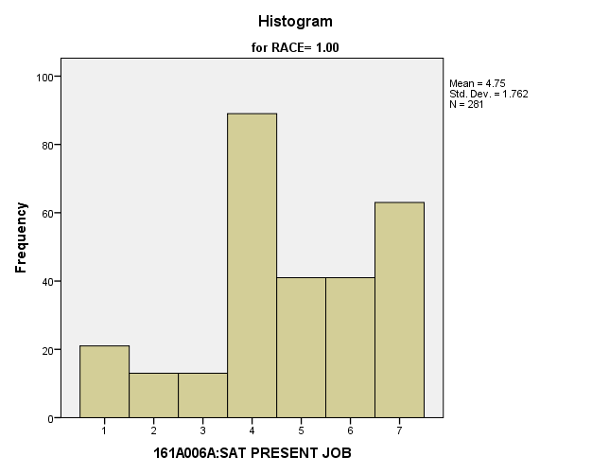

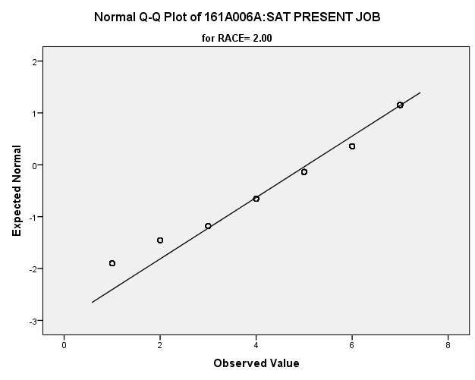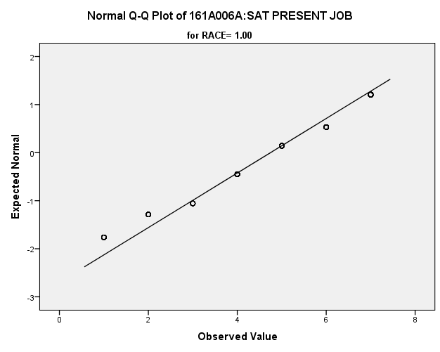

*Primary Analysis:*

|  |  |  |  |  |  |
| --- | --- | --- | --- | --- | --- |
| ***Group Statistics*** | | | | | |
|  | RACE | N | Mean | Std. Deviation | Std. Error Mean |
| 161A006A:SAT PRESENT JOB | 1.00 | **281** | **4.75** | **1.762** | **.105** |
| 2.00 | **625** | **5.07** | **1.690** | **.068** |

|  |  |  |  |  |
| --- | --- | --- | --- | --- |
| ***Independent Samples Test*** | | | | |
|  | | Levene's Test for Equality of Variances | | t-test for Equality of Means |
| F | Sig. | t |
|
| 161A006A:SAT PRESENT JOB | Equal variances assumed | **1.019** | **.313** | **-2.587** |
| Equal variances not assumed |  |  | **-2.547** |

|  |  |  |  |  |
| --- | --- | --- | --- | --- |
| ***Independent Samples Test*** | | | | |
|  | | t-test for Equality of Means | | |
| df | Sig. (2-tailed) | Mean Difference |
|
| 161A006A:SAT PRESENT JOB | Equal variances assumed | **904** | **.010** | **-.318** |
| Equal variances not assumed | **519.708** | **.011** | **-.318** |

|  |  |  |  |  |
| --- | --- | --- | --- | --- |
| ***Independent Samples Test*** | | | | |
|  | | t-test for Equality of Means | | |
| Std. Error Difference | 99% Confidence Interval of the Difference | |
| Lower | Upper |
| 161A006A:SAT PRESENT JOB | Equal variances assumed | **.123** | **-.636** | **-.001** |
| Equal variances not assumed | **.125** | **-.641** | **.005** |

|  |  |  |
| --- | --- | --- |
| ***Measures of Association*** | | |
|  | Eta | Eta Squared |
| 161A006A:SAT PRESENT JOB * RACE | **.086** | **.007** |

**Satisfaction with Current Neighborhood:** Within the potential recruit group, are there racial differences in how satisfied they are with their current neighborhood?

**Variables used:** The dependent variable was satisfaction with current neighborhood, with students rating satisfaction on a scale of 1 to 7, with a higher number meaning more satisfaction. The independent (grouping) variable was race.

**Analysis Procedure:**

* A t-test was used to compare average rating of how satisfied students were with their current neighborhood between the two racial groups (whites versus non-whites)
* Before conducting analysis, the distribution for how satisfied students were with their current neighborhood was checked separately for the two groups by means of visual inspection of histograms and Q-Q plots. No outliers were observed. However, the distribution was similarly skewed for both groups.
* The equality of variances assumption was tested. This assumption was met.

**Results:**

* Null and alternative hypothesis. H0: μ1 = μ2; Ha: μ1 ≠ μ2.
* Calculated t value: t = -3.371, df = 287, reject H0, with a p-value of .001; Eta squared = .038

**Interpretation:** There is a significant difference between the two groups in how satisfied students are with their current neighborhood. Furthermore, 3.8% of how satisfied students are with their current neighborhood is due to their race.

**Supporting Analysis:**

*Preliminary Analysis:*

|  |  |  |  |  |
| --- | --- | --- | --- | --- |
| ***Descriptives*** | | | | |
|  | RACE | | | Statistic |
| 161A006B:SAT NEIGHBORHOD | 1.00 | Mean | | **4.92** |
| 99% Confidence Interval for Mean | Lower Bound | **4.73** |
| Upper Bound | **5.12** |
| 5% Trimmed Mean | | **5.03** |
| Median | | **5.00** |
| Variance | | **3.237** |
| Std. Deviation | | **1.799** |
| Minimum | | **1** |
| Maximum | | **7** |
| Range | | **6** |
| Interquartile Range | | **3** |
| Skewness | | **-.478** |
| Kurtosis | | **-.662** |
| 2.00 | Mean | | **5.61** |
| 99% Confidence Interval for Mean | Lower Bound | **5.49** |
| Upper Bound | **5.74** |
| 5% Trimmed Mean | | **5.75** |
| Median | | **6.00** |
| Variance | | **2.388** |
| Std. Deviation | | **1.545** |
| Minimum | | **1** |
| Maximum | | **7** |
| Range | | **6** |
| Interquartile Range | | **2** |
| Skewness | | **-1.043** |
| Kurtosis | | **.366** |

|  |  |  |  |  |
| --- | --- | --- | --- | --- |
| ***Descriptives*** | | | | |
|  | RACE | | | Std. Error |
| 161A006B:SAT NEIGHBORHOD | 1.00 | Mean | | **.076** |
| 99% Confidence Interval for Mean | Lower Bound |  |
| Upper Bound |  |
| 5% Trimmed Mean | |  |
| Median | |  |
| Variance | |  |
| Std. Deviation | |  |
| Minimum | |  |
| Maximum | |  |
| Range | |  |
| Interquartile Range | |  |
| Skewness | | **.103** |
| Kurtosis | | **.206** |
| 2.00 | Mean | | **.048** |
| 99% Confidence Interval for Mean | Lower Bound |  |
| Upper Bound |  |
| 5% Trimmed Mean | |  |
| Median | |  |
| Variance | |  |
| Std. Deviation | |  |
| Minimum | |  |
| Maximum | |  |
| Range | |  |
| Interquartile Range | |  |
| Skewness | | **.076** |
| Kurtosis | | **.152** |

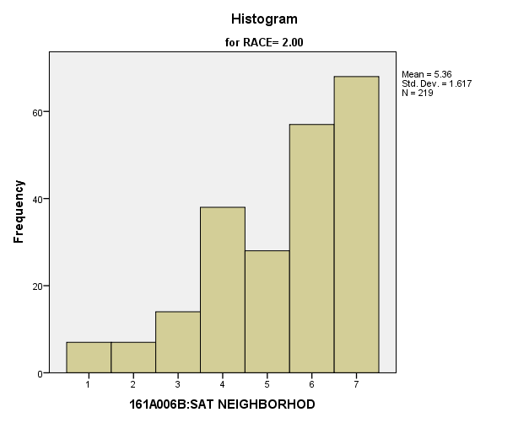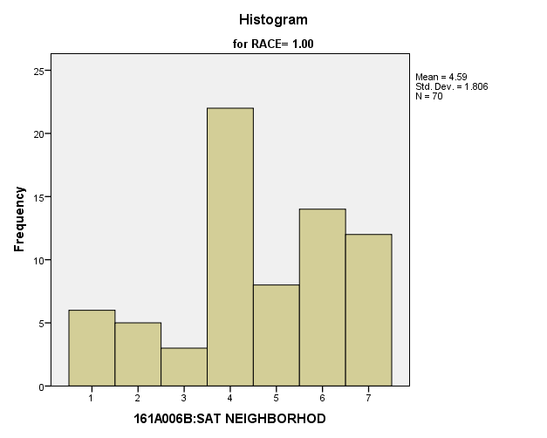

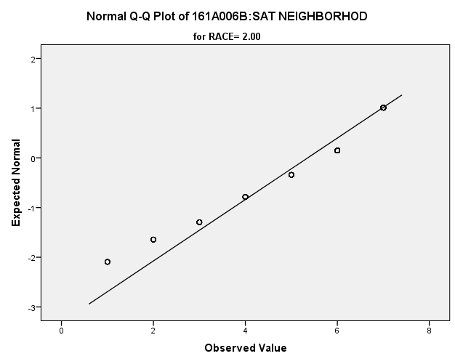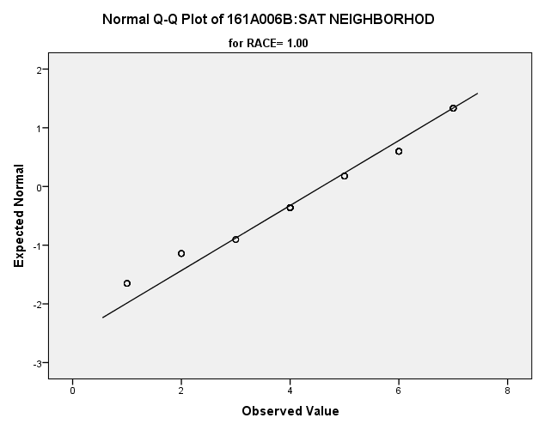

*Primary Analysis:*

|  |  |  |  |  |  |  |  |  |  |  |  |  |  |  |
| --- | --- | --- | --- | --- | --- | --- | --- | --- | --- | --- | --- | --- | --- | --- |
| **Group Statistics** | | | | | | | | | | | | | | |
|  | RACE | | | N | | Mean | | | | Std. Deviation | | Std. Error Mean | | |
| V1642 | 1.00 | | | **70** | | **4.59** | | | | **1.806** | | **.216** | | |
| 2.00 | | | **219** | | **5.36** | | | | **1.617** | | **.109** | | |
| **Independent Samples Test** | | | | | | | | | | | | | | | | | | | |
|  | | | | | | | Levene's Test for Equality of Variances | | | | | | | t-test for Equality of Means | | | | | |
| F | | | | Sig. | | | t | | | df | Sig. (2-tailed) | |
|
| V1642 | Equal variances assumed | | | | | | **1.120** | | | | **.291** | | | **-3.371** | | | **287** | **.001** | |
| Equal variances not assumed | | | | | |  | | | |  | | | **-3.185** | | | **106.701** | **.002** | |
| **Independent Samples Test** | | | | | | | | | | | | | | | | | | | | |
|  | | | | | | | | t-test for Equality of Means | | | | | | | | | | | | |
| Mean Difference | | | | | Std. Error Difference | | | 99% Confidence Interval of the Difference | | | | |
| Lower | | | Upper | |
| V1642 | | Equal variances assumed | | | | | | **-.770** | | | | | **.229** | | | **-1.363** | | | **-.178** | |
| Equal variances not assumed | | | | | | **-.770** | | | | | **.242** | | | **-1.405** | | | **-.136** | |
| **Measures of Association** | | | | | | | | |
|  | | | Eta | | Eta Squared | | | |
| V1642 * RACE | | | **.195** | | **.038** | | | |

**Satisfaction with Personal Safety:** Within the potential recruit group, are there racial differences in how satisfied they are with their personal safety?

**Variables used:** The dependent variable was satisfaction with personal safety, with students rating satisfaction on a scale of 1 to 7, with a higher number meaning more satisfaction. The independent (grouping) variable was race.

**Analysis Procedure:**

* A t-test was used to compare average rating of how satisfied students were with their personal safety experience between the two racial groups (whites versus non-whites)
* Before conducting analysis, the distribution was checked separately for the two groups by means of visual inspection of histograms and Q-Q plots. No outliers were observed.
* The equality of variances assumption was tested. This assumption was not met.

**Results:**

* Null and alternative hypothesis. H0: μ1 = μ2; Ha: μ1 ≠ μ2.
* Calculated t value: t = -10.493, df = 921.8, reject H0, with a p-value of .000; Eta squared = .081

**Interpretation:** There is not a significant difference between the two groups in how satisfied students are with their personal safety. Furthermore, 8.1% of how satisfied students were was due to their race.

**Supporting Analysis:**

*Preliminary Analysis:*

|  |  |  |  |  |
| --- | --- | --- | --- | --- |
| ***Descriptives*** | | | | |
|  | RACE | | | Statistic |
| 161A006C:SAT PRSNL SAFTY | 1.00 | Mean | | **5.10** |
| 99% Confidence Interval for Mean | Lower Bound | **4.92** |
| Upper Bound | **5.29** |
| 5% Trimmed Mean | | **5.20** |
| Median | | **5.00** |
| Variance | | **2.853** |
| Std. Deviation | | **1.689** |
| Minimum | | **1** |
| Maximum | | **7** |
| Range | | **6** |
| Interquartile Range | | **3** |
| Skewness | | **-.524** |
| Kurtosis | | **-.618** |
| 2.00 | Mean | | **6.00** |
| 99% Confidence Interval for Mean | Lower Bound | **5.90** |
| Upper Bound | **6.11** |
| 5% Trimmed Mean | | **6.14** |
| Median | | **6.00** |
| Variance | | **1.692** |
| Std. Deviation | | **1.301** |
| Minimum | | **1** |
| Maximum | | **7** |
| Range | | **6** |
| Interquartile Range | | **1** |
| Skewness | | **-1.383** |
| Kurtosis | | **1.358** |

|  |  |  |  |  |
| --- | --- | --- | --- | --- |
| ***Descriptives*** | | | | |
|  | RACE | | | Std. Error |
| 161A006C:SAT PRSNL SAFTY | 1.00 | Mean | | **.072** |
| 99% Confidence Interval for Mean | Lower Bound |  |
| Upper Bound |  |
| 5% Trimmed Mean | |  |
| Median | |  |
| Variance | |  |
| Std. Deviation | |  |
| Minimum | |  |
| Maximum | |  |
| Range | |  |
| Interquartile Range | |  |
| Skewness | | **.103** |
| Kurtosis | | **.206** |
| 2.00 | Mean | | **.041** |
| 99% Confidence Interval for Mean | Lower Bound |  |
| Upper Bound |  |
| 5% Trimmed Mean | |  |
| Median | |  |
| Variance | |  |
| Std. Deviation | |  |
| Minimum | |  |
| Maximum | |  |
| Range | |  |
| Interquartile Range | |  |
| Skewness | | **.076** |
| Kurtosis | | **.152** |

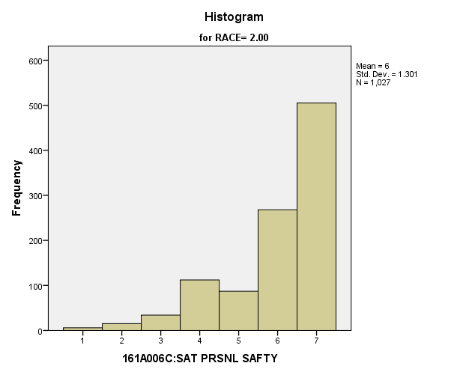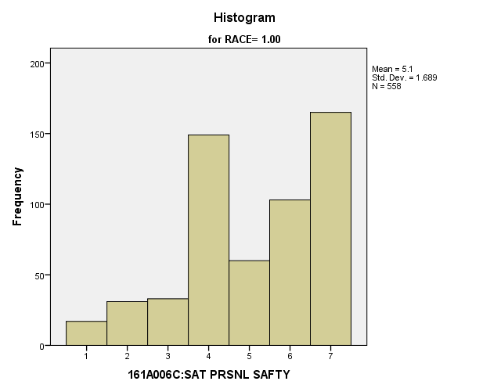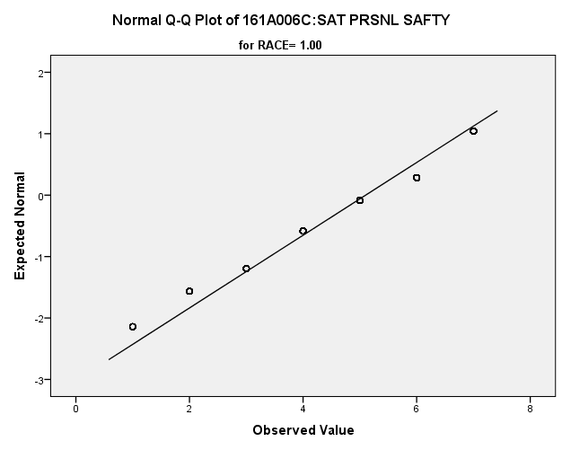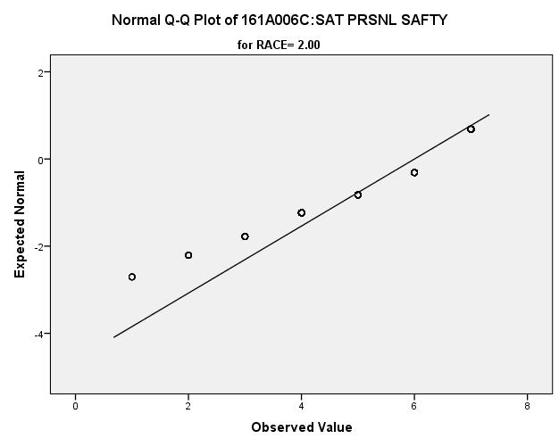

*Primary Analysis:*

|  |  |  |  |  |  |
| --- | --- | --- | --- | --- | --- |
| ***Group Statistics*** | | | | | |
|  | RACE | N | Mean | Std. Deviation | Std. Error Mean |
| 161A006C:SAT PRSNL SAFTY | 1.00 | **558** | **5.10** | **1.689** | **.072** |
| 2.00 | **1027** | **6.00** | **1.301** | **.041** |

|  |  |  |  |  |
| --- | --- | --- | --- | --- |
| ***Independent Samples Test*** | | | | |
|  | | Levene's Test for Equality of Variances | | t-test for Equality of Means |
| F | Sig. | t |
|
| 161A006C:SAT PRSNL SAFTY | Equal variances assumed | **110.419** | **.000** | **-11.805** |
| Equal variances not assumed |  |  | **-10.943** |

|  |  |  |  |  |
| --- | --- | --- | --- | --- |
| ***Independent Samples Test*** | | | | |
|  | | t-test for Equality of Means | | |
| df | Sig. (2-tailed) | Mean Difference |
|
| 161A006C:SAT PRSNL SAFTY | Equal variances assumed | **1583** | **.000** | **-.900** |
| Equal variances not assumed | **921.821** | **.000** | **-.900** |

|  |  |  |  |  |
| --- | --- | --- | --- | --- |
| ***Independent Samples Test*** | | | | |
|  | | t-test for Equality of Means | | |
| Std. Error Difference | 99% Confidence Interval of the Difference | |
| Lower | Upper |
| 161A006C:SAT PRSNL SAFTY | Equal variances assumed | **.076** | **-1.096** | **-.703** |
| Equal variances not assumed | **.082** | **-1.112** | **-.688** |

|  |  |  |
| --- | --- | --- |
| ***Measures of Association*** | | |
|  | Eta | Eta Squared |
| 161A006C:SAT PRSNL SAFTY * RACE | **.284** | **.081** |

**Satisfaction with Safety of Their Property:** Within the potential recruit group, are there racial differences in how satisfied they are with the safety of their property?

**Variables used:** The dependent variable was satisfaction with the safety of their property, with students rating satisfaction on a scale of 1 to 7, with a higher number meaning more satisfaction. The independent (grouping) variable was race.

**Analysis Procedure:**

* A t-test was used to compare average rating of how satisfied students were with the safety of their property between the two racial groups (whites versus non-whites)
* Before conducting analysis, the distribution was checked separately for the two groups by means of visual inspection of histograms and Q-Q plots. No outliers were observed.
* The equality of variances assumption was tested. This assumption was not met.

**Results:**

* Null and alternative hypothesis. H0: μ1 = μ2; Ha: μ1 ≠ μ2.
* Calculated t value: t = -9.875, df = 1040, reject H0, with a p-value of .000 ; Eta squared = .062

**Interpretation:** There is not a significant difference between the two groups in how satisfied students are with safety of their property. Furthermore, 6.2% of how satisfied students were was due to their race.

**Supporting Analysis:**

*Preliminary Analysis:*

|  |  |  |  |  |
| --- | --- | --- | --- | --- |
| ***Descriptives*** | | | | |
|  | RACE | | | Statistic |
| 161A006D:SAT OWN PROP SF | 1.00 | Mean | | **4.63** |
| 99% Confidence Interval for Mean | Lower Bound | **4.43** |
| Upper Bound | **4.82** |
| 5% Trimmed Mean | | **4.70** |
| Median | | **4.00** |
| Variance | | **3.073** |
| Std. Deviation | | **1.753** |
| Minimum | | **1** |
| Maximum | | **7** |
| Range | | **6** |
| Interquartile Range | | **2** |
| Skewness | | **-.323** |
| Kurtosis | | **-.722** |
| 2.00 | Mean | | **5.51** |
| 99% Confidence Interval for Mean | Lower Bound | **5.38** |
| Upper Bound | **5.63** |
| 5% Trimmed Mean | | **5.65** |
| Median | | **6.00** |
| Variance | | **2.475** |
| Std. Deviation | | **1.573** |
| Minimum | | **1** |
| Maximum | | **7** |
| Range | | **6** |
| Interquartile Range | | **3** |
| Skewness | | **-1.043** |
| Kurtosis | | **.392** |

|  |  |  |  |  |
| --- | --- | --- | --- | --- |
| ***Descriptives*** | | | | |
|  | RACE | | | Std. Error |
| 161A006D:SAT OWN PROP SF | 1.00 | Mean | | **.074** |
| 99% Confidence Interval for Mean | Lower Bound |  |
| Upper Bound |  |
| 5% Trimmed Mean | |  |
| Median | |  |
| Variance | |  |
| Std. Deviation | |  |
| Minimum | |  |
| Maximum | |  |
| Range | |  |
| Interquartile Range | |  |
| Skewness | | **.104** |
| Kurtosis | | **.207** |
| 2.00 | Mean | | **.049** |
| 99% Confidence Interval for Mean | Lower Bound |  |
| Upper Bound |  |
| 5% Trimmed Mean | |  |
| Median | |  |
| Variance | |  |
| Std. Deviation | |  |
| Minimum | |  |
| Maximum | |  |
| Range | |  |
| Interquartile Range | |  |
| Skewness | | **.076** |
| Kurtosis | | **.153** |

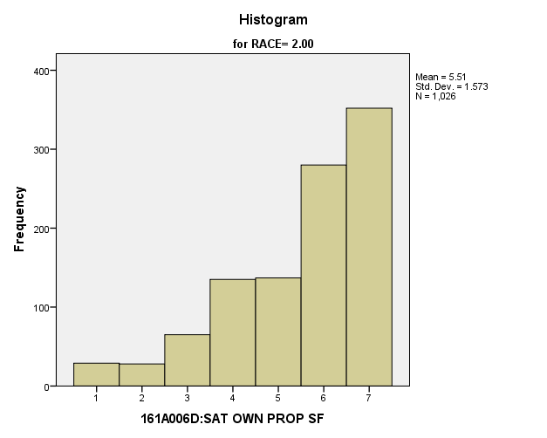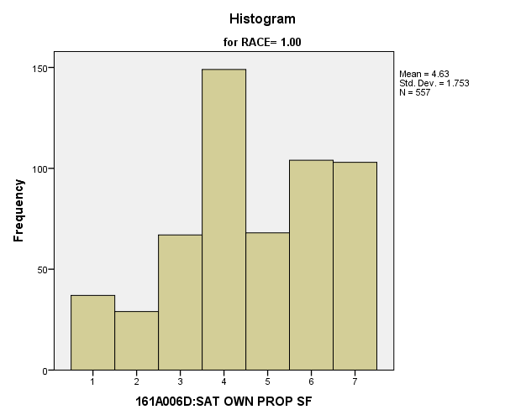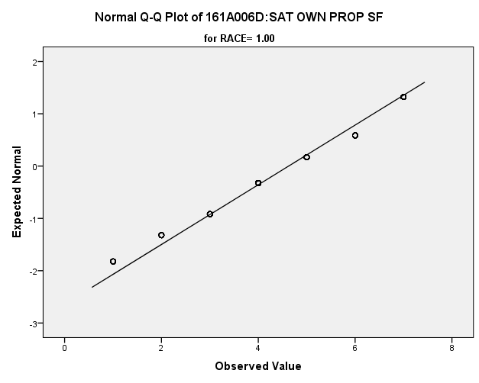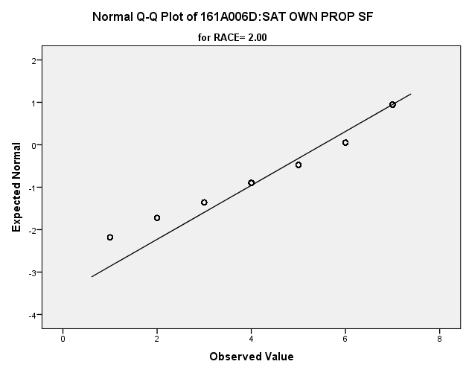

*Primary Analysis:*

|  |  |  |  |  |  |
| --- | --- | --- | --- | --- | --- |
| ***Group Statistics*** | | | | | |
|  | RACE | N | Mean | Std. Deviation | Std. Error Mean |
| 161A006D:SAT OWN PROP SF | 1.00 | **557** | **4.63** | **1.753** | **.074** |
| 2.00 | **1026** | **5.51** | **1.573** | **.049** |

|  |  |  |  |  |
| --- | --- | --- | --- | --- |
| ***Independent Samples Test*** | | | | |
|  | | Levene's Test for Equality of Variances | | t-test for Equality of Means |
| F | Sig. | t |
|
| 161A006D:SAT OWN PROP SF | Equal variances assumed | **15.322** | **.000** | **-10.196** |
| Equal variances not assumed |  |  | **-9.875** |

|  |  |  |  |  |
| --- | --- | --- | --- | --- |
| ***Independent Samples Test*** | | | | |
|  | | t-test for Equality of Means | | |
| df | Sig. (2-tailed) | Mean Difference |
|
| 161A006D:SAT OWN PROP SF | Equal variances assumed | **1581** | **.000** | **-.879** |
| Equal variances not assumed | **1040.591** | **.000** | **-.879** |

|  |  |  |  |  |
| --- | --- | --- | --- | --- |
| ***Independent Samples Test*** | | | | |
|  | | t-test for Equality of Means | | |
| Std. Error Difference | 99% Confidence Interval of the Difference | |
| Lower | Upper |
| 161A006D:SAT OWN PROP SF | Equal variances assumed | **.086** | **-1.102** | **-.657** |
| Equal variances not assumed | **.089** | **-1.109** | **-.650** |

|  |  |  |
| --- | --- | --- |
| ***Measures of Association*** | | |
|  | Eta | Eta Squared |
| 161A006D:SAT OWN PROP SF * RACE | **.248** | **.062** |

**Satisfaction with Education Experience:** Within the potential recruit group, are there racial differences in how satisfied they are with their education experience?

**Variables used:** The dependent variable was satisfaction with education experience, with students rating satisfaction on a scale of 1 to 7, with a higher number meaning more satisfaction. The independent (grouping) variable was race.

**Analysis Procedure:**

* A t-test was used to compare average rating of how satisfied students were with their education experience between the two racial groups (whites versus non-whites)
* Before conducting analysis, the distribution for how satisfied students were with their education experience was checked separately for the two groups by means of visual inspection of histograms and Q-Q plots. No outliers were observed.
* The equality of variances assumption was tested. This assumption was met.

**Results:**

* Null and alternative hypothesis. H0: μ1 = μ2; Ha: μ1 ≠ μ2.
* Calculated t value: t = -1.416, df = 287, fail to reject H0, with a p-value of .158

**Interpretation:** There was not a significant difference between the two groups in how satisfied students were with their education experience.

**Supporting Analysis:**

*Preliminary Analysis:*

|  |  |  |  |  |
| --- | --- | --- | --- | --- |
| ***Descriptives*** | | | | |
|  | RACE | | | Statistic |
| 161A006E:SAT EDUC EXPRNC | 1.00 | Mean | | **5.08** |
| 99% Confidence Interval for Mean | Lower Bound | **4.92** |
| Upper Bound | **5.25** |
| 5% Trimmed Mean | | **5.16** |
| Median | | **5.00** |
| Variance | | **2.251** |
| Std. Deviation | | **1.500** |
| Minimum | | **1** |
| Maximum | | **7** |
| Range | | **6** |
| Interquartile Range | | **2** |
| Skewness | | **-.424** |
| Kurtosis | | **-.425** |
| 2.00 | Mean | | **5.24** |
| 99% Confidence Interval for Mean | Lower Bound | **5.12** |
| Upper Bound | **5.36** |
| 5% Trimmed Mean | | **5.35** |
| Median | | **6.00** |
| Variance | | **2.239** |
| Std. Deviation | | **1.496** |
| Minimum | | **1** |
| Maximum | | **7** |
| Range | | **6** |
| Interquartile Range | | **2** |
| Skewness | | **-.898** |
| Kurtosis | | **.432** |

|  |  |  |  |  |
| --- | --- | --- | --- | --- |
| ***Descriptives*** | | | | |
|  | RACE | | | Std. Error |
| 161A006E:SAT EDUC EXPRNC | 1.00 | Mean | | **.064** |
| 99% Confidence Interval for Mean | Lower Bound |  |
| Upper Bound |  |
| 5% Trimmed Mean | |  |
| Median | |  |
| Variance | |  |
| Std. Deviation | |  |
| Minimum | |  |
| Maximum | |  |
| Range | |  |
| Interquartile Range | |  |
| Skewness | | **.104** |
| Kurtosis | | **.207** |
| 2.00 | Mean | | **.047** |
| 99% Confidence Interval for Mean | Lower Bound |  |
| Upper Bound |  |
| 5% Trimmed Mean | |  |
| Median | |  |
| Variance | |  |
| Std. Deviation | |  |
| Minimum | |  |
| Maximum | |  |
| Range | |  |
| Interquartile Range | |  |
| Skewness | | **.076** |
| Kurtosis | | **.152** |

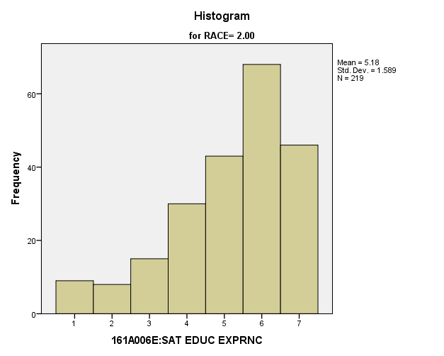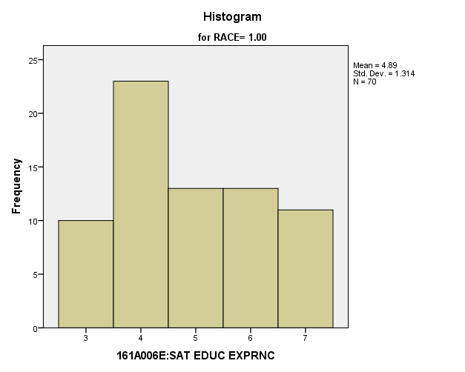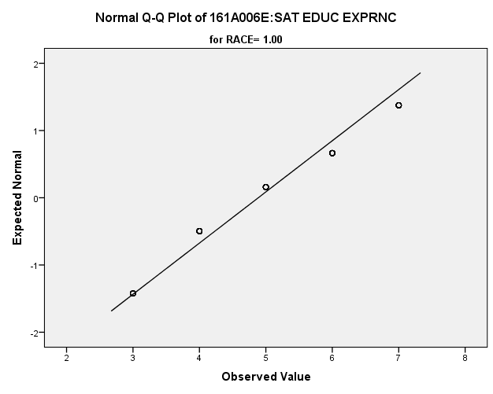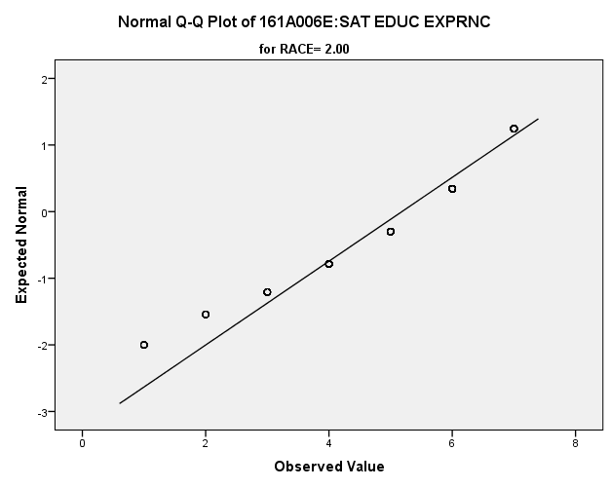

*Primary Analysis:*

|  |  |  |  |  |  |
| --- | --- | --- | --- | --- | --- |
| **Group Statistics** | | | | | |
|  | RACE | N | Mean | Std. Deviation | Std. Error Mean |
| V1645 | 1.00 | **70** | **4.89** | **1.314** | **.157** |
| 2.00 | **219** | **5.18** | **1.589** | **.107** |

|  |  |  |  |  |  |  |
| --- | --- | --- | --- | --- | --- | --- |
| **Independent Samples Test** | | | | | | |
|  | | Levene's Test for Equality of Variances | | t-test for Equality of Means | | |
| F | Sig. | t | df | Sig. (2-tailed) |
|
| V1645 | Equal variances assumed | **1.506** | **.221** | **-1.416** | **287** | **.158** |
| Equal variances not assumed |  |  | **-1.561** | **139.033** | **.121** |

|  |  |  |  |  |  |
| --- | --- | --- | --- | --- | --- |
| **Independent Samples Test** | | | | | |
|  | | t-test for Equality of Means | | | |
| Mean Difference | Std. Error Difference | 99% Confidence Interval of the Difference | |
| Lower | Upper |
| V1645 | Equal variances assumed | **-.297** | **.210** | **-.841** | **.247** |
| Equal variances not assumed | **-.297** | **.190** | **-.794** | **.200** |

**Satisfaction with Friends:** Within the potential recruit group, are there racial differences in how satisfied they are with their friends?

**Variables used:** The dependent variable was satisfaction with friends, with students rating satisfaction on a scale of 1 to 7, with a higher number meaning more satisfaction. The independent (grouping) variable was race.

**Analysis Procedure:**

* A t-test was used to compare average rating of how satisfied students were with their friends between the two racial groups (whites versus non-whites)
* Before conducting analysis, the distribution for how satisfied students were with their friends was checked separately for the two groups by means of visual inspection of histograms and Q-Q plots. No outliers were observed. However, the distribution was left skewed for both groups.
* The equality of variances assumption was tested. This assumption was not met.

**Results:**

* Null and alternative hypothesis. H0: μ1 = μ2; Ha: μ1 ≠ μ2.
* Calculated t value: t = -3.193, df = 96.002, reject H0, with a p-value .000; Eta squared = .045

**Interpretation:** There is a significant difference between the two groups in how satisfied students were with their friends. Furthermore, 4.5% of how satisfied students were with their friends is due to their race.

**Supporting Analysis:**

*Preliminary Analysis:*

|  |  |  |  |  |
| --- | --- | --- | --- | --- |
| ***Descriptives*** | | | | |
|  | RACE | | | Statistic |
| 161A006F:SAT OWN FRIENDS | 1.00 | Mean | | **5.80** |
| 99% Confidence Interval for Mean | Lower Bound | **5.64** |
| Upper Bound | **5.95** |
| 5% Trimmed Mean | | **5.94** |
| Median | | **6.00** |
| Variance | | **1.997** |
| Std. Deviation | | **1.413** |
| Minimum | | **1** |
| Maximum | | **7** |
| Range | | **6** |
| Interquartile Range | | **2** |
| Skewness | | **-1.150** |
| Kurtosis | | **.870** |
| 2.00 | Mean | | **5.98** |
| 99% Confidence Interval for Mean | Lower Bound | **5.87** |
| Upper Bound | **6.08** |
| 5% Trimmed Mean | | **6.12** |
| Median | | **6.00** |
| Variance | | **1.653** |
| Std. Deviation | | **1.286** |
| Minimum | | **1** |
| Maximum | | **7** |
| Range | | **6** |
| Interquartile Range | | **2** |
| Skewness | | **-1.427** |
| Kurtosis | | **1.746** |

|  |  |  |  |  |
| --- | --- | --- | --- | --- |
| ***Descriptives*** | | | | |
|  | RACE | | | Std. Error |
| 161A006F:SAT OWN FRIENDS | 1.00 | Mean | | **.060** |
| 99% Confidence Interval for Mean | Lower Bound |  |
| Upper Bound |  |
| 5% Trimmed Mean | |  |
| Median | |  |
| Variance | |  |
| Std. Deviation | |  |
| Minimum | |  |
| Maximum | |  |
| Range | |  |
| Interquartile Range | |  |
| Skewness | | **.104** |
| Kurtosis | | **.207** |
| 2.00 | Mean | | **.040** |
| 99% Confidence Interval for Mean | Lower Bound |  |
| Upper Bound |  |
| 5% Trimmed Mean | |  |
| Median | |  |
| Variance | |  |
| Std. Deviation | |  |
| Minimum | |  |
| Maximum | |  |
| Range | |  |
| Interquartile Range | |  |
| Skewness | | **.076** |
| Kurtosis | | **.153** |

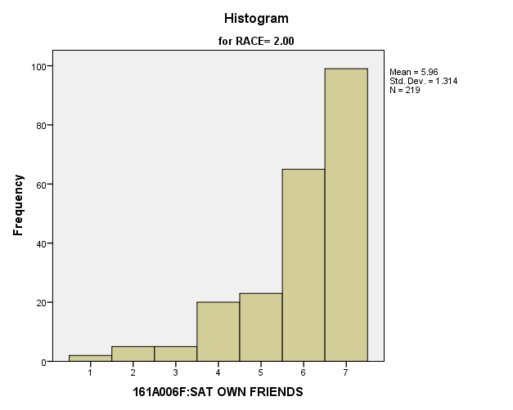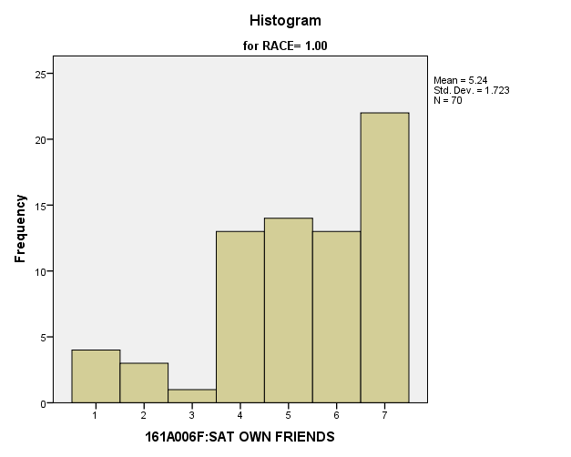

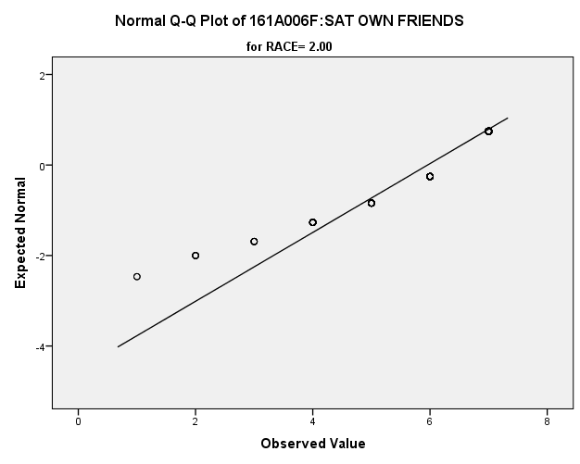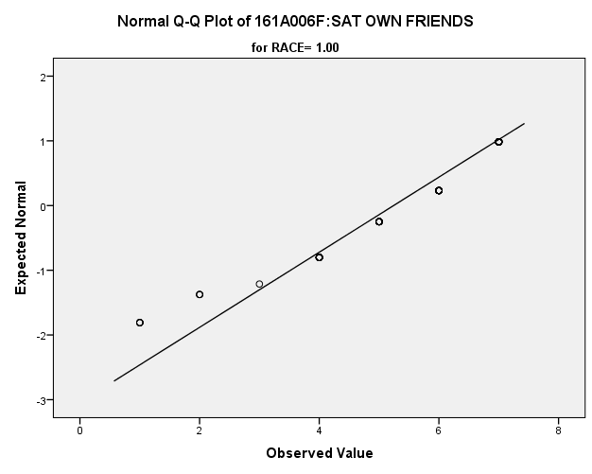

*Primary Analysis:*

|  |  |  |  |  |  |  |  |  |
| --- | --- | --- | --- | --- | --- | --- | --- | --- |
| **Group Statistics** | | | | | | | | |
|  | RACE | N | Mean | | Std. Deviation | | Std. Error Mean | |
| V1646 | 1.00 | **70** | **5.24** | | **1.723** | | **.206** | |
| 2.00 | **219** | **5.96** | | **1.314** | | **.089** | |
| **Independent Samples Test** | | | | | | | | | | | |
|  | | | | Levene's Test for Equality of Variances | | | | t-test for Equality of Means | | | |
| F | | Sig. | | t | | df | Sig. (2-tailed) |
|
| V1646 | Equal variances assumed | | | **11.060** | | **.001** | | **-3.664** | | **287** | **.000** |
| Equal variances not assumed | | |  | |  | | **-3.193** | | **96.002** | **.002** |

|  |  |  |  |  |  |
| --- | --- | --- | --- | --- | --- |
| **Independent Samples Test** | | | | | |
|  | | t-test for Equality of Means | | | |
| Mean Difference | Std. Error Difference | 99% Confidence Interval of the Difference | |
| Lower | Upper |
| V1646 | Equal variances assumed | **-.716** | **.195** | **-1.223** | **-.209** |
| Equal variances not assumed | **-.716** | **.224** | **-1.305** | **-.127** |

|  |  |  |
| --- | --- | --- |
| **Measures of Association** | | |
|  | Eta | Eta Squared |
| V1646 * RACE | **.211** | **.045** |

**Satisfaction with Getting Along with Parents:** Within the potential recruit group, are there racial differences in how satisfied they are with how they get along with their parents?

**Variables used:** The dependent variable was satisfaction with getting along with parents, with students rating satisfaction on a scale of 1 to 7, with a higher number meaning more satisfaction. The independent (grouping) variable was race.

**Analysis Procedure:**

* A t-test was used to compare average rating of how satisfied students are with getting along with their parents between the two racial groups (whites versus non-whites)
* Before conducting analysis, the distribution for how satisfied students are with getting along with their parents was checked separately for the two groups by means of visual inspection of histograms and Q-Q plots. No outliers were observed. However, the distribution was left skewed for both groups.
* The equality of variances assumption was tested. This assumption was met.

**Results:**

* Null and alternative hypothesis. H0: μ1 = μ2; Ha: μ1 ≠ μ2.
* Calculated t value: t = -1.236, df = 268, fail to reject H0, with a p-value of .218

**Interpretation:** There is not a significant difference between the two groups in how satisfied students are with getting along with their parents.

**Supporting Analysis:**

*Preliminary Analysis:*

|  |  |  |  |  |
| --- | --- | --- | --- | --- |
| ***Descriptives*** | | | | |
|  | RACE | | | Statistic |
| 161A006G:SAT GT ALNG PRN | 1.00 | Mean | | **5.32** |
| 99% Confidence Interval for Mean | Lower Bound | **5.14** |
| Upper Bound | **5.51** |
| 5% Trimmed Mean | | **5.46** |
| Median | | **6.00** |
| Variance | | **2.765** |
| Std. Deviation | | **1.663** |
| Minimum | | **1** |
| Maximum | | **7** |
| Range | | **6** |
| Interquartile Range | | **3** |
| Skewness | | **-.834** |
| Kurtosis | | **-.004** |
| 2.00 | Mean | | **5.49** |
| 99% Confidence Interval for Mean | Lower Bound | **5.35** |
| Upper Bound | **5.62** |
| 5% Trimmed Mean | | **5.64** |
| Median | | **6.00** |
| Variance | | **2.703** |
| Std. Deviation | | **1.644** |
| Minimum | | **1** |
| Maximum | | **7** |
| Range | | **6** |
| Interquartile Range | | **2** |
| Skewness | | **-1.079** |
| Kurtosis | | **.412** |

|  |  |  |  |  |
| --- | --- | --- | --- | --- |
| ***Descriptives*** | | | | |
|  | RACE | | | Std. Error |
| 161A006G:SAT GT ALNG PRN | 1.00 | Mean | | **.070** |
| 99% Confidence Interval for Mean | Lower Bound |  |
| Upper Bound |  |
| 5% Trimmed Mean | |  |
| Median | |  |
| Variance | |  |
| Std. Deviation | |  |
| Minimum | |  |
| Maximum | |  |
| Range | |  |
| Interquartile Range | |  |
| Skewness | | **.103** |
| Kurtosis | | **.206** |
| 2.00 | Mean | | **.051** |
| 99% Confidence Interval for Mean | Lower Bound |  |
| Upper Bound |  |
| 5% Trimmed Mean | |  |
| Median | |  |
| Variance | |  |
| Std. Deviation | |  |
| Minimum | |  |
| Maximum | |  |
| Range | |  |
| Interquartile Range | |  |
| Skewness | | **.076** |
| Kurtosis | | **.152** |

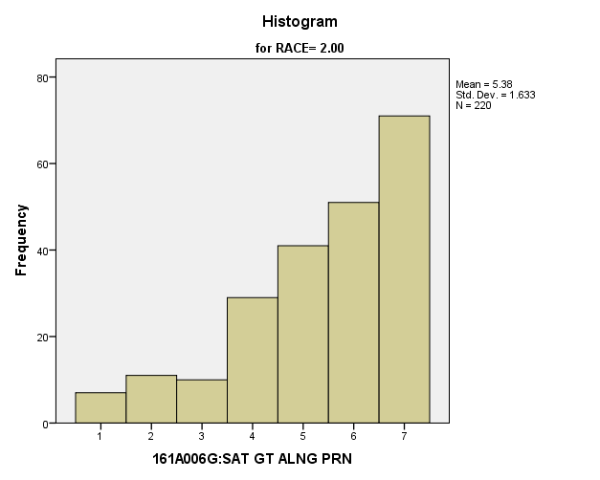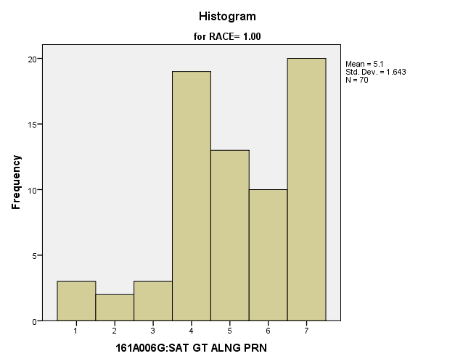

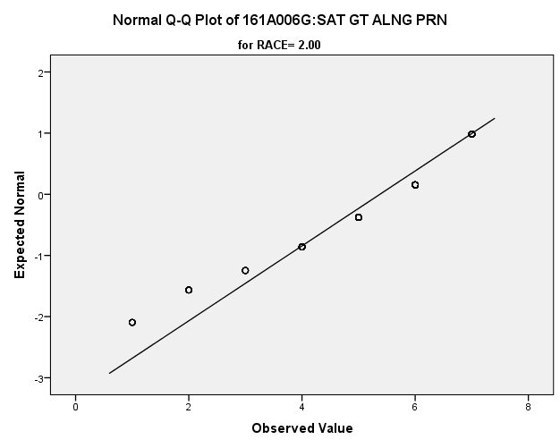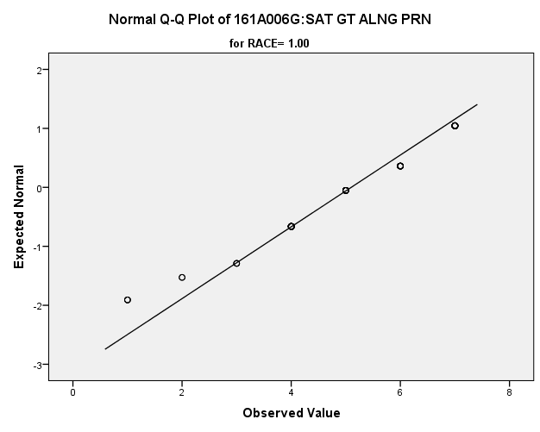

*Primary Analysis:*

|  |  |  |  |  |  |  |  |  |
| --- | --- | --- | --- | --- | --- | --- | --- | --- |
| **Group Statistics** | | | | | | | | |
|  | RACE | N | Mean | | Std. Deviation | | Std. Error Mean | |
| V1647 | 1.00 | **70** | **5.10** | | **1.643** | | **.196** | |
| 2.00 | **220** | **5.38** | | **1.633** | | **.110** | |
| **Independent Samples Test** | | | | | | | | | | | |
|  | | | | Levene's Test for Equality of Variances | | | | t-test for Equality of Means | | | |
| F | | Sig. | | t | | df | Sig. (2-tailed) |
|
| V1647 | Equal variances assumed | | | **.003** | | **.958** | | **-1.236** | | **288** | **.218** |
| Equal variances not assumed | | |  | |  | | **-1.232** | | **115.559** | **.221** |

|  |  |  |  |  |  |
| --- | --- | --- | --- | --- | --- |
| **Independent Samples Test** | | | | | |
|  | | t-test for Equality of Means | | | |
| Mean Difference | Std. Error Difference | 99% Confidence Interval of the Difference | |
| Lower | Upper |
| V1647 | Equal variances assumed | **-.277** | **.224** | **-.859** | **.305** |
| Equal variances not assumed | **-.277** | **.225** | **-.867** | **.312** |

**Satisfaction with Yourself:** Within the potential recruit group, are there racial differences in how satisfied they are with themselves?

**Variables used:** The dependent variable was satisfaction with yourself, with students rating satisfaction on a scale of 1 to 7, with a higher number meaning more satisfaction. The independent (grouping) variable was race.

**Analysis Procedure:**

* A t-test was used to compare average rating of how satisfied students are with themselves between the two racial groups (whites versus non-whites)
* Before conducting analysis, the distribution for how satisfied students are with themselves was checked separately for the two groups by means of visual inspection of histograms and Q-Q plots. No outliers were observed. However, the distribution was left skewed for both groups.
* The equality of variances assumption was tested. This assumption was met.

**Results:**

* Null and alternative hypothesis. H0: μ1 = μ2; Ha: μ1 ≠ μ2.
* Calculated t value: t = .096, df = .287, fail to reject H0, with a p-value of .923

**Interpretation:** There is not a significant difference between the two groups in how satisfied students are with themselves.

**Supporting Analysis:**

*Preliminary Analysis:*

|  |  |  |  |  |
| --- | --- | --- | --- | --- |
| ***Descriptives*** | | | | |
|  | RACE | | | Statistic |
| 161A006H:SAT YOURSELF | 1.00 | Mean | | **5.31** |
| 99% Confidence Interval for Mean | Lower Bound | **5.12** |
| Upper Bound | **5.51** |
| 5% Trimmed Mean | | **5.46** |
| Median | | **6.00** |
| Variance | | **3.209** |
| Std. Deviation | | **1.791** |
| Minimum | | **1** |
| Maximum | | **7** |
| Range | | **6** |
| Interquartile Range | | **3** |
| Skewness | | **-.865** |
| Kurtosis | | **-.208** |
| 2.00 | Mean | | **5.18** |
| 99% Confidence Interval for Mean | Lower Bound | **5.04** |
| Upper Bound | **5.32** |
| 5% Trimmed Mean | | **5.30** |
| Median | | **6.00** |
| Variance | | **2.998** |
| Std. Deviation | | **1.732** |
| Minimum | | **1** |
| Maximum | | **7** |
| Range | | **6** |
| Interquartile Range | | **3** |
| Skewness | | **-.745** |
| Kurtosis | | **-.388** |

|  |  |  |  |  |
| --- | --- | --- | --- | --- |
| ***Descriptives*** | | | | |
|  | RACE | | | Std. Error |
| 161A006H:SAT YOURSELF | 1.00 | Mean | | **.076** |
| 99% Confidence Interval for Mean | Lower Bound |  |
| Upper Bound |  |
| 5% Trimmed Mean | |  |
| Median | |  |
| Variance | |  |
| Std. Deviation | |  |
| Minimum | |  |
| Maximum | |  |
| Range | |  |
| Interquartile Range | |  |
| Skewness | | **.103** |
| Kurtosis | | **.206** |
| 2.00 | Mean | | **.054** |
| 99% Confidence Interval for Mean | Lower Bound |  |
| Upper Bound |  |
| 5% Trimmed Mean | |  |
| Median | |  |
| Variance | |  |
| Std. Deviation | |  |
| Minimum | |  |
| Maximum | |  |
| Range | |  |
| Interquartile Range | |  |
| Skewness | | **.076** |
| Kurtosis | | **.153** |

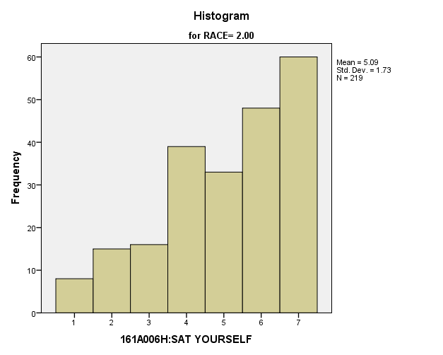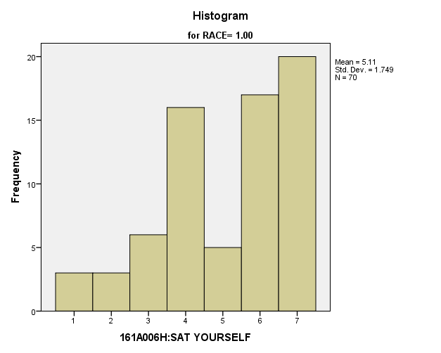

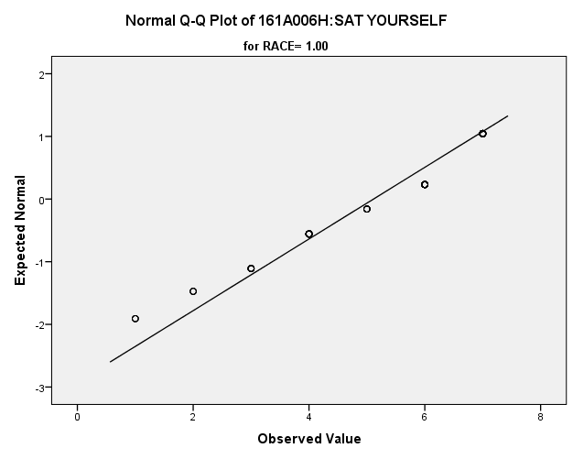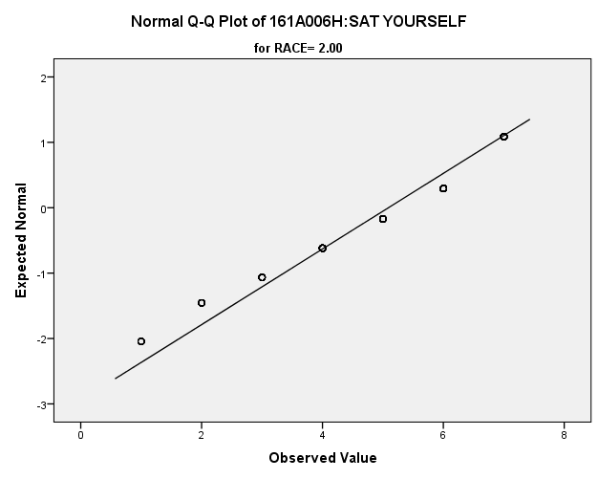

*Primary Analysis:*

|  |  |  |  |  |  |  |  |  |
| --- | --- | --- | --- | --- | --- | --- | --- | --- |
| **Group Statistics** | | | | | | | | |
|  | RACE | N | Mean | | Std. Deviation | | Std. Error Mean | |
| V1648 | 1.00 | **70** | **5.11** | | **1.749** | | **.209** | |
| 2.00 | **219** | **5.09** | | **1.730** | | **.117** | |
| **Independent Samples Test** | | | | | | | | | | | |
|  | | | | Levene's Test for Equality of Variances | | | | t-test for Equality of Means | | | |
| F | | Sig. | | t | | df | Sig. (2-tailed) |
|
| V1648 | Equal variances assumed | | | **.249** | | **.618** | | **.096** | | **287** | **.923** |
| Equal variances not assumed | | |  | |  | | **.096** | | **115.311** | **.924** |

|  |  |  |  |  |  |
| --- | --- | --- | --- | --- | --- |
| **Independent Samples Test** | | | | | |
|  | | t-test for Equality of Means | | | |
| Mean Difference | Std. Error Difference | 99% Confidence Interval of the Difference | |
| Lower | Upper |
| V1648 | Equal variances assumed | **.023** | **.238** | **-.595** | **.640** |
| Equal variances not assumed | **.023** | **.240** | **-.604** | **.650** |

**Satisfaction with Standard of Living:** Within the potential recruit group, are there racial differences in how satisfied they are with their standard of living?

**Variables used:** The dependent variable was satisfaction with their standard of living, with students rating satisfaction on a scale of 1 to 7, with a higher number meaning more satisfaction. The independent (grouping) variable was race.

**Analysis Procedure:**

* A t-test was used to compare average rating of how satisfied students are with their standard of living between the two racial groups (whites versus non-whites)
* Before conducting analysis, the was checked separately for the two groups by means of visual inspection of histograms and Q-Q plots. No outliers were observed. However, the distribution was left skewed for both groups.
* The equality of variances assumption was tested. This assumption was not met.

**Results:**

* Null and alternative hypothesis. H0: μ1 = μ2; Ha: μ1 ≠ μ2.
* Calculated t value: t = -7.833, df =996, reject H0, with a p-value of .000; Eta squared = .041

**Interpretation:** There is a significant difference between the two groups in how satisfied students are with their standard of living. Furthermore, about 4.1% of how satisfied students are is due to their race.

**Supporting Analysis:**

*Preliminary Analysis:*

|  |  |  |  |  |
| --- | --- | --- | --- | --- |
| ***Descriptives*** | | | | |
|  | RACE | | | Statistic |
| 161A006I:SAT STD OF LVG | 1.00 | Mean | | **5.32** |
| 99% Confidence Interval for Mean | Lower Bound | **5.15** |
| Upper Bound | **5.49** |
| 5% Trimmed Mean | | **5.45** |
| Median | | **6.00** |
| Variance | | **2.539** |
| Std. Deviation | | **1.593** |
| Minimum | | **1** |
| Maximum | | **7** |
| Range | | **6** |
| Interquartile Range | | **3** |
| Skewness | | **-.800** |
| Kurtosis | | **.026** |
| 2.00 | Mean | | **5.94** |
| 99% Confidence Interval for Mean | Lower Bound | **5.84** |
| Upper Bound | **6.05** |
| 5% Trimmed Mean | | **6.09** |
| Median | | **6.00** |
| Variance | | **1.802** |
| Std. Deviation | | **1.342** |
| Minimum | | **1** |
| Maximum | | **7** |
| Range | | **6** |
| Interquartile Range | | **2** |
| Skewness | | **-1.432** |
| Kurtosis | | **1.683** |

|  |  |  |  |  |
| --- | --- | --- | --- | --- |
| ***Descriptives*** | | | | |
|  | RACE | | | Std. Error |
| 161A006I:SAT STD OF LVG | 1.00 | Mean | | **.067** |
| 99% Confidence Interval for Mean | Lower Bound |  |
| Upper Bound |  |
| 5% Trimmed Mean | |  |
| Median | |  |
| Variance | |  |
| Std. Deviation | |  |
| Minimum | |  |
| Maximum | |  |
| Range | |  |
| Interquartile Range | |  |
| Skewness | | **.103** |
| Kurtosis | | **.206** |
| 2.00 | Mean | | **.042** |
| 99% Confidence Interval for Mean | Lower Bound |  |
| Upper Bound |  |
| 5% Trimmed Mean | |  |
| Median | |  |
| Variance | |  |
| Std. Deviation | |  |
| Minimum | |  |
| Maximum | |  |
| Range | |  |
| Interquartile Range | |  |
| Skewness | | **.076** |
| Kurtosis | | **.152** |

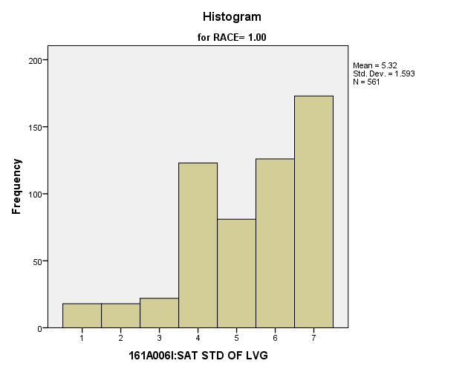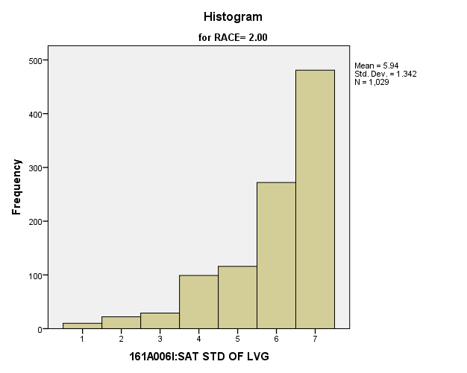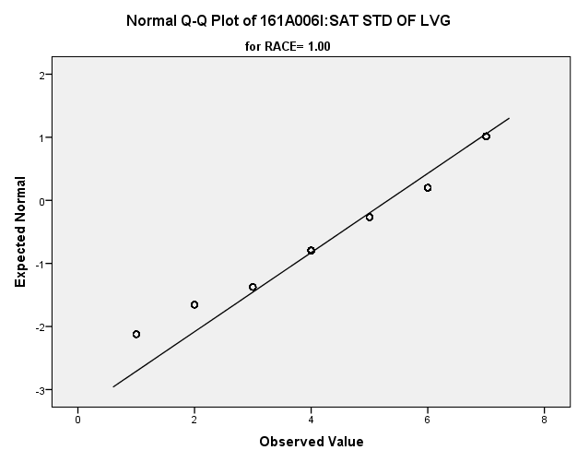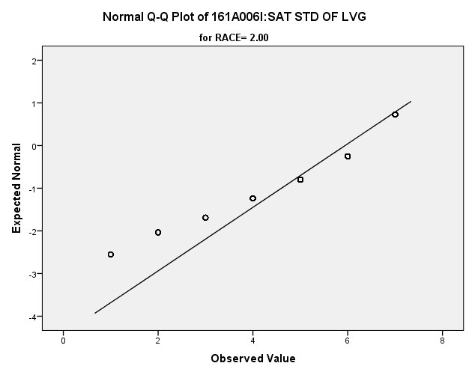

*Primary Analysis:*

|  |  |  |  |  |  |
| --- | --- | --- | --- | --- | --- |
| ***Group Statistics*** | | | | | |
|  | RACE | N | Mean | Std. Deviation | Std. Error Mean |
| 161A006I:SAT STD OF LVG | 1.00 | **561** | **5.32** | **1.593** | **.067** |
| 2.00 | **1029** | **5.94** | **1.342** | **.042** |

|  |  |  |  |  |
| --- | --- | --- | --- | --- |
| ***Independent Samples Test*** | | | | |
|  | | Levene's Test for Equality of Variances | | t-test for Equality of Means |
| F | Sig. | t |
|
| 161A006I:SAT STD OF LVG | Equal variances assumed | **50.885** | **.000** | **-8.287** |
| Equal variances not assumed |  |  | **-7.883** |

|  |  |  |  |  |
| --- | --- | --- | --- | --- |
| ***Independent Samples Test*** | | | | |
|  | | t-test for Equality of Means | | |
| df | Sig. (2-tailed) | Mean Difference |
|
| 161A006I:SAT STD OF LVG | Equal variances assumed | **1588** | **.000** | **-.625** |
| Equal variances not assumed | **996.027** | **.000** | **-.625** |

|  |  |  |  |  |
| --- | --- | --- | --- | --- |
| ***Independent Samples Test*** | | | | |
|  | | t-test for Equality of Means | | |
| Std. Error Difference | 99% Confidence Interval of the Difference | |
| Lower | Upper |
| 161A006I:SAT STD OF LVG | Equal variances assumed | **.075** | **-.819** | **-.430** |
| Equal variances not assumed | **.079** | **-.829** | **-.420** |

|  |  |  |
| --- | --- | --- |
| ***Measures of Association*** | | |
|  | Eta | Eta Squared |
| 161A006I:SAT STD OF LVG * RACE | **.204** | **.041** |

**Satisfaction with Amount of Free Time:** Within the potential recruit group, are there racial differences in how satisfied they are with the amount of time they have for doing things that they like?

**Variables used:** The dependent variable was satisfaction with amount of free time, with students rating satisfaction on a scale of 1 to 7, with a higher number meaning more satisfaction. The independent (grouping) variable was race.

**Analysis Procedure:**

* A t-test was used to compare average rating of how satisfied students are with their free time between the two racial groups (whites versus non-whites)
* Before conducting analysis, the distribution for how satisfied students are with their free time was checked separately for the two groups by means of visual inspection of histograms and Q-Q plots. No outliers were observed. However, the distribution was similarly skewed for both groups.
* The equality of variances assumption was tested. This assumption was met.

**Results:**

* Null and alternative hypothesis. H0: μ1 = μ2; Ha: μ1 ≠ μ2.
* Calculated t value: t = -2.122, df = 285, fail to reject H0, with a p-value of .035

**Interpretation:** There is not a significant difference between the two groups in how satisfied students are with their free time.

**Supporting Analysis:**

*Preliminary Analysis:*

|  |  |  |  |  |
| --- | --- | --- | --- | --- |
| ***Descriptives*** | | | | |
|  | RACE | | | Statistic |
| 161A006J:SAT TIME FR THG | 1.00 | Mean | | **4.44** |
| 99% Confidence Interval for Mean | Lower Bound | **4.23** |
| Upper Bound | **4.65** |
| 5% Trimmed Mean | | **4.49** |
| Median | | **4.00** |
| Variance | | **3.572** |
| Std. Deviation | | **1.890** |
| Minimum | | **1** |
| Maximum | | **7** |
| Range | | **6** |
| Interquartile Range | | **3** |
| Skewness | | **-.228** |
| Kurtosis | | **-.981** |
| 2.00 | Mean | | **4.78** |
| 99% Confidence Interval for Mean | Lower Bound | **4.64** |
| Upper Bound | **4.92** |
| 5% Trimmed Mean | | **4.87** |
| Median | | **5.00** |
| Variance | | **3.093** |
| Std. Deviation | | **1.759** |
| Minimum | | **1** |
| Maximum | | **7** |
| Range | | **6** |
| Interquartile Range | | **2** |
| Skewness | | **-.517** |
| Kurtosis | | **-.636** |

|  |  |  |  |  |
| --- | --- | --- | --- | --- |
| ***Descriptives*** | | | | |
|  | RACE | | | Std. Error |
| 161A006J:SAT TIME FR THG | 1.00 | Mean | | **.080** |
| 99% Confidence Interval for Mean | Lower Bound |  |
| Upper Bound |  |
| 5% Trimmed Mean | |  |
| Median | |  |
| Variance | |  |
| Std. Deviation | |  |
| Minimum | |  |
| Maximum | |  |
| Range | |  |
| Interquartile Range | |  |
| Skewness | | **.103** |
| Kurtosis | | **.206** |
| 2.00 | Mean | | **.055** |
| 99% Confidence Interval for Mean | Lower Bound |  |
| Upper Bound |  |
| 5% Trimmed Mean | |  |
| Median | |  |
| Variance | |  |
| Std. Deviation | |  |
| Minimum | |  |
| Maximum | |  |
| Range | |  |
| Interquartile Range | |  |
| Skewness | | **.076** |
| Kurtosis | | **.153** |

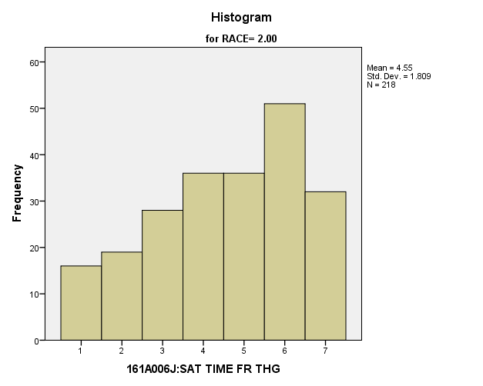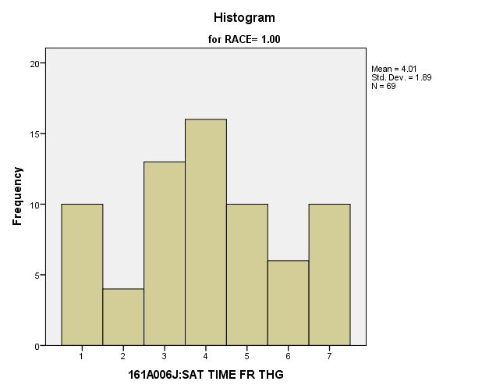

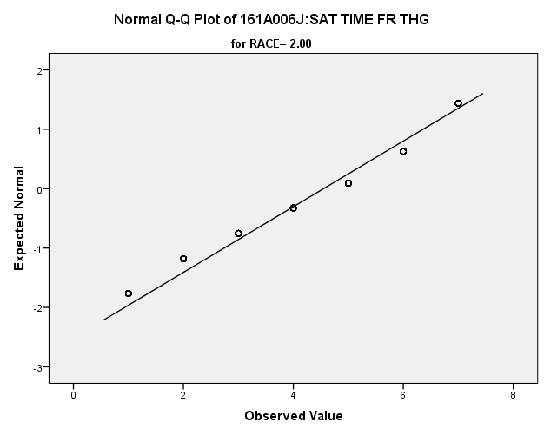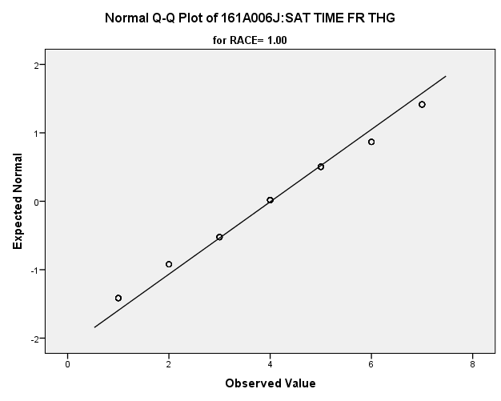

*Primary Analysis:*

|  |  |  |  |  |  |  |  |  |
| --- | --- | --- | --- | --- | --- | --- | --- | --- |
| **Group Statistics** | | | | | | | | |
|  | RACE | N | Mean | | Std. Deviation | | Std. Error Mean | |
| V1650 | 1.00 | **69** | **4.01** | | **1.890** | | **.228** | |
| 2.00 | **218** | **4.55** | | **1.809** | | **.123** | |
| **Independent Samples Test** | | | | | | | | | | | |
|  | | | | Levene's Test for Equality of Variances | | | | t-test for Equality of Means | | | |
| F | | Sig. | | t | | df | Sig. (2-tailed) |
|
| V1650 | Equal variances assumed | | | **.132** | | **.717** | | **-2.122** | | **285** | **.035** |
| Equal variances not assumed | | |  | |  | | **-2.074** | | **110.222** | **.040** |

|  |  |  |  |  |  |
| --- | --- | --- | --- | --- | --- |
| **Independent Samples Test** | | | | | |
|  | | t-test for Equality of Means | | | |
| Mean Difference | Std. Error Difference | 99% Confidence Interval of the Difference | |
| Lower | Upper |
| V1650 | Equal variances assumed | **-.536** | **.253** | **-1.191** | **.119** |
| Equal variances not assumed | **-.536** | **.258** | **-1.213** | **.141** |

**Satisfaction with Leisure Time:** Within the potential recruit group, are there racial differences in how satisfied they are spending their leisure time?

**Variables used:** The dependent variable was satisfaction with leisure time, with students rating satisfaction on a scale of 1 to 7, with a higher number meaning more satisfaction. The independent (grouping) variable was race.

**Analysis Procedure:**

* A t-test was used to compare average rating of how satisfied students are with their leisure time between the two racial groups (whites versus non-whites)
* Before conducting analysis, the distribution for how satisfied students are with their leisure time was checked separately for the two groups by means of visual inspection of histograms and Q-Q plots. No outliers were observed. However, the distribution was left skewed for both groups.
* The equality of variances assumption was tested. This assumption was met.

**Results:**

* Null and alternative hypothesis. H0: μ1 = μ2; Ha: μ1 ≠ μ2.
* Calculated t value: t = -1.939, df = 286, fail to reject H0, with a p-value of .05

**Interpretation:** There is not a significant difference between the two groups in how satisfied students are with their leisure time

**Supporting Analysis:**

*Preliminary Analysis:*

|  |  |  |  |  |
| --- | --- | --- | --- | --- |
| ***Descriptives*** | | | | |
|  | RACE | | | Statistic |
| 161A006K:SAT SPD LEISR | 1.00 | Mean | | **4.98** |
| 99% Confidence Interval for Mean | Lower Bound | **4.79** |
| Upper Bound | **5.16** |
| 5% Trimmed Mean | | **5.07** |
| Median | | **5.00** |
| Variance | | **2.793** |
| Std. Deviation | | **1.671** |
| Minimum | | **1** |
| Maximum | | **7** |
| Range | | **6** |
| Interquartile Range | | **3** |
| Skewness | | **-.428** |
| Kurtosis | | **-.615** |
| 2.00 | Mean | | **5.39** |
| 99% Confidence Interval for Mean | Lower Bound | **5.26** |
| Upper Bound | **5.51** |
| 5% Trimmed Mean | | **5.51** |
| Median | | **6.00** |
| Variance | | **2.419** |
| Std. Deviation | | **1.555** |
| Minimum | | **1** |
| Maximum | | **7** |
| Range | | **6** |
| Interquartile Range | | **3** |
| Skewness | | **-.825** |
| Kurtosis | | **-.078** |

|  |  |  |  |  |
| --- | --- | --- | --- | --- |
| ***Descriptives*** | | | | |
|  | RACE | | | Std. Error |
| 161A006K:SAT SPD LEISR | 1.00 | Mean | | **.071** |
| 99% Confidence Interval for Mean | Lower Bound |  |
| Upper Bound |  |
| 5% Trimmed Mean | |  |
| Median | |  |
| Variance | |  |
| Std. Deviation | |  |
| Minimum | |  |
| Maximum | |  |
| Range | |  |
| Interquartile Range | |  |
| Skewness | | **.103** |
| Kurtosis | | **.206** |
| 2.00 | Mean | | **.049** |
| 99% Confidence Interval for Mean | Lower Bound |  |
| Upper Bound |  |
| 5% Trimmed Mean | |  |
| Median | |  |
| Variance | |  |
| Std. Deviation | |  |
| Minimum | |  |
| Maximum | |  |
| Range | |  |
| Interquartile Range | |  |
| Skewness | | **.076** |
| Kurtosis | | **.152** |

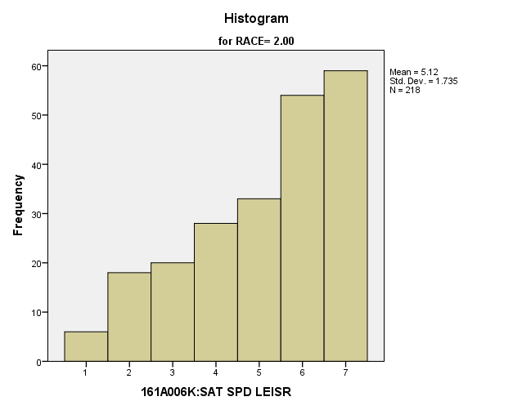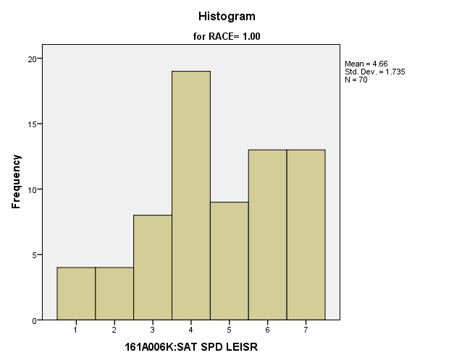

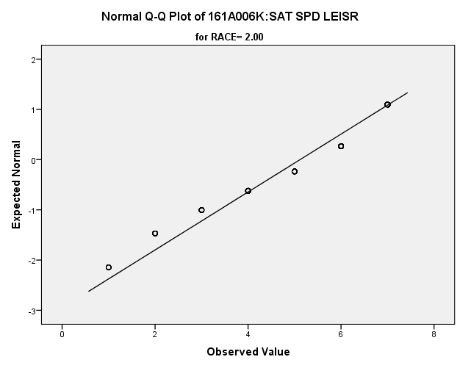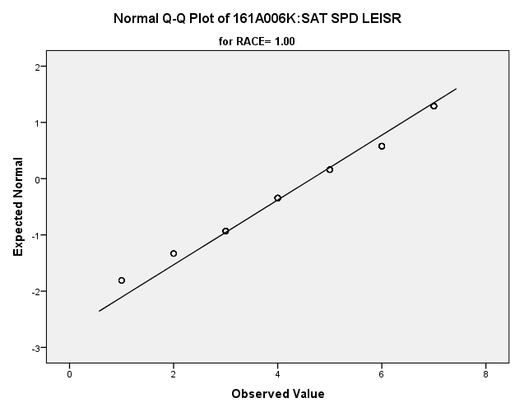

|  |  |  |  |  |  |  |  |  |
| --- | --- | --- | --- | --- | --- | --- | --- | --- |
| *Primary Analysis:*  **Group Statistics** | | | | | | | | |
|  | RACE | N | Mean | | Std. Deviation | | Std. Error Mean | |
| V1651 | 1.00 | **70** | **4.66** | | **1.735** | | **.207** | |
| 2.00 | **218** | **5.12** | | **1.735** | | **.117** | |
| **Independent Samples Test** | | | | | | | | | | | |
|  | | | | Levene's Test for Equality of Variances | | | | t-test for Equality of Means | | | |
| F | | Sig. | | t | | df | Sig. (2-tailed) |
|
| V1651 | Equal variances assumed | | | **.000** | | **.983** | | **-1.939** | | **286** | **.053** |
| Equal variances not assumed | | |  | |  | | **-1.939** | | **116.564** | **.055** |

|  |  |  |  |  |  |
| --- | --- | --- | --- | --- | --- |
| **Independent Samples Test** | | | | | |
|  | | t-test for Equality of Means | | | |
| Mean Difference | Std. Error Difference | 99% Confidence Interval of the Difference | |
| Lower | Upper |
| V1651 | Equal variances assumed | **-.462** | **.238** | **-1.080** | **.156** |
| Equal variances not assumed | **-.462** | **.238** | **-1.086** | **.162** |

**Satisfaction with Life:** Within the potential recruit group, are there racial differences in how satisfied they are with life?

**Variables used:** The dependent variable was satisfaction with life, with students rating satisfaction on a scale of 1 to 7, with a higher number meaning more satisfaction. The independent (grouping) variable was race.

**Analysis Procedure:**

* A t-test was used to compare average rating of how satisfied students are with life between the two racial groups (whites versus non-whites)
* Before conducting analysis, the distribution for how satisfied students are with life was checked separately for the two groups by means of visual inspection of histograms and Q-Q plots. No outliers were observed. However, the distribution was left skewed for both groups.
* The equality of variances assumption was tested. This assumption was met.

**Results:**

* Null and alternative hypothesis. H0: μ1 = μ2; Ha: μ1 ≠ μ2.
* Calculated t value: t = -2.50, df = 287, fail to reject H0, with a p-value of .013

**Interpretation:** There is not a significant difference between the two groups in how satisfied students are with life

**Supporting Analysis:**

*Preliminary Analysis:*

|  |  |  |  |  |
| --- | --- | --- | --- | --- |
| ***Descriptives*** | | | | |
|  | RACE | | | Statistic |
| 161A006L:SAT LIFE AS WHL | 1.00 | Mean | | **4.92** |
| 99% Confidence Interval for Mean | Lower Bound | **4.76** |
| Upper Bound | **5.09** |
| 5% Trimmed Mean | | **5.01** |
| Median | | **5.00** |
| Variance | | **2.386** |
| Std. Deviation | | **1.545** |
| Minimum | | **1** |
| Maximum | | **7** |
| Range | | **6** |
| Interquartile Range | | **2** |
| Skewness | | **-.511** |
| Kurtosis | | **-.243** |
| 2.00 | Mean | | **5.22** |
| 99% Confidence Interval for Mean | Lower Bound | **5.10** |
| Upper Bound | **5.34** |
| 5% Trimmed Mean | | **5.33** |
| Median | | **6.00** |
| Variance | | **2.319** |
| Std. Deviation | | **1.523** |
| Minimum | | **1** |
| Maximum | | **7** |
| Range | | **6** |
| Interquartile Range | | **2** |
| Skewness | | **-.761** |
| Kurtosis | | **-.009** |

|  |  |  |  |  |
| --- | --- | --- | --- | --- |
| ***Descriptives*** | | | | |
|  | RACE | | | Std. Error |
| 161A006L:SAT LIFE AS WHL | 1.00 | Mean | | **.065** |
| 99% Confidence Interval for Mean | Lower Bound |  |
| Upper Bound |  |
| 5% Trimmed Mean | |  |
| Median | |  |
| Variance | |  |
| Std. Deviation | |  |
| Minimum | |  |
| Maximum | |  |
| Range | |  |
| Interquartile Range | |  |
| Skewness | | **.104** |
| Kurtosis | | **.207** |
| 2.00 | Mean | | **.048** |
| 99% Confidence Interval for Mean | Lower Bound |  |
| Upper Bound |  |
| 5% Trimmed Mean | |  |
| Median | |  |
| Variance | |  |
| Std. Deviation | |  |
| Minimum | |  |
| Maximum | |  |
| Range | |  |
| Interquartile Range | |  |
| Skewness | | **.076** |
| Kurtosis | | **.153** |

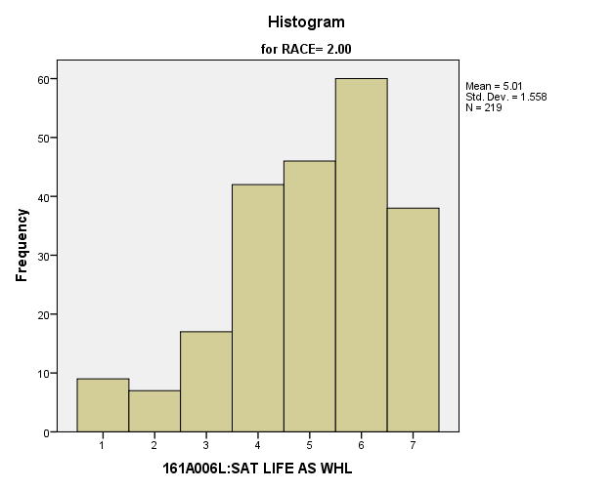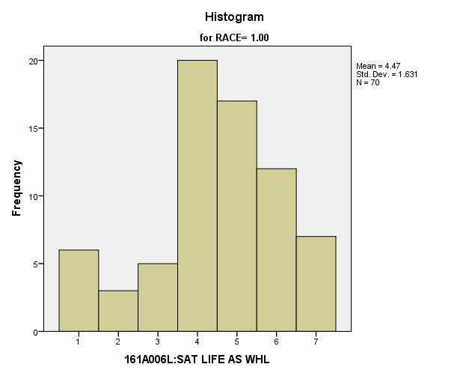

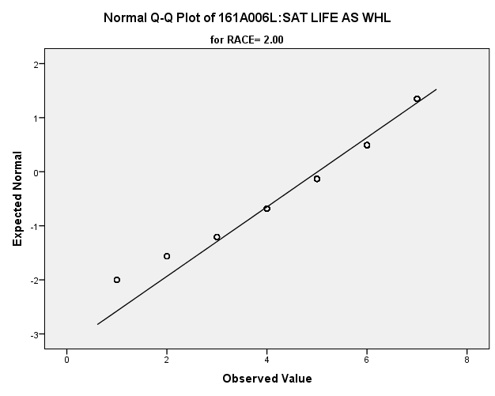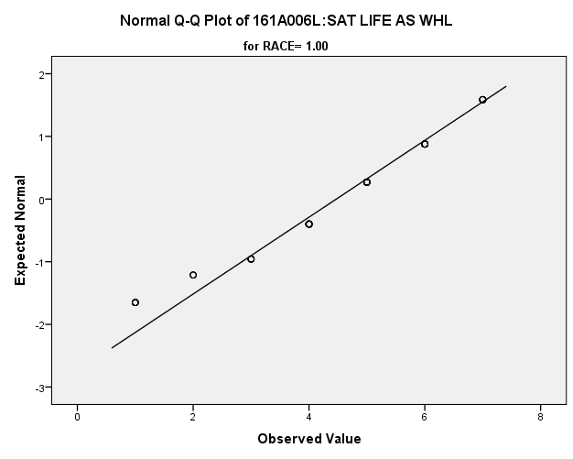

|  |  |  |  |  |  |  |  |  |  |  |  |
| --- | --- | --- | --- | --- | --- | --- | --- | --- | --- | --- | --- |
| *Primary Analysis:*  **Group Statistics** | | | | | | | | | | | |
|  | RACE | | N | Mean | | | Std. Deviation | | Std. Error Mean | | |
| V1652 | 1.00 | | **70** | **4.47** | | | **1.631** | | **.195** | | |
| 2.00 | | **219** | **5.01** | | | **1.558** | | **.105** | | |
| **Independent Samples Test** | | | | | | | | | | | | | | | | |
|  | | | | | Levene's Test for Equality of Variances | | | | | | t-test for Equality of Means | | | | | |
| F | | | Sig. | | | t | | | df | Sig. (2-tailed) | |
|
| V1652 | Equal variances assumed | | | | **.185** | | | **.667** | | | **-2.507** | | | **287** | **.013** | |
| Equal variances not assumed | | | |  | | |  | | | **-2.448** | | | **112.110** | **.016** | |
| **Independent Samples Test** | | | | | | | | | | | | | | | | | |
|  | | | | | | t-test for Equality of Means | | | | | | | | | | | |
| Mean Difference | | | | Std. Error Difference | | | 99% Confidence Interval of the Difference | | | | |
| Lower | | | Upper | |
| V1652 | | Equal variances assumed | | | | **-.542** | | | | **.216** | | | **-1.103** | | | **.019** | |
| Equal variances not assumed | | | | **-.542** | | | | **.221** | | | **-1.123** | | | **.038** | |

**Satisfaction with Government:** Within the potential recruit group, are there racial differences in how satisfied they are with the government?

**Variables used:** The dependent variable was satisfaction with the government, with students rating satisfaction on a scale of 1 to 7, with a higher number being more satisfied. The independent (grouping) variable was race (white or non-white).

**Analysis Procedure:**

* A t-test was used to compare average rating of how satisfied students are with the way the government is operating between the two racial groups (whites versus non-whites)
* Before conducting analysis, the distribution for how satisfied students are with the way the government is operating was checked separately for the two groups by means of visual inspection of histograms and Q-Q plots. No outliers were observed. However, the distribution of how satisfied students are with the way the government is operating was similarly skewed for both groups.
* The equality of variances assumption was tested. This assumption was met.

**Results:**

* Null and alternative hypothesis. H0: μ1 = μ2; Ha: μ1 ≠ μ2.
* Calculated t value: t = .466, df = 285, fail to reject H0, with a p-value of .642

**Interpretation:** There is not a significant difference between the two groups in how satisfied students are with the way the government is operating.

**Supporting Analysis:**

*Preliminary Analysis:*

|  |  |  |  |  |
| --- | --- | --- | --- | --- |
| ***Descriptives*** | | | | |
|  | RACE | | | Statistic |
| 161A006M:SAT GOVT OPRTNG | 1.00 | Mean | | **3.42** |
| 99% Confidence Interval for Mean | Lower Bound | **3.24** |
| Upper Bound | **3.59** |
| 5% Trimmed Mean | | **3.35** |
| Median | | **4.00** |
| Variance | | **2.502** |
| Std. Deviation | | **1.582** |
| Minimum | | **1** |
| Maximum | | **7** |
| Range | | **6** |
| Interquartile Range | | **2** |
| Skewness | | **.156** |
| Kurtosis | | **-.332** |
| 2.00 | Mean | | **3.30** |
| 99% Confidence Interval for Mean | Lower Bound | **3.18** |
| Upper Bound | **3.42** |
| 5% Trimmed Mean | | **3.24** |
| Median | | **3.00** |
| Variance | | **2.186** |
| Std. Deviation | | **1.479** |
| Minimum | | **1** |
| Maximum | | **7** |
| Range | | **6** |
| Interquartile Range | | **2** |
| Skewness | | **.206** |
| Kurtosis | | **-.287** |

|  |  |  |  |  |
| --- | --- | --- | --- | --- |
| ***Descriptives*** | | | | |
|  | RACE | | | Std. Error |
| 161A006M:SAT GOVT OPRTNG | 1.00 | Mean | | **.067** |
| 99% Confidence Interval for Mean | Lower Bound |  |
| Upper Bound |  |
| 5% Trimmed Mean | |  |
| Median | |  |
| Variance | |  |
| Std. Deviation | |  |
| Minimum | |  |
| Maximum | |  |
| Range | |  |
| Interquartile Range | |  |
| Skewness | | **.103** |
| Kurtosis | | **.206** |
| 2.00 | Mean | | **.046** |
| 99% Confidence Interval for Mean | Lower Bound |  |
| Upper Bound |  |
| 5% Trimmed Mean | |  |
| Median | |  |
| Variance | |  |
| Std. Deviation | |  |
| Minimum | |  |
| Maximum | |  |
| Range | |  |
| Interquartile Range | |  |
| Skewness | | **.076** |
| Kurtosis | | **.153** |

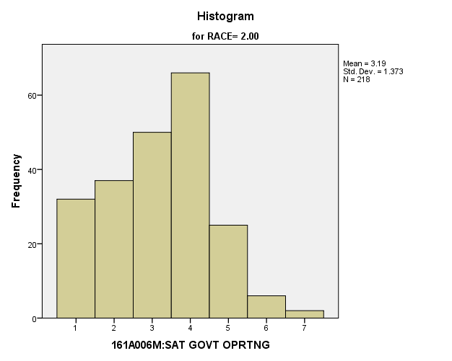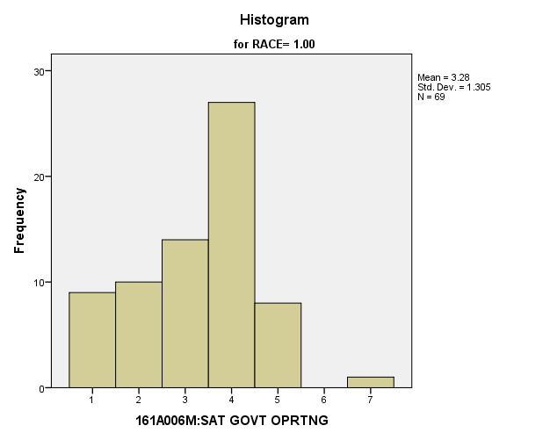

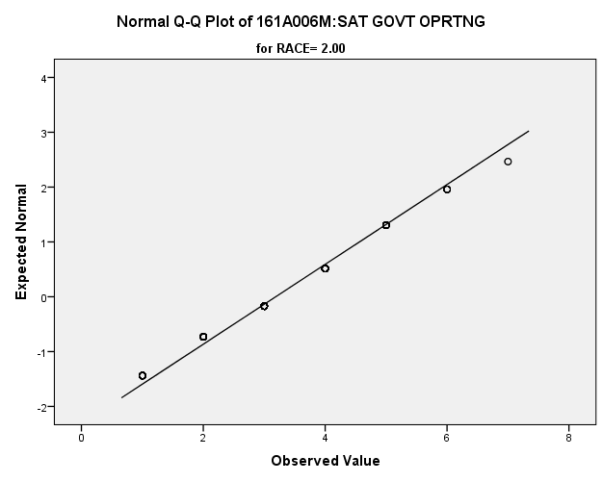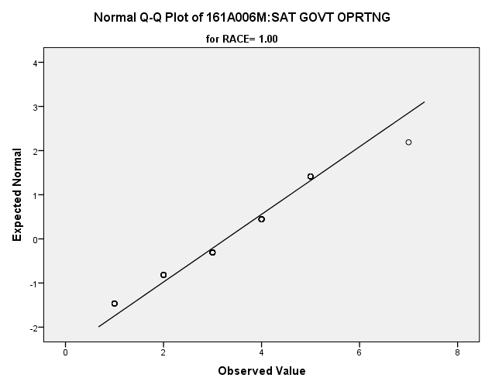

*Primary Analysis:*

|  |  |  |  |  |  |  |  |  |
| --- | --- | --- | --- | --- | --- | --- | --- | --- |
| **Group Statistics** | | | | | | | | |
|  | RACE | N | Mean | | Std. Deviation | | Std. Error Mean | |
| V1653 | 1.00 | **69** | **3.28** | | **1.305** | | **.157** | |
| 2.00 | **218** | **3.19** | | **1.373** | | **.093** | |
| **Independent Samples Test** | | | | | | | | | | | |
|  | | | | Levene's Test for Equality of Variances | | | | t-test for Equality of Means | | | |
| F | | Sig. | | t | | df | Sig. (2-tailed) |
|
| V1653 | Equal variances assumed | | | **.292** | | **.589** | | **.466** | | **285** | **.642** |
| Equal variances not assumed | | |  | |  | | **.478** | | **119.448** | **.633** |

|  |  |  |  |  |  |
| --- | --- | --- | --- | --- | --- |
| **Independent Samples Test** | | | | | |
|  | | t-test for Equality of Means | | | |
| Mean Difference | Std. Error Difference | 99% Confidence Interval of the Difference | |
| Lower | Upper |
| V1653 | Equal variances assumed | **.087** | **.187** | **-.399** | **.573** |
| Equal variances not assumed | **.087** | **.183** | **-.391** | **.565** |

**Satisfaction with Amount of Fun:** Within the potential recruit group, are there racial differences in how satisfied they are with the amount of fun they have?

**Variables used:** The dependent variable was satisfaction with amount of fun, with students rating satisfaction on a scale of 1 to 7, with a higher number meaning more satisfaction. The independent (grouping) variable was race.

**Analysis Procedure:**

* A t-test was used to compare average rating of how satisfied students are with the amount of fun they have between the two racial groups (whites versus non-whites)
* Before conducting analysis, the distribution for how satisfied students are with the amount of fun they have was checked separately for the two groups by means of visual inspection of histograms and Q-Q plots. No outliers were observed. However, the distribution was left skewed for both groups.
* The equality of variances assumption was tested. This assumption was met.
* Eta Squared was calculated to assess effect size.

**Results:**

* Null and alternative hypothesis. H0: μ1 = μ2; Ha: μ1 ≠ μ2.
* Calculated t value: t = -3.251, df = 288, reject H0, with a p-value of .001; Eta Squared = .035

**Interpretation:** There is a significant difference between the two groups in how satisfied students are with the amount of fun they have. Furthermore, 3.5% of how satisfied students are with the amount of fun they have is due to their race.

**Supporting Analysis:**

*Preliminary Analysis:*

|  |  |  |  |  |
| --- | --- | --- | --- | --- |
| ***Descriptives*** | | | | |
|  | RACE | | | Statistic |
| 161A006N:SAT AMT OF FUN | 1.00 | Mean | | **4.71** |
| 99% Confidence Interval for Mean | Lower Bound | **4.52** |
| Upper Bound | **4.89** |
| 5% Trimmed Mean | | **4.78** |
| Median | | **5.00** |
| Variance | | **2.854** |
| Std. Deviation | | **1.689** |
| Minimum | | **1** |
| Maximum | | **7** |
| Range | | **6** |
| Interquartile Range | | **2** |
| Skewness | | **-.320** |
| Kurtosis | | **-.647** |
| 2.00 | Mean | | **5.10** |
| 99% Confidence Interval for Mean | Lower Bound | **4.98** |
| Upper Bound | **5.22** |
| 5% Trimmed Mean | | **5.20** |
| Median | | **5.00** |
| Variance | | **2.371** |
| Std. Deviation | | **1.540** |
| Minimum | | **1** |
| Maximum | | **7** |
| Range | | **6** |
| Interquartile Range | | **2** |
| Skewness | | **-.689** |
| Kurtosis | | **-.063** |

|  |  |  |  |  |
| --- | --- | --- | --- | --- |
| ***Descriptives*** | | | | |
|  | RACE | | | Std. Error |
| 161A006N:SAT AMT OF FUN | 1.00 | Mean | | **.071** |
| 99% Confidence Interval for Mean | Lower Bound |  |
| Upper Bound |  |
| 5% Trimmed Mean | |  |
| Median | |  |
| Variance | |  |
| Std. Deviation | |  |
| Minimum | |  |
| Maximum | |  |
| Range | |  |
| Interquartile Range | |  |
| Skewness | | **.103** |
| Kurtosis | | **.206** |
| 2.00 | Mean | | **.048** |
| 99% Confidence Interval for Mean | Lower Bound |  |
| Upper Bound |  |
| 5% Trimmed Mean | |  |
| Median | |  |
| Variance | |  |
| Std. Deviation | |  |
| Minimum | |  |
| Maximum | |  |
| Range | |  |
| Interquartile Range | |  |
| Skewness | | **.076** |
| Kurtosis | | **.152** |

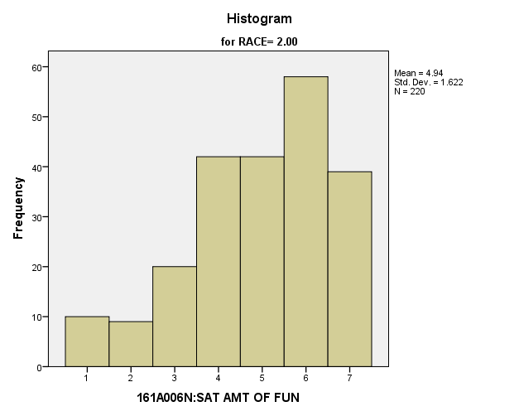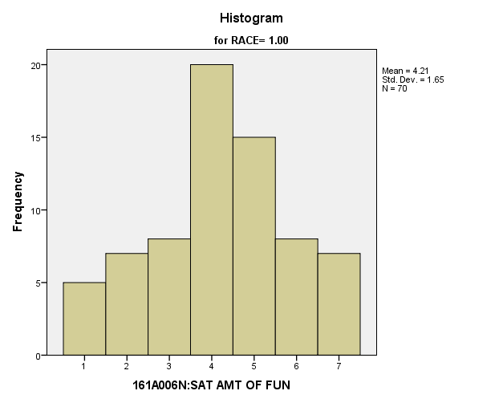

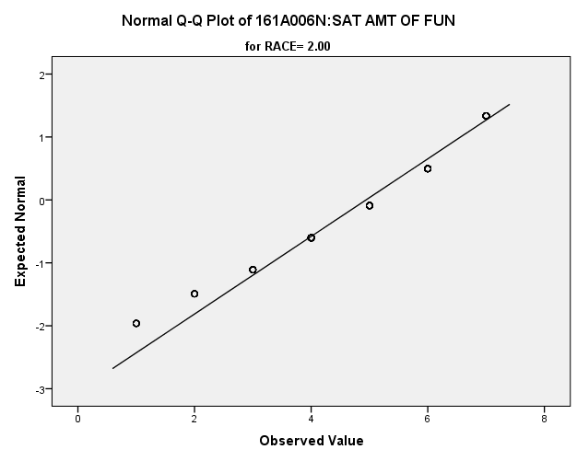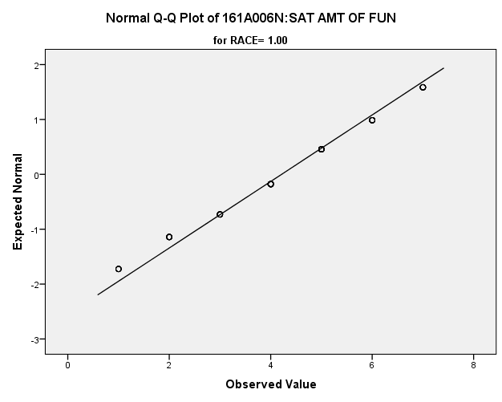

|  |  |  |  |  |  |  |  |  |  |  |  |
| --- | --- | --- | --- | --- | --- | --- | --- | --- | --- | --- | --- |
| *Primary Analysis:*  **Group Statistics** | | | | | | | | | | | |
|  | RACE | | N | Mean | | | Std. Deviation | | Std. Error Mean | | |
| V1654 | 1.00 | | **70** | **4.21** | | | **1.650** | | **.197** | | |
| 2.00 | | **220** | **4.94** | | | **1.622** | | **.109** | | |
| **Independent Samples Test** | | | | | | | | | | | | | | | | |
|  | | | | | Levene's Test for Equality of Variances | | | | | | t-test for Equality of Means | | | | | |
| F | | | Sig. | | | t | | | df | Sig. (2-tailed) | |
|
| V1654 | Equal variances assumed | | | | **.005** | | | **.946** | | | **-3.251** | | | **288** | **.001** | |
| Equal variances not assumed | | | |  | | |  | | | **-3.223** | | | **114.565** | **.002** | |
| **Independent Samples Test** | | | | | | | | | | | | | | | | | |
|  | | | | | | t-test for Equality of Means | | | | | | | | | | | |
| Mean Difference | | | | Std. Error Difference | | | 99% Confidence Interval of the Difference | | | | |
| Lower | | | Upper | |
| V1654 | | Equal variances assumed | | | | **-.727** | | | | **.224** | | | **-1.306** | | | **-.147** | |
| Equal variances not assumed | | | | **-.727** | | | | **.225** | | | **-1.317** | | | **-.136** | |

|  |  |  |
| --- | --- | --- |
| **Measures of Association** | | |
|  | Eta | Eta Squared |
| V1654 * RACE | **.188** | **.035** |

*5.c. Student Trustworthy and Fairness Variables*

**People Can be Trusted:** Within the potential recruit group, are there racial differences in how strongly they feel that people can’t be trusted?

**Variables used:** The dependent variable was if people can be trusted. The independent (grouping) variable was race.

**Analysis Procedure:**

* A t-test was used to compare average rating of how much students think that people can be trusted between the two racial groups (whites versus non-whites)
* Before conducting analysis, the distribution for how much students think that people can be trusted was checked separately for the two groups by means of visual inspection of histograms and Q-Q plots. No outliers were observed. However, the distribution was right skewed for both groups.
* The equality of variances assumption was tested. This assumption was met.

**Results:**

* Null and alternative hypothesis. H0: μ1 = μ2; Ha: μ1 ≠ μ2.
* Calculated t value: t = -1.866, df = 272, fail to reject H0, with a p-value of .062

**Interpretation:** There is not a significant difference between the two groups in how much students think that people can be trusted

**Supporting Analysis:**

*Preliminary Analysis:*

|  |  |  |  |  |
| --- | --- | --- | --- | --- |
| ***Descriptives*** | | | | |
|  | RACE | | | Statistic |
| 161A008:PPL CAN B TRSTD | 1.00 | Mean | | **1.52** |
| 99% Confidence Interval for Mean | Lower Bound | **1.44** |
| Upper Bound | **1.60** |
| 5% Trimmed Mean | | **1.46** |
| Median | | **1.00** |
| Variance | | **.482** |
| Std. Deviation | | **.694** |
| Minimum | | **1** |
| Maximum | | **3** |
| Range | | **2** |
| Interquartile Range | | **1** |
| Skewness | | **.977** |
| Kurtosis | | **-.329** |
| 2.00 | Mean | | **1.69** |
| 99% Confidence Interval for Mean | Lower Bound | **1.63** |
| Upper Bound | **1.76** |
| 5% Trimmed Mean | | **1.66** |
| Median | | **1.00** |
| Variance | | **.626** |
| Std. Deviation | | **.791** |
| Minimum | | **1** |
| Maximum | | **3** |
| Range | | **2** |
| Interquartile Range | | **1** |
| Skewness | | **.605** |
| Kurtosis | | **-1.149** |

|  |  |  |  |  |
| --- | --- | --- | --- | --- |
| ***Descriptives*** | | | | |
|  | RACE | | | Std. Error |
| 161A008:PPL CAN B TRSTD | 1.00 | Mean | | **.030** |
| 99% Confidence Interval for Mean | Lower Bound |  |
| Upper Bound |  |
| 5% Trimmed Mean | |  |
| Median | |  |
| Variance | |  |
| Std. Deviation | |  |
| Minimum | |  |
| Maximum | |  |
| Range | |  |
| Interquartile Range | |  |
| Skewness | | **.107** |
| Kurtosis | | **.214** |
| 2.00 | Mean | | **.025** |
| 99% Confidence Interval for Mean | Lower Bound |  |
| Upper Bound |  |
| 5% Trimmed Mean | |  |
| Median | |  |
| Variance | |  |
| Std. Deviation | |  |
| Minimum | |  |
| Maximum | |  |
| Range | |  |
| Interquartile Range | |  |
| Skewness | | **.078** |
| Kurtosis | | **.157** |

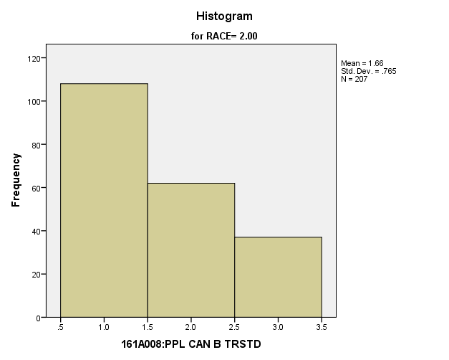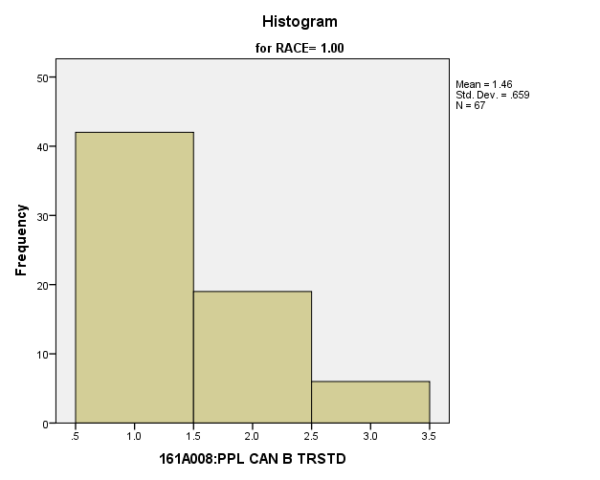

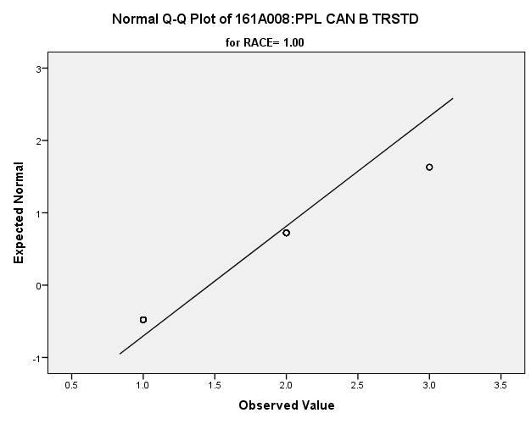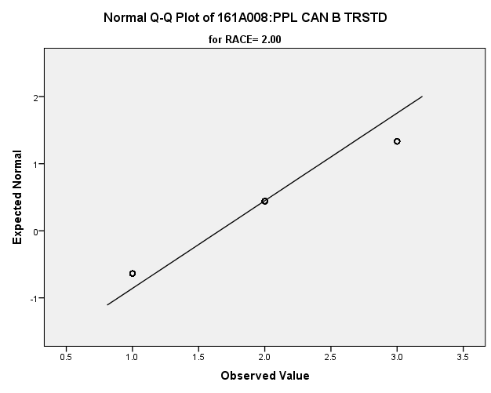

|  |  |  |  |  |  |  |  |  |  |  |  |
| --- | --- | --- | --- | --- | --- | --- | --- | --- | --- | --- | --- |
| *Primary Analysis:*  **Group Statistics** | | | | | | | | | | | |
|  | RACE | | N | Mean | | | Std. Deviation | | Std. Error Mean | | |
| V1669 | 1.00 | | **67** | **1.46** | | | **.659** | | **.081** | | |
| 2.00 | | **207** | **1.66** | | | **.765** | | **.053** | | |
| **Independent Samples Test** | | | | | | | | | | | | | | | | |
|  | | | | | Levene's Test for Equality of Variances | | | | | | t-test for Equality of Means | | | | | |
| F | | | Sig. | | | t | | | df | Sig. (2-tailed) | |
|
| V1669 | Equal variances assumed | | | | **5.199** | | | **.023** | | | **-1.866** | | | **272** | **.063** | |
| Equal variances not assumed | | | |  | | |  | | | **-2.014** | | | **128.370** | **.046** | |
| **Independent Samples Test** | | | | | | | | | | | | | | | | | |
|  | | | | | | t-test for Equality of Means | | | | | | | | | | | |
| Mean Difference | | | | Std. Error Difference | | | 99% Confidence Interval of the Difference | | | | |
| Lower | | | Upper | |
| V1669 | | Equal variances assumed | | | | **-.194** | | | | **.104** | | | **-.464** | | | **.076** | |
| Equal variances not assumed | | | | **-.194** | | | | **.096** | | | **-.447** | | | **.058** | |

**People Take Advantage:** Within the potential recruit group, are there racial differences in how strongly they feel that people take advantage of others?

**Variables used:** The dependent variable was if people take advantage of others. The independent (grouping) variable was race.

**Analysis Procedure:**

* A t-test was used to compare average rating of how much students think that people take advantage of others between the two racial groups (whites versus non-whites)
* Before conducting analysis, the distribution for how much students think that people take advantage of others was checked separately for the two groups by means of visual inspection of histograms and Q-Q plots. No outliers were observed. However, the distribution was XXXXX skewed for both groups.
* The equality of variances assumption was tested. This assumption was met.
* Eta squared was calculated to assess effect size.

**Results:**

* Null and alternative hypothesis. H0: μ1 = μ2; Ha: μ1 ≠ μ2.
* Calculated t value: t = -2.297, df = 284, reject H0, with a p-value of .004; Eta squared = .013

**Interpretation:** There is a significant difference between the two groups in how much students think that people take advantage of others. Furthermore, 1.3% of how much students think that people take advantage of others is due to their race.

**Supporting Analysis:**

*Preliminary Analysis:*

|  |  |  |  |  |
| --- | --- | --- | --- | --- |
| ***Descriptives*** | | | | |
|  | RACE | | | Statistic |
| 161A010:PPL TRY BE FAIR | 1.00 | Mean | | **1.63** |
| 99% Confidence Interval for Mean | Lower Bound | **1.55** |
| Upper Bound | **1.71** |
| 5% Trimmed Mean | | **1.59** |
| Median | | **1.00** |
| Variance | | **.536** |
| Std. Deviation | | **.732** |
| Minimum | | **1** |
| Maximum | | **3** |
| Range | | **2** |
| Interquartile Range | | **1** |
| Skewness | | **.710** |
| Kurtosis | | **-.823** |
| 2.00 | Mean | | **1.80** |
| 99% Confidence Interval for Mean | Lower Bound | **1.74** |
| Upper Bound | **1.86** |
| 5% Trimmed Mean | | **1.78** |
| Median | | **2.00** |
| Variance | | **.578** |
| Std. Deviation | | **.761** |
| Minimum | | **1** |
| Maximum | | **3** |
| Range | | **2** |
| Interquartile Range | | **1** |
| Skewness | | **.351** |
| Kurtosis | | **-1.200** |

|  |  |  |  |  |
| --- | --- | --- | --- | --- |
| ***Descriptives*** | | | | |
|  | RACE | | | Std. Error |
| 161A010:PPL TRY BE FAIR | 1.00 | Mean | | **.031** |
| 99% Confidence Interval for Mean | Lower Bound |  |
| Upper Bound |  |
| 5% Trimmed Mean | |  |
| Median | |  |
| Variance | |  |
| Std. Deviation | |  |
| Minimum | |  |
| Maximum | |  |
| Range | |  |
| Interquartile Range | |  |
| Skewness | | **.105** |
| Kurtosis | | **.209** |
| 2.00 | Mean | | **.024** |
| 99% Confidence Interval for Mean | Lower Bound |  |
| Upper Bound |  |
| 5% Trimmed Mean | |  |
| Median | |  |
| Variance | |  |
| Std. Deviation | |  |
| Minimum | |  |
| Maximum | |  |
| Range | |  |
| Interquartile Range | |  |
| Skewness | | **.077** |
| Kurtosis | | **.154** |

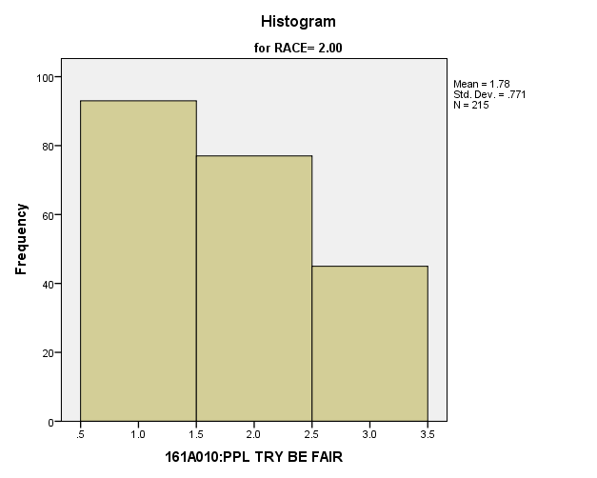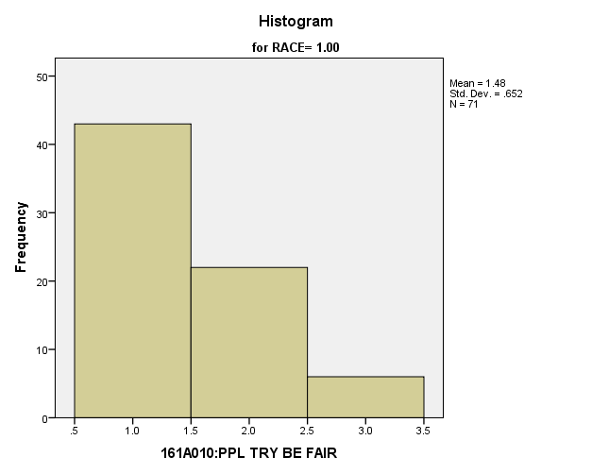

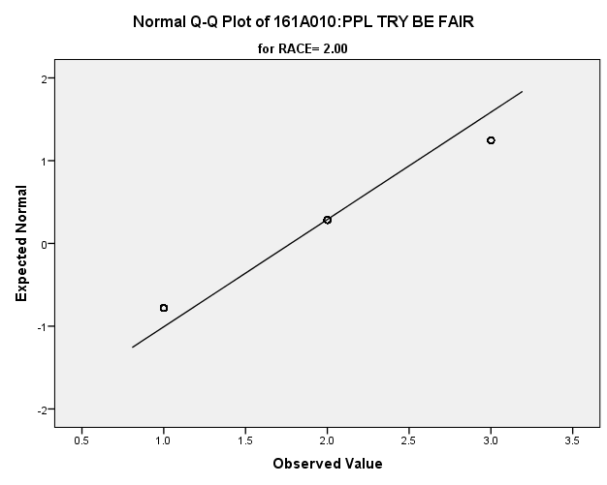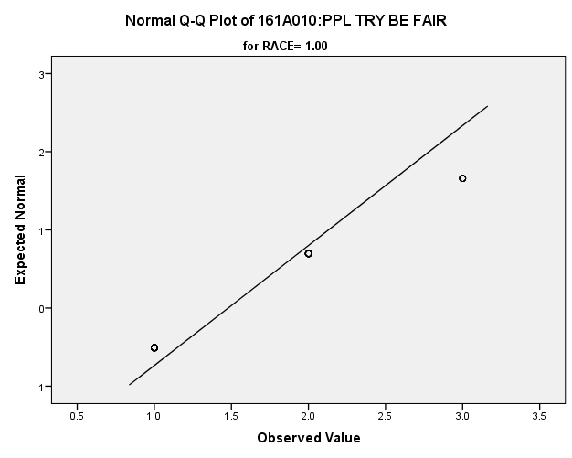

*Primary Analysis:*

|  |  |  |  |  |  |  |  |  |  |  |  |
| --- | --- | --- | --- | --- | --- | --- | --- | --- | --- | --- | --- |
| **Group Statistics** | | | | | | | | | | | |
|  | RACE | | N | Mean | | | Std. Deviation | | Std. Error Mean | | |
| V1671 | 1.00 | | **71** | **1.48** | | | **.652** | | **.077** | | |
| 2.00 | | **215** | **1.78** | | | **.771** | | **.053** | | |
| **Independent Samples Test** | | | | | | | | | | | | | | | | |
|  | | | | | Levene's Test for Equality of Variances | | | | | | t-test for Equality of Means | | | | | |
| F | | | Sig. | | | t | | | df | Sig. (2-tailed) | |
|
| V1671 | Equal variances assumed | | | | **3.555** | | | **.060** | | | **-2.927** | | | **284** | **.004** | |
| Equal variances not assumed | | | |  | | |  | | | **-3.185** | | | **139.955** | **.002** | |
| **Independent Samples Test** | | | | | | | | | | | | | | | | | |
|  | | | | | | t-test for Equality of Means | | | | | | | | | | | |
| Mean Difference | | | | Std. Error Difference | | | 99% Confidence Interval of the Difference | | | | |
| Lower | | | Upper | |
| V1671 | | Equal variances assumed | | | | **-.298** | | | | **.102** | | | **-.562** | | | **-.034** | |
| Equal variances not assumed | | | | **-.298** | | | | **.094** | | | **-.542** | | | **-.054** | |

|  |  |  |
| --- | --- | --- |
| **Measures of Association** | | |
|  | Eta | Eta Squared |
| V1669 * RACE | **.112** | **.013** |

**Skipping School Recently:** Within the potential recruit group, are there racial differences in how many days they have skipped in the past four weeks?

**Variables used:** The dependent variable was skipping school in past four weeks. The independent (grouping) variable was race.

**Analysis Procedure:**

* A t-test was used to compare average rating of how many days students skipped in the past four weeks between the two racial groups (whites versus non-whites)
* Before conducting analysis, the distribution for how many days students skipped in the past four weeks was checked separately for the two groups by means of visual inspection of histograms and Q-Q plots. No outliers were observed. However, the distribution was right skewed for both groups.
* The equality of variances assumption was tested. This assumption was met.

**Results:**

* Null and alternative hypothesis. H0: μ1 = μ2; Ha: μ1 ≠ μ2.
* Calculated t value: t = .306, df = 273, fail to reject H0, with a p-value of .760

**Interpretation:** There is not a significant difference between the two groups in how many days students skipped in the past four weeks

**Supporting Analysis:**

*Preliminary Analysis****:***

|  |  |  |  |  |
| --- | --- | --- | --- | --- |
| ***Descriptives*** | | | | |
|  | RACE | | | Statistic |
| 161C018B:#DA/4W SC MS CU | 1.00 | Mean | | **1.71** |
| 99% Confidence Interval for Mean | Lower Bound | **1.54** |
| Upper Bound | **1.88** |
| 5% Trimmed Mean | | **1.50** |
| Median | | **1.00** |
| Variance | | **2.040** |
| Std. Deviation | | **1.428** |
| Minimum | | **1** |
| Maximum | | **7** |
| Range | | **6** |
| Interquartile Range | | **1** |
| Skewness | | **2.155** |
| Kurtosis | | **3.722** |
| 2.00 | Mean | | **1.62** |
| 99% Confidence Interval for Mean | Lower Bound | **1.52** |
| Upper Bound | **1.72** |
| 5% Trimmed Mean | | **1.45** |
| Median | | **1.00** |
| Variance | | **1.381** |
| Std. Deviation | | **1.175** |
| Minimum | | **1** |
| Maximum | | **7** |
| Range | | **6** |
| Interquartile Range | | **1** |
| Skewness | | **2.266** |
| Kurtosis | | **5.181** |

|  |  |  |  |  |
| --- | --- | --- | --- | --- |
| ***Descriptives*** | | | | |
|  | RACE | | | Std. Error |
| 161C018B:#DA/4W SC MS CU | 1.00 | Mean | | **.064** |
| 99% Confidence Interval for Mean | Lower Bound |  |
| Upper Bound |  |
| 5% Trimmed Mean | |  |
| Median | |  |
| Variance | |  |
| Std. Deviation | |  |
| Minimum | |  |
| Maximum | |  |
| Range | |  |
| Interquartile Range | |  |
| Skewness | | **.110** |
| Kurtosis | | **.219** |
| 2.00 | Mean | | **.038** |
| 99% Confidence Interval for Mean | Lower Bound |  |
| Upper Bound |  |
| 5% Trimmed Mean | |  |
| Median | |  |
| Variance | |  |
| Std. Deviation | |  |
| Minimum | |  |
| Maximum | |  |
| Range | |  |
| Interquartile Range | |  |
| Skewness | | **.079** |
| Kurtosis | | **.158** |

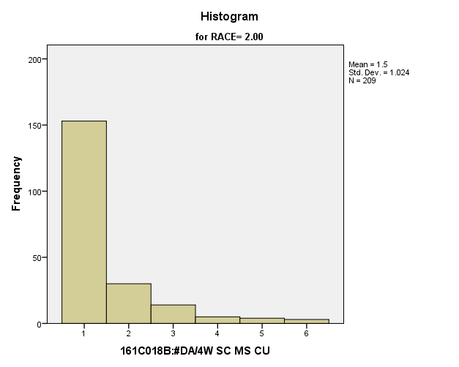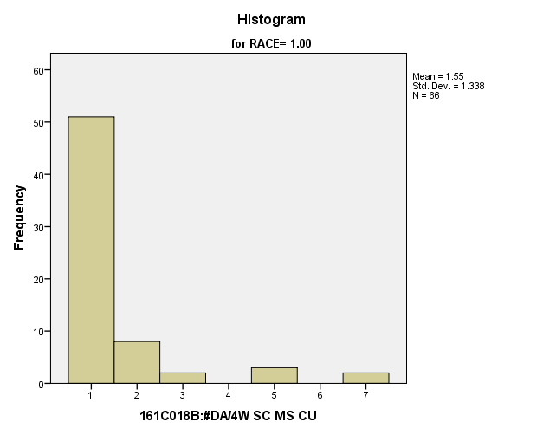

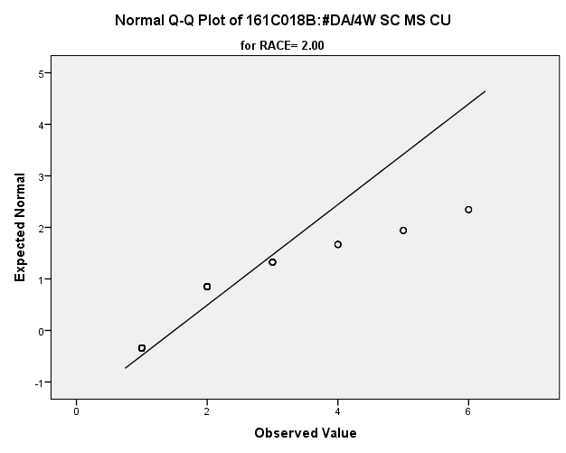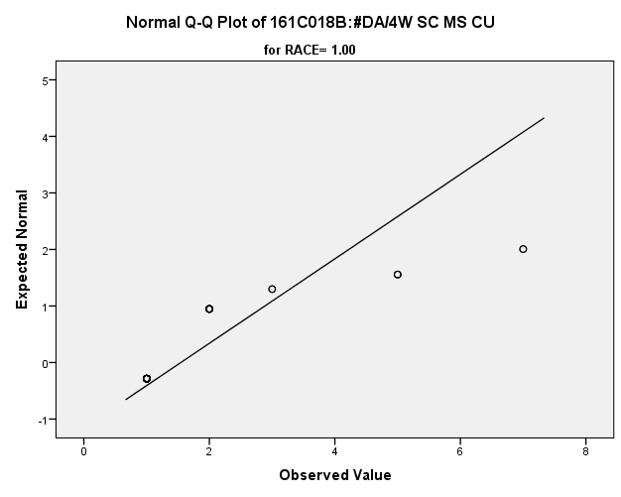

*Primary Analysis:*

|  |  |  |  |  |  |  |  |  |  |  |  |
| --- | --- | --- | --- | --- | --- | --- | --- | --- | --- | --- | --- |
| **Group Statistics** | | | | | | | | | | | |
|  | RACE | | N | Mean | | | Std. Deviation | | Std. Error Mean | | |
| V1176 | 1.00 | | **66** | **1.55** | | | **1.338** | | **.165** | | |
| 2.00 | | **209** | **1.50** | | | **1.024** | | **.071** | | |
| **Independent Samples Test** | | | | | | | | | | | | | | | | |
|  | | | | | Levene's Test for Equality of Variances | | | | | | t-test for Equality of Means | | | | | |
| F | | | Sig. | | | t | | | df | Sig. (2-tailed) | |
|
| V1176 | Equal variances assumed | | | | **1.014** | | | **.315** | | | **.306** | | | **273** | **.760** | |
| Equal variances not assumed | | | |  | | |  | | | **.267** | | | **90.321** | **.790** | |
| **Independent Samples Test** | | | | | | | | | | | | | | | | | |
|  | | | | | | t-test for Equality of Means | | | | | | | | | | | |
| Mean Difference | | | | Std. Error Difference | | | 99% Confidence Interval of the Difference | | | | |
| Lower | | | Upper | |
| V1176 | | Equal variances assumed | | | | **.048** | | | | **.156** | | | **-.358** | | | **.453** | |
| Equal variances not assumed | | | | **.048** | | | | **.179** | | | **-.424** | | | **.520** | |

*5.d. Student Relationship with Government Variables*

**People Should Always Obey the Law:** Within the potential recruit group, are there racial differences in how strongly they feel that people should always obey the law?

**Variables used:** The dependent variable was if people should always obey the law. The independent (grouping) variable was race.

**Analysis Procedure:**

* A t-test was used to compare average rating of how much students thought that people should always obey the law between the two racial groups (whites versus non-whites)
* Before conducting analysis, the distribution for how much students thought that people should always obey the law was checked separately for the two groups by means of visual inspection of histograms and Q-Q plots. No outliers were observed. However, the distribution was similarly skewed for both groups.
* The equality of variances assumption was tested. This assumption was met.

**Results:**

* Null and alternative hypothesis. H0: μ1 = μ2; Ha: μ1 ≠ μ2.
* Calculated t value: t = -1.505, df = 282, fail to reject H0, with a p-value of .134

**Interpretation:** There is not a significant difference between the two groups in how much students thought that people should always obey the law.

**Supporting Analysis:**

*Preliminary Analysis:*

|  |  |  |  |  |
| --- | --- | --- | --- | --- |
| ***Descriptives*** | | | | |
|  | RACE | | | Statistic |
| 161A011A:-OBY LW = -GD CTZ | 1.00 | Mean | | **2.79** |
| 99% Confidence Interval for Mean | Lower Bound | **2.65** |
| Upper Bound | **2.94** |
| 5% Trimmed Mean | | **2.77** |
| Median | | **3.00** |
| Variance | | **1.704** |
| Std. Deviation | | **1.305** |
| Minimum | | **1** |
| Maximum | | **5** |
| Range | | **4** |
| Interquartile Range | | **2** |
| Skewness | | **.067** |
| Kurtosis | | **-1.073** |
| 2.00 | Mean | | **2.90** |
| 99% Confidence Interval for Mean | Lower Bound | **2.80** |
| Upper Bound | **3.00** |
| 5% Trimmed Mean | | **2.89** |
| Median | | **3.00** |
| Variance | | **1.453** |
| Std. Deviation | | **1.206** |
| Minimum | | **1** |
| Maximum | | **5** |
| Range | | **4** |
| Interquartile Range | | **2** |
| Skewness | | **-.129** |
| Kurtosis | | **-1.044** |

|  |  |  |  |  |
| --- | --- | --- | --- | --- |
| ***Descriptives*** | | | | |
|  | RACE | | | Std. Error |
| 161A011A:-OBY LW = -GD CTZ | 1.00 | Mean | | **.056** |
| 99% Confidence Interval for Mean | Lower Bound |  |
| Upper Bound |  |
| 5% Trimmed Mean | |  |
| Median | |  |
| Variance | |  |
| Std. Deviation | |  |
| Minimum | |  |
| Maximum | |  |
| Range | |  |
| Interquartile Range | |  |
| Skewness | | **.105** |
| Kurtosis | | **.209** |
| 2.00 | Mean | | **.038** |
| 99% Confidence Interval for Mean | Lower Bound |  |
| Upper Bound |  |
| 5% Trimmed Mean | |  |
| Median | |  |
| Variance | |  |
| Std. Deviation | |  |
| Minimum | |  |
| Maximum | |  |
| Range | |  |
| Interquartile Range | |  |
| Skewness | | **.077** |
| Kurtosis | | **.154** |

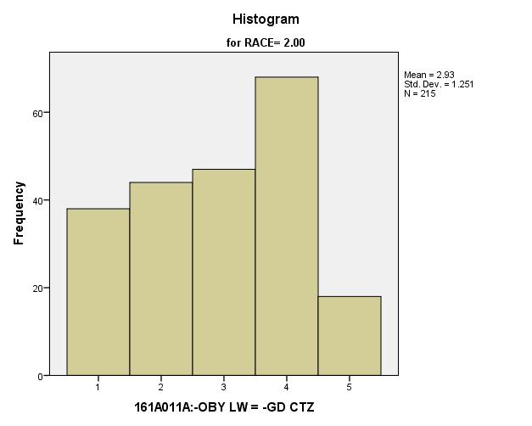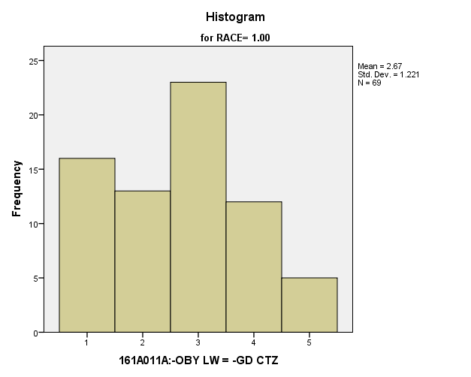

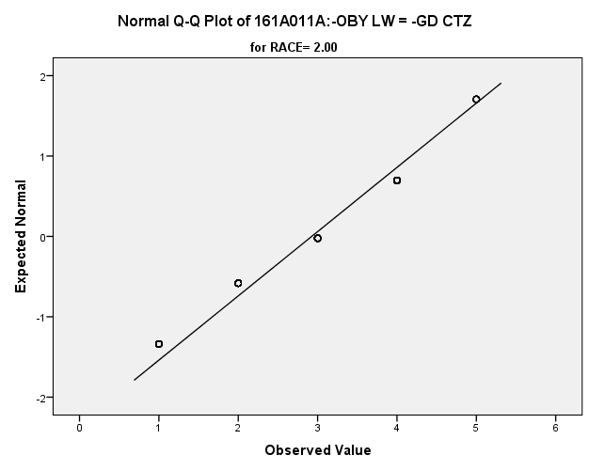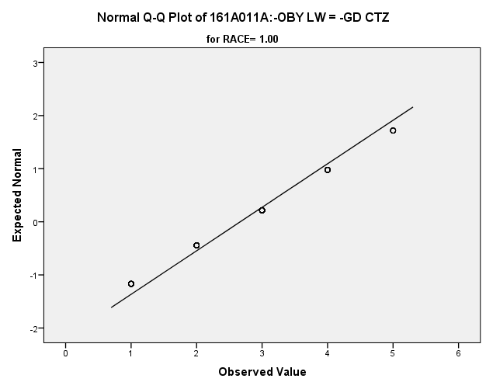

*Primary Analysis:*

|  |  |  |  |  |  |  |  |  |  |  |  |
| --- | --- | --- | --- | --- | --- | --- | --- | --- | --- | --- | --- |
| **Group Statistics** | | | | | | | | | | | |
|  | RACE | | N | Mean | | | Std. Deviation | | Std. Error Mean | | |
| V1672 | 1.00 | | **69** | **2.67** | | | **1.221** | | **.147** | | |
| 2.00 | | **215** | **2.93** | | | **1.251** | | **.085** | | |
| **Independent Samples Test** | | | | | | | | | | | | | | | | |
|  | | | | | Levene's Test for Equality of Variances | | | | | | t-test for Equality of Means | | | | | |
| F | | | Sig. | | | t | | | df | Sig. (2-tailed) | |
|
| V1672 | Equal variances assumed | | | | **.150** | | | **.698** | | | **-1.505** | | | **282** | **.134** | |
| Equal variances not assumed | | | |  | | |  | | | **-1.524** | | | **117.312** | **.130** | |
| **Independent Samples Test** | | | | | | | | | | | | | | | | | |
|  | | | | | | t-test for Equality of Means | | | | | | | | | | | |
| Mean Difference | | | | Std. Error Difference | | | 99% Confidence Interval of the Difference | | | | |
| Lower | | | Upper | |
| V1672 | | Equal variances assumed | | | | **-.259** | | | | **.172** | | | **-.705** | | | **.187** | |
| Equal variances not assumed | | | | **-.259** | | | | **.170** | | | **-.704** | | | **.186** | |

**Good Citizens Agree with Government** Within the potential recruit group, are there racial differences in how strongly they feel that good citizens go along with the government no matter what?

**Variables used:** The dependent variable was if good citizens agree with the government. The independent (grouping) variable was race.

**Analysis Procedure:**

* A t-test was used to compare average rating of how much students think that good citizens should agree with the government between the two racial groups (whites versus non-whites)
* Before conducting analysis, the distribution for how much students think that good citizens should agree with the government was checked separately for the two groups by means of visual inspection of histograms and Q-Q plots. No outliers were observed. However, the distribution money was right skewed for both groups.
* The equality of variances assumption was tested. This assumption was met.

**Results:**

* Null and alternative hypothesis. H0: μ1 = μ2; Ha: μ1 ≠ μ2.
* Calculated t value: t = 1.083, df = 283, fail to reject H0, with a p-value of .280

**Interpretation:** There is not a significant difference between the two groups in how much students think that good citizens should agree with the government.

**Supporting Analysis:**

*Preliminary Analysis:*

|  |  |  |  |  |
| --- | --- | --- | --- | --- |
| ***Descriptives*** | | | | |
|  | RACE | | | Statistic |
| 161A011B:GD CTZN ALG GOV | 1.00 | Mean | | **2.22** |
| 99% Confidence Interval for Mean | Lower Bound | **2.09** |
| Upper Bound | **2.35** |
| 5% Trimmed Mean | | **2.13** |
| Median | | **2.00** |
| Variance | | **1.466** |
| Std. Deviation | | **1.211** |
| Minimum | | **1** |
| Maximum | | **5** |
| Range | | **4** |
| Interquartile Range | | **2** |
| Skewness | | **.631** |
| Kurtosis | | **-.623** |
| 2.00 | Mean | | **2.10** |
| 99% Confidence Interval for Mean | Lower Bound | **2.01** |
| Upper Bound | **2.18** |
| 5% Trimmed Mean | | **2.02** |
| Median | | **2.00** |
| Variance | | **1.203** |
| Std. Deviation | | **1.097** |
| Minimum | | **1** |
| Maximum | | **5** |
| Range | | **4** |
| Interquartile Range | | **2** |
| Skewness | | **.672** |
| Kurtosis | | **-.471** |

|  |  |  |  |  |
| --- | --- | --- | --- | --- |
| ***Descriptives*** | | | | |
|  | RACE | | | Std. Error |
| 161A011B:GD CTZN ALG GOV | 1.00 | Mean | | **.052** |
| 99% Confidence Interval for Mean | Lower Bound |  |
| Upper Bound |  |
| 5% Trimmed Mean | |  |
| Median | |  |
| Variance | |  |
| Std. Deviation | |  |
| Minimum | |  |
| Maximum | |  |
| Range | |  |
| Interquartile Range | |  |
| Skewness | | **.105** |
| Kurtosis | | **.209** |
| 2.00 | Mean | | **.035** |
| 99% Confidence Interval for Mean | Lower Bound |  |
| Upper Bound |  |
| 5% Trimmed Mean | |  |
| Median | |  |
| Variance | |  |
| Std. Deviation | |  |
| Minimum | |  |
| Maximum | |  |
| Range | |  |
| Interquartile Range | |  |
| Skewness | | **.077** |
| Kurtosis | | **.154** |

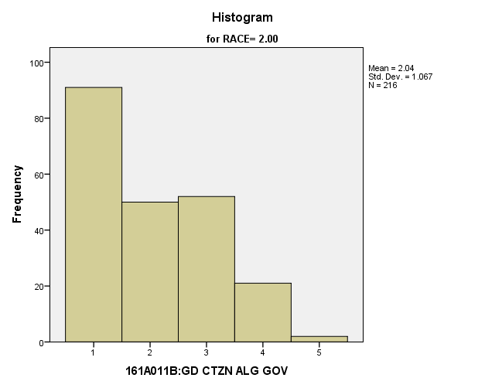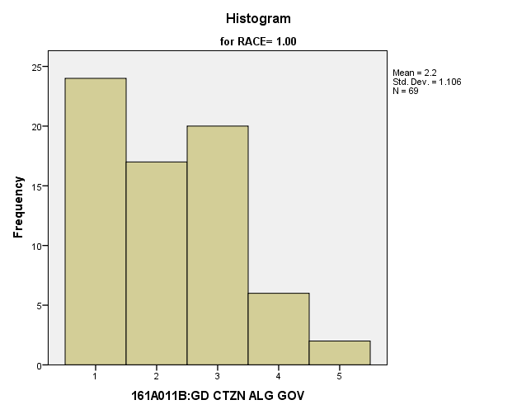

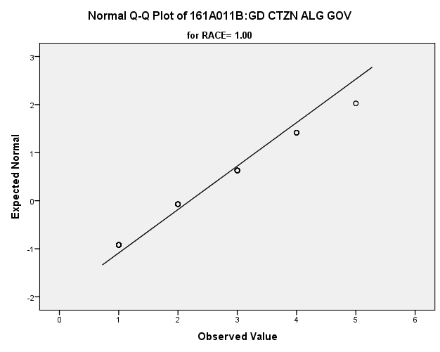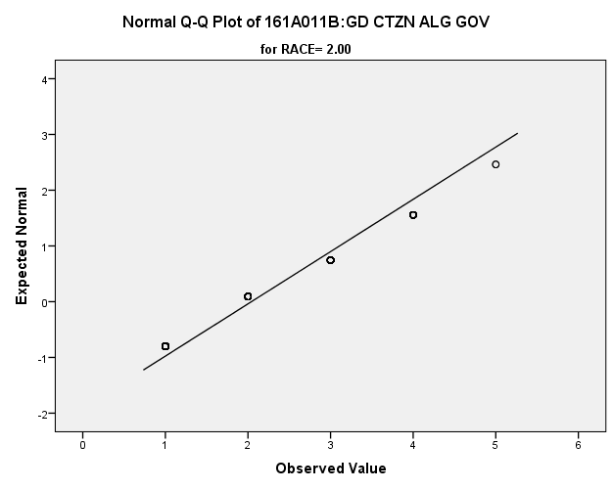

*Primary Analysis:*

|  |  |  |  |  |  |  |  |  |  |  |  |
| --- | --- | --- | --- | --- | --- | --- | --- | --- | --- | --- | --- |
| **Group Statistics** | | | | | | | | | | | |
|  | RACE | | N | Mean | | | Std. Deviation | | Std. Error Mean | | |
| V1673 | 1.00 | | **69** | **2.20** | | | **1.106** | | **.133** | | |
| 2.00 | | **216** | **2.04** | | | **1.067** | | **.073** | | |
| **Independent Samples Test** | | | | | | | | | | | | | | | | |
|  | | | | | Levene's Test for Equality of Variances | | | | | | t-test for Equality of Means | | | | | |
| F | | | Sig. | | | t | | | df | Sig. (2-tailed) | |
|
| V1673 | Equal variances assumed | | | | **.251** | | | **.617** | | | **1.083** | | | **283** | **.280** | |
| Equal variances not assumed | | | |  | | |  | | | **1.063** | | | **111.316** | **.290** | |
| **Independent Samples Test** | | | | | | | | | | | | | | | | | |
|  | | | | | | t-test for Equality of Means | | | | | | | | | | | |
| Mean Difference | | | | Std. Error Difference | | | 99% Confidence Interval of the Difference | | | | |
| Lower | | | Upper | |
| V1673 | | Equal variances assumed | | | | **.161** | | | | **.149** | | | **-.225** | | | **.547** | |
| Equal variances not assumed | | | | **.161** | | | | **.152** | | | **-.236** | | | **.559** | |

**Good Citizens Challenge the Government** Within the potential recruit group, are there racial differences in how strongly they feel that people should challenge the government?

**Variables used:** The dependent variable was if good citizens challenge the government. The independent (grouping) variable was race.

**Analysis Procedure:**

* A t-test was used to compare average rating of how much students think that good citizens should challenge the government between the two racial groups (whites versus non-whites)
* Before conducting analysis, the distribution for how much students think that good citizens should challenge the government was checked separately for the two groups by means of visual inspection of histograms and Q-Q plots. No outliers were observed. However, the distribution was left skewed for both groups.
* The equality of variances assumption was tested. This assumption was met.

**Results:**

* Null and alternative hypothesis. H0: μ1 = μ2; Ha: μ1 ≠ μ2.
* Calculated t value: t = -2.176, df = 282, fail to reject H0, with a p-value of .20

**Interpretation:** There is not a significant difference between the two groups in how much students think that good citizens should challenge the government.

**Supporting Analysis:**

*Preliminary Analysis:*

|  |  |  |  |  |
| --- | --- | --- | --- | --- |
| ***Descriptives*** | | | | |
|  | RACE | | | Statistic |
| 161A011C:GD CTZN CHG GOV | 1.00 | Mean | | **3.51** |
| 99% Confidence Interval for Mean | Lower Bound | **3.38** |
| Upper Bound | **3.63** |
| 5% Trimmed Mean | | **3.56** |
| Median | | **3.00** |
| Variance | | **1.213** |
| Std. Deviation | | **1.102** |
| Minimum | | **1** |
| Maximum | | **5** |
| Range | | **4** |
| Interquartile Range | | **1** |
| Skewness | | **-.375** |
| Kurtosis | | **-.335** |
| 2.00 | Mean | | **3.70** |
| 99% Confidence Interval for Mean | Lower Bound | **3.61** |
| Upper Bound | **3.78** |
| 5% Trimmed Mean | | **3.75** |
| Median | | **4.00** |
| Variance | | **.976** |
| Std. Deviation | | **.988** |
| Minimum | | **1** |
| Maximum | | **5** |
| Range | | **4** |
| Interquartile Range | | **1** |
| Skewness | | **-.486** |
| Kurtosis | | **-.044** |

|  |  |  |  |  |
| --- | --- | --- | --- | --- |
| ***Descriptives*** | | | | |
|  | RACE | | | Std. Error |
| 161A011C:GD CTZN CHG GOV | 1.00 | Mean | | **.047** |
| 99% Confidence Interval for Mean | Lower Bound |  |
| Upper Bound |  |
| 5% Trimmed Mean | |  |
| Median | |  |
| Variance | |  |
| Std. Deviation | |  |
| Minimum | |  |
| Maximum | |  |
| Range | |  |
| Interquartile Range | |  |
| Skewness | | **.105** |
| Kurtosis | | **.210** |
| 2.00 | Mean | | **.031** |
| 99% Confidence Interval for Mean | Lower Bound |  |
| Upper Bound |  |
| 5% Trimmed Mean | |  |
| Median | |  |
| Variance | |  |
| Std. Deviation | |  |
| Minimum | |  |
| Maximum | |  |
| Range | |  |
| Interquartile Range | |  |
| Skewness | | **.077** |
| Kurtosis | | **.154** |

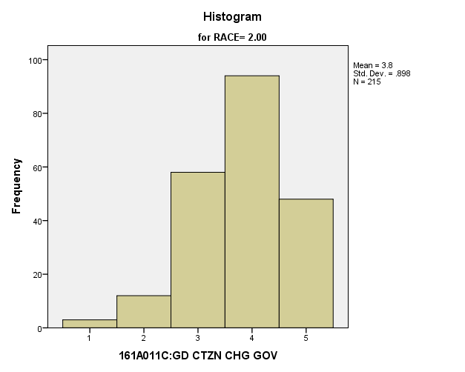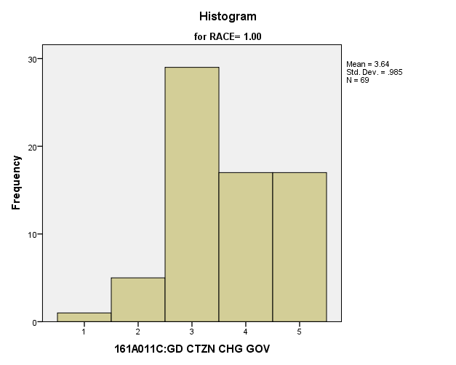

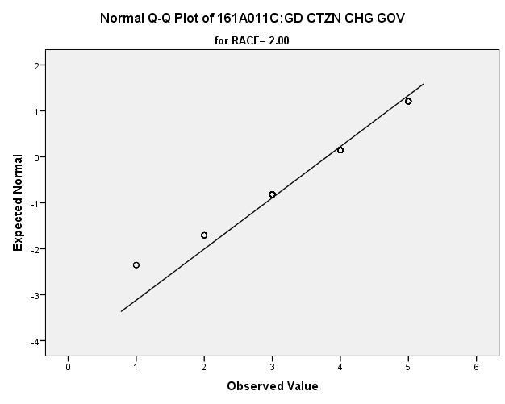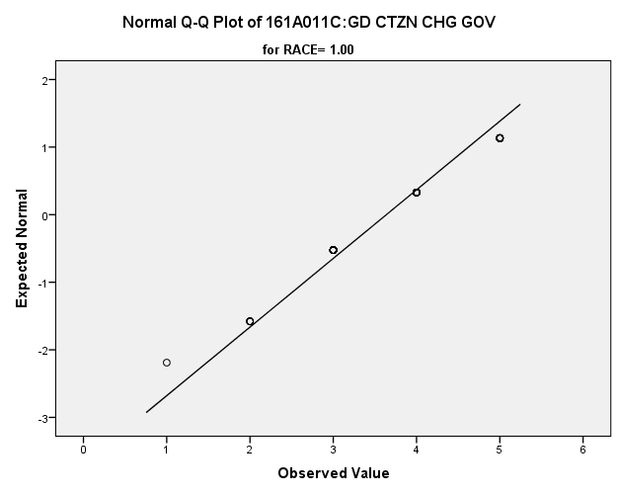

|  |  |  |  |  |  |  |  |  |  |  |  |
| --- | --- | --- | --- | --- | --- | --- | --- | --- | --- | --- | --- |
| *Primary Analysis:*  **Group Statistics** | | | | | | | | | | | |
|  | RACE | | N | Mean | | | Std. Deviation | | Std. Error Mean | | |
| V1674 | 1.00 | | **69** | **3.64** | | | **.985** | | **.119** | | |
| 2.00 | | **215** | **3.80** | | | **.898** | | **.061** | | |
| **Independent Samples Test** | | | | | | | | | | | | | | | | |
|  | | | | | Levene's Test for Equality of Variances | | | | | | t-test for Equality of Means | | | | | |
| F | | | Sig. | | | t | | | df | Sig. (2-tailed) | |
|
| V1674 | Equal variances assumed | | | | **3.568** | | | **.060** | | | **-1.276** | | | **282** | **.203** | |
| Equal variances not assumed | | | |  | | |  | | | **-1.217** | | | **106.683** | **.226** | |
| **Independent Samples Test** | | | | | | | | | | | | | | | | | |
|  | | | | | | t-test for Equality of Means | | | | | | | | | | | |
| Mean Difference | | | | Std. Error Difference | | | 99% Confidence Interval of the Difference | | | | |
| Lower | | | Upper | |
| V1674 | | Equal variances assumed | | | | **-.162** | | | | **.127** | | | **-.492** | | | **.168** | |
| Equal variances not assumed | | | | **-.162** | | | | **.133** | | | **-.512** | | | **.188** | |

**USA is Best System in World** Within the potential recruit group, are there racial differences in how strongly they feel that the USA has the best system in the world?

**Variables used:** The dependent variable was if the USA is the best system in the world. The independent (grouping) variable was race.

**Analysis Procedure:**

* A t-test was used to compare average rating of how much students think that our system is the best in the world between the two racial groups (whites versus non-whites)
* Before conducting analysis, the distribution for how much students think that our system is the best in the world was checked separately for the two groups by means of visual inspection of histograms and Q-Q plots. No outliers were observed. However, the distribution was similarly skewed for both groups.
* The equality of variances assumption was tested. This assumption was not met.

**Results:**

* Null and alternative hypothesis. H0: μ1 = μ2; Ha: μ1 ≠ μ2.
* Calculated t value: t = .196, df = 136.472, fail to reject H0, with a p-value of .845

**Interpretation:** There is not a significant difference between the two groups in how much students think that our system is the best in the world.

**Supporting Analysis:**

*Preliminary Analysis:*

|  |  |  |  |  |
| --- | --- | --- | --- | --- |
| ***Descriptives*** | | | | |
|  | RACE | | | Statistic |
| 161A011F:OUR SYST ST BS | 1.00 | Mean | | **2.97** |
| 99% Confidence Interval for Mean | Lower Bound | **2.84** |
| Upper Bound | **3.10** |
| 5% Trimmed Mean | | **2.96** |
| Median | | **3.00** |
| Variance | | **1.377** |
| Std. Deviation | | **1.173** |
| Minimum | | **1** |
| Maximum | | **5** |
| Range | | **4** |
| Interquartile Range | | **2** |
| Skewness | | **-.080** |
| Kurtosis | | **-.624** |
| 2.00 | Mean | | **2.94** |
| 99% Confidence Interval for Mean | Lower Bound | **2.84** |
| Upper Bound | **3.03** |
| 5% Trimmed Mean | | **2.93** |
| Median | | **3.00** |
| Variance | | **1.401** |
| Std. Deviation | | **1.184** |
| Minimum | | **1** |
| Maximum | | **5** |
| Range | | **4** |
| Interquartile Range | | **2** |
| Skewness | | **-.016** |
| Kurtosis | | **-.749** |

|  |  |  |  |  |
| --- | --- | --- | --- | --- |
| ***Descriptives*** | | | | |
|  | RACE | | | Std. Error |
| 161A011F:OUR SYST ST BS | 1.00 | Mean | | **.050** |
| 99% Confidence Interval for Mean | Lower Bound |  |
| Upper Bound |  |
| 5% Trimmed Mean | |  |
| Median | |  |
| Variance | |  |
| Std. Deviation | |  |
| Minimum | |  |
| Maximum | |  |
| Range | |  |
| Interquartile Range | |  |
| Skewness | | **.105** |
| Kurtosis | | **.210** |
| 2.00 | Mean | | **.037** |
| 99% Confidence Interval for Mean | Lower Bound |  |
| Upper Bound |  |
| 5% Trimmed Mean | |  |
| Median | |  |
| Variance | |  |
| Std. Deviation | |  |
| Minimum | |  |
| Maximum | |  |
| Range | |  |
| Interquartile Range | |  |
| Skewness | | **.077** |
| Kurtosis | | **.154** |

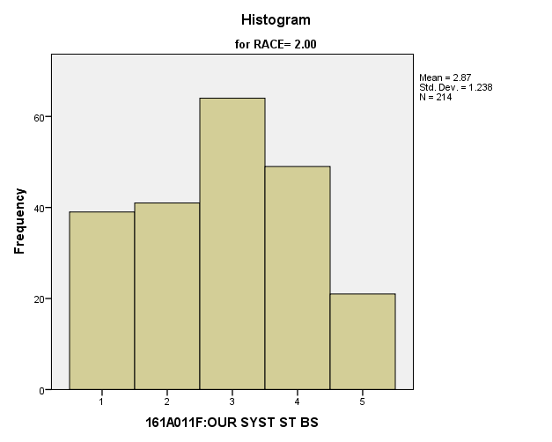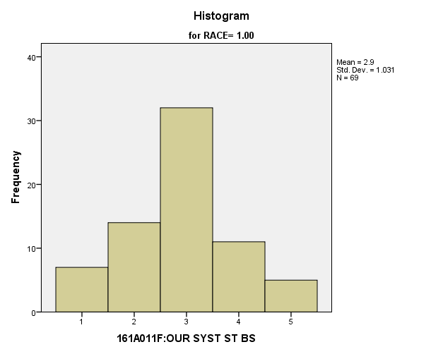

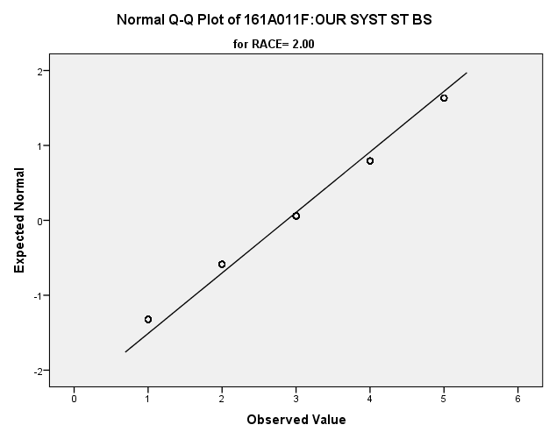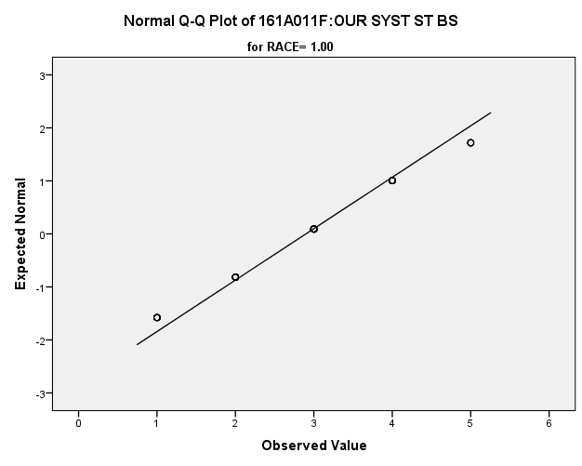

*Primary Analysis:*

|  |  |  |  |  |  |  |  |  |  |  |  |
| --- | --- | --- | --- | --- | --- | --- | --- | --- | --- | --- | --- |
| **Group Statistics** | | | | | | | | | | | |
|  | RACE | | N | Mean | | | Std. Deviation | | Std. Error Mean | | |
| V1677 | 1.00 | | **69** | **2.90** | | | **1.031** | | **.124** | | |
| 2.00 | | **214** | **2.87** | | | **1.238** | | **.085** | | |
| **Independent Samples Test** | | | | | | | | | | | | | | | | |
|  | | | | | Levene's Test for Equality of Variances | | | | | | t-test for Equality of Means | | | | | |
| F | | | Sig. | | | t | | | df | Sig. (2-tailed) | |
|
| V1677 | Equal variances assumed | | | | **7.344** | | | **.007** | | | **.178** | | | **281** | **.859** | |
| Equal variances not assumed | | | |  | | |  | | | **.196** | | | **136.472** | **.845** | |
| **Independent Samples Test** | | | | | | | | | | | | | | | | | |
|  | | | | | | t-test for Equality of Means | | | | | | | | | | | |
| Mean Difference | | | | Std. Error Difference | | | 99% Confidence Interval of the Difference | | | | |
| Lower | | | Upper | |
| V1677 | | Equal variances assumed | | | | **.029** | | | | **.165** | | | **-.398** | | | **.457** | |
| Equal variances not assumed | | | | **.029** | | | | **.150** | | | **-.363** | | | **.422** | |

*5.e. Student Ability to Follow Rules Variables:*

**Going to School is Enjoyable** Within the potential recruit group, are there racial differences in how strongly they feel that school is an enjoyable experience for them?

**Variables used:** The dependent variable was if going to school is enjoyable. The independent (grouping) variable was race.

**Analysis Procedure:**

* A t-test was used to compare average rating of how much students think that going to school is enjoyable between the two racial groups (whites versus non-whites)
* Before conducting analysis, the distribution for how much students think that going to school is enjoyable between was checked separately for the two groups by means of visual inspection of histograms and Q-Q plots. No outliers were observed. However, the distribution of how important students found having lots of money was right skewed for both groups.
* The equality of variances assumption was tested. This assumption was me.

**Results:**

* Null and alternative hypothesis. H0: μ1 = μ2; Ha: μ1 ≠ μ2.
* Calculated t value: t = -1.623, df = 282, fail to reject H0, with a p-value of .104

**Interpretation:** There is not a significant difference between the two groups in how much students think that going to school is enjoyable between.

**Supporting Analysis:**

*Preliminary Analysis:*

|  |  |  |  |  |
| --- | --- | --- | --- | --- |
| ***Descriptives*** | | | | |
|  | RACE | | | Statistic |
| 161A011I:GO SCH ENJY XPR | 1.00 | Mean | | **3.44** |
| 99% Confidence Interval for Mean | Lower Bound | **3.31** |
| Upper Bound | **3.58** |
| 5% Trimmed Mean | | **3.49** |
| Median | | **4.00** |
| Variance | | **1.498** |
| Std. Deviation | | **1.224** |
| Minimum | | **1** |
| Maximum | | **5** |
| Range | | **4** |
| Interquartile Range | | **1** |
| Skewness | | **-.474** |
| Kurtosis | | **-.626** |
| 2.00 | Mean | | **3.48** |
| 99% Confidence Interval for Mean | Lower Bound | **3.39** |
| Upper Bound | **3.58** |
| 5% Trimmed Mean | | **3.54** |
| Median | | **4.00** |
| Variance | | **1.422** |
| Std. Deviation | | **1.193** |
| Minimum | | **1** |
| Maximum | | **5** |
| Range | | **4** |
| Interquartile Range | | **1** |
| Skewness | | **-.610** |
| Kurtosis | | **-.473** |

|  |  |  |  |  |
| --- | --- | --- | --- | --- |
| ***Descriptives*** | | | | |
|  | RACE | | | Std. Error |
| 161A011I:GO SCH ENJY XPR | 1.00 | Mean | | **.053** |
| 99% Confidence Interval for Mean | Lower Bound |  |
| Upper Bound |  |
| 5% Trimmed Mean | |  |
| Median | |  |
| Variance | |  |
| Std. Deviation | |  |
| Minimum | |  |
| Maximum | |  |
| Range | |  |
| Interquartile Range | |  |
| Skewness | | **.105** |
| Kurtosis | | **.209** |
| 2.00 | Mean | | **.038** |
| 99% Confidence Interval for Mean | Lower Bound |  |
| Upper Bound |  |
| 5% Trimmed Mean | |  |
| Median | |  |
| Variance | |  |
| Std. Deviation | |  |
| Minimum | |  |
| Maximum | |  |
| Range | |  |
| Interquartile Range | |  |
| Skewness | | **.077** |
| Kurtosis | | **.154** |

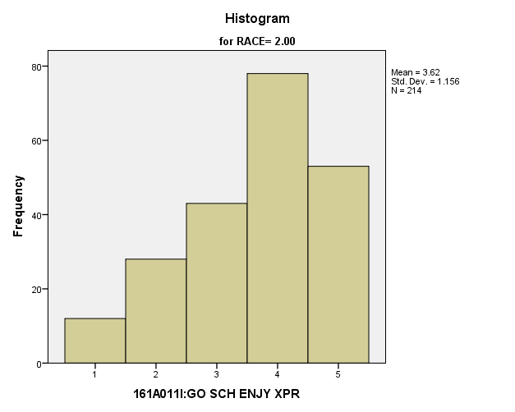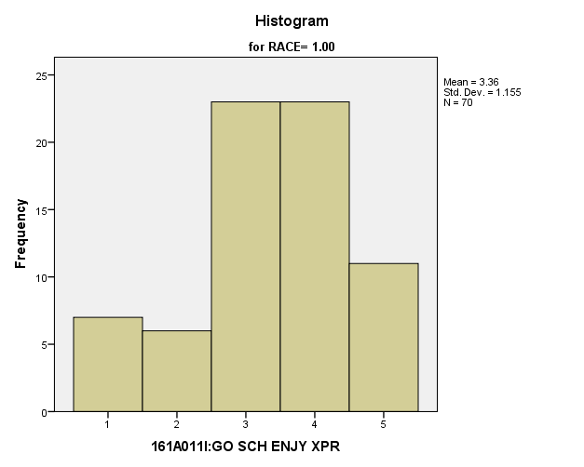

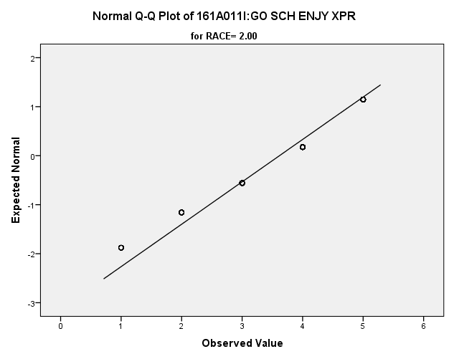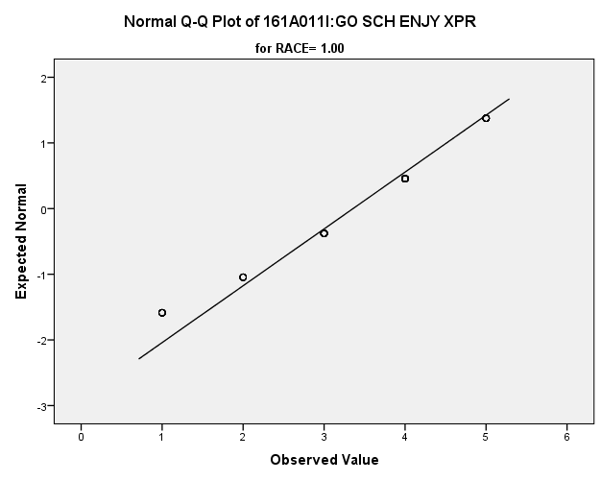

*Primary Analysis:*

|  |  |  |  |  |  |  |  |  |
| --- | --- | --- | --- | --- | --- | --- | --- | --- |
| **Group Statistics** | | | | | | | | |
|  | RACE | N | Mean | | Std. Deviation | | Std. Error Mean | |
| V1680 | 1.00 | **70** | **3.36** | | **1.155** | | **.138** | |
| 2.00 | **214** | **3.62** | | **1.156** | | **.079** | |
| **Independent Samples Test** | | | | | | | | | | | |
|  | | | | Levene's Test for Equality of Variances | | | | t-test for Equality of Means | | | |
| F | | Sig. | | t | | df | Sig. (2-tailed) |
|
| V1680 | Equal variances assumed | | | **.085** | | **.771** | | **-1.632** | | **282** | **.104** |
| Equal variances not assumed | | |  | |  | | **-1.632** | | **117.515** | **.105** |

|  |  |  |  |  |  |
| --- | --- | --- | --- | --- | --- |
| **Independent Samples Test** | | | | | |
|  | | t-test for Equality of Means | | | |
| Mean Difference | Std. Error Difference | 99% Confidence Interval of the Difference | |
| Lower | Upper |
| V1680 | Equal variances assumed | **-.260** | **.159** | **-.672** | **.153** |
| Equal variances not assumed | **-.260** | **.159** | **-.676** | **.157** |

**Doing Well in School is Important:** Within the potential recruit group, are there racial differences in how strongly they feel that doing well in school is important for their job and life in general?

**Variables used:** The dependent variable was if doing well in school is important. The independent (grouping) variable was race.

**Analysis Procedure:**

* A t-test was used to compare average rating of how much students think that doing well in school is important between the two racial groups (whites versus non-whites)
* Before conducting analysis, the distribution for how much students think that doing well in school is important was checked separately for the two groups by means of visual inspection of histograms and Q-Q plots. No outliers were observed. However, the distribution was left skewed for both groups.
* The equality of variances assumption was tested. This assumption was met.

**Results:**

* Null and alternative hypothesis. H0: μ1 = μ2; Ha: μ1 ≠ μ2.
* Calculated t value: t = -.798, df = 284, fail to reject H0, with a p-value of .426

**Interpretation:** There is not a significant difference between the two groups in how much students think that doing well in school is important.

**Supporting Analysis:**

*Preliminary Analysis:*

|  |  |  |  |  |
| --- | --- | --- | --- | --- |
| ***Descriptives*** | | | | |
|  | RACE | | | Statistic |
| 161A011J:DO WL SC IMP/JB | 1.00 | Mean | | **4.18** |
| 99% Confidence Interval for Mean | Lower Bound | **4.06** |
| Upper Bound | **4.30** |
| 5% Trimmed Mean | | **4.30** |
| Median | | **5.00** |
| Variance | | **1.217** |
| Std. Deviation | | **1.103** |
| Minimum | | **1** |
| Maximum | | **5** |
| Range | | **4** |
| Interquartile Range | | **1** |
| Skewness | | **-1.351** |
| Kurtosis | | **1.066** |
| 2.00 | Mean | | **4.24** |
| 99% Confidence Interval for Mean | Lower Bound | **4.16** |
| Upper Bound | **4.32** |
| 5% Trimmed Mean | | **4.35** |
| Median | | **5.00** |
| Variance | | **.966** |
| Std. Deviation | | **.983** |
| Minimum | | **1** |
| Maximum | | **5** |
| Range | | **4** |
| Interquartile Range | | **1** |
| Skewness | | **-1.397** |
| Kurtosis | | **1.586** |

|  |  |  |  |  |
| --- | --- | --- | --- | --- |
| ***Descriptives*** | | | | |
|  | RACE | | | Std. Error |
| 161A011J:DO WL SC IMP/JB | 1.00 | Mean | | **.047** |
| 99% Confidence Interval for Mean | Lower Bound |  |
| Upper Bound |  |
| 5% Trimmed Mean | |  |
| Median | |  |
| Variance | |  |
| Std. Deviation | |  |
| Minimum | |  |
| Maximum | |  |
| Range | |  |
| Interquartile Range | |  |
| Skewness | | **.105** |
| Kurtosis | | **.209** |
| 2.00 | Mean | | **.031** |
| 99% Confidence Interval for Mean | Lower Bound |  |
| Upper Bound |  |
| 5% Trimmed Mean | |  |
| Median | |  |
| Variance | |  |
| Std. Deviation | |  |
| Minimum | |  |
| Maximum | |  |
| Range | |  |
| Interquartile Range | |  |
| Skewness | | **.077** |
| Kurtosis | | **.154** |

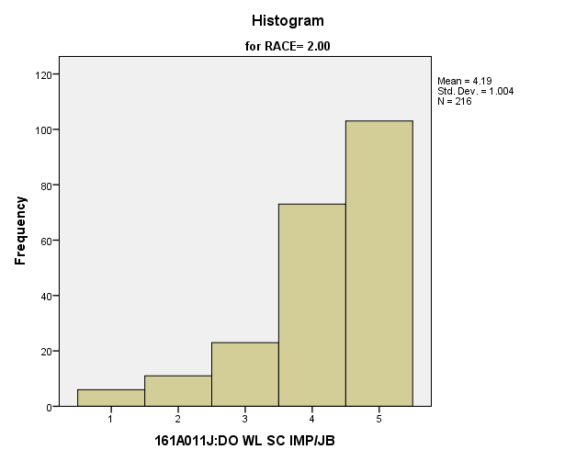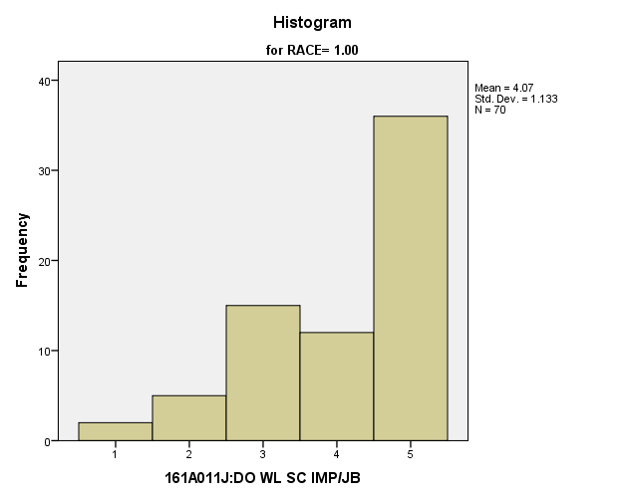

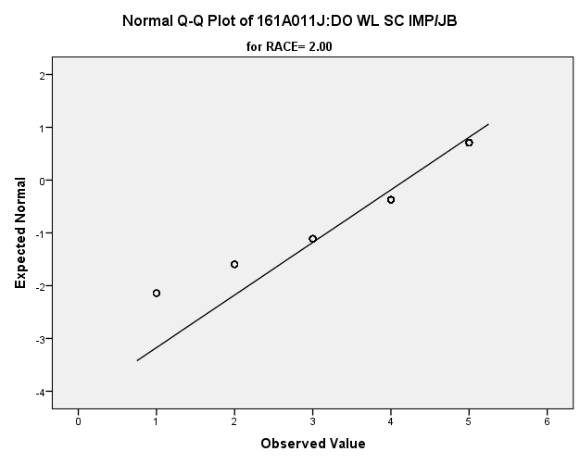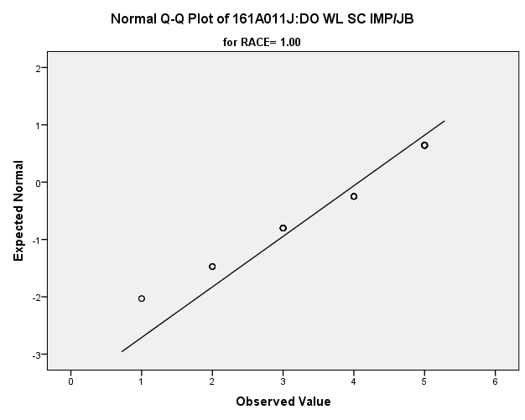

|  |  |  |  |  |  |  |  |  |  |  |  |
| --- | --- | --- | --- | --- | --- | --- | --- | --- | --- | --- | --- |
| *Primary Analysis:*  **Group Statistics** | | | | | | | | | | | |
|  | RACE | | N | Mean | | | Std. Deviation | | Std. Error Mean | | |
| V1681 | 1.00 | | **70** | **4.07** | | | **1.133** | | **.135** | | |
| 2.00 | | **216** | **4.19** | | | **1.004** | | **.068** | | |
| **Independent Samples Test** | | | | | | | | | | | | | | | | |
|  | | | | | Levene's Test for Equality of Variances | | | | | | t-test for Equality of Means | | | | | |
| F | | | Sig. | | | t | | | df | Sig. (2-tailed) | |
|
| V1681 | Equal variances assumed | | | | **4.288** | | | **.039** | | | **-.798** | | | **284** | **.426** | |
| Equal variances not assumed | | | |  | | |  | | | **-.750** | | | **106.322** | **.455** | |
| **Independent Samples Test** | | | | | | | | | | | | | | | | | |
|  | | | | | | t-test for Equality of Means | | | | | | | | | | | |
| Mean Difference | | | | Std. Error Difference | | | 99% Confidence Interval of the Difference | | | | |
| Lower | | | Upper | |
| V1681 | | Equal variances assumed | | | | **-.114** | | | | **.143** | | | **-.484** | | | **.256** | |
| Equal variances not assumed | | | | **-.114** | | | | **.152** | | | **-.512** | | | **.284** | |